AN ANALYSIS OF JUNIOR HIGH SCHOOL STUDENTS’ ERRORS IN SOLVING MATHEMATICAL LITERACY QUESTIONS ORIENTED TO HOTS

Hapsari Wikan Pangastuti^{1, a)}, Elly Arliani^{2, b)}
^{1,2}Universitas Negeri Yogyakarta
^{a)}hapsariwikan.2018@student.uny.ac.id
^{b)}arlianielly@uny.ac.id

Abstract
This study aims to describe (1) students' mathematical literacy skills, (2) types of student errors in solving HOTS-oriented mathematical literacy questions, and (3) the causes of students making mistakes. This research is qualitative research with a descriptive method. The participants in this study were 32 students from class VIII G at Junior High School in Bantul Regency. Data were collected through tests, interviews, and documentation. Furthermore, the data obtained were then analyzed using the steps of data reduction, data presentation, and concluding. The results of the study include: (1) The achievement of mathematical literacy abilities of class VIII G students at level 1 to level 6 are 6.25%, 28.125%, 12.5%, 3.125%, 37.5%, and 12, respectively. 5%; (2) types of errors made by students, namely incorrect data, incorrect procedures, missing data, missing conclusions, response level conflicts, indirect manipulation, skill hierarchy problems, and in addition to the seven categories above. The most mistakes made by students were missing conclusions by 25.8%; (3) the causes of students making mistakes are that students are not careful in understanding the questions, students do incorrect calculations, students do not focus on seeing data, students use formulas incorrectly, and lack of time management in solving problems.
Keywords: Literacy ability, Error analysis, HOTS-oriented mathematical literacy questions, Statistics, Watson's Criteria

PRELIMINARY
One way to enhance a country's character, civilization, and growth for the future is through education. One of the subjects with a significant impact on education is mathematics. Math is studied at all educational levels, including elementary school, junior high school/MTs, high school/equivalent, and university, which may be seen by the fact that it receives more class hours than other disciplines. Due to the current state of globalization, Indonesian students must be prepared to compete with students from other nations.
Reading and writing are fundamental skills that every human being must possess since they are the foundational knowledge that underpins all of science. Mathematical literacy is the capacity to use knowledge of mathematics to address issues. Every student in Indonesia needs to acquire mathematical literacy because it is one of the crucial elements required to develop 21st-century abilities (Anggoro et al., 2019). The ability to develop, apply, utilize, and interpret mathematics to solve issues in a variety of contexts in daily life is referred to as mathematical literacy (PISA, 2022). Ojose (2011) defined mathematical literacy as having the knowledge necessary to comprehend and apply fundamental math in daily life. A students’ capacity to recognize and comprehend how mathematics functions in daily life is known as mathematical literacy (Stacey & Turner, 2015). According to this viewpoint, Sari (2015) defined mathematical literacy as the capacity of a person to effectively formulate, utilize, and interpret mathematics in solving problems in daily life.
A students’ performance in studying mathematics, specifically in grasping knowledge of facts, concepts, and procedurals, and then linking mathematics with multiple contexts, is measured by their mastery of mathematical literacy. The reality is that Indonesian students underperform in their mathematical literacy. Indonesia ranks 72 with a score of 379 and an OECD average score of 487, according to the 2018 Program for International Student Assessment (PISA) survey performed by the Organization for Economic Cooperation and Development (OECD) in 78 countries. Their mathematical literacy can be increased by teaching students to respond to Higher Order Thinking Skills (HOTS) problems. HOTS questions assist students to improve critical and creative thinking abilities because they require students to think at a higher level and employ the reasoning process.
Statistics is taught in Indonesia from elementary school through university. This fact shows the importance of statistics in daily life. According to Sariningsih and Herdiman (2017), statistics have a variety of benefits for human life, ranging from simple to complex. OECD (2014) separates content features into four categories: change and relationship, space and shape, quantity, and uncertainty and data. Students must research the topic of uncertainty and data and interpret the data given in tables or graphs. This topic focuses on data interpretation and presentation. The questions in the content concern statistical data.
Based on the results of the mathematics teacher's interview with the researcher, he disclosed that she rarely assigned questions about mathematical literacy that were HOTS-oriented when students were learning mathematics in class. Due to time constraints, only one or two numbers are used when using literacy questions with all HOTS levels. She added that rigorous analysis of students' errors when answering mathematics problems is still uncommon.
In order to reduce the frequency of mistakes that students usually make that are similar, teachers can utilize error analysis as a tool in their decision-making process when selecting the best teaching strategy. Conceptual, principle, operational, and thoughtless errors are among the mistakes that students usually make (Nuritasari et al., 2017). According to research by Fazzilah et al. (2020) entitled “Analisis Kesalahan Siswa dalam Menyelesaikan Soal PISA Konten Uncertainty and Data” students made errors in understanding the problem 15%, transformation errors 55%, process skill errors 35%, and errors in deciding the final solution 50%.

Students' errors in solving math problems can be analyzed using a various methods, such as the Newman Procedure, SOLO Taxonomy (Structure of the Observed Learning Outcome), Polya, and Watson. The researchers used the Watson criteria to determine students' types of errors. According to Munawaroh et al. (2018), the error analysis by Watson's criteria consists of the following eight categories: inappropriate data (ID), inappropriate procedure (IP), omitted data (OD), omitted conclusion (OC), response level conflict (RLC), undirected manipulation (UM), skill hierarchy problem (SHP), and above other (AO).
It is vital to investigate why students make these errors after being aware of the locations and types of errors committed. Both internal and external factors might cause students' mistakes. In comparing internal and external factors, internal factors are those that arise inside the students. External factors, on the other hand, arise from outside the students themselves, in the form of the environment, both the natural and social environments. In order for students to successfully solve math problems, efforts or learning methods are required to minimize the possibility of errors. Therefore, it is important to examine the students' errors in order to avoid repeating them in the future.
Based on this description, the researcher believes that a more thorough examination of student errors in HOTS-oriented mathematical literacy problems involving statistical material is necessary. This analysis can reveal why students make mistakes and create ways to minimize these issues.

RESEARCH METHODS
This study used descriptive qualitative research methods. This study was carried out to identify the mistakes students made when tackling HOTS-oriented mathematical literacy problems based on Statistics topic. This study was conducted in class VIII G at one of the public junior high schools in Bantul Regency for the 2021/2022 academic year, namely on May 24, 2022, with an allotted time of 80 minutes to work on problems. This study's research subjects were 32 students from class VIII G at one of Bantul Regency's public junior high schools. Several students were chosen to participate in interviews to learn more about the errors that students made when trying to answer mathematical literacy questions on statistical material oriented toward the HOTS.

The information used in this study came from student work on HOTS-oriented mathematical literacy questions on Statistics topics in the form of description questions along with information from student interviews. By combining this data with other sources, it is possible to recognize the various errors students make when trying to answer questions about mathematical literacy targeted at the HOTS. HOTS-oriented mathematical literacy questions for statistical materials and interview guidelines were employed in this study as instruments. Supervisors, mathematics education lecturers, and math subject teachers tested the measure’s validity. Data were gathered for this study using tests, interviews, and documentation. The descriptive method was employed in this study's data analysis. The information gleaned from the written test results was utilized to identify the locations and categories of mistakes made by students when responding to HOTS-oriented mathematical literacy questions. Data reduction, data presentation, and conclusion-making were used to analyze the data. According to Paskalis (2008), the following formula can be used to calculate the percentage of mistakes students make when answering questions about mathematical literacy that are oriented on the HOTS that address each of the Watson criteria:
$$Pi=\frac{ni}{N}×100\%$$
Information:
Pi= the percentage of each type of student error
ni = the number of errors in each type of error
N = the number of errors of all types of errors
Meanwhile, Mujayanti (2011) classifies the percentage of errors made by students as shown in table 1.
Table 1 Classification of the Percentage of Types of Errors
Percentage | Category
$$Pi≥55\%$$ | Very High
$$40\%≤Pi<55\%$$ | High
$$25\%≤Pi<40\%$$ | High Enough
$$10\%≤Pi<25\%$$ | Small
$$Pi<10\%$$ | Very Small

RESEARCH RESULTS AND DISCUSSION
RESULT
The following information is provided regarding the results of the analysis of students' mathematical literacy abilities, the errors made by students in answering HOTS-oriented mathematical literacy questions, and the reasons behind such errors, which are presented per category following Watson's criteria.
- Students' Mathematical Literacy Ability
According to the outcomes of the HOTS-oriented mathematical literacy test, students had an average level of mathematical literacy of 59.5 with a standard deviation of 26.58. The ideal score was 100, while the highest and lowest scores were 96 and 4, respectively. Table 2 displays the class VIII G students' proficiency in mathematical literacy.
Table 2 Mathematical literacy level of class VIII students G
Literacy Level Achieved | Percentage (%) | Achievement Value (Min/Max)
1 | 2 (6.25%) | 4/8
2 | 9 (28.125%) | 20/48
3 | 4 (12.5%) | 50/54
4 | 1 (3.125%) | 62
5 | 12 (37.5%) | 76/82
6 | 4 (12.5%) | 88/96

- Student Errors according to Watson Criteria
The written test results for class VIII G students are shown below, along with a breakdown of the errors students made based on Watson's criterion for each number when trying to solve HOTS-oriented mathematical literacy questions.
Table 3 Percentage of Student Errors according to the Watson Criteria
Error | Question Number |  |  |  |  | The number of each type of error | Percentage
Error | 1 | 2 | 3 | 4 | 5 | The number of each type of error | Percentage
Inappropiate Data (ID) | 2 | 22 | - | 1 | - | 25 | 14%
(Inappropriate Procedure/IP) | 1 | 23 | - | 4 | 1 | 29 | 16.3%
Omitted Data (OD) | 1 | - | 2 | 1 | - | 4 | 2.2%
Omitted Conclusion (OC) | 2 | 27 | 3 | 13 | 1 | 46 | 25.8%
Response Level Conflic (RLC) | - | - | - | 2 | 1 | 3 | 1.7%
Undirected Manipulation (UM) | - | 23 | - | - | - | 23 | 12.9%
Skills Hierarchy Problem (SHP) | 6 | - | 3 | 4 | - | 13 | 7.3%
Above Other (AO) | 1 | 5 | 5 | 10 | 14 | 35 | 19.7%
Amount |  |  |  |  |  | 178

According to Watson's criteria, the errors made by students in resolving HOTS-oriented mathematical literacy problems for Statistics materials are divided into the following eight categories.
Inappropriate Data (ID)
According to the findings of the study of students' work in resolving concerns about mathematical literacy that were oriented on the HOTS, it was discovered that students had entered the data inappropriately for questions 1, 2, and 4. There were two students in question 1, 22 in question 2, and one in question 4, respectively. Question No. 2 has the majority of errors. An example of inappropriate data errors from student work is the following:
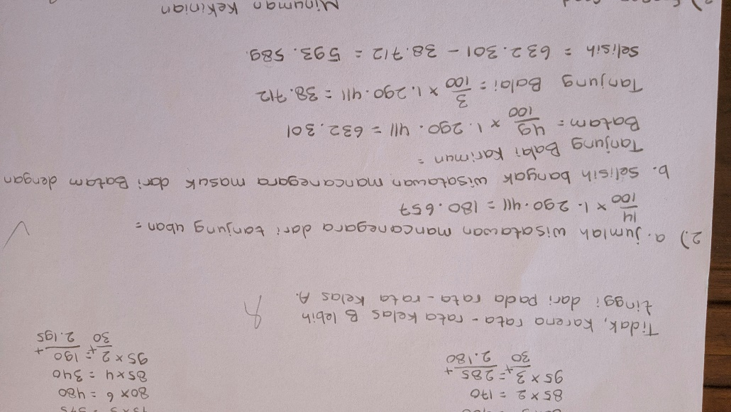
Figure 1 Example of Inappropriate Data
It is obvious from the outcomes of the solutions given above that students erred in using the formula to resolve problem number 2. Without first looking for the number of international tourists who entered Indonesia by sea first, students instantly calculated the percentage required by each question point by the total number of foreign tourists entering Indonesia in January 2020.
Inappropriate Procedure (IP)
Based on the study's findings, it was discovered that four out of the five questions contained improper procedural errors. The four inquiries are 1, 2, 4, and 5. In questions 1 and 5, there is just one student, in questions 2 there are 23 students, and in questions 4 there are 4 students. The second question is where the majority of errors happen. As an example of inappropriate procedural errors, the following student work is provided:
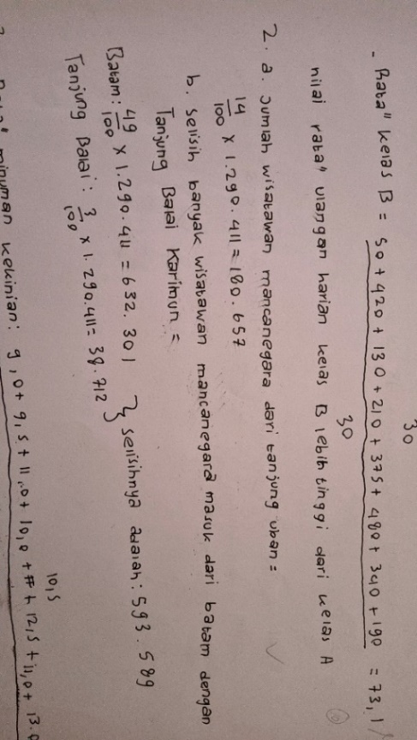
Figure 2 Example of Improper Procedure Error
It is obvious from the outcomes of the answers given above that students employ the wrong techniques or strategies to solve the problems.
Omitted Data (OD)
According to the research's findings, three of the five questions contained errors with omitted data. The three questions are numbered 1, 3, and 4. There is one student for questions 1 and 4, and two students for question 3. The majority of errors occur in question number three. The following is an example of omitted data from student work:
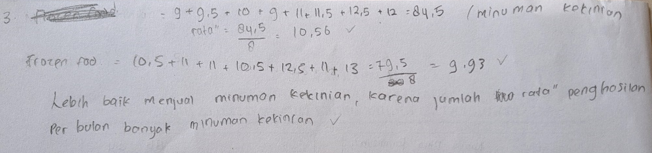
Figure 3 Example of Omitted Data
According to the results of the answers given above, it is obvious that students made mistakes in the form of missing data errors because they missed to enter the data correctly when resolving the problem. Students write $10.5+11+11+10.5+10.5+12.5+11+13$ instead of the requested information, which is $11+10.5+10+9+11+11.5+12+12.5$ for the average frozen food sales. For the average current drink sales, the numbers are $9+9.5+11+10+10.5+12.5+11+13$ , but students write $9+9.5+10+9+11+11.5+12.5+12$.
Omitted Conclusion (OC)
Based on the study's findings, it was discovered that every question contained an omitted conclusion error. The specifics are as follows: Question 1 has two students, Question 2 has twenty-seven, Question 3 has three, Question 4 has thirteen, and Question 5 has one student. The following result of student work serves as an illustration of an omitted conclusion errors:
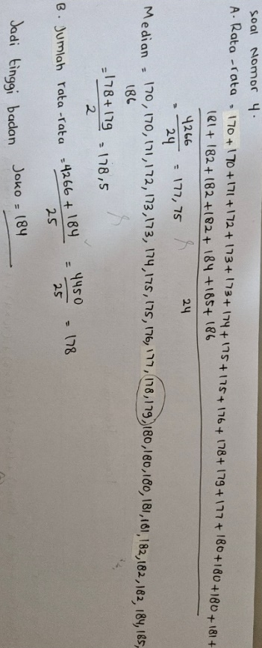
Figure 4 Example of Omitted Conclusion
It is obvious from the answers given above that the students correctly answered all of the questions. Students had the final results but did not write down the judgments they came to about whether Joko could or could not join the steel club 78.
Response Level Conflict (RLC)
Based on the study's findings, it was discovered that two of the five questions contained response level conflict error. The two questions are numbered 4 and 5. There are two students in question number 4, and one in question number 5. The fourth question had the most mistakes. The following is an example of a response level conflict error based on student work:
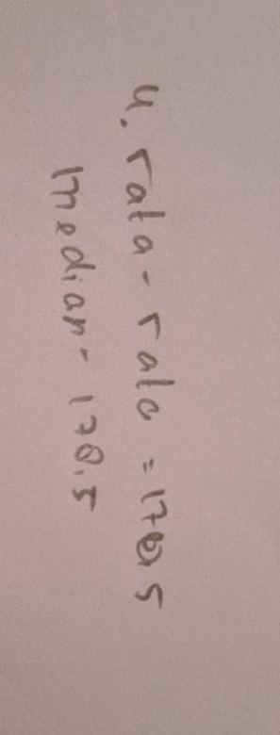
Figure 5 Example of Response Level Conflict
Based on the student work examples above, it is clear that students just wrote the final findings in the form of the average height of the steel athlete candidate 78 and the median value without writing down the procedures for completion.
Undirected Manipulation (UM)
According to the study's findings, undirected manipulation errors occurred in only one of the five questions, namely question number 2, with as many as 23 students. As an example of an undirected manipulation error, consider the following student work:
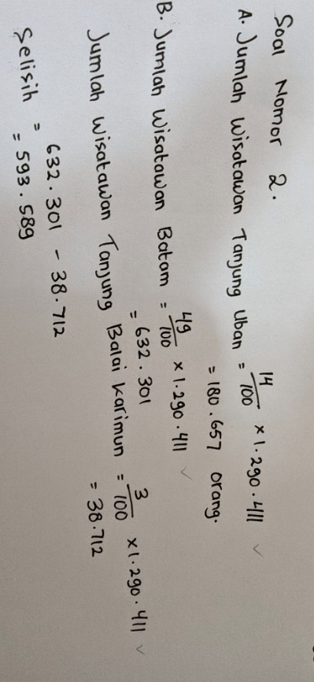
Figure 6 Examples of Undirected Manipulation
According to the results of the student responses above, it can be seen that students directly multiply the percentage required by each question point by the total number of foreign tourists entering Indonesia in January 2020 without first looking for the number of foreign tourists entering Indonesia in January 2020 by sea.

Skills Hierarchy Problem (SHP)
Based on the study's findings, it was discovered that three out of the five questions contained the skill hierarchy error. The three questions are numbered one, three, and four. There are six students in question 1, three students in question 3, and four students in question 4. The majority of errors occur in question number one. As an example of an error in the skill hierarchy problem, the following student work is the outcome:
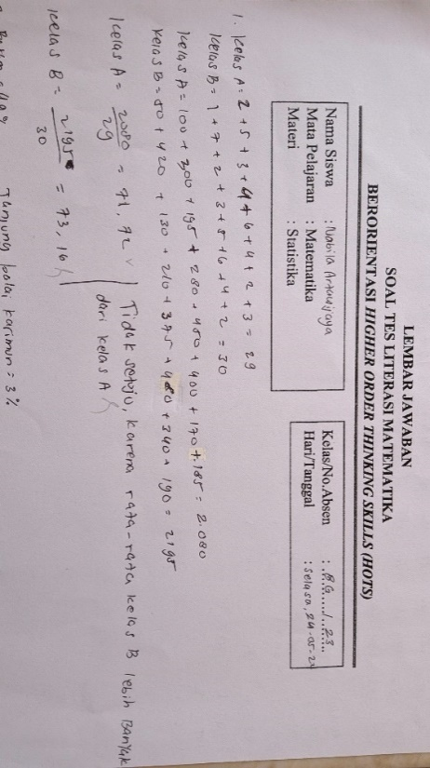
Figure 7 Example of Skill Hierarchy Problem Error
The results of the answers above show that students made errors in their calculations to determine the final value. In question number 1, the statistics for class A students totaled 30. However, the students discovered that class A students actually included 29 students. Additionally, the calculation used to determine the sum of the values for each class is also not wholly accurate.
Above Other (AO)
Based on the study's findings, it was discovered that all of the given questions contained errors outside of the seven categories mentioned above. The specifics are that there is only one student in question number 1, five students in questions 2 and 3, ten students in question 4, and fourteen students in question 5. The majority of errors occur in question number 5. The reason for this is that students struggle with time management, which leads them to concentrate on the first few number problems while running out of time to complete the remaining ones. Students therefore leave their answers blank.

DISCUSSION
The results of the analysis revealed that students have varying levels of capability, as evidenced by their ability in mathematical literacy. Students are able to solve the issue and comprehend the meaning of the given questions. Some students possess the capacity to comprehend, resolve, and even accurately communicate problems. Although the final score fell short of a perfect score, some students could advance to the highest level, level 6. Level 1 was attained by 6.25% of students, who received a minimum score of 4 and a maximum score of 8, Level 2 by 28.125% of students, who received a minimum score of 20 and a maximum score of 48, Level 3 by 12.5% of students, who received a minimum score of 50 and a maximum score of 54, Level 4 by 3.125% of students who received a score of 62, Level 5 by 37.5% of students, who received a minimum score of 76 and a maximum score of 82, and Level 6 by 12.5% of students, who received a minimum score of 88 and a maximum score of 96.
In the meantime, according to the data analysis findings of the errors produced by class VIII G students, namely, Inappropriate Data (ID), students in this error category have attempted to operate mathematical issues appropriately but are not appropriate in utilizing formulae to solve the provided problem. In actuality, students erred in their solution to question number 2. Students had forgotten which formula to utilize. Students' negligence in reading the questions given is what leads to them committing this error. This finding consistent with what Hartati (2019) said, students' errors in the erroneous data category were caused by their hasty effort to answer the questions.
Inappropriate procedure errors (IP), in this type of error students attempt to solve questions at the appropriate level, but the processes utilized are inappropriate. For instance, students may apply the method or steps to solve issues improperly or may forget to write the procedures. In fact, many students make this error when attempting to solve question number 2. Students attempt to resolve problems in the incorrect manner or using the incorrect steps. Instead of looking for the total number of foreign visitors entering Indonesia by sea first, as asked in the question, students multiply each percentage by the overall number of foreign tourists entering Indonesia to find the exact number of foreign tourists entering Indonesia. However, based on the findings of interviews researchers had with students, it showed that they were aware of the proper processes to solve question No. 2, they were just too lazy to swap out their incorrect responses for the new ones. According to research by Pala et al. (2019), students grasp the actions that must be performed to solve the provided problems but do not put them into practice. According to research by Farhan et al. (2019), students desire to finish working on issues as soon as possible, thus they do not always write down the steps for doing so entirely, accurately, and clearly.
Omitted Data (OD), under this category of errors, there is missing data from student answers when students try to solve mathematical problems. It becomes out of sync with other processes as a result, and the completion result is incorrect. In fact, students entered their data less carefully when solving question number 3. Students make this error because they are in a rush and do not focus on viewing the value in the graph, which causes them to enter data upside down. This is consistent with the findings of research by Winarsih & Sugiarti (2015) that students' incomplete data entry and less thorough question-solving practices are the main causes of missing data errors. Jihe et al. (2021) discovered that the source of missing data errors was that students were too rushed to finish their assignments and were not careful enough, resulting in improper data entry and an incorrect final result.
Omitted Conclusion (OC), in this error category students have followed the correct steps to complete the question, but they have made a mistake in their conclusion, or they have completed the supplied question but have forgotten to add a conclusion. Students actually followed the correct steps to solve problem number 4, but they did not write down their conclusions. This indicates that the second question in point 4b, which asks whether Joko can enter the steel club 78 or not, has not been addressed by the students. This is consistent with studies by Cahyani & Aini (2021), who found that students' incapacity to connect previously acquired material to draw conclusions is the reason why they reach incorrect conclusions.
Response level conflict (RLC) errors fall under this category of errors since the students still do not grasp the questions and are not clear about what method or steps to take to attain the desired outcomes. For instance, some students merely record their final answers without providing any logical steps for how they arrived at those conclusions when solving a problem. In reality, it can be shown in the students' answers to question number four. In this instance, students merely wrote down the final outcomes they obtained, namely the average and median, without writing how or what procedures they took to achieve these results. This is in line with the argument made by Winarsih & Sugiarti (2015) that the reason why students make response-level conflict errors is that they do not fully grasp the question's meaning and are not prepared to solve the problem.
Undirected Manipulation (UM) occur when students correctly answer a question, but their reasoning or approach is illogical. For instance, students may have utilized illogical reasoning to reach their conclusions, but they may have done so incorrectly, or they may have misunderstood the questions that were asked and how to answer them. In fact, question 2 is where this mistake happens most frequently. Students have difficulty understanding the question's intent. On the answer sheet, it is obvious that the students did not first look up the percentage of foreign tourists who entered Indonesia by sea before multiplying the percentage required by each question point by the overall number of foreign tourists. This is in line with research done by Zain et al. (2017), which found that the reasons why students make mistakes are a lack of understanding of the questions, a lack of understanding of the concepts related to the questions, a wrong interpretation of the questions' meaning, and a lack of understanding of the steps taken to solve the problems in sequence.
Skills Hierarchy Problem (SHP) errors occur when students are less careful in executing counting skills, incorrect operations, and other tasks. Students are actually able to comprehend and answer question 1. However, because they made errors in their calculations, their result was incorrect. Students incorrectly added the number of students in classes A and B, as seen on the worksheet. In question number 1, the data for class A students is 30, however the student wrote down 29 students. The calculation used to determine the overall value for each class is likewise not quite correct. According to Cahyani and Aini's (2021) research, students make errors in the skill hierarchy problem because they are incorrect in calculating and re-checking answers.
Other than the seven categories listed above Above Other (AO), this mistake category covers student errors that are not listed in the seven categories listed above. Students that do not follow directions or solve the difficulties at hand fall under this category of errors. For instance, students may just rewrite the questions, miss to enter replies that follow the instructions provided in the question, or choose not to respond to the question at all. In fact, the researcher utilized 5 different kinds of questions, and each set contained this error. This indicates that some students do not answer all of the researcher's questions. Students make this mistake because they do not manage their time well when answering questions. According to research by Palayukan (2018), students are more likely to tackle problems that are regarded as easy initially, which is why they frequently make mistakes in categories other than the seven listed above. When the time allotted to work on the questions is nearly up, pupils forget to do them, resulting in students missing to provide the desired answer or unable to accomplish it.
Based on the findings of the interviews that were performed, the researchers identified the reasons why students err when attempting to answer mathematical literacy questions that were HOTS-oriented. These factors include students not paying close attention to the questions when understanding them, students making inaccurate calculations, students not paying attention to the facts, students applying the wrong formulae, and students not managing their time well while completing questions. Additionally, students are less used to working on HOTS-oriented questions and model questions for mathematical literacy because, from the teacher's perspective, they are rarely given due to the limited time if they utilize many model questions.

CONCLUSION
Based on the data analysis results reported in the research and discussion results, it is possible to conclude that students' average mathematical literacy ability is 59.5, with a standard deviation of 26.58. The most outstanding score was 96, the lowest was 4, and 100 was the perfect score. The percentages of class VIII G students that achieved mathematical literacy skills at levels 1 to 6 are 6.25%, 28.125%, 12.5%, 3.125%, 37.5%, and 12.5%.
The types of errors made by class VIII G students in solving HOTS-oriented mathematical literacy questions based on the Watson criteria are Inappropriate Data (ID) of 14%, Inappropriate Procedure (IP) of 16.3%, Omitted Data (OD) of 2.2%, Omitted Conclusion (OC) of 25.8%, Response Level Conflict (RLC) of 1.7%, Undirected Manipulation (UM) by 12.9%, Skills Hierarchy Problem (SHP) 7.3%, and 19.7% excluding the seven categories above Above Other (AO). With a percentage of 25.8%, the error type that most students commit is the Omitted Conclusion (OC).
Students making mistakes in HOTS-oriented mathematical literacy questions are caused by a lack of full knowledge of the questions, inaccurate calculations, a lack of emphasis on observing data, inappropriate use of methods, and a lack of time management in answering issues. Additionally, students are less used to working on HOTS level questions and model questions for mathematical literacy because, from the teacher’s perspective, they are rarely given due to the limited time if they utilize a lot of such model questions.
According to the results acquired, substantial efforts are required to overcome the errors encountered by students when completing statistical questions, in this case the HOTS-oriented mathematical literacy questions. If this problem is disregarded, students will likely make mistakes not only in the statistical material but also in other subjects.

REFERENCES
Anggoro, A. Y., Julie, H., Sanjaya, F., Andy Rudhito, M., & Wiadnyana, D. P. (2019). The mathematics education department students’ ability in mathematical literacy for the change and relationship problems on the PISA adaptation test. Journal of Physics: Conference Series, 1397(1). https://doi.org/10.1088/1742-6596/1397/1/012085
Cahyani, A., & Aini, I. N. (2021). Analisis kesalahan siswa dalam menyelesaikan soal trigonometri berdasarkan kriteria watson. 4(2), 365–372. https://doi.org/10.22460/jpmi.v4i2.365-372
Farhan, B., Aly, N., Matematika, P., & Tamansiswa, U. S. (2019). Analisis Kesalahan Dalam Menyelesaikan Soal Matematika Pada Siswa Kelas X SMK Negeri 1 Seyegan. 7(1), 135–144.
Fazzilah, E., Nia, K., Effendi, S., & Marlina, R. (2020). Analisis Kesalahan Siswa Dalam Menyelesaikan Soal. 04(02), 1034–1043.
Hartati, L. (2019). Analisis Kesalahan Mahasiswa dalam Menyelesaikan Soal Aljabar Linear Dasar Berdasarkan Kriteria Watson. November, 97–104. https://doi.org/10.30998/simponi.v0i0.324
Jihe, C., Pereira, J., Mingli, Z., Wiranota, H., & Tamur, M. (2021). The Analysis of Students ’ Error in Solving Mathematics Problem The Analysis of Students ’ Error in Solving Mathematics Problem. August.
Mujayanti, N. (2011). Analisis Kesalahan Siswa Berdasarkan Kategori Kesalahan Menurut Watson dalam Menyelesaikan Permasalahan Statistika Siswa Kelas XI IPA SMA Negeri 2 Genteng.
Nuritasari, F., Hasanah, S. I., & Sholehoddin, A. (2017). Analisis Kesalahan Siswa Dalam Menyelesaikan Soal Matematika Pokok Bahasan Matriks Di Kelas Xi Ma. JP2M (Jurnal Pendidikan Dan Pembelajaran Matematika), 3(2), 108. https://doi.org/10.29100/jp2m.v3i2.1761
OECD. (2014). PISA 2012 Results: What Students Know and Can Do: Student Performance in Mathematics, Reading and Science.: Vol. I. https://doi.org/10.1787/9789264208780-5-en
Ojose, B. (2011). Mathematics literacy : are we able to put the mathematics we learn into everyday use? Journal of Mathematics Education, 4(1), 89–100.
Pala, R. H., Herman, T., & Prawanto, S. (2019). Students ’ error on mathematical literacy problems. https://doi.org/10.1088/1742-6596/1157/2/022125
Palayukan, Hersiyati; Pelix, L. (2018). Analisis Kesalahan Siswa dalam Menyelesaikan Soal Perbandingan Trigonometri pada Segitiga Siku-siku. 4.
Paskalis, Y. W. (2008). Analisis Kesalahan Siswa Kelas VII D dan VII E SMPK Maria Fatima Jember dalam Menyelesaikan Soal Cerita pokok Bahasan Aritmetika Sosial Semester Ganjil Tahun Ajaran 2007/2008. Universitas Jember.
PISA. (2022). PISA 2022 MATHEMATICS FRAMEWORK. https://pisa2022-maths.oecd.org/
Sari, R. H. N. (2015). Seminar Nasional Matematika dan Pendidikan Matematika UNY 2015 713 Literasi Matematika: Apa, Mengapa dan Bagaimana? 713–720.
Sariningsih, R., & Herdiman, I. (2017). Mengembangkan kemampuan penalaran statistik dan berpikir kreatif matematis mahasiswa di Kota Cimahi melalui pendekatan open-ended. Jurnal Riset Pendidikan Matematika, 4(2), 239. https://doi.org/10.21831/jrpm.v4i2.16685
Stacey, K., & Turner, R. (2015). The evolution and key concepts of the PISA mathematics frameworks. In Assessing Mathematical Literacy: The PISA Experience. https://doi.org/10.1007/978-3-319-10121-7_1
Winarsih, K. A., & Sugiarti, T. (2015). Analisis Kesalahan Siswa Berdasarkan Kategori Kesalahan Menurut Watson Dalam Menyelesaikan Permasalahan Pengolahan Data Siswa Kelas VI SDN Baletbaru 02 Sukowono Jember Tahun Pelajaran 2014 / 2015 ( Error Analysis of Students by Categories Errors According.
Zain, A. N., Supardi, L., & Lanya, H. (2017). Analisis Kesalahan Siswa dalam Menyelesaikan Soal Matematika Materi Trigonometri. Jurnal Inovasi Pendidikan Dan Pembelajaran Matematika, 3(1), 12–16.

