Understanding the role of abstraction solutions to different student problem-solving skills
Sarah Desiana Pahu
Postgraduate Program, Mathematics Education Department, University of Yogyakarta

Corresponding author : sarahpahu341@gmail.com

Abstract. Problem solving ability (problem solving) is very important in the learning process, especially in resolving a problem. In general it can be explained that problem solving is the process of implementing knowledge that has been implemented by previous students in a new situation. The importance of problem solving skills by learners in mathematics, namely: (1) Problem solving skills is a general purpose of teaching mathematics; (2) solutions that include methods, procedures and strategies are the core and major processes in the mathematical curriculum; (3) Problem solving is the basic ability in learning mathematics. One way to support the student problem solving skills is by implementing an abstraction solution. Abstraction solutions can be said to be a solution or workaround where there is a selection done against an object so that only the remaining part is important and becomes a new structure. Abstraction is distinguished into three forms and on reflective abstraction there are levels that will be used as an example of problem solving.
- Introduction
Mathematics is one of the disciplines that can improve the ability to think and argue, contribute to the resolution of daily problems and in the world of work, and provide support in the development of science and Technology (Susanto, 2013:185). While Afidah and Khairunnisa (2014) stated that for the world of knowledge, mathematics serves as a symbolic language which is a scientific means to develop logical thinking. Therefore mathematics is very important to learn and how good it can be applied in daily life well.
In learning Math, there is math problem definitely. According to Polya in Hudojo (2005) There are two kinds of mathematical problems namely (1) problems to find, can be theoretical or practical, abstract or concrete, including puzzles. We have to look for the problem variables, we try to get, generate or construct all kinds of objects that can be used to solve that problem; (2) The problem to prove is to point out that a statement is true or false — not both. To be able to solve problems in mathematics needed problem solving skills. In the process of learning mathematics in the school of course teaches problem solving to students is a very important activity where teachers as educators should strive to make students accept and respond to the questions posed by him and then guide the students to problem solving. For students, problem solving is very important and should be learned because by understanding the problem solving process students are expected to be skilled in identifying relevant concepts, formulating the problem solving and being able to organize the skills that have been previously possessed.
A wide range of businesses are done by educators to help students solve their problem-solving skills. This is a challenge for educators because if you are not careful about teaching problem solving, the problem that is presented to students is likely to be meaningless and the skills of the students do not develop even disappear. According to the Travers in Hudojo (2005), the researchers suggested that teachers slightly reduced the teaching way to students by providing relationships between the elements in the problem, but should help students identify the logical assumptions found in the matter.
Mathematics is often associated with an abstract word, it is also reinforced by the Hudojo statement that mathematics with regard to ideas or abstract concepts arranged in a hierarchical and deductive reasoning. Seeing this, it is very important for a student to have good abstraction skills in solving problems especially math problems. To help students ' abstraction skills need an abstraction solution where these allow educators to strive to implement and teach the right abstraction solutions to students. It is not easy because the teacher has to find the right groove considering that mathematics is an abstract concept pattern and mathematical problems often relate to something contextual so it is necessary to have hard work for educators to help students abstraction process.

- Discussion
- Troubleshooting Capabilities
Problem solving ability (problem solving) is very important in the learning process, especially in resolving a problem. In general it can be explained that problem solving is the process of implementing knowledge that has been implemented by previous students in a new situation. According to Sumarmo in Sumartini (2016) stating the problem solving is a process to overcome the difficulties encountered to achieve a goal that is balanced. Meanwhile, according to Nurfitriyanti (2016) Mathematical problem solving ability is the ability to find a way out of the answers that want to be solved, requiring a higher type of study and understanding the objective, as well as the ability to support a lot of creativity. Problem-solving capabilities mean the ability to apply previous knowledge to unfamiliar situations. One's ability to identify or recognize problems, usually solves problems using different ways. Meanwhile, according to Nurfitriyanti (2016) Mathematical problem solving ability is the ability to find a way out of the answers that want to be solved, requiring a higher type of study and understanding the objective, as well as the ability to support a lot of creativity. Problem-solving capabilities mean the ability to apply previous knowledge to unfamiliar situations. One's ability to identify or recognize problems, usually solves problems using different ways.
Charles and O'daffer (1997) stated the purpose of solving problems in learning Mathematics is to: (1) Develop student thinking skills, (2) Develop the ability to select and use problem solving strategies, (3) Develop attitudes and beliefs in resolving problems, (4) Develop students ' ability to use interconnected knowledge, (5) Develop students ' ability to monitor and evaluate their own thoughts and work during the completion of the problem, (6) Develop students ' ability to solve problems in a cooperative learning environment, (7) Develop students ' ability to find correct answers to varying issues.
According to Runtukahu and Kandou (2016), solving math problems can be distinguished into two types: (1) routine or abstract problem solving. In routine troubleshooting usually about the story, the child applies the same mathematical way as described by the teacher; (2) Non-routine troubleshooting or real-world troubleshooting. The problem starts from the real situation and its completion is by translating the issue into the mathematical model and then restored to the real world problem.
The importance of problem-solving skills by learners in mathematics was asserted by Branca in Nurfitriyanti (2016), namely: (1) The ability to resolve problems is a general purpose of teaching mathematics; (2) solutions that include methods, procedures and strategies are the core and major processes in the mathematical curriculum; (3) Problem solving is the basic ability in learning mathematics. Seeing how important problem-solving skills are, especially in mathematics, makes us educators to be more diligent in teaching and guiding students to be better so that they can create good learning.

  - Abstraction Solutions
According to Soedjadi (2000) An abstraction occurs when we look at some objects then we drop the attributes or attributes of that object that are considered insignificant or unnecessary, and eventually only be noticed or taken in the important traits shared. Budiarto (2005) In his study stated that abstraction is a process by which students organize vertically against pre-constructed mathematics into a new mathematical structure. According to an indirect author's view of the abstraction solution can be said to be a solution or workaround where there is a selection done against an object so that only the remaining part is important and becomes a new structure. It is very rare for us to hear that its name is abstraction solution especially when working on the problem, when actually learning abstraction is very important.
According to Piaget (1951) abstraction is distinguished into three forms, namely: (1) Empirical abstraction (empirical abstraction); (2) Pseudo Empirical abstraction (pseudo-empirical abstraction); (3) Reflective abstraction (reflective abstraction). In the process of abstraction there are levels of abstraction according to Cifarelli in Nurita (2017) as follows :
The first level is recognition. At this level, learners identify a pre-existing mathematical structure. The identification of this mathematical structure occurs when learners are aware of a structure that has been used previously on mathematical problems encountered today. To achieve that goal, they must recall the structures that had been obtained in previous activities and use them in subsequent activities.
The second level is the representation (representation). At this level, learners use diagrams in solving a situation to help translate a mathematical structure using any possible workarounds or solutions. So at this level learners start to jerk the question into the form of mathematics in order to be operated as requested. Changing the problem into this mathematical model could be by associating a previous issue with the things that previous learners have gained.
The third level is structural abstraction. At this level, students are able to create abstraction and representation of completion activities. Students are also able to relate things from previous activities. Learners can visualize and reorganize all of his fictional activities and then interpret into new knowledge. New structures, activities, and knowledge that add learners ' knowledge themselves. The occurrence of this abstraction activity is sometimes not realized by learners, but sometimes there is also a conscious.
The fourth Level is structural awareness. At this level, learners are able to demonstrate the ability and completion of a mathematical problem without having to complete all of its fictional activities. At this level learners are able to think about the structure and plot of completion and make decisions without having to do physical form completion or mentally represent the method of completion.

2.3 The role of abstraction solutions for students ' problem solving skills
In general to solve problems especially in mathematical problems, we often use the steps of Polya. The steps of Polya in Susanto (2013) Learning Problem Solving are: (1) understand the problem; (2) Planning completion; (3) perform calculations; (4) Re-examine the processes and results.
It is important for us to know how the role of abstract solutions to students problem solving skills is different. To better understand the following are examples of mathematical problems with abstraction solutions with levels of abstractions:
Mr. Edi has a square-shaped garden with a length of 20 meters. In every corner of the garden, there is a water shower to soak up the garden with a 7 metre long shower range. Calculate the area of the garden that is not exposed to water.

Table 1. Examples of troubleshooting with abstraction processes
Understanding the problem
Level of abstraction | Characteristics | Completion activities
Recognition (Recognition) | Read the question/problem. How attention to the problem is read, takes a long time or short. How to reorganize the problem structure that is being encountered. | Recall regarding Square:  1. Have 4 sides of the same length. 2. Has 4 equal angle points of 90 ° (right angle). 3. Has 2 same diagonal pieces of length. 4. Have 4 fold symmetry and rotational symmetry. Recall about the circles: 1. has one side. 2. The rotational symmetry and the the infinite fold symmetry
Representation (Representation) | Declare what relationship is known by what is asked. | Show sketch of field area and watered area.  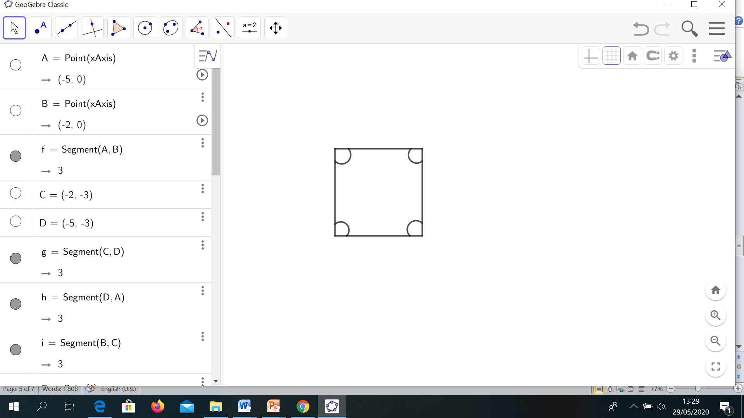  Length of garden = 20 m  The watered garden = 7 m
Structural Abstraction (Structural Abstraction) | Develop a new strategy for a problem, which previously had not been used. Reorganizing mathematical problem structures in the form of arranging, organizing and developing. | States the formula of the garden area without the area of watered garden.  Garden Shower Area
Structural Awareness (Structural Awareness) | Giving arguments or reasons properly decisions are made and is able to summarize their activities properly during problem solving and be linked structured. | Able to understand that to know the area that is not watered by calculating the area of the square minus the area of the circle.
Planning Troubleshooting
Recognition (Recognition) | How to understand every words in a problem. How to make a plan, translate and transform the information or structure in the problem. | Long side garden shaped square = s  The furthest flush = r
Representation (Representation) | Present into an image and understand the problem structure. | 7m  20 m  Garden area = s × s  Area of watered garden = $4×\left(\frac{1}{4}πr^{2}\right)$ = $π{×r}^{2}$  Areas not splashed with water= Garden area – Area of watered garden
Structural Abstraction (Structural Abstraction) | Develop a new strategy for a problem which has not been used before. Organizing mathematical structures in the form of arranging, organizing and developing. | Areas not splashed with water= (s × s) – ($π{×r}^{2})$
Troubleshooting
Recognition (Recognition) | Resolves issues as planned. Using alternative workarounds. Develop other strategies to get a solution.
Representation (Representation) | Resolves issues with images. | Garden area = s × s  = 20 × 20 = 400 $m^{2}$  Area of watered garden  = $4×\left(\frac{1}{4}πr^{2}\right)$ = $π{×r}^{2}$  = $\frac{22}{7}×7×7$  = 154 $m^{2}$
Structural Abstraction (Structural Abstraction) | Developing a new strategy for a problem, which has not been used before. Organizing mathematical structures in the form of arranging, organizing and developing. | areas not splashed with water  = (s × s) – ($π{×r}^{2})$  = 400 $m^{2}-154 m^{2}$  = 246 $m^{2}$
Structural Awareness (Structural Awareness) | Giving arguments or reasons properly decisions are made and is able to summarize their activities properly during problem solving and be linked structured. | The area of square are  20 × 20 = 400 $m^{2}$ minus the circle area $\frac{22}{7}×7×7$ = 154 $m^{2}$ So the areas not splashed with water are 400 $m^{2}-154 m^{2}$ = 246 $m^{2}$
Rechecking Process and Results
Recognition (Recognition) | Solving problems as planned. Using alternative workarounds. Developing the other strategies to get a solution. | Area of watered garden  = $154 m^{2}$  areas not splashed with water  = 246 $m^{2}$
Representation (Representation) | Solving problems by images. | Garden area = Area of watered garden + areas not splashed with water
Structural Abstraction (Structural Abstraction) | Developing a new strategy for a problem, which has not been used before. Organizing mathematical structures in the form of arranging, organizing and developing. | Garden area  = $154 m^{2}$ + 246 $m^{2}$  = 400 $m^{2}$  Thus, the areas not splashed with water are 246 $m^{2}$.

Through the example above, we can see that through reflective abstraction process has been done helping to lead new thinking in solving a problem. Coupled with step by step from reflective abstraction solutions, the learning process is better structured. It is very important to be taught to students considering the different problem solving skills of students. So the authors argue that through an abstraction solution in solving the problem, students ' knowledge can be more structured though not all of the students ' abilities are the same but how good it is through abstraction solutions can help open up thinking and problem solving well.

- Conclusion
Through the discussion outlined, the author concludes that problem solving skills are crucial especially in solving a problem. To assist the problem solving skills of different students one of them by utilizing the role of abstraction solutions. It's not easy and it takes time to apply it to students, but it doesn't hurt to unlock new knowledge and more structured troubleshooting steps.

Reference :
Afidah & Khairunnisa. 2014. Matematika Dasar. Jakarta: Rajawali Pers.
Budiarto, M, T. 2005. Proses abstraksi siswa smp kelas 1 dalam mengkonstruksi kubus dari rangkaian 6 persegi. Prosiding Seminar Nasional Penelitian, Pendidikan & Penerapan MIPA 2005. PM-3 Mega Unesa.
Charles, R & O’Daffer, P. 1997. How to Evaluate Progress in Problem Solving. NCTM. Reston, VA.
Hudojo, H. 2005. Pengembangan Kurikulum dan Pembelajaran Matematika. Malang: UM. Press.
Nurfitriyanti, M. 2016. Model Pembelajaran Project Based Learning Terhadap Kemampuan Pemecahan Masalah Matematika. Jurnal Formatif 6(2): 149-160.

Nurita, R. D. 2018. Proses Abstraksi Dalam Memecahkan Masalah Matematika Berdasarkan Kemampuan Matematis Peserta Didik Di SMP Negeri 2 Kebomas. undergraduate thesis, Universitas Muhammadiyah.
Piaget, J. P. 1951. Dreams, and Imitation in Childhood. New York: Norton.
Runtukahu, J. T. & Kandou. S. 2016. Pembelajaran Matematika Dasar Bagi Anak Berkesulitan Belajar. Yogyakarta: Ar-Ruzz Media.
Susanto, A. 2013. Teori Belajar & Pembelajaran di Sekolah Dasar. Jakarta: Kencana Prenada Media Group.
Soedjadi, R. 2000. Kiat Pendidikan Matematika Di Indonesia (Konstatasi Keadaan Masa Kini Menuju Harapan Masa Depan). Jakarta: Dirjen Dikti, Departemen Pendidikan Nasional.
Sumartini, T. S. 2016. Peningkatan Kemampuan Pemecahan Masalah Matematis Siswa melalui Pembelajaran Berbasis Masalah. Jurnal Pendidikan Matematika STKIP Garut.
Susanto, A. 2013. Teori Belajar & Pembelajaran di Sekolah Dasar. Jakarta: Kencana Prenada Media Group.

