Mathematical Communication of Vocational School Students in Solving The Problem of Linear Programs Based on their Learning Styles

D Patimah1*,Wahyudin2

1Program Studi Pendidikan Matematika, Sekolah Pascasarjana, Universitas Pendidikan Indonesia, Jl. Dr. Setia Budhi No. 229. Bandung 40154, Indonesia

2Departemen Pendidikan Matematika, Universitas Pendidikan Indonesia, Jl. Dr. Setia Budhi No. 229. Bandung 40154, Indonesia

*Corresponding author’s email dedepatimah15@upi.edu

**Abstract**. Mathematical communication in learning mathematics is very important and must be owned by students because it can regulate and combine students’ Mathematical thinking both in verbal and writing manner. The purpose of this study is to analyze the mathematical communication of students who have auditory and visual learning styles in solving linear program problems. This research employed a qualitative research method with a case study research design. This research involved 5 students who had studied Linear program material. They worked on some pre-designed mathematical communication problems and an interview was conducted afterward. The results of this study suggested that students with auditory learning styles and those with visual learning styles have different ways of communicating their thoughts and ideas.

**1. Introduction**

Four competencies that must be possessed by 21st-century students are called 4C, namely critical thinking and problem solving, creativity, communication skills (ability to communicate), and collaborative work ability (ability to work together). Communication ability is an ability that has an important role to support the competencies of other abilities.

Important mathematical communication skills that should be acquired by students are cited in the National Council of Teachers of Mathematics [8], namely 1) the ability to solve problems (mathematical problem solving); 2) the ability of mathematical reasoning; 3) the ability of communication (mathematical communication); 4) the ability to associate ideas (mathematical connection); and 5) the ability to present ideas (mathematical representation). Communication is a way to share thoughts and ideas. When students in the classroom are challenged to solve mathematical problems, communication is the most important tool to express the results of their thoughts both verbally and written to others[6]. By doing so, the student is learning how to trust others. Meanwhile, the students who are listening to their friends’ explanation will get the chance to develop their mathematical understanding. Therefore, mathematical communication is crucial for students as it facilitates an interaction where students 'mathematical ideas will be explored from various perspectives so that it can help sharpen students' thinking [2].

Mathematical communication is no less important to be acquired by students [5]. The communication skills in learning mathematics need to be considered because it can regulate and combine students’ mathematical thinking both verbally and written. If students have communication skills, they will surely engage in the depth of mathematical understanding of the concepts being learned.

Each student has a unique personality that is different from one another in terms of their level of learning speed and learning style. These different ways of learning inform the easiest way for students to absorb information during learning. The easiest and fastest way for someone to do it is known as a learning style[5].Learning styles as concepts that people prefer to process information in different ways and learn better when the teaching methods are suitable and appropriate for their learning styles[4] .Learning styles into three namely Visual learning styles (learning through seeing, Auditory Learning Styles (Learning through Hearing), Kinesthetic Learning Styles (Learning through Moving, Working, and Touching)[7].

**2. Method**

This research employed a qualitative research method using a case study design. Case Study is one of the research designs commonly used by interpreters in small-scale studies that focus on cases [1]. Case studies aim to uncover the reasons behind the occurrence of a matter and understand the interrelated factors. Case studies allow the use of more than one data collection method such as documents, interviews, and surveys [3].

The subjects in this study were 5 female students of one vocational school who have learned the lesson about the linear programs in their school. In this study, all subjects were given two kinds of tests. The first test was a learning style questionnaire and the second one was a mathematical communication written test. The learning style questionnaire was used to classify students into two groups whether students have a visual or auditory learning style. Meanwhile, the mathematical communication skills test was used to see the ability of students who have a visual learning style and those who have an auditory learning style. Furthermore, the students' mathematical communication ability test answers would be analyzed and some students who gave interesting answers would be interviewed.

**3.** **Result and Discussion**

In this study, 5 students were asked to work on learning style questionnaires and communication skills tests online. According to the analysis of the learning questionnaire, two students have an auditory learning style while the other three students have a visual learning style. Further, the students with auditory learning styles will be referred to S1, S2 while the students with visual learning styles will be referred to S3, S4, and S5. The following is the linear program problems that should be solved by the students:

**Linear Program Problem:**

A tailor is making two shirt models. The first model requires 1 meter of plain fabric and 1.5 meters of patterned fabric. However, the tailor only has 20 meters of plain fabric and 10 meters of patterned fabric. What is the maximum number of shirts that can be made?

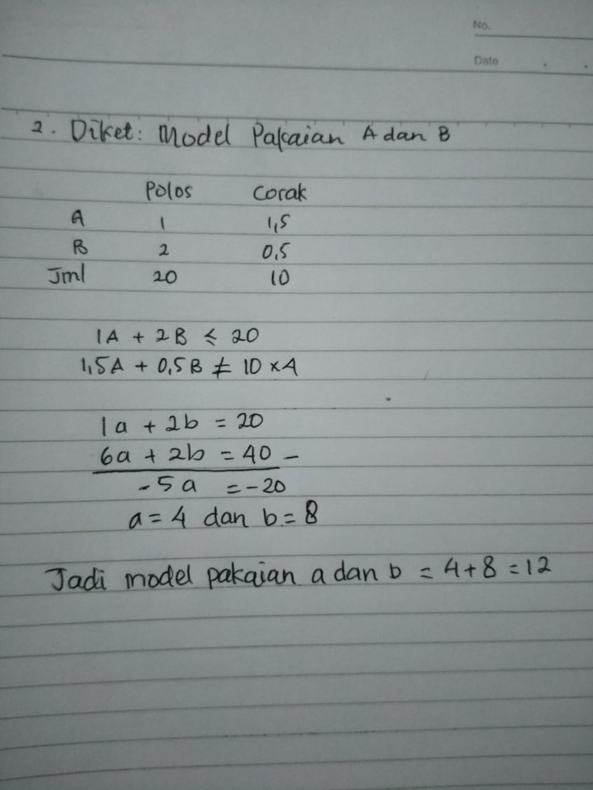

Figure 1. S1 Answer Sheet

According to the picture above, S1 has already understood the purpose of the problem given. However, she did not simplify what is known or the proof by written examples, such as let *shirt model one* be *A*, *the* *shirt model two* be *B*, *the plain fabric* be *x*, and *the patterned fabric* be *y* instead she directly wrote *A*, *B,* *plain* and *patterned*. This means that S1 has not been able to state the situation in a written form but has attempted to state the situation in the problem into a mathematical model by writing equation 1A + 2B ≤ 20,1,5 A + B ≠ 10. However, there is a mistake in writing a symbol in which the sign ≠ is supposed to be ≤. She solves the equation using the elimination method so that the value of a = 4 that should be consistent with uppercase A is not substituted as the value of A = 4 into one of the available equations. She immediately answered the value of b –that was supposed to be uppercase B with 8 instead. To conclude his answer, the purpose of the calculation is not explained. S1 only writes 4 + 8 = 12. Nevertheless, S1 could solve the problem correctly.

Figure 2. S2 Answer Sheet

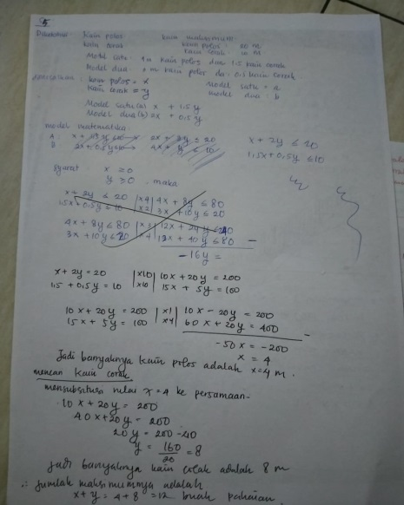

The picture above shows that S2 has already understood the purpose of the problem given. She even tries to simplify what is known or the proof by written examples, for example, let *the shirt model one* be *a*, *the* *shirt model two* be *b*, *the plain fabric* be *x*, *the patterned fabric* be *y*. The written example suggests that the student has been able to state the situation in a written form despite having difficulty in changing the equation into a mathematical model. It can be seen from the crossed out equation, where it is written A` = x + 1.5 y ≤20 and B = 2x + 0.5 y≤10 but later he revises the errors in writing the former mathematical model into equation A` = x + 2y ≤20 and B = 1.5x + 0.5 y≤10. Besides, she multiplies the equation to convert the decimal numbers to integers as she experiences difficulty when she discovers some decimal numbers. At last, she solves the equation using the elimination method so that the value of x = 4m is obtained. Then she substitutes the value of x = 4m to the equation 10x + 20 y = 200. In conclusion, S2 can solve the given problem correctly and restate it in her words by writing it in the conclusions. She gives an elaborative explanation regarding the maximum number of clothes that can be made through an equation x + y = 4 + 8 = 12 pieces of shirt.

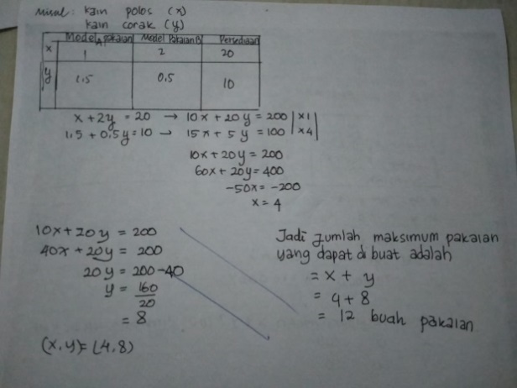

Figure 3. S3 Answer Sheet

Figure 3 suggests that S3 has understood the purpose of the problem given. She has been able to simplify what is known or the proof by written example, for example, let *the plain fabric* be *x*, *the patterned fabric* be *y*. This means that the student has no difficulty in stating the situation in written form. However, it is seen that she has difficulty in changing the situation into a mathematical model for she does not write it in the mathematical equation of A` = x + 2y ≤ 20 and B = 1.5x + 0.5 y ≤ 10. In the next stage, the equation abruptly changes from x + 2y ≤ 20 to 10x + 20y ≤ 200 and 1.5x + 0.5y ≤ 10 to 15x + 5y ≤ 100 without any explanation over the purpose of two equations are multiplied by 10 is to turn the decimal numbers in the equation into integers. In addition, while S3 tries to substitute x = 4 into the equation 10x + 20 y ≤ 200, she made a mistake by writing 40x + 20 y ≤ 200 instead of 40 + 20 y ≤ 200. Even though the writing suggests that S3 is still having some difficulties related to the substitution of the x value = 4, she could solve the problem correctly.

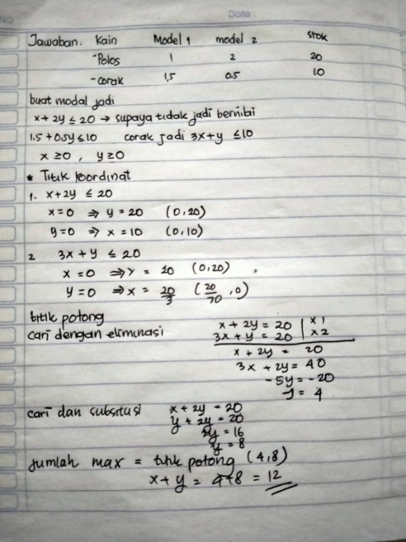

Figure 4. S4 Answer Sheet

Figure 4 proves that S4 has understood the purpose of the problem given as she is able to simplify the problem into a chart. She is also able to state the situation of the problem in mathematical form in detail and provide the reason for changing the original equation in the form of decimal numbers into integers. It shows that S4 is able to state the situation in her model or language. For example, S4 looks for the coordinates of each obtained mathematical equation but does not draw it into a graphical form. As a result, S4 has difficulty in transforming it into a graphical form. In the next stage of the process, she uses the method of elimination where the x value = 4 is substituted in the equation to obtain the value of y = 8. In addition, S4 is able to express the mathematical conclusions that she obtained in her language as she provides detailed writing in the conclusion, the total maximum = cut point (4,8) where x + y = 4 + 8 = 12 pieces of shirt. Finally, S4 can provide the correct answer.

Figure 5. S5 Answer Sheet

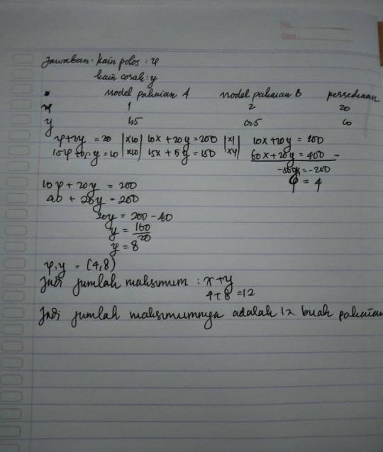

Figure 5 reveals that S5 has understood the purpose of the given problem. She is able to simplify the problem into a chart, state the situation of the problem in mathematical form comprehensively, and write the reason for changing the form of decimal numbers in the original equation into integers. In addition, S5 student has been able to state the situation into her model or language. At the next stage of the process, she uses the elimination method and explains in detail the change of the two equations from decimal numbers to integers. S5 is also able to express the mathematical conclusions she obtained with her language, this can be seen in the conclusions where it is written in detail as follow *the maximum number = x + y = 4 + 8 = 12*. It appears that S5 is able to express the results of the calculations into her language as she narrates *the maximum number is 12 pieces of shirts* in the conclusion. This proves that S5 manages to answer the question correctly.

4. Conclusion

Of the five students in this study, it can be revealed that the students with an auditory learning style do not communicate their mathematical ideas in writing but their ideas are actualized in the concept of thought and expressed verbally. This suggests that students who have an auditory learning style have difficulty communicating their thoughts and ideas in writing and in their language. Meanwhile, the students who have a visual learning style communicate their thoughts and ideas in writing and are able to rewrite them in their language. However, both students group who have auditory and visual learning styles still have some mistakes regarding the use of mathematical symbols.

**References**

.

1. Cohen, L., Manion, L., Morrison, K. 2018. *Research Methods in Education 8th Edition* (New York: Routledge)
2. Duun & Honingsfeld (2013).Learning style: What We Know And What We Need. The Educational Forum. Volume 77, 2013 - [Issue 2](https://www.tandfonline.com/toc/utef20/77/2). <https://doi.org/10.1080/00131725.2013.765328>
3. Gall, D., dkk. (2009). *Applying Educational Research. Person* ( United States)
4. Gudnason (2017). Learning Style in education a Critique. BU Journal of Graduated Studies In Education. Volume 9
5. Marzuki.et.al (2019). Creative Thinking ability based on learning style reviewed from mathematical communication skill. Journal Of Physic. doi:10.1088/1742-6596/1315/1/012066
6. Rayner, S. G. (2015) *Cognitive Styles and Learning Styles*. In, J. D. Wright, (Ed.).International Encyclopedia of Social and Behavioral Sciences (2nd edition), Vol 4. Pp 110 – 117
7. Khaled. S &Lyne Baldwin (2003). *Web-Based Learning International and Learning Style*.British Journal of Educational Technology*.*https :// doi.org// 10.1080/1470329032000128369
8. NCTM (2000) . Principles and Standards for School Mathematics (USA: authors )