Health Assessment of a Sharia Cooperation Using Multilevel Fuzzy Mamdani

A Fauziah, S Andayani

Mathematics Study Program, Universitas Negeri Yogyakarta, Indonesia

[asyifa.fauziah2015@student.uny.ac.id](mailto:asyifa.fauziah2015@student.uny.ac.id), [andayani@uny.ac.id](mailto:andayani@uny.ac.id)

**Abstract**. This study aims to develop rules for assessing the health of the Sharia Savings and Loans Cooperation using the multilevel Mamdani Fuzzy Inference System. This assessment process is carried out in stages by dividing the assessment criteria into three categories, namely Assessment A relating to capital, Assessment B relating to management, and Assessment C relating to the principles of Islamic cooperatives. The outputs of the three assessment groups are used as input to assess the overall health of the cooperation. The accuracy of the assessment results is measured using the MAPE value, and the results show that the MAPE for assessment A is 91.21%, for B's assessment is 90.05%, and for C's is 91.96%. Overall, the MAPE of the fuzzy health assessment system for Savings and Loans Cooperation is 92.63%. It can be concluded that the health assessment of the Savings and Loans Cooperation using the multilevel Mamdani Fuzzy Inference method has good accuracy.

1. Introduction

One of the branches of mathematics that is widely used in decision making that contains uncertainty is fuzzy logic. Fuzzy set theory is a mathematical framework used to present uncertainty, ambiguity, imprecision, lack of information and partial truth [1]. Fuzzy means obscurity that causes many interpretations, which are often encountered in everyday life. For example, in classifying the health level of a business entity, it often calls it healthy, unhealthy, and quite healthy. In this case, it is not known exactly when the business entity can be said to be healthy or unhealthy. Therefore, fuzzy logic can be used, where this logic can define mathematically by giving each individual possibility a value in the universe of conversation which represents the degree of membership in a fuzzy set [2].

The assessment process is basically a decision making on several alternatives by considering several criteria. Decision making involving fuzzy set theory is often called Fuzzzy Multiple Criteria Decision Making (FMCDM). By using fuzzy sets, decision making with various criteria is easier to do, because of the flexible nature of fuzzy sets. FMCDM is used for ranking to make it easier to determine the best alternative. One method that is often used in judgment or decision making is the Fuzzy Inference System (FIS). The results of the decision-making system using fuzzy sets provide the best alternative in choosing or deciding something [3]. There are 3 types of FIS methods, namely the Tsukamoto method, the Mamdani method and the Sugeno method [4]; while others mentioned there are 4 methods, namely Tsukamoto, Mamdani, Sugeno, and Tahani [5].

A lot of research on the application of FIS in decision making has been found and is still developing today. The use of fuzzy sets in the feasibility level assessment process using the Fuzzy Inference system provides precise and objective results [6]. Some examples are the determination of Asahan University student presidential candidates using the fuzzy Sugeno method (Muhammad Yasin et al, 2017), the selection of contract workers using the Tsukamoto method (Fadil and Dadang, 2016), determining the class of drugs. However, from the existing studies, the stratified FIS method has never been used, that is, in one system the output of an FIS becomes an input for another FIS to obtain the final output system.

In this research, the multilevel FIS Mamdani method will be used in the formation of a health assessment decision-making system for savings and loan cooperatives. The Mamdani FIS method has a calculation result that is closer to the actual result (Batubara, 2017). The Mamdani FIS method also has a smaller error rate than the Tsukamoto and Sugeno FIS method (Ayuningtias et al, 2017). Research related to the calculation of the health level of savings and loan cooperatives has been conducted by Rahmiadi and Yenni (2019). In this study, the performance measurement of savings and loan services in cooperatives was carried out using the AHP method.

Guidelines for health assessment of savings and loan cooperatives have been regulated in the deputy regulation for the supervision of the Ministry of Cooperatives and Small and Medium Enterprises of the Republic of Indonesia number: 06 / Per / Dep.6 / IV / 2016. In these guidelines, the health of cooperatives is determined on the basis of 8 criteria, namely capital, earning asset quality, management, efficiency, liquidity, cooperative identity, independence and growth, and compliance with sharia principles. This study will use the basic principles of cooperative health assessment and the eight criteria according to the guidebook.

The output that will be produced is in the form of an assessment of the health level of savings and loan cooperatives which are divided into 4 categories, namely healthy, fairly healthy, under supervision, and under special supervision.

Based on the description above, this research will develop a decision support system for health assessment of sharia savings and loan cooperatives using the modified Mamdani method of FIS. Modifications were made by classifying the criteria according to their characteristics, and developing an FIS for each group. The output of each FIS is used as the main FIS system input. This modification is hereinafter referred to as the multilevel Mamdani FIS method.

1. Basic Concepts

## Fuzzy set

According to Sari and Alisah (2012) fuzzy logic is an improvement from Boolean logic which was introduced from Calivornia Barkeley University in 1965. In Boolean logic it states that everything can only be expected in two values, namely, 0 and 1 or yes and no. So in fuzzy logic it is only possible for membership values from 0 to 1.

In a Fuzzy set, an element x in a set A has two possibilities, namely x is a member of A or x is not a member of A. all of its members or by specifying the properties that the members of the set must fulfill. In a rule, set A is represented as:

$A=\left\{x∈U|x meet certain conditions\right\}$

With the value *x*  has the following function :

$μ_{A}\left(x\right)=\left\{\begin{aligned}1 jika x∈A \\ 0 jika x∈A\end{aligned}\right.$ (2.1)

The fuzzy set in universe U is denoted by the membership function $μ_{A}(x)$ which has a value in the interval [0,1]. Fuzzy set is a generalization of the classical set with a membership function for values in the interval [0,1]. In other words, the membership function of the classical set can only take two values, namely zero and one. Meanwhile, the membership function of the fuzzy set is a continuous function with a range [0,1]. Fuzzy set is a set with a continuous membership function (Wang, 1997: 22).

## Fuzzy Membership Function

The membership function is a curve that shows the mapping of data input points into their membership values which have a curve between 0 and 1. The following are some of the functions according to Kusumadewi and Purnomo (2004: 8) that can be used to find membership values:

1. Linier Representation

There are 2 linear representations, namely an ascending linear representation and a downward linear representation, following the ascending linear membership function:

|  |  |
| --- | --- |
| $$μ[x]=\left\{\begin{matrix}0; x≤a \\ \frac{x-a}{b-a}; a≤x≤b \\ 1; x≥b\end{matrix}\right.$$ | (2.2) |

Here's a descending linear membership function

|  |  |
| --- | --- |
| $$μ[x]=\left\{\begin{matrix}\frac{b-x}{b-a}; a≤x≤b \\ 0; x≥b\end{matrix}\right.$$ | (2.3) |

1. Triangle Curve Representation

The triangle curve is a combination of two linear lines, namely linear and linear descending, so the membership function is as follows:

|  |  |
| --- | --- |
| $$μ\left[x\right]= \left\{\begin{matrix}0; x≤a atau x≥c \\ \frac{x-a}{b-a}; a≤x≤b \\ \frac{c-x}{c-b}; b≤x≤c\end{matrix}\right.$$ | (2.4) |

1. Trapezoid Curve Representation

The trapezium curve is basically like a triangular curve, only on this curve there are several points that have membership values ​​[1], following is the membership function of the trapezium curve:

|  |  |
| --- | --- |
| $$μ\left[x\right]=\left\{\begin{matrix}0; x≤a atau x≥d \\ \frac{x-a}{b-a}; a≤x≤b \\ \begin{matrix}1; b≤x≤c \\ \frac{d-x}{d-c}; c≤x≤d\end{matrix}\end{matrix}\right.$$ | (2.5) |

## Fuzzy Set Operation Teory

The basic operators in the fuzzy set created by Zadeh according to Kusumadewi and Purnomo (2004: 25) are:

1. Operation AND

This operation is related to the interaction operation on the set $α-predikat$ as the result of operation with the AND operator is obtained by taking the smallest membership value between elements in the relevant set.

|  |  |
| --- | --- |
| $$μ_{A∩B}=min⁡(μ_{A}\left[x\right], μ_{B}\left[y\right])$$ | (2.6) |

1. Operation OR

This operator corresponds to the union operation on the $α-predikat$ set as a result of the operation with the OR operator obtained by taking the largest membership value between elements in the corresponding set.

|  |  |
| --- | --- |
| $$μ_{A∪B}=\max{(μ_{A}\left[x\right], μ_{B}\left[y\right])}$$ | (2.7) |

1. Operation NOT

This operator deals with the union operation on the set. $α-predikat$ as a result of operation with NOT operator is obtained by subtracting the membership value of the element in the set from 1.

|  |  |
| --- | --- |
| $$μ_{A'}=1-μ_{A}[x]$$ | (2.8) |

## Fuzzy Mamdani Inference Method

According to Kusumadewi and Purnomo (2004: 39), the Fuzzy Inference System Mamdani Method or often called the Max-Min method, to get the output value, 4 steps are carried out, namely:

1. Formation of Fuzzy Set

In the formation of a fuzzy set, the membership function is used to calculate the entire fuzzy set. The first step in the fuzzyfication process is to determine the fuzzy variables and their fuzzy sets. Then determine the degree of membership between fuzzy input data and fuzzy sets that have been defined for each input variable of each fuzzy rule (Carolina, 2016). In Mamdani FIS, the input and output variables are divided into one or more fuzzy sets.

1. Aplication Function Implication (Rule)

The application of the implication function is a step in searching for the fuzzy output value of the fuzzy input by means of the value of the fuzzy input that comes from the process of forming a fuzzy set and then it is entered into the rules that have been made to become the output fuzzy. The number of fuzzy rules is formed based on the number of variables and membership functions with the formula $n^{v}$,where $n$ is the number of variables used and $v$ v is the number of membership functions. For example: there are 3 variables in Assessment A, where in each variable has 3 membership functions, then there are $3^{3}$ =27rules in Assessment A. The Max-Min implication function according to Ginting (2014) is an logic structure consisting of a collection of premises and one conclusion, the form of these implications, namely:

$$IF \left(premis-1\right)∘\left(premis-2\right)∘\left(premis-3\right)∘…∘\left(premis-n\right)THEN Konklusi$$

Where ∘ is an operator (AND or OR). The Max-min implication function will cut the fuzzy set output.

The following is an overview of the Max-Min implication function

Rule 1

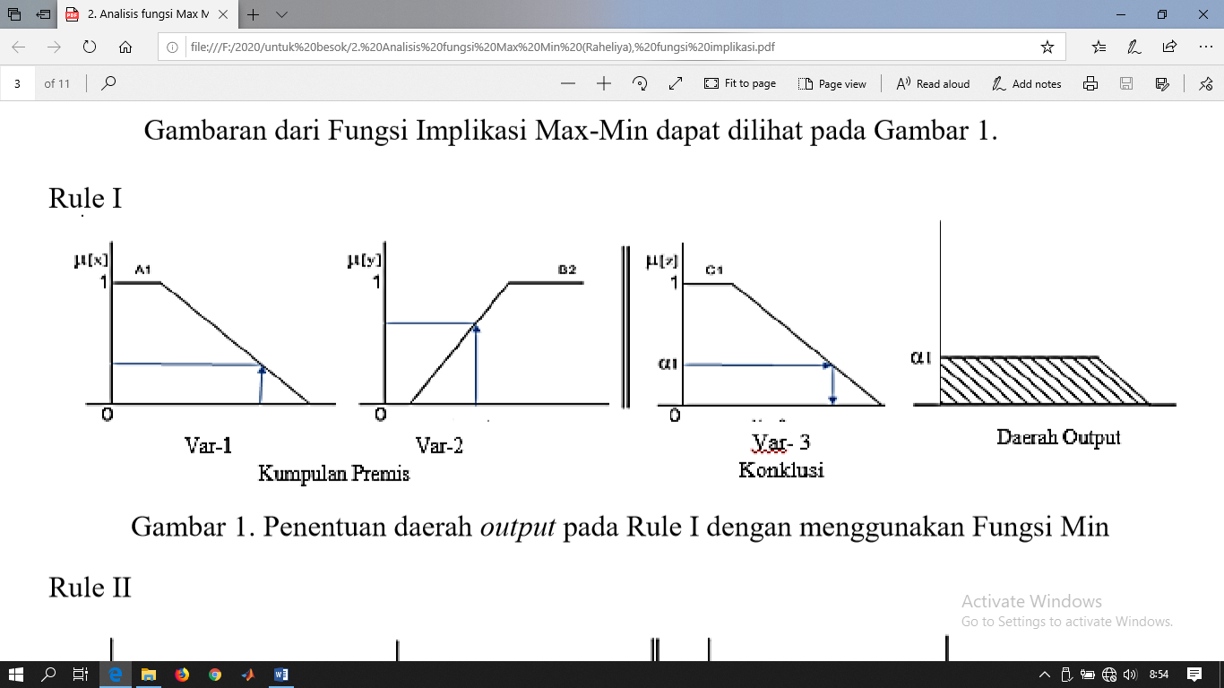

**Figure 1.** Determination of the output area in rule 1 using the Min function

Rule 2

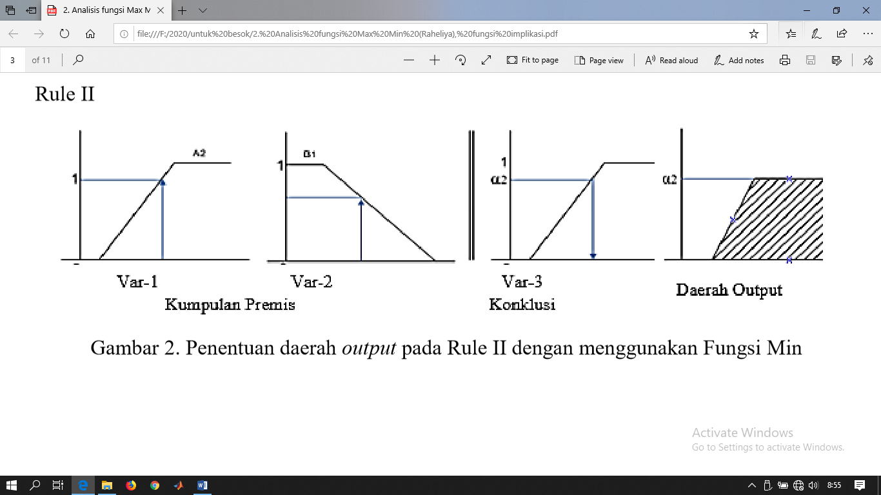

**Figure 2.** Determination of the output area in rule 2 using the Min function

Rule Output Area

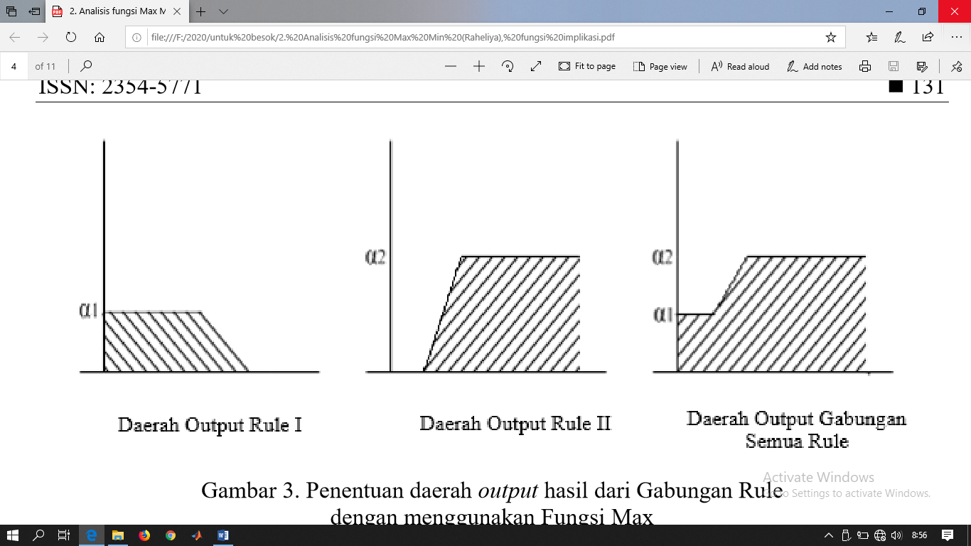

**Figure 3.** Determination of the output area resulting from the combined rule with the Max Function

1. Composition Rule

If a system consists of several rules, the inference is obtained from the collection and correlation between the rules. One of the fuzzy inference methods is the Max (maximum) method, using this method the fuzzy set solution is obtained by taking the maximum value of the rule, then using it to modify the fuzzy area, and applying it to the output using the OR (union) operator. If all propositions have been evaluated, the output will contain a fuzzy set that reflects the contribution of each proposition. The following is the fuzzy inference formula according to Kusumadewi and Purnomo (2004: 40):

|  |  |
| --- | --- |
| $$μ_{sf}\left[X_{i}\right]=max⁡(μ_{sf}\left[X_{i}\right], μ_{kf}\left[X_{i}\right])$$ | (2.9) |

Information:

$μ_{sf}[X_{i}]$ = membership value of the fuzzy solution up to rule until i

$μ_{kf}[X_{i}]$ = nilai keanggotaan konsekuen fuzzy aturan ke-i

1. Defuzzyfikacation

The input for the defuzzyfication process is the fuzzy set obtained from the composition of the rules. The output of the defuzzyfication process is the number in the domain of the fuzzy set. According to Setiadji (2009: 187) the defuzzyfication method is used to produce the desired solution variable value from a fuzzy area. One of the defuzzification methods is the Centroid method, the following is the formula for the continuous Centroid method according to Setiadji (2009: 187):

|  |  |
| --- | --- |
| $$Z_{0}=\frac{\int_{a}^{b}{Z.U_{(Z)}.dx}}{\int_{a}^{b}{U_{(Z)}.dx}}$$ | (2.10) |

Information:

$Z$ = i-th domain value

$U_{(Z)}$ = the degree of membership of the point

$Z_{0 }$ = defuzzyfication result value

## The Accuracy of The Result

The accuracy of the results is calculated using MAPE (Mean Absolute Precentage Error) which is a measure of relative error. MAPE is formulated as follows:

|  |  |
| --- | --- |
|  | (2.11) |

Information:

n = total data

x = original data

y = *model output*

## Health Assessment of Sharia Cooperation

The calculation in the Health Assessment for Savings and Loans Cooperatives has been regulated in the regulation of the Deputy for Supervision of the Ministry of Cooperatives and Small and Medium Enterprises of the Republic of Indonesia number: 06 / Per / Dep.6 / IV / 2016. There are 8 aspects in the Health Assessment of Savings and Loans cooperatives including:

1. Capital
2. Earning Asset Quality
3. Liquidity
4. Management
5. Efficiency
6. Identity of the Cooperative
7. Growth and Development
8. Compliance with Sharia Principles
9. Research Method

This research was conducted to calculate the results of the Health Assessment of Savings and Loans Cooperatives with Fuzzy Mamdani. In this study, there are 8 variables in the Health Assessment of Savings and Loans cooperatives, namely capital, fixed asset quality, liquidity, management, efficiency, cooperative identity, growth and development, and compliance with sharia principles. To make it easier to obtain the results of the assessment, the calculation is carried out with Fuzzy Mamdani in stages by dividing into 3 assessments, namely A based on capital, B based on management, and C based on cooperatives. Each result or output from Assessments A, B, and C will be calculated the Health Assessment of the Savings and Loan Cooperative. In this study, the membership function of the trapezium curve representation is used, uses the and operator in the formation of rules, uses the centroid method in its defuzzyfication, and uses MAPE in calculating the accuracy of the results.

1. Result and Discussion

The data used in this study are 8 data on the Health Assessment of Savings and Loan Cooperatives from 33 Sharia Cooperatives in Sleman Regency in 2019, the following are the Health Assessment data for Savings and Loans Cooperatives

**Table 1.** Health Assessment of Sharia Cooperative Data

|  |  |  |  |  |  |  |  |  |  |
| --- | --- | --- | --- | --- | --- | --- | --- | --- | --- |
| Penilaian | Cooperative | | | | | | | | |
| 1 | 2 | 3 | . | . | . | 31 | 32 | 33 |
| A. *Permodalan* | 9,28 | 4,74 | 10 | . | . | . | 10 | 3,92 | 9,36 |
| B. *Kualitas Aktiva Produktif* | 15 | 20 | 9,31 | . | . | . | 15 | 17,5 | 12,5 |
| C. *Likuiditas* | 10 | 3,75 | 12,5 | . | . | . | 10 | 12,5 | 3,75 |
| D. *Manajemen* | 9,95 | 14,5 | 6,55 | . | . | . | 8,9 | 13,3 | 15 |
| E. *Efisiensi* | 7,5 | 8,5 | 8,5 | . | . | . | 7,5 | 8,5 | 8,5 |
| F. *Jati diri Koperasi* | 6,25 | 6,25 | 10 | . | . | . | 7,5 | 6,25 | 6,25 |
| G. Pertumbuhan dan Perkembangan | 4,5 | 7,75 | 5,5 | . | . | . | 4,5 | 6,25 | 5,5 |
| H. *Kepatuhan prinsip syariah* | 8 | 10 | 7 | . | . | . | 8 | 10 | 10 |

The output of this research is the results of the Health Assessment for Savings and Loans Cooperatives which have 3 variable inputs which are the outputs of Assessment A, Assessment B, and Assessment C. The following is a table of inputs and outputs for the Health Assessment for Savings and Loans Cooperatives

**Table 2.** Input and Output of Health Sharia Cooperative

|  |  |  |
| --- | --- | --- |
| No | *Output* | *Input* |
| 1. | Assessment A | 1. Capital 2. Earning Asset Quality 3. Liquidity |
| 2. | Assessment B | 1. Management 2. Efficiency |
| 3. | Assessment C | 1. Identity of the Cooperative 2. Growth and Development 3. Compliance with Sharia Principles |
| 4. | Health Assessment of Sharia Cooperative | 1. Output of Assessment A 2. Output of Assessment B 3. Output of Assessment C |

The following is a table of fuzzy set formation with the membership function of the trapezium curve representation

**Table 3.** Membership Function Graph

|  |  |  |  |
| --- | --- | --- | --- |
| Assessment | Membership Function Graph | Fuzzy Set Name | Domain |
| Capital |  | Tidak sehat  Cukup sehat  Sehat | [0 5,5]  [4,5 8]  [7 10] |
| Earning Asset Quality |  | Tidak baik  Cukup baik  Baik | [0 10,5]  [9,5 15,5]  [14,5 20] |
| Liquidity |  | Tidak liquid  Cukup liquid  Liquid | [0 8]  [7 11,75]  [10,75 15] |
| Output of Assessment A |  | Tidak baik  Kurang baik  Cukup baik  Baik | [0 13,25]  [11,25 24,5]  [22,5 35,75]  [33,75 45] |
| Management |  | Tidak baik  Cukup baik  Baik | [0 8,5]  [7,5 12,25]  [11,25 15] |
| Efficiency |  | Tidak efisien  Cukup efisien  Efisien | [0 6]  [5 8,5]  [7,5 10] |
| Output of Assessment B |  | Tidak baik  Kurang baik  Cukup baik  Baik | [0 8,25]  [6,25 14,5]  [12,5 20,75]  [18,75 25] |
| Identity of the Cooperative |  | Tidak baik  Cukup baik  Baik | [0 5,5]  [4,5 8]  [7 10] |
| Growth and Development |  | Rendah  Sedang  Tinggi | [0 5,5]  [4,5 8]  [7 10] |
| Compliance with Sharia Principles |  | Tidak patuh  Cukup patuh  Patuh | [0 5,5]  [4,5 8]  [7 10] |
| Output of Assessment C |  | Tidak baik  Kurang baik  Cukup baik  Baik | [0 9,5]  [7,5 17]  [15 24,5]  [22,5 30] |
| Health Sharia Cooperative |  | DPK  DP  Cukup Sehat  Sehat | [0 56]  [51 71]  [66 85]  [80 100] |

After the establishment of the membership function, a rule will be formed. The formation of fuzzy rules in this study uses the And operator. There are 27 rules in Assessment A, 9 rules on Assessment B, 27 rules on Assessment C, and 64 rules on Health Assessment for Savings and Loans cooperatives.

The next step in the Mamdani Fuzzy Inferent System is the application of the implication function. The following is an example of the application of the implication function for Assessment B. There is a value of 9.95 on the management variable and 7.5 in the efficiency variable.

The following is a fuzzy set of inputs to the Management and Efficiency variables based on the management membership function and efficiency

$$μ_{{M }_{Tidak_baik}}\left(9,95\right)=0$$

$$μ_{M_{Cukup_baik}}\left(9,95\right)=1$$

$$μ_{M_{Baik}}\left(9,95\right)=0$$

$$μ_{E_{Tidak_efisien}}(7,5)=0$$

$$μ_{E_{Cukup_efisien}}(7,5)=1$$

$$μ_{E_{Efisien}}(7,5)=0$$

Based on the rules that have been made for Assessment B, the following membership degrees are obtained:

$$α_{1}=\min\left(μ_{M_{Baik}}\left(9,95\right),μ_{E_{Efisien}}\left(7,5\right)\right)=\min\left(0,0\right)=0$$

$$α_{2}=\min\left(μ_{M_{Baik}}\left(9,95\right),μ_{E_{Tidak_Efisien}}\left(7,5\right)\right)=\min\left(0,0\right)=0$$

$$\begin{matrix}. \\ . \\ .\end{matrix}$$

$$α_{9}=\min\left(μ_{M_{Tidak_Baik}}\left(9,95\right),μ_{E_{Tidak_Efisien}}\left(7,5\right)\right)=\min\left(0,0\right)=0$$

The following are the results of the implications if they are depicted in the assessment output graph B 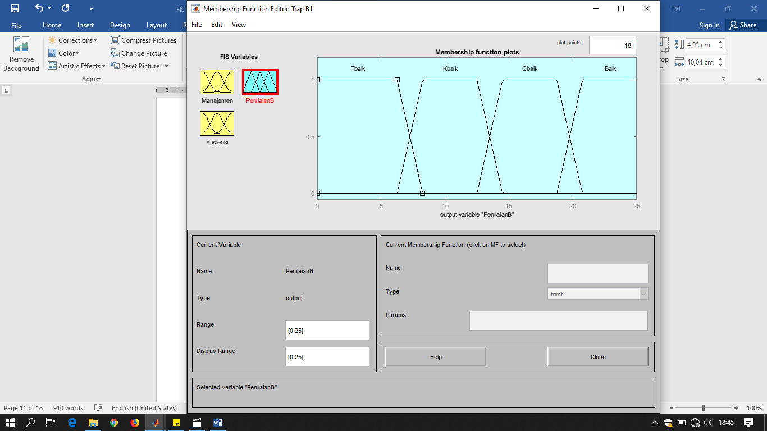

**Figure 4.** Output of Assessment B Graph Inference Result

The final step of the Mamdani Fuzzy Inferense System is to calculate the defuzzification or the final results that will be obtained in the Health Assessment of Savings and Loans cooperatives. In research for defuzzyfication using the centroid method. Based on the example of the application of the implication function, the value of Assessment B will be calculated, here is the membership function based on the output of the implication function application

$$μ_{B_{cukup_baik}}\left[x\right]=\left\{\begin{matrix}0; x≤12,5 atau x≥20,75 \\ \frac{x-12,5}{14,5-12,5}; 12,5≤x≤14,5 \\ \begin{matrix}1; 14,5≤x≤18,75 \\ \frac{20,75-x}{20,75-18,75}; 18,75≤x≤20,75\end{matrix}\end{matrix}\right.$$

Then the defuzzyfication calculation is done using the centroid method according to the formula 2.10

$$Z_{0}=\frac{\int_{a}^{b}{Z.U_{(Z)}.dx}}{\int_{a}^{b}{U_{(Z)}.dx}}=\frac{momen}{luas}$$

Here is the calculation for the moment

$$M_{1}=\int_{12,5}^{14,5}{\left(\frac{x-12,5}{14,5-12,5}\right)x dx}$$

$$M_{1}=\int_{12,5}^{14,5}{0,5x^{2}-6,25x dx}=13,833$$

$$M_{2}=\int_{14,5}^{18,75}{\left(1\right)x dx=70,656}$$

$$M_{3}=\int_{18,75}^{20,75}{\left(\frac{20,75-x}{20,75-18,75}\right)x dx}$$

$$M_{3}=\int_{18,75}^{20,75}{10,375x-0,5x^{2} dx=19,41}$$

Total moment = M1+M2+M3= 103,899

Here is the calculation for area

$$A1=\int_{12,5}^{14,5}{0,5x-6,25 dx=1}$$

$$A_{2}=\int_{14,5}^{18,75}{1 dx}=4,25$$

$$A_{3}= \int_{18,75}^{20,75}{10,375x-0,5x dx=1}$$

So the tota area is A1+A2+A3=6,25

Then the defuzzyfication value is obtained as follows

$$Z_{0}=\frac{103,899}{6,25}=16,62$$

Based on the above calculations, it was found that the value for the output was 16.62.

After calculating, the accuracy of the Health Assessment of the Savings and Loans cooperative using MAPE is obtained as follows

**Table 4.** Nilai Keakuratan Hasil dengan MAPE

|  |  |  |
| --- | --- | --- |
| No | Assessment | Accuracy |
| 1. | Assessment A | 91,21% |
| 2. | Assessment B | 90,05% |
| 3. | Assessment C | 91,96% |
| 4. | Health Assessment of a Sharia Coopertive | 92,63% |

1. Conclusion

Based on the results of this study, it can be said that the assessment of the health of a cooperative which has 8 variables can be carried out in stages by grouping the inputs into 3 categories according to their characteristics. The three categories are assessment A related to capitalization, assessment B relating to management, and assessment C related to cooperative principles. The Health Assessment of Savings and Loans Cooperatives using the Mamdani method has an accuracy of 92.63%. Thus, apart from being able to assess the health integrity of the cooperative as a whole, this SPK can also provide an assessment in these categories..

1. References
2. Sinaga, R. (2014). Sistem Pendukung Keputusan Dalam Menyeleksi Anggota Paskibraka dengan Menggunakan Metode Simple Additive Weighting (SAW) Pada Kantor Dinas Pemuda dan Olahraga Kab. Simalungungun. Pelita Informatika Budi darma, Volume: VI, Nomor: 3, ISSN 2301-9425.
3. Andayani, S. (2015). Eksploitasi VAriabel Linguistik Fuzzy dalam Asesmen Pembelajaran. Seminar Nasional Matematika dan Pendidikan Matematika UNY.
4. Rohayani, H. (2013). Analisis Sistem Pendukung Keputusan Dalam Memilih Program Studi Menggunakan Metode Logika Fuzzy. Jurnal Sistem Informasi (JSI), Vol. 5, No. 1, ISSN Online: 2355-4614.
5. Kusumadewi, S., & Purnomo, H. (2004). Aplikasi Logika Fuzzy Untuk Pendukung Keputusan. Yogyakarta: Graha Ilmu.
6. Buana, W. (2017). Penerapan Fuzzy Mamdani Untuk SIstem Pendukung Keputusan Pemilihan Telepon Seluler. Jurnal Edik Informatika, ISSN: 2407-0491.
7. Arfida, S. (2012). Implementasi Fuzzy Terhadap SIstem Pendukung Keputusan Dalam Menentukan Kelayakan Pembiayaan Pengajuan Kredit Barang. Jurnal Informatika, Vol. 12, No. 2.
8. Ayuningtias, L. P., Irfan, M., & Jumadi. (2017). Analisis Perbandingan Logic *Fuzzy* Metode Tsukamoto, Sugeno, dan Mamdani. *Jurnal Teknik Informatika*.
9. Batubara, S. (Agustus 2017). Analisis Perbandingan Metode *Fuzzy* Mamdani dan *fuzzy* Sugeno Untuk Penentuan Kualitas Cor Beton Instan. *IT Journal Research and development Vol. 2, No. 1*.
10. Charolina, Y. (2016). Sistem Pendukung Keputusan untuk Menentukan Pemberian Bonus Tahunan Menggunakan Metode Fuzzy Logic Tipe Mamdani. Jurnal Teknologi Informasi Volume 12, Nomor 2, ISSN: 1979-1496.
11. Ginting, R. B. (Februari 2014 - April 2014). Analisis Fungsi Implikasi Max-Min dan Max-Prod Dalam Pengambilan Keputusan. Cites Journal, Vol. 1, No. 2.
12. Jasri, & Nazli, R. (2018). Penerapan Metode Mamdani untuk Sistem Pendukung Keputusan Penentuan Golongan Obat Sesuai Dengan Penyakit DIabetes. Jurnal Teknologi dan Open Source, Vol. 1, No. 2.
13. Merry, L., Ginting, M., & Marpaung, B. (2014). Pemilihan Supplier Buah dengan Pendekatan Metode Analytical Hierarchy Process (AHP) dan Topsis: Studi Kasus Pada Perusahaan Retail. Jurnal Teknik dan Ilmu Komputer.
14. Rahmiati, & Yenni, H. (Mei 2019). Aplikasi Pengukuran Kinerja Layanan Simpan Pinjam Pada Koperasi Dengan Metode AHP. Jurnal Informatika, Manajemen dan komputer, Vol. 11, No. 1.
15. Sanjaya, F. I., & Hekasputra, D. (2016). Sistem Pendukung Keputusan Pemilihan tenaga Kontrak Melalui Pendekatan Fuzzy Inference System dengan Metode Tsukamoto (Studi Kasus PT. Solo Murni). Seminar NAsional Aplikasi Teknologi Informasi (SNATi).
16. Sari, E. R., & Alisah, E. (2012). Studi Tentang Persamaan Fuzzy. Jurnal CAUCHY,Volume 2 No.2, ISSN: 2086-0382.
17. Setiadji. (2009). Himpunan dan Logika Samar Serta Aplikasinya. Yogyakarta: Graha Ilmu.
18. Simargolang, M. Y., Siregar, Y. H., & Tamba, H. S. (2017). Sistem Pendukung Keputusan Menggunakan Metode Fuzzy Sugeno untuk Menentukan Calon Presiden Mahasiswa di Universitas Asahan. Jurnal Teknik Informatika.
19. Wang, L. X. (1997). A Course in Fuzzy Systems and Control. Englewood Cliffs: Prentice-Hall International Inc.
20. Wulandari, N. (2014). Perancangan Sistem Pendukung Keputusan Pemilihan Supplier di PT. Alfindo Dengan Metode Analytical Hierarchy Process (AHP). Jurnal Sistem Informasi Vol-1 No.1.
21. Yuhasriati. (Oktober 2012). Pendekatan Realistik dalam Pembelajaran Matematika. Jurnal Peluang, Volume 1, Nomor 1 , ISSN: 2302-5158.
22. Kemenkop. (2016). Peraturan Deputi Bidang Pengawasan Kementerian Koperasi dan Usaha Kecil dan Menengah Republik Indonesia Nomor 07/Per/Dep.6/IV/2016 tentang Pedoman Penilaian Kesehatan Koperasi Simpan Pinjam Pembiayaan Syariah dan Unit Simpan Pinjam Pembiyaan Syariah Koperasi.