Analysis of Students’ Mathematics Communication Skill : In Case Triangle and Quadrangle

N N A Panggabean1*, Turmudi2

1 Program Studi Pendidikan Matematika, Sekolah Pascasarjana, Universitas Pendidikan Indonesia, Jl. Dr. Setiabudi No. 229, Bandung 40154, Indonesia

2 Departemen Pendidikan Matematika, Sekolah Pascasarjana, Universitas Pendidikan Indonesia, Jl. Dr. Setiabudi No. 229, Bandung 40154, Indonesia

*Corresponding author’s email: nazlaulia@upi.edu

**Abstract**. In the process of learning mathematics in the class, communication is very important. Many students seem to have difficulties understanding mathematics problems related to the way students can differ in processing message symbols, storing, and using information to respond to a task because learning tends to be theoretical and not based on real context. The aim of this study is to analyse a student's mathematical communication skill in triangle and quadrangle. This research is a qualitative research using descriptive research methods. Subjects of this research were five students of junior high school grade VIII who had learned about geometric triangles and quadrangles in grade VII. The instrument used the ability of mathematics communication test. Based on the results of the analysis, students' mathematical communication skills are quite good. There are some students who were still not quite right in doing the algebraic operations calculations, had errors in calculations, did not use units in their answers and did not write an explanation step by step. So, to improve students' mathematical communication skills, it is better if teachers use an attractive learning approach skills, it is better if the teacher using an attractive learning approach

1. Introduction

In the process of learning mathematics, communication abilities are very important, whether students to students or teachers to students. This inlines with the Indonesian Ministry of Education goals that one of the Mathematics goals is to learn to communicate ideas effectively[1]. Communication skills is also the most important part of mathematics and mathematics education[2]. Mathematical communication is a way to clarify understanding and share ideas in learning-teaching mathematics. In learning mathematics, ideas that emerge from problem solving processes can be used as reflection, discussion and change [3]. Nartani [4] stated that a student's mathematical communication ability is the main process that must be possessed by students to improve thinking ability in mathematics lessons. However, in the learning process many students are still having difficulties understanding the problems that are given by the teacher. Then, when students are given math problems, students often use incorrect mathematical symbols and most students find it difficult to turn mathematical problem questions into sentences or mathematical models. This is because learning tends to be theoretical and not based on real contexts. Many students seem to have difficulties understanding a mathematics problem that is related to the way students can differ in processing message symbols, storing and using information to respond to a task. Then, thus the students' lack of mathematical communication was related to lack of their mathematical communication in elementary school. Also, Osterholm said that many students seem to have difficulties understanding mathematics problems that are related to the way students can differ in processing message symbols, storing and using information to respond to a task [5]. This is supported by the results of research that states that some of the students who do not understand the meaning of the question become wrong in concluding the answer correctly [6].

The quadrangle and triangle materials are important for students because this material is usually found in daily life problems such as finding area and circumference, as a tool in calculating projects or work. Problems of daily life related to numbers and calculations are written down in math problems in the form of stories. The indicator of mathematics communication skills include expressing everyday situations into a mathematical model and solving them to express the situation of everyday events in the form of images [7]. The indicators of mathematical communication skills based on Nurjannah are connecting objects, pictures and diagrams become mathematical ideas, describe mathematical ideas orally or in writing with real objects, pictures, graphics and algebra and express everyday events in language or mathematical symbols [8].

So, the indicator used in this research is to express real objects, situations and daily events in the form of mathematical models (pictures, tables, diagrams, graphs, mathematical expressions) into written form. So, based on the explanation above the aim of this study is to analyze a student's mathematical communication skill in triangle and quadrangle.

1. Methods

This research is qualitative research that used descriptive research methods. The subjects of this research were five grade VIII students of junior high school who had learned about geometric triangles and quadrangles in grade VII. The instrument used the ability of mathematical communication tests.

1. Result and Discussion

Table 1 shows the test instrument students' mathematical communication skills given to students.

**Table 1. Mathematical Communication Skill Test Instrument**

|  |  |
| --- | --- |
| No | Problem |
| 1. | Mrs. Rahmi will make a triangle stamp with a base of 4 cm and a height of 8 cm. Every 1 cm2 costs Rp. 20000. How much does it cost to make 10 stamps? |
| 2. | A rectangular garden with a size of 18m x 16m. In the park a fish pond is 11m x 11m in size, then around the pond will be given a road with a width of 1.5m x 1.5m. The rest of the park will be planted with grass at a cost of Rp. 22000, - / m2  a) Draw a sketch of the situation of the park equipped with elements that are known and asked  b) What is the total cost of planting grass needed in the garden? |
| 3. | Afroh will make a flat shape that has a side length of 6x cm, (24-x) cm, and (4x+6) cm with a circumference of 66 cm2. Determine the value of x and the length of each side. Then draw and explain what flatter shapes that afroh made? |

Based on the problem, four out of five students get the final answer correctly, but the use of units in the answers is still often forgotten by students, then the step-by-step explanation is also not written by students. In figure 1(a) the student understands the problem and is able to solve it but the student found the triangle area formula incorrectly, so they get the wrong final result. In figure 1(b) it looks like the students' answers are correct, but the use of the unit like cm2 and the step by step explanation was not written down.

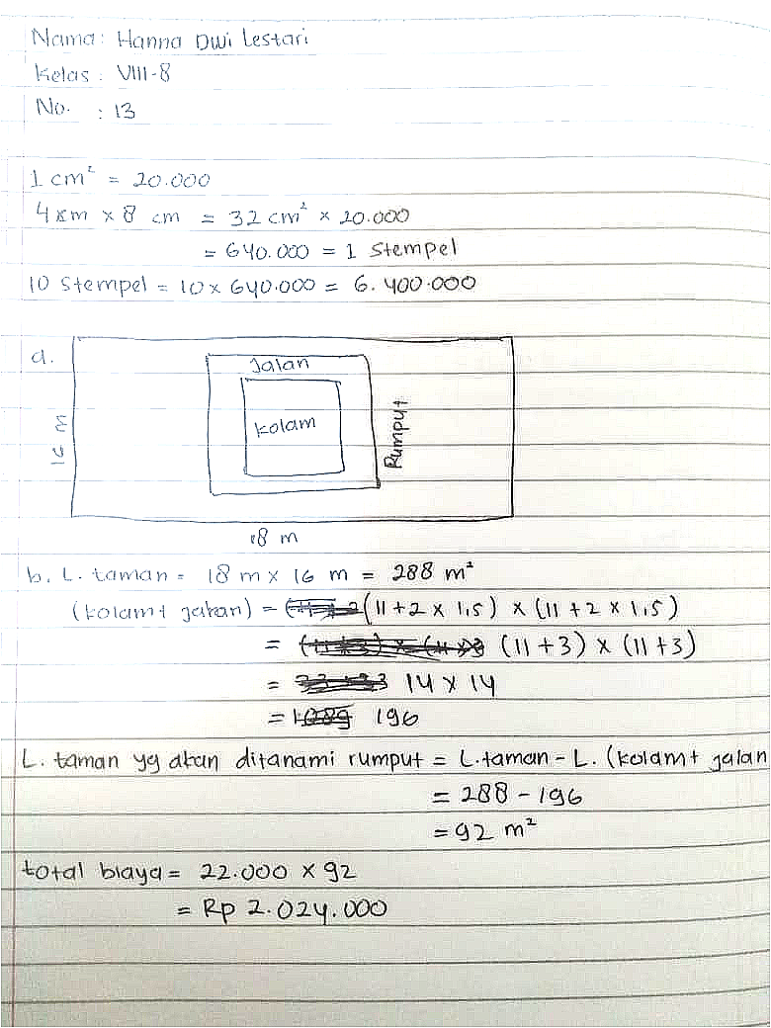

**(a)**

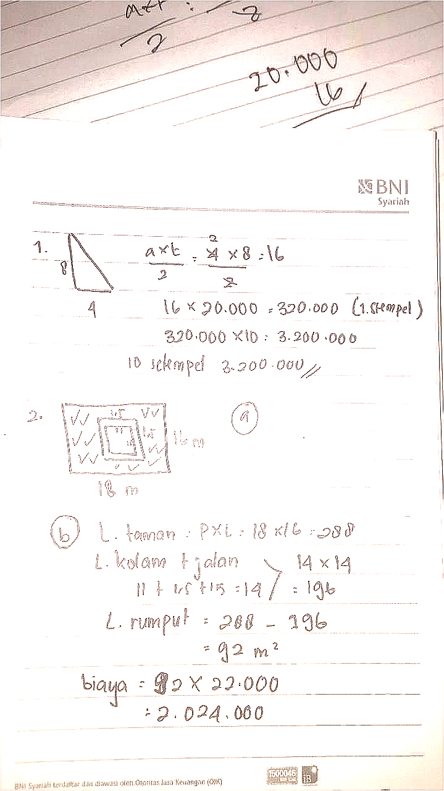

**(b)**

**Figure 1**. Student’s answer for problem 1

Then Then in problem 2, four out of five students got the final answer correctly. In figure 2(a) students got the answers correctly, but in the sketch of the picture, students did not give a sign that 1.5 m is the length of the road. The use of units in the answers is still often forgotten by students, then the step-by-step explanation is also not written by students. Then, the student wrote that the 11 m is the area of ​​the pool whereas 11 m is the length of the side of the pool. The student also immediately multiplied 14 x 14 without giving an explanation of the purpose of the step. The most common mistakes were concept of errors and operation errors so they got the wrong final result [9]. We can see in the In figure 2(b) that the students had a mistake in concept error and operation error where they incorrectly found the area of ​​the section to be planted with grass, where they did subtraction to the garden area and pool area then did addition to the road area, so the end result was wrong. In this case students still could not connect images to mathematical models, and then from the figure 2(a) and 2(b) both students did not give the conclusion at the end of the answer. This is due to giving a conclusion at the end of the answer, it can be said that the students believe their answers are problem solutions [10].



**(a)**

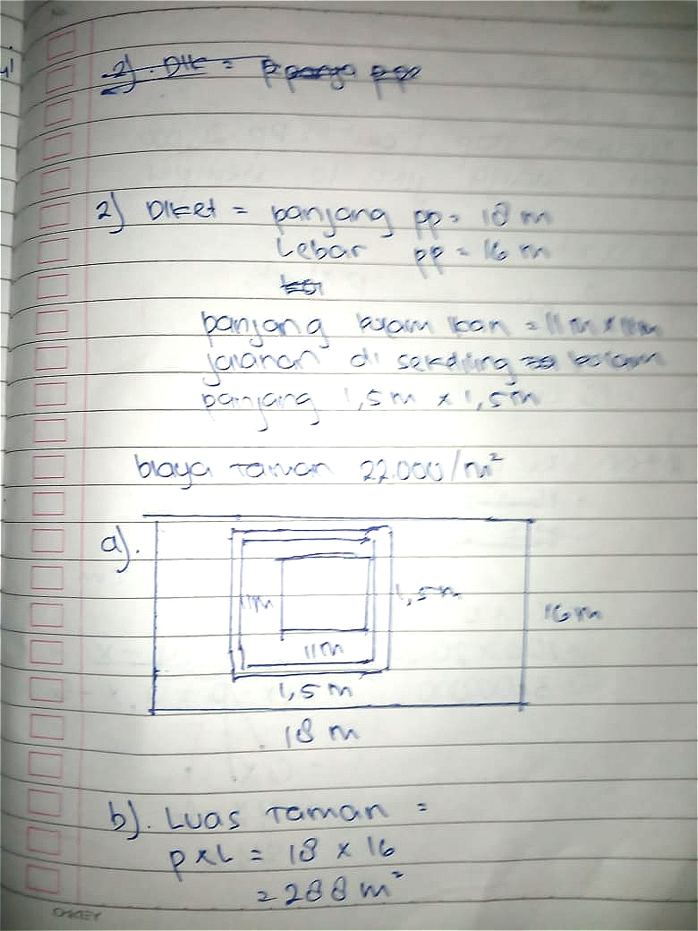

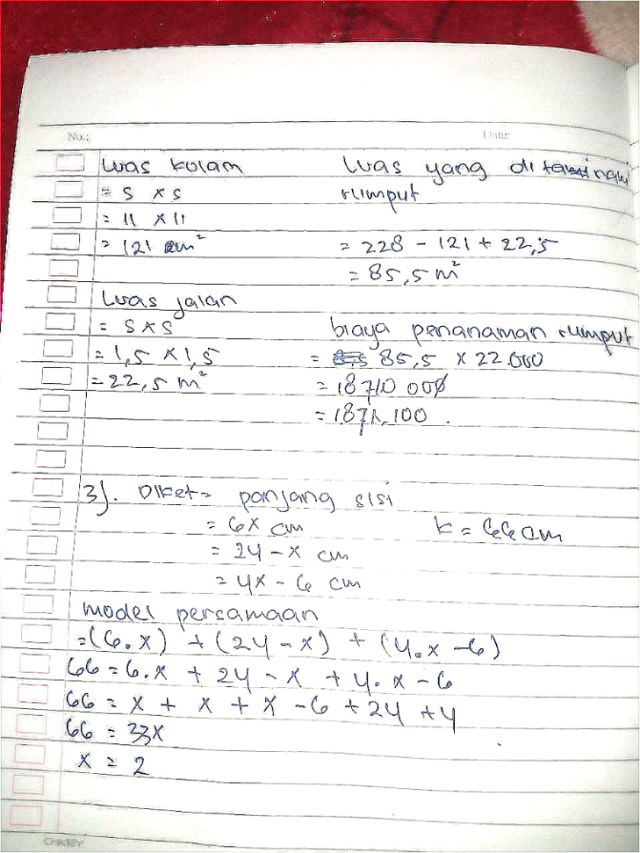

**(b)**

**Figure 2**. Student’s answer for problem 2

In problem 3, In problem 3, three out of 5 students got the value of x ​​correctly, 2 of them answer correctly and completely. In figure 3(a) students did not correctly find the value x. This can be seen from the answers of students who are still wrong in solving the linear equation of one variable in finding the value of x, where x + x + x = x3 which the right answer is 3x. Overall, the completion steps in Figure 3(a) were wrong, then in the picture of the triangle, the students also concluded that the triangle image formed was a right triangle with no clear reason. In figure 3(b) the student's answers were correct as well as the sketches of the triangles and their reasons were also correct. The use of units like m2 and step-by-step explanations did not write down and both of the students in the figure 3(a) and 3(b) also did not write what was known and what was asked in the problem.

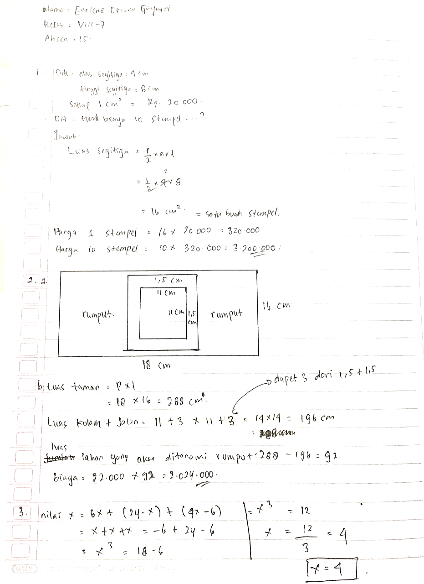

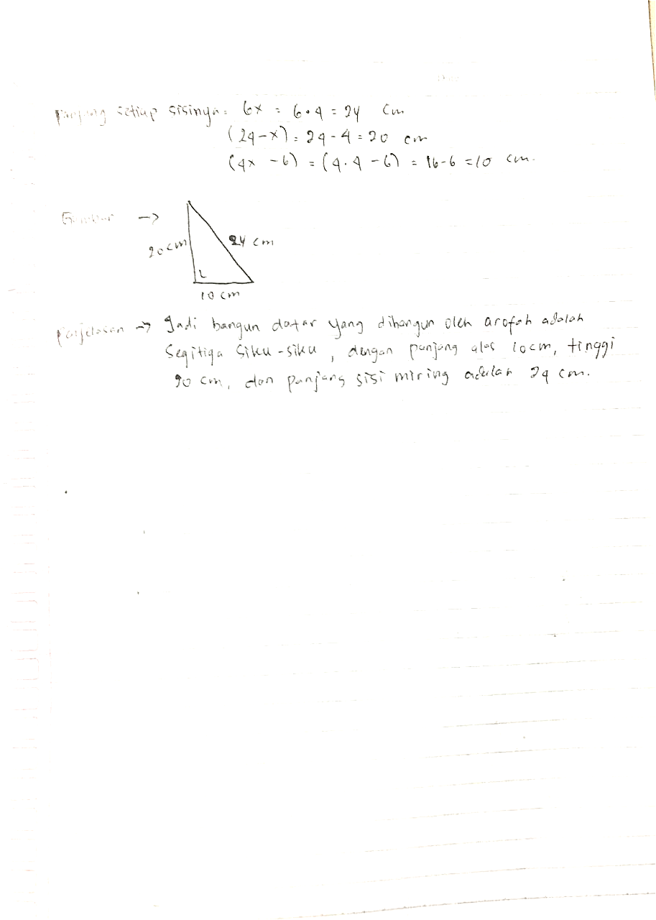

**(a)**

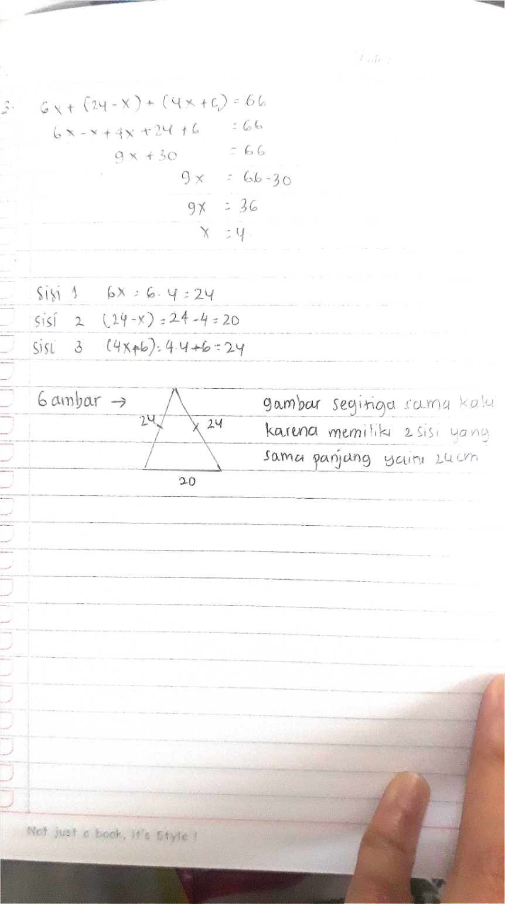

**(b)**

**Figure 3**. Student’s answer for problem 2

.

1. Conclusion

Based on the results of the analysis, it can be concluded that the students' mathematical communication skills are quite good. It can be seen that the five students understood the questions, but some of them did not write down what they knew and what was asked in the questions. There are also some students who were still inaccurate when performing calculation operations of algebraic operations, errors in calculations, did not use units in their answers, did not write step-by-step explanations. In improving students' mathematical communication skills, it is better that the teacher uses an attractive learning approach, so that the students will be able to understand the mathematical concept easily. It is because mathematics is learned to help students so that it can be useful for their future, including how to handle problems in everyday life.

1. References

[1] Kemendikbud RI. Lampiran nomor 16 Permendikbud no. 24 Tahun 2016 (2016). Indonesia.

[2] Fachrurazi. (2011). *Penerapan Pembelajaran Berbasis Masalah Untuk Meningkatkan Kemampuan Berpikir Kritis dan Komunikasi Matematis Siswa Sekolah Dasar*. Jurnal UPI Edisi Khusus ISSN 1412-565X h.76-89.

[3] NCTM. (2000). Principles and Standadrs for School Mathematics. Reston, VA:NCTM

[4] Nartani, C. I., Hidayat, R. A., & Sumiyati, Y. (2015). Communication in Mathematics Contextual. *International Journal of Innovation and Research in Educational Sciences*, *2*(4), 284-287.

[5] Österholm, M. (2006). Characterizing reading comprehension of mathematical texts. *Educational studies in mathematics*, *63*(3), 325.

[6] Fauziyah, R. R., & Jupri, A. (2020). Analysis of elementary school students’ ability on mathematical communication and mathematical representation. In *Journal of Physics: Conference Series* (Vol. 1521, p. 032080).

[7] Sumarmo U Hendriana H Ahmad and Yuliani A, 2019 *Tes dan Skala Matematika Benuansa High Order Thingking Skills* (Cimahi : Refika) p 24

[8] Nurjanah, N., Herman, T., & Prabawanto, S. (2019). Analysis of Student Mathematical Communication Ability. In *J. Phys.: Conf. Ser* (Vol. 1157, pp. 1-7).

[9] Rusyda, N. A., Kusnandi, K., & Suhendra, S. (2017, September). A Cognitive Analysis of Students’ Mathematical Problem Solving Ability on Geometry. In *Journal of Physics: Conference Series* (Vol. 895, No. 1, p. 012081). IOP Publishing.

[10] Widodo, S. A. Turmudi, & Dahlan, JA (2019). An error students in mathematical problems solves based on cognitive development. *International Journal of Scientific & Technology Research*, *8*(7), 433-439.

Acknowledgments

The author would like to express gratitude to UPI (Universitas Pendidikan Indonesia-Indonesia University of Education) for the academic support.