**The SIR Fuzzy Epidemic Model (Susceptible, Infected, Recovered) On Spreading Tuberculosis Disease**

**M D Mawarni1 and D Lestari2**

1,2Mathematics Education Departement, Universitas Negeri Yogyakarta, Indonesia

1 [dyahmawarayu@gmail.com](mailto:dyahmawarayu@gmail.com)

2 [dwilestari.math@gmail.com](mailto:dwilestari.math@gmail.com); [dwilestari@uny.ac.id](mailto:dwilestari@uny.ac.id);

**Abstract.** This research aims to determine the mathematical modeling, stability analysis, and the result of a numerical simulation of the spread of tuberculosis disease in Indonesia in 2017. The stages performed were to form a fuzzy SIR epidemic model (Susceptible, Infected, Recovered), determine the equilibrium point, determine the basic reproduction number, analyze the stability around the equilibrium point, and conduct a simulation using the Maple 18 software. The results of the study acquired two equilibrium points which were disease-free and endemic. The equilibrium point is free of local asymptotic stable disease when the basic reproduction number is worth less than one. It means for a long period of time tuberculosis disease will be reduced or disappear from the population. Meanwhile, the endemic equilibrium is locally asymptotically stable if the basic reproduction number is worth more than one. This means that tuberculosis disease will spread and be endemic to the disease. Based on the simulation established, the greater the rate of transmission, the more the disease will spread and the smaller the recovery rate, the more the disease will spread.

***Keywords :*** *SIR fuzzy epidemic model, tuberculosis, equilibrium point, stability, fuzzy basic reproduction number*

1. **INTRODUCTION**

Mycobacterium tuberculosis is a bacterium causing tuberculosis (TB). Tuberculosis is classified as an epidemic disease that can be transmitted through the airways. It generally attacks the lungs and can spread to other parts of the body such as the lymph nodes, bones, central nervous system, heart, and other organs. In addition, it can lead to death.

In 2017, the number of the people suffering from it recorded was 842 thousand, 116 thousand of whom died from this disease [1]. Based on the Profile of the Health Office in 2018, it was noted that the success rate in treating tuberculosis patients in Indonesia in 2017 was 85.7%. Meanwhile, the success rate of TB treatment to achieve is at least 90.0%, so it is still below the minimum limit.

To determine the spread of tuberculosis, mathematical modeling can be performed using the SIR model. SIR model is divided into three phases, which are Susceptible (S) or individuals who are susceptible to disease, Infected (I) or individuals who are infected and can transmit the disease, and Recovered (R) or individuals who are recovered. Fuzzy logic is an appropriate way to put the input space into an output space [2]. In fuzzy logic, there is a process, which is the determination of fuzzy sets that can provide answers to a problem containing uncertainty.

In [3], [4], and [5] have been discussed about epidemic model of tuberculosis. Meanwhile, research about fuzzy epidemic model can be seen in [6], [7], [8], and [9]. This research will discuss the mathematical modeling of the spread of tuberculosis using the fuzzy SIR (Susceptible, Infected, Recovered) epidemic model based on research by [5]. Fuzzy numbers are used to model the spread of tuberculosis with transmission rate and recovery rate parameters. Based on the data obtained, stability analysis, equilibrium point analysis, basic reproduction number analysis, and numerical simulations of the fuzzy SIR epidemic model will be conducted.

Based on the 2018 health profile, data for 2017 showed that the total population of Indonesia was 261,890,872, where 131,579,184 were male and 130,311,688 were female. The discovery of cases of tuberculosis patients in 2017 was 430,524 people [10]. This numerical simulation will produce a simulation graph using Maple 18 software.

1. **RESULTS AND DISCUSSION**

The form of the fuzzy membership function for the parameter *β* is shown in the following equation:

$$\frac{dS}{dt}=-b\left(σ\right)\frac{I}{N}S-μS+Π,$$

$$\frac{dI}{dt}=b\left(σ\right)\frac{I}{N}S-\left(μ+μ_{t}+c\left(σ\right)\right)I, (1)$$

$$\frac{dR}{dt}=c\left(σ\right)I-μR,$$

where $N=S+I+R.$

The fuzzy membership function of the disease transmission rate parameter *b (σ)* is [8]:

$$b\left(σ\right)=\left\{\begin{matrix}0 & if σ<σ_{m} \\ \frac{σ-σ_{m}}{σ_{0}-σ_{m}} & if σ_{m}≤σ≤σ_{0} \\ 1 & if σ_{0}<σ<σ_{M}\end{matrix} , (2)\right.$$

If the bacterial load is low, then disease transmission is negligible and there is a bacterial load $σ_{m}$ required. In addition, there are a number of bacteria $(σ_{0})$ where the maximum transmission rate is equal to one. The number of bacteria is always limited by $σ_{M}$ for each disease. A diagram of the membership function $b\left(σ\right)$ is in Figure 1 as follows.

$$σ_{m}$$

$$σ_{0}$$

$$σ_{M}$$

$$σ$$

$$β$$

Figure 1. Membership Functions of *b = b (σ)*

The fuzzy membership function for the recovery rate *c = c (σ)* is

$$c\left(σ\right)=\left\{\begin{matrix}\frac{\left(c_{0}-1\right)}{σ_{M}}σ+1 & if 0≤σ≤σ_{M} \\ 0 & for σ others \end{matrix}\right., (3)$$

where $c_{0}>0$ is the lowest recovery rate. The following is a diagram of the membership function *c = c (σ)*. The recovery rate after infection is *c = c (σ)*. The higher the load of bacteria, the longer it will take to recover from disease.

$$c_{0}$$

$$σ_{M}$$

$$σ$$

$$c\left(σ\right)$$

Figure 2. Membership Functions *c = c (σ)*

It is assumed that the bacterial load of the group Σ studied may be different for each individual and Σ is a linguistic variable classified according to the group studied. Each of the classifications will be modeled by a fuzzy number with the membership function as follows:

* 1. *Equilibrium Point*

The equilibrium point can be found by making the system constant with time, that is, a condition where $\frac{dS}{dt}=0$, $\frac{dI}{dt}=0$, and $\frac{dR}{dt}=0$. Thus, it is obtained that:

1. *If $I=0$, then the Equation System (1) has a disease-free equilibrium point $E_{1}=\left(S,I,R\right)=\left(\frac{Π}{μ},0,0\right)$.*
2. *If $I≠0$, then the Equation System (1) has an epidemic equilibrium point $E_{2}=\left(S,I,R\right)$*

$$=\left(\frac{Π\left(μ+c\left(σ\right)\right)}{μ\left(b\left(σ\right)-μ_{t}\right)},\frac{Π\left(b\left(σ\right)-μ-μ_{t}-c\left(σ\right)\right)}{\left(μ+μ_{t}+c\left(σ\right)\right)\left(b\left(σ\right)-μ_{t}\right)},\frac{Πc\left(σ\right)\left(b\left(σ\right)-μ-μ_{t}-c\left(σ\right)\right)}{μ\left(μ+μ_{t}+c\left(σ\right)\right)\left(b\left(σ\right)-μ_{t}\right)}\right)$$

*On one condition $b\left(σ\right)>μ+μ_{t}+c\left(σ\right)$*

*2.2 Basic Reproduction Numbers*

If $R_{0}<1$, the disease does not attack the population or it is free from infection. If $R_{0}>1$, each patient can possibly spread the disease to more than 1 new patient, so that it can spread endemic.

The basic reproduction number $(R_{0})$ is determined using the next generation matrix method. Therefore, the basic reproduction number of the System of Equation (1) obtained is

* 1. *Stability Analysis*

The stability of the equilibrium point of the Equation System (1) is presented in Theorems 1. and 2. as follows:

**Theorem 1.**

1. *If $R_{0}<1$, then the disease-free equilibrium point $E_{1}=(S,I,R)$ = $\left(\frac{Π}{μ},0,0\right)$ is locally asymptotically stable.*
2. *If $R_{0}>1$,then the disease-free equilibrium point $E_{1}=(S,I,R)$ = $\left(\frac{Π}{μ},0,0\right)$ is unstable.*

**Theorem 2.**

1. *If $R_{0}<1$, then the epidemic equilibrium point $E_{2}=\left(S,I,R\right)=\left(\frac{Π\left(μ+c\left(σ\right)\right)}{μ\left(b\left(σ\right)-μ_{t}\right)},\frac{Π\left(b\left(σ\right)-μ-μ_{t}-c\left(σ\right)\right)}{\left(μ+μ_{t}+c\left(σ\right)\right)\left(b\left(σ\right)-μ_{t}\right)},\frac{Πc\left(σ\right)\left(b\left(σ\right)-μ-μ_{t}-c\left(σ\right)\right)}{μ\left(μ+μ_{t}+c\left(σ\right)\right)\left(b\left(σ\right)-μ_{t}\right)}\right)$ is stable.*
2. *If $R_{0}>1,$ then the epidemic equilibrium point $E_{2}=\left(S,I,R\right)=\left(\frac{Π\left(μ+c\left(σ\right)\right)}{μ\left(b\left(σ\right)-μ_{t}\right)},\frac{Π\left(b\left(σ\right)-μ-μ_{t}-c\left(σ\right)\right)}{\left(μ+μ_{t}+c\left(σ\right)\right)\left(b\left(σ\right)-μ_{t}\right)},\frac{Πc\left(σ\right)\left(b\left(σ\right)-μ-μ_{t}-c\left(σ\right)\right)}{μ\left(μ+μ_{t}+c\left(σ\right)\right)\left(b\left(σ\right)-μ_{t}\right)}\right)$ is locally asymptotically stable.*
   1. *Fuzzy SIR Epidemic Model Simulation on the Spread of Tuberculosis*

2.4.1 Transmission Rate Parameter Simulation (low case)

The parameter values *b (σ)* = 0.015 and *c (σ)* = 0.027 [5] are given, and then the value of $R_{0}$ = 0.365959491 is obtained.

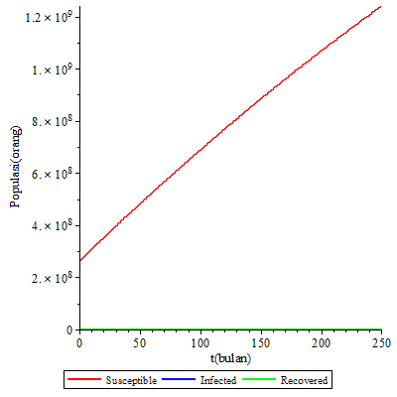

Figure 3. Simulation Graph for $R_{0}=0.3655959491$

Based on Figure 3, changes occur in the population of the Susceptible, Infected, and Recovered classes over time. The populations of the Infected and Recovered classes are close to zero or can go to zero, while the population of the Susceptible class has increased. The numerical values for the disease-free equilibrium point $E_{1}$ are $S^{*}=4.066.029.242$; $I^{*}=0$; and $R^{*}=0$.

Based on the calculations on the Jacobian matrix for the disease-free equilibrium point $E_{1}$, the eigenvalues obtained are $λ_{1}=-1.19047619×{10}^{-3}$, $λ_{2}=-1.19047619×{10}^{-3}$, and $λ_{3}=-26.02890099×{10}^{-3}$. Therefore, the eigenvalue whose real part is negative results in a disease-free equilibrium point $E_{1}$ to be locally asymptotically stable. Thus, in the long term the disease will disappear from the population.

2.4.2 Transmission Rate Parameter Simulation (medium case)

The parameter values used are $b\left(σ\right)=0.056$ and $c\left(σ\right)=0.027$ [5] and the basic reproduction number value $R_{0}=1,364891543$ is obtained.

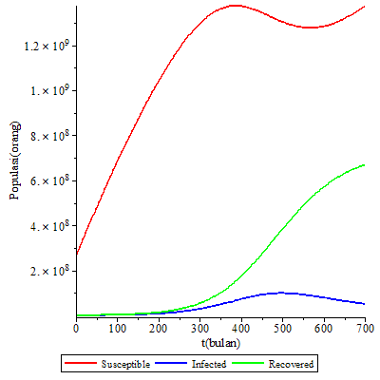

Figure 4. Simulation Graph for $R_{0}=1.364891543$

It shows that the populations of the Susceptible and Recovered classes have increased. The population of the Infected class decreases over time. The numerical values for the endemic equilibrium point $E_{2}$ of the parameter are $S^{*}=2,655,679,270$; $I^{*}=40,922,082.23≈40,922,082$; and $R^{*}=928,112,825.2$ or $≈928,112,825$. Meanwhile, the numerical values for the disease-free equilibrium point $E_{1}$ are $S^{*}=4,066,029,242$; $I^{*}=0$; and $R^{*}=0$.

The eigenvalues of an endemic equilibrium point $E_{2}$ are $λ_{1}=-1.19047619×{10}^{-3}$, $λ_{2}=-0.91135082×{10}^{-3}+4.37745643×{10}^{-3} I$, and $λ_{3}=-0.91135082×{10}^{-3}-4.37745643×{10}^{-3} I$. The three eigenvalues whose real part is negative result in stable endemic equilibrium point $E_{2}$ to be locally asymptotically stable. This causes the disease to spread and become an endemic disease.

The eigenvalues of the disease-free equilibrium point $E_{1}$ are $λ_{1}=-1.19047619×{10}^{-3}$, $λ_{2}=-1.19047619×{10}^{-3}$, and $λ_{3}=14.971099×{10}^{-3}$. There is an eigenvalue whose real part is positive, namely $λ_{3}$, so that the disease-free equilibrium point $E_{1}$ is unstable. This causes the disease to spread and to be endemic in the population.

2.4.3 Transmission Rate Parameter Simulation (high case)

The simulation with parameter values $b\left(σ\right)=0.15$ and $c\left(σ\right)=0.027$ [5] is given, and the basic reproduction number $R_{0}=3.655959491$ is obtained.

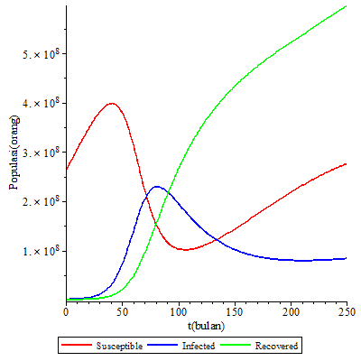

Figure 5. Simulation Graph for $R_{0}=3.655959491$

The graph shows that the populations of the Susceptible and Recovered classes are increasing, while the population of the Infected class is decreasing. The numerical values for the endemic equilibrium point $E_{2}$ resulting from the parameters that meet the requirements $R_{0}>1$ are $S^{*}=835,680,840.9≈835,680,841$; $I^{*}=93,730,340.41≈93,730,340$; and $R^{*}=2,125,804,121$. The numerical values for the disease-free equilibrium point $E_{1}$ are $S^{*}=4,066,029,242$; $I^{*}=0$; and $R^{*}=0$.

The endemic equilibrium point $E_{2}$ has eigenvalues, which are $λ_{1}=-2.89614812×{10}^{-3}+12.81639559×{10}^{-3} I$, $λ_{2}=-2.89614812×{10}^{-3}-12.81639559×{10}^{-3} I$, and $λ_{3}=-1.19047619×{10}^{-3}$. All eigenvalues have negative in real part, so that the endemic equilibrium point $E_{2}$ is locally asymptotically stable. Thus, the disease will spread and become endemic in the population.

The eigenvalues of the disease-free equilibrium point $E_{1}$ are $λ_{1}=-1.19047619×{10}^{-3}$, $λ_{2}=-1.19047619×{10}^{-3}$, and $λ_{3}=108.97109900×{10}^{-3}$. There is one eigenvalue whose real part is positive, which is $λ_{3}$, which means that the disease-free equilibrium point $E_{1}$ is unstable. To sum up, the disease will spread and become endemic.

The boundary among the three classifications uses the numerical value of the equilibrium point in the Infected population. Thus, the fuzzy membership function used in the simulation (in ${10}^{7} )$ obtained is

$$μ\left(I_{low}\right)=\left\{\begin{matrix}1 & if I≤0 \\ \frac{I-4.1}{0-4.1} & if 0<I≤4.1 \\ 0 & for another I \end{matrix}\right.,$$

$$μ\left(I_{medium}\right)=\left\{\begin{aligned}\begin{matrix}0 & if I≤0 \\ \frac{I-0}{4.1-0} & if 0<I≤4.1\end{matrix} \\ \begin{matrix}\frac{I-9.4}{4.1-9.4} & if 4.1<I≤9.4 \\ 0 & for another I \end{matrix}\end{aligned}\right.,$$

$$μ\left(I_{high}\right)=\left\{\begin{matrix}0 & if I≤4.1 \\ \frac{I-4.1}{9.4-4.1} & if 4.1<I≤9.4 \\ 1 & for another I \end{matrix}.\right.$$

The graph of fuzzy numbers that is formed is

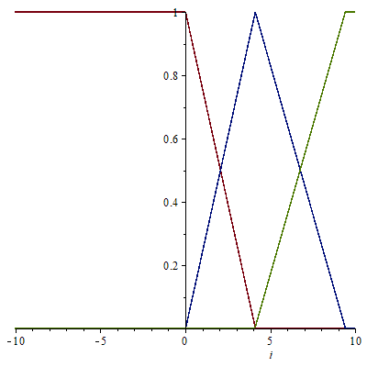

Figure 6.Graph of membership function for transmission rates classified as low, medium and high (red, blue and green respectively)

Figure 6. is a graph of the fuzzy membership function on the bacterial transmission rate which is classified into three, namely low, medium, and high. It appears that the higher the rate of disease transmission, the higher the population of infected individuals.

2.4.4 Recovery Rate Parameter Simulation (low case)

When the parameter values *b (σ)* = 0.15 and *c (σ)* = 0.04 are given, the value of $R_{0}=2.776291897$ is obtained.

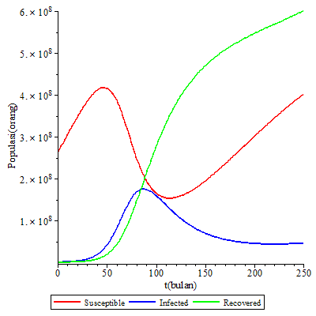

Figure 7. Simulation Graph for $R_{0}=2.776291897$

It appears that the populations of the Susceptible and Recovered classes are increasing. The population of the Infected class is decreasing and is below the population of the Susceptible class when approximately *t* = 100. The numerical values of the resulting endemic equilibrium point $E_{2}$ are $S^{*}=1,221,053,932$; $I^{*}=62,686,364.26≈62,686,364$; and $R^{*}=2,106,261,840$. The numerical values for the disease-free equilibrium point $E_{1}$ are $S^{*}=4,066,029,242$; $I^{*}=0$; and $R^{*}=0$.

The eigenvalues of the endemic equilibrium point $E_{2}$ are $λ_{1}=-1.98210368×{10}^{-3}+11.53717163{×10}^{-3} I$, $λ_{2}=-1.98210368×{10}^{-3}-11.53717163{×10}^{-3} I$, and $λ_{3}=-1.19047619×{10}^{-3}$. Thus, the eigenvalue the real part of which is negative results in the endemic equilibrium point $E_{2}$ to be locally asymptotically stable. This means that the disease will spread more and more in the population and become endemic.

The disease-free equilibrium point $E_{1}$ has the following eigenvalues: $λ_{1}=-1.19047619×{10}^{-3}$, $λ_{2}=-1.19047619×{10}^{-3}$, and $λ_{3}=95.97109901×{10}^{-3}$. The eigenvalue whose real part is positive is $λ_{3}>0$. Therefore, disease-free equilibrium point $E_{1}$ is unstable causing the disease to spread and to become endemic in the population.

2.4.5 Recovery Rate Parameter Simulation (medium case)

The simulation with parameters *b (σ)* = 0.15 and *c (σ)* = 0.1 is given. If the parameter values are substituted in Equation (4), the value of $R_{0}=1.315455983$ is obtained.

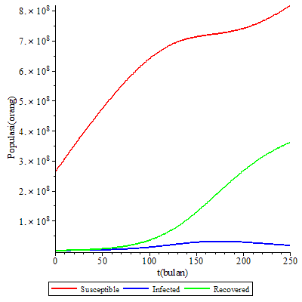

Figure 8. Simulation Graph for $R_{0}=1.315455983$

Figure 8. shows that the populations of the Susceptible and Recovered classes are increasing. The population of the Infected class is decreasing and is below the population of the Susceptible class. The numerical values for the endemic equilibrium point $E_{2}$ of the parameter values which satisfy the requirements $R_{0}>$ are $S^{*}=2,999,698,965$; $I^{*}=11,132,623.34≈11,132,623$; and $R^{*}=935,140,360.9≈935,140,361$. Meanwhile, the numerical values of the disease-free equilibrium point $E_{1}$ are $S^{*}=4,066,029,242$; $I^{*}=0$; and $R^{*}=0$.

The endemic equilibrium point $E_{2}$ has the following eigenvalues: $λ_{1}=-1.19047619×{10}^{-3}$, $λ_{2}=-0.80683280×{10}^{-3}+6.59353103 ×{10}^{-3} I$, and $λ_{3}=-0.80683280×{10}^{-3}-6.59353103 ×{10}^{-3} I$. Eigenvalues whose real part is negative result in endemic equilibrium point $E_{2}$ to be locally asymptotically stable. Thus, the disease will spread and become endemic to the population.

The eigenvalues for the disease-free equilibrium point $E_{1}$ are $λ_{1}=-1.19047619×{10}^{-3}$, $λ_{2}=-1.19047619×{10}^{-3}$, and $λ_{3}=35.97109900×{10}^{-3}$. There is an eigenvalue whose real part is positive because $λ_{3}>0$. This causes the disease-free equilibrium point $E_{1}$ to be unstable so that the disease will spread and become endemic.

2.4.6 Recovery Rate Parameter Simulation (high case)

For the high case, after the parameter values, *(σ)* = 0.15 and *c (σ)* = 0.3 are given, the basic reproduction number with value $R_{0}=0.4776630416$ is obtained. Based on the parameter values given, the simulation results from dari $R_{0}>1$ are:

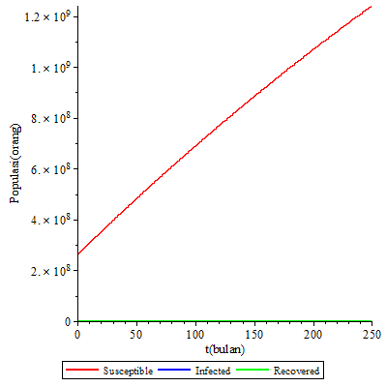

Figure 9. Simulation Graph for $R_{0}=0.4776630416$

The graph shows that the population of the Susceptible class is increasing. The populations of the Infected class and the Recovered class are close to zero or towards zero. The numerical values of the resulting disease-free equilibrium point $E_{1}$ are $S^{*}=4,066,029,242$; $I^{*}=0$; and $R^{*}=0$.

The eigenvalues of the disease-free equilibrium point $E_{1}$ are $λ_{1}=-1.19047619×{10}^{-3}$, $λ_{2}=-1.19047619×{10}^{-3}$, and $λ_{3}=-164.028901×{10}^{-3}$. For the eigenvalues whose real part is negative, it can be concluded that the disease-free equilibrium point $E_{1}$ is locally asymptotically stable so that the disease will progressively disappear from the population.

In the three simulations of the recovery rate, the classification limit was obtained using the numerical values of equilibrium point of the Infected class population. The fuzzy membership function used in the simulation (in ${10}^{7}$) obtained is

$$μ\left(I_{low}\right)=\left\{\begin{matrix}1 & if I≤0 \\ \frac{I-1.1}{0-1.1} & if 0<I≤1.1 \\ 0 & for another\end{matrix}\right.$$

$$μ\left(I_{medium}\right)=\left\{\begin{aligned}\begin{matrix}0 & if I≤0 \\ \frac{I-0}{1.1-0} & if 0<I≤1.1\end{matrix} \\ \begin{matrix}\frac{I-6.3}{1.1-6.3} & if 1.1<I≤6.3 \\ 0 & for another\end{matrix}\end{aligned}\right.$$

$$μ\left(I_{high}\right)=\left\{\begin{matrix}0 & if I≤1.1 \\ \frac{I-1.1}{6.3-1.1} & if 1.1<I≤6.3 \\ 1 & for another\end{matrix}\right.$$

The graph of fuzzy numbers is presented in Figure 10 as follows,

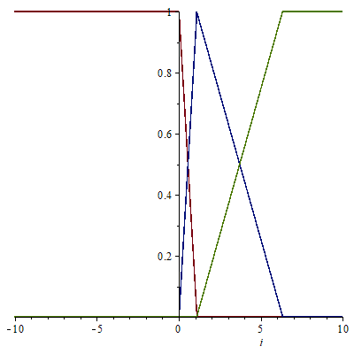

Figure 10. Graph of the membership function for the recovery rate classified as low, medium and high (red, blue and green respectively)

Figure 10. is a graph of the fuzzy membership function for disease recovery rates which are classified into three, namely low, medium, and high. Thus, the higher the recovery rate, the higher the number of individual populations who will recover from the disease.

Based on numerical analysis of the fuzzy SIR epidemic model on the spread of tuberculosis, with given initial values and parameters, it has been found that the greater the rate of disease transmission with the same disease recovery rate, the more the disease will spread. Thus, the smaller the rate of disease recovery with the same disease transmission rate, the more spread the disease will spread.

1. **CONCLUSION**

To sum up from the discussion, the mathematical model formed is a system of first order differential equations. Analysis of the stability of the fuzzy SIR epidemic model on the spread of tuberculosis has obtained two equilibrium points, which are the disease-free and endemic equilibrium points. Based on the results of numerical analysis of tuberculosis patients in Indonesia with the parameters and initial values that have been given, it has been found that the greater the disease contact or transmission rates with the same recovery rate, the more the disease will spread. Meanwhile, the greater the recovery rate for the disease with the same transmission rate, the less the the disease will spread even disappear from the population.

1. **BIBLIOGRAPHY**

[1] WHO. (2018). *Tuberculosis*. Retrieved from World Health Organization:https://www.who.int/en/news-room/fact-sheets/detail/tuberculosis diakses pada tanggal 26 Oktober 2019

[2] Kusumadewi, S. (2003). *Artificial Intelligence (Teknik dan Aplikasinya) Edisi 1.* Yogyakarta: Graha Ilmu.

[3] Chavez C C and Sony B J 2004 Dynamical Models of Tuberculosis and Their Applications. *Mathematical Biosciemces and Engineering*. **1**(2). 361-404.

[4] Aparico J P and Chavez C C 2009 Mathematical Modelling of Tuberculosis Epidemics *Mathematical Biosciemces and Engineering* **6(**2) 209-237.

[5] Fredlina, K. Queena, Oka, Tjoko B., & Dwipayana, I Made Eka. (2012). Model SIR (Susceptible, Infectious, Recovered) untuk Penyebaran Penyakit Tuberculosis. *E-Jurnal Matematika*, Vol. 1. No. 1: 152-58.

[6] Mishra, Bimal Kumar & Prajapati, Apeksha. (2013). Spread of Malicious Objects in Computer Network: A Fuzzy Approach. *Applications annd Applied Mathematics*, 8: 684-700.

[7] Ndii, M. Z., Amarti, Z., Wiraningsih, E. D., Supriatna, A. K. (2018). Rabies epidemic model with uncertainty in parameters: crisp and fuzzy approaches. *IOP Conference Series: Materials Science and Engineering*, No. 332: 1-8.

[8] Verma, R. , Upadhyay, R., & Tiwari, S.P. (2018). Dymanical Behaviors of Fuzzy SIR Epidemic Model. *Advances in Intelligent Systems and Computing*, 482-492.

[9] Amarti, Z., Anggriani, N., & Supriatna, A. K. (2019). Fuzzy epidemic model in a population having critical density dependent growth. *MSCEIS*.

[10] Kementrian Kesehatan Republik Indonesia. (2019). *Profil Kesehatan Indonesia 2018.* Jakarta: Kementrian Kesehatan Republik Indonesia.