Initial Wave Profile for 2D Linear Shallow Water Equation with Moving Bottom
N Binatari¹, G E Setyowisnu², and D Darmawan³
^{1,2} Department of Mathematics Education, Faculty of Mathematics and Natural Science, Yogyakarta State University, Yogyakarta, Indonesia
³ Department of Physics Education, Faculty of Mathematics and Natural Science, Yogyakarta State University, Yogyakarta, Indonesia

nikenasih@uny.ac.id, setyowisnu99@gmail.com,
Abstract. This paper presents the initial wave profile generated by moving bottom using the approximation of 2D Linear Shallow Water Equation (LSWE) with conservation law. The idea was to approximate the model into nonhomogeneous 2D wave equation. Simulations for several cases are provided.
- Introduction
Tsunami is an interesting case in partial differential equations (PDE) to be studied. Its height affected by so many factors, such as wind, gravitation, earth rotation, and the friction of water surface with some objects like moving ships or falling meteor. Tsunami model can be obtained using SWE (or Saint-Venant Equation). It is a derivative of Navier-Stock Equation that describes fluid, which the horizontal length of the model far more than its vertical length. Thus, SWE is very compatible to be used on tsunami modeling.
There are several studies on SWE, such as [1] that studied LSWE using Finite Element Method (FEM) for numerical solution and [2] that simulate on water wave with moving topography using Finite Difference Method (FDM). Both researchs talk about non-conservative shallow water equation for tsunami modelling in one dimension. The result showed that the length of movement and the form of bottom deformation affect the initial wave profile. In 2019, tsunami modelling as the application of shallow water equation for conservation law had been studied numerically [dutik1]. Since it only study in one dimension, using its idea, in this paper we will generated the study in two dimensions using conservative law.
Suppose the water height fluctuation at particular $x, y,$ and $t$ will be analyzed with assumptions that the fluid is inviscid, irrotational, and incompressible. Then, the density at each point is $ρ$ at a constant value. Free surface denoted by $η\left(x,y,t\right)=η$, bottom denoted by $-h\left(x,y,t\right)=-h$, and water height denoted by $ζ\left(x,y,t\right)=ζ$, where $ζ=η+h$.
Below is the illustration figure for the studied problem based on the assumption.
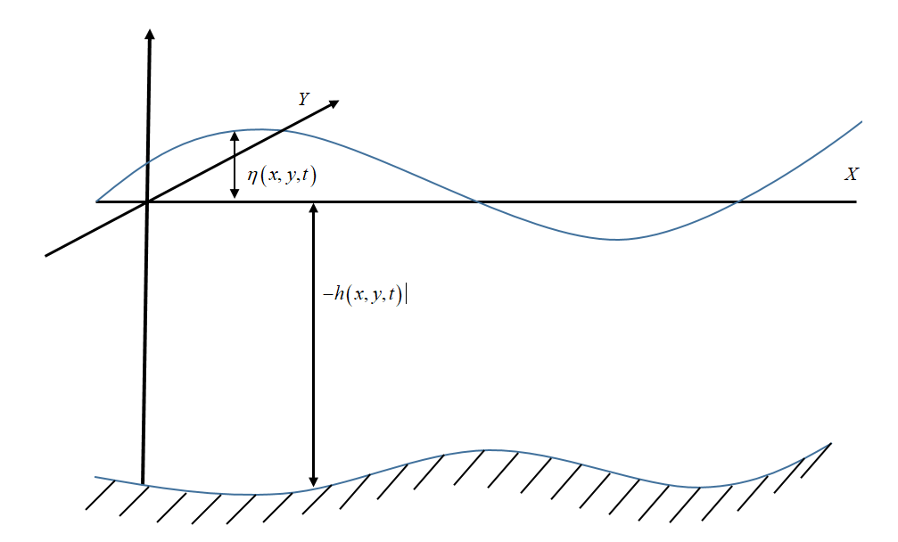
Figure 1. Problem Illustration
By using Figure 1, PDE system model will be constructed, which the mass conservation and momentum conservations are as follows.
Mass Conservation
 | $$\frac{∂ζ}{∂t}+\frac{∂\left(ζu\right)}{∂x}+\frac{∂\left(ζv\right)}{∂y}=0.$$ | (1)
Momentum Conservations
 | $$\frac{∂\left(ζu\right)}{∂t}+\frac{∂}{∂x}\left(ζu^{2}+\frac{1}{2}gζ^{2}\right)+\frac{∂}{∂y}\left(ζuv\right)=0,$$ | (2)
 | $$\frac{∂\left(ζv\right)}{∂t}+\frac{∂}{∂x}\left(ζuv\right)+\frac{∂}{∂y}\left(ζv^{2}+\frac{1}{2}gζ^{2}\right)=0.$$ | (3)
Because $ζ=η+h$, where $η, u$ and $v$ are unknown, so (1), (2) and (3) are nonlinear PDE system. We will only study on very small time conversion, thus the system will be analyzed by using linearization around its initial value.
Linear mass conservation and linear momentum conservations are the result of system linearization by subtituting $ζ=η+h$ then eliminate nonlinear forms as given in Equation (4), (5) and (6) and later is called as Linear Shallow Water Equation (LSWE).
Linear Mass Conservation
 | $$\frac{∂η}{∂t}+\frac{∂\left(hu\right)}{∂x}+\frac{∂\left(hv\right)}{∂y}=-\frac{∂h}{∂t}.$$ | (4)
Linear Momentum Conservations
 | $$\frac{∂\left(hu\right)}{∂t}+\frac{∂}{∂x}\left(gηh+\frac{1}{2}gh^{2}\right)=0,$$ | (5)
 | $$\frac{∂\left(hv\right)}{∂t}+\frac{∂}{∂y}\left(gηh+\frac{1}{2}gh^{2}\right)=0.$$ | (6)
Suppose the water surface is initially flat, so the initial value $η\left(x,y,0\right)=0$ and $η_{t}(x,y,0)=0$.
- Results

Transform the LSWE to 2D Wave Equation
In this section, LSWE will be transformed to 2D wave equation. First, (4), (5), and (6) derived consecutively towards $t, x,$ and $y$. Thus we obtain
 | $$\frac{∂^{2}η}{∂t^{2}}+\frac{∂^{2}\left(hu\right)}{∂x∂t}+\frac{∂^{2}\left(hv\right)}{∂y∂t}=-\frac{∂^{2}h}{∂t^{2}},$$ | (7)
 | $$\frac{∂^{2}\left(hu\right)}{∂x∂t}=-\left[gh\frac{∂^{2}η}{∂x^{2}}+\left(2g\frac{∂h}{∂x}\right)\frac{∂η}{∂x}+\left(g\frac{∂^{2}h}{∂x^{2}}\right)η+g\left({\left(\frac{∂h}{∂x}\right)}^{2}+h\frac{∂^{2}h}{∂x^{2}}\right)\right],$$ | (8)
 | $$\frac{∂^{2}\left(hv\right)}{∂y∂t}=-\left[gh\frac{∂^{2}η}{∂y^{2}}+\left(2g\frac{∂h}{∂y}\right)\frac{∂η}{∂y}+\left(g\frac{∂^{2}h}{∂y^{2}}\right)η+g\left({\left(\frac{∂h}{∂y}\right)}^{2}+h\frac{∂^{2}h}{∂y^{2}}\right)\right].$$ | (9)
Then, by substituting Equation 8 and Equation 9 into (7) we obtain Equation 10.
 | $$\frac{∂^{2}η}{∂t^{2}}-g\left[h\left(\frac{∂^{2}η}{∂x^{2}}+\frac{∂^{2}η}{∂y^{2}}\right)+2\left(\frac{∂h}{∂x}\frac{∂η}{∂x}+\frac{∂h}{∂y}\frac{∂η}{∂y}\right)+\left(\frac{∂^{2}h}{∂x^{2}}+\frac{∂^{2}h}{∂y^{2}}\right)η\right]=g\left[{\left(\frac{∂h}{∂x}\right)}^{2}+{\left(\frac{∂h}{∂y}\right)}^{2}+h\left(\frac{∂^{2}h}{∂x^{2}}+\frac{∂^{2}h}{∂y^{2}}\right)\right]-\frac{∂^{2}h}{∂t^{2}}.$$ | (10)

Solution
Suppose the depth gradient or the depth fluctuation at $x$ and $y$ is very small, so the value of $\frac{∂h}{∂x}$ and $\frac{∂h}{∂y}$ along with each of their derivation towards $x$ and $y$ are close to zero. Thus, (10) can be written as
 | $$\frac{∂^{2}η}{∂t^{2}}-gh\left(\frac{∂^{2}η}{∂x^{2}}+\frac{∂^{2}η}{∂y^{2}}\right)=-\frac{∂^{2}h}{∂t^{2}}.$$ | (11)
Assume there is no friction on the surface, and potential energy will be transformed to kinetic energy. Supposed speed propagation of tsunami in the open ocean, [dutykh dias]
$$c^{2}=gh.$$
Thus, (11) can be written as
 | $$\frac{∂^{2}η}{∂t^{2}}-C^{2}\left(\frac{∂^{2}η}{∂x^{2}}+\frac{∂^{2}η}{∂y^{2}}\right)=-\frac{∂^{2}h}{∂t^{2}}, C^{2}=\frac{c^{2}}{2}$$ | (12)
with infinite boundary condition (the solution has no domain boundary).
After the general form of nonhomogeneous 2D wave equation is obtained in (12), the exact solution will be sought using Green's Method. This method was introduced by George Green (1793-1841) at first on 1828 in his essay titled "Essay on the Application of Mathematical Analysis to the Theory of Electricity and Magnetism" [3]. The positive of Green Method is that it can be used well on nonhomogeneous DE cases, thus its usage is very well-suited to be applied in this study.
Green's Method usage involves Dirac Delta Function which is a derivative of Heaviside Function towards its independent variable and can be written as
$$H\left(x-x_{0}\right)=\int_{-∞}^{x-x_{0}}{δ\left(s\right)}ds.$$
Thus, according to [4], the Green's function of (12) that stated by Heaviside function and $r=\sqrt{{\left(x-x_{0}\right)}^{2}+{\left(y-y_{0}\right)}^{2}}$, can be written as
 | $$G\left(x,y,t;x_{0},y_{0},t_{0}\right)=\frac{1}{2πC\sqrt{C^{2}{\left(t-t_{0}\right)}^{2}-r^{2}}}H\left(\left(t-t_{0}\right)-\frac{r}{C}\right).$$ | (13)
Assumed, $h\left(x,y,t\right)=h_{0}-S\left(x,y\right) T\left(t\right)$. Since the initial values of the problem are homogeneous so we obtain the exact solution of (12) as given in Equation 14.
 | $$η\left(x,y,t\right)=\int_{0}^{∞}{\int_{-∞}^{∞}{\int_{-∞}^{∞}{G\left(x,y,t;x_{0},y_{0},t_{0}\right)\left(\frac{∂^{2}}{∂t^{2}}\left(S\left(x_{0},y_{0}\right) T\left(t_{0}\right)\right)\right)}dx_{0}}dy_{0}}dt_{0}.$$ | (14)
    - Simulation
    - A subsubsection. The paragraph text follows on from the subsubsection heading but should not be in italic.

- Conclusion

References

[1] | N. Binatari, "Solusi Numerik Persamaan Gelombang Air Dangkal Linear Menggunakan FEM," Seminar Nasional Matematika dan Pendidikan Matematika UNY, pp. 299-306, 2018.
[2] | N. B. Sudi Mungkasi, "Finite Difference Methods for Simulation of Water Waves Generated by Moving Topography," Journal of Physics, pp. 1-7, 2018.
[3] | D. G. Duffy, Green's Functions With Applications, CRC Press, Taylor & Francis Group, 2015.
[4] | R. Haberman, Applied Partial Differential Equations With Fourier Series and Boundary Value Problems, New Jersey: Pearson, 2013.

