**Goal programming problems solution with weighted method and its application in production planning in PT. Pardic Jaya Chemicals.**

**S A Anggera1, and H P Lestari2**

1, 2 Mathematics Education, Faculty of Mathematics and Natural Sciences, Universitas Negeri Yogyakarta, Indonesia

1 septi.ayu2016@student.uny.ac.id

2 himmawati@uny.ac.id

**Abstract**. The purpose of this study is to solve the problem of production planning to minimize overstock with forecasting methods where the results are used to form a Goal Programming model and solved by the Weighted method. Overstock problems can be solved by using the demand forecasting method by comparing the MAD, MSE, and MFE values of four forecasting methods including the Double Moving Average, Single Exponential Smoothing, Double Exponential Smoothing, and Linear Trend method. Forecasting results we obtained are then used to form the Goal Programming model. Another goal to be achieved is to reduce inventory costs and also get profit from sales so that the Weighted method is used here because each target has a different importance weight. The amount of the estimated cost of inventory due to forecast in 2020 will decrease from Rp. 8,130,505,919 to around Rp. 4,589,859,000. Sales profit is obtained with an income of Rp. 379,942,200.

1. **INTRODUCTION**

PT. Pardic Jaya Chemicals is one of the synthetic resin producing companies in Indonesia, the resulting production is a semi-finished material (Tanjung, 2016). PT. Pardic Jaya Chemicals has changing customer demand every time which causes problems in predicting customer demand. To address unmet requests, PT. Pardic Jaya Chemicals made a policy to increase the size of orders and determine the amount of inventory in PT. Pardic Jaya Chemicals is based on the customer's direct request. However, this caused problems with storage in PT. Pardic Jaya Chemicals warehouses, which is a warehouse experienced a very high increase in inventory or overstock, because the demand made by customers with actual shipped differences is quite far away. Resin products manufactured by PT. Pardic Jaya Chemicals has stock at the end of each year, which indicates the need to store for the stock in different time periods according to the needs and order of the product. Overstock problems can increase inventory costs at warehouses and the extent of damage caused by the number of products piling up is getting higher.

Basically the overstock problem occurs due to an error in determining the amount to be produced in the next period resulting in an increase in inventory costs for the existing stock piles in the warehouse as well as the buildup of goods that have a higher risk of damage to goods. This means that the less stock there is, the less inventory costs have to be incurred. On the other hand the company also expects a high amount of profit from the results of sales of its products. In this case forecasting plays an important role in production planning to minimize the risk of both problems.

The overstock problem can be solved by more accurately planning how much production the PT. Pardic Jaya Chemicals should produce. Therefore, the overstock problem requires forecasting in its calculations. The request forecasting method is chosen to solve the problem, which is then the result obtained from forecasting used to form the Goal Programming model. PT. Pardic Jaya Chemicals not only wants a reduced overstock but also wants to profit from each product it sells, so Goal Programming is the right model to solve some of these problems because Goal Programming is a model that is able to solve linear program problems that have more than one goal or goal to achieve. The Weighted method is selected because the destination function in the Goal Programming model does not have its completion sequence priority. However, in solving it each goal has its own importance weight so that Weighted methods are considered suitable and able to solve the problems that have been described and able to realize the purpose of this research. It is therefore necessary to research how to solve production planning problems to minimize the on-the-case overstock with the Goal Programming model using the Weighted method.

1. **RESULT AND DISCUSSION**

Overstock problems can increase the cost of inventory in warehouses and the level of damage caused by the number of products piling up is higher, as it can lead to increased inventory costs then the data of the forecast results that have been obtained is then used to form a Goal Programming model.

The Goal Programming model must be created based on the problems that occur in PT. Pardic Jaya Chemicals to obtain the optimal amount in resin production. In the Goal Programming model, the factors to note are variables, goal constraints and goal functions. The first variable specified is the amount and type of resin to be produced. Obstacle equations are created based on the principle of Goal Programming which is the development of linear programs.

1. *Goal Programmung Formulation*

Goal Programming's mathematical model formulation of the problem to be solved is to determine the optimal combination in minimizing overstock. Thus, the variable decisions are:

$x_{7}=$ total production of product *Alukidir* B

$x_{8}=$ total production of product *Burnock* B

$x_{9}=$ total production of product *Pherosol* A

$x_{10}=$ total production of product *Sundhoma* A

$b_{1}=$ inventory costs in warehouses

$b_{2}=$ the size of resin production profit

$x_{1}=$ total production of product *Acrydic* A

$x_{2}=$ total production of product *Acrydic* B

$x_{3}=$ total production of product *Acrydic* C

$x_{4}=$ total production of product *Acrydic* D

$x_{5}=$ total production of product *Alukidir* A

$x_{6}=$ total production of product *Burnock* A

The goals that are formed are customized to the goals that will be achieved, namely:

1. Minimize stock inventory costs
2. Maximize production capacity to meet demand
3. Maximize sales profit

The following mathematical modeling steps of production planning using the Goal Programming model with the Weighted method.

1. *Constraint and objective function formulation*
2. Minimize stock inventory costs

**Table 1.** Inventory cost of product.

|  |  |  |  |
| --- | --- | --- | --- |
| **Product** | **Inventory cost /kg** | **Product** | **Inventory cost /kg** |
| *Acrydic* A | Rp. 67.314,95 | *Burnock A* | Rp. 27.604,71 |
| *Acrydic* B | Rp. 67.984,39 | *Alukidir B* | Rp. 31.939,96 |
| *Acrydic* C | Rp. 80.601,11 | *Burnock B* | Rp. 21.540,07 |
| *Acrydic* D | Rp. 30.879,63 | *Pherosol A* | Rp. 29.134,44 |
| *Alukidir* A | Rp. 27.428,83 | *Sundhoma A* | Rp. 25.613,32 |

Goal constraints minimize inventory costs, which means want to realize goals below a certain value. The equation of the function of the constraints becomes:

$$\sum_{j=1}^{n}{P_{i}x_{j}}+{d_{i}}^{-}-{d_{i}}^{+}=b_{i} …(1)$$

In the previous period the cost of inventory to be incurred for unsold product stock amounted to Rp. 3,682,975,671. Therefore, for the next period large storage costs should be minimized. Based on the equation (1) the constraint equation is obtained to minimize the cost of stock inventory to be:

$$67.314,95x_{1}+67.984,39x_{2}+80.601,11x_{3}+30.879,63x_{4}+27.428,83x_{5}$$

$$+27.604,71x_{6}+31.939,96x_{7}+21.540,07x_{8}+29.134,44x_{9}+25.613,32x_{10}$$

$$+{d_{1}}^{-}-{d_{1}}^{+}=b_{1}$$

The cost of the distribution must reach below a certain value which means variable ${d_{1}}^{+}$ is a deviation variable, then the equation of the destination function becomes:

Minimize

$$z_{1}={d_{1}}^{+}$$

1. Maximize production capacity to meet demand

The amount of production capacity is determined using the forecasting methods of Double Moving Average, Single Exponential Smoothing, Double Exponential Smoothing, and Linear Trend. After the request forecasting, a more accurate forecasting method will be chosen. Forecasting is said to be good when it has the smallest MAD and MSE accuracy values, as well as near-zero MFE. The forecast results obtained for each resin product can be seen in Table 2.

**Table 2**. Results forecast demand for resin products in 2020.

|  |  |  |  |
| --- | --- | --- | --- |
| **Variable** | **Forecast** | **Variable** | **Forecast** |
| *Acrydic* A | 17.185,30 kg | *Burnock A* | 16.593,33 kg |
| *Acrydic* B | 7.816,67 kg | *Alukidir B* | 6.333,34 kg |
| *Acrydic* C | 9.552,00 kg | *Burnock B* | 13.014,60 kg |
| *Acrydic* D | 15.325,90 kg | *Pherosol A* | 11.892,70 kg |
| *Alukidir* A | 8.024,40 kg | *Sundhoma A* | 5.903,33 kg |

The goal of maximizing production capacity to meet demand, which means want to realize a goal with a certain value has constraints written in the equation.

$$x_{j}+{d_{i}}^{-}-{d_{i}}^{+}=b_{i} …(2)$$

Based on the equation (2), constraint equations are obtained to maximize production capacity to meet the demand, namely:

$x_{6}+{d_{7}}^{-}-{d_{7}}^{+}= 16.593,33$

$x_{7}+{d_{8}}^{-}-{d_{8}}^{+}= 6.333,34$

$x_{8}+{d_{9}}^{-}-{d_{9}}^{+}= 13.014,60$

$x_{9}+{d_{10}}^{-}-{d_{10}}^{+}= 11.892,70$

$x_{10}+{d_{11}}^{-}-{d_{11}}^{+}= 5.903,33$

$x_{1}+{d_{2}}^{-}-{d_{2}}^{+}= 17.185,30$

$x_{2}+{d_{3}}^{-}-{d_{3}}^{+}= 7.816,67$

$x_{3}+{d_{4}}^{-}-{d_{4}}^{+}= 9.552,00$

$x_{4}+{d_{5}}^{-}-{d_{5}}^{+}= 15.325,90$

$x_{5}+{d_{6}}^{-}-{d_{6}}^{+}= 8.024,40$

With the equation the function of the purpose becomes:

Minimize

$$z_{2}=\sum_{i=2}^{11}{{d_{i}}^{+}+{d_{i}}^{-}}$$

1. Maximize sales profit

The company wants the most revenue from the proceeds from the sale of each of its products. Sales profit data for each product can be found in Table 3 below.

**Table 3.** Profit per product.

|  |  |  |  |
| --- | --- | --- | --- |
| **Product** | **Production Cost /kg** | **Selling Price /kg** | **Profit** |
| *Acrydic* A | Rp. 31.362,47 | Rp. 38.147,03 | Rp. 6784,56 |
| *Acrydic* B | Rp. 27.563,46 | Rp. 33.029,58 | Rp. 5466,12 |
| *Acrydic* C | Rp. 24.412,85 | Rp. 29.421,35 | Rp. 5008,50 |
| *Acrydic* D | Rp. 24.890,37 | Rp. 28.697,94 | Rp. 3807,56 |
| *Alukidir* A | Rp. 18.066,33 | Rp. 18.564,14 | Rp. 497,81 |
| *Burnock A* | Rp. 22.717,28 | Rp. 23.432,64 | Rp. 715,37 |
| *Alukidir B* | Rp. 18.462,92 | Rp. 20.257,19 | Rp. 1794,27 |
| *Burnock B* | Rp. 19.554,74 | Rp. 24.202,41 | Rp. 4647,68 |
| *Pherosol A* | Rp. 25.205,80 | Rp. 26.109,62 | Rp. 903,82 |
| *Sundhoma A* | Rp. 18.769,58 | Rp. 21.473,13 | Rp. 2703,54 |

Goal constraints maximize the company's revenue, which means that want to realize goals above a certain value can be written in the equation:

$$\sum_{j=1}^{n}{R_{i}x_{j}}+{d_{i}}^{-}-{d_{i}}^{+}=b_{i} …(3)$$

Sales profit stipulated in PT. Pardic Jaya Chemicals 10% to 15% of total product sales. Based on the previous year's sales data, the company made a profit of Rp. 355,404,598. Based on the equation (3) then obtained equation constraints to maximize sales profit to be:

$$6.784,56x_{1}+5.466,12x_{2}+5.008,5x_{3}+3.807,56x_{4}+497,81x_{5}$$

$$+715,37x_{6}+1.794,27x_{7}+4.647,68x_{8}+903,82x_{9}+2.703,54x_{10}$$

$$+{d_{12}}^{-}-{d_{12}}^{+}=b_{2}$$

The profit of product sales must reach above a certain value which means variable ${d_{12}}^{-}$ is a deviation variable, then the objective function equation becomes:

Minimize

$$z_{3}={d_{12}}^{-}$$

1. *Goal weight determining*

Each goal in the Goal Programming model has no sequence priority in its completion. However, each goal has its own importance weight so the Weighted method is used to solve the overstock problem. The weight of interest of each goal you want to achieve can be seen in Table 4.

**Tabel 4**1. Goal weight value.

|  |  |  |
| --- | --- | --- |
| **Sasaran** | | **Bobot** |
| 1. | Minimize stock inventory costs | 100 |
| 2. | Maximize production capacity to meet demand | 70 |
| 3. | Maximize sales profit | 50 |

Assuming the $w_{1}$ as the weight on the first target, $w_{2}$ as the weight on the second target, and $w_{3}$ as the weight on the third target. Then the purpose function model with weighting is:

Minimize:

$$z=\sum_{i=1}^{12}{w_{k}({d_{i}}^{+}+{d_{i}}^{-})}$$

For $i=1,2,…,12$ and $k=1,2,3$

1. *Goal Programming troubleshooting using weighted method*

Based on the equation of constraints and objective functions that have been outlined, the formulation of the Goal Programming model with weighted method can be formulated as follows.

$$\min{z}=w_{1}{d_{1}}^{+}+\sum_{i=2}^{11}{w_{2}\left({d_{i}}^{+}+{d_{i}}^{-}\right)}+{w_{3}d_{12}}^{-}$$

In accordance with the objectives to be achieved, the Goal Programming model for production planning in PT. Pardic Jaya Chemicals is as follows:

$$\min{z}=100{d_{1}}^{+}+\sum_{i=2}^{11}{70({d_{i}}^{+}+{d_{i}}^{-})}+{50d_{12}}^{-}$$

With constraint,

$$67.314,95x_{1}+67.984,39x_{2}+80.601,11x_{3}+30.879,63x_{4}$$

$$+27.428,83x_{5}+27.604,71x_{6}+31.939,96x_{7}+21.540,07x_{8}$$

$$+29.134,44x_{9}+25.613,32x_{10}-{d_{1}}^{+}+{d_{1}}^{-}=b_{1}$$

$$x_{1}+{d_{2}}^{-}-{d_{2}}^{+}= 17.185,30$$

$$x_{2}+{d_{3}}^{-}-{d_{3}}^{+}= 7.816,67$$

$$x_{3}+{d_{4}}^{-}-{d_{4}}^{+}= 9.552,00$$

$$x_{4}+{d_{5}}^{-}-{d_{5}}^{+}= 15.325,90$$

$$x_{5}+{d_{6}}^{-}-{d_{6}}^{+}= 8.024,40$$

$$x_{6}+{d_{7}}^{-}-{d_{7}}^{+}= 16.593,33$$

$$x_{7}+{d_{8}}^{-}-{d_{8}}^{+}= 6.333,34$$

$$x_{8}+{d_{9}}^{-}-{d_{9}}^{+}= 13.014,60$$

$$x_{9}+{d_{10}}^{-}-{d_{10}}^{+}= 11.892,70$$

$$x_{10}+{d_{11}}^{-}-{d_{11}}^{+}= 5.903,33$$

$$6.784,56x_{1}+5.466,12x_{2}+5.008,5x_{3}+3.807,56x_{4}$$

$$+497,81x_{5}+715,37x_{6}+1.794,27x_{7}+4.647,68x_{8}$$

$$+903,82x_{9}+2.703,54x_{10}+{d_{12}}^{-}-{d_{12}}^{+}=b_{2}$$

$$x_{1},…,x_{10}≥0$$

$${d_{1}}^{+},{d_{2}}^{-},{d_{2}}^{+},{d_{3}}^{-},{d_{3}}^{+},…,{d_{11}}^{-},{d_{11}}^{+},{d_{12}}^{-}≥0$$

After the Weighted Goal Programming model is obtained, further solution is done to achieve optimum solution by using simplex algorithm as follows.

**Table 5.** Weighted Goal Programming completion simplex initial table.

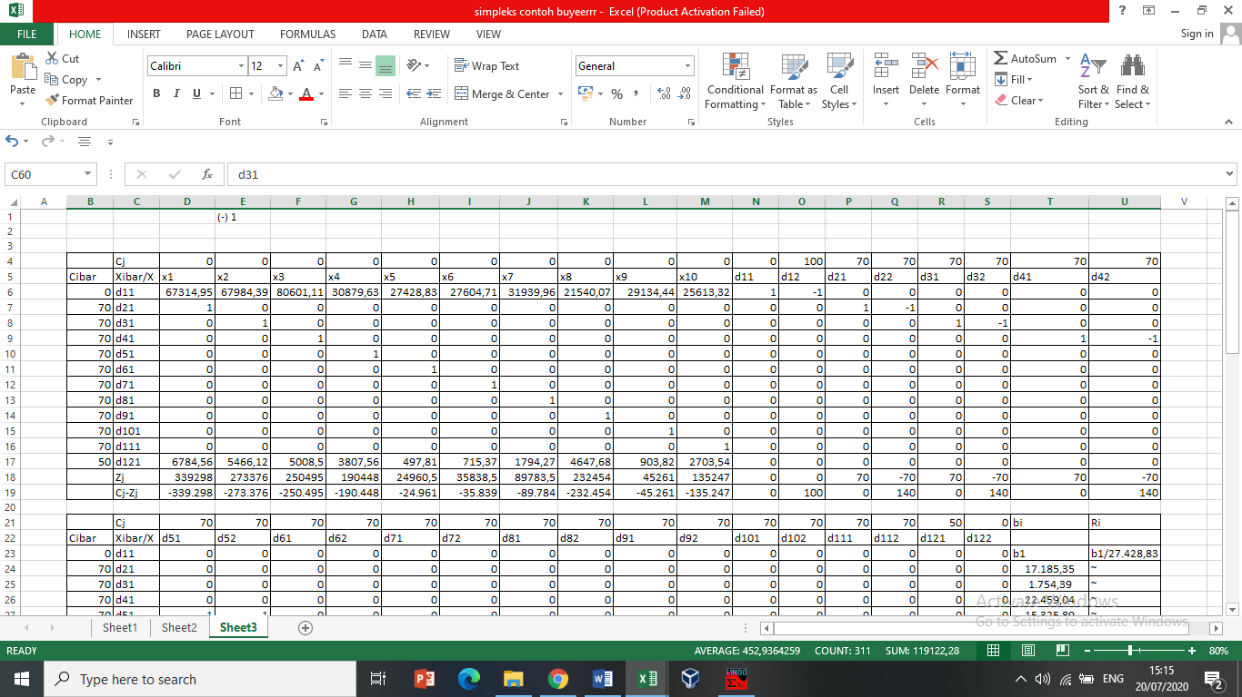

**Table 5.** Weighted Goal Programming completion simplex initial table (continued).

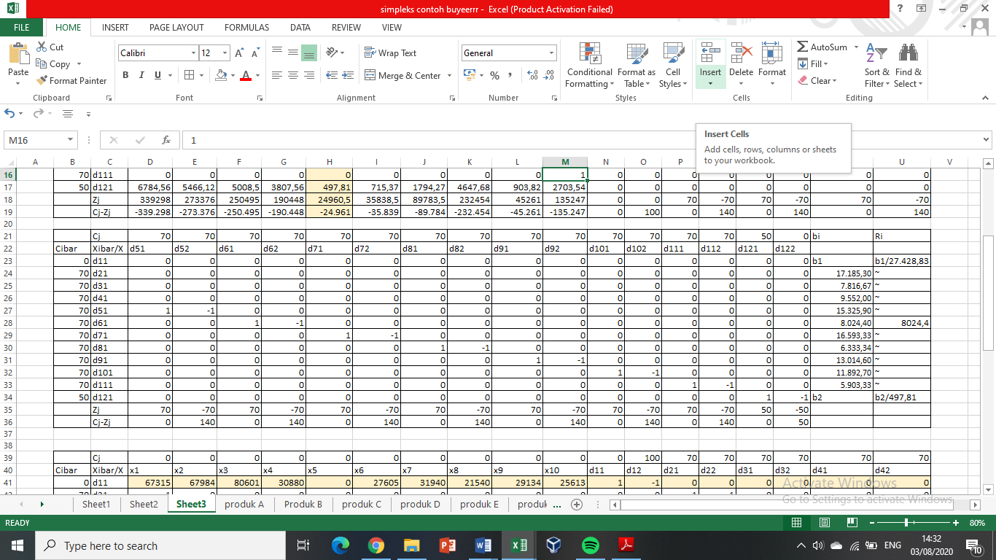

**Table 6.** Simplex iteration I completion weighted goal programming table.

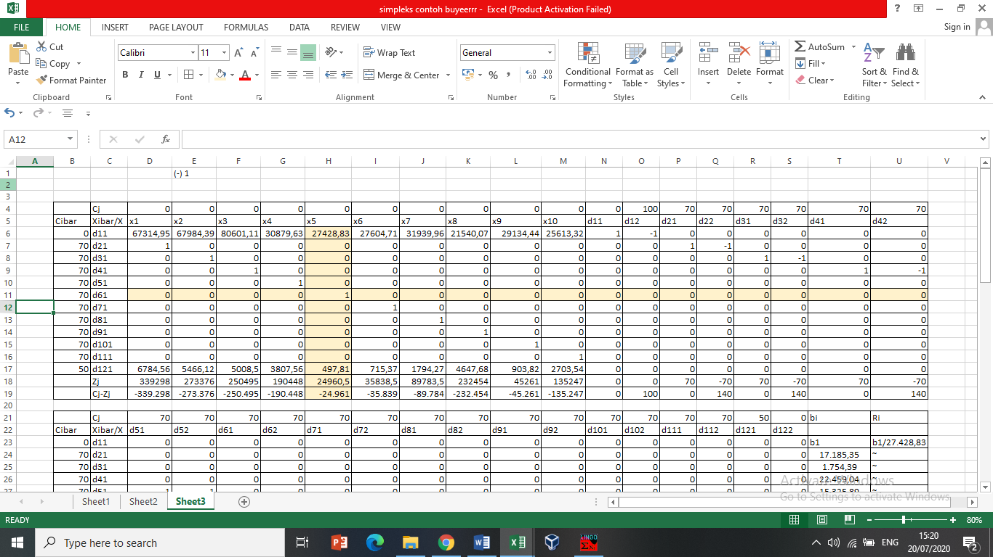

**Table 6.** Simplex iteration I completion weighted goal programming table (continued).

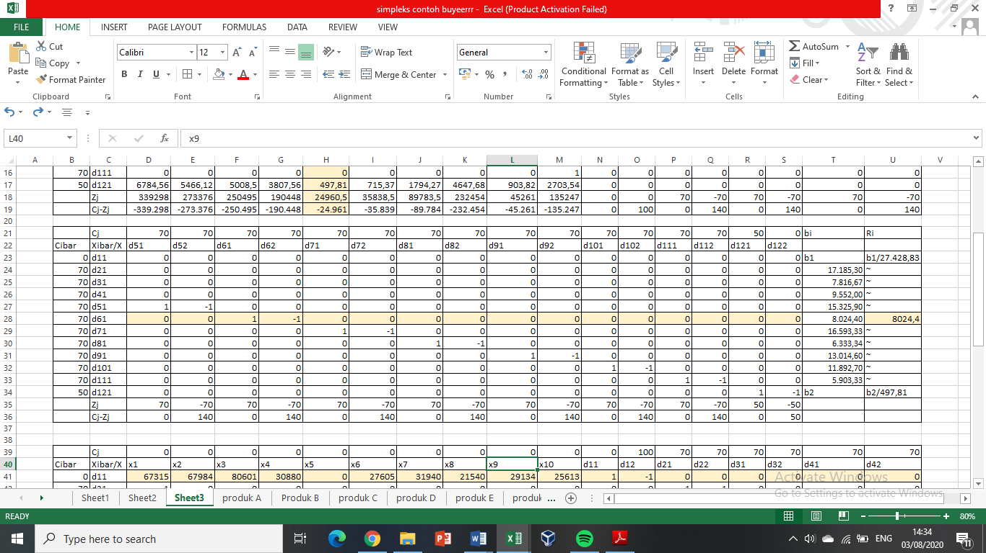

**Tabel 7.** Simplex iteration II completion weighted goal programming table.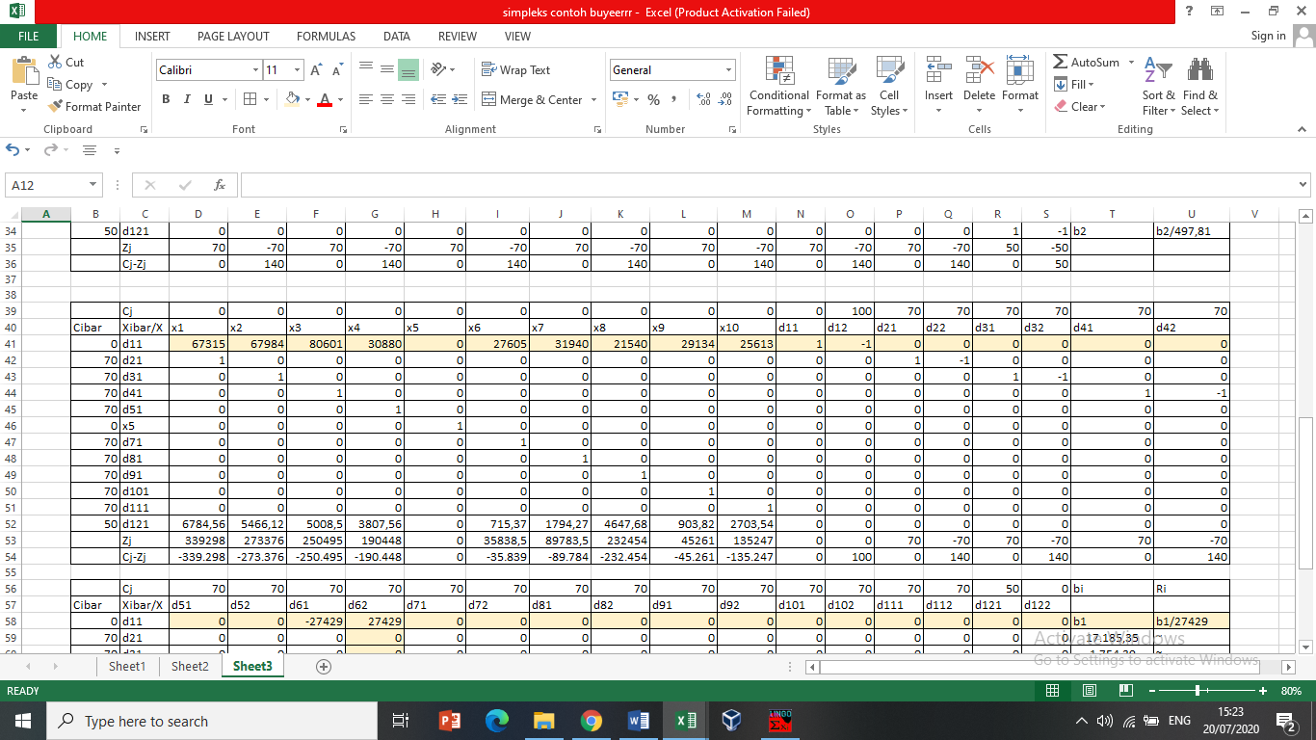

**Tabel 7.** Simplex iteration II completion weighted goal programming table (continued).

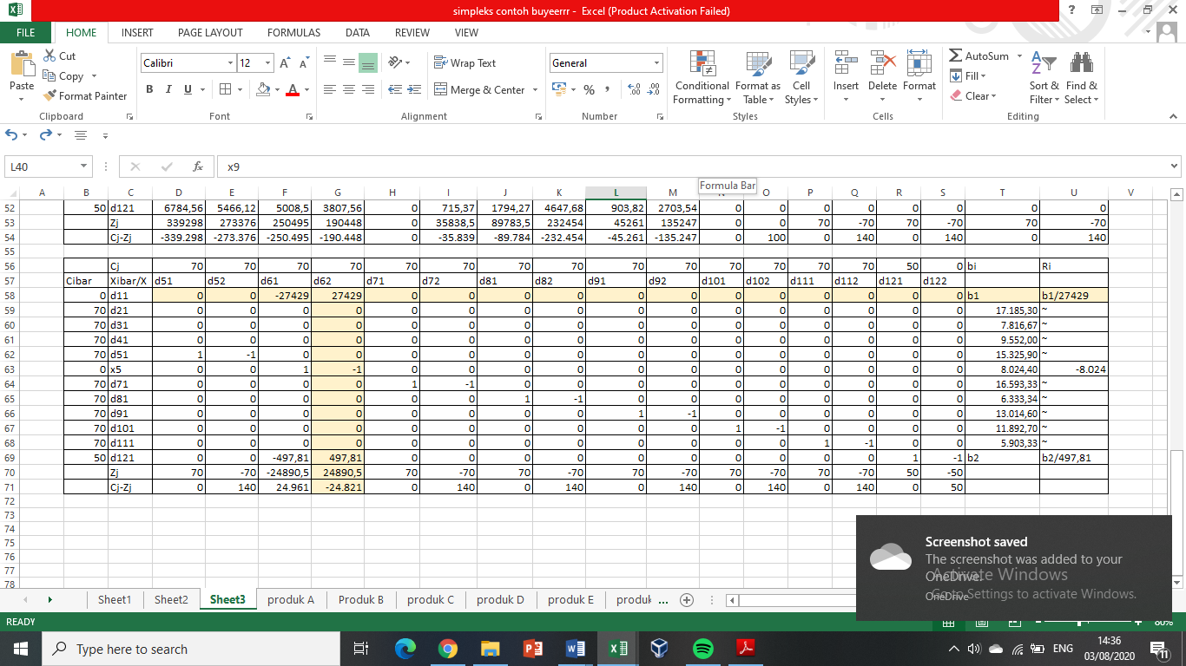

Completion of the next iteration continued using LINGO 18.0 software.

The results of the combination of variable decisions from the optimization results made with the help of the LINGO 18.0 program can be seen in Table 8 below.

|  |  |  |  |  |
| --- | --- | --- | --- | --- |
| **No** | **Constraint** | **Goal** | **Result** | **Description** |
| I | Minimize stock inventory costs | b1 | Rp. 4.589.859.000 | Achieved |
| II | Maximize production capacity to meet demand | 17.185,30 kg | 17.185,30 kg | Achieved |
| 7.816,67 kg | 7.816,67 kg | Achieved |
| 9.552,00 kg | 9.552,00 kg | Achieved |
| 15.325,90 kg | 15.325,90 kg | Achieved |
| 8.024,40 kg | 8.024,40 kg | Achieved |
| 16.593,33 kg | 16.593,33 kg | Achieved |
| 6.333,34 kg | 6.333,34 kg | Achieved |
| 13.014,60 kg | 13.014,60 kg | Achieved |
| 11.892,70 kg | 11.892,70 kg | Achieved |
| 5.903,33 kg | 5.903,33 kg | Achieved |
| III | Maximize sales profit | b2 | Rp. 379.942.200 | Achieved |

**Table 8.** Optimal decision variable value.

Based on Table 8 it can be seen that to achieve the product demand fulfillment goal can be achieved by all types of products. From the output obtained, the model recommends producing Acrydic A products as much as 17,185.30 kg, Acrydic B products as much as 7,816.67 kg, Acrydic C products as much as 9,552.00 kg, Acrydic D products as much as 15,325.90 kg, Alukidir A products as much as 8,024.40 kg, Burnock A products as much as 16,593.33 kg, Alukidir B products as much as 6,333.34 kg, Burnock B products as much as 13,014.60 kg, Pherosol A products as much as 11,892.70 kg , and Sundhoma A products as much as 5,903.33 kg. The goal to minimize the amount of stock distribution costs was rp. 4,589,859,000, and the goal to maximize sales profit was achieved with an income of Rp. 379,942,200.

1. *Overstock discussion*

Problems faced by PT. Pardic Jaya Chemicals is a very high increase in inventory or overstock due to the demand made by customers with actual shipped quite far differences as a result there is always a buildup of stock in the warehouse every year. After analyzing the results of production planning at PT. Pardic Jaya Chemicals using the Goal Programming model, the results for each decision variable can be seen in Table 2.

The variable decision is the number of products to be produced for the next period, until Table 9 is the forecast result for 2020. To find out how the overstock reduction can be by looking at the comparison of the amount of sales per year.

**Table 10.** Comparison of the number of sales a year

|  |  |  |  |
| --- | --- | --- | --- |
| **Product** | **Sales 2017** | **Sales 2018** | **Sales 2019** |
| *Acrydic* A | 16.720 | 23.370 | 13.700 |
| *Acrydic* B | 13.300 | 8.740 | 5.040 |
| *Acrydic* C | - | 18.240 | 11.418 |
| *Acrydic* D | 15.200 | 17.480 | 16.340 |
| *Alukidir* A | 3.800 | 5.320 | 6.650 |
| *Burnock* A | 21.660 | 17.483 | 20.140 |
| *Alukidir B* | 18.050 | 15.960 | 7.600 |
| *Alukidir B* | 9.720 | 13.140 | 11.340 |
| *Pherosol A* | 11.020 | 12.920 | 11.400 |
| *Sundhoma A* | 9.657 | 6.670 | 7.820 |

**Table 11.** Comparison of the number of forecasts a year.

|  |  |  |  |
| --- | --- | --- | --- |
| **Produk** | ***Forecast* 2017** | ***Forecast* 2018** | ***Forecast* 2019** |
| *Acrydic* A | 50.680 | 38.850 | 28.740 |
| *Acrydic* B | 17.600 | 20.330 | 11.970 |
| *Acrydic* C | - | 11.940 | 36.680 |
| *Acrydic* D | 22.800 | 15.960 | 15.010 |
| *Alukidir* A | 12.000 | 11.000 | 8.960 |
| *Burnock* A | 30.600 | 24.660 | 21.200 |
| *Alukidir B* | 20.140 | 16.440 | 12.610 |
| *Alukidir B* | 5.800 | 17.400 | 8.540 |
| *Pherosol A* | 11.590 | 13.110 | 10.450 |
| *Sundhoma A* | 22.000 | 11.690 | 9.370 |

Based on Table 10 the number of sales always has a very distant difference with the number of forecasts calculated in Table 11, so that every year PT. Pardic Jaya Chemicals always has a very large stock. After analysis using goal programming model obtained results as in Table 8 which is forecasting the number of products for pt production. Pardic Jaya Chemicals in 2020.

Based on Table 9 can be seen from the amount that is not very large difference with the number of sales in the previous year, which means if the number of sales is less than the number of forecasts then the remaining production is not as much as in previous years.

The estimated cost of inventory due to forecast in 2020 decreased in number from the previous year. In 2019 the estimated cost of inventory is estimated to be Rp. 8,130,505,919 and in 2020 the amount is around Rp. 4,589,859,000.

1. **Conclusion**
2. Troubleshooting Goal Programming with Weighted method using lingo 18.0 software help. From the output obtained, the model recommends producing Acrydic A products as much as 17,185.30 kg, Acrydic B products as much as 7,816.67 kg, Acrydic C products as much as 9,552.00 kg, Acrydic D products as much as 15,325.90 kg, Alukidir A products as much as 8,024.40 kg, Burnock A products as much as 16,593.33 kg, Alukidir B products as much as 6,333.34 kg, Burnock B products as much as 13,014.60 kg, Pherosol A products as much as 11,892.70 kg , and Sundhoma A products as much as 5,903.33 kg.
3. The amount of production for 2020 obtained based on the analysis of the Goal Programming model has a number that does not differ much from the previous period. The estimated cost of inventory due to the forecast in the year decreased in number from the previous year. In 2019 the estimated cost of inventory is estimated to be Rp. 8,130,505,919 and in 2020 the amount is around Rp. 4,589,859,000.
4. **REFERENCES**
5. Tanjung, F. K. (2016). Laporan Kerja Praktek Safety Inspection di PT. Pardic Jaya Chemicals. *Makalah*.