Solution of the SIR Mathematical Model with Births and Deaths for COVID-19 Spread using *Microsoft Excel*

Dewa Putu Wiadnyana Putra, Marcellinus Andy Rudhito

Department of Mathematics Education, Universitas Sanata Dharma, Yogyakarta

Email: dewa@usd.ac.id

**Abstract**. This study aims to find the solution of SIR (susceptible, infectious and recovered) modelling which considers natural births and deaths for the spread of Covid-19 in populations of an area for normal, new normal and lockdown conditions using Microsoft Excel. This research consists two stages, 1) study the numerical solution SIR model using spreadsheet of Microsoft Excel, and 2) build Microsoft Excel Applets for simulation of the system. The results show that the SIR model with consider births and deaths for spread of Covid-19 can be solved numerically by Microsoft Excel, by changing the system of differential equations into system of difference equations. Furthermore, by using existing facilities in Microsoft Excel, the Microsoft Excel Applets can be built to simulate system in normal, new normal, and lockdown conditions.

1. Introduction

There are at least five types of mathematical model in Epidemiology, namely Compartment model, Stochastic model, Phenomenological model or time growth curve model, Time series or Predictive classes of data mining and AI, and Hybrid model classes (a combination of two or more model classes) Experts in modeling the spread of the disease have started to conduct studies on Covid-19. One of the studies made was a mathematical modeling of the spread of Covid-19. [1] and [2] conducted a study of the spread of Covid-19 in Wuhan City using the SEIR (Susceptible-Exposed-Infectious-Removed) Model.

The SEIR model is a compartment model for the spread of disease. The simplest compartment model for the spread of disease is the SIR model without considering natural mortality and mortality factors. In this article, we will discuss the SIR model by taking into account the natural factors of birth and death. This model will be applied to three different conditions, 1) normal conditions (without intervention), 2) new normal conditions (by applying, healthy living habits, physical distancing) and lockdown conditions (quarantine area). Furthermore, the solution and the simulation will be investigated using the Microsoft Excel Applets. This simulation can be carried out interactively and can be easily understood by the general public.

The mathematical concept used in this model is differential equations. The mathematical concepts used in Covid-19 SIR modeling use the concept of differential equations. Model construction and the solution are technically difficult for the general public to understand. The assumptions and conditions in the model after being converted into parameters are also not easy to understand. Therefore, the public needs to be given a simple understanding of the concept of mathematical models used for the spread of Covid-19, for example assumptions, modeling, solutions, simulation results and predictions.

The solution and simulation of a mathematical model is an important part. The simulation results can show visually about the current situation and predictions of a situation. Software that can be used to simulate a mathematical model of the spread of disease includes MATLAB, Mathematica, GeoGebra, Microsoft Excel, and others. Microsoft Excel is a spreadsheet software that is very well known and has very good capabilities. The solving of a particular mathematical model can be solved numerically using Microsoft Excel and then graphs its model solution. Model simulation activities using Microsoft Excel can also be designed interactively, namely by utilizing the slider facility which can be used to change the parameters in the mathematical model according to the assumed conditions. Interactive exploration of Applets is expected to make it easier to carry out or understand the simulation results of the Covid-19 spread mathematical model.

1. Research Methodology

This study consisted of two stages, 1) investigates the solution of the SIR mathematical model which consider natural birth and death numerically and 2) completing it using a spreadsheet and compiling an Applet for system simulation using Microsoft Excel. Model simulation will be built in an Applet of Microsoft Excel. Facilities in Microsoft Excel for simulation views, including Input, Graph (Chart) and Spreadsheet (numerical display). The parameters in the model will be displayed and can be shifted using a slider to make it more interactive.

1. Result and discussion

The SIR model that considers natural births and deaths in a population is a generalization of the SIR model. In the SIR model with a constant population, it is assumed that the birth and death rates in the population are the same. The SIR model which consider the demographic factors was carried out by [7] assuming the birth rate was the same as the natural death rate. The assumption in those research is that there is no demographic population growth. The birth rate  and mortality rate  in this study used the Crude Birth Rate (CBR) and Crude Death Rate (CDR). The interval of parameter value of  and  in this study, and. The interval is obtained from CBR and CDR data for Indonesia, which are respectively at and. The ability of an individual to transmit the virus to other individuals is denoted bywhich can be expressed by the following equation

 (1)

with is parameter of the transmission rate [3]. The assumption in this model is that the natural deaths rate in each compartment is the same. If  stated parameters are for the recovery rate and  is the parameters for the death rate (cause diseases), flowchart of the SIR model which consider natural births and deaths can seen bellow.















*S*

*R*

*I*

**Figure 1. Flowchart SIR Model with Natural Birth and Death**

The solution of this model will be solved numerically. Therefore, the system of differential equations in the model will be changed into a system of different equations [4]. Based on the diagram above, different equations can be drawn up as follows.

 (2)

The state population values ​​used in this study is, with state of subpopulation in each compartment are,  and. Estimation of the parameter values ​​of death rate (cause disease) and recovery rate using the data on the spread of Covid-19 in Indonesia which is available in [5] on March 2 to 13 August 2020. The parameter values  ​​and  respectively are  and. Furthermore, the value of the transmission rate in equation (1) is determined by knowing the value of the Reproductive Number. Based on [3] the equation given by

 (3)

The interval value of for Covid-19 spread was obtained from January 1 to February 7, 2020, is  [1]. Based on equations (1) and (3), the interval of transmission rate ​​is.

Iteration is done using Microsoft Excel. The following is data iteration with the respective parameter values are,,,, and. The model solution is determined by graph of time. The facilities used are scatter with smooth lines and markers available in Microsoft Excel.

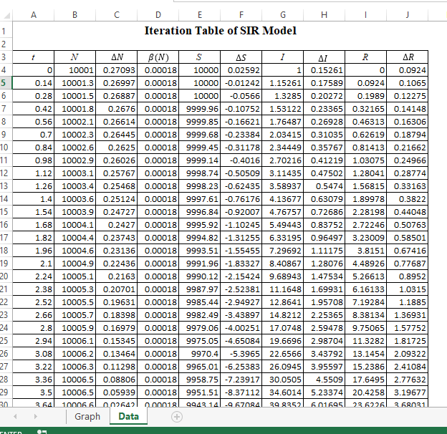

**Figure 2. Table Iteration using Microsoft Excel**

* 1. *Solution of Model in Normal Condition (without intervention)*

This situation is a normal situation without any intervention by the people or government on the spread of Covid-19. People carry out activities such as before the pandemic occurred in their area. The assumption used in this study is that the virus transmission rate is constant. The parameter values ​​used in this situation can be seen in the following table.

**Table 1. Value of Parameter of the Model**

|  |  |  |
| --- | --- | --- |
| Parameter | Value | Reference |
|  |  | CBR Indonesia 2018 |
|  |  | CDR Indonesia 2018 |
|  |  | Assume |
|  |  | Assume |
|  |  | Assume |

Base on the value of each parameter in table 1, the solution of the model is graph in following figure.

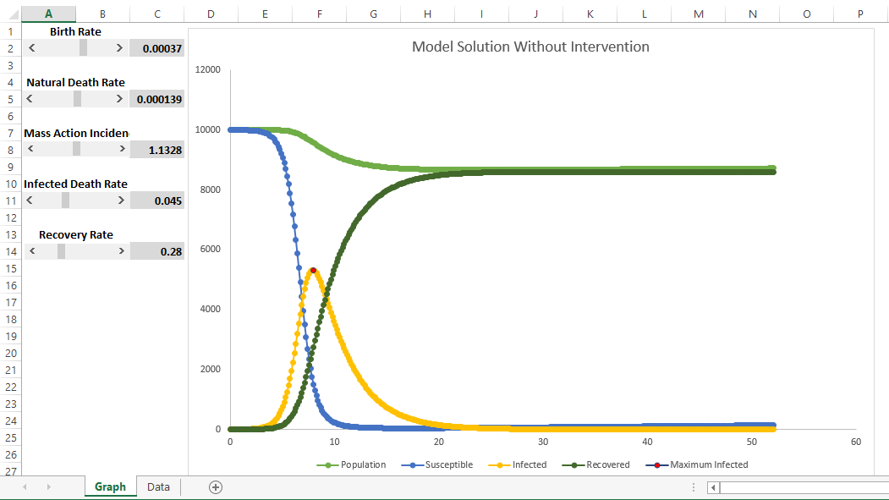

**Figure 3. Solution Model in Normal Condition using Microsoft Excel**

The peak of the pandemic occurs in the seventh week. The total population infected was 5312 people. Meanwhile, population growth originates from differences in values ​​and causes an increase in susceptible class. The increase began to occur in the seventeenth week, with. This increase will potentially lead to a second wave of the spread of Covid-19 in Indonesia.

* 1. *Solution of Model in New Normal Condition*

People and government intervention in the spread of Covid-19 needs to be done. In this situation, the intervention carried out is in the form of implementing a healthy life habits. Washing hands, using masks when doing outdoor activities, not touching the nose, mouth and eyes with hands, and social and physical distancing are interventions carried out in this situation (new normal). The mobility of the people is not limited in this situation. Interventions were initiated in the fourth week after the start of the pandemic. This intervention assumes that the transmission rate can be reduced about 50% from the initial state. Based on table 1, the parameter values  ​​change to  since the fourth week. The other parameter values ​​are fixed as given in table 1. The solution of model in the new normal condition are graphed in figure bellow.

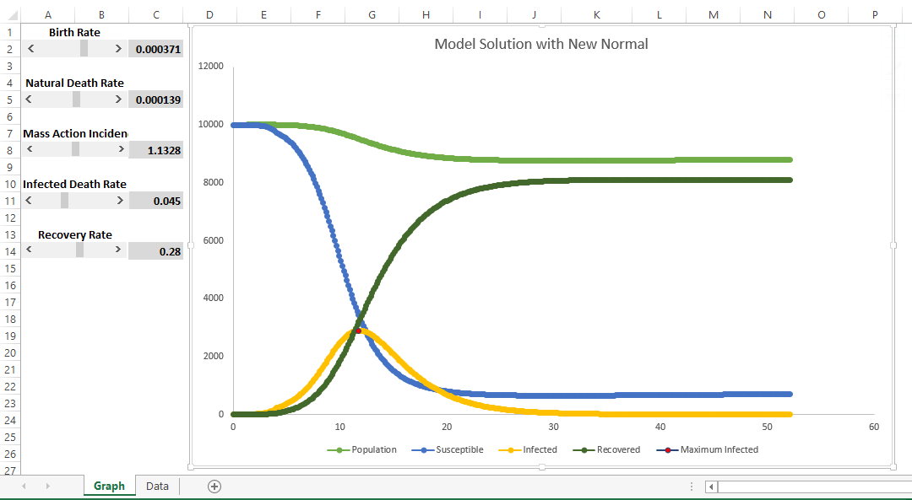

**Figure 4. Solution Model with New Normal Condition using Microsoft Excel**

The peak of the pandemic occurred in the eleventh week with the infected population was 2893. As a result of population growth, in this situation there is also the potential for a second wave of pandemic to occur, namely in the thirtieth week.

* 1. *Solution of Model in Lockdown Condition*

The government can implement a policy to quarantine an area (lockdown) to limit the transmission of Covid-19. Regional quarantines can reduce transmission rates very quickly. In this model, the lockdown starts in the fourth week of the pandemic. After this intervention, the parameter values ​​were reduced by 50% up to the sixth week. After that, the transmission rate will be 0, because mobility and community interaction do not occur in this situation. The parameter values ​​(except) use the values ​​in table 1. The following is the solution of the model with lockdown intervention.

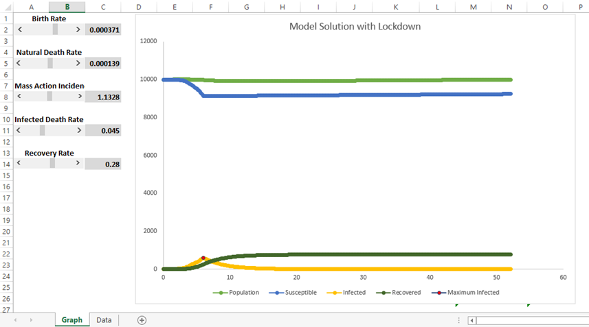

**Figure 5. Solution Model with Lockdown Condition using Microsoft Excel**

The peak of the pandemic occurred at week six with a total of 602 infected individuals. After the peak of the pandemic, individuals who are categorized as susceptible will not be infected with Covid-19. At week 18th it was seen that the infected individuals were below 1% of the population.

Based on the three situations above, the following is a summary of the SIR model solutions by considering the natural birth and death rates.

**Table 2. Comparison Pandemic Peak and Infected People with 3 Condition**

|  |  |  |  |
| --- | --- | --- | --- |
| Strategy | Start Strategy  (week) | Pandemic Peak  (week) | Percentage of Infected People |
| No Intervention | - | 7 | 52% |
| “New Normal” | 4 | 11 | 28% |
| Lockdown | 4 | 6 | 6% |

1. Conclusion

The SIR model with natural births and deaths can be solved using Microsoft Excel. The Differential Equation System in the SIR model is converted into a system of difference equations. The solution of the model was carried out in two stages, 1) iteration and 2) graph the solution in chart using Microsoft Excel. A large enough population growth can potentially cause a second wave of the Covid-19 pandemic under Normal and New Normal conditions.

1. Acknowledgments

We would like to thank the Sanata Dharma University Research Institute (LPPM) for providing support and research funding in the field of Covid-19.

1. References
2. Lin, Qianying, dkk. 2020. A Conceptual Model for the Coronavirus Disease 2019 (COVID 19) outbreak in Wuhan, China with Individual Reaction and Govermental Action, International Journal of Infectious Diseases, Vol. 93 pp. 211-216.
3. Rong. Xinmiao, dkk. 2020. Effect of Delay in Diagnosis on Transimission of COVID-19. Mathematical Biosciences and Engineering. 17(3), pp. 2725-2740
4. Brauer, Fred, Carlos Castillo-Chavez, dan Zhilan Feng. 2019. ***Mathematical Models in Epidemology***. New York : Springer Science+Bussinnes Media, LLC.
5. Jonas Hall, Thomas Lingefjärd. 2017. Mathematical modeling : applications with *Microsoft Excel*. New Jersey : John Wiley & Sons, Inc.
6. Kawal informasi seputar COVID-19 secara tepat dan akurat. <https://kawalcovid19.id/> ( 14 August 2020)
7. Liu, Ying et al. 2020. The Reproductive Number of COVID-19 is Higher Compared to SARS Coronavirus. International Journal of Travel Medicine. Pp 1-4. Doi : 10.1093/jtm/taaa021.
8. Derdei, D. et al. 2010. A SIR Model with Differential Mortality and Constant Population. ResearchGate.