Dynamics of Covid-19 Spread Using SEIR Epidemic Model and Use of Optimal Control with Fixed time and Free End Point in Semarang City Indonesia

aDhimas Mahardika, R. Heru Tjahjana, Hj Sunarsih

Jalan Prof Soedharto, Tembalang, 50246, Semarang, Jawa Tengah

adhimasmahardika@student.undip.ac.id

**Abstract**. Covid-19 infection are very lethal and life threatening to human life, for prevention it is necessary to conduct restriction on community activities (RCA), RCA here is intended to limit people to do their activities outside their home, the point is that these people are expected to stay at home during pandemic. Conducting RCA is control function that will be applied to the dynamic modelling of Covid-19 spread using Pontryagin Minimum Principle, the present paper will describe model formulation of Covid-19 with control. Furthermore, we use Pontryagin Minimum Principle to find optimal solution of the control. The optimal control will aim to minimize the number of suspected, exposed and infected population and control function. Numerical calculations also performed to illustrate the graph of Covid-19 spread model with and without control. The type of the optimal control in this discussion is fixed time with free endpoint.

1. Introduction

The use of dynamic system applications in biology has shown significant changes in mathematics and biosciences in recent years [1]. This dynamic system will use the optimal control laws to look for optimization of functional objectives for a certain period of time, to find the optimum control of the dynamic system, Pontryagin Minimum Principle will be used [2]. The type of optimal control in this discussion is fixed time and free end point which means that the time duration of the state model is determined and the endpoints of the state model are free.

In 2019, in the city of Wuhan there was a corona virus outbreak that infected and killed thousands of people. and then Covid-19 is the name given by the world researcher and SARS Cov 2 as the name of the virus [3]. This outbreak began in the Hunan area in the seafood market. where many small mammals are traded especially bats, based on information from WHO [4]. Initially palm civets and raccoon dogs were thought by researchers to be the source of the infection, and the researchers suggested that the palm civet might be the secondary hosts [5]. In Hong Kong there is a sample from a person that shows of antibodies against SARS-coronavirus, it means corona virus has already circulating among human in 2003 [6]. The researchers later suggested that The Rhinolophus bats were the source of the virus [7].

In Indonesia, to limit the spread of Covid-19, the government used two methods, namely large-scale social restrictions (LSSR) and restriction on community activities (RCA), LSSR and RCA here basically is intended to limit people to do their activities outside their home, the point is that these people are expected to stay at home during pandemic, but LSSR has stricter rules then RCA. LSSR is applied in Jakarta as capital city of Indonesia and RCA is applied in Semarang city Indonesia. RCA here later on will be the control function that will be applied to the dynamic system model of the spread of Covid-19.

1. Covid-19 Spread Dynamic Model

In this section we will divide the total population into four compartment, which is population of susceptible (*S*), exposed (*E*), infected (*I*), and recovered (*R*).

Then the mathematical model for the compartments without control:



With *S*(0) > 0, *E*(0) > 0, *I*(0 )> 0, *R*(0) > 0.

And mathematical model for the compartments with control:

 (2)

, , ,  equal the rate of population change of the susceptible, exposed, infected, and recovered respectively,  is rate of transmission from susceptible to exposed, here is equal with number of the initial value of susceptible population,  is rate of transmission from exposed to infected,  is rate of transmission from infected to recovery, with , , are the parameters. Dynamic system of (1) is taken from [8] and then given the control function *u*1, *u*2, *u*3, *u*4

Here *u*1, *u*2, *u*3, *u*4, means how many susceptible, exposed, infected and recovered people are required to remain at home respectively during the period of time.

1. Optimal Control Analysis

To control the spread of Covid-19, we apply optimal control method, the purpose is to minimizing susceptible (*S*), exposed (*E*), infected (*I*) population and value (cost) of the control *u*1, *u*2, *u*3, *u*4.

Define cost function

*J* (*u*1, *u*2, *u*3, *u*4) =

minimize 0.5 ( *S*2(*t*) + *E*2(*t*) + *I*2(*t*) + *u*12(*t*) + *u*22(*t*) + *u*32(*t*) + *u*42(*t*) ) *dt* (3)

Subject to

 (4)

With *S*(0) > 0, *E*(0) > 0, *I*(0) > 0, *R*(0) > 0.

Our purpose is to find control function of *u*1*, *u*2*, *u*3*, *u*4* such that

*J*(*u*1*, *u*2*, *u*3*, *u*4*) = minimizing {( *u*1*, *u*2*, *u*3*, *u*4* ); *u*1*, *u*2*, *u*3*, *u*4* *U*} subject to (3)

Define control set by

*U* = {( *u*1, *u*2, *u*3, *u*4) *u*i measurable of Lebesque on [0,T], i= 1,2,3,4}.

## Matrix of Controllability

The controllability of system is needed in order to stabilize the system. In addition, solutions to an optimal control problem may not be obtained if the system concerned is not able to be controlled. Thus, it needs to be analyzed about the control of the system. Controllability can be analyzed by forming a control matrix and determining the number of ranks of the matrix [9] Then define dynamic model of system (2) as

 (5)

, ,

, , , 

Then the Controllability matrix

C = [*g*1, *g*2, *g*3, *g*4, [*f*, *g*1], [*f*, *g*2], [*f*, *g*3], [*f,* *g*4]]

Where [*f*, *g*1], [*f*, *g*2], [*f*, *g*3], [*f,* *g*4] are Lie bracket operation [9] and defined as

 (6)

Then



, 

, 

, , , 

Then the controllability matrix



has rank 4, so that system (1) is controllable.

## Convexity

Some text. Convexity of the integrand of the objective functional with respect to the control variables is necessary to ensures that there is a global minimum value solution, meaning that any Pontryagin solution is optimal.

**Theorem 1.** The objective functional integrand of equation (3) is convex

**Proof of theorem 1.** As we can see in the equation (3) the objective functional integrand

0.5 (S2(*t*) + *E*2(*t*) + *I*2(*t*) + *u*12(*t*) + *u*22(*t*) + *u*32(*t*) + *u*42(*t*)) (7)

are consist of addition of quadratic function, quadratic function is convex and the addition of quadratic function also convex.

1. Optimality Condition

To find the optimal solution, will be used Pontryagin Minimum Principle (PMP), then we define Hamiltonian and Lagrangian associated with the optimal control problem.

Let the Lagrangian L is given by:

*L* (*S*, *E*, *I*, *u1*, *u2*, *u3*, *u4*) = 0.5 (*S*2(*t*) + *E*2(*t*) + *I*2(*t*) + *u*12(*t*) + *u*22(*t*) + *u*32(*t*) + *u*42(*t*))

and the Hamiltonian H:

*H* (*S*, *E*, *I*, *u*1, *u*2, *u*3, *u*4, *λ*1, *λ*2, *λ*3, *λ*4) =

0.5 ( *S*2(*t*) + *E*2(*t*) + *I*2(*t*) + *u*12(*t*) + *u*22(*t*) + *u*32(*t*) + *u*42(*t*) ) + *λ*1(*t*) + *λ*2(*t*) + *λ*3(*t*) + *λ*4(*t*)

Here , , , are adjoin variables that satisfies :

 (8)

Then the optimal variables of control









With , , , 

1. Numerical Analysis and Discussions

The numerical analysis of the optimal control problem in equation system (2) is formulated as boundary value problem and performed with MATLAB programming. and the numerical calculation of equation system (1) also calculated with MATLAB using forward fourth order Runge-Kutta method. Later on we will compare the graph of dynamic system (1) and dynamic system (2) with fixed time (*T* = 18 days) and free end point (*x*(0) determined but *x*(*T*) are free), where *x* is the variable state (*x* = *S*, *E*, *I*, *R*).

|  |  |  |  |
| --- | --- | --- | --- |
| Table 1. Parameter data of the dynamic system of equation (2) | |  |  |
| Parameter | Description | Value | Reference |
| *S*(0) | Initial point/value of susceptible | 187 | [10] |
| *E*(0) | Initial point/value of exposed | 114 | [10] |
| *I*(0) | Initial point/value of infected | 36 | [10] |
| *R*(0) | Initial point/value of recovered | 10 | [10] |
| *β* | Parameter of rate from susceptible to exposed | 0.15747 | [8] |
| *σ* | Parameter of rate from exposed to infected | 0.3 | Fitted |
| *γ* | Parameter of rate from infected to recovery | 0.154 | [8] |
| *n* | Parameter equal with initial value of susceptible (*S*(0)) | 187 | [10] |

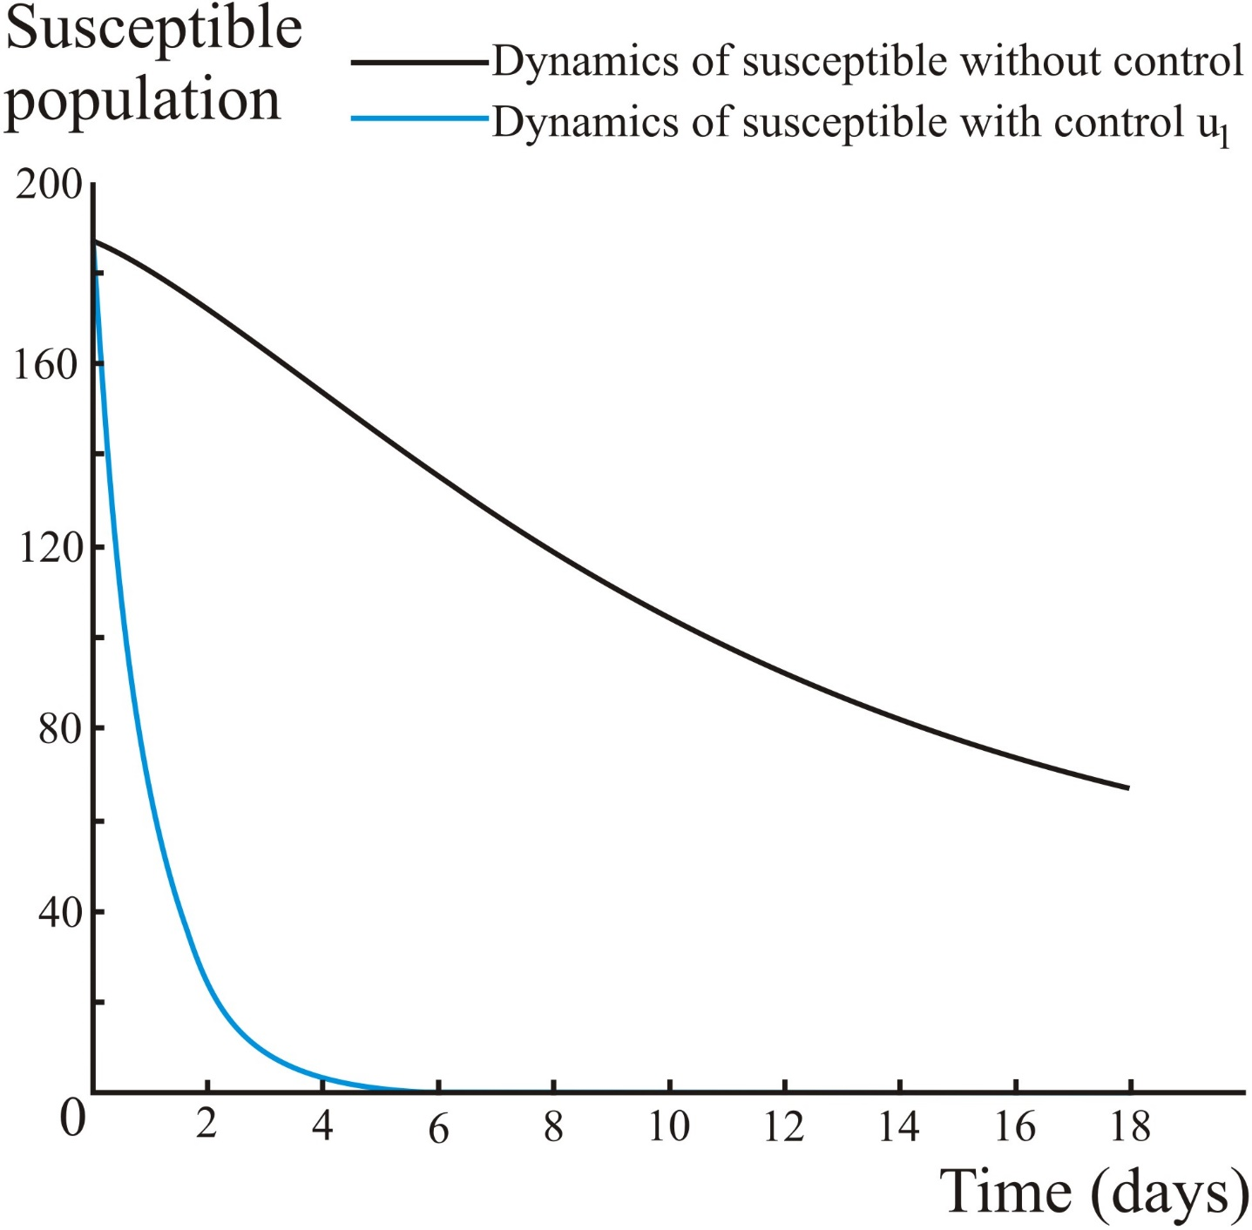

Figure 1. Dynamics of susceptible population

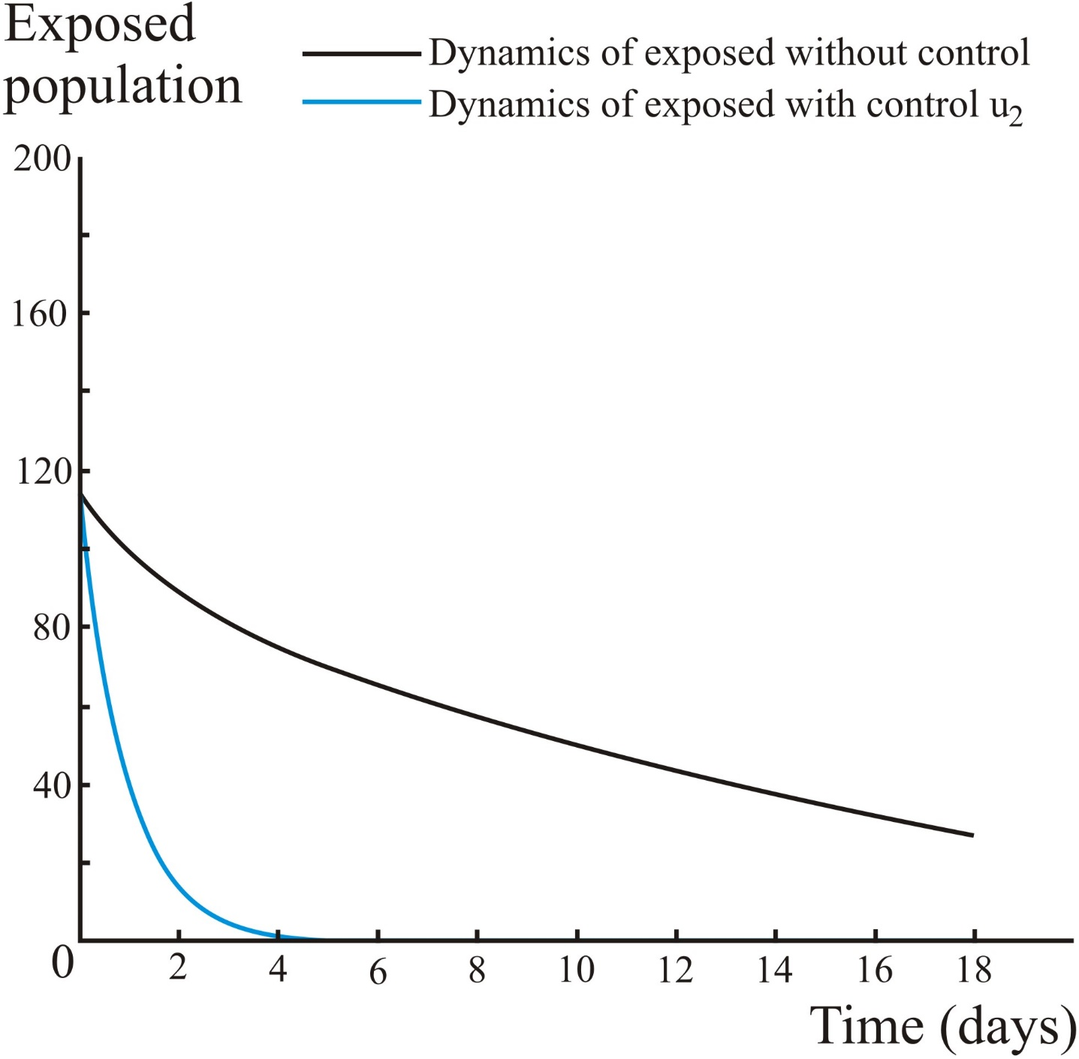

Figure 2. Dynamics of exposed population

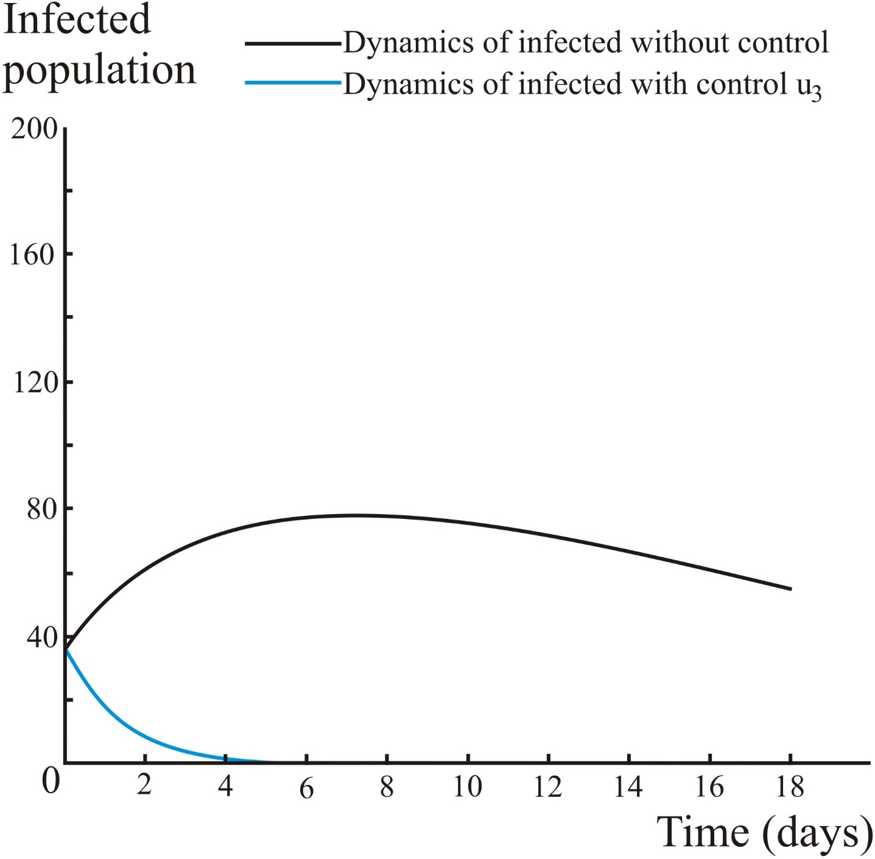

Figure 3. Dynamics of infected population

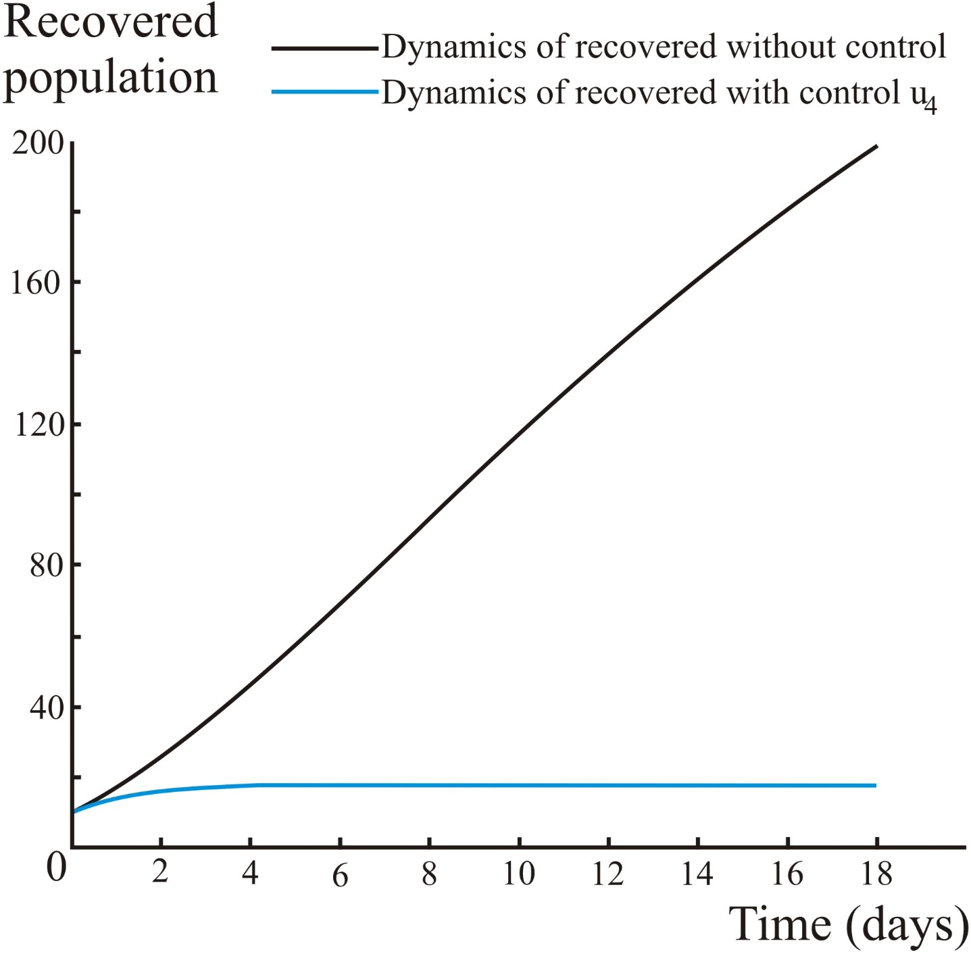

Figure 4. Dynamics of recovered population

After numerical calculations as we can see in the simulation graphs in Figs 1 to 4 control function are applied to the system and the controls able to decrease susceptible, exposed, infected population. The terms –*u*1, –*u*2, –*u*3, –*u*4 in the dynamic system (2) means that there is a reduction in the rate of change of the susceptible, exposed, infected and recovered population by *u*1, *u*2, *u*3, *u*4 respectively. For more detailed description will be given the following example:

By numerical calculation using MATLAB software it is known that *u*1(2) = 24.82, *u*2(2) = 12.37, *u*3(2) = 8.52, *u*4(2) = –1.7 with *t* = 2 days, means when the rate of the susceptible population at *t* = 2 days must be reduced by 25 individuals (rounding up from 24.82), when the rate of the exposed population at *t* = 2 days must be reduced by 13 individuals (rounding up from 12.37), when the rate of the infected population at *t* = 2 days must be reduced by 9 individuals (rounding up from 8.52). Meaning that in the second day we should limit 25 susceptible individuals, 13 exposed individuals, and 9 infected individuals to stay at home simultaneously.

For the recovered individuals, since *u*4(2) = –1.7, according to mathematical systems means we have to let or send two people to move outside their home, which is impossible in reality, so by logical thinking when the person is cured (recovered), the cure is due to the treatment carried out from quarantining or treating an infected person by the authorities, then logically the authorities should advise the person who recovered to stay rested during RCA period, or at least the person who recovered, must have realized to keep resting until the RCA period is over. So this control value is used as a benchmark for how many people must remain at home on day two.

The depiction of the use of this control can be seen in Fig. 5.

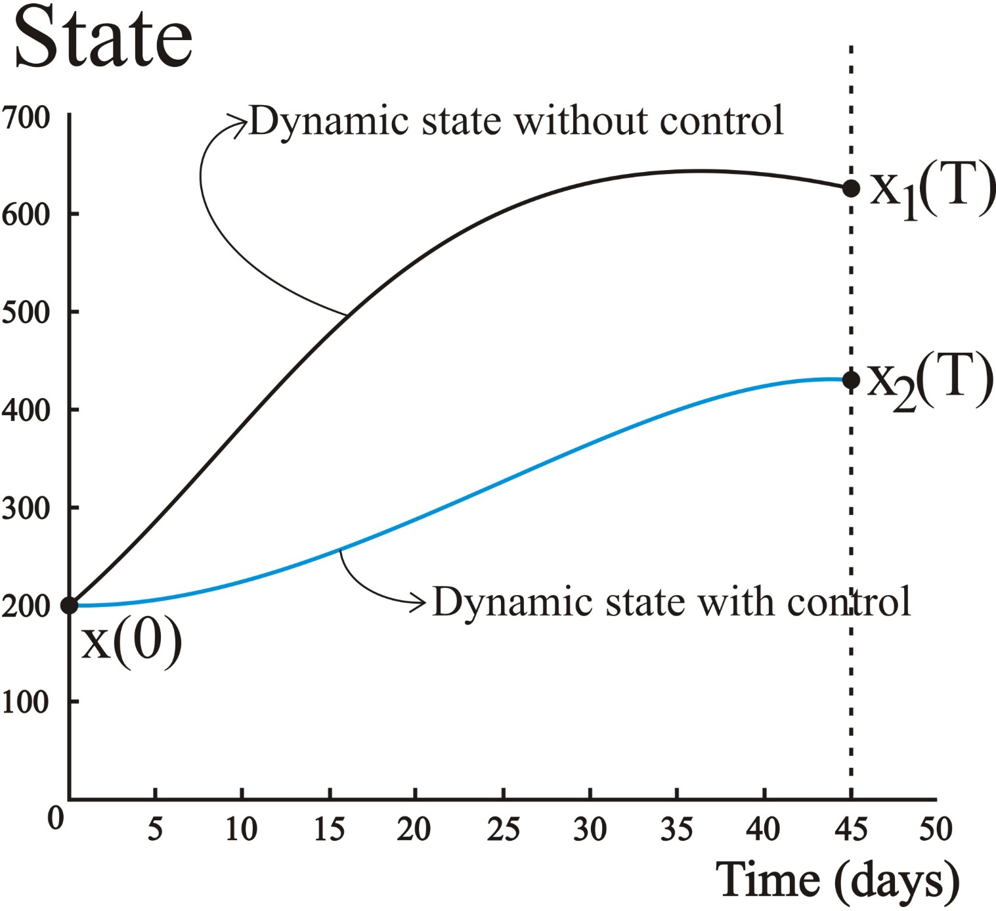

Figure 5. Dynamics of state vs time

The use of this control is expected to reduce the state final point at the specified time T (45 days), as we can see in Fig. 5 x2(T) < x1(T). The type of this optimal control problem is fixed time with free end point.

1. Conclusion

The use of control *u*1, *u*2, *u*3, *u*4 with the Pontryagin Minimum Principle method which is applied to the dynamic modeling of Corona virus spread, can be seen in the numerical simulation in figs 1 to 3 there is a reduction in the population of susceptible, exposed and infected populations, which means conducting RCA has an impact on reducing the population of susceptible, exposed and infected.

In the end, use of control function in the dynamic model are expected to provide advice to the authorities to handle and control Covid-19 outbreak in Semarang city.

References

1. F. Brauer and C. Castillo-Chavez, Mathematical Models in Population Biology and Epidemiology. New York, NY: Springer New York, 2012. More references
2. L. S. Pontryagin, Mathematical Theory of Optimal Processes. Routledge, 2018.
3. M. A. Shereen, S. Khan, A. Kazmi, N. Bashir, and R. Siddique, “COVID-19 infection: Origin, transmission, and characteristics of human coronaviruses,” Journal of Advanced Research, vol. 24, pp. 91–98, 2020. https://doi.org/10.1016/j.jare.2020.03.005.
4. C. Wang, P. W. Horby, F. G. Hayden, and G. F. Gao, “A novel coronavirus outbreak of global health concern,” The Lancet, vol. 395, no. 10223, pp. 470–473, 2020. https://doi.org/10.1016/s0140-6736(20)30185-9.
5. B. Kan, M. Wang, H. Jing, H. Xu, X. Jiang, M. Yan, W. Liang, H. Zheng, K. Wan, Q. Liu, B. Cui, Y. Xu, E. Zhang, H. Wang, J. Ye, G. Li, M. Li, Z. Cui, X. Qi, K. Chen, L. Du, K. Gao, Y.-T. Zhao, X.-Z. Zou, Y.-J. Feng, Y.-F. Gao, R. Hai, D. Yu, Y. Guan, and J. Xu, “Molecular Evolution Analysis and Geographic Investigation of Severe Acute Respiratory Syndrome Coronavirus-Like Virus in Palm Civets at an Animal Market and on Farms,” Journal of Virology, vol. 79, no. 18, pp. 11892–11900, 2005. https://doi.org/10.1016/s0140-6736(20)30185-9
6. B. J. Zheng, Y. Guan, K. H. Wong, J. Zhou, K. L. Wong, B. W. Y. Young, L. W. Lu, and S. S. Lee, “SARS-related Virus Predating SARS Outbreak, Hong Kong,” Emerging Infectious Diseases, vol. 10, no. 2, pp. 176–178, 2004. https://doi.org/10.3201/eid1002.
7. Z. Shi and Z. Hu, “A review of studies on animal reservoirs of the SARS coronavirus,” Virus Research, vol. 133, no. 1, pp. 74–87, 2008. https://doi.org/10.1016/j.virusres.2007.03.012
8. Yang Z, Zeng Z, Wang K, Wong S-S, Liang W, Zanin M, et al. Modified SEIR and AI prediction of the epidemics trend of COVID-19 in China under public health interventions. Journal of Thoracic Disease. 2020;12(3):165–74.
9. Hedrick JK, Girard A. Control of nonlinear dynamic systems: Theory and applications. Controllability and observability of Nonlinear Systems. 2005;48.
10. Pelacakan Wilayah [Internet]. hit counter script. [cited 2020May24]. Available from: <https://siagacorona.semarangkota.go.id/>.

**Acknowledgments**

The authors thank the lecturers who have provided lessons and suggestions for writing this article material.