Geometry, Culture, and Gender: an Analysis of Students’ Problem Solving Ability

Arief Budi Wicaksono1, Aprilia Nurul Chasanah2, Estina Widyaningsih3, Gunawan4

1,2,3,4Mathematics Education Study Program, Universitas Tidar, Magelang, Indonesia

1ariefbudiw@untidar.ac.id

**Abstract**. The purpose of this research is to describe the ability of cultural-based geometry problems in student of the mathematics education are reviewed from gender differences. This research is a qualitative descriptive with the research subject is students of the Mathematics Education Study Program, Universitas Tidar on the course of Space Geometry as many as six students (high ability, average ability, and low ability) that each category consists of males and females. The instruments in this research are about tests of geometry-based problem-solving ability and interview guidelines. Data is analyzed qualitatively and data validation uses triangulation. The results showed that students are low ability, both male and female have problem-solving skills in poor category. The students have limitations on understanding problems, drafting problem-solving plans, implementing the problem-solving plans, and returning troubleshooting results. Average ability students, both male and female, have fair problem-solving ability in the category. The students have limitations in implementing problem-solving plans and returning problem-solving results. High ability students, both male and female, have fair problem-solving ability. The student is able to understand the problem, develop a problem-solving plan, enough in implementing the problem-solving plan, and check back problem-solving results.

1. **Introduction**

Education is a process of forming human resources potential to improve quality in its life. One of the areas of study that plays an important role in the world of education in mathematics. Many other areas of study require mathematics to learn. Mathematics is a means of solving problems in daily life so it is learned at every level of education both primary and secondary education even from an early age. [1] It establishes five mathematical standards, namely problem solving, communication, connection, reasoning, and representation. Based on that, one of the skills that students must have in mathematics learning is problem-solving ability. Mastering problem-solving ability are crucial for students as most mathematical competencies have problem-solving ability.

According to [2] problem-solving is the processing of finding answers by individuals applying their existing knowledge and skills to tools and applications to meet the requirements of new situations due to new and unknown situations, problem solving is considered a model of high mental activity. [3] It reveals that problem-solving refers to the efforts of people to achieve goals because they do not have an automated purpose. Problem-solving is an attempt to solve a problem with existing knowledge and skills to reach the destination and a model of solution discovery through troubleshooting steps. [4] It reveals four steps of solving the problem of understand the problem, devise a plan, carry out the plan, and looking back. At each troubleshooting steps will go into the troubleshooting indicator. [1] The problem-solving indicator is 1) developing new mathematical knowledge through problem-solving, 2) solving mathematical problems in various contexts, 3) implementing the right strategy to solve the problem, 4) reflects the problem-solving process.

Measuring problem-solving ability is very precise done with mathematical geometry. [5] Revealing geometry is a branch of mathematics taught with the aim that students can understand the properties and relationships between elemental geometry and can be a good problem solver. Clements & Battista (in [6]) reveal learning geometry can improve student thinking skills using visual images. Learning geometry means learning visual patterns. The step is to present questions about contextual problem-solving. Problems with contextual troubleshooting can be common contextual problems as well as contextual problems that are raised about culture. The cultural context in this research is about geometry with the theme of Central Java and the special region of Yogyakarta that has diversity in every aspect of the culture, which is the philosophical and scientific value explored. The presentation of the question is intended to allow students to see the mathematical aspects of the local culture around them and to solve mathematical problems related to their culture.

To get an overview of trends in problem-solving in mathematics can refer to the results of the research Capper (in [7]) which suggests that previous student experiences, cognitive development, and interests on mathematics are factors that are very influential in the success in problem-solving in mathematics. With regard to the influence of cognitive aspects that are one of the innate aspects of male and female gender that can change and develop at all times. Therefore, cognitive aspects include ways of thinking including gender differences. Some researchers believe that the influence of gender factors (the influence of male and female differences) in mathematics occurs due to biological differences in the brain of male and female gender known through the observation that girls are generally superior in language and writing, whereas boys are superior in mathematics because of their better space ability. As a result, gender differences in mathematics are quite difficult to change. However, on the other hand, various studies have stated that no role of gender is outperformed in mathematics and women can be superior in various mathematics-related fields. Based on the explanation above, researchers are interested in conducting research on the geometry of culture-based problem-solving ability in mathematics education students at Universitas Tidar which are reviewed from gender differences.

1. **Research Methods**

This type of research is a qualitative descriptive. The subject of the study is a semester II student of Mathematics Education Study Program for 6 students, consisting of the male and female gender. The subject selection is purposive sampling with the high, average, and low ability of subject criteria. The instruments in this study are about tests of geometry-based problem-solving ability and interview guidelines. Research data in the form of documentation data written on the results of problems solving geometry based on culture and interviews with research subjects. The research data is obtained with tests, then confirmed with interviews. Written data is analyzed based on problem-solving ability, while the interview data is analyzed according to analysis technique expressed by [8] namely (1) data reduction, (2) data presentation, and (3) withdrawal of conclusion. Analysis results of written data and interviews are then validated using triangulation. Indicators and guidelines for the assessment of problem-solving ability are presented in Table 1.

**Table 1.** Indicators and guidelines for troubleshooting ability assessment

|  |  |  |
| --- | --- | --- |
| Troubleshooting Stages (indicators) | Category | Description |
| Understanding the problem | Good | Able to understand the problem thoroughly, namely known information and questions posed from the problems provided |
|  | Fair | Misinterpret some problems or do not understand the overall problem |
|  | Poor | Misinterpret the problem completely or do not understand the problem as a whole |
| Develop a problem- solving plan | Good | Create troubleshooting steps correctly and lead to the correct solution |
|  | Fair | Create a troubleshooting step that can be applied but lets not get the corresponding result/get the wrong result |
|  | Poor | Do not create relevant troubleshooting steps |
| Implementing the problem-solving plan | Good | Solve all problems and get correct answers |
|  | Fair | Solve some problems and get correct answers |
|  | Poor | Do not troubleshoot or resolve some or all problems but get incorrect results |
| Recheck the troubleshooting results | Good | Check the problem solving results and write conclusions appropriately |
|  | Fair | Examine the results of troubleshooting and/or write down conclusions with less precise/incomplete |
|  | Poor | Do not check the troubleshooting results and not write down conclusions |

1. **Result and Discussions**

The results gained in this research are the ability of mathematics education students in the management of cultural-based geometry problem differentiated by gender. Below are presented written documentation results and interviews of research subjects as well as categorization of their problem-solving ability.

* 1. *Low ability students*

In low ability students, researchers took the subject of both men and women by analyzing the problem of geometry in question number 1. The answers of each gender are as follows.

* + 1. *Low ability male subjects*

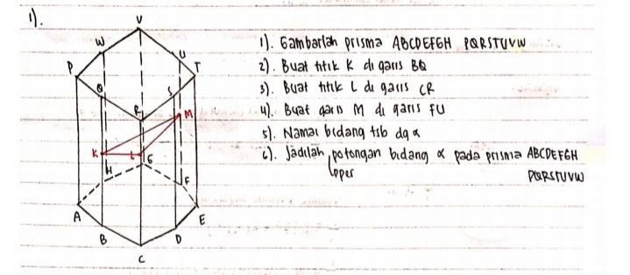

**Figure 1.** Low ability male subject answer

Based on the written results of problem-solving on the subject of low ability males, the subject could be described poor at the stage of understanding the problem of being unable to understand the problem as a whole, it appears that the subject does not write any known information and questions posed from the problem given. The subject is fair at the stage of drafting a problem-solving plan seen in the illustration of the question of an eight-pointed prism that is able to place the position of the known point but has not been able to reveal what method will be used to paint the slice field. In the stage of implementing the problem-solving plan, the subject completes the steps in determining the slice field, but the field formed from connecting the dots is known to mean the slice field. Therefore the subject is not able to correct the problem. The subject is also lacking in the stage of re-checking the resolution results for not writing conclusions from the answer obtained.

* + 1. *Low ability female subjects*

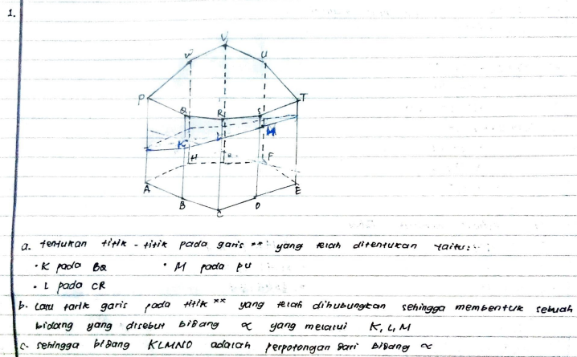

**Figure 2.** Low ability female subjects answer

Based on the written results of problem-solving on the subject of low ability female, the subject could be described poor at the stage of understanding the problem of being unable to understand the problem as a whole, it appears that the subject does not write any known information and questions posed from the problem given. The subject is fair at the stage of drafting a problem-solving plan seen in the illustration of the question of an eight-pointed prism that is able to place the position of the known points but has not been able to reveal what method will be used to paint the slice field. At the stage of implementing the problem-solving plan, the subject does not complete the steps in determining the slice field visible in step b in Figure 2 which should be the steps to determine the slices field is further sorted, then the results obtained from the problem are also incorrect. In the stage of checking back, the problem solving the subject is lacking because it does not write down the conclusions of the answers obtained. Based on the above exposure, it can be deduced the written result of both the male and female subjects in the low-skilled category in Table 2 below.

**Table 2.** Low ability students summaries

|  |  |  |  |
| --- | --- | --- | --- |
| **Stages** | **Category** | | **Conclusion** |
| **Male** | **Female** |
| Understanding the problems | Poor | Poor | Low ability students are unable to understand the whole problem, devise a problem solving plan that can be applied but get the wrong problem solving, and do not examine or write down the conclusions from the answers obtained. The distinguishing thing between a male and female subject is to the stage of implementing a problem solving plan, at this stage women are better than men but on the subject of women is still not perfect. Thus, the students' problem solving ability low in question number 5 are in poor category for both male and female subjects. |
| Develop a problem- solving plan | Fair | Fair |
| Implementing the problem-solving plan | Poor | Poor |
| Recheck the troubleshooting results | Poor | Poor |

Based on the overall answer to the subject with low ability, both the male and female subjects are in poor category. The subject has limitations on understanding problems, drafting problem-solving plans, implementing problem-solving plans, and returning troubleshooting results. This is contrary to research from [9], stating that a low ability student has fair problem-solving ability in the category. Also, the study compared to the research results [10] is only different in the female gender category, stating that low ability students with male gender have problem-solving ability in fewer categories and the female gender has insufficient problem-solving ability.

* 1. *Average ability students*

In average ability students, researchers took the subject of both men and women by analyzing the problem of geometry in question number 5. The answers of each gender are as follows.

* + 1. *Average ability male subjects*

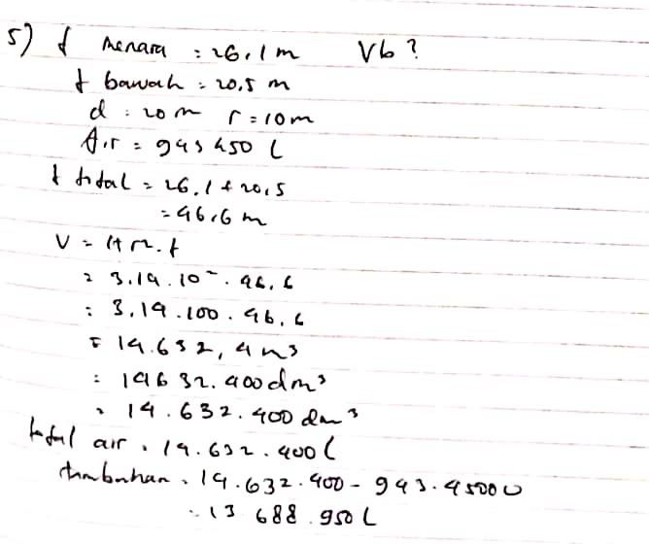

**Figure 3.** Average ability male subjects answer

Based on the written results of problem-solving on an average ability male subject, the subject may be described in stages of understanding the problem of being able to write well, it appears that the male subject can write out the known information and questions posed in the question correctly. At the stage of drafting a problem-solving plan, the subject is fair in this stage by writing the volume of the tubes and the formula determines the additional water needed in the water tower structure but has not been able to illustrate the problem in the image of the tube-building. At the stage of implementing the problem-solving plan, the subject is unable to settle properly, there is a high error in the volume of tubes that are supposed to be high from the difference between the building height and the pillar height. In the stage of rechecking the problem resolution, the subject does not write down the conclusions of the answers he acquired so that they are lacking in this stage.

* + 1. *Average ability female subjects*

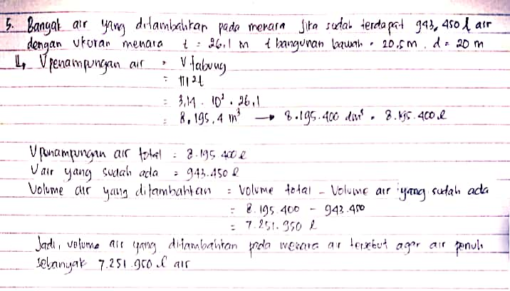

**Figure 4**. Average ability female subject anwer

Based on the written results of problem-solving on the subject of average ability female, it can be described that the subject in stages of understanding the problem can already be written well, it appears that the subject of women can write the known information and questions asked in question correctly. At the stage of drafting a problem-solving plan, the subject is fair in this stage by writing the volume of the tubes and the formula determines the additional water needed in the water tower structure but has not been able to illustrate the problem in the image of the tube-building. At the stage of implementing the problem-solving plan, the subject is unable to settle properly, there is a high error in the volume of tubes that are supposed to be high from the difference between the building height and the pillar height. In the stage of rechecking the problem resolution, the subject can write down the conclusion of the answer it acquired but the answer is still wrong. Based on the above exposure, the written results of the male and female subjects in the category are currently in Table 3 below.

**Table 3.** Average ability students summaries

|  |  |  |  |
| --- | --- | --- | --- |
| **Stages** | **Category** | | **Conclusion** |
| **Male** | **Female** |
| Understanding the problems | Good | Good | Students can understand the problem as a whole but in the stage of device poor precise problem-solving plan so that it is possible to obtain incorrect troubleshooting. The distinguishing thing between the male and female subjects is that at the stage of rechecking the problem-solving results, at this stage women are better than men but on the subject of women is still not perfect. Thus, the problem-solving ability of students on question number 5 is in the category of enough for both male and female subjects. |
| Develop a problem- solving plan | Fair | Fair |
| Implementing the problem-solving plan | Fair | Fair |
| Recheck the troubleshooting results | Poor | Fair |

Based on the overall answer to the subject with average ability, both the male and female subjects are fair categories. The subject has limitations in implementing problem-solving plans and returning problem-solving results. This is according to research from [9], stating that students who are ability of having problem-solving ability fair and good categories. Also, this research is contrary to the results of the study [10] stating that students are average ability, both male and female have problem-solving ability in good categories.

* 1. *High ability students*

In low ability students, researchers took the subject of both men and women by analyzing the problem of geometry in question number 1. The answers of each gender are as follows.

* + 1. *High ability male subjects*

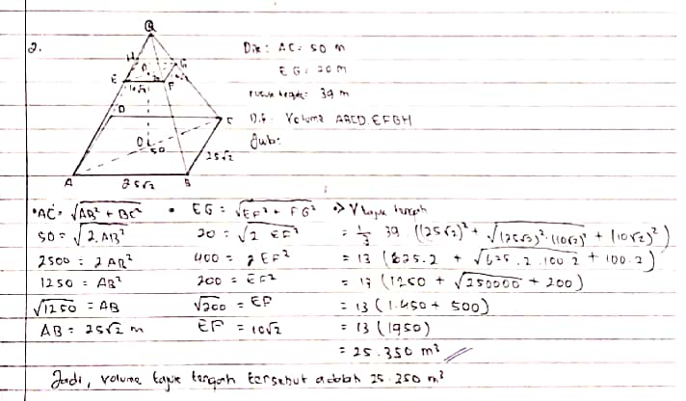

**Figure 5.** High ability male subject answer

Based on the written results of problem-solving on the subject of high ability males, it can be described that the subject in stages of understanding the problem can already be written well, it appears that the male subject can write down what is known and asked questions correctly. At the stage of implementing the problem-solving plan, the subject is already good in this stage is able to write the formula of the volume of the pyramid is directly attached, and able to illustrate the problem in the form of the image wakes up the rectangle limas. In the stage of implementing the problem-solving plan, the subject is an error in working on the question, there is a mistake in determining the volume of the title of the Grand Mosque which is supposed to be 36 (obtained using Pythagoras 'theorem), but the subject writes the height of 39. In the stage of rechecking the problem resolution, the subject can write down the conclusion of the answer it acquired but the answer is still wrong.

* + 1. *High ability female subjects*

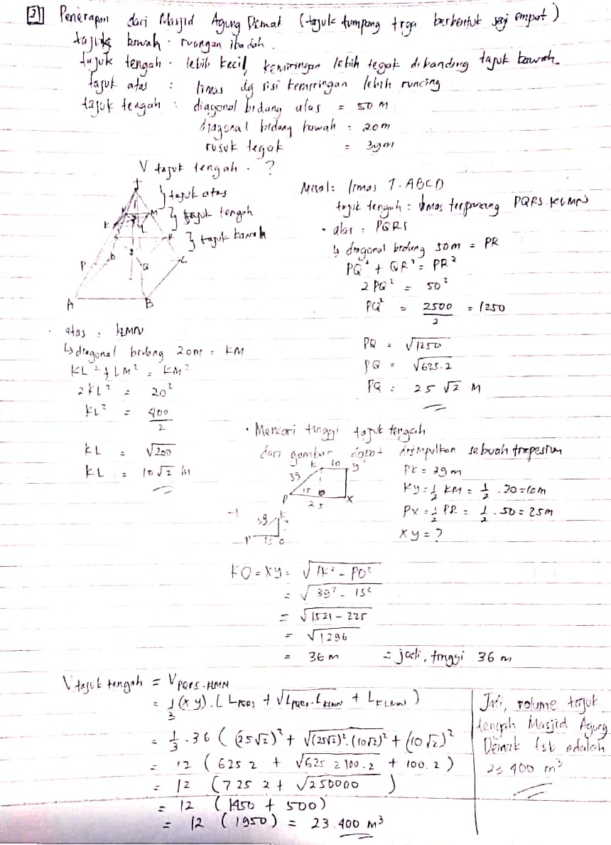

**Figure 6.** High ability female subject answer

Based on the written results of problem-solving on the subject of high ability female, it can be described that the subject is well in the stage of understanding the problem, it appears that the subject of women can write the known information and questions posed on the question correctly. In the stage of drafting a problem-solving plan, the subject has been able to make troubleshooting steps correctly and leads to the correct solution seen in the illustration of the rectangular limas space that has been in accordance with the heading of the building of the Great Mosque of Demak and wrote fair conditions of the problem posed such as the long side of the upright Limas is surrounded, the upper and the area of At the stage of implementing the problem-solving plan, the subject has been able to complain the whole problem properly and get the answer correctly. In the stage of rechecking the problem resolution of the subject has been able to check the results again and write down the conclusions of the answers obtained. Based on the above exposure, it can be concluded the written result of both male and female subjects in the high ability category in Table 4 follows.

**Table 4.** High ability students summaries

|  |  |  |  |
| --- | --- | --- | --- |
| **Stages** | **Category** | | **Conclusion** |
| **Male** | **Female** |
| Understanding the problems | Good | Good | High ability students understand the problem as a whole, putting together a proper problem-solving plan, and leading to the correct solution. The thing that distinguishes both male and female subjects is the stage of implementing the problem-solving plans and rechecking the problem-solving results. On the male subject is still not perfect at that stage, while the subject of female is good at that stage. Thus, the students' problem-solving ability to be in question number 2 is in the category fair for male subjects and good categories for female subjects. |
| Develop a problem- solving plan | Good | Good |
| Implementing the problem-solving plan | Enough | Good |
| Recheck the troubleshooting results | Fair | Good |

Based on the overall answer to the subject with high ability, both the male and female subjects are fair categories. The subject was able to understand the problem, devise a problem-solving plan, fair in implementing the problem-solving plan, and checking back the problem resolution. This is contrary to research from [9], stating that high ability students have the ability to solve good problem-solving ability. Also, this research is contrary to the results of the research [10] stating that students are high ability, both male and female gender have problem-solving ability in good categories.

1. **Conclusions**

In this research explaining the students' ability to solve problems in local culture-based geometry tends to experience differences in individual abilities in both males and females. Students are highly able and are likely to be better at solving problems in geometry compared to low ability students. Both male and female students have high ability problem-solving ability in fair categories. The student is able to understand the problem, develop a problem-solving plan, fair in implementing the problem-solving plan, and check back problem-solving results. Students who are both male and female capable of having problem-solving ability fair categories. The students have limitations in implementing the problem-solving plans and returning problem-solving results. Low ability students both male and female have problem-solving ability in poor category. The students have limitations on understanding problems, drafting problem-solving plans, implementing the problem-solving plans, and returning troubleshooting results. The findings in this research revealed that mathematical abilities strongly support students' ability in solving mathematical problems although presented in an ungeneralized context (local-based culture).

1. **References**

[1] National Council of Teachers of Mathematics 2000 *Principles and standards for school mathematics* (Reston. VA: National Council of Teachers of Mathematics)

[2] Chao J Y, Tzeng, Po, Hsin Y 2017 “The Study of Problem Solving Process of E-book PBL Course of Atayal Senior High School Students in Taiwan” *EURASIA Journal of Mathematics Science and Technology Education.* **13**(3), 1001-1012

[3] Schunk, D H 2012 *Learning Theories an Educational Perspective.* (Yogyakarta: Pustaka

Pelajar)

[4] Polya, G 2014 *How to solve it: A new aspect of mathematical method* (New Jersey, NJ.: Princeton University Press)

[5] Safrina K, dkk 2014 “Peningkatan Kemampuan Pemecahan Masalah Geometri melalui Pembelajaran Kooperatif Berbasis Teori Van Hiele” *Jurnal Didaktik Matematik.* **1**(1), 9-20

[6] Tieng P G & Eu L K 2014 “Improving Students’ Van Hiele Level of geometric Thinking Using Geometer’s Sketchpad” *The Malaysian Online Journal of Education Technology.* **2**(3),20-31

[7] Suherman E, dkk 2003 *Strategi Pembelajaran Matematika Kontemporer* (Bandung: PT Remaja Rosdakarya)

[8] Miles M B & Huberman A M 1994 *Qualitative data analysis: An expanded sourcebook* (London: SAGE Publications Ltd)

[9] Samo, D D 2017 “Kemampuan Pemecahan Masalah Mahasiswa Tahun Pertama pada Masalah Geometri Konteks Budaya” *Jurnal Riset Pendidikan Matematika.* **4**(2), 14-152

[10] Latifah M & Khabibah S 2017 “Profil Pemecahan Masalah Geometri Siswa SMA Ditinjau Dari Perbedaan Jenis Kelamin dan Kemampuan Spasial” *MATHEdunesa Jurnal Ilmiah Pendidikan Matematika.* **3**(6), 37-46