An Analysis of High School Students’ Error in Completing Trigonometry Problems Based on Movshovitz-Hadar, Zaslavsky, And Inbar Categories
Aulia Nur Arivina¹, Jailani²
¹Graduate Program of Mathematics Education, Yogyakarta State University, Yogyakarta, Indonesia
²Mathematics Education Department, Yogyakarta State University, Yogyakarta, Indonesia

Email: ¹aulianur.2018@student.uny.ac.id.

Abstract. Trigonometry is a new mathematical material that is studied by high school students in class X. Trigonometry is important for students to understand because the material is not only used in mathematics but also science, engineering, and other fields. An important component in proving the quality of learning is assessment. Therefore, this study aims to describe student errors that arise when solving trigonometry problems. This research is used a qualitative approach with descriptive method. The subjects of this study were 32 high school students grade X in Semarang City, Indonesia in the academic year 2019/2020. The grouping of student error types is based on Movshovitz-Hadar, Zaslavsky, and Inbar categories. Classification of student errors include misused data, misinterpreted language, logically invalid inference, distorted theorem or definition, unverified solution, and technical error. The analysis shows that the mistakes made by students are writing information is not following information in the problem, using the value of a variable for another variable, error in copying the details of the question to the answer sheet, error using symbols from other concepts, error when using rules or formula, error checking the result, erroneous in the calculation, and error manipulating algebraic symbols or operations.
- Introduction
The government and education units improve the quality of assessments and encourage the achievement of competency standards for graduates nationally through holding national examination, national standard school exams, and examinations [1]. The National Examination is an activity to measure the achievement of graduates’ competencies in certain subjects nationally by referring to the Graduate Competency Standards. The National Examination is held using a computer (UNBK), and paper-based (if UNBK can’t be implemented). The results of the Mathematics National Examination for SMA / MA in the 2018/2019 Academic Year show that the Geometry and Trigonometry test material obtained the lowest percentage when compared to other test materials (Table 1). There are four Mathematics test materials in the Computer-Based National Examination for Science and Social Sciences majors, but the language majors don’t contain calculus test material (only three test materials).

Table 1. The results of the Mathematics National Examination for SMA / MA in the 2018/2019
Test Materials | Major
 | Science | Social | Language
Algebra | 45,61 | 38,38 | 38,5
Calculus | 35,02 | 27,99 | -
Geometry and Trigonometry | 34,63 | 21,82 | 36,54
Statistics | 35,10 | 37,64 | 36,63

Trigonometry is one of the mathematics content materials studied by students at the secondary education level (Senior High School) [2]. Trigonometry is the basis for many courses in mathematics — starting in grade school with geometric shapes and map reading and moving on through calculus [3]. Trigonometry is the study of angles and triangles and the wonderful things about them and that you can do with them. For centuries, humans have been able to measure distances that they can’t reach because of the power of this mathematical subject [3]. Trigonometry has the answers to so many questions in engineering, navigation, and medicine. People today benefit big-time by having ways to solve equations in trigonometry that are quick and efficient because the mathematicians of old who created the systems that we use today [3].
An important skill for the teacher is being able to identify where students misunderstand and anticipate when they acquire new conceptual learning [4]. Assessment is a general term for various procedures used to get information about student performance through paper tests, long responses (essays), authentic assignments, teacher observations, and student self-reports [5]. The benefits of assessment for teachers are to help identify student errors, determine the main student errors, and find out how often they occur [6]. Formative assessment provides information to teachers and students about how students are toward learning goals. Providing good feedback is one skill that teachers need to master as part of a good formative assessment [7]. The error analysis can help teachers to better understand the causes of the mathematical difficulties experienced by students, eventually building a recovery model that is suitable with the weakness levels of students. The importance of item analysis is to provide feedback about the difficulties faced by students.
Students’ errors was based on several errors’ classifications [8][9][13]. There are various error analysis models which have been proposed by researchers and educators in the statistics and mathematics. Among the models are the Error Hierarchy Model by Newman which classified the types of errors made by students into careless errors, systematic errors and random errors on differentiation topic [8]. Empirical Classification Model by Nitsa Moshovitz-Hadar coded mathematical errors according to categories of misused data, misinterpreted language, logically invalid inference, distorted theorem or definition, unverified solution, and technical error.
Analysis of student errors in solving the problem of applying spherical trigonometry shows that the error type in understanding concept gets the highest percentage compared to mistake to understanding problems, careless/inadequate mistakes, error in notation usage, and error of process skills [10]. Analysis of students' errors in trigonometric equations shows that the number of the data error is 34%, the misconception is 32.35%, strategy error is 45.15%, miscalculation is 34.81% and the conclusion is error 30.38% [11]. Therefore, it is necessary to further analyze the difficulties experienced by students in the Trigonometry material.

- Method
This research is descriptive qualitative research. Qualitative research is an approach for exploring and understanding the meaning of individuals or groups ascribe to a social or human problem [12]. This study uses descriptive research because this research describes the types of errors qualitatively analyzed following the actual situation [13]. The subjects in this study were 32 students of class X at SMA 5 Semarang. This research was conducted in the even semester of the 2019/2020 academic year. The data collection technique in this study used a problem-solving ability test instrument.
We adapted the categorization of errors made by students from the framework proposed by Movshovitz-Hadar, Zaslavsky, and Inbar [14]. The following six descriptive categories of errors are presented as models for classifying errors in mathematics in secondary schools, misused data, misinterpreted language, logically invalid inference, distorted theorem or definition, unverified solution, and technical errors (see Table 2).
Table 2. Description of errors that adapted from Movshovitz-Hadar, Zaslavsky, and Inbar
Type of error | Description of error
Misused data | Designating as "given" a piece of information that neither is stated nor follows immediately from the given information
 | Neglecting some given data necessary for the solution and compensating for the lack of information by explicitly adding irrelevant data
 | Stating explicitly as a requirement something that was not required in the problem.
 | Assigning to a given piece of information a meaning inconsistent with the text
 | Imposing a requirement that disagrees with the given information
 | Using a numerical value of one variable for another variable
 | Incorrectly copying some details from the test to the workbook.
Misinterpreted language | Translating an expression from natural language into a mathematical term or equation that represents a relation different from the one described verbally
 | Designating a mathematical concept by a symbol traditionally designating another concept and operating with the symbol in its convention
 | Incorrectly interpreting graphical symbols as mathematical terms or vice
Logically invalid inference | Errors that deal with fallacious reasoning and not with specific content; that is, new information invalidly drawn from a given piece of information or from a previously inferred one.
Distorted theorem or definition | Applying a theorem or definition outside its condition
 | Applying a distributive property to a non-distributive function or operation
 | Incorrectly citing a definition, theorem, rule or formula
Unverified solution | The final result is not the solution to the problem: error in examining the final result
Technical error | Error in calculation due to carelessness
 | Error in manipulating algebraic symbol or operation
 | Error in applying an algorithm

3. Result and Discussion
3.1. Misused data
Misused data occurs when assigning to a given piece of information a meaning inconsistent with the text, incorrectly copying some details from the test to the workbook, using a numerical value of one variable for another variable.
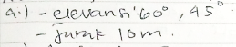
Figure 1. The first misused data

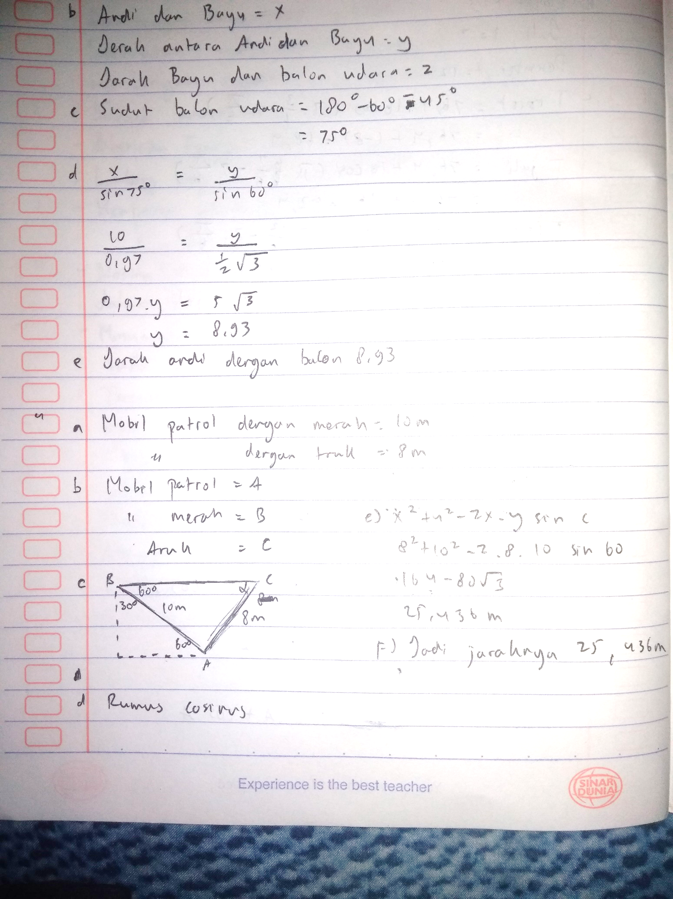
Figure 2. The second misused data
In Figure 1, students did not write down the appropriate information completely and correctly. The correct answer (a) is Banu observing the hot air balloon with an elevation angle of 60 °, Andi observing the hot air balloon with an elevation angle of 45 °, the distance between Andi and Banu is 10 m. Students incorrectly copying some details from the test to the workbook so that only writing information that corresponds to the problem is the elevation of 60 °, 45 °, and a distance of 10 m.
In Figure 2, students provide some information that does not match the questions. Students are not careful in writing Banu's name so they write Bayu's name. In answer (b) students are asked to write an example and ilustration following the information. Students are incomplete to write down the first information, they should write down the variables that represent the distance between Andi and Bayu, the distance between Andi and the hot air balloon, and the distance between Andi and the hot air balloon. If the first line is variable x to show the distance between Andi and Banu, then no variable represents the distance between Andi and the hot air balloon. Therefore, in Figure 2 shows that students are using a numerical value of one variable for another variable. This is why drawing accurate diagrams is important in trigonometry; sometimes we need them to make it absolutely clear what information we can just assume and what information we can’t [15]
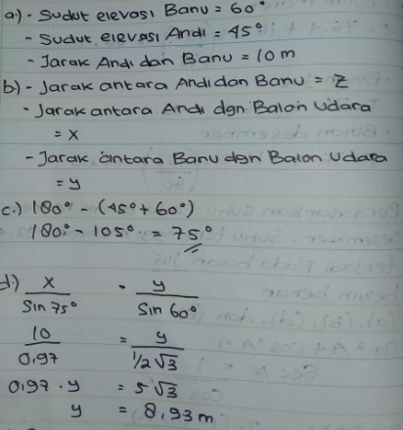
Figure 3. The third misused data
In Figure 3, students are not consistent in using the variables x, y, z. when making examples (answer b) and when doing calculations (answer d). If referring to answer b, they should use the formula $\frac{z}{\sin{{75}^{°}}}=\frac{x}{\sin{{60}^{°}}}$. It shows that students use a numerical value of one variable for another variable. A mnemonic that may help is “the length of the side opposite the angle we are trying to find goes on the opposite side of the equation from the other two side lengths.” [15]

3.2. Misinterpreted language
Misinterpreted language occurs when designating a mathematical concept by a symbol traditionally designating another concept and operating with the symbol in its convention.
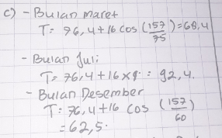
Figure 4. The first misinterpreted language
Students are asked to determine the normal temperature in Savannah, Georgia in March, July and December with $T=76,4+16\cos\left(\frac{πt}{6}-\frac{7π}{6}\right)$, t is the time (in months) and t = 1 for January. In trigonometry, π (in radians) means 180 °. Therefore, Figure 4 shows that students possible to understand π on problems with $\frac{22}{7}$. When substituting π with $\frac{22}{7}$, students also not carefully, so there is a calculation error. Students need to check that they are in the correct mode, i.e. using degrees instead of radians for problems dealing with angles in triangles [15].

3.3. Logically invalid inference,
Logically invalid inference occurs when errors that deal with fallacious reasoning and not with specific content
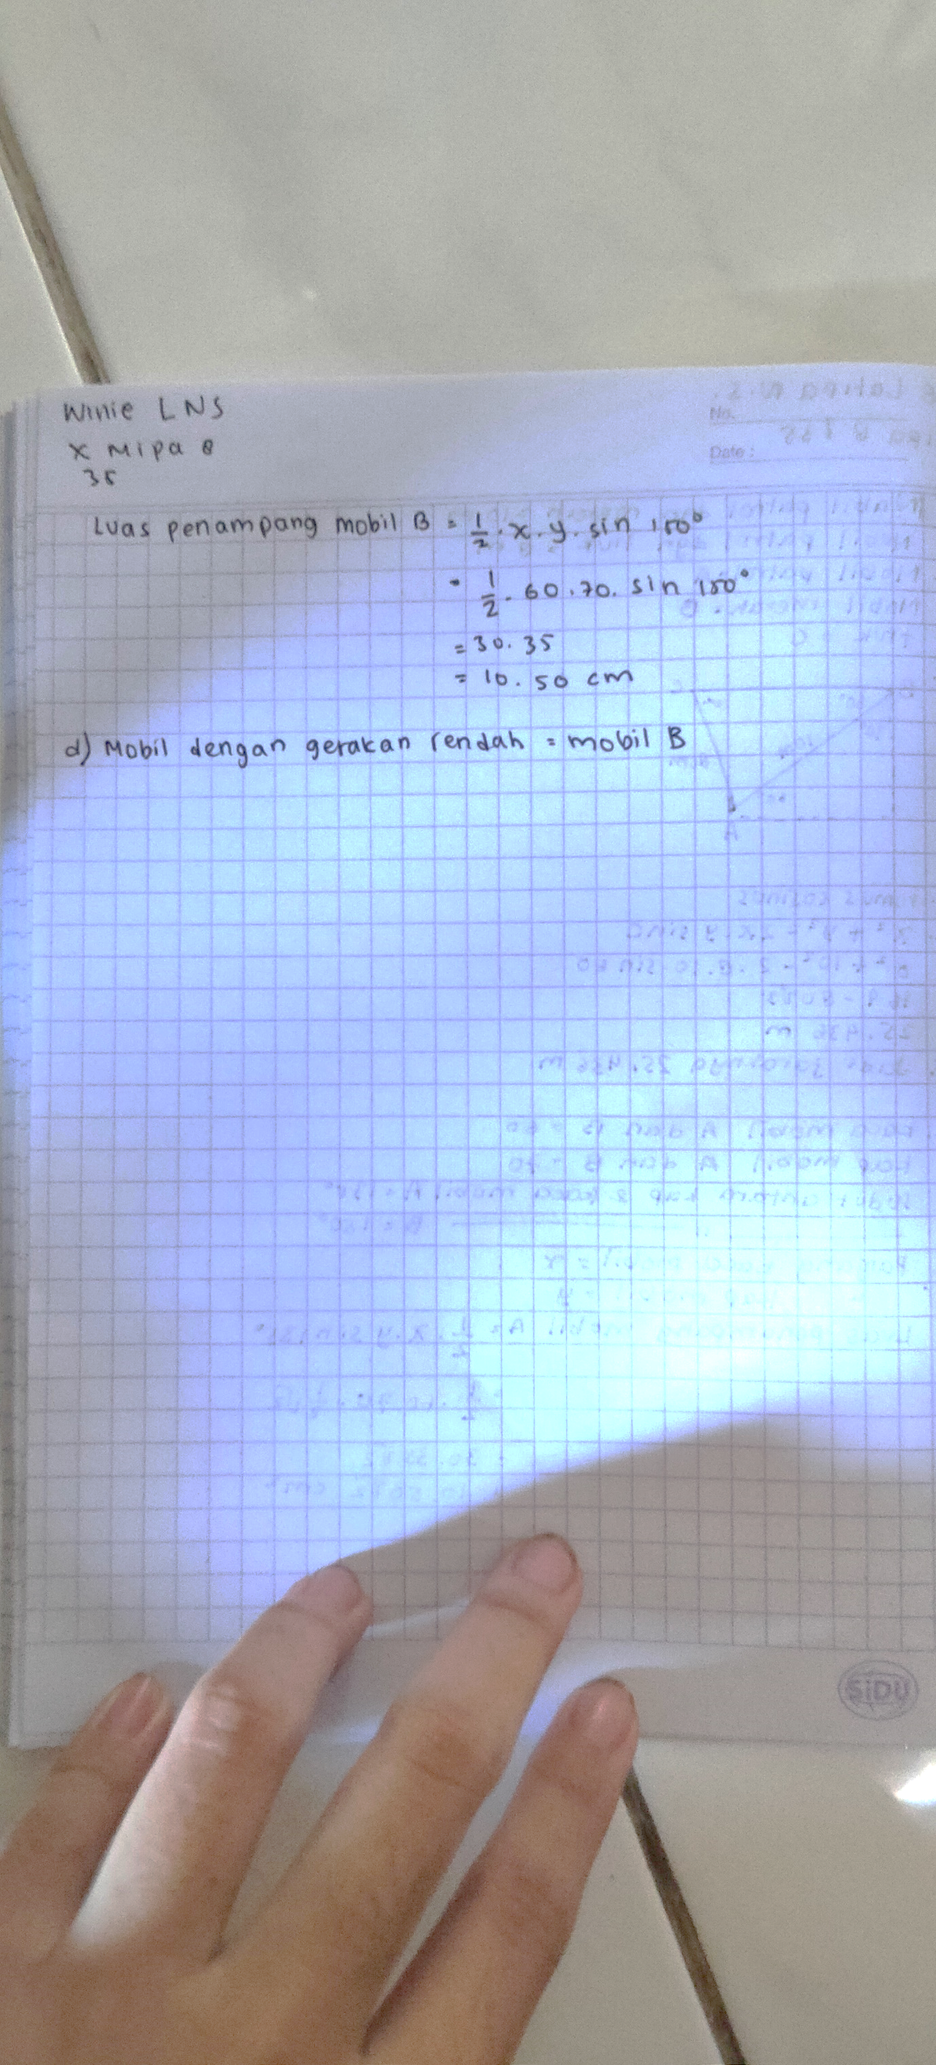
Figure 5. The first logically invalid inference
Students are asked to determine the lower air friction between two cars if the length of the windshield, the length of the hood and the angle between the hood and the windshield is known. The smaller the cross-sectional area, the lower the air friction. Students have calculated the cross-sectional area for car A and car B, but students conclude by stating that the low motion car is car B. Air movement and friction are different so that students experience errors in concluding.

3.4. Distorted theorem or definition,
Distorted theorem or definition occurs when applying a theorem or definition outside its condition, incorrectly citing a definition, theorem, rule or formula.
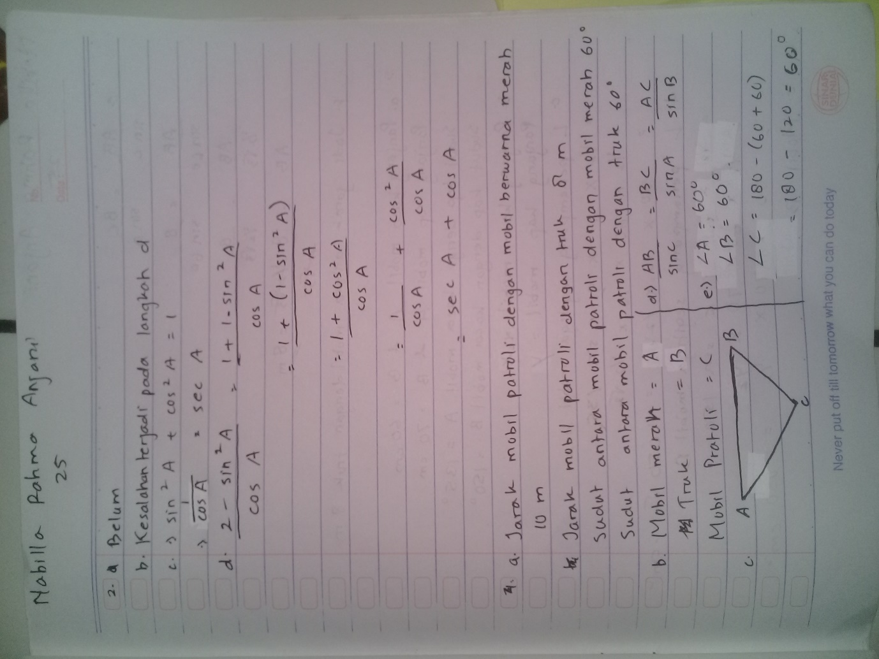
Figure 6. The first distorted theorem or definition
The problem related to Figure 6 is that students to determine the distance between the red car and the truck, if it is known that the distance between the patrol car and the red car is 10 m, the distance between the patrol car and the truck is 8 m, and the angle formed between the patrol car and the red car and the truck is 60 °. Based on information on this problem, we know that the lengths of two sides and one corner are flanked by the same two sides. If you want to determine the length of the side in front of the corner, so the student should use the cosine rule. Figure 6 shows that the student uses the sine rule, so that the student applies a theorem or definition outside its condition. Errors in using formulas are caused by students' failure to understand and describe what the questions need [16] Students make process skills error because students cannot solve problems in the algorithm so that students must be trained to solve problems based on correct, careful, detailed, and complete procedures [17]
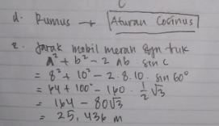
Figure 7. The second distorted theorem or definition
The student’s answer in Figure 7 part d shows that the student correctly used the cosine rule to solve the problem, but in part e the student did not write the cosine rule correctly. The students should write the distance between the red car and the truck $=a^{2}+b^{2}-2.a.b.\cos{C}$. We can say that students incorrectly citing a definition, theorem, rule or formula. The results of Siyepu's [18] study discussing error analysis show that teachers must prepare lessons to guide students when understanding and applying the constraints of rules and formulas. The difficulties of students in solving trigonometric identity problems, namely the difficulty of students applying general trigonometry formulas, difficulty describing each of the trigonometric comparison relationships, and difficulties in performing algebraic calculations/computation [19].

3.5. Unverified solution,
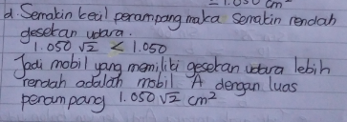
Figure 8. The unverified solution
Unverified solution occurs when error in examining the final result. The problem in Figure 8 is the same as the problem in Figure 5. Students are wrong in determining the conclusion. Because student incorrectly determining the greater value between 1050√2 and 1050. The student should state that 1050√2 is over 1050 and car B is a car that has lower air friction than car A. The impact of the error is the student incorrectly concluding the conclusive answer and claiming that car A has lower air friction.

3.6. Technical error
Technical error occurs when student error in calculation due to carelessness and error in manipulating algebraic symbol or operation.
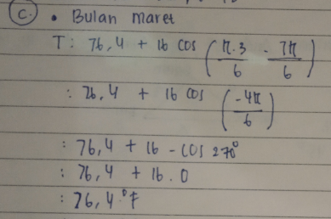
Figure 9. The first technical error
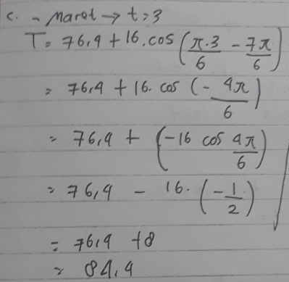
Figure 10. The second technical error
The problems in Figure 9 and Figure 10 are the same as the problems in Figure 4. The first and second lines of students’ answers in Figure 9 are correct, but on the third line, there are some errors in the conclusive answer. Students should write $\cos\left(-\frac{4π}{6}\right)=\cos{\frac{4π}{6}}=\cos{120°}$ so that the calculation on the third line becomes $76,4+16.(\cos{120°})$. The students experienced an error in calculation because of carelessness. The student error made in Figure 10 is writing $\cos\left(-\frac{4π}{6}\right)=-\left(\cos{\frac{4π}{6}}\right)$. We know that students do an error in manipulating algebraic symbols or operations. This is line with Rawley, another common error is to get the degrees-to-radians formula and the radians-to-degrees formula mixed up [15]. Schnepper add that technical errors are caused by a lack of student attention, basic math errors, or weaknesses in prerequisite skills [4].

4. Conclusion
Based on the results and discussion, the analysis of students’ error in completing trigonometry problems based on Movshovitz-Hadar, Zaslavsky, And Inbar Categories namely: (a) assigning to a given piece of information a meaning inconsistent with the text, (b) using a numerical value of one variable for another variable, (c) incorrectly copying some details from the test to the workbook, (d) designating a mathematical concept by a symbol traditionally designating another concept and operating with the symbol in its convention, (e) errors that deal with fallacious reasoning and not with specific content, (f) applying a theorem or definition outside its condition, (g) incorrectly citing a definition, theorem, rule or formula, (h) error in examining the final result, (i) error in calculation due to carelessness, (j) error in manipulating algebraic symbol or operation.

REFERENCES
[1] Permendikbud 2017 Undang-undang Republik Indonesia Nomor 3 Tahun 2017 Tentang Penilaian Hasil Belajar Oleh Pemerintah Dan Penilaian Hasil Belajar Oleh Satuan Pendidikan (Jakarta: Kementrian Pendidikan dan Kebudayaan.)
[2] Permendikbud 2016 Undang-undang Republik Indonesia Nomor 21 Tahun 2016 Tentang Standar Isi Pendidikan Dasar dan Menenga (Jakarta: Kementrian Pendidikan dan Kebudayaan)
[3] Sterling, M. J. 2014. Trigonometry for Dummies, 2nd Edition. (New Jeesey: John Wiley & Sons, Inc.)
[4] Schnepper, Lauren C. & McCoy, Leah P 2017 Analysis of Misconceptions in High School Mathematics Networks: An Online Journal for Teacher Research 15(1) 1-7
[5] Miller, Linn, Grondlund 2008 Measurement and assessment in teaching (USA: Pearson Education)
[6] Nitko, A.J, Brookhart, S.M. 2011 Educational assessment of students (Upper Saddle River: SAGE Pearson Education)
[7] Brookhart, S. M 2008 How to give effective feedback to your students. (Alexandria, VA: Association of Supervision and Curriculum Development)
[8] Newman, M. A 1977 An analysis of sixth-grade pupils’ errors on written mathematical tasks. Victorian Institute for Educational Research Bulletin, 39, 31-43.
[9] Radatz, H. 1979 Error Analysis in Mathematics Education Journal for Research in Mathematics Education, 10(3), 163-172
[10] Ahmad, H., Febryanti, Muthmainnah, Yakin, A. A., Sarbi, S 2018 The Analysis of Student Error in Solve the Problem of Spherical Trigonometry Application. J. Phys.: Conf. Ser. 1114 012114, 1-9
[11] Fahrudin, D., Mardiyana, Pramudya, I. 2019 Profile of students' errors in trigonometry equations. J. Phys.: Conf. Ser. 1188 012044 1-8
[12] Creswell, J. W. 2014 Research design: qualitative, quantitative, and mixed methods approaches (United States of America: SAGE Publications, Inc.)
[13] Sukmadinata, N. S. 2011 Metode Penelitian Pendidikan (Bandung: Remaja Rosdakarya)
[14] Movshovitz-Hadar, N., Zaslavsky, O., Inbar, S. 1987 An Empirical Classification Model for Errors in High School Mathematics Journal for Research in Mathematics Education, 18(1), 3-14.
[15] Rawley, E 2012 Trigonometry Teacher’s Edition - Common Errors (US: CK-12 Foundation)
[16] Usman, M. H. & Hussaini, M. M 2017 Analysis of Students’ Error in Learning of Trigonometry Among Senior Secondary School Students in Zaria Metropolis, Nigeria. IOSR Journal of Mathematics, 13, 1-4.
[17] Sari, R. H. Y. & Wutsqa, D. U 2019 Analysis of student’s error in resolving the Pythagoras problems J. Phys.: Conf. Ser. 1320 012056
[18] Siyepu, S. W 2015 Analysis of errors in derivatives of trigonometric functions. International Journal of STEM Education, 2 (16), 1-16
[19] Rohimah, S. M., & Prabawanto, S 2019 Student’s Difficulty Identification in Completing the Problem of Equation and Trigonometry Identities International Journal of Trends in Mathematics Education Research, 2(1), 34-36

