Identification of the Difficulties of Deaf Students in Understanding the Concept of Circles and Their Transformations in SLB Negeri 2 Bantul

Andriyani1,J L Buliali2, A Sugiyarta1,3

1Universitas Ahmad Dahlan

2Institut Teknologi Sepuluh Nopember

3SMA Muhammadiyah 3 Yogyakarta

E-mail: andriyani@mpmat.uad.ac.id

**Abstract.** Students' difficulties in understanding the concept of circles and their transformations are important issues to be resolved by starting a more in-depth study or research first, to identify and find out what difficulties deaf students have in understanding the concept of circles and their transformations. Deaf students still have great difficulty understanding the concept of circles and their transformations which are part of abstract geometry material because there is still segmentation and segregation in their educational services. The aim of this study was to identify the difficulties of deaf students in understanding the concept of circles and their transformations. This research is a mixed method research with data collection through tests, observation and semi-structured interviews. Data analysis using quantitative and qualitative analysis. The results of the d test show that the understanding of the nine students varies, where the highest score is 39, the lowest score is 18, and the average score is 29.33 for the maximum test score is 100.With the achievement of the lowest score, the highest score and the far average score. below the maximum score of the test, the understanding of the concept of circles and the transformation achieved by students is still low. From the table above, it is also known that the standard deviation value is 7.38, which means that the mean difference in the value of each student with the mean of all students (group) is low because it is less than the set KKM, which is 60.

1. Introduction

Geometry is one of the mathematics subject topics that students learn at school [1]. The concepts contained in geometry underlie all mathematical thinking [2], even more broadly, the core knowledge of geometry is said to be the universal ability of a human mind [3]. According to The National Mathematics Advisory Panel [4], geometry has an important role as a basic foundation of mathematics that supports the mastery of concepts both algebraic, number, arithmetic, and advanced mathematical concepts. More clearly, geometry contributes to the development of mathematical competencies and other cognitive abilities such as IQ [5] [6]. In line with this, Tatsuoka et al [7] said that knowledge in geometry is closely related to mathematical reasoning as well as several other mathematical concepts and skills possessed by students. For this reason, geometry is important to understand the concept of learning mathematics.

The importance of geometry is what should make geometry the focus of the mathematics curriculum at every level of education [8]. But it turns out that the significant role of geometry does not necessarily make teachers always prepare adequate provisions in mastering geometry and the teaching and learning process, even many teachers are not ready to teach geometry [9]. Teacher unpreparedness of course also has implications for the mastery of student competencies and this is very ironic considering that many students' daily lives intersect with the context of geometry. According to Andriyani & Juniati [10], geometry is a branch of mathematics that is better known to students than other branches of mathematics because students have already acquired the introduction of the basic concept of geometry in the form of indirect knowledge through their informal educational environment. Marjorie Senechal in Clements & Sarama [8] also adds that no mathematics subject is more relevant to the real world than geometry.

In the research of Gal & Linchevski [11] and Adolphus [12], it is known that students have difficulty understanding geometry topics. The failure to understand geometry is one proof of mistakes made in studying geometry [13]. Concerning geometric difficulties, circle material is one of the materials that students find difficult to understand [14]. This is reinforced by the results of the answers to PISA questions which show the difficulties of students in solving contextual circle problems [15]. Supporting this, the results of research by Timutius et al [16] on middle school students also show that there are still many difficulties and mistakes of students in solving circle problems. These errors are due to students' misunderstanding information, not solving problems systematically, and not understanding pictures (or other presentations). Not much different, students in middle school also experience some difficulties and errors when solving problems related to circle elements because some students cannot use mathematical concepts and do not know problem-solving procedures correctly [17].

The difficulties of students in middle school in understanding the concept of circles can affect understanding and problem-solve in other materials related to the concept of circles, such as transformation material, one of which is rotation. Moreover, not all students can optimize their abilities in learning, including deaf students who have limited hearing and verbal communication barriers [18]. According to Article 8, Article 9, and Article 10, Permendikbud No. 157 of 2014, curriculum content special education for deaf students is equivalent to the content of a regular education curriculum that is tailored to their specific needs so that student barriers can be minimized and the achievement of student competencies can be more optimal. This means the circle material and its transformation taught to normal children should also be taught to the deaf. With the condition of differences in the physiological structure of the deaf which sometimes still creates a negative stigma for the people, most of the educational services for deaf people still contain segmentation and are segregative. In learning certain math topics that are considered difficult to accept students with special needs and experience communication barriers, sometimes teachers have to sort certain material not to be taught and even if taught, the teacher still adopts the learning tools used by normal children. This is because it is not easy for teachers to develop a learning device that suits the needs and characteristics of students [19].

Based on survey data and information that the researcher obtained from deaf teachers and students at SLB Negeri 2 Bantul Yogyakarta, students tend to have difficulty imagining abstract concepts of geometric shapes including circles. Often the teacher has to bring a model or draw a shape on the blackboard to help students understand the concept of the shape they want to explain, but students still find it difficult to imagine. As a result, students memorize more concepts than understand them. The students' difficulties in understanding the concepts experienced by these students, then impacted on the mastery of other concepts in geometry (for example in the concept of transformation of shapes such as rotation), this is indicated by the low scores of students in each test and final semester test where around 90% of students have not achieved KKM is related to geometry materials that contain circular contexts.

Students' difficulties in understanding the concept of circles and their transformations are important issues to be resolved by starting a more in-depth study or research first, to identify and find out what difficulties deaf students have in understanding the concept of circles and their transformations. The results of the identification of difficulties in understanding are what the teacher can use later to help students overcome their difficulties and as a consideration for doing Remedial Teaching seen from the inability of students to understand during learning and the common mistakes students make in completing their learning assignments. This is in line with what was conveyed by the Departemen Pendidikan dan Kebudayaan [20], that the mistakes made by students indicate the difficulties they are experiencing.

According to Supartini in Suwarto [21], the difficulty is defined as a student's failure to achieve learning goals characterized by a minimum level of mastery, not achieving proper achievement, failure to achieve developmental tasks, and not achieving the level of mastery needed as a prerequisite for continued learning. at the next level. In line with this, Dalyono [22] defines learning difficulties as a condition that makes students unable to learn properly so that students find it difficult to accept or absorb lessons at school. Based on this definition, the learning difficulty referred to and examined in this study is a condition of the inability of SLB Negeri 2 Bantul deaf students to understand the concept of circles and their transformations.

According to Rumini in Irham & Wiyani [23], students who experience difficulties will experience certain obstacles in following the learning process and cannot achieve optimal learning outcomes. Furthermore, in the OECD [24] it is also stated that students who experience various difficulties ranging from comprehension, oral and written use, thinking, speaking, reading, writing, and mathematical operations allow critical gaps between student potential and progress. The difficulties experienced by students in learning mathematics material are possible because students find it difficult to learn the material [25]

According to Lerner [26], students who experience difficulties in mathematics have certain characteristics, namely difficulties in processing information, difficulties related to language and reading skills, and mathematics anxiety. Furthermore, the WGHB Misunderstood Minds Educational Foundation [27] classifies signs of difficulty that can be seen in students, including output difficulties, organizational difficulties, difficulties in language, difficulties in paying attention, visual-spatial difficulties or sorting, and the difficulty of doing multiple tasks at the same time. Meanwhile, according to Cooney, Davis, & Henderson [28], students' math learning difficulties are grouped based on two types of mathematical knowledge, namely conceptual knowledge and principle knowledge, which are then expanded again when solving problems so that the group has difficulty solving problems verbally. So, if students show one of these characteristics or signs in the learning process, it can be believed that students have difficulty learning.

Based on the problems experienced by students with hearing impairments at SLB Negeri 2 Bantul in learning circles and their transformations as well as some of the characteristics of learning difficulties they experience, it is deemed necessary and important to conduct an in-depth study of the difficulties experienced by deaf students. So that the formulation of the problem studied in this study is how difficult the students with hearing impairment in SLB Negeri 2 Bantul understand the concept of circles and their transformations.

1. Method

This research is mixed research with quantitative and qualitative approaches. The subjects in this study were 9 deaf students at SLB Negeri 2 Bantul who had studied circle material and its transformations but had difficulty understanding these geometric concepts. Students who have difficulty understanding the concept are students who get the KKM score on geometry material of less than 60. Besides that, input from the mathematics subject teacher is also considered.

The procedure of this research is firstly carried out by collecting data about the achievement of the student's KKM geometry through the examination of documentation and interviews with mathematics subject teachers. Students who experience difficulties are then given an understanding test which contains 7 (seven) indicators of understanding following the indicators of understanding conveyed [29]. The next step is the researcher interviews and observes student behavior during the test to confirm students' answers who are considered to still need further exploration for researchers

The research data were obtained through tests, observation, and semi-structured interviews. The instrument used to analyze students' difficulties in understanding the concept is an understanding test that contains seven indicators, namely interpretation, giving examples, grouping, summary, proof, comparison. The instruments used to confirm students' difficulties in understanding the concepts were observation guidelines and interview guidelines.

Analysis of research data was carried out during and after data collection so that the data obtained were systematically structured and easier to interpret according to the formulation of the problem. The steps of analyzing and interpreting data were carried out in the following stages: (1) collecting and formulating all data obtained from the field, (2) analyzing students' difficulties in understanding the concepts on each item of the question, and overall, (3) drawing conclusions.

1. Result and Discussion

The data obtained in this study consisted of two types, namely quantitative data and qualitative data. The data analysis used was quantitative data analysis carried out by checking students' answers and continued by scoring the test answers. Student test results are categorized according to the understanding aspect, then the average value of students' understanding is looked for in each aspect of understanding. Qualitative data analysis was carried out through descriptive analysis to explore students' difficulties in understanding the concept of circles and their transformations based on seven aspects of understanding that were adapted to the content of the cognitive process of understanding according to Anderson & Krathwohl.

Based on the results of the students' understanding test at SLB Negeri 2 Bantul, it was found that the average understanding of students in every aspect of understanding was as follows: 41.18 for the average value of understanding in the interpretation aspect; 27.78 for the mean score of understanding in the sampling aspect; 33.33 for the average score of understanding on the aspect of grouping; 16.67 for the mean score of understanding in the aspect of summarization; 41.98 for the average score of understanding in the aspect of explanation; 7.41 for the mean score of understanding in the inference aspect; and 49.63 for the mean score of understanding in the aspect of comparison. The description of the achievement of students' understanding in each of these aspects can be seen in the diagram of the results of the student understanding test as illustrated in Figure 1 and table 1 below.

**Figure 1**. The Results of Understanding of Deft Students in SLB Negeri 2 Bantul

The illustration of the bar chart in Figure 1. above shows that the average understanding score for the comparison aspect is the student's highest understanding achievement, while the average understanding score for the explanation aspect is the student's lowest understanding achievement. This shows that students are better able to detect the relationship between two circular and non-circular objects that undergo transformation based on similarities or differences, rather than abstracting the concept of circles and their transformations based on certain patterns from a series of examples given. This is in line with the opinion of Anderspn & Krathwohl [29], which states that a person is said to conclude that he is able to abstract existing concepts or principles, including abstracting pattern discovery from a series of examples. Meanwhile, someone is said to compare if he is able to detect the relationship between two or more objects, events, problems or situations, both similarities and differences.

From the diagram above it is also known that the average value of understanding in each aspect is less than 50. This shows that the ability of students to understand in terms of the content of the cognitive process of interpreting, giving examples, classifying, summarizing, explaining, concluding and comparing has still not reached the criteria. Minimum skills that must be obtained by students in every aspect, namely 60.

**Table 1**. Average Value, Standard Deviation, Highest Value, Lowest Value of 9 Students at SLB Negeri 2 Bantul

|  |  |  |
| --- | --- | --- |
| No | Statistic | Value |
| 1 | Respondent (N) | 9 |
| 2 | Test Ideal Value | 100 |
| 3 | Highest Value | 39 |
| 4 | Lowest Value | 18 |
| 5 | Average | 29,33 |
| 6 | Standard Deviation | 7,38 |

Table 1 above shows that the results of the nine students' comprehension tests vary, where the highest score is 39, the lowest score is 18, and the average score is 29.33 for the maximum test score is 100.With the achievement of the lowest score, the highest score and average -The average is far below the maximum score of the test, the understanding of the concept of circles and the transformation achieved by students is still low. From the table above, it is also known that the standard deviation value is 7.38, which means that the average difference in the value of each student with the mean of all students (his group) is low. The low achievement of each aspect of understanding will be identified through exploration with observation and semi-structured interviews to find out the mistakes made by students when answering test questions. From this error, the difficulties experienced by students will be determined in understanding the concept of circles and their transformations.

After analyzing the results of the test results for understanding the concept of circles and their transformations, the researcher conducted an analysis of students' difficulties based on errors when answering test questions containing seven aspects of understanding involving several cognitive processes as presented by Anderson & Krathwohl [29], namely: interpreting, exemplifying, classifying, summarizing, explaining, infering and comparing. Researchers also explored the reasons students could answer questions correctly, as comparative and supporting information for the analysis. Based on written answers, observations and explanations in interviews with students, the identification of students' difficulties in understanding the concept of circles and their transformations is described according to the classification of aspects of understanding presented below.

2.1. Difficulties of Interpreting

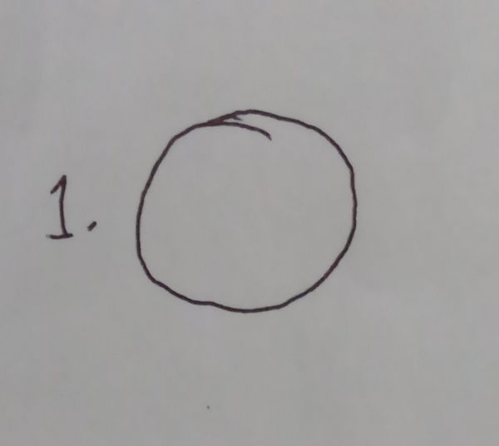 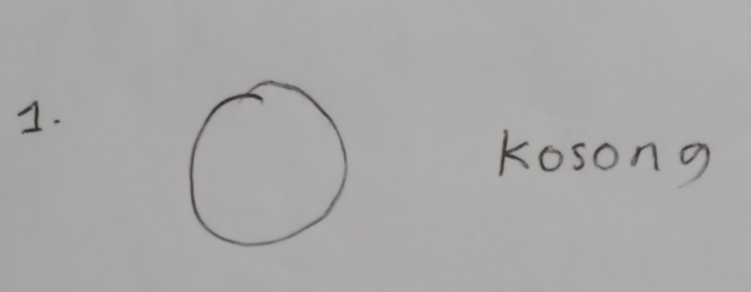

(a) (b)

**Figure 2 (a) – (b).** Students Illustrate Circles

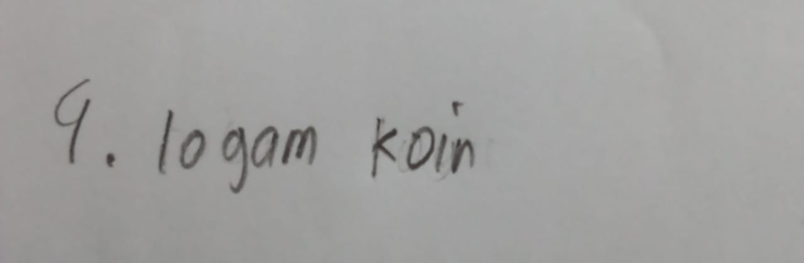 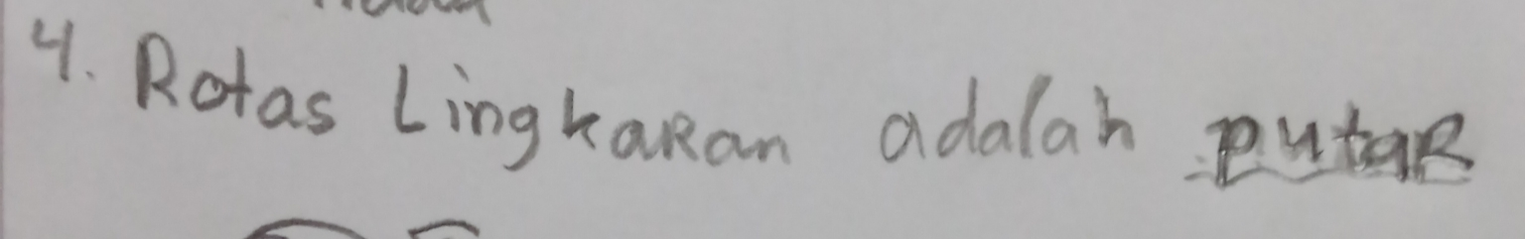

(a) (b)

**Figure 3 (a) – (b).** Students Do Not Understand the Concept of Rotation

On figure. 2(a) it is known that students interpret information from one form of written representation about a circle into another form, namely drawing a circle shape correctly. In addition, students also interpreted circles as a form which means empty, as shown in Figure 2(b). Here the students interpreted the circle by using meaningless attributes that could not be used to construct the meaning of a circle. These two pictures show that students can change information from one form of written representation to just a picture, but cannot interpret the abstract concept of a circle as a characteristic of mathematical object properties. This is in line with the opinion of Anderson & Krathwohl [29] regarding the achievement of aspects of interpretation in an understanding.

In Figure 3(a) it is known that students cannot interpret the abstract concept of rotation, they instead mention the name of the object in the rotating problem, namely a metal coin. In addition, there are 3 out of 9 students who have been able to interpret rotation as rotation even though they cannot represent the details of the intended rotation as shown in the picture. 3(b). Others, there are many students who cannot answer the meaning of rotation. This shows that students have not been able to change information from one form of written representation to another, especially the abstract concept of wake rotation as a characteristic of mathematical object properties. This interpretation achievement indicator is in line with the opinion of Anderson & Krathwohl [29] regarding the cognitive process of interpreting an understanding.

2.2. Difficulties of Exemplifying

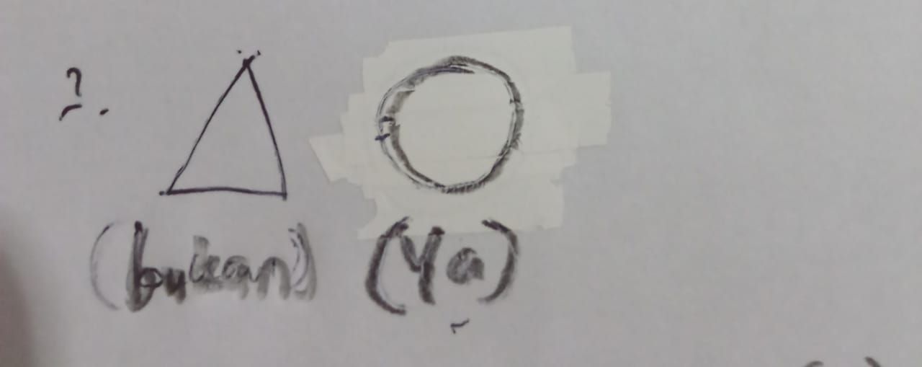

**Figure 4.** Students can only provide one example circle and one example not a circle

On figure. 4 note that students can only give one example of a circle and one example is not a circle. Other students actually looked confused about being able to give an example instead of an example, so that 6 out of 9 students chose not to answer. This shows that students have not been able to provide specific examples of a certain concept through identifying the characteristics of the concept to select / construct a specific example. This sampling achievement indicator is in line with the opinion of Anderson & Krathwohl [29] regarding the cognitive process of exemplifying in an understanding.

2.3. Difficulties of Classifying

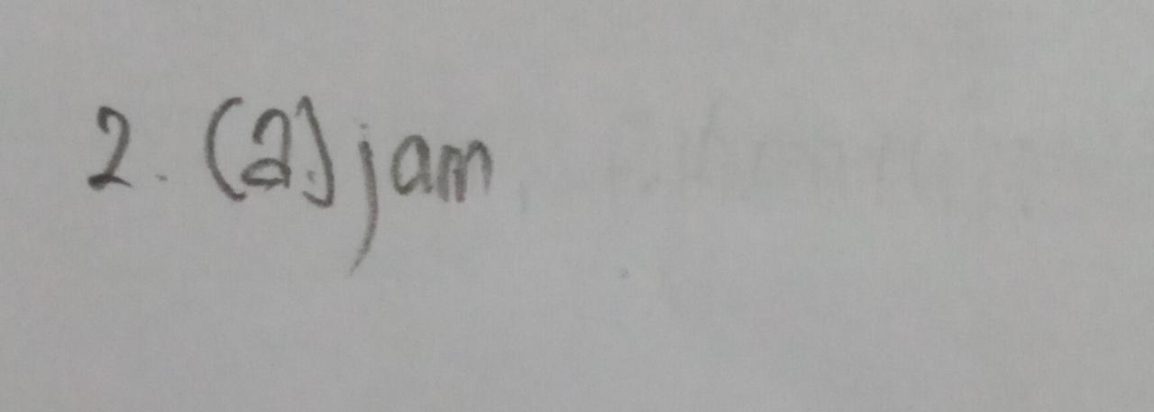 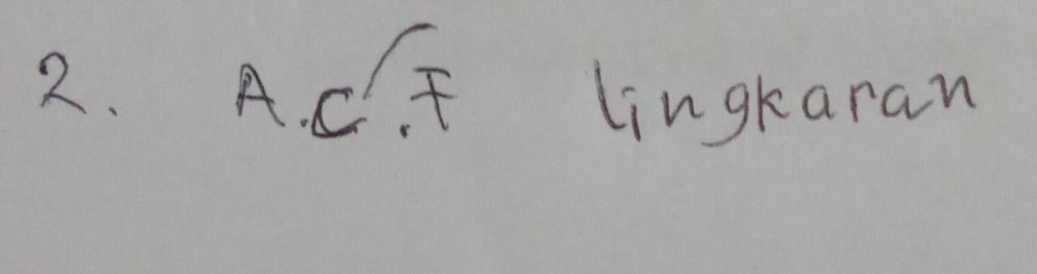

(a) (b)

**Figure 5 (a) – (b).** Some students only group one type of object

On figure. 5(a) it is known that some students only group one type of object which is included in a circle and one type of object that is not a circle, while some other students only group objects that are included as a circle without grouping objects that are not included as a circle as in the figure 5(b). This shows that students have not been able to fully define all objects into certain categories / concepts. The achievement indicator of this grouping is in line with the opinion of Anderson & Krathwohl [29] regarding the cognitive process of classifying into an understanding.

2.4. Difficulties of Summarizing

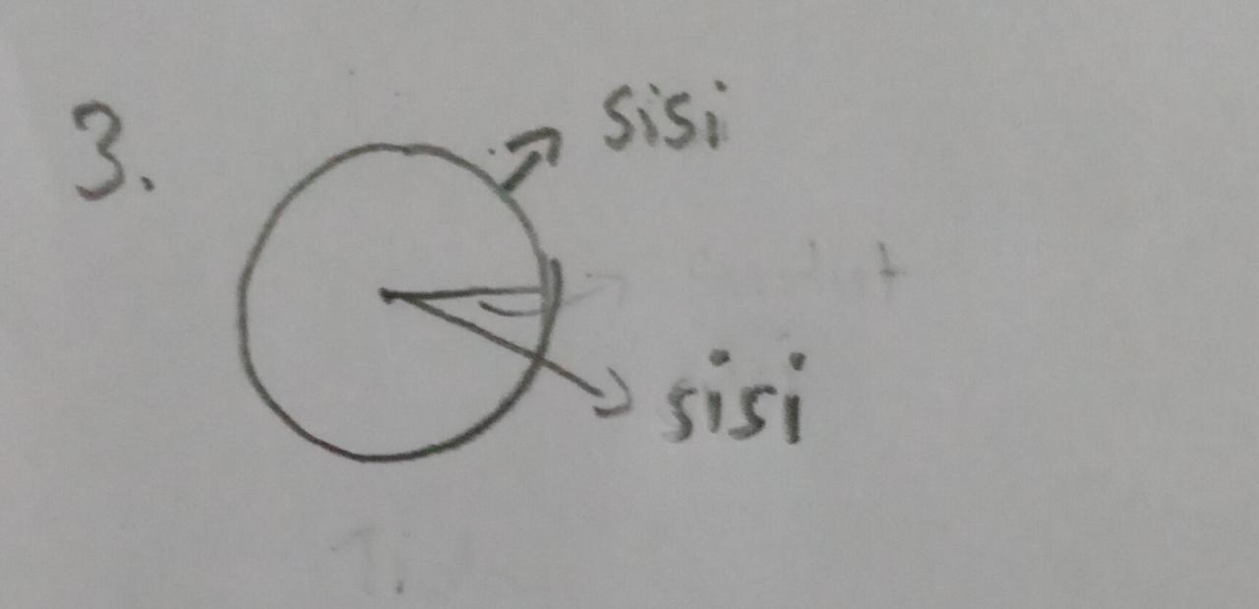

**Figure 6.** Students can only name part of the attribute circle

On figure. 6 it is known that students can only mention part of the attribute circle without explaining how the routine attribute is, namely the side. Meanwhile, some other students could not put forward what the elements of the circle were based on the references given by the teacher. When asked more deeply, they conveyed that they were still confused and forgot. This shows that students cannot present the information presented in a concise sentence structure. This summary performance indicator is in line with Anderson & Krathwohl's [29] opinion regarding the cognitive process of summarizing in an understanding.

2.5. Difficulties of Inferring

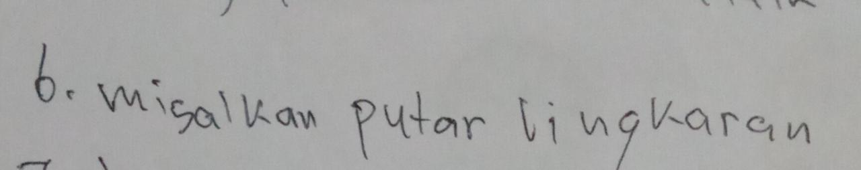

**Figure 7.** Students only pay attention and determine one rotation process / circle rotation only

On figure. 7 it is known that students only pay attention and determine one rotation process / circle rotation only, while a series of other processes of repeated rotation of a circle with different rotation directions are ignored. So that the pattern from a series of examples of the circular rotation process and the spherical shell is not well abstracted. This shows that students have not been able to abstract existing concepts through finding patterns from a series of examples / events. This conclusion achievement indicator is in line with the opinion of Anderson & Krathwohl [29] regarding the cognitive process inferring in an understanding.

2.6. Difficulty Comparing

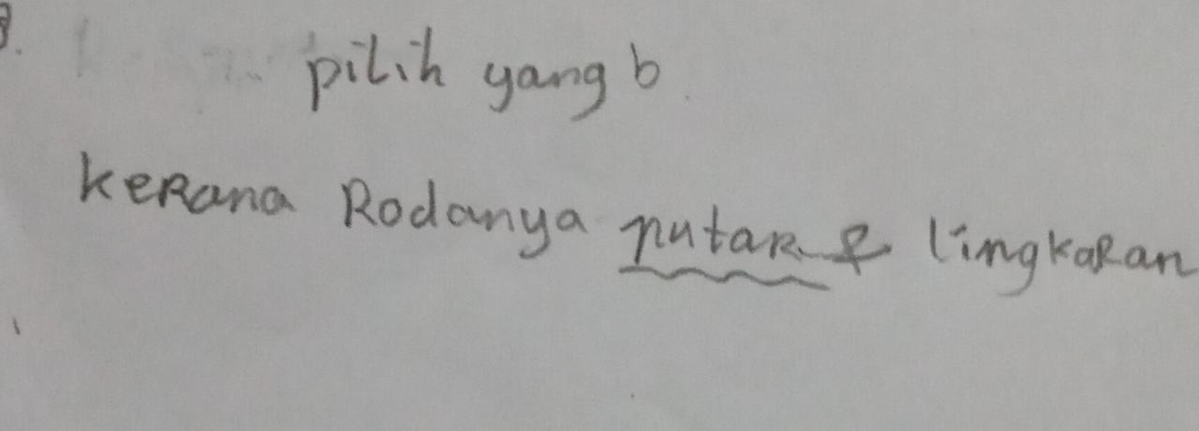 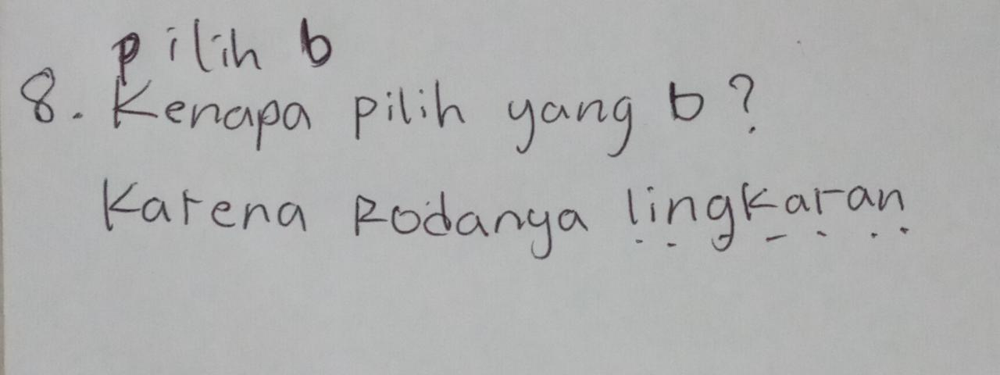

(a) (b)

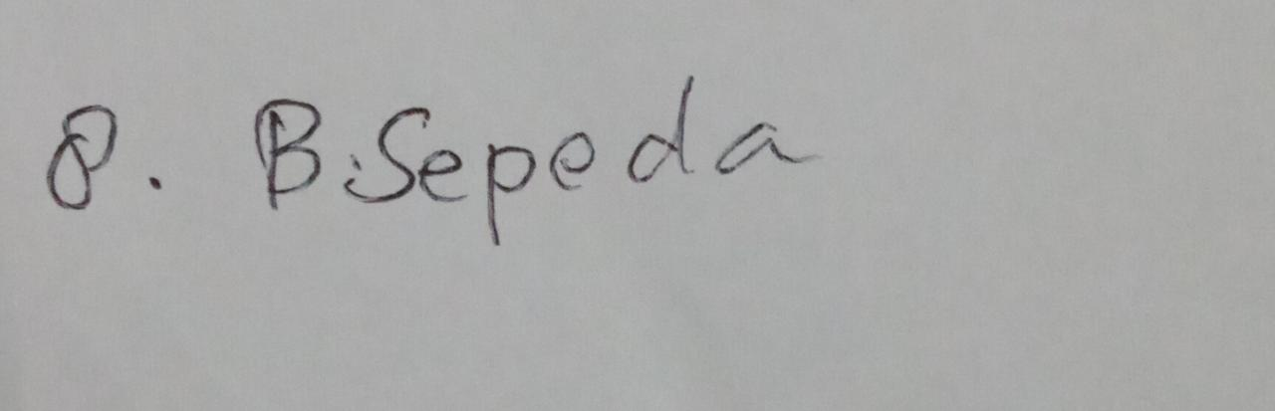

(c)

**Figure 8 (a) – (c).** Students can choose exactly which object can rotate well

On figure. 8(a) shows that students can choose exactly which object can rotate well, by relating the reason to the shape of the circle and its transformation. However, in Figure 8(b). It is also known that students explain the reasons for selecting objects because of the shape of the object parts associated with the circle. Whereas in Figure 8(c). students seem that students can only choose exactly which object rotates well without being able to explain why. From the three images, it is known that most students can detect the relationship between two objects based on their similarities and differences so that students can choose exactly which objects can rotate well. This comparison performance indicator is in line with Anderson & Krathwohl's [29] opinion regarding the cognitive process of comparing in an understanding.

2.7. Difficulty Explaining

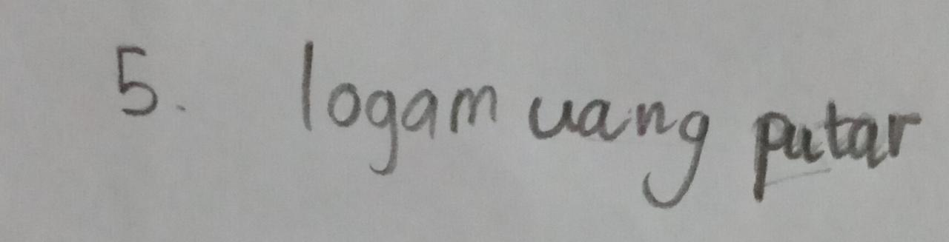 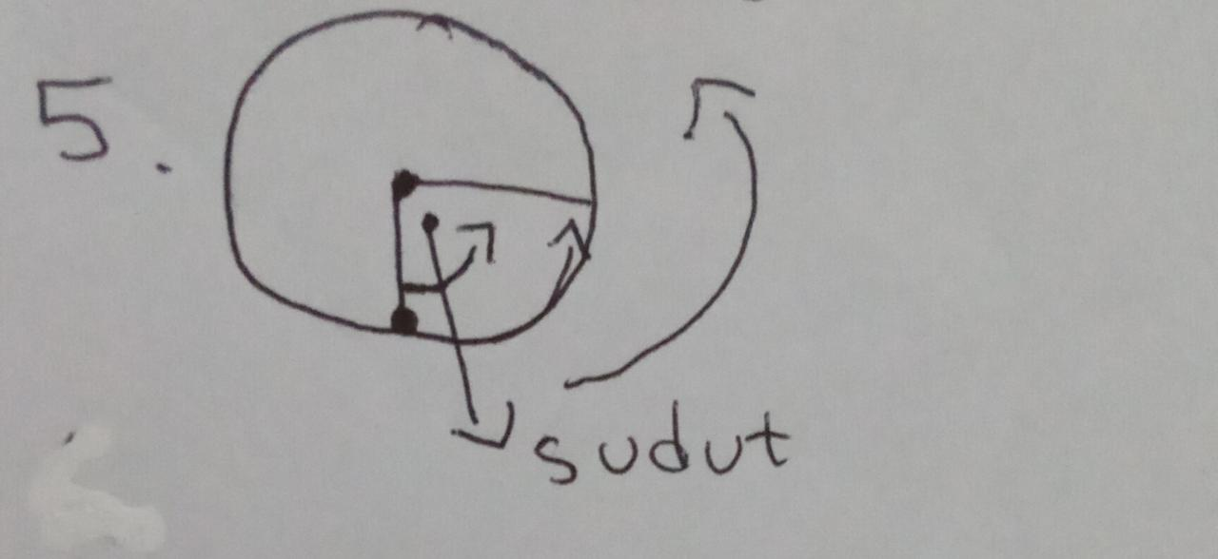

(a) (b)

**Figure 9 (a) – (b).** Students have not been able to explain the angle of rotation in a circle

On figure. 9(a) shows that students have not been able to explain the angle of rotation in a circle based on the causality relationship, students actually reiterate what happened to the circular object in the question, in this case a coin. Whereas in Figure 9(b), it can be seen that there are students who explain the angle of rotation in a circle by depicting a coin with a circle shape and an angle of a certain size and having a certain direction of rotation. The two pictures show that there are students who can make a cause-and-effect relationship in a circle model to explain the angle of rotation even though not in detail. This comparison performance indicator is in line with Anderson & Krathwohl's [29] opinion regarding the cognitive process of explaining in an understanding.

Based on the analysis of the results of the comprehension tests, observations and interviews above, information was obtained related to the high difficulty of students in understanding the concept of circles and their transformations which involve interpreting, giving certain examples, classifying, summarizing, concluding, comparing and explaining activities caused by their misconceptions of the concept. the base of the circle and its transformation. This misconception of the concept as the basic object of mathematics causes students to fail to be able to relate one concept to another. In other words, students 'misconceptions about the basic concepts of geometry have implications for students' misconceptions about the use of geometric principles because of the hierarchical nature of mathematics learning. If examined more deeply, this is in accordance with the main difficulties experienced by students when studying geometry, namely misconceptions of geometric concepts and principles [13] [30].

Reviewing the results of the analysis of the seven aspects of student understanding, it was found that although the achievement of each aspect of students' understanding was low, they had good abilities in the aspect of comparing which required good abilities to detect the relationship between several objects being compared. Likewise, with the aspects of interpreting and explaining which require the ability to change information from one form of representation and make causal relationships in a model. The average achievement of these three aspects is 44.26. The achievement of these three aspects of understanding is inversely proportional to the achievement of the aspects of concluding, summarizing, categorizing and exemplifying. The average achievement of the four aspects of understanding is 21.30 or less than half of the achievements of the other three aspects of understanding.

From the results of interviews with students, it was found that so far students only used textbooks that contained a collection of formal definitions and circle formulas, so that students had the wrong perspective and chose to memorize due to their failure to understand these abstract concepts. In addition, student disabilities and teacher limitations are the reasons for teachers not to teach the concept of rotation to students who feel learning difficulties. This is like the affirmation of Cooney [31] which states that the main cause of student learning difficulties is pedagogical factors related to student readiness to learn. Furthermore, and Bell [32] also added the importance of understanding mathematics teachers towards theories relating to how students learn and think so that these theories can be applied in their respective classes.

1. Conclusion

Based on the results of students' understanding tests, it was found that the average understanding of students on aspects interpretation 41.18; the sampling aspect 27.78; grouping aspects 33,33; summary aspects 16.67; aspect of explanation 41,98; inference aspect 7,41; and aspect comparison 49.63. From these results, it can be concluded that the achievement of all aspects is less than 50, even though the Minimum Proficiency Criteria that must be obtained in each aspect is 60. However, from these results, it is found that the aspect of comparison is the highest aspect, namely 49.63 while the lowest aspect is 7, 41. This shows that students are better able to detect the relationship between two circular and non-circular objects that undergo transformation based on similarities or differences they have, rather than abstracting the concept of circles and their transformations based on certain patterns from a series of examples given. Apart from the comparative aspect, other aspects were obtained low. This is because students have not been able to interpret what they have obtained previously, such as interpreting circles with using meaningless attributes that cannot be used to construct the meaning of a circle. Then the difficulty aspect provides examples, this is because students have not been able to provide specific examples of a certain concept through identifying the characteristics of the concept to select / construct a specific example. Furthermore, for the grouping aspect, this is because the students are not completely could define all objects into a particular category / concept. Then summarizing the aspect, this is becausecannot present the information presented in a concise sentence structure. Furthermore, the difficulty aspect concludes, this is because students cannot abstract existing concepts through finding patterns from a series of examples / events. And then the difficulty aspect explains, this is because students who are can make a cause-effect relationship in a circular model to explain the angle of rotation, although not in detail.

Based on the analysis of the results of comprehension tests, observations and interviews, the high difficulty of students in understanding the concept of circles and their transformations. So that there is a misconception of the concept as the basic object of mathematics, causing students to fail to be able to connect one concept to another. The results of the analysis of the seven aspects of student understanding, it was found that although the achievement of each aspect of students' understanding was low, they had good abilities in the aspect of comparing. In addition, the interpreting and explaining aspects require the ability to change information from one form of representation and make causal relationships in a model. And the achievement of these three aspects of understanding is inversely proportional to the achievement of the aspects of concluding, summarizing, categorizing and exemplifying. Based on the results of interviews with students, it was found that so far students only used textbooks containing a collection of formal definitions and circle formulas, so that students had the wrong perspective and chose to memorize due to their failure to understand these abstract concepts. In addition, student disabilities and teacher limitations are the reasons for teachers not to teach the concept of rotation to students who feel learning difficulties.

**Acknowledgments**

The research team thank you very much to the Indonesian Ministry of Research, Technology and Higher Education who have been provided grant funds to fund this research. Furthermore, all members of the community academics at Universitas Ahmad Dahlan and Institut Teknologi Sepuluh Nopember who have been part of this research, both as research observers, interviewer and granting permission to conduct research.

References

[1] Hidayati V R., Subanji, Sisworo. 2020. Students' Mathematical Connection Error in Solving PISA Circle Problem. JurnalIlmiahPendidikanMatematika. 8 (2). 76-84

[2] Bronowski,J. 1947. Mathematics.In D. Thomson&J. Reeves (Eds.) The Quality of Education: Methods and Purposes in The Secondary Curriculum. London: Frederick Muller.

[3] Dehaene,S., Izard, V., Pica, P.,&Spelke, E S.2006. Core Knowledge of Geometry in an Amazonian Indigene Group. Science, 311, 381-384.

[4] The National Mathematics Advisory Panel.2008. Foundations for success: Thefinal report of the national mathematicsadvisory panel. Washington, DC.:Department of Education, Office ofPlaning. Evaluation and PolicyDevelopment.

[5] Clements, D.H.,&Battista, M.T.1992. Geometry and Spasial Reasoning. In D.A. Grouws (Ed.) Handbook of Research on Mathematics Teaching and Learning. New York: Macmillan.

[6] Clements, D.H.&Sarama,J. 2007. Early Childhood Mathematics Learning. In F.K.Lester Jr (Ed.) Second Handbook of Research on Mathematics Teaching and Learning. Ney York: Information Age Publishing

[7] Tatsuoka, K.K., Corter, J.E.&Tatsuoka, C. 2004. Patterns of Diagnosed Mathematical Content and Process Skills in TIMSS-R Across a Sample of 20 Countries. American Educational Research Journal. 41. 901-926.

[8] Clements, D. H., &Sarama, J. (2011). Earlychildhood teacher education: The case ofgeometry. Journal of MathematicsTeacher Education, 14(2), 133–148.

[9] Jones, K., Mooney, C.,&Harries, T. 2002. Trainee Primary Teachers' Knowledge of Geometry for Teaching. Proceedings of the British Society for Research into Learning Mathematics. 22(2). 95-100

[10] Andriyani&Juniati, D.2019. The Investigation of Blind Students’ Misconception in Constructing Quadrilateral Analytic Definition UsingGeometry’s Puzzle. Journal of Physics: Conference Series. 1417.012059

[11] Gal, H., &Linchevski, L. 2010. To see or not to see: analyzing difficulties in geometry from theperspective of visual perception. Educational Studies in Mathematics, 74(2), 163–183.

[12] Adolphus, T. 2011. Problems of teaching and learning of geometry in secondary schools inRivers State, Nigeria. International Journal of Emerging Sciences, 1(2), 143–152.

[13] Özerem, A. 2012. Misconceptions in geometryand suggested solutions for seventh gradestudents. Procedia - Social andBehavioral Sciences, 55, 720–729.

[14] Fabiyi, T. R. 2017. Geometry Concepts in Mathematics Perceived Difficult To Learn By SeniorSecondary School Students in Ekiti State, Nigeria. IOSR Journal of Research & Method inEducation (IOSRJRME), 07(01), 83–90.

[15] Hidayati, V. R., Subanji, &Sisworo. (2017). Analisis Kesalahan Siswa SMP dalam Menyelesaikan Masalah Matematika PISA pada Tahapan Penyelesaian Blum-Leiss. Prosiding Seminar Nasional Pendidikan Matematika, 108–119. Malang: Program Studi Pendidikan Matematika Pascasarjana Universitas Negeri Malang.

[16] Timutius, F., Apriliani, N. R., & Bernard, M. 2018. Analisis Kesalahan Siswa Kelas IX – G Di SMP Negeri 3 Cimahi Dalam Menyelesaikan Soal Pemecahan Masalah Matematik Pada Materi Lingkaran. Jurnal Pembelajaran Matematika Inovatif, 1(3), 305–312.

[17] Apriliawan, A., Gembong, S., & Sanusi, S. 2013. Analisis Kesalahan Penyelesaian Soal Uraian Matematika Siswa MTs pada Pokok Bahasan Unsur-Unsur Lingkaran. JIPM (Jurnal Ilmiah Pendidikan Matematika), 1(2). 120-127.

[18] Sulisworo, D. 2020. Praktik Pembelajaran Online Era Covid-19. Yogyakarta: CV Markumi

[19] Andriyani, Karim, & Fahmi, S. 2020. The development of a Braille geometrymodule based on visual impairment students synthetic touch ability with RMT approach. AIP Conference Proceedings. 2215.060001.

[20] Departemen Pendidikan dan Kebudayaan. 2012. Model kurikulum tingkat satuan pendidikan dan model pengembangan silabus mata pelajaran SMP/MTs. Jakarta: BP Cipta Jaya.

[21] Suwarto. 2013. Pengembangan tes diagnostic dalam pembelajaran. Yogyakarta: Pustaka Pelajar.

[22] Dalyono. 2009. Psikologi Pendidikan. Semarang: PT. Rineka Cipta.

[23] Irham, M., & Wiyani, N, A. 2013. Psikologi Pendidikan: Teori dan Aplikasi dalam Proses Pembelajaran. Yogyakarta: Ar-ruz Media.

[24] OECD. 2009. Student with disabilities, learning difficulties and disadvantages inthe baltic states, south eastern europe andmalta. London: European commissionjoint research centre (JRC).

[25] Azis & Sugiman. 2015. Analisis Kesulitan Kognitif dan Masalah Afektif Siswa SMA dalam Belajar Matematika Menghadapi Ujian Nasional. Jurnal Riset Pendidikan Matematika. 2(2). 162-174.

[26] Lerner, J.W. 2006. Learning disabilities andrelated disorders. New York: HoughtonMifflin Company.

[27] Kereh, C. T., Sabadar, J., & Tjiang, P. C.2013. Identifikasi kesulitan belajarmaha siswa dalam konten matematika pada materi pendahuluan fisika inti. Proceedings of Seminar Nasional Sains dan Pendidikan Sains VIII. 4. 10-17.

[28] Cooney, T. J., Davis, E. J., & Henderson, K. B.1975. Dynamics of teaching secondary school mathematics. New York:Houghton Miffin.

[29] Anderson, L.W. & Krathwohl.2001. A Taxonomi for Learning, Teaching, and Assessing: A Revision of Bloom’s Taxonomy of Educational Objectives. New York: Addison Wesley Longman, Inc.

[30] Kabaca, T., Karadag, Z., &Aktumen, M. 2011. Misconception, cognitive conflict and conceptual changes in geometry: a case study with pre-service teachers. Mevlana International Journal of Education (MIJE), 1(2), 44–55

[31] Cooney, T. J., Davis, E. J., & Henderson, K. B. (1975). Dinamics of teaching secondary school mathematics. Boston: Houghton Mifflin Company.

[32] Bell, F. H. (1978). Teaching and learning mathematics (In Secondary Schools). Washington: The Mathematics Assosiation of America and Nation Council of Teachers Mathematics.