Self-assessment in self-regulated learning: a literature review

**D Rahmawati 1, H Retnawati 2**

1Graduate Program of Mathematics Education, Universitas Negeri Yogyakarta, Yogyakarta, Indonesia

2Department of Mathematics Education, Universitas Negeri Yogyakarta, Yogyakarta, Indonesia

E-mail: dianaqquarahma23@gmail.com

**Abstract.** Self-assessment is one of formative assessment used in assess student outcome in learning process. Self-assessment is used as a tool in self-regulated learning to optimize the meaning of “assessment as learning”. This study aims to describe the relationship between self-assessment and self-regulated learning and how the implementation of both topics on learning mathematics at senior high school or undergraduate level. A total 12 studies related to self-assessment, self-regulated learning and mathematics were included from different location and range between 2009 to 2018. The result shows that the relationship between self-assessment and self-regulated learning are reciprocal relationship that are inseparable one another. Self-assessment gives positive effects in enhance students’ self-regulation, self-efficacy and performance in self-regulated learning at mathematics course. Self-regulated learning need self-assessment to optimize the outcome of learning.

1. Introduction

Assessment are used to investigate what people *know* and *can do* and to make decision regarding whether they learned what was expected [1]. Assessment always connected to learning theory, assess theory, assess design and outcome in the cycle of learning process. Assessment for learning used assessment just for assess students’ outcome. It can’t represent the students’ point of view. [2–4] illustrates and show students’ difficulties in learning mathematics in teachers’ and researchers’ point of view but not yet describe from student. Assessment as learning overcome those obstacles by making assessment as part of the learning process itself.

Over last two decades, self-assessment, as one of formative assessment used in assess student outcome in learning process, still received attention from mathematics education researchers and practitioners. Self-assessment is an assessment that help teachers assess not only students’ products learning (or outcomes) but also their learning process and behavior [5]. [6] Brown and Harris state that self-assessment is an evaluation of a student’s own work products and processes in classroom settings, [7] rather than relying on their teacher as the sole source of evaluative judgements.

There are many studies that reveal the effects of using self-assessment to learning process and students’ skill [8–12] and how self-assessment can help teachers to improve their reflective learning [5]. The teachers give positive response to using self-assessment in assess the learning process in classroom. They believe that self-assessment can improve students’ progress in the teaching and learning process [13]. But the effectiveness of self-assessment to assess students’ process can be influenced by many factors. The usefulness of self-assessment for decision-making seems to depend, in part, upon whether the student can accurately or realistically judge the qualities of their own work [6]. Beside, students are reluctant to assess their own self because lack of confidence to judge their own work [14].

Nowadays the implementation of self-assessment as an assessment in learning process widely integrated with self-regulated learning (SRL). The reason is because the use of assessment not just to assess learning (*assessment for learning*) but can also be used as a form of learning itself (*assessment as learning*). Using assessment as learning can guide students to improve their reflective process in classroom. [15] state that self-assessment, as formative assessment, and self-regulated learning are two pillars of educational research. The integration of this two allows students to develop themselves more optimally by understanding their process and outcome and managing their strength and weakness in learning independently.

Self-regulation is an active learning process that may include setting learning goals and determining the approaches and resources required to achieve these goals, as well as reacting to feedback so as to enhance the final outcomes [16]. Self-regulation is a cyclical process because the input of the initial capabilities is used to make decisions to repeat the efforts that have been made [17–19]. Zimmerman [15] define self-regulated learning is the study of how and when learners set goals and then systematically carry out cognitive, affective, and behavioural practices and procedures that move them closer to those goals. Self-regulated learning is a conscious condition or initiative of an individual to learn, set learning goals and methods or learning strategies and to do reflection or self-evaluation in learning activities [20]. In simply term, self-regulated learning is the ability to manage themselves in the study [18].

The implementation of self-assessment in self-regulated learning provoke many questions about what and how self-assessment in self-regulated learning help students enhance their outcomes and optimize their learning process. In self-regulated learning paying attention to three phases, that are cognition, performance control and self-reflection, so the teachers might contribute to give learning activities that are implemented both inside and outside the classroom and through the provision of tasks [19]. The cognition phases related to task analysis and self-motivation conviction. The performance control phases include self-control and self-observation. Lastly, the self-reflection phases consist of self-consideration and self-reaction [18].

For self-regulated learning to be equally adaptive and effective, students should be able to accurately monitor and assess their own performance and recognize what an appropriate next task would be [8]. The relationship between self-assessment and self-regulated learning are reciprocal relationship that are inseparable one another. This study will describe how the implementation of self-assessment in self-regulated learning and what effects does it have on learning mathematics.

1. Method

Method used in this study is analyze articles related to self-assessment and self-regulated learning in range from 2009 to 2018. The search process for articles related by access PsycINFO, ERIC, Springer and Google Scholar with keyword “self-assessment”, “self-regulated learning”, “self-assessment, self-regulated learning”, “self-assessment mathematics”, “self-regulated learning mathematics” and “self-assessment, self-regulated learning mathematics”. The reduction process is carried out to sort out articles in accordance with the aim of this study. The titles of article included in this study are summarirzed in table 1.

Table 1. The summarize of article included

|  |  |  |  |
| --- | --- | --- | --- |
|  | Authors | Year | Title of Article |
| 1 | Bose, J., & Rengel, Z. | 2009 | A model formative assessment strategy to promote student-centered self-regulated learning in higher education |
| 2 | Clark, I. | 2012 | Formative Assessment: Assessment Is for Self-regulated Learning |
| 3 | Kostons, D., van Gog, T., & Paas, F. | 2012 | Training self-assessment and task-selection skills: A cognitive approach to improving self-regulated learning |
| 4 | Panadero, E., Tapia, J. A., & Huertas, J. A. | 2012 | Rubrics and self-assessment scripts effects on self-regulation, learning and self-efficacy in secondary education |
| 5 | Panadero, E., Alonso-Tapia, J., & Reche, E. | 2013 | Rubrics vs. self-assessment scripts effect on self-regulation, performance and self-efficacy in pre-service teachers |
| 6 | Ahmed, W., Werf, G. V. D., Kuyper, H., & Minnaert, A. | 2013 | Emotions, self-regulated learning, and achievement in mathematics: a growth curve analysis |
| 7 | Panadero, E., Alonso-Tapia, J., & Huertas, J. A. | 2014 | Rubrics vs. self-assessment scripts: effects on first year university students’ self-regulation and performance |
| 8 | Cho, Moon-Heum & Heron, M. L. | 2015 | Self-regulated learning: the role of motivation, emotion, and use of learning strategies in students’ learning experiences in a sel-paced online mathematics course |
| 9 | Ng, Eugenia M. W. | 2016 | Fostering pre-service teachers’ self-regulated learning through self- and peer- assessment of wiki projects |
| 10 | Panadero, E., Jonsson, A., & Botella, J. | 2017 | Effects of self-assessment on self-regulated learning and self-efficacy: Four meta-analyses |
| 11 | Sun, Z., Xie, K., & Anderman, L. H. | 2017 | The role of self-regulated learning in students’ success in flipped undergraduate math course |
| 12 | Panadero, E., Andrade, H., & Brookhart, S. | 2018 | Fusing self-regulated learning and formative assessment: a roadmap of where we are, how we got here, and where we are going |

1. Self-assessment in self-regulated learning

Bose and Rengel emphasize that self-assessment (or self-reflection) is key component in promoting self-regulated learning with formative strategies [21]. The reason why self-assessment is the heart of self-regulation is because by knowing students’ strength and weakness, teachers can offer specific feedback against the learning outcomes. Black and William [22] place the emphasis on modification of teaching and learning strategies and the inclusion of students as ‘agents’ in shaping their own learning experience. [16] Ng research find that students tend to assess their own self than asses by their classmate. The research finding from multiple sources suggested that the assessment result by students similar to assessment by the teacher. Meta-analysis by [15] illustrates in figure 1 the development of relationship between self-assessment (as part of formative assessment) and self-regulated learning from the first time this topic presented in 80’ to become a topic that widely discussed.

Panadero et al. gave evident from both theoretical and empirical support that the relationship between self-assessment and self-regulated learning and that training in self-assessment may indeed enhance the use or self-regulated learning skills [23]. Relationship between self-assessment and self-regulated learning always connected to feedback and self-efficacy. Feedback is the core reason of using self-assessment in increase the use of self-regulated learning. Effective feedback, which forms the core of formative assessment practice and self-regulated learning, occurs when learners are encourage to articulate their tacit knowledge (existing motives, ideas, opinions, beliefs, and knowledgeable skills) [22].

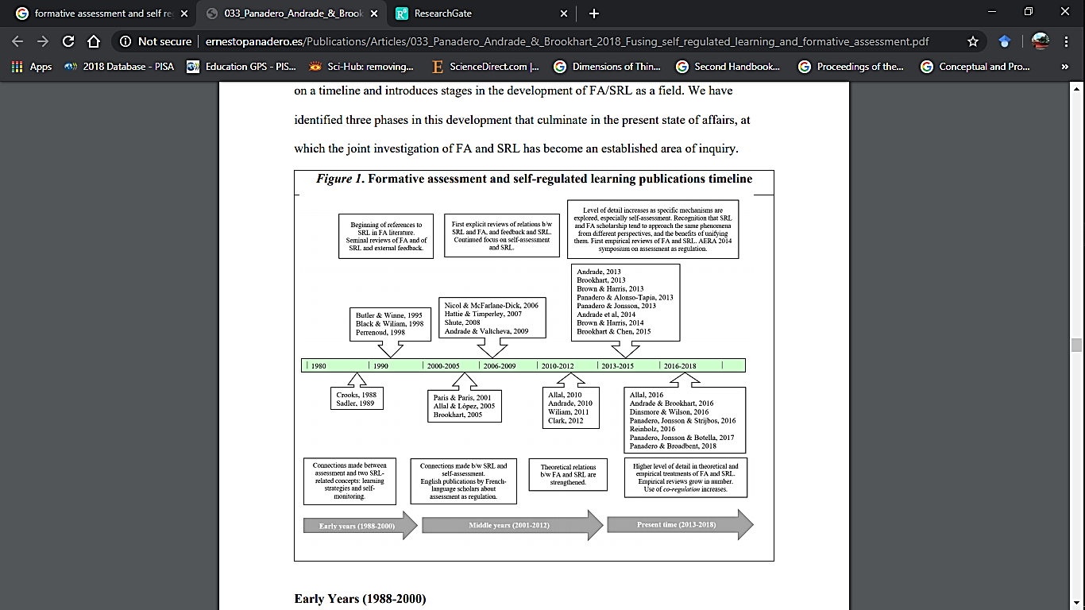

**Fig. 1** Formative assessment and self-regulated learning publications timeline [15]

Self-efficacy is a topic that widely associated in research related to self-assessment and self-regulated learning. Bandura [22] define self-efficacy as beliefs about capabilities to produce designated levels of performance that exercise influence over meaningful events. Students who believe that they are capable learners are ready to assess their own work, identify their current strength and weakness and be productive and persistent in planning the next steps they need to make improvements. [24] Sun and Anderman research show that math self-efficacy and the use of help seeking strategies (self-regulated) significantly impact students’ math learning achievements in flipped math class. The result demonstrates the importance of students’ self-regulated learning processes in learning environment, particularly in terms of students’ prior math knowledge, math self-efficacy and the use of help-seeking strategies. [25] Cho and Heron show that self-efficacy significantly predicted students’ achievement in mathematics course, in which individuals are expected to work independently to set goals, practice content, and successfully complete the course.

Otherwise, [9,10,26,27] results show that self-regulated learning gave positive but not significant effects to students’ self-efficacy. This result can be considered for more objective research in the future that include the factors why the effect is not significant. Beside self-efficacy, emotional variables also has significant effects [25]. This result supported by research that show significant relationship between positive emotions and self-regulated learning and achievement. The research give evidence that negative emotions –boredom and anxiety- have weaker effects than positive emotions –enjoyment and pride- to students learning process and outcome.

Panadero et al. compile of some recommendations guidelines for teachers’ implementation of self-assessment in classroom that have special relevance for the development of self-regulated learning in this following list [23]:

1. Deﬁne the criteria by which students assess their work
2. Teach students how to apply the criteria
3. Give students feedback on their self-assessments
4. Give students help in using self-assessment data to improve performance
5. Provide sufﬁcient time for revision after self-assessment
6. Do not turn self-assessment into self-evaluation by counting it toward a grade

Assessment by which student can assess their work in self-regulation learning, [9] propose three type of interventions aimed at promoting self-assessment:

1. Self-evaluation or self-grading, implies to asking students to evaluate and score their own work without of use a specific tool.
2. Rubrics, are self-assessment tool with three characteristics: a list of criteria for assessing the important goals of a task, a scale for grading the different levels of achievement and a description for each qualitative level.
3. Scripts, including cues and prompts, are specific sets of steps structured accordingly to the expert model of performing a task from beginning to end.

Self-evaluation or self-grading is not an optimal pedagogical approach. This type of self-assessment did not provide students with assessment criteria and unable to promote precise self-assessment. Panadero et al. show that the use of rubrics and scripts has a positive effects on enhancing the students’ mastery of the task because they include the key aspects relevant for the task [10]. Panadero et al. also find that both intervention did not have same effects to students’ self-regulation [9]. Scripts can increase students’ self-regulation and rubrics decrease it. But [26] show that rubrics was better that scripts in increase students’ performance. This difference may occur because the effects of self-assessment to students learning influences by many other factors.

1. **Conclusion**

The using of self-assessment in self-regulated learning give positive impact to students’ performance, self-regulation and also self-efficacy. Other topics related to self-assessment and self-regulated learning are feedback and emotional variables. From this point, there are many other factors and that can be discussed related to the development of self-assessment in self-regulated learning.

**References**

[1] Baird J A, Andrich D, Hopfenbeck T N and Stobart G 2017 Assessment and learning: fields apart? *Assess Educ Princ Policy Pract* **24** 317–50

[2] Hadi S, Retnawati H, Munadi S, Apino E and Wulandari N F 2018 The difficulties of high school students in solving higher-order thinking skills problems *Probl Educ 21st Century* **76** 520–32

[3] Nurharyanto D W and Retnawati H 2020 The difficulties of the elementary school students in solving the mathematical narrative-type test items *J Prima Edukasia* **8** 29–39

[4] Wijaya A, Retnawati H, Setyaningrum W, Aoyama K and Sugiman S 2019 Diagnosing Students’ Learning Difficulties in the Eyes of Indonesian Mathematics Teachers *J Math Educ* **10** 357–64

[5] Fan L 2011 Implementing Self-Assessment to Develop Reflective Teaching and Learning in Mathematics *Assess Math Classr* 275–90

[6] Brown G and Harris L 2014 The future of self-assessment in classroom practice: Reframing self- assessment as a core competency *Front Learn Res* **3** 22–30

[7] Andrade H and Valtcheva A 2009 Promoting learning and achievement through self-assessment *Theory Pract* **48** 12–9

[8] Kostons D, van Gog T and Paas F 2012 Training self-assessment and task-selection skills: A cognitive approach to improving self-regulated learning *Learn Instr* **22** 121–32

[9] Panadero E, Alonso-Tapia J and Reche E 2013 Rubrics vs. self-assessment scripts effect on self-regulation, performance and self-efficacy in pre-service teachers *Stud Educ Eval* **39** 125–32

[10] Panadero E, Tapia J A and Huertas J A 2012 Rubrics and self-assessment scripts effects on self-regulation, learning and self-efficacy in secondary education *Learn Individ Differ* **22** 806–13

[11] Panadero E, Jonsson A and Botella J 2017 Effects of self-assessment on self-regulated learning and self-efficacy: Four meta-analyses *Educ Res Rev* **22** 74–98

[12] Purnomo Y W 2015 Pengembangan Desain Pembelajaran Berbasis Penilaian Dalam Pembelajaran Matematika *J Cakrawala Pendidik* **2** 182–91

[13] Panadero E, Brown G and Courtney M 2014 Teachers’ reasons for using self-assessment: a survey self-report of Spanish teachers *Assess Educ Princ Policy Pract* **21** 365–83

[14] Leach L 2012 Optional self-assessment: Some tensions and dilemmas *Assess Eval High Educ* **37** 137–47

[15] Panadero E, Andrade H and Brookhart S 2018 Fusing self-regulated learning and formative assessment: a roadmap of where we are, how we got here, and where we are going *Aust Educ Res* **45** 13–31

[16] Ng E M W 2016 Fostering pre-service teachers’ self-regulated learning through self- and peer assessment of wiki projects *Comput Educ* **98** 180–91

[17] Retnawati H 2015 The Comparison of The Accuracy of Likert Scale *J Kependidikan Penelit Inov Pembelajaran* **45** 156–67

[18] Retnawati H 2016 Proving content validity of self-regulated learning scale (the comparison of AIKEN index and expanded gregory index) Heri *Res Eval Educ* **2** 155–64

[19] Retnawati H 2017 Improving the understanding of research methodology and self-regulated learning through blog project *Cakrawala Pendidik* **XXXVI** 180–91

[20] Yanto B and Retnawati H 2018 Self-Regulated Learning Mathematics of Students in Secondary School *5th ICRIEMS Proceedings* (Yogyakarta: Faculty of Mathematics And Natural Sciences) pp 393–8

[21] Bose J and Rengel Z 2009 A model formative assessment strategy to promote student-centered self-regulated learning in higher education *US-China Educ Rev* **6** 29–35

[22] Clark I 2012 Formative Assessment: Assessment Is for Self-regulated Learning *Educ Psychol Rev* **24** 205–49

[23] Panadero , E ., Jonsson , A ., & Strijbos J . W 2016 Scaffolding Self-Regulated Learning Through Self-Assessment and Peer Assessment : Guidelines for Classroom Implementation *Assess Learn Meet Chall Implement* 311–26

[24] Sun Z, Xie K and Anderman L H 2017 The role of self-regulated learning in students’ success in flipped undergraduate math courses *Internet High Educ* **36** 41–53

[25] Cho M H and Heron M L 2015 Self-regulated learning: the role of motivation, emotion, and use of learning strategies in students’ learning experiences in a self-paced online mathematics course *Distance Educ* **36** 80–99

[26] Panadero E, Alonso-Tapia J and Huertas J A 2014 Rubrics vs. self-assessment scripts: effects on first year university students’ self-regulation and performance *Infanc y Aprendiz* **37** 149–83

[27] Panadero E 2017 A review of self-regulated learning: Six models and four directions for research *Front Psychol* **8** 1–28