Gender differences in mathematics achievement, competitiveness, fear of failure, and resilience: analysis of PISA 2018 in Indonesia
D Rahmawati ¹ and Kismiantini ²
¹Graduate Program of Mathematics Education, Universitas Negeri Yogyakarta, Yogyakarta, Indonesia
²Department of Statistics, Universitas Negeri Yogyakarta, Yogyakarta, Indonesia
E-mail: dianaqquarahma23@gmail.com
Abstract. Gender differences and psychological attributes have important role in learning process and achievement, including in mathematics fields. The psychological attributes have different effect to students’ achievement based on the gender. This study aims to compare the impact of competitiveness, fear of failure and resilience to mathematics achievement between male and female students using PISA 2018 in Indonesia. The total students included were 10,379 of 15 years old students (4,932 males and 5,447 females) from 397 different schools in Indonesia. Multilevel analysis used to examine the effect of the predictors in hierarchical structures (individual-level and school-level). Based on the analysis, the multilevel analyses results found that the competitiveness and fear of failure were significant relationship to mathematics achievements, while resilience was not significant. The girls had higher math score, more competitive and dare to failure than boys. However, boys showed better resilience but the differences were not significant.
- Introduction
In recent decades, women actively participate in the development of the world in various fields. The role of women can be considered equivalent to the role of men. However, gender differences are still a notable topic that deserve attention. Gender differences in education remain ubiquitous. Gender differences have important role in learning process and achievement, including in mathematics fields. Stereotypes about female inferiority in mathematics are prominent among children and adolescents, parents and teachers [1]. [2] Linn and Hyde clarified the nature of gender differences in cognitive, psychological and physical task and their implications for mathematics.
Numerous study discussed gender differences in mathematics with mixed results. [3] Ellison and Swanson results show there is a large gender gap among high math achievers. [4] Stoet and Geary results show that gender differences in mathematics was small but remained relatively stable over the ten years. But [1][5][6] show that there are no significant differences between boys and girls, despite there is more positive math attitudes and affect among males [6] or girls lose one-fourth of a standard deviation relative to boys over first six years of school [7]. As for [8] result based on the interpretation of PISA 2018 data, it suggests that gender differences are generally small. Boys outperformed girls just by five score points in mathematics on average across OECD countries. However, while claiming victory in having closed gender gaps in girls’ and boys’ cognitive skills, education may have lost sight of other social and emotional dimensions of learning that may have stronger impact on children as they think about what they want to be when they grow up.
Beside gender differences in learning outcome, gender differences in various psychological attributes recently gained prominence [9]. The psychological attributes such as competitiveness, fear of failure and resilience gave different impact to boys and girls. Competitiveness is typically measured as either the performance response to a competitive setting compared to a non-competitive setting, or as a preference for competition such as self-selecting into competitive setting instead on a non-competitive setting [10]. Boys show more competitive attitude than girls in both performance change in response to competition and the choice to compete. In higher education and workforce, women are strongly underrepresented in math-intensive fields in most developed countries [11].
Fear of failure has been directly correlated with lack of self-confidence, poor feelings of self-esteem, and low risk-taking. Females often underestimate their mathematical and spatial perception skills due to lack of confidence. Women fear that their success will create a problem in their interpersonal relationship, particularly if they are going against societal norms of sex or gender acceptable roles [12]. Conroy [12] state fearing failure has been associated with a decrease in goal attainment and enjoyment of chores or duties, as well as an increase in avoiding tasks. Fear of failure is hypnotized to prompt the adoption of performance-avoidance goals that focus on the avoidance of negative consequences. An individual with a high fear of failure perceptually and cognitively orientates to failure-relevant information and thus encounters anxiety prior to and during task engagement. They seek to avoid failure by avoiding the situation, by quitting or withdrawing effort, or by trying hard to succeed and thus avoid failure. The core emotion of fear of failure is most likely shame, a devastating emotion that entails a sense of one’s global incompetence [13].
Provided that people seem to experience failure and competition differently, resilience becomes especially important to address. Resilience exist in wider psychological literature as a concept to describe the phenomenon of how some young people avoid negative consequences and succeed despite significant adversity [14]. For more specific, resilience is related to students’ affective ability to deal with and be able to overcome obstacles and negative situations in the learning process. Turning those negative situations into situations that support them [15]. Girls have consistently been found to have higher scores that boys for individual characteristics factor of resilience. Girls have higher scores in communication, empathy, help-seeking, goals and aspiration. They are also more likely to report positive connections with parents, teachers, and adults in the community, peer relations and autonomy experiences than boys [16].
Actually, each psychological attributes have a role in predicting students’ mathematics achievement. Competitiveness, fear of failure and resilience related to learning process and students’ mathematics achievement. [17] demonstrated how competitiveness affected by the power of education achievement (e.g. mathematics) and [18] demonstrated that adolescent have a clear understanding of how confidence, competition and failure have a significant impact on their achievement. [19] found that competitiveness was positively related to performance and mastery goals. This results show the reciprocity relationship between competitiveness and achievement. As for fear of failure, [13] revealed the negative effect that fear of failure has in the mathematics learning. Students’ fear of failure was found to negatively influence the adoption of mastery goals, positively influence the adoption of performance-approach goals, and also directly and negatively influence their mathematics performance. [14] construct “mathematical resilience” to describe the positive attributes that required to prepare in engage with, learn, and use mathematics both at school and beyond. In other words, this attributes directly influence students’ mathematics achievement.

- Method

2.1 Data
Data for this study were drawn from database of Programme for International Student Assessment (PISA) 2018 by Organization for Economic Cooperation and Development’s (OECD). The data used is PISA data for Indonesia country. Total 12,098 of 15 years old students took part in PISA in 2018. The variables included in this study are mathematics score, competitiveness score, fear of failure score, resilience score and gender (1 = female, 2 = male). After removing the missing data in the selected variables of interest, the comprised data were 10,379 students (4,932 males and 5,447 females) from 397 schools.

2.2 Data Analysis
The variables used in this study are students’ mathematics achievement, competitiveness, fear of failure, resilience and gender. The multilevel model (MLM) used to analyse multilevel data (students nested within schools) [20]. The multilevel analysis was used to examine the effect of competitiveness, fear of failure and resilience to mathematics achievement based on student gender in nested data. First, empty models were estimated to decompose the total variance in outcome variables into within- and between-school variance. Then, a random slope model that include all variables was estimated. After the multilevel models, the differences between male and female students for each variable of interest are determined by using t-test independent sample to compare two population means.

- Result and Discussion
Based on the result of multilevel model (Table 1), competitiveness and fear of failure statistically significant related to mathematics achievement, but resilience not significant. In congruence with the finding of prior research [19], competitiveness positively related to mathematics achievement. On the contrary, fear of failure does not give negative impact to mathematics achievement. The result show that fear of failure has positive coefficient for predict mathematics score. Resilience also have different result from prior research. Resilience have positive coefficient for predict mathematics achievement but does not significant statistically. It means resilience can be ignored in predict mathematics achievement. The model for predict students’ mathematics achievement based on the result of multilevel analysis can be written as the following eq. (1).

$\hat{{MathScore}_{ij}}=914.51+8.38 {Compete}_{ij}+2.47 {FailFear}_{ij}+0.19 {Resilience}_{ij}$ (1)

The estimated coefficient $8.38$ for competitiveness and $2.47$ for fear of failure are interpreted as the average impact of competitiveness and fear of failure on the mathematics achievement across school. The value of $101.9$ represents that the relationship of the competitiveness and fear of failure to mathematics score variables differs across schools. As for the value of $103,513.5$ is the largest source of random variation in mathematics achievement across schools and $2,014.6$ is the largest source of random variation within-schools.

Table 1 The results of multilevel model
 | Empty Model |  |  | Full Model
 | B | SE | B |  | SE
Fixed
Intercept | $915.60$*** | $$16.18$$ | $914.51$*** |  | $$16.17$$
Competitiveness |  |  | $8.38$*** |  | $$0.60$$
Fear of Failure |  |  | $2.47$*** |  | $$0.52$$
Resilience |  |  | $$0.19$$ |  | $$0.57$$
Random
Variance between-school | $$103,640.4$$ |  | $$103,513.5$$
Variance within-school | $$2,064.2$$ |  | $$2,014.6$$
Gender Variance | $$95.0$$ |  | $$101.9$$
***$p<0.001$

The reverse impact of failure to mathematics achievement in Indonesia from the prior findings possibly affected by the culture differences. Positive impact of failure happens when students choose to face failure and trying hard to succeed [13]. This type of reaction when facing failure can be categorized as a resilience. Resilience as the ability that allows students to deal with difficult situations [15] help students turning failure into motivation or other positive attitudes to be better. The positive resilience itself is shown in the result. There are many possible reasons to why the impact of resilience to mathematics achievement is not significant. One possible reason is that students did not aware of resilience itself. In relation to mathematics, [14] state four correlated factors constructing the ability of mathematical resilience: value, struggle, growth and resilience. But it’s possible if students can manage some factors of mathematical resilience but not significant in resilience factor. [15] Hutauruk and Priatna show that students have mathematical resilience ability but does not get significant differences in growth and resilience factor.
The result of t-test to determine the gender differences in competitiveness, fear of failure, resilience and mathematics achievement shown in table 2. Based on the result, the variables statistically significant different between females and males, except resilience. Female students have higher score in mathematics achievement and competitiveness than male students, but have lower mean in fear of failure.

Table 2 Gender differences between female and male students
 | Female |  | Male |  | t-test for equality Means*
 | M | SD | M | SD | t | Sig.
Math Score | $$936.807$$ | $$324.923$$ | $$909.486$$ | $$316.048$$ | $$-4.334$$ | $$0.0000$$
Competitiveness | $$0.215$$ | $$0.779$$ | $$0.165$$ | $$0.820$$ | $$-3.187$$ | $$0.0007$$
Fear of Failure | $$-0.013$$ | $$0.796$$ | $$0.006$$ | $$0.859$$ | $$-6.436$$ | $$0.0000$$
Resilience | $$-0.106$$ | $$0.881$$ | $$-0.218$$ | $$0.894$$ | $$1.120$$ | $$0.8687$$
* df = $10377$

In figure 1, the differences between females and males for mathematics achievement, competitiveness, fear of failure and resilience illustrated in boxplot. Boxplot for mathematics achievement, competitiveness and fear of failure clearly shown that the gap between females and males. But boxplot for resilience does not have much difference between both gender.

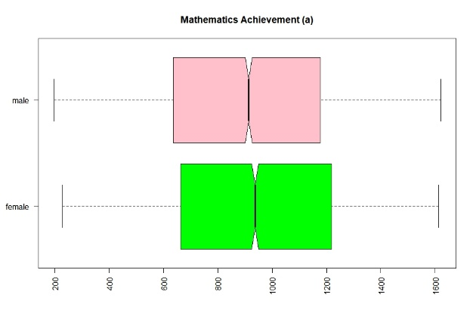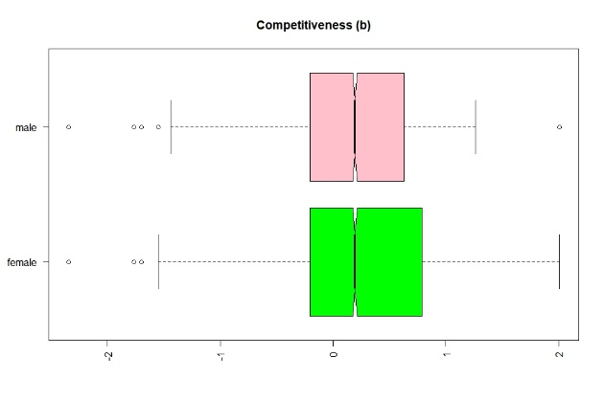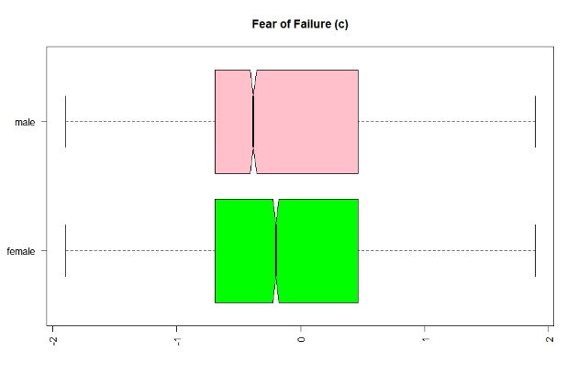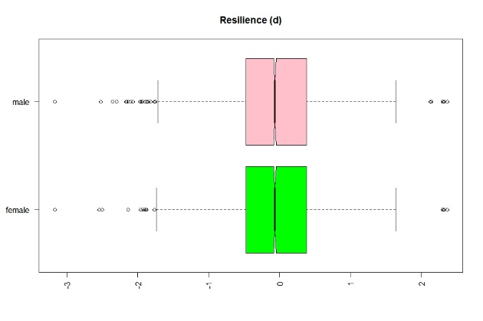
Figure 1 Boxplot of mathematics achievement (a), competitiveness (b), fear of failure (c) and resilience (d) based on gender differences

Based on the result, girls have higher scores in mathematics achievement, more competitive and more dare to face failure that boys. This result show that female Indonesian students are more dominant than male students in mathematics fields. It happens because more male students do not care about mathematics and avoid exact subjects. They tend to enjoy sport or language subjects. As [21] state that boys with more traditional gender ideology have more masculine subject preference and girls with more feminine subject preferences. Gender stereotypes views mathematics as a typically masculine domain and language as a typically feminine domain. But recent research show that gender stereotypes associated with mathematics and language are changing. Boys and girls still view language as a typically feminine but no longer regard mathematics as typically masculine. So it is possible and reasonable that girls are more dominant in mathematics than boys in Indonesian.

- Conclusion
Competitiveness and fear of failure gave positive impact on mathematics achievement and can be used to predict students’ mathematics score. Resilience have positive but not significant impact to mathematics achievement. However, gender differences for mathematics achievement, competitiveness and fear of failure are statistically significant. Otherwise, resilience does not have significant difference. The findings in this study have several differences with the prior research, many factors can be the cause of this difference findings. Gender differences and the impact various psychological attributes to mathematics achievement are topics that remains widely discussed in the following years.

References

[1] Lindberg S M, Hyde J S, Petersen J L and Linn M C 2010 New Trends in Gender and Mathematics Performance: A Meta-Analysis Psychol Bull 136 1123–35
[2] Linn M C and Hyde J S 1989 Gender , Mathematics , and Science Educ Res 18 17–9, 22–7
[3] Ellison G and Swanson A 2010 The gender gap in secondary school mathematics at high achievement levels: Evidence from the American mathematics competitions J Econ Perspect 24 109–28
[4] Stoet G and Geary D C 2013 Sex Differences in Mathematics and Reading Achievement Are Inversely Related: Within- and Across-Nation Assessment of 10 Years of PISA Data PLoS One 8
[5] Ajai J T and Imoko B I 2015 Gender differences in mathematics achievement and retention scores: A case of problem-based learning method Int J Res Educ Sci 1 45–50
[6] Else-Quest N M, Hyde J S and Linn M C 2010 Cross-National Patterns of Gender Differences in Mathematics: A Meta-Analysis Psychol Bull 136 103–27
[7] G. Fryer Jr. R and D. Levitt S 2012 An Empirical Analysis of the Gender Gap in Mathematics Am Econ J Appl Econ 25 147–67
[8] Schleicher A 2019 PISA 2018 insights and interpretations OECD Publ 64
[9] Niederle M 2017 A gender agenda: A progress report on competitiveness Am Econ Rev 107 115–9
[10] Cárdenas J C, Dreber A, von Essen E and Ranehill E 2012 Gender differences in competitiveness and risk taking: Comparing children in Colombia and Sweden J Econ Behav Organ 83 11–23
[11] Buser T, Peter N and Wolter S C 2017 Gender, competitiveness, and study choices in high school: Evidence from Switzerland Am Econ Rev 107 125–30
[12] Nelson K L, Ph D, Newman D N, Mcdaniel J R and Buboltz W C 2013 Gender Differences in Fear of Failure amongst Engineering Students 3 10–6
[13] Pantziara M and Philippou G N 2015 Students’ motivation in the mathematics classroom: revealing causes and consequenses Copyr Int J Sci Math Educ 13 385–412
[14] Lee C and Johnston-Wilder S 2017 The Construct of Mathematical Resilience (Elsevier Inc.)
[15] Hutauruk A J B and Priatna N 2017 Mathematical Resilience of Mathematics Education Students J Phys Conf Ser 895
[16] Sun J and Stewart D 2007 Age and Gender Effects on Resilience in Children and Adolescents Int J Ment Health Promot 9 16–25
[17] Baumann C and Winzar H 2016 The role of secondary education in explaining competitiveness Asia Pacific J Educ 36 13–30
[18] Archard N 2012 Adolescent girls and leadership: the impact of confidence, competition, and failure Int J Adolesc Youth 17 189–203
[19] King R B, McInerney D M and Watkins D A 2012 Competitiveness is not that bad...at least in the East: Testing the hierarchical model of achievement motivation in the Asian setting Int J Intercult Relations 36 446–57
[20] Peugh J L 2010 A practical guide to multilevel modeling J Sch Psychol 48 85–112
[21] Van der Vleuten M, Jaspers E, Maas I and van der Lippe T 2016 Boys’ and girls’ educational choices in secondary education. The role of gender ideology Educ Stud 42 181–200

