Analysis of student errors in solving integer multiplication problem

Florida Moza

Fakultas Keguruan dan Ilmu Pendidikan, Universitas Sanata Dharma

[florida.moza@gmail.com](mailto:florida.moza@gmail.com)

**Abstract**. Integer multiplication is one of the main subjects taught in class VII. This study aims to describe the types of student errors about integer multiplication. This type of research used this research is descriptive qualitative research. The subjects of this study were students of class VII SMPK St. Paulus Karuni. The instrument in this study is a integer multiplication test item that has been designed according to the problems student normally work on, namely in working on the problem, it is made step by step that requires students to write their changes and their reason. The reason given was in the form of a contract and the theorems according to what they had learned. Data collection methods in the form of test result. Data analysis techniques used are (1) data reduction, (2) data display, and (3) conclusion drawing and verification. The result showed that students made several mistakes in solving problem about integer multiplication such as concept errors, syntax errors (writing errors), counting errors (semantic errors) and errors seeing operation marks.

1. Introduction

Mathematics is the science of numbers, the relationship between numbers and operational procedures used in solving problems regarding numbers $\left[1\right]$. According to Ainurrohmah & Mariana, understanding mathematical concepts is an important part that students must learn because they are often needed and implemented in their daily activities, both at school, at home and in the community. Heather C. Hill, explained that in mathematics subject matter related to the understanding of concepts that students must have including understanding of arithmetic operations. Numbers round is one of the materials in mathematic $\left[2\right]$. Karso, explain integers are numbers consisting of positive integers, negative integers and zero (..., -3, -2, -1, 0, 1, 2, 3,...) $\left[3\right]$. Integers are very important material for students to learn, because of their usefulness in solving various problems in everyday life as well as prerequisite materials for learning other concepts, such as Cartesian coordinates and algebra $\left[4\right]$. According to the 2013 Curriculum, integer material is taught in class VII in semester one. One of the subject matter taught in class VII is the Round Number Multiplication $\left[5\right]$.

Integer multiplication can be interpreted as a repeated sum. So to find the result of a *a x b* is the same as showing the sum of $b+…+b$ as many a $\left[6\right]$. Integer multiplication is the subject matter taught since elementary school and taught in junior high. If students can’t understand the concept of integer multiplication as multiply negative numbers with negative numbers, positive numbers with negative numbers, negative numbers to positive numbers, positive numbers with positive number, and the nature of the multiplication of the number zero then they will not be able to solve the problems integer multiplication exactly. Therefore, students need to understand the concept of integer multiplication well. But students still have difficulty working on integer multiplication problems. Based on the results of his research Utami $\left[7\right]$ and Mulyati $\left[8\right]$ explained that the condition of students still experiencing difficulties in solving mixed count operations on integers. The difficulty experienced by students is not understanding the concept of the properties of multiplication operations well. In the book Kaune, Christa & Elmar Cohors-Fresenborg, explains that apart from understanding the concept of integer multiplication well, students must also avoid syntactic errors and semantic errors. Syntax errors are writing errors made by students or a violation of the agreed form such as writing incomplete brackets or excess brackets. Whereas semantic errors are calculation errors. $\left[9\right]$.

The mistakes made by students in solving integer multiplication problems may be the same as those experienced by other schools, including in SMPK St. Paulus Karuni. Based on the results of interviews conducted by researchers with mathematics teachers in class VII and based on teaching experience in SMPK St. Paulus Karuni found that integer multiplication is one of the material that is quite difficult for students, namely not understanding the concept well and not being able to calculate well. Some students make mistakes on integer multiplication. Therefore, researchers are interested in analyzing the types of errors made by students in solving various questions about multiplication of integers in class VII. Researchers gave test question to grade VII students of SMPK St. Paulus Karuni. The test given to students is the form of integer multiplication question. This test not only asks students to give results but students must work through the process with step by step along with giving reasons. These reasons are in the form of axioms ($N^{+},N^{x},I^{+},I^{x}, K^{+},K^{x},A^{+}, A^{x},$ and ${ D}^{-}$) and theorems (T1-T17) that are appropriate and what they have learned. The following axioms and theorems used are as follows $\left[9\right]$.

|  |  |
| --- | --- |
| **N+** |  |
| **I+** |  |
| **K+** |  |
| **A+** |  |
| **D-** |  |
| **T1** | $$\left(a+0\right)=a$$ |
| **T2** | $$0=\left(-0\right)$$ |
| **T3** | $$\left(0-a\right)=\left(-a\right)$$ |
| **T4** | $$\left(a-a\right)=0$$ |
| **T5** | $$\left(a-0\right)=a$$ |
| **T6** | $$\left(-\left(-a\right)\right)=a$$ |
| **T7** | $$\left(a-(-b)\right)=\left(a+b\right)$$ |
| **T8** | $$\left((-a)-(-b)\right)=\left(b-a\right)$$ |
| **T9** | $$\left(-\left(a+b\right)\right)=\left(\left(-a\right)+(-b)\right)$$ |
| **T10** | $$\left(\left(-a\right)+b\right)=\left(-\left(a-b\right)\right)$$ |
| **T11** | $\left(-\left(a-b\right)\right)$**= $\left(b-a\right)$** |
| **T12** |  |

|  |  |
| --- | --- |
| **Nx** |  |
| **Kx** |  |
| **Ax** |  |
| **D** | $$\left(a×\left(b+c\right)\right)= \left(\left(a×b\right)+\left(a×c\right)\right)$$ |
| **T13** | $$\left(0×a\right)=0$$ |
| **T14** | $$\left(a×\left(-b\right)\right)=\left(-\left(a×b\right)\right)$$ |
| **T15** | $$\left(\left(-a\right)×b\right)=\left(-\left(a×b\right)\right)$$ |
| **T16** | $$\left(\left(-a\right)×b\right)=\left(a×\left(-b\right)\right)$$ |
| **T17** | $$\left(\left(-a\right)×\left(-b\right)\right)=\left(a×b\right)$$ |

Axioms and Theorems

1. Research Methods

This type of research used this research is descriptive qualitative research. This study aims to describe the types of student errors regarding integer multiplication. The subjects of this study were 18 grade VII students of the 2019/2020 academic year consisting of 12 girls and 6 boys. This research procedure consists of three main stages, namely preparation, implementation and data analysis. At the preparatory stage, the researcher prepared a test about the multiplication of integer. In the next stage, researchers provide problems relating to multiplication of integer. Then the researcher analyzes the students answer to find out and describe the mistakes made by students. The data analysis technique used according to Miles and Huberman in Gunawan, namely (1) data reduction: in this section the researcher performs data reduction, namely summarizing and selecting things that are important to be analyzed, (2) data display: In this section, researcher analyzes the data based on the problem formulation, and (3) conclusion drawing/verifying: In this section, the researcher draws conclusions related to the types of errors students make on integer multiplication. $\left[10\right]$.

1. Result and Discussion

The researcher gave an integer multiplication test to the students. Based on the results of data analysis, the researcher found 4 errors made by students when solving equations about integer multiplication. All types of mistakes made and the number of mistakes made by students can be seen in table 1.

**Table 1**. Types of mistakes students make

|  |  |
| --- | --- |
| **Error type** | **The number of students who made mistakes** |
| Concept error (giving reasons) | 7 people |
| Syntax error (Writing mistake) | 18 people |
| Semantic error (Counting error) | 12 people |
| error saw the operation sign | 1 people |

## Concept Error (giving reasons)

In the first type of error that is about concept errors or students give reasons that are not appropriate. Possibly why students make mistakes because students cannot properly understand the properties of integer multiplication contained in contracts or theorems on multiplication. The following forms of mistakes that make by students:

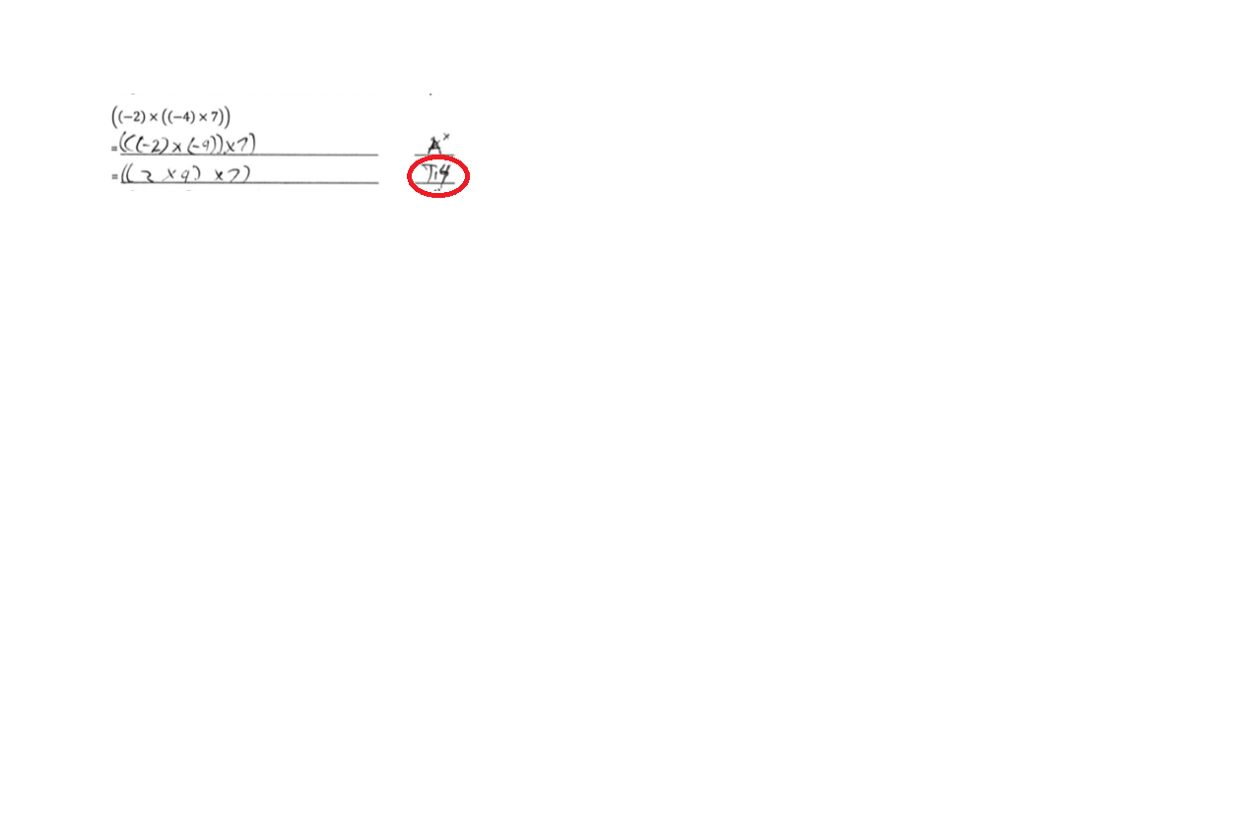

**Figure 1.** Misconceptions made by student

In figure 1, it appears that students do not yet understand the reasons for integer multiplication operation so that students are still incorrect in giving reasons that are appropriate for changes in the third line. I the third row, students using T14 (Theorem 14) that is $(a × (-b)) = (-(a × b))$ and write the change $((-2) × (-4)) = (2 ×4)$. The reasons is not in accordance with the form of the change. At T14 the negative is only at b whereas in the negative form a and b, the appropriate reason is T17 with form $((-a) × (-b)) = (a × b)$.

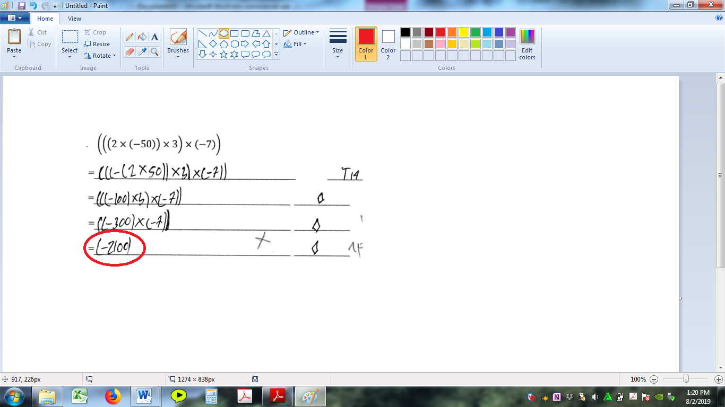

**Figure 2**. Misconceptions made by student

In figure 2, student are asked to solve problem by applying various suitable reasons. In the second line, students use T14 $(a × (-b)) = (-(a ×b))$ to changes $(2 × (-50))$ to $(-(2 × 50)).$ In the third row, students use lupis ($◊$) to calculate $(2 ×50) = 100$. Then in the fourth row students use lupis ($◊$) again for $((-100) × 3) = (-300).$ In this change, students do not apply one reason, students should first change ((-100) $×$ 3) to (-(100 $×$ 3)) with reason $T15 \left(\left(-a\right)× b\right)= \left(-\left(a × b\right)\right),$ then finally use lupis ($◊$). In the last line students use the lupis reason for changing $((-300) × (-7)) = (-2100)$. In this section, students make mistakes that students do not understand well the concepts of integer multiplication properties such as multiplication of negative numbers with negative numbers. Should be before using the reason lupis ($◊$), first must use reason T17 $((-a) ×(-b)) = (a ×b)$, to change $((-300) ×(-7))$ to $(300 × 7)$, then finally use lupis to calculate $(300 ×7) = 2100$.

## Syntax Error (Writing mistake)

Syntax errors are mistakes made by students in the form of mathematical writing such as there are excess brackets or less brackets. The possibility of why students make syntactic errors because students cannot see and control for themselves whether there are errors. The following are forms of errors made by students.

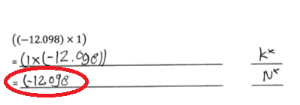

**Figure 3.** Syntactic errors made by students

In figure 3, students are asked to calculate the results of $((-12.098) ×1)$ by giving the appropriate reasons. First, students use the reason $K^{×} \left(a×b\right)=\left(b×a\right)$ to swap places between (-12.098) and 1, which originally (-12.098) to the left on the multiplication sign moves to the right of the sign and the others are the same. Then in the next line students use the reason Nx with the change (-12.098. On the third line, there was a syntactic error, namely the students did not write the closing brackets. Last change should be (-12.098).

**Figure 4.** Syntactic errors made by students

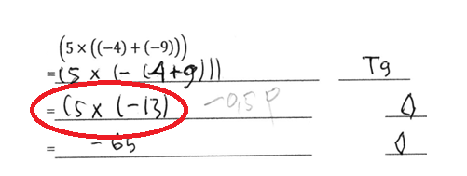

In figure 4, students are asked to calculate the result of $(5 × ((-4)+ (-9)))$ by providing the appropriate reasons. First, students use the reason T9 by changing $((-4)+ (-9))$ to $(-(4+9))$, as a namely 4 and as b namely 9. Then on the next line students use the reason lupis ($◊$) to count 4+ 9 = 13. In the alteration in this third line that has been marked with a red circle, there is a syntax error, that is students do not write the closing brackets. The students does not notice that the last closing bracket is the opening bracket before -13. The changes in the third line should be $(5 × (-13))$. Then in the last line students use the lupis ($◊$) to calculate $(5 × (-13)) = -65.$

## Semantic Error (Counting error)

Semantic errors are errors made by students during calculations. The possibility of students making semantic mistakes because students cannot calculate well and do not understand the multiplication concept from elementary school well. Students only memorize but do not know where it came from. For example the student knows that $3×8=24$ but does not understand where it was obtained. The following are forms of errors made by students:

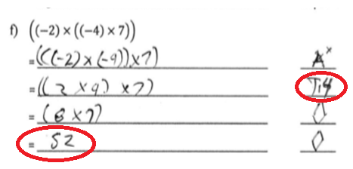

**Figure 5.** Semantic errors made by students

In this exercise (figure 5), students are asked to complete $\left(\left(-2\right)×\left(\left(-4\right)×7\right)\right)$ by providing appropriate reasons. In the second row students use reason. In the second row students use reason $A^{x}$ to change what was originally one small group (-4) and 7 changed to one group, namely (-2) and (-4). Then in the third line the students made a concept error, namely using the reason T14 for the change, it should appropriate T17. Then on the fourth line, students use the lupis ($◊$) reason for changes $\left(2×4\right)=8.$ Furthermore, on the last line the students use the lupis $\left(◊\right)$ reason for making change $\left(8×7\right)=52$. On this line, the student made a semantic error, it should be the result of $\left(8×7\right)=56$.

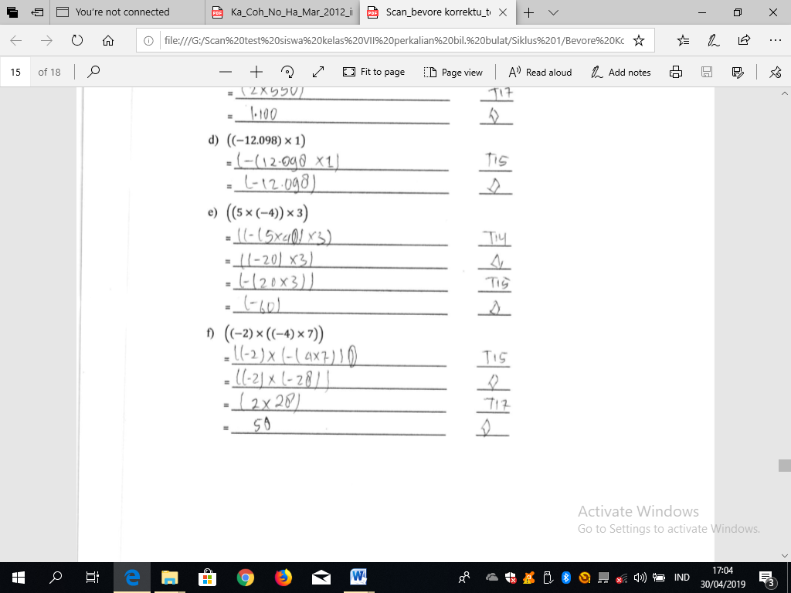

**Figure 6.** Semantic errors made by students

In Figure 6, it can be seen that students have not been able to count well. The student miscalculated 2 and 28 and the result was 50. Students use the reasons for lupis $\left(◊\right)$ to calculate $\left(2×28\right)=50$. The product of 2 and 28 should be 56.

## Error saw the operation sign

Apart from concept errors, syntax errors and semantic errors, students also make mistake such as incorrectly seeing operation signs. For example they think the add operation is a multiply. The first possibility is that students make this mistake because students do not see well the operation on the problem. Whereas the second possibility is because students do not understand well about the operation, for example the addition sign $\left(+\right)$ function for what, the multiplication sign $\left(×\right)$ functions for what. The following are forms of errors made by students:

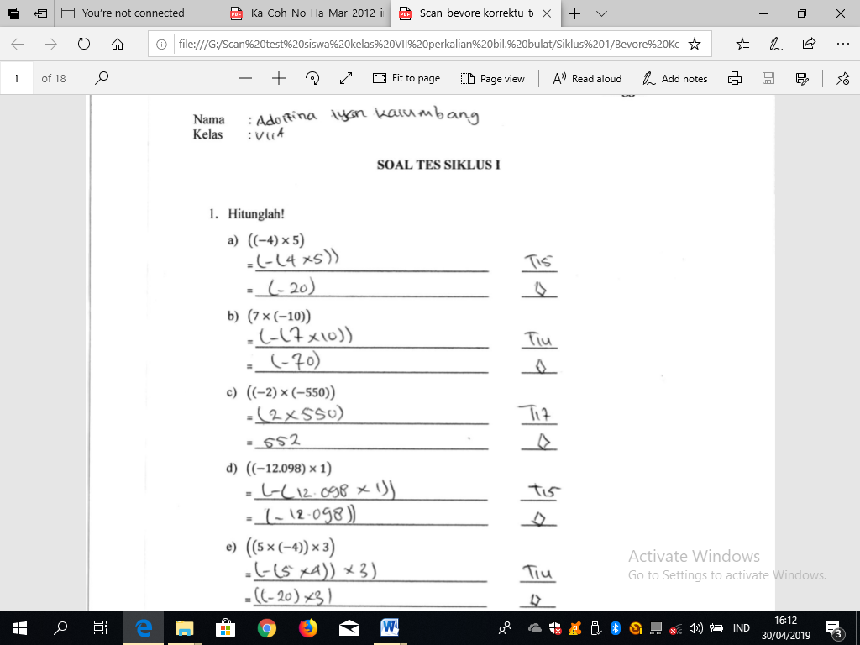

**Figure 7.** Error saw the operation sign

In the exercise above, students are asked to complete $((-2)×(-550))$ by providing suitable reasons. First students use reason $T17 ((-a)×(-b)) = (a ×b)$, by changing $((-2) × (-550))$ to $(2 × 550)$ which as **a** is 2 and as **b** is 550. Then the students use the lupis $\left(◊\right)$ reason for calculation $(2 × 550) = 552$. It can be seen that the students did not pay close attention that the sign of the operation was not a sign of addition but a sign of multiplication. So that students make mistakes, namely adding 2 to 550 and the result is 552. In this section, students do not see and control back what has been done. Should change it on the grounds of lupis $\left(◊\right)$ namely $\left(2× 550\right)=1.100$.

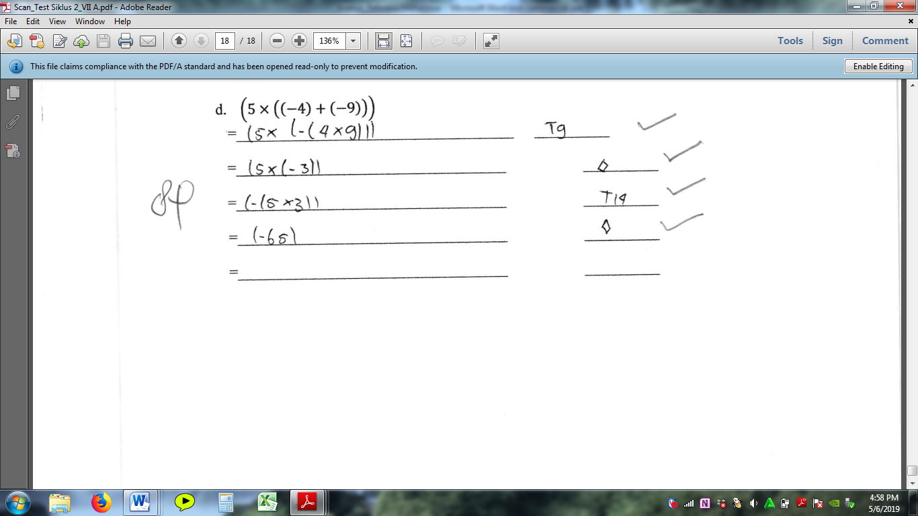

**Figure 8**. Mistakes that students make

In figure 8, it can be seen that students made the same mistakes, namely errors related to operations. In the second line, students use reason $T9 (-(a + b)) = ((-a) + (-b))$ for changing $((-4) + (-9)) = (-(4 × 9))$. In this section, the student made a multiplication sign on 4 and 9 which should be changed namely $((-4) + (-9)) = (-(4 + 9))$. Then in the third row, students use the lupis $\left(◊\right)$ reason to count $(4 × 9)$ and result answer 3. In this section, students make mistake again, namely students cannot count properly should $(-(4 × 9)) = (-36).$ Then on the next line students use reason T14, for changing $\left(5×\left(-3\right)\right)=\left(-\left(5×3\right)\right)$. Then on the last line, students make a calculation error by using the lupis $\left(◊\right)$ reason for the calculation $\left(-\left(5×3\right)\right)=\left(-65\right)$, should be $\left(-\left(5×3\right)\right)=\left(-15\right)$.

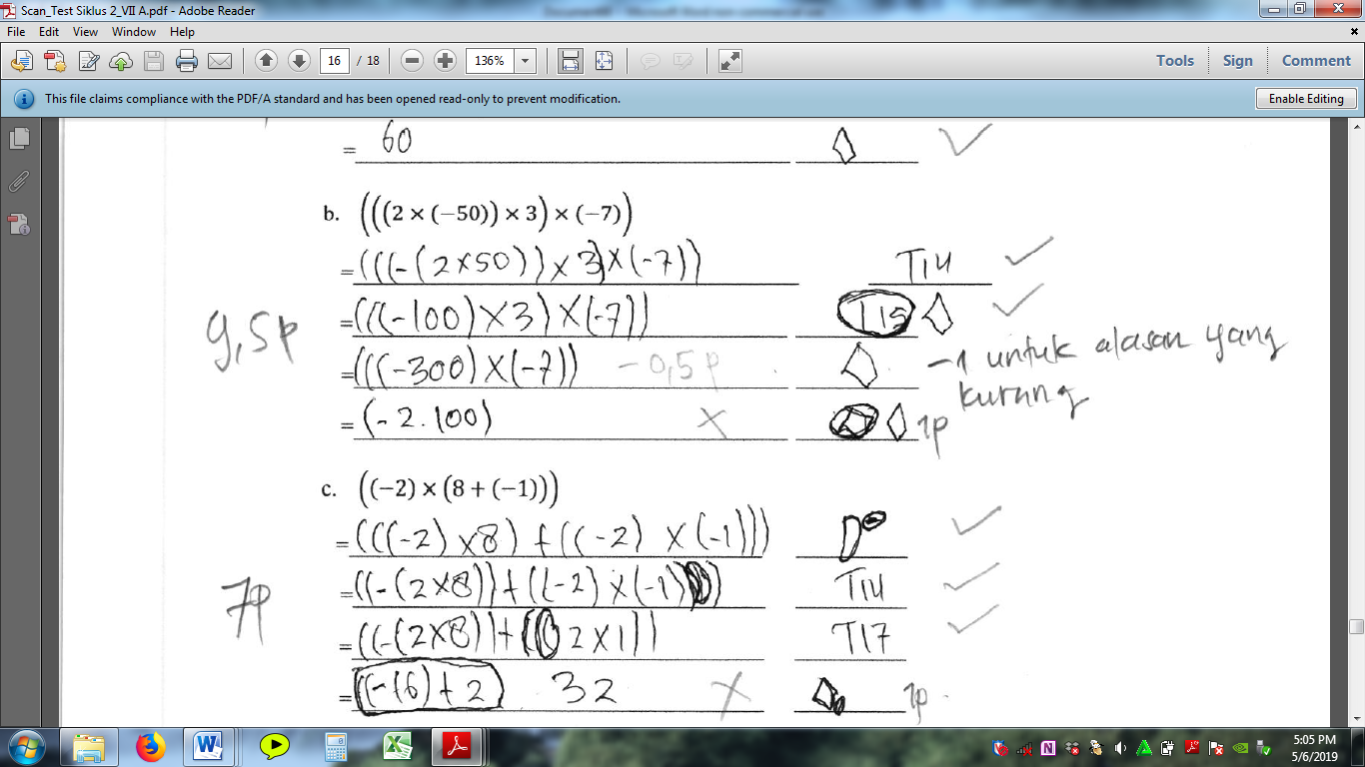

**Figure 9.** Mistakes that students make

In figure 9, students are asked to complete $\left(\left(-2\right)×\left(8+\left(-1\right)\right)\right)$. In the second line, students use the reason D (distributive) with the changes. In the third row, students use reason T14 to change $\left(\left(-2\right)×8\right)=\left(-\left(2×8\right)\right)$. In the fourth line, students change $\left(\left(-2\right)×\left(-1\right)\right)=\left(2×1\right)$ for the reason T17. Furthermore, in the last line, students use the lupis $\left(◊\right)$ reason to changes $\left(\left(\left(-2\right)×8\right)+\left(2×1\right)\right)=32$. We can see the students answers that were given a circle next to 32, students wrote $\left(\left(-16\right)+2\right)$. So that from this form we can know that students misinterpreted the sign of the addition operation into a sign of the multiplication operation so that answered $\left(\left(-16\right)+2\right)=32$. But students also make a mistake if using the multiplication integer operation it should produce $\left(-32\right)$.

1. Conclusion

Based on research and discussion, it was found that an error was made by the VII grade students of SMPK St. Paulus Karuni, namely there are 4 types of errors in solving problems related to the multiplication of integer with various possible reasons for each error being analysed. All errors found in this study were concept errors, syntactic errors, calculating errors made by students (semantic errors) and errors in seeing operation signs. Concept errors occur because students do not understand well the concept of multiplication of integer, students only memorize, not understand, so that sometimes there are misconceptions made by students. Syntactic errors are mistake made by students in the form of mathematical writing as there are excess brackets. Syntax errors occur because students cannot see and control their own (monitoring) the answer whether there are still errors. Semantic errors are errors made by students during calculations. The possibility of students making semantic errors because students cannot count well and do not understand the multiplication concept from SD well. While the last mistake the student made was wrong in seeing the sign of the operation, such as the student assuming that the plus operation sign is a sign of multiplication so that the number should be added up but the students multiplies the number and vice versa.

References

1. Departemen Pendidikan Nasional. 2008. *Kamus Besar Bahasa Indonesia Pusat Bahasa.* Jakarta : PT Gramedia Pustaka Utama.
2. Karlimah, Nur, L., & Oktaviyani, H. 2019. *Pemahaman Konsep Operasi Hitung Penjumlahan Bilangan Cacah Siswa Sekolah Dasar.* Premiere Educandum: Jurnal Pendidikan Dasar dan Pembelajaran Volume 9 (2) 123-129.
3. Karso, dkk. 2011*. Pendidikan Matematika 1.* Jakarta : Universitas Terbuka.
4. Ate, Dekriati. 2016. *Jumping Back And Forth – Permainan Sebagai Microworld Untuk Memperkenalkan Konsep Bilangan Bulat*. Yogyakarta : Seminar Nasional Matematika dan Pendidikan Matematika.
5. Notodiputro, Khairil Anwar. 2013. *Kompetensi Dasar dan Kompetensi Inti Kurikulum 2013.* Kementrian Pendidikan dan Kebudayaan.
6. Gatot Muhsetyo, dkk. 2015*. Pembelajaran Matematika SD.* Tangerang Selatan : Universitas Terbuka
7. Utami, Lina. 2016. Analisis kesulitan siswa SMP kelas VII dalam menyelesaikan soal operasi hitung bilangan dan solusi pemecahannya.Universitas Muhammadiyah Surakarta.
8. Mulyati, Sri. 2017*. Analisis kesalahan matematika dilihat dari motivasi belajar belajar siswa pada materi operasi hitung bilangan bulat kelas VII SMPN 17 Purworejo.*Universitas Muhammadiyah Purworejo.
9. Kaune, Christa & Elmar Cohors-Fresenborg. 2017. *Kontrak untuk perhitungan, buku kerja untuk siswa kelas 7.* STKIP Weetebula : Lembaga Matematika Kognitif.
10. Gunawan, Iman. 2014. *Metode Penelitian Kualittaif: Teori dan Praktik*. Jakarta: Bumi Aksara.