Developing realistic mathematics education learning set in polyhedron subject to improve mathematical concepts understanding skills

A Nailurrohmah and N M Murdiyani

Mathematics Education Department, Faculty of Mathematics and Science, Universitas Negeri Yogyakarta, DI Yogyakarta, Indonesia

E-mail: aulia.nailurrohmah2016@student.uny.ac.id, [nila_mareta@uny.ac.id](mailto:nila_mareta@uny.ac.id)

**Abstract**. This study aims to develop a learning set with Realistic Mathematics Education (RME) approach to improve mathematical concepts understanding skills of 8th grade students in junior high school that has valid, practical, and effective qualifications. The type of this study is development research using ADDIE model, including Analysis, Design, Development, Implementation, and Evaluation. The instruments used in this study are validation sheet to measure validity aspects, student response questionnaire to measure practicality aspects, and conceptual understanding test to measure effectiveness aspects. The result of this study is a learning set with Realistic Mathematics Education approach in polyhedron subject to improve mathematical concepts understanding skills of 8th grade students in junior high school. In general, the developed learning set is of good quality. The aspect of validity of learning set meets very good category with average score of lesson plan is 4,66 from the maximum score 5 and average score of student worksheet is 4,44 from the maximum score 5. The aspect of practicality of learning set meets good category with average score of students’ response questionnaire is 4,04 from the maximum score 5. And the aspect of effectiveness of learning set meets good category based on the percentage of students’ mastery learning at posttest which is 61% and the increase in the average score of pretest to posttest, from 38,52 to 73,35.

1. Introduction

One of the 5 competencies assessed in mathematics learning according to The Regulation of The Minister of Education and Culture Number 58 of 2014 [1] is conceptual understanding. Conceptual understanding is the ability related to understanding mathematical ideas [2] which are in the form of concepts, operations, and relations in mathematics [3]. This conceptual understanding is not only knowing and remembering mathematical concepts, but also being able to represent it into other representations that are easy to understand and being able to apply the concepts learned [4]. Besides, this conceptual understanding allows students to solve mathematical problems in various forms and situations, so that students are able to solve problems that they have never encountered before [5].

Conceptual understanding is an important aspect of learning [6], especially in mathematics, because conceptual understanding is a key component in mathematics mastery [7]. It will determine the success of learning [8]. If students do not have good conceptual understanding, then they will find it difficult to understand concepts at a higher level, because learning mathematical concepts is like building a multi-storey building where the second floor and the next floor will not build properly if the foundation and the previous floor does not build properly [8].

The results of Trends in International Mathematics and Science Study (TIMSS) 2011 [9] shows that the students’ mathematical concepts understanding in 8th grade in Indonesia is still low. Students’ performances, both in the cognitive domain (knowing, applying, and reasoning) and the content domain (number, algebra, geometry, data and chance), were still significantly below the international average [9]. The results of National Examination (UN) also shows the same thing. The results from the academic year of 2016/2017 to 2018/2019 show that the students’ performances in mathematics were always the lowest compared to other subjects. Furthermore, students’ performances on the 2019 National Examination on the topic of geometry in DI Yogyakarta, especially the city of Yogyakarta, also received the lowest ranking compared to other topics. The low of students’ conceptual understanding, especially in the topic of geometry, shows that the students still find it difficult to learn the topic.

The students’ difficulty is usually caused by a learning process that is too abstract and difficult for them to imagine the concepts. In Indonesia, junior high school students are usually 12-15 years old, so according to Piaget’s theory [10], they are already at the formal operational stage, which means that they have started to think abstractly and logically. But in reality, students still find it hard to think abstractly, especially in geometry. Students tend to be in the concrete operational stage, where they still need concrete things in learning. This is supported by the opinion by Santrock [11] that junior high school students are in the concrete operational stage and are just starting to think abstractly and formally. In addition, mathematics learning that is carried out is usually still dominated by teachers [12], so that students tend to be passive during learning. Teachers also rarely use the context of problems of daily life, where 88% of the problems presented in the learning are only related to language and mathematical symbols [12]. According to Makonye [13], teacher only teaches students the procedural steps without being linked with students’ real life, so that students learn mathematical concepts without understanding them. This kind of learning is problematic, because it only encourages students to memorize the steps without understanding them, which can limit the relationship of the concepts learned with the real situations [13].

Based on the description above, learning with the RME approach can be a solution. This is supported by the research done by Nugraheni and Sugiman [8], Hidayat and Iksan [14], also Lestari and Surya [15], that learning using RME approach gives a better conceptual understanding for students than direct instruction. RME is a mathematics learning approach that uses realistic context as a starting point for mathematics learning [2]. This realistic context is a real situation for students [16], as stated by Van den Heuvel-Panhuizen and Drijvers [17] that the context of realistic problems does not only refer to situations in the real world, but it has a broader connotation which is the situations that is real and can be imagined by students. The context in RME is used as a beginning of the discovery of mathematical concepts or formal mathematical knowledge that can encourage problem solving and problem organizing activities [2]. By using a context in mathematics learning, mathematical concepts can be more meaningful for students because it presents the abstract mathematical concepts into concepts that are easier for students to understand [18]. In addition, in RME, students also learn mathematics by developing and applying mathematical concepts in everyday situations and problems [19], so that students can be more active in learning by constructing and developing their own conceptual understanding.

In RME, there are several stages of student learning activities. According to Frans Moerland [20] and Gravemeijer [18], there are 4 levels of activities. (1) Mathematical environmental orientation (situational level), which is mathematical activities related to providing a context for realistic problems. (2) The use of model props (referential level), which is the use of models or props to describe and explore the context of realistic problems. (3) Making a mathematical foundation (general level), which is the use of number that can lead to mathematical problem solving. (4) The use of formal mathematics (formal level), which is in the form of solving realistic problems using the formal mathematics language.

These levels are then being used as steps for students’ learning process, which will be included in the learning set to be developed, which are lesson plan (RPP) and student worksheet (LKS). This developed learning set are expected to meet the good quality standards. This quality can be assessed from 3 aspects, namely validity, practicality, and effectiveness. Therefore, the questions in this study are as follows. (1) How to develop Realistic Mathematics Education (RME) learning set in polyhedron subject to improve students’ mathematical concepts understanding? (2) How is the quality of Realistic Mathematics Education (RME) learning set in polyhedron subject to improve students’ mathematical concepts understanding? And lastly, the purpose of this research is to produce Realistic Mathematics Education (RME) learning set, including lesson plan (RPP) and student worksheet (LKS), in polyhedron subject to improve mathematical concepts understanding skills that has valid, practical, and effective qualifications.

1. Research Methods

This research is a developmental research which is intended to develop learning set, including lesson plan (RPP) and student worksheet (LKS), with Realistic Mathematics Education (RME) approach in polyhedron subject to improve mathematical concepts understanding skills of 8th grade students in junior high school that has valid, practical, and effective qualifications. The development model used is ADDIE model that includes 5 stages, namely Analysis, Design, Development, Implementation, And Evaluation [21]. The subject of this research were students of class VIII B SMP N 9 Yogyakarta in the academic year of 2019/2020 with a total of 31 students. This research was conducted in March-April 2020.

## Development Procedure

The development procedure begins with analysis stage that includes needs analysis, curriculum analysis, and student characteristics analysis. This analysis stage is carried out to determine the need for development research to produce a learning set. This analysis is based on the data collected from various relevant sources, such as learning observations, teacher interviews, identification of learning sets and other related documents, and relevant theoretical studies.

The second stage is design stage. This stage is carried out based on the results of the analysis obtained in the previous stage. At this stage, the design of student activities and learning set are made. These designs are based on the theories related to RME approach, mathematical concepts understanding skills, learning set, polyhedron subject, and other theories related to this research.

The third stage is development stage. This stage is the realization of the product design that has been made before. At this stage, the development of learning set and assessment instruments is carried out. Then, the developed product is validated by validator. And lastly, revisions are made based on the validation results.

The fourth stage is implementation stage. At this stage, the developed learning set is implemented in classroom learning. This aims to determine the quality of the learning set based on practicality and effectiveness aspects.

The last stage is evaluation stage. This stage is an evaluation to measure the achievement of product development goals, namely practicality and effectiveness. In addition, product revisions are also carried out according to the evaluation results obtained in order to improve product quality.

## Instrument and Data Collection Technique

Data collection technique are in the form of test and non-test. Test instrument consists of students’ conceptual understanding test, while non-test instruments consist of validation sheets for learning set and students’ response questionnaires. Validation sheets are used to measure validity aspect of learning set. Students’ response questionnaires are used to measure the practicality aspect of learning set. And conceptual understanding tests are used to measure the effectiveness aspect of learning set.

## Data Analysis Technique

Data analysis in this study consists of validity, practicality, and effectiveness aspects. These analyzes is carried out in order to obtain an overview of the quality of the developed product. In this study, the classification guidelines according to Widoyoko [22] is used to determine the product quality criteria, as in table 1.

**Table 1.** Product Quality Classification Guidelines

|  |  |
| --- | --- |
| **Interval Score** | **Criteria** |
| $$\overline{x}>M_{i}+1,8×{sb}_{i}$$ | Very Good |
| $$M_{i}+0,6×{sb}_{i}<\overline{x}≤M_{i}+1,8×{sb}_{i}$$ | Good |
| $$M_{i}-0,6×{sb}_{i}<\overline{x}≤M_{i}+0,6×{sb}_{i}$$ | Enough |
| $$M_{i}-1,8×{sb}_{i}<\overline{x}≤M_{i}-0,6×{sb}_{i}$$ | Poor |
| $$\overline{x}≤M_{i}-1,8×{sb}_{i}$$ | Very Poor |

With,

$M_{i}$ (ideal average) $=\frac{1}{2}$ (ideal maximum score + ideal minimum score)

${sb}_{i}$ (ideal standard deviation) $=\frac{1}{6}$ (ideal maximum score – ideal minimum score)

$\overline{x}=$ empirical score

Validity analysis aims to determine whether the developed product meets the valid criteria or not. To measure the validity, validators are given several questions with 5 assessment categories, with a maximum score of 5 and a minimum score of 1. The results of this assessment are then processed and classified into 5 criteria. Based on table 1, we can determine the validity classification of developed learning set as shown in table 2.

**Table 2.** Quality Classification Guidelines

|  |  |
| --- | --- |
| **Interval Score** | **Criteria** |
| $$\overline{x}>4,2$$ | Very Good |
| $$3,4<\overline{x}≤4,2$$ | Good |
| $$2,6<\overline{x}≤3,4$$ | Enough |
| $$1,8<\overline{x}≤2,6$$ | Poor |
| $$\overline{x}≤1,8$$ | Very Poor |

The developed learning set is said to be valid if the average score for each aspect and the average total score meets the minimum ‘good’ criteria.

Practicality analysis aims to determine whether the developed product meets the practical criteria or not. To measure the practicality, students are given several questions with 5 assessment categories, with a maximum score of 5 and a minimum score of 1. The results of this assessment are then processed and classified into 5 criteria. Based on table 1, we can also determine the practicality classification of developed learning set as shown in table 2. The developed learning set is said to be practical if the average score meets the minimum ‘good’ criteria.

Effectiveness analysis aims to determine whether the developed product meets the effective criteria or not. To measure the effectiveness, students are given mathematical concepts understanding test. This test is done twice, i.e. pretest and posttest, using similar and equivalent instrument. Furthermore, the developed learning set is said to be effective in improving students’ mathematical concepts understanding if the posttest average score increases compared to the pretest average score, and the percentage of students’ mastery learning at posttest meets the minimum ‘good’ criteria. Calculation of average score of the test using the following formula.

$$average score=\frac{total test score}{the number of students who took the test}$$

Calculation of the percentage of students’ mastery learning uses KKM (minimum criteria of mastery learning), which is 73. The calculation formula is as follows.

$$percentage (p)=\frac{the number of students who achieve KKM}{the number of students who took the test}×100\%$$

Meanwhile the effectiveness classification based on table 1 can be seen in table 3 below.

**Table 3.** Effectiveness Classification Guidelines

|  |  |
| --- | --- |
| **Interval Score** | **Criteria** |
| $$p>80\%$$ | Very Good |
| $$60\%<p≤80\%$$ | Good |
| $$40\%<p≤60\%$$ | Enough |
| $$20\%<p≤40\%$$ | Poor |
| $$p≤20\%$$ | Very Poor |

1. Research Results and Discussion

The developed learning set contains RME approach steps that facilitate students’ mathematical concepts understanding. This learning set is developed using the ADDIE model. The explanation of the developing process are as follows.

## Analysis Stage

The first stage is analysis stage. At this stage, needs analysis, curriculum analysis, and student characteristics analysis are carried out. These analyzes are carried out to determine the need for development research to produce a learning set.

The first analysis is needs analysis. This analysis is carried out to find out the problems faced in learning mathematics, especially in 8th grade junior high school, and problems in mathematics learning set used in school. The results of this analysis indicate that the students’ conceptual understanding is still categorized as low, especially in the topic of geometry, based on the results of TIMSS 2011 [9] and the results of the National Examination (UN) in 2016 to 2019 [23]. In addition, the learning process is less meaningful because teacher usually dominates the learning process and students tend to be passive during learning activities. The learning set used is also not fully facilitating students to construct and develop their conceptual understanding.

The second analysis is curriculum analysis. This analysis is carried out by examining various competencies in the curriculum used. Based on the results of teacher interviews, we obtained information that SMP N 9 Yogyakarta uses the 2013 Curriculum (K13). One of the subjects is polyhedron. This subject is given in 2nd semester of 8th grade junior high school. The results of this analysis are in the form of Competency Achievement Indicators (IPK) which are described based on Core Competencies (KI) and Basic Competencies (KD), which later will be used as basic guidelines for developing polyhedron subject in learning set.

The last analysis is student characteristics analysis. This analysis is carried out by identifying student characteristics in order to identify the appropriate learning set so that it could help students during the learning process. Based on the results of classroom observations, mathematics teacher interviews, and relevant theoretical students, it was found that the learning is still teacher-centered so that students tend to be passive during learning process, students’ conceptual understanding is still low, and students are still at the concrete operational stage and are just starting to think abstractly or formally [11] so that students still need concrete things to help them understand the concepts. Besides that, students do not have learning set that use the RME approach to help them develop their conceptual understanding. Therefore, it is necessary to develop learning set (RPP and LKS) with RME approach to facilitate students’ mathematical concepts understanding.

## Design Stage

The second stage is design stage. At this stage, the design of student activities is made, in accordance with RME approach. In addition, the learning set design is also made based on the analysis results obtained in the previous stage.

The design of student activities is designed with the aim of being used as steps for students’ learning process, which will be included in the learning set to be developed. This design is based on the RME approach theory. According to the RME iceberg theory, there are 4 levels of student activities [18] [20]. The first level is a mathematical environmental orientation (situational level). This level is in the form of presenting the context of realistic problems to students and familiarizing students to understand and solve problems without relating it to formal mathematics. The second level is the use of model props (referential level). This level is marked by the use of teaching aids to help understanding mathematical concepts. Besides that, students can create models or props to represent the context of the problems. The third level is making a mathematical foundation (general level). At this level, the model used has already used number. Students begin to build their knowledge of mathematical concepts by conducting experiments to solve problems. The last one is the use of formal mathematics (formal level). At this level, students solve realistic problems using formal mathematics language which is abstract and logical. Here are some examples of student activity designs that are designed.

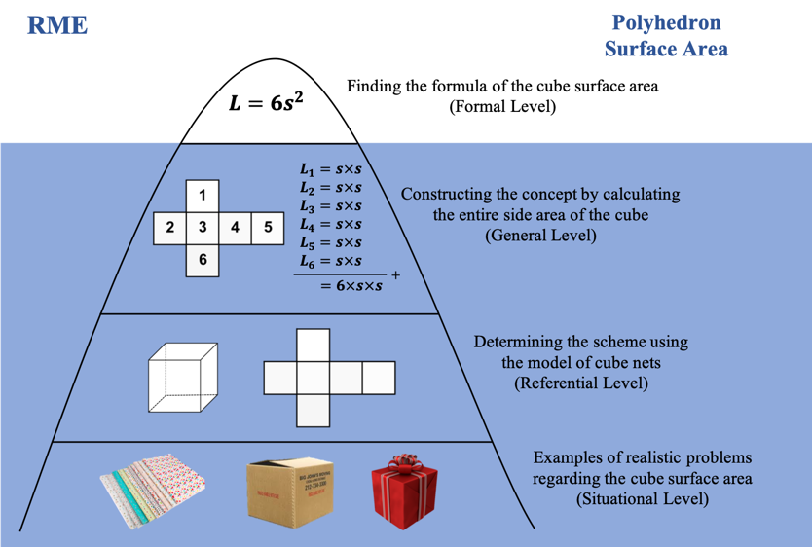

**Figure 1**. Activities for Finding the Concept of Cube Surface Area

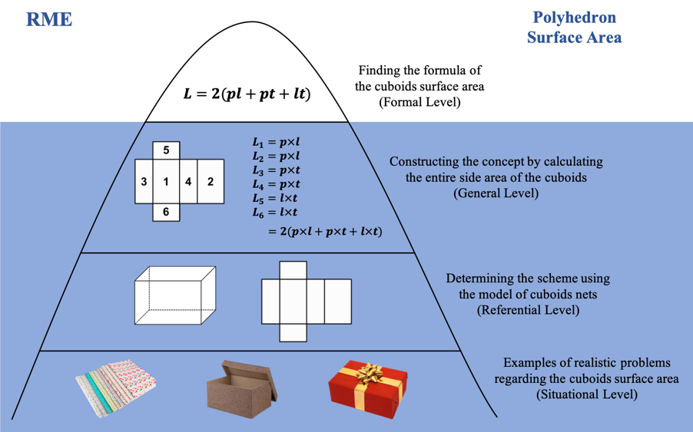

**Figure 2**. Activities for Finding the Concept of Cuboids Surface Area

The design of learning sets includes lesson plan (RPP), student worksheet (LKS), and its assessment instruments. The lesson plan design process includes determining its identity, determining KI and KD, describing IPK and learning objectives, collecting learning materials, designing learning process, and determining assessment technique. Meanwhile, the worksheet design process consists of designing the worksheet framework, preparing the worksheet features, and collecting references. The design of assessment instruments in the form of learning set assessment sheets, students’ response questionnaires, and conceptual understanding test questions. These designs are in the form of assessment points to assess the quality of the developed learning set.

## Development Stage

The third stage is development stage. This stage includes the development of learning set and assessment instruments, validation, and revision. The lesson plan (RPP) is developed based on the structure of lesson plan’s components according to The Regulation of The Minister of Education and Culture Number 22 of 2016 [24]. Student worksheet (LKS) is developed by taking into account several criteria, namely the compatibility of materials, the compatibility of LKS with didactic conditions, the compatibility of LKS with construction conditions, the compatibility of LKS with technical conditions, the compatibility of LKS with RME approach, and the compatibility of LKS with conceptual understanding indicators. Meanwhile the assessment instruments are developed based on the assessment points that was arranged at the design stage.

The learning set is then validated by 2 validator, which are UNY mathematics education lecturer and junior high school mathematics teacher. After that, the learning set is revised based on the suggestions from the validator. This revision is done in order to improve product quality. The following are the validation results obtained.

**Table 4.** Lesson Plan Validation Results

|  |  |  |  |  |
| --- | --- | --- | --- | --- |
| **Assessment Aspects** | **Validator 1** | **Validator 2** | **Average** | **Criteria** |
| Lesson plan identity | 5,00 | 5,00 | 5,00 | Very Good |
| IPK and learning objectives | 5,00 | 5,00 | 5,00 | Very Good |
| Materials | 4,67 | 4,33 | 4,50 | Very Good |
| Learning approaches and methods | 4,50 | 4,50 | 4,50 | Very Good |
| Learning activities | 4,88 | 4,25 | 4,56 | Very Good |
| Media and learning resources | 4,50 | 4,50 | 4,50 | Very Good |
| Learning assessments | 4,67 | 4,83 | 4,75 | Very Good |
| Language | 4,67 | 4,00 | 4,33 | Very Good |
| Average | 4,77 | 4,55 | 4,66 | Very Good |
| Criteria | Very Good | Very Good | Very Good |  |

**Table 5.** Student Worksheet Validation Results

|  |  |  |  |  |
| --- | --- | --- | --- | --- |
| **Assessment Aspects** | **Validator 1** | **Validator 2** | **Average** | **Criteria** |
| Materials | 5,00 | 3,78 | 4,39 | Very Good |
| Compatibility of LKS with didactic conditions | 4,50 | 3,50 | 4,00 | Good |
| Compatibility of LKS with construction conditions | 4,86 | 4,71 | 4,79 | Very Good |
| Compatibility of LKS with technical conditions | 4,63 | 4,75 | 4,69 | Very Good |
| Compatibility of LKS with RME approach | 4,50 | 3,75 | 4,13 | Good |
| Compatibility of LKS with conceptual understanding indicators | 5,00 | 3,50 | 4,25 | Good |
| Average | 4,78 | 4,11 | 4,44 | Good |
| Criteria | Very Good | Good | Good |  |

**Table 6.** Conceptual Understanding Test Validation Results

|  |  |  |  |  |
| --- | --- | --- | --- | --- |
| **Assessment Aspects** | **Validator 1** | **Validator 2** | **Average** | **Criteria** |
| Questions | 5,00 | 5,00 | 5,00 | Very Good |
| Answer keys and scoring guidelines | 5,00 | 5,00 | 5,00 | Very Good |
| Language | 4,67 | 4,33 | 4,50 | Very Good |
| Average | 4,91 | 4,82 | 4,86 | Very Good |
| Criteria | Very Good | Very Good | Very Good |  |

Based on the tables above, it can be seen that the developed learning set has met the minimum ‘good’ criteria. Therefore, the developed learning set can be said to be valid and can be used in learning with small revision. The validity of the developed learning set shows that the learning set have been developed based on the theories used as guidelines in developing learning tools. In this case, the lesson plan is said to be valid because it has referred to The Regulation of The Minister of Education and Culture Number 22 of 2016 [24], adjusted to the aspects of the worksheet, included the stages in RME approach, as well as activities to improve students’ conceptual understanding. Student worksheet is also said to be valid because it has met several criteria, namely compatibility of materials, the compatibility of LKS with didactic conditions, the compatibility of LKS with construction conditions, the compatibility of LKS with technical conditions, the compatibility of LKS with RME approach, and the compatibility of LKS with conceptual understanding indicators.

## Implementation Stage

The fourth stage is implementation stage. The implementation of RME learning set, which are lesson plan (RPP) and student worksheet (LKS), in polyhedron subject was carried out at SMP N 9 Yogyakarta to 31 students of class 8B. This activity was carried out from March 13 2020 to April 13 2020. The learning activities were carried out in 7 meetings with 5 meetings for the implementation of learning and 2 meetings for the implementation of pretest and posttest.

The learning activities were carried out face-to-face and online. Face-to-face learning was carried out 2 times. This face-to-face learning activities are done according to the activity design contained in the previous lesson plan, which includes preliminary activities, core activities, and closing activities. Meanwhile, online learning was carried out 5 times. Online learning was done because face-to-face learning is not possible because of the covid-19 pandemic. This online learning used student worksheet that had been given at previous meetings and was done using WhatsApp Group (WA) as a medium for discussion and Google Classroom (GC) as a medium for collecting discussion results and posttest. This online learning also includes preliminary activities, core activities, and closing activities. Before implementing online learning, several preparations were done. One of these preparations is making lesson plan for online learning. This lesson plan consisted of 4 meetings and adjusted to the previous lesson plan. This lesson plan was then consulted in order to get some improvements.

## Evaluation Stage

The last stage is evaluation stage. At this stage, the revision of learning set is carried out based on the students’ suggestions, the results of students’ answers in the worksheet, and the results of the evaluation at the implementation stage. One of the revision made was the revision of some incorrect use of words in the worksheet, which could lead to confusion among students. Besides that, revision was made to the question on page 45. The revision made were in the form of adding question descriptions so that students could more easily understand the problem given. This was done because the majority of students gave the wrong answer or the answer that does not meet the expectation.

In addition, at this stage, analysis of practicality and effectiveness of the developed learning set are also carried out. The following are the analysis results obtained.

**Table 7.** Practicality Analysis Results

|  |  |  |
| --- | --- | --- |
| **Assessment Aspects** | **Average** | **Criteria** |
| Convenience | 4,09 | Good |
| Assistance | 3,93 | Good |
| Attractiveness | 4,21 | Very Good |
| Average | 4,04 | Good |
| Criteria | Good |  |

Based on the table above, it can be seen that the developed learning set has met the minimum ‘good’ criteria. Therefore, the developed learning set can be said to be practical. It means that there is a convenience and assistance felt by students by using the developed learning set during learning process.

**Table 8.** Effectiveness Analysis Results

|  |  |  |
| --- | --- | --- |
| **Aspect** | **Pretest Results** | **Posttest Results** |
| **Students’ scores** | | |
| 1. Highest score | 77 | 100 |
| 1. Lowest score | 10 | 43 |
| 1. Average | 38,52 | 73,35 |
| **Students’ mastery learning** | | |
| 1. Number of students who have reached KKM | 5 | 19 |
| 1. Number of students who have not reached KKM | 26 | 12 |
| 1. Percentage | 16% | 61% |
| 1. Criteria | Very poor | Good |

Based on the table above, it can be seen that the average score from pretest to posttest has increased, from 38,52 50 73,35. In addition, the percentage of students’ mastery learning in posttest has met the ‘good’ criteria, which is 61%. Therefore, the developed learning set can be said to be effective. It means that the developed learning set has been able to improve students’ mathematical concepts understanding, especially in polyhedron subject.

1. Conclusion

Based on the results of data analysis and the discussion that have been carried out, the conclusions of this study are as follows. (1) The learning set, including lesson plan (RPP) and student worksheet (LKS), with Realistic Mathematics Education approach in polyhedron subject to improve mathematical concepts understanding skills uses ADDIE model, namely Analysis, Design, Development, Implementation, and Evaluation. (2) The learning set, including lesson plan (RPP) and student worksheet (LKS), with Realistic Mathematics Education approach in polyhedron subject to improve mathematical concepts understanding skills meets validity aspect based on the validator assessments, practicality aspect based on students’ response questionnaire, and effectiveness aspect based on the results of mathematical concepts understanding test.

References

1. Kemendikbud 2014 *Peraturan Menteri Pendidikan dan Kebudayaan Nomor 58 Tahun 2014* (Jakarta: Kemendikbud)
2. Lestari K E and Yudhanegara M R 2017 *Penelitian Pendidikan Matematika* (Bandung: PT Refika Aditama)
3. National Research Council 2001 *Adding It Up: Helping Children Learn Mathematics* (Washington DC: National Academy Press) p 5
4. Sanjawa W 2008 *Perencanaan dan Desain Sistem Pembelajaran* (Jakarta: Kencana) p 125
5. Ghazali N H C and Zakaria E 2011 Students’ procedural and conceptual understanding of mathematics *Aus. J. Basic. Applied. Sci.* **5** 684-91
6. Santrock J W 2011 *Psikologi Pendidikan (Ed 3 Book 2)* ed R Oktaviani (Jakarta: Salemba Humanika) p 2
7. Andamon J C and Tan D A 2018 Conceptual understanding, attitude and performance in mathematics of grade 7 students *Int. J. Sci. Tech. Research.* **7** 96-105
8. Nugraheni E A and Sugiman 2013 Pengaruh pendekatan pmri terhadap aktivitas dan pemahaman konsep matematika siswa smp *Pythagoras. J. Pend. Mat.* **8** 101-8
9. Mullis I V S, Martin M O, Foy P and Arora A 2012 *TIMSS 2011 International Results in Mathematics* (Netherlands: TIMSS & PIRLS International Study Center) p 462
10. Suparno P 2001 *Teori Perkembangan Kognitif Jean Piaget* (Yogyakarta: Penerbit Kanisius) p 25
11. Santrock J W 2011 *Psikologi Pendidikan (Ed 3 Book 1)* ed R Oktaviani (Jakarta: Salemba Humanika) p 61
12. World Bank 2010 *Inside Indonesia's Mathematics Classrooms: A TIMSS Video Study of Teaching Practices and Student Achievement* (Washington D.C.: World Bank Group) p 50-4
13. Makonye J P 2014 Teaching functions using a realistic mathematics education approach: a theoritical perspective *Int. J. Edu. Sci.* **7** 653-62
14. Hidayat R and Iksan Z H 2015 The Effect of realistic mathematic education on students’ conceptual understanding of linear programming *Creative. Edu.* **6** 2438-45
15. Lestari L and Surya E 2017 The effectiveness of realistic mathematics education approach on ability of students’ mathematical concept understanding *Int. J. Sci. Basic. Applied. Res. IJSBAR.* **34** 91-100
16. Gravemeijer K and Doorman M 1999 Context problems in realistic mathematics education: a calculus course as an example *Edu. Stud. Math.* **39** 111-29
17. Van den Heuvel-Panhuizen M and Drijvers P 2014 Realistic mathematics education *Encyclo. Math. Edu.* 521-34
18. Wijaya A 2012 *Pendidikan Realistik Suatu Alternatif Pendekatan Pembelajaran Matematika* (Yogyakarta: Graha Ilmu)
19. Van den Heuvel-Panhuizen M 2003 The didactical use of models in realistic mathematics education: an example from a longitudinal trajectory on percentage *Edu. Studi. Math.* **54** 9-35
20. Sugiman 2011 Peningkatan Pembelajaran Matematika dengan Menggunakan Pendekatan Matematika Realistik
21. Mulyatiningsih E 2011 *Riset Terapan Bidang Pendidikan dan Teknik* (Yogyakarta: UNY Press) p 184-6
22. Widoyoko E P 2017 *Evaluasi Program Pembelajaran: Panduan Praktis bagi Pendidik dan Calon Pendidik* (Yogyakarta: Pustaka Pelajar) p 238
23. Puspendik Laporan Hasil Ujian Nasional https://puspendik.kemdikbud.go.id/hasil-un/
24. Kemendikbud 2016 *Peraturan Menteri Pendidikan dan Kebudayaan Nomor 22 Tahun 2016* (Jakarta: Kemendikbud)