Development of College Student Reasoning : Representation of Proof in Trigonometry Course

R. Rosnawati1, Caturiyati2, Himawati Puji Lestari3

1,2,3Lecturer, Department of Mathematics Education, Yogyakarta State University

[rosnawati@uny.ac.id](mailto:rosnawati@uny.ac.id). [caturiyati@uny.ac.id](mailto:caturiyati@uny.ac.id), [himawatipl@uny.ac.id](mailto:himawatipl@uny.ac.id)

**Abstract.** The purpose of this study was to describe the reasoning abilities of mathematics education students in developing the ability to compile a proof and to investigate changes in the ability to compile a proof after attending trigonometry courses. In this qualitative descriptive study, 60 mathematics education students were conducted. Proofing skills are investigated in relation to direct proof. As a result it can be concluded that the student's proofing skills at qualifications are sufficient. Based on the results of the study, it is recommended to make general teaching methods in mathematics education student lectures.

1. Introduction

Reasoning is an important part of all disciplines and plays a special role and fundamental in mathematics. In the most general terms, reasoning can be thought of as the process of drawing conclusions based on the evidence or assumptions established to obtain truth, whereas the activity of reasoning is the process of logical thinking. Reasoning in mathematics includes informal reasoning and formal reasoning (Viholainen, 2007). One indicator of formal reasoning is taking logical conclusions from assumptions and definitions in the evidentiary process. The formal reasoning used in proof requires them to explore and the properties that exist in mathematics to make arguments. Proving activities are also carried out in mathematics learning at school.

Without considering specific constructs of evidence, students can use formal reasoning to make connections regarding various materials. Mathematical proof is a formal way of expressing certain types of reasoning and justification (NCTM, 2000: 56-58). Evidence serves to (1) explain why certain mathematical results must be correct, (2) develop autonomous learners by providing the skills needed to evaluate the validity of their own and others' reasoning, and (3) reveal connections and provide insight into the underlying structures of mathematics (3) (Knuth, 2000). The ability to prove requires reasoning, mathematics teachers and even prospective mathematics teachers should have good reasoning, because later it will be tasked with developing students' reasoning abilities.

The results showed the students have little understanding of evidence and difficulties in building it yourself (Stylianides, 2010; Miyazaki, et.al 2017). The performance of students' mathematical arguments in the field of trigonometry is largely imprecise (Maknun et.al., 2018). Student learning outcomes are highly correlated with the teacher's ability to explain, there is a substantial positive effect of knowledge of pedagogical content on student learning outcomes (Baurment, et al. 2010). It is necessary to prepare the ability of teachers and teacher candidates even showed proof material in schools, one of which is trigonometry. This implies that mathematics learning activities in the class did not support the reasoning abilities of students, especially the reasoning in the proof of evidence either directly or in the form of conjecture.

Proof is a sequence of logical an arguments, the statement implies the other, which would explain why a given statement is true. To prove it can use the theorem that has been proven before to deduce new ones, or it can also refer to axioms which are true statements that are accepted by everyone. Until it shows proof of truth, that statement is never accepted as true. Mathematical proof is absolute, which means that once the theorem is proven, it is proven forever.

In college, starting from the day of learning, generally the lecturers will be very careful with their explanations, every word will be defined, notations are presented clearly and every theorem is proven. Based on previous studies, learning activities in tertiary institutions with activities that include evidentiary activities will develop student reasoning. However, several study results show that the ability of students to construct formal evidence is not sufficient (Nadilah, 2017). In the trigonometry course, generally the presentation of material begins with the concept of trigonometry comparisons and trigonometric functions, as well as theorems that most students have known during high school, the presentation of proof can be found in several high school mathematics resource books.

In higher education, students are facilitated to learn to prove theorems, either using direct evidence, indirect evidence or by mathematical induction. To show proof of a theorem, logical reasoning is used, namely drawing conclusions through a series of correct statements and mathematical statements including axioms, definitions, theorems, lemmas, and consequences. The theorem that has been proven before can be used to prove new theorems, or the proof can refer to an axiom which is a truth that can be accepted by everyone. The hope is that in proving learning lectures it will bring increased reasoning, but in one study it has been shown that evidence is often seen by students as complete learning and memorizing facts and procedures.

Constructing proof of theorems requires correct logical reasoning and mathematical statements covering axioms, definitions, theorems, lemmas, and corollary. Proof is a sequence of logical statements, that one implies the other, which would explain why a given statement is true. The theorems which have been proven previously can be used to deduce new theorems; one can also refer to axioms, which are starting points, "rules" that are accepted by everyone. In proof it is possible to form new statements from existing statements. The formation of new statements generally uses logical operators. Logical operators (or conjunctions) in mathematical statements are words or combinations of words that combine one or more mathematical statements to create new mathematical statements. A combined statement is a statement that contains one or more operators, generally the operators used are disjunction, conjunction, implication.

The sum and different identities is one of the items in trigonometry given in Senior High School. In some textbooks, the proof of the sum and different identities is found, so it can be assumed that the proof of the sum and different identities has been given in mathematics class in Senior High School. The proof is shown using the previously proven theorem that rules for the cosine and the distance between two points. To facilitate proof, usually a picture is presented as shown in Figure 1, delivery of evidence at the school level shows an effort to develop students' reasoning. The number angle is a material in lectures in the mathematics education department, the presentation of proof is enriched with various ways of proof, one of the proofs using trigonometric comparisons (Schaums, 2016) is shown in Figure 2. Determining the area of ​​a triangle with the radius of the circle in the triangle is new obtained by students. Determination of the length of the radius of the circle in a triangle was introduced when proving the sine rule, with the help of Figure 3. Based on this situation, students' understanding of trigonometry and student reasoning was quite good.

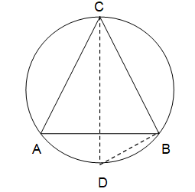

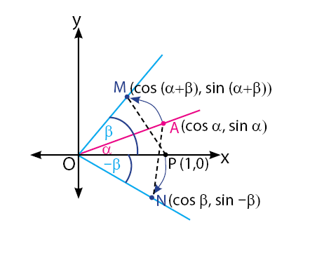

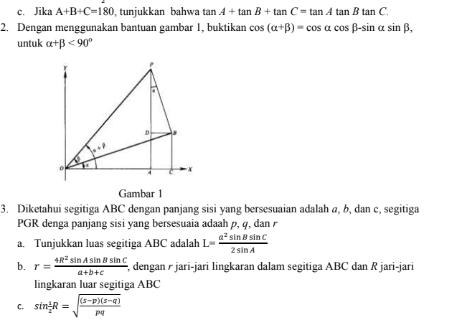

Figure 1 Figure 2 Figure 3

Construction evidence refers to the ability of students to build a deductive argument that links logical statements that are formed using a mathematical conclusion (Stylianides, 2007). When carrying out evidence construction, students demand analytical mastery using their mathematical knowledge to connect arguments to evidence, so that the logical validity of the evidence is obtained (Weber & Alcock, 2004).

Method

Researchers have worked with sixty students taking courses in algebra and trigonometry. During the lecture, the presentation of evidence was presented in several ways to provide insights to students regarding various alternative proofs. The reasoning instrument was developed in order to see the arguments prepared by students, namely in the form of direct proof questions. Direct proof is the simplest proof, because it does not require special techniques. Arguments are constructed using a series of simple statements, each of which must follow directly from the previous one. It is important not to skip any steps as this can lead to gaps in reasoning. To prove a hypothesis, one can use axioms, as well as predefined statements from different theorems

Two things designed in the instrument consist of proof that has been presented in the lecture, proof as part of the proof that has been presented in the lecture, and proof of statements that have not been presented in the lecture. The following is an indicator of the questions being developed

1. Show evidence of the rule for the number of two angles

2. Show proof of the length of the radius of the inner circle of the triangle

3. Show proof of the area of ​​a triangle involving the radius of the circle in the triangle

4. Prove the truth of statements in trigonometry

The assessment rubric in this proof uses 3 aspects, namely readability, validity, and fluency (Brown, 2010). Readability is related to the presentation of a series of statements that are coherent so that they do not appear to jump, validity is related to the correct use of logic, fluency is related to the correct use of notation and terminology.

Results and Discussion

The percentage of students who answered to the correct point is presented in chart 1 below. There are only 1 out of 4 evidentiary problems that can be answered by students with more than 50%, while the rest is less than 50%. This shows that the ability of students to show evidence is still not good. To be able to show proof requires deductive reasoning skills. From this data, it shows that students' reasoning skills are still not good.

Figure 4

From the data presented, only 22.5% of students were able to show the correctness of the number angle rule using trigonometric comparisons. The problem given is proving the number angle rule by using certain restrictions, namely by involving trigonometric comparisons, where this proof is generally only introduced in lectures. The low ability of students to prove the theorems that have been conveyed in class, shows that they still consider proof in class to be memorizing facts and procedures (Law, et.al, 2017). Some present evidence presented informally, this shows that the presentation of evidence is influenced by their own knowledge (Bronkhorst et. Al., 2019), proving by using what has to be proven (Noto, et al. 2019) as presented in Figure 5. Proof by informal is not recommended in lectures, although in school mathematics this proof is often given.

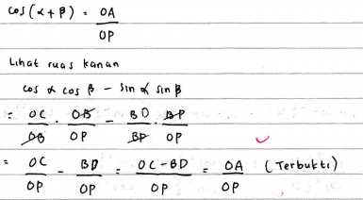

Right side

Left side

Figure 5

Construction in proving the determination of the area of a triangle presented by students uses two theorems or statements that have been previously proven. Another activity is to perform algebraic manipulation for conclusions. In this proof there were 66.5% who answered correctly, it was found that some students had difficulty building a relationship between the two theorems, they could not decide how to start the proof (Guler, 2016). In this problem the argument used is to use the following two things, that is *L* = $\frac{1}{2}ab\sin{C}$ and the sine rule $\frac{\sin{A}}{a}=\frac{\sin{B}}{b}=\frac{\sin{C}}{c}$, the logic used is to use disjunction and implication, in this case deductive reasoning is used. One of the arguments prepared by the students is presented in Figure 5 below.

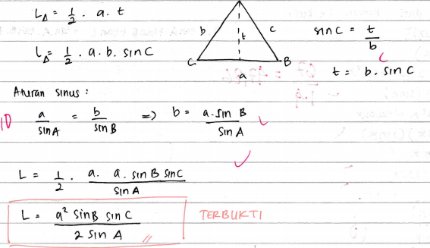

Statement 1 and 2 are true

Statement 2 is true

Statement 1 is true

Figure 6

Often mistakes in the evidence presented, do not pay attention to the necessary conditions that must be given (Stavrou, 2014), in this case it is interpreted by the presentation of a statement that shows weaknesses in the aspect of fluency. The following proof of evidence will be perfect, if the arguments given are presented the necessary conditions, that is tanA.tan B ≠ 1 (see Figure 7).

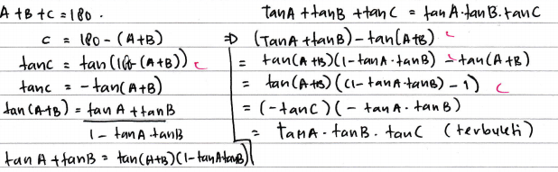

required conditions *tan*A.*tan* B ≠ 1.

Figure 7

The percentage of students who answered correctly related to the radius of the outer circle of the triangle was the lowest compared to other proofs. In the problem of proof, this is to show the radius of the inner circle of the triangle if we know the three-fold shrinkage of the triangle. The radius of the inner circle is introduced when students learn the proof of sine rule. This makes it difficult for students to see how to find the length of the radius of the outer circle of the triangle, when viewed from the length of the sides of the triangle and the angles in the triangle, it can be assumed that students do not understand each step of the proof in class, in addition to reasoning. It takes student connection skills related to concepts that have been previously studied (Demir, et. al, 2018). One of the arguments presented by the students in proving the radius of the outer circle of the triangle is shown in Figure 8.

Conclusion

Presentation of evidence of a theorem in mathematics learning is intended to develop the reasoning abilities of prospective teacher students. This reasoning ability is needed so that prospective teachers who have the task of being able to develop students' mathematical reasoning abilities. Care is needed in presenting evidence in lectures to emphasize each step of evidence, so as not to make the delivery of evidence in lectures limited to facts and procedural matters. Various alternatives of formal proof need to be presented so that students are able to develop formal reasoning.

Reference

Ayers, F. Moyer R. 2016. *Trigonometry*. Schum’s outlines. Singapora: Mc Graw Hill

Baumert, J, Kunter, M., Blum, W., Brunner, M., Voss, T., Klusman, U., Krauss, S., Neubrand, M, Tsai., Y.M. 2010. Teachers’ Mathematical Knowledge, Cognitive Activation in the Classroom, and Student Progress. *American Educational Research Journal March* 2010, Vol. 47, No. 1, pp. 133–180.

Bronkhorst, H. Roorda, G. Suhre2, C., Goedhart1, M. 2019. Logical Reasoning in Formal and Everyday Reasoning Tasks . *International Journal of Science and Mathematics Education*.

Brown, D.E. Michael, S. 2010. Assessing Proofs With Rubrics: the RVF Method. *Proceeding* of the 13th Annual Conference on Reseach in Undergraduate Mathematics Education.

Gershenson, S. 2016. Linking Teacher Quality, Student Attendance, and Student Achievement. *Finance and Policy*. Volume 11, No 2.

Guler, G. 2016. The Difficulties Experienced in Teaching Proof to Prospective Mathematics Teachers: Academician Views. *Higher Education Studies*; Vol. 6, No. 1; pp. 145-158

Law, F.F., Shahrill, M., Mundia, L. 2015. Investigating Students’ Conceptual Knowledge and Procedural Skills in the Learning of College Level Trigonometry. *Research Journal of Applied Sciences, Engineering and Technology* 9(11): 952-962, 2015

Stronge, J.H, Ward, T.J., Tucker, P.D, Hindman, J. 2008. What is the Relationship Between Teacher Quality and Student Achievement? An Exploratory Study. [*Journal of Personnel Evaluation in Education*](https://www.researchgate.net/journal/0920-525X_Journal_of_Personnel_Evaluation_in_Education). 20(3):165-184

Maknum, C.L, Rosjanuardi, R., Ikhwanudin, T. 2018. Students’ Mathematical Argumentation In Trigonometry. Proceedings of INTCESS2018- 5th *International Conference on Education and Social Sciences* 5-7 February 2018- Istanbul, Turkey.

Miyazaki, M., Fujita, T., Jones, K. 2017. Students’ understanding of the structure of deductive proof. Educ Stud Math (2017) 94:223–239

Nadilah., M. Prabawanto, S. 2017. Mathematical Proof Construction: Students’ Ability in Higher Education. *Journal of Physics*: Conf. Series 895 (2017) 012094. pp. 1-5. doi :10.1088/1742-6596/895/1/012094.

Noto, M.S. Priatna, N., Dahlan, J.A. 2019. Mathematical proof: The learning obstacles of Preservice Mathematics Teachers On Transformation Geometry. *Journal on Mathematics Education*. Volume 10, No. 1, January 2019, pp. 117-126.

Stavrou, S.G. 2014. Common Errors and Misconceptions in Mathematical Proving by Education Undergraduates. *IUMPST*: The Journal. Vol 1, pp 1-8.

Viholainen, 2007. Students’ Choices Between Informal and Formal Reasoning in a Task Concerning Differentiability. *Proceeding*. CERME 5 (2007)

Weber., K. 2001. Student Difficulty in Constructing Proofs: The Need for Strategic Knowledge. Educational Studies in Mathematics , 2001, Vol. 48, No. 1 (2001), pp. 101-119

Weber, K. & Mejia-Ramos, J.P. 2011. Why and how mathematicians read proofs: an exploratory study. *Educational Studies in Mathematics*, April 2011, Vol. 76, No. 3 (April 2011), pp. 329-344

Weber, K., & Alcock, L. (2004). Semantic and syntactic proof productions. Educational Studies in