The Role of Abstraction Ability in Mathematical Problem Solving

S Ningsih2 and K Hidayati2

1Mathematics Education Postgraduate Program, Universitas Negeri Yogyakarta, Sleman, Indonesia

2Mathematics Education Study Program, Faculty of Mathematics and Natural Sciences, Universitas Negeri Yogyakarta, Sleman, Indonesia

E-mail: 1sriningsih.2019@student.uny.ac.id, 1sriningsihid@gmail.com, 2kana@uny.ac.id

**Abstract**. Problem-solving is the ability that involves a cognitive process in solving a problem with several stages, understanding the problem, planning problem-solving strategies, implementing the chosen solution strategy, and re-examining problem-solving. Abstraction is the process of constructing a new structure to find new concepts or strategies that can be used in solving problems. Abstraction plays an important role in the process of solving mathematical problems, students can solve problems if mathematical concepts are well embedded. The abstraction process is fundamental in embed the initial concepts of mathematics. Abstraction stages are divided into four stages, recognition,the representation,structural abstraction and the highest stage is the awareness of the structure.

1. Introduction

Mathematics is a subject that trains thinking to be able to solve problems, even the purpose of learning mathematics is to develop problem-solving skills both simple math problems and complex math problems [1]. Problem-solving is one of the abilities that is considered important in the learning process, some countries make problem-solving as the center of the curriculum. In Indonesia, it is specifically mentioned that every student must have the ability to solve problems in everyday life and to use the right strategies to solve real or contextual problems. In solving problems, it involves cognitive and affective processes so that there is an interaction between knowledge and the problems encountered.

Students can solve problems if mathematical concepts are embedded properly. The abstraction process is fundamental in embed the initial concepts of mathematics [2]. Abstraction is a basic step in creating that concepts so new objects emerge [3]. In line with Mitchelmore and White [4] also define abstraction is an activity of vertical reorganization of mathematical concepts that have been constructed previously through a new mathematical structure. This means that the abstraction process constructs a new structure to find new concepts or strategies that can be used in solving problems. For example, natural numbers are abstracted as a counting process or a process matching, then the natural numbers are used as objects to construct integers through abstraction, so rational numbers, real numbers, and complex numbers are built through the abstraction process.

Piaget [5] states that in abstraction there is a three-part(their tripartite theory), empirical abstraction is centered on how students can construct the meaning of the properties of an object, pseudo empirical abstraction is centered on how students construct meaning the properties of action on objects, reflective abstraction is centered on the idea of ​​action and operation into thematic objects of thought or assimilation related to the categorization of mental operations and abstraction of mental objects. The three-part (their tripartite theory) is interrelated with one another, but the main focus is on how students can develop reflective abstraction. When students carry out activities or in the process of reflective abstraction, it means that these students construct conceptual knowledge.

1. Discussion

## *Mathematical Problem Solving*

Problem-solving is one of the abilities expected of students and even the National Council of Mathematics Teachers (NCTM) states that learning mathematics is designed to make students become problem solvers [6]. This shows how important it is for students to have problem-solving abilities so that many countries include problem-solving as a central competency in the curriculum. OECD (2013) in the framework of assessment and analysis of PISA 2012 defines problem-solving as a competency that involves a person in the process of cognitive understanding and solving problematic situations [1].

Hesse states that problem-solving is a series of hierarchical steps that begin with examining problems to be identified, recognizing patterns and relationships between elements, and formulating them into rules, these rules are then generalized and generalizations tested for alternative results that are said to be problem solvers, and finally testing hypotheses [7]. Mathematical problem-solving abilities of students can be defined as the ability of students to understand problems, plan problem-solving strategies, carry out the chosen resolution strategy, and re-check the problem solving to then make solutions systematically and inseparably with an accurate representation of the problem [8]. By having problem-solving abilities, students are expected to be able to adapt with new conditions and face life's difficulties, and apply problem-solving processes in everyday life.

The steps for solving mathematical problems according to Polya (1973) consist of four steps, including [9]:

1. Understanding the problem: at this stage students can understand the problem, identify existing problems, sort information on the problem which is then used in the solving process problem. If needed, students can also describe the situation with the right notation. The process of understanding the problem can affect the ability of students to solve problems.
2. Develop a plan: at this stage, students can find the relation between existing information and previous similar problems. It takes a provision for prior knowledge related to relevant material.
3. Carry out the plan: At this stage students carry out the plans that have been prepared following the previous stages.
4. Re-checking: at this stage students re-examine the problem-solving procedure that has been carried out. This stage is very important to avoid inaccuracy in the previous stages.
   1. *Abstraction in Mathematical Problem Solving*

Abstraction has two meanings, namely as a process of 'describing' a situation and a concept as a result of a process [10]. Abstraction will only occur from some objects if it removes properties or features that are not important [11], abstraction occurs when from several objects then the characteristics or properties are "dropped" considered insignificant, and finally only pay attention to or take the important properties that they have together. Abstraction starts from a collection of objects, then grouped by its relations and properties that are considered important. The results of the abstraction consist of a set of all objects that have important properties and relations so that the abstraction is a process of decontextualization [12]. Abstraction has the main characteristic of finding the same or general properties of a set [13].

Mathematical problem solving is a complex mental process, requiring visualization, imagination, manipulation, analysis, abstraction and statement of ideas [14]. Piaget explained that abstraction occurs because of 'mental action' which is influenced by mental concepts [12]. This mental concept is driven by the mental operation of the object captured by the mind, as shown in the following diagram:

Object

Captured thoughts mental

Operations mental

Mental concepts

Mental action

Abstraction

Figure 1: diagram mental concept

Piaget distinguishes abstraction into three parts, empirical abstraction, pseudo-empirical abstraction and reflective abstraction. Inreflective abstraction, students construct conceptual knowledge, this is following the constructivist theory which states that a person's knowledge is a person's construction. Stages of reflective abstraction activity by Cifarelli (1988) is divided into four stages, recognition, the representation, structural abstraction and the highest stage is the awareness of structure [15].

Table 1 characteristics in the abstraction stage

|  |  |
| --- | --- |
| Stages of abstraction | Characteristics |
| Recognition | Recall and re-identify previous activities related to the problems encountered. |
| Representation | Writing and translating information in mathematical notation as well as executing alternative possible methods of solution. |
| Structural Abstraction | Revolutionizing, developing strategies, anticipating difficulties, and organizing problem structures in the process of problems. |
| Structural Awareness | 1. Realize its capabilities and similarities in anticipation of problem-solving outcomes without running all the thought activities. 2. Give arguments or reasons for decisions made. 3. Realize the difficulties during the completion process when using alternative methods of completion. 4. Reflecting on the decisions obtained for subsequent activities. 5. Able to show summary of its activity during problem-solving. |

When students solve a problem, it means that these students are aware of what is being abstracted. In this case, it is necessary to pay attention to whether students can express their activities in solving problems. The following is an example of the role of abstraction in solving mathematical problems:

Determine the surface area of ​​the shape below:

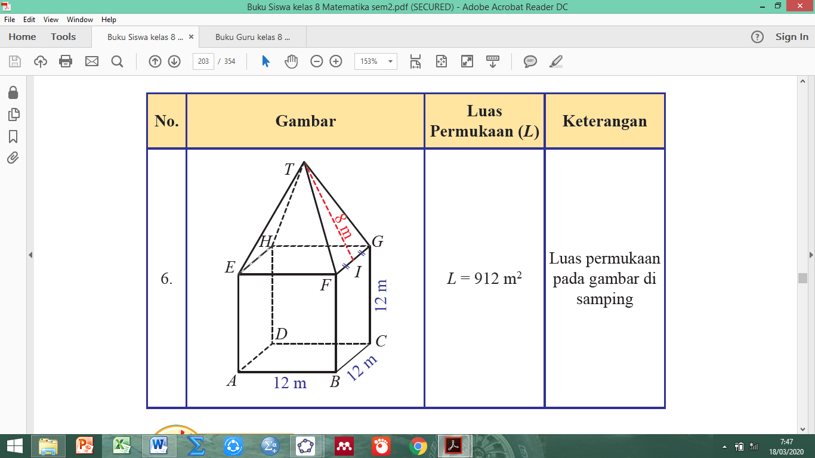

Figure 2: shape ABCDEFGHT

**Understand the problem:**

1. Choose and write down the information of the problem according to the need to solve the problem
2. Write down what is asked about the problem using notation or symbols of mathematics

You know: Build space in the form of a cube with a pyramid-shaped cover

Length of a side of the cube = 12 cm

Height of triangle FGT = 8 cm

Wanted: Surface area of ​​the shape?

**Planning Problem Solving**:

1. Using known information to determine the settlement strategy
2. Writing down a predetermined settlement strategy.

To determine the area of ​​the shape, it can add up the area of ​​each side that limits the space. The geometrical form is a cube with a pyramid-shaped cover

**Resolving issues as planned:**

Resolving problems by continuing with a predefined strategy

**

**Checking back the results obtained:**

1. Conclude from the results of problem-solving strategies
2. Check back results settlement with the other strategies

So broad wake of the space is 912 cm2

Summary results of abstraction in problem-solving will be presented in the following:

Table 2 Summary results of abstraction in problem-solving troubleshooting steps

|  |  |  |
| --- | --- | --- |
| Toubleshooting steps | Stages abstraction | Characteristics and activities |
| Understanding the problem | Recognition | Identify and reorganize the structure of the encountered problem. |
| Representation | Stating what relationship is known with what is being asked. |
| Structural Abstraction | Developing a new strategy for a problem, which has not been used previously.  Organizing the structure of mathematical problems in the form of compiling, organizing, and developing. |
| Structural awareness | Provides reasons for each step or procedure used and summarizes in a structured and systematic manner the problem-solving process. |
| Planning for problem-solving | Recognition | The results of identification are used to plan and translate or transform information for the problem-solving process. |
| Representation | Are students planning correctly? Have represented in the form of pictures and understand the structure of the problem. |
| Structural Abstraction | Developing a new strategy for a problem, which has not been used previously.  Organizing the structure of mathematical problems in the form of compiling, organizing, and developing. |
| Solve problems according to the procedure | Recognition | Predetermined and use alternatives or different problem-solving strategies. |
| Representation | Is planning properly? Has represented in the form of an image and solved the problem. |
| Structural Abstraction | Develop new strategies for a problem, which has not been used before.  Organizing the structure of mathematical problems in the form of compiling, organizing, and developing |
| Structural awareness | Provides reasons for each step or procedure used and summarizes in a structured and systematic manner the problem-solving process. |
| Review the results obtained | Recognition | Identify or recall the results obtained. |
| Representation | Is planning properly? Has represented in the form of an image and solved the problem. |
| Structural Abstraction | Developing a new strategy for a problem, which has not been used previously.  Organizing the structure of mathematical problems in the form of compiling, organizing, and developing. |

1. Conclusion

Abstraction plays an important role in the process of solving mathematical problems, students can solve problems if mathematical concepts are embedded properly. The abstraction process is fundamental in planting the initial concepts of mathematics. Problem-solving is the ability that involves cognitive processes in solving a problem by understanding the problem, planning problem-solving strategies, implementing the chosen resolution strategy, and re-examining problem-solving. In problem-solving involves a complex mental process where the ability to describe, manipulate, abstract, and analyze ideas required. Abstraction occurs because 'mental action' is influenced by mental concepts, this mental concept is moved by mental operations of the object captured by the mind.

References

1. Psycharis, S., & Kallia, M. (2017). The effects of computer programming on high school students’ reasoning skills and mathematical self-efficacy and problem solving. *Instructional Science*, *45*(5), 583–602. https://doi.org/10.1007/s11251-017-9421-5
2. Merliza, P. (2016). Peranan Kemampuan Abstraksi Peserta Didik dalam Pembelajaran Matematika Melalui Soal Rich Context Persamaan Linear Dua Variabel. *PRISMA, Prosiding Seminar Nasional Matematika*, 104–110. https://journal.unnes.ac.id/sju/index.php/prisma/article/view/21436
3. Ferrari, P.L. 2003. Abstraction in Mathematics. *Philosopical Transtions of the Royal. Society*. London. 358, 1225-1230.
4. Mitchelmore, M & White P. 2004. Development of angle concepts by progressive abstraction and generalization. *Eductional Studies in Mathematics*, 41(3), 209-238.
5. Wiryanto. (2014). Level-Level Abstraksi dalam Pemecahan Masalah Matematika. *Jurnal Pendidikan Teknik Elektro*, *3*, 569–578.
6. Amir, M. F., Hasanah, F. N., & Musthofa, H. (2018). Interactive multimedia based mathematics problem solving to develop students’ reasoning. *International Journal of Engineering and Technology(UAE)*, *7*(2.14 Special Issue 14), 272–276. https://doi.org/10.31219/osf.io/qx63e
7. Hesse, F., Care, E., Buder, J., Sassenberg, K., & Griffi, P. (2015). A Framework for Teachable Collaborative Problem Solving Skills. *Assessment and Teaching of 21st Century Skills*, 37–56. https://doi.org/10.1007/978-94-017-9395-7
8. Ulandari, L., Amry, Z., & Saragih, S. (2019). Development of Learning Materials Based on Realistic Mathematics Education Approach to Improve Students’ Mathematical Problem Solving Ability and Self-Efficacy. *International Electronic Journal of Mathematics Education*, *14*(2), 331–340. https://doi.org/10.29333/iejme/5721
9. Polya, G. 1973. *How To solve It*. Secon Edition. New Jersey: Princeton Univercity Press.
10. Gray, E. & Tall, D. 2007. Abstraction as a Natural Process of Mental Compression. *Mathematicx Education Research Journal*. Vol. 19, No.2, 23-40
11. Soedjadi, R. 2000. *Kiat Pendidikan Matematika di Indonesia.* Konstatasi Keadaan Masa Kini Menuju Harapan Masa Depan. Jakarta. Direktorat Jenderal Pendidikan Tinggi, Departemen Pendidikan Nasional.
12. Wiryanto. (2014). Level-Level Abstraksi dalam Pemecahan Masalah Matematika. *Jurnal Pendidikan Teknik Elektro*, *3*, 569–578.
13. Hershkowitz,R., Schwarz, B., & Dreyfus, T. 2001. Abstraction in Context. *Journal for Research in Mathematics Education*. Volume 32, Number 2, 2001, 195 – 222
14. Johnson & Rising. 1972. *Guidelines for Teaching Mathematics*. California: Wadsworth publishing Company, Inc.
15. Cifarelli, V. V. 1988. The role of abstraction as a learning process in mathematical problem solving. Doctoral dissertation, Purdue University, Indiana. USA