**What processes underlie the relation between problem solving ability and logical thinking ability?**

**D P Maharani1 and A Mahmudi1**

1Mathematics Education of Postgraduate Program, Yogyakarta State University, Colombo Street, Yogyakarta, Indonesia

[dheanisaprachma.2019@student.uny.ac.id](mailto:dheanisaprachma.2019@student.uny.ac.id)

**Abstract**: Education is primarily aimed at forming individuals to be able to think and solve problems well. There are various general process in problem solving. One of these process is logical thinking. This underlies that problem solving ability and logical thinking ability is important to developed students can solve problems both in mathematical problems and everyday problems. Therefore, this study discussed problem solving ability and logical thinking ability and their relationship. Based on the results of this discussion, it was found that the ability problem solving ability has a relationship with logical thinking ability when viewed from indicators and process of thinking. In other words, we can use instruments that measure logical thinking ability to measure problem solving ability.

1. **Introduction**

Mathematics is a basic science that is developing rapidly both in terms of material and in its use. In addition, mathematics as one of the subjects in schools is considered to play an important role in shaping students to be qualified in thinking to study something logically and systematically. Therefore, learning mathematics in each education unit is expected to be able to foster students' abilities and skills so that they are capable to face various mathematical problems and daily life problems. These abilities are listed in the general objectives of learning mathematics in NCTM [1], namely: 1) problem solving skills; 2) the ability to argue; 3) communication skills; 4) the ability to make connections; and 5) the ability to represent.

Based on the general objectives of learning mathematics by NCTM, it is stated that one of the abilities that students must have is problem solving ability. NCTM [1] also added that problem solving is one of the main focuses on learning mathematics. Hence we need special attention so that students' problem-solving abilities always increase. This problem-solving ability by Robert L. Solso [2] is defined as the ability to think focus and directly to find solutions or a specific problem solutions.

Besides problem solving ability, another ability that needs to be developed is the ability to think logically. The ability to think logically is one aspect of higher order thinking [3]. This ability are required by every individual in an educational environment [4]. The importance of the ability to think logically because these thinking skills include thinking activities based on the knowledge that we build, about what we know and about how to draw conclusions that are done deductively and inductively [5]. Therefore, providing the ability to think in mathematics is very important and needed by students because basically mathematics trains humans to think logically and with mathematics other sciences can develop quickly [6].

Suriasumantri [7] proposed that one of the abilities that is narrowly related to solving mathematical problems is the ability to think logically, which is the ability to find a truth based on certain rules, patterns or logic. Meanwhile problem solving is the cornerstone of school mathematics. For that reason, it is clear that logical thinking ability and problem solving ability are closely related.

In addition, this research will describe how the relationship between logical thinking ability and problem-solving ability is based on their respective characteristics.

1. **Results and Discussion**
   1. Logical Thinking Ability

Logical thinking ability or think rationally is a thinking ability that needs to be developed to optimize left brain development [4]. Logical thinking can also be a way of finding truth in knowledge. This is supported by the opinion of Akhsanul [8] which states that logical thinking ability is the main factor in building a concept and it may be acquired through a series of learning activities. Logical thinking can also be used by individuals when they face with certain problems. Piaget [9] states that logical thinking as mental operations used by individuals when they encounter specific problem.

Several researchers have defined the meaning of the logical thinking ability. One of them is Albrecht [10] states that logical thinking is simply the use of one brunch of statements to support another brunch of statements. Meanwhile, according to Garner [5] who states that logical thinking is to think of the basic knowledge, what we know, and certainly what we can prove. Furthermore, it is also said that to develop logical thinking skills, it is necessary to understand several concepts, they are propositions, premises, arguments, and conclusions. Thus, in mathematics the process of being able to think logically to obtain the correct truth or the process of drawing conclusions is done in a rational way or think inductively and deductively.

Deductive thinking according to Ayalon and Even [11] is unique in that it is the process of inferring conclusion from known information (premise) based on formal logic rules, where conclusions are necessarily derived from the given information and there is no need to validate them by experiments. Meanwhile, inductive thinking is the opposite, to be exact the process of drawing general conclusions from specific things. As Barwise & Etchemendy [12] stated that in science, induction refers to drawing conclusions based on a number of experiments of a specific nature. Furthermore, Albrecht [10] suggests logical steps in solving problems, among others, (1) stepping, solving problems in simple stages, dividing them, then drawing simple if-then conclusions; (2) picturing, drawing sketches, diagrams, or illustrations; (3) rephrasing, stating the problem in a different way so that it is easy to understand; (4) fencing, simplifying conclusions and eliminating irrelevant possibilities; (5) itemizing, listing all known options, possibilities, and setting situations; (6) chaining, arranging a variety of known approach options that look feasible; (7) jumping the track, stopping to reconsider the whole series of problem solving, starting again with a different approach or point of view.

Based on the opinion of the experts, it can be concluded that the logical thinking ability is an activity that aims to find solutions to problems through the investigation of a fact or phenomenon coherently and to make hypotheses or conjectures to reach a conclusion. Some indicators according to some experts will be presented in the following table.

**Table 1. Indicator of the logical thinking ability according to the experts**

|  |  |  |
| --- | --- | --- |
| Author | Year | Indicator |
| Sumarmo | 2010 | 1. Draw analogies, generalizations, and construct conjectures. 2. Draw logically based on inference rules, check the validity of the argument and construct valid arguments. 3. Arrange direct, indirect, and mathematical induction proofs. |
| Damirel | 2013 | 1. Use numbers effectively 2. Provide scientific solutions to problems 3. Detect the separation between the concepts. 4. Classify. 5. Generalize. 6. Represent a math formula. 7. Compute. 8. Provide hypothesis, testing, and simulation. |
| Saragih | 2012 | 1. Understand the meaning. 2. Apply. 3. Analyze. 4. Evaluate. |

Based on the opinions of the experts regarding the indicators of logical thinking ability, it can be concluded that the indicators of logical thinking ability are as follows.

**Table 2. Indicator of the logical thinking ability**

|  |  |
| --- | --- |
| Steps on how to think logically | Indicator |
| Stepping | 1. Classify simple steps 2. Draw a simple if-then conclusion |
| Picturing | 1. Describe the sketches and diagrams 2. Write down the illustrations. |
| Rephrasing | 1. Categorize problems so that they become easy to understand. |
| Fencing | 1. Simplify the conclusions. 2. Discard the irrelevant possibilities. |
| Itemizing | 1. List all the possible approach options. 2. Write down all the possibilities. |
| Chaining | 1. Arrange various options in the form of logical chain. 2. Apply the appropriate approach. |
| Jumping the track | 1. Reconsider selected steps. 2. Evaluate problem solving with different approaches. |

* 1. Problem Solving Ability

Problem solving ability are important skills for students to develop. This is in line with the statement proposed by Branca [13], that problem solving ability is very important because (a) problem solving is the general goal of teaching mathematics, (b) problem solving which includes methods, procedures and strategies is a core and main process in the mathematics curriculum, and (c) problem solving is a basic skill in learning mathematics. In agreement with this, NCTM [1] also states that problem solving is an integral part of learning mathematics, so it cannot be separated from learning mathematics. In addition, Pimta, Tayruakham, and Nuangchalerm [14] stated that mathematical problem is a tool used as not only to help students develop their thinking abilities, but it also helps them to develop their basic skills of solving the problem in daily life.

Krulik and Rudnick [15] state that problem solving is the means by which an individual uses previously acquired knowledge, skills, and understanding to satisfy the demands of an unfamiliar situation. In line with Krulik and Rudnick, Barmby et al. [16] argued that problem solving is the activity called into play when there is a demand to apply knowledge, skills, and experience to unfamiliar situations. Unfamiliar situations or unfamiliar problems are situations or problems that have never been encountered by students and require more ability to solve them. This statement is based on the opinion of Stanic and Kpatrick [2] that non-routine problem solving in characterized as a higher level skill to be acquired after skill at solving routine problems (which, in turn, is to be acquired after students learns basic mathematical concept and skill). Then Van de Walle [9] adds that these non-routine problems are not routine problems that are usually given in learning, but non-routine problems that students do not yet know about the solving procedure and require high-level skills that are attained by students after having an understanding of concepts and basic math skills. Furthermore, Polya [17] states that there are steps to solve the problem, they are, (1) understanding the problem; (2) planning problems; (3) carry out the plan; (4) recheck.

In referring to the experts’ opinions, it can be concluded that problem solving ability is the ability of students to solve problems that are not routine by using previous experience (knowledge) and settlement steps. Some indicators according to some experts will be presented in the following table.

**Table 3. Indicator of problem solving ability according to experts**

|  |  |  |
| --- | --- | --- |
| Author | Year | Indicator |
| NCTM | 2000 | 1. Identify the elements that are known, in question, and the adequacy of the elements needed. 2. Formulate mathematical problems to compile mathematical models. 3. Implement strategies to solve various problems (same types and new problems) in or outside mathematics. 4. Explain or interpret the results according to the original problem. 5. Use math meaningfully. |
| Lestari & Yudhanegara | 2015 | 1. Identify known elements, questions, and adequacy of information. 2. Formulate mathematical problems or compile mathematical models. 3. Implement strategies to solve problems. 4. Enlighten or interpret the results of solving the problem. |
| Wardhani | 2010 | 1. Demonstrate the problem understanding. 2. Organize data and select relevant information in problem solving. 3. Present problems mathematically in various forms. 4. Choose the right problem-solving approach and method. 5. Develop problem solving strategies. 6. Create and interpret a mathematical model of a problem. |

Based on the opinions of the experts regarding the indicators of problem solving abilities, it can be concluded that the indicators of problem solving abilitiy are as follows.

**Table 4. Indicator of problem solving ability**

|  |  |
| --- | --- |
| Problem solving steps | Indicator |
| Understand the problems | 1. Identify what is known. 2. Identify what to ask. 3. Identify the elements of the necessary elements. |
| Plan the problems | 1. Model the problem. 2. Write down the formulas and methods to be used. 3. Formulate the steps that will be used. |
| Carry out the plan | 1. Implement plans and strategies that have been drawn up to solve problems. |
| Check again | 1. Review the answers that have been obtained using other settlement strategies. 2. Conclude the completion of the process that has been carried out. |

* 1. Relationship of Logical Thinking Ability and Problem Solving Ability

Based on the previous description regarding logical thinking skills and problem solving abilities, it can be concluded that there is a relationship between logical thinking skills and problem solving abilities. This can be seen from the relationship between the indicators of each capability. This relationship can be seen in the following chart.

**Chart 1. Relationship of Logical Thinking Ability and Problem Solving Ability**

**Indicator of**

**problem solving ability**

**Indicator of**

**logical thinking ability**

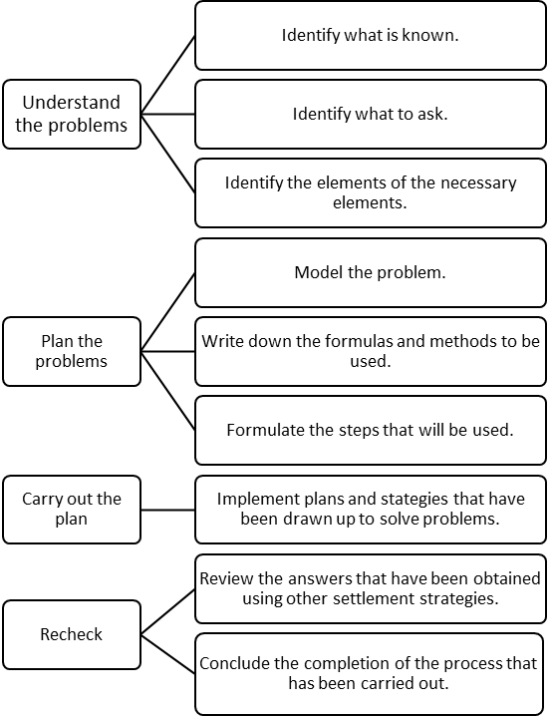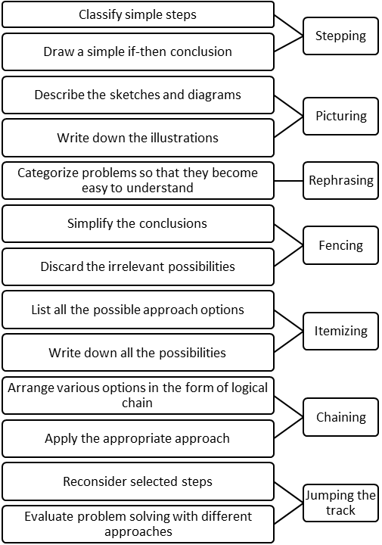

1. **Conclusion**

Based on the several literatures which have been reviewed by researchers, it can be summed up that the ability to think logically has a close relationship with problem solving abilities. This is supported by the opinion of Sinnot in Pezzuti et al. [18] that with the use of logical thinking, one can understand reality and make inferences to solve day-to-day problems when they tend to be ambiguous.

**References**

1. National Council of Teachers of Mathematics (NCTM). 2000. *Principle and Standards for School Mathematics*.
2. Solso, Robert L. dkk. 2007. *Psikologi Kognitif*. Jakarta: Erlangga.
3. King, F.J., Goodson, L., & Rohani, F. 2010. *Higher order thinking skills: definition, teaching strategies, assessment.* Diambil pada tanggal 6 Juni 2020, dari <http://goo.gl/su233T>.
4. Yen, T.S., & Halili, S.H. 2015. Effective teaching of higher-order thinking (HOT) in education. *The Online Journal of Distance Education and e-Learning,* 3 (2), 41-47.
5. Garner, E. 2012. *Thinking skills: Using your brain in the information age ventus publishing aps*.
6. Sumarmo, U. 2010. *Berpikir logis, kritis, kreatif dan budi pekerti: Apa, mengapa, dan bagaimana dikembangkan pada siswa.* Presented at Seminar Nasional Pendidikan Matematika, Universitas Negeri Yogyakarta.
7. Tuna, A., Biber, A. C., & Incikapi, L. 2013. An analysis of mathematics teacher candidates’ logical thinking levels: case of Turkey. *Journal of Educational and Instructional Studies in the World*. 3. 83.
8. Akhsanul In’am. 2016. A Logical Thinking Analysis through the Euclidean Geometry. *Globaal Journal of Pure and Applied Mathematic*, 12, 1069-1075
9. Van De Walle, J. A. 2007. *Elementary and middle school mathematics: teaching developmently (6th ed)*. Boston, MA: Pearson Education, Inc.
10. Albrecht, K. 1980. *Brain Power: Learn to improve your thinking skills.* New York: Prentice-Hall, Inc.
11. Ayalon, M., & Even, R. 2008. Deductive reasoning: in the eye of the beholder. *Educ stud math*, 69, 135-247.
12. Barwise, J. & Etchemendy, J. 1999. *Language, proof and logic.* New York: Spinger Science Business Media.
13. Branca, N.A. 1980. *Problem Solving as Goal, Process and Basic Skills.* In S Krulik and R.E. Reys (Eds). Problem Solving in School Mathematics. Washigton DC: NCTM.
14. Pimta, S. Tayruakham, S., & Nuangchalerm, P. 2009. Factors influencing mathematics problem-solving ability of sixth grade students. *Journal of Social Sciences*, 5(4), 381-385.
15. Krulik, S., & Rudnick, J. A. 1995. *The New sourcebook for teaching reasoning and problem solving in elementary school.* Boston, MA: Allyn & Bacon.
16. Barmby P. Bilsborough, L., Hariries, T., et al 2009. *Primary mathematics teaching for understanding.* London: Mc Graw-Hill Hause.
17. Polya, G. 1973. *How to solve it: A new aspect of mathematical method.* Princeton: Princeton University Press.
18. Pezzuti, L., et al., The relevance of logical thinking and cognitive style to everyday problem solving among older adults, *Learning and Individual Differences*, 36, 218-223, 2014.
19. Lestari, K. E. & Yudhanegara, M. R. 2015. *Penelitian Pendidikan Matematika.* Bandung: PT. Refika Aditama.
20. Schoenfeld, A. 1992. Learning to think mathematics: problem solving, metacognition, and sense making in mathematics. Dalam D.A. Grouws, (Eds.), *Handbook of research on mathematics teaching and learning* (pp. 334-366). New York: Macmillan Publishing Company.
21. Suherman, E., dkk. 2003. *Strategi Pembelajaran Matematika Kontemporer*. Bandung: UPI.
22. Wardhani, S., Wiworo, Guntoro, S.T., et al. 2010. *Pembelajaran kemampuan pemecahan masalah matematika di SMP.* Yogyakarta: PPPPTK Matematika.
23. Widyastuti, N. S., Pujiastuti, P. 2014. *Pengaruh Pendidikan Matematika Realistik Indonesia (PMRI) terhadap Pemahaman Konsep dan Berpikir Logis Siswa.* Jurnal Prima Edukasia, 2(2), 183-193.
24. Suriasumantri, Jujun S. 2002. *Filsafat Ilmu Sebuah Pengantar Populer*. Jakarta: Pustaka SinarHarapan. pp: 39-49.