The Role of Rice in Constructing the Volume of Sphere in Learning Geometry

S Purnamasari1*, and Turmudi2

1Program Studi Pendidikan Matematika, Sekolah Pascasarjana, Universitas Pendidikan Indonesia, Jl. Dr. Setiabudi No. 229, Bandung 40154, Indonesia

2Departemen Pendidikan Matematika, Sekolah Pascasarjana, Universitas Pendidikan Indonesia, Jl. Dr. Setiabudi No. 229, Bandung 40154, Indonesia

*Corresponding author’s e-mail: sintapurnamasari@upi.edu

**Abstract**. This study aims to determine the role of the rice context in constructing the volume of the sphere in learning geometry in class IX. The context in this study uses learning tools for a hemispherical container and a cone-shaped container, as well as using rice as a medium in the filling experiment process for understanding the concept of spherical volume with the Indonesian Realistic Mathematics Education (PMRI) approach. This study used a design research method with three stages, namely preparing for experiment and preliminary design, teaching experiment, and retrospective analysis. The results showed that the students could understand the geometry concept of spherical volume using the rice context. The use of rice in learning spherical volume geometry gives positive results for students so that students can find the geometry formula for the volume of a sphere using the rice context.

1. Introduction

Mathematics is one of the fields of study at all levels of education from elementary to college. Mathematics is a science that is very useful in solving problems of everyday life as well as to understand other sciences. Mathematics is the study of patterns and relationships, way or pattern of thinking, an art, a language, and a tool [1].

One of the mathematics studied in junior high school is the geometry of curved side spaces, namely spherical geometry. A spherical geometry with curved side rounded. This means that the sphere has area and volume. Volume can be measured by filling, namely filling with liquid repeatedly, and packing, which is filling with packaging according to a three-dimensional arrangement repeatedly [2]. Measurement by filling can use liquids such as water, oil, juice, or using seeds. Research conducted by Widiawati [3] in her journal article, namely the use of sunflower seeds in the learning volume of a sphere in the classroom has a positive effect on students. This is because students are involved directly in the learning and associate the material according to the real-life of students.

Data from international research, namely Trends in International Mathematics and Science Study (TIMSS) and National Assessment of Educational Progress (NAEP) consistently show that students are weaker in the field of measurement compared to other topics [4]. The measurement here is intended about volume, one of which is the volume of a sphere. There are still many students who have difficulty determining the volume of a sphere. Most students only apply the volume formula without understanding the basic concept [5]. The knowledge of volume formulas alone causes students not to understand the basic concept. Thus, a teacher must be able to create learning conditions that invite students to be active by finding basic mathematical concepts, especially in spherical volume geometry.

Based on these problems, a way to understand the concept of the geometry of spherical volume is needed which is effective, interesting, and easy to understand well by students so that they become more motivated to learn, both about basic knowledge and understanding concepts. One way is by designing lessons using the Indonesian Realistic Mathematics Education (PMRI) approach.

Indonesian Realistic Mathematics Education (PMRI) is a learning approach that begins by presenting contextual/realistic problems. The teacher invites students to learn by connecting the learning material with the real world that is close to the students themselves. The teacher allows students to solve problems in their way. The teacher creates a pleasant learning atmosphere and the teacher acts as a facilitator. Research conducted by Juwita [6] in her journal, namely the role of watermelon in the learning volume of a sphere with the PMRI approach can improve students' understanding of spherical volume material so that the learning process of spherical volume becomes meaningful. The students play the role of scientists or mathematicians, to collect data for finding the formula of mathematics, the volume of sphere formula using watermelon as a ball model [7].

Learning using the PMRI approach cannot be separated from the role of context. Context is the first step in building students' initial knowledge of the material to be studied. Mathematics lessons should give students guided opportunities to re-invent mathematics by doing it; students begin with contexts, rather than abstract mathematics rules [8]. The context in research can be in the form of games, use of learning tools, or other situations as long as it is meaningful and can be imagined in the minds of students. The context in this study uses learning tools for a half-spherical container and a cone-shaped container, as well as using rice as a medium in the process of filling experiments for understanding the concept of spherical volume with the Indonesian Realistic Mathematics Education (PMRI) approach. Researchers take the context of rice because students can easily find it in real life. Rice is an important staple food in Indonesia. Rice can be used as an informal way of filling experiments to understand the concept of spherical volume geometry.

Based on the description that has been stated above, this study aims to determine the role of the rice context in constructing the volume of the sphere in learning geometry in class IX.

1. Methods

The method used in this research is a design research method type validation study that aims to prove the learning theory on spherical volume material. The learning is carried out using the Indonesian Realistic Mathematics Education (PMRI) approach on spherical volume geometry material using the rice context.

There are three stages of design research, namely preparing for experiment and preliminary design, teaching experiment, and retrospective analysis [9]. First, preparing for experiment and preliminary design. The teacher examines the students' abilities by asking questions about matters related to the volume of space, and designing the alleged learning trajectory, namely sequencing estimates of the strategies students will use in the process of thinking development and predicting the answers that arise. The teacher collects information in the form of reviewing the material in mathematics textbooks regarding the volume of a sphere. Second, teaching experiments. The teaching experiment stage is the core stage. Third, retrospective analysis, the learning trajectory that has been designed is compared with the ongoing learning process. To get a better learning design, teacher feedback is very important.

The data collection technique used the Student Worksheet (LKPD) documentation and field notes. The analysis of the results of observations, interviews, and documentation was carried out qualitatively.

1. Result and Discussion

The research was conducted on grade IX students by applying the Indonesian Realistic Mathematics Education (PMRI) approach using the rice context through several activities in learning ball volume. Learning with this approach consists of three activities. Before starting the learning activity, each group of students is given a Student Worksheet (LKPD) to guide students' understanding of the ball volume learning process.

In the first activity, students prepare a hemispherical-shaped container in each group. Hemispherical containers, for example, aluminum bowls, glass bowls, and plastic bowls. Notice the following figure.

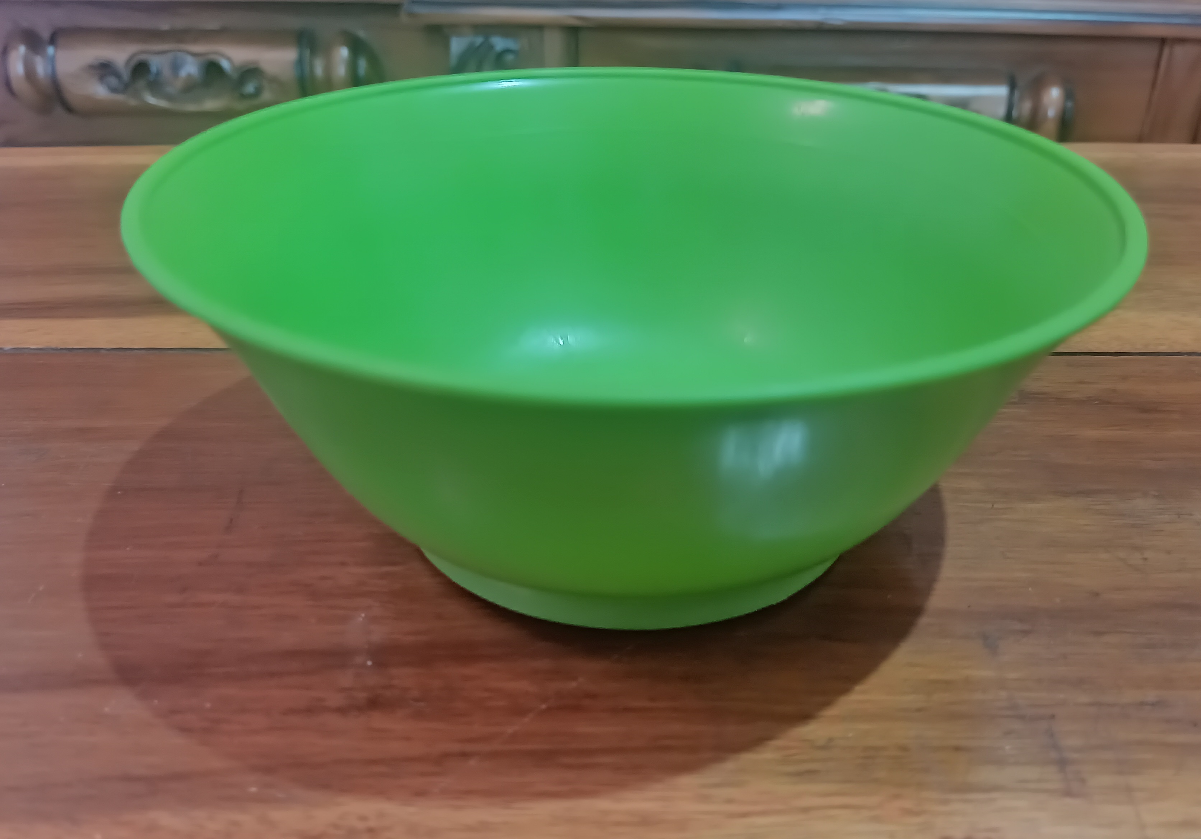

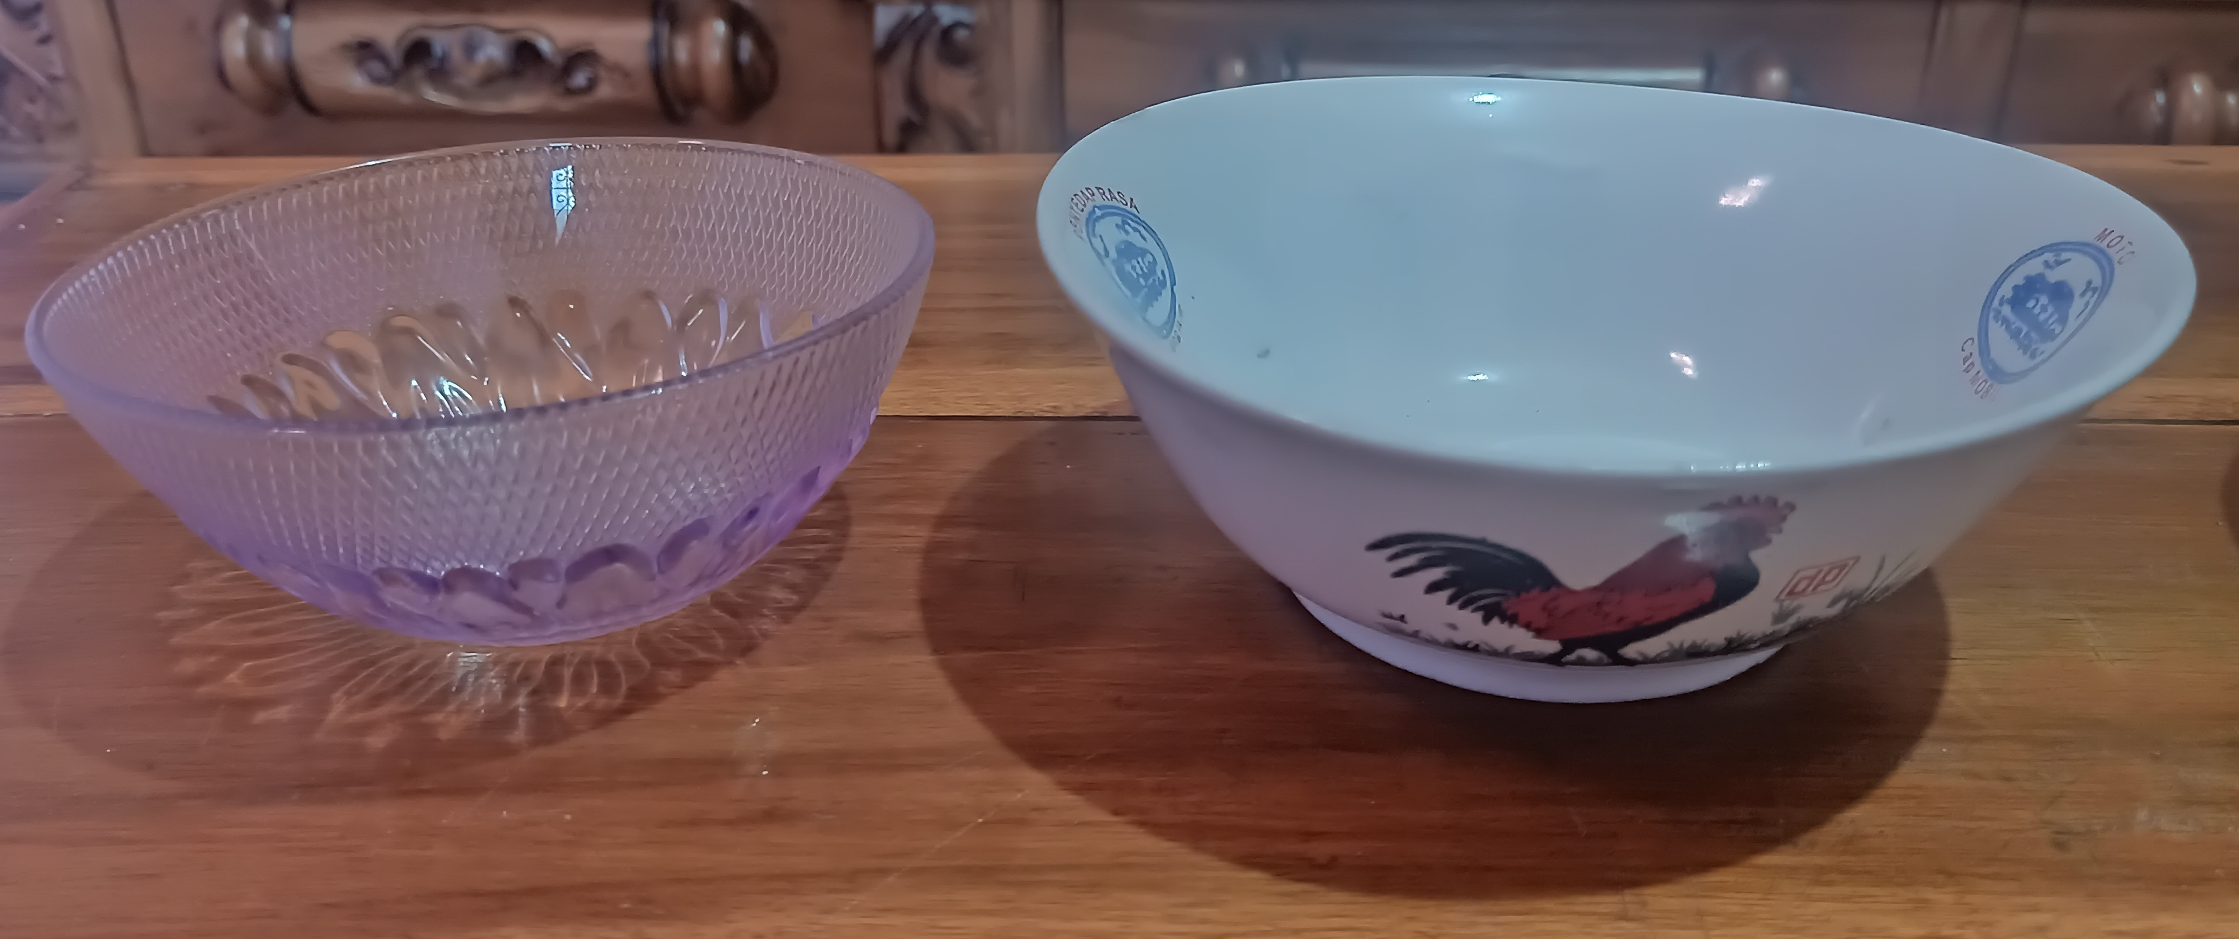

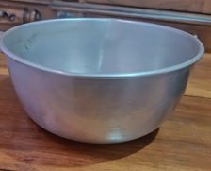

|  |  |  |
| --- | --- | --- |
| **Figure 1.** Aluminum bowls | **Figure 2.** Glass bowls. | **Figure 3.** Plastic bowls. |

Figures 1, 2, and 3 are hemispherical bowl containers. Students can make it by cutting a plastic ball so that it forms a hemispherical. Students are asked to split the plastic ball into two equal parts. Then, the students determine the diameter and height of the hemispherical.

In the second activity, students prepare a cone-shaped container in each group. Conical containers, for example, bakery screw molds, ice cream cones, and birthday hats. Students can make it with cardboard to form a cone. Students make a cone with the criteria of the height of the cone and the radius of the cone equal to the radius of a hemispherical. A hemispherical container of radius $r$ and a conical container of radius $r$ and height also $r$. The radius of a hemispherical $\left(r\right)$ = the radius of the cone $\left(r\right)$. And the height of the cone $\left(t\right)$ = the radius of the hemispherical $\left(r\right)$. This means that the height of the two shapes is the same and the radius of the two shapes are the same.

Based on activity one and activity two, in the process of making a hemispherical and cone students can gain an understanding of the making of a hemispherical and cone. Hemispherical and cones are used as learning tools in learning the volume of the sphere. Meanwhile, rice is used as a medium in the process of filling experiments to understand the concept volume of a sphere

In the third activity, students prepare enough rice. Students take the rice then pour the rice into a cone-shaped container until it is full. Next, the students poured the rice contained in a cone-shaped container into a hemispherical container. In this case, the rice plays a role in filling the space in a hemispherical and cone, in other words, the students move the rice by measuring using the cone into the hemispherical. In this activity, the students also completed the question "How many filling is needed so that the hemispherical container is filled with rice?" The following is a conversation dialogue on the process of pouring rice.

|  |
| --- |
| *Teacher: "Take the rice and then pour the rice into a cone-shaped container until it is full.*  *Next, pour the rice from a cone-shaped container into a hemispherical container.*  *Watch what happened? "*  *Student: "Hemispherical is not filled, Mrs"*  *Teacher: "Then how about hemispherical filled with rice?"*  *Student: "Take the rice again, Mrs, use a cone and then pour it into hemispherical"*  *Teacher: "Yes, right"*  *Teacher: "How many filling does it take so that the hemispherical container is filled with*  *rice?"*  *Student: "Two times filling of rice, Mrs"* |

**Figure 4.** Teacher and Student Conversation Transcript.

Based on Figure 4, namely the conversation between the teacher and students, after the cone filling process is complete, then the students pour the rice contained in the cone-shaped container into a hemispherical container. In the first pouring, it turns out that the rice from the cone can fill half of the hemispherical container. Next, the students repeat the previous step, namely pouring the rice into the cone until it is full, then the students pour the rice from the cone container into a hemispherical container, and so on until the hemispherical container is filled with rice. After the filling process is complete and the hemispherical container is filled with rice, students are asked to conclude group activities on the experiments that have been carried out. The following are the results of students' answers can be seen in Figure 5.

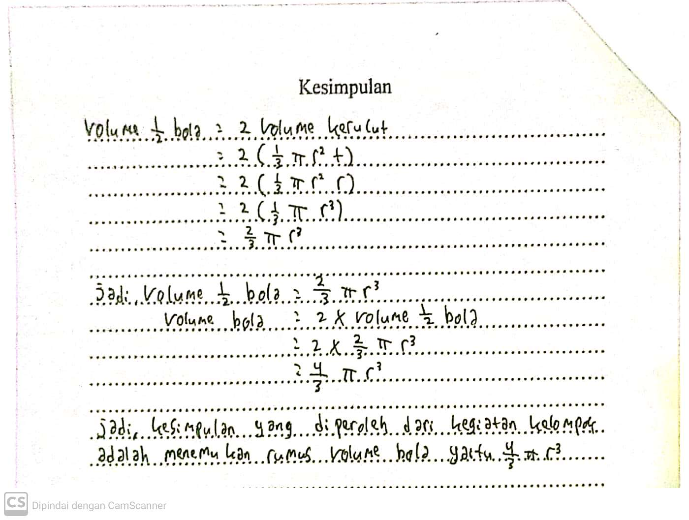

**Figure 5.** Examples of students' answers in completing the final questions in group activities.

Based on Figure 5, from the students' answers in completing the final questions in the experiments that have been carried out, the students have understood the concept volume of a sphere where the students concluded the results of their experiments by presenting that the volume of a hemispherical is equal to twice the volume of a cone. The hemisphere is half the ball. The ball used is a plastic ball that has been divided into two equal parts.

By converting it to a mathematical concept, students change the volume of cone = $\frac{1}{3}πr^{2}t$, where $t$ equals to the radius of a hemispherical, and the volume of a hemispherical is $\frac{2}{3}πr^{3}$. Based on this concept, students understand that the concept volume of a hemispherical is equal to twice the volume of a cone.

Next, students look for the volume of a sphere. The student finishes by answering that the volume of a sphere is equal to twice the volume of a hemispherical. By converting it to a mathematical concept, students change the volume of the sphere = $2 x \frac{2}{3}πr^{3}$. So that the volume of the sphere = $\frac{4}{3}πr^{3}$ is obtained. Based on this concept, students understand that the concept volume of a sphere is equal to twice the volume of a hemispherical. This shows that students understand the concept volume of a sphere. It can be seen from the conclusion that the students found the formula for the volume of a sphere, which is $\frac{4}{3}πr^{3}$.

Student activities in this study are based on the implementation of Indonesian Realistic Mathematics Education (PMRI). Each student activity has a learning design by the characteristics of Indonesian Realistic Mathematics Education (PMRI). The first characteristic of Indonesian Realistic Mathematics Education (PMRI) is the role of context. In this lesson, the role of the context used is rice. Rice is a real context that students often encounter as a daily staple food. In this activity, students experiment with rice filling in the Student Worksheet (LKPD) and solve problems. This activity provides new and different things so that students find learning in class to be more interesting and easy to understand. The second characteristic is the use of learning tools. The use of learning tools can be seen when students carry out activities 1 and 2. Students make a hemispherical container and a cone-shaped container. The third characteristic is the use of student construction results. This can be seen in the implementation process of the three activities that have been carried out. The teacher gives freedom to students in answering problem-solving questions on the Student Worksheet (LKPD) using their respective strategies. The strategies found were in measuring the radius and height of a hemispherical, also when measuring the height and radius of the cone, students using a ruler, stick, or with the ropes around them. Also, in the activity of making cone circles, some students use bows, compasses, ropes or some use plastic plates by tracing the edges of the plates. The fourth characteristic is the interactivity. Interactivity occurs between teachers and students in every learning activity they do. The teacher conducts the process of mentoring students with a conversational dialogue during the learning process. The fifth characteristic is linkage. The linkage in question is that in the learning process of the volume of a sphere there is a connection with the concept of circles, comparisons, counting operations, cones, and hemispherical.

Based on these five characteristics, students have carried out activity one, activity two, and activity three according to the Indonesian Realistic Mathematics Education (PMRI) approach. Students have been able to do learning well and students can easily understand the basic concept of spherical volume. This can be seen in student learning to find the volume of a sphere formula with its strategy. Therefore, students can easily remember the formula for the volume of the ball without having to memorize the formula.

1. Conclusion

The role of rice in understanding the concept of spherical volume geometry can have a positive influence on students in grade IX. It can be seen that there is student interest in rice media and the learning is going well, students can easily understand the concept volume of a sphere. The use of this context can help students to rediscover and understand the basic concepts of spherical volume. Students' understanding of the concept of spherical volume develops from the informal stage to the formal stage. Students can find the formula for the volume of the sphere by using real situations in the student environment. This situation can be properly instilled in students so that students can more easily learn mathematics material, especially on spherical volume material.

References

1. Reys R 2019 *Helping Children Learn Mathematics (*Australia: John Wiley & Sons Australia Ltd)
2. Curry M and Outhred L 2005 Conceptual Understanding of Spatial Measurement *Building Connections:* *Theory, Research and Practice* 265-272
3. Widiawati, Helni I and Herdiyan S 2019 Penggunaan Kuaci pada Pembelajaran Volume Bola di Kelas *Jurnal Pendidikan Matematika : Judika Education* **2** 66-72
4. Walle V D and John A 2008 *Elementary and Middle School Mathematics: Teaching Developementally 7th edition* (Boston: Allyn and Bacon)
5. Takaria J 2017 Pemahaman Konsep Volume Bangun Ruang Melalui Hukum Kekekalan Isi *Jurnal Pedagogika dan Dinamika Pendidikan.* **7** 79-89
6. Juwita H, Ratu I I P and Somakim 2015 Peranan Buah Semangka dalam Pembelajaran Volume Bola. *Jurnal Elemen*. **1** 130 – 143
7. Turmudi and Julia 2014 Exploring the formula of the sphere via watermelon: a lesson study at a junior secondary school. In the 6th Int. Conf. of Teacher Education (UPI-UPSI). The standardization of Teacher Education: Asian Qualification Framework. 25-26 Juni Bandung p. 141-163
8. Turmudi and Erlina E 2012 Constructing formula of pyramid volume by comparing volume of prism with the beach sand and container media in junior secondary school: A lesson study. In the *5th Int. Conf. on Research and Education in Mathematics. AIP Conf. Proc.* **1450** p.173-182
9. Gravemeijer K and Paul C 2006 Design Research From A Learning Design Perspective ed Akker et al *Educational Design Research* (New York: Routledge) 17–51