Development of realistic mathematics education learning to enhance student’s mathematical justification skill

Zuliyanti and I Rizkianto

Mathematics Education Departement, Faculty of Mathematics and Science Education, Yogyakarta State University, Indonesia

Email: [zuliyanti.xia432@gmail.com](mailto:zuliyanti.xia432@gmail.com), [ilham_rizkianto@uny.ac.id](mailto:ilham_rizkianto@uny.ac.id)

**Abstract**. The efforts to enhance student’s mathematical justification skill can be done through a learning process by providing realistic problems that promote a maningful learning and involving real activity in guided discovery process that can give students opportunities to explain and justify their answer. One of learning approach that can facilitate these activities is realistic mathematics education approach. This developmental research aims to produce mathematics learning material that includes lesson plans and student worksheets with realistic mathematics education learning approach to enhance mathematical justification skill on linear programming material. This research also aims to know the quality of learning material in the aspect of validity, practicality, and effectiveness. Type of this research was research and development with ADDIE model, consisting of Analysis, Design, Development, Implementation, and Evaluation. The object of this research was learning materials with realistic mathematics education learning approach to enhance mathematical justification skill on linear programming material. The instruments used in this research were validation sheets for measuring the validity for the learning material, student questionnaire for measuring the practicality, and mathematical justification skill test for measuring the effectiveness of the learning material. The result of this study learning materials with realistic mathematics education learning approach fulfilled the validity, practicality, and effectiveness criteria to enhance mathematical justification skill.

1. Introduction

In this century, we are facing an era of globalization and fundamental changes that requires development of human resources quality. Education is an important aspect to improving the quality of human resources. To create that, a learning process that can support the development of 21st century skills is needed. The ability of 21st century skills including are critical thinking and communication [1]. These skills can be developed from various disciplines delivered through subjects. One of the subjects given at school is learning mathematics.

One of mathematical skill that can support the growth and development of other math-related abilities is justification skill. Justification helped students enhance their critical thinking and communication skill [2]. Beyond mathematics, justification played a role in promoting the development of “student goals”. This is important for students not as people who do or use mathematics, but as future adults. Justification fostered student perseverance, independence, critical thinking skills, and the habit of mind to support one’s ideas, or request that of another.

The development of justification skills in mathematics learning is very important. Justification is a critical mathematical practice that must play a role in teaching and learning at all grade levels [3]. Justifying a claim or a result involves presenting reasons convincing to oneself and others [4]. In high school, the standards for accepting explanations should become stingent, and students should develop a repetoire of increasingly sophisticated methods of reasoning and proof [5]. Justifications need to rely on acccepted concept, properties, procedures, and mathematical ideas. Thus, it is essential that students understand the need for justification from very early in their schooling.

The importance of mathematical justification skill has not yet been supported by the achievement of mathematical justification skill itself. In fact, there are many problems in mathematics learning that have caused the achievement of mathematical justification skill is still low. Trends in International Mathematics and Science Study (TIMSS) is international assessments in mathematics and science. According to the results of TIMSS, Indonesian scores are relatively low [6], [7], [8], [9], [10].

Table 1. The results of TIMSS

|  |  |  |  |  |
| --- | --- | --- | --- | --- |
| Year | Indonesian Ranking | Number of Participated Countries | Indonesian Score | Average of International Score |
| 1999 | 34 | 38 | 403 | 487 |
| 2003 | 35 | 46 | 411 | 467 |
| 2007 | 36 | 49 | 397 | 500 |
| 2011 | 38 | 42 | 386 | 500 |
| 2015 | 45 | 50 | 397 | 500 |

The results of TIMSS show that Indonesian students are still in *knowing* level, the lowest of cognitive level [6]. They have not yet been able to apply their basic knowledge to solve problems (*applying*), neither to understand, apply knowledge in complex problems, make conclusions and make generalizations (*reasoning*). Whereas mathematical justification skill is one of the cognitive abilities in the reasoning domain, in addition to the ability to analyze, integrate, synthesize, evaluate, determine conclusions, and genera1ize [11].

To enhance mathematical justification skill, learning material which can give students opportunity to practice this ability is needed. Making sure that the tasks we give are known by students and unfamiliar vocabulary was explained can help students to generate an initial idea and developing a justification [3]. In other words, we need to ensure the tasks we give are imaginable and meaningful for students. A knowledge will be meaningful for students when the learning process involves realistic problems [12]. In addition, learning that involves real mathematical activities at the time of guided discovery can provide students opportunities to explain their answers and give acceptable justification [13].

Based on observations of learning at Muntilan 1 Senior High School, most of the students’ time in class was used to listen the explanations from teacher and students have not yet been facilitated to participate learning actively. In addition, mathematic book that used in learning has not yet provided opportunity for students to reinvention and reconstruct their own knowledge. Afterwards when students answered the questions, they were used to prioritized the correctness and accuracy of their answers and had not yet concerned the mathematical arguments about why the answer is correct or not.

One of learning approach which involves realistic problems is realistic mathematics education. This learning approach provide real-world problem and imagineable problem for students [14]. There are five main principles in this learning approach [15]: (a.) the use of real context, (b.) the use of vertical instruments (chart, model, schema), (c.) the use of student works and construction, (d.) interactivity, and (e.) intertwinement. There are real student activities in vertical instrument and students reinvention the formal knowledge from that activities.

According to the analysis above, the efforts to enhance student’s mathematical justification skill can be done through a learning process by providing realistic problems that promote a maningful learning and involving real activity in guided discovery process that can give students opportunities to explain and justify their answer. One of learning approach that can facilitate these activities is realistic mathematics education approach.

1. Method

This research is Research and Development (R&D) with ADDIE development model which has five steps, they are Analysis, Design, Development, Implementation, and Evaluation [16]. The population in this study were all eleventh-grade students of Muntilan 1 Senior High School. The sample of this study were 32 students of XI MIPA 4 that was chosen randomly.

The steps of development consist of five steps of ADDIE model, they are: 1). Analysis, includes analysis of learning material needs, student characteristics, and curriculum. 2). Design, design for learning material consist of lesson plans and student worksheets with realistic mathematics education approach to enhance mathematical justification skill for eleventh-grade students. Moreover, would be designed learning material assessment instruments that include lesson plans and worksheets assessment, student response questionnaire, learning implementation observation sheet, and justification skill test questions. 3). Development. In this step, the realization of the product framework is made to become a product that is ready to be implemented. Futhermore, expert lecture and mathematics teacher validate lesson plans and worksheets that developed to analysis the learning material quality and give suggestions to revise the products. 4). Implementation. Revised learning materials were implemented in school and the researcher had a role as teacher. 5). Evaluation to analysis the oversights that occur during the research process and analysis learning materials quality from practicality and effectiveness aspect.

Data collection techniques in this study were test and non-test techniques. The test technique is used to quantify the learning materials quality from effectiveness aspect according to the result of justification skill test. Non-test technique is used to quantify the learning materials quality from validity dan practicality aspect used lesson plans and student worksheets assessments, student response questionnaire, and learning implementation observation sheet.

Types of data in this studi were qualitative and quantitative data. Qualitative data included suggestions from validators and observers that compiled to get general conclusions. This data were used to revise the products. Quantitative data obtained from learning materials validation results by experts, student response questionnaire about developed products, learning implementation observation sheet, and justification skill test questions. Quantitative data were average of lesson plans assessment score (44 items), average of student worksheets assessment score (29 items), result of student response questionnaire (13 items), and result of mathematics justification skill test. Lesson plans and student worksheets assessment on Likert scale or five scale, while student response questionnaire on four scale that converted to be qualitative data with this formula [17]:

Table 2. Converted score of lesson plans validity assessment

|  |  |
| --- | --- |
| Average Score | Criteria |
| $$\overline{x}>184,8$$ | Very Valid |
| $$149,6<\overline{x}≤184,8$$ | Valid |
| $$114,4<\overline{x}≤149,6$$ | Quite Valid |
| $$79,2<\overline{x}≤114,4$$ | Less Valid |
| $$\overline{x}≤79,2$$ | Very Less Valid |

Table 3. Converted score of student worksheets validity assessment

|  |  |
| --- | --- |
| Average Score | Criteria |
| $$\overline{x}>121,8$$ | Very Valid |
| $$98,6<\overline{x}≤121,8$$ | Valid |
| $$75,4<\overline{x}≤98,6$$ | Quite Valid |
| $$52,2<\overline{x}≤75,4$$ | Less Valid |
| $$\overline{x}≤52,2$$ | Very Less Valid |

Table 4. Converted score of student response questionnaire assessment

|  |  |
| --- | --- |
| Average Score | Criteria |
| $$\overline{x}>42,25$$ | Very Practical |
| $$32,5<\overline{x}≤42,25$$ | Practical |
| $$22,75<\overline{x}≤32,5$$ | Less Practical |
| $$\overline{x}≤22,75$$ | Very Less Practical |

The learning materials fulfilled valid criteria if the average score of lesson plans and student worksheets assessment are at least in “valid” category. The learning materials fulfilled practical criteria if the average score of student response questionnaire is at least in “practical” category. The learning materials fulfilled effective criteria in terms of mathematical justification skill if class average score is more than the passing score set by school, which is 72, and at least 70% of students in the class have reached the passing score.

1. Result and discussion

The products developed were learning materials based on realistic mathematics education to enhance mathematical justification skill which used ADDIE development model are described as follows:

## Analysis

According to the analysis, it was found that students’ mathematical justification skill were still low. This is indicated by Indonesian score in in ternational study TIMSS in mathematics which has not yet reached the reasoning level. In fact, one element of reasoning ability is justification skill.

In terms of the learning process of mathematics, students had not yet given opportunities to reinvention and construct their own knowledge. Students were immediately given formal mathematics at the beginning of the lesson, so that students recognized mathematics material only as meaningless numbers and formulas. Other than that, some of students were passive in the class. Most of students’ time in class was used to listen the explanations from teacher and students have not yet been facilitated to participate learning actively. In addition, mathematic book that used in learning has not yet provided opportunity for students to reinvention and reconstruct their own knowledge. Afterwards when students answered the questions, they were used to prioritized the correctness and accuracy of their answers and had not yet concerned the mathematical arguments about why the answer is correct or not. Students still had not developed the various steps to solve the problems and neither observed the reason of the answers.

According to the analysis of needs in respect of the fulfillment of process standards, the meaningful learning materials which can practice and get used students to explain the steps and the reason of their answers, are needed to enhance students’ mathematical justification skill.

## Design

The results obtained from the analysis step were used as the basis for deesign of learning materials. The development of lesson plans mostly refers to the rules for development of lesson plan for the 2013 Curriculum as stated in [18] in respect of the standard of primary and secondary education. In addition, other guidelines for development of lesson plan is [19] in respect of the core competencies and basic competencies of learning. There are four lesson plans for four class meetings.

## Development

The results of development step is the realization of a product framework to become a product that is ready to be implemented. In addition, expert lecture and mathematics teacher validated the lesson plans and student worksheets. The validator of this studi are (1). Dra. Mathilda Susanti, M.Si. and (2). Suripto, S.Pd.. Suggestions from the validators were used as material to revise the product of lesson plans and student worksheets. The results of the assessment of each validator are presented in the following table.

**Table 5**. Results of learning materials assessment

|  |  |  |  |  |  |
| --- | --- | --- | --- | --- | --- |
| Learning materials | Validators | | Average | Maximum Score | Criteria |
| 1 | 2 |
| Lesson plans | 189 | 185 | 187 | 220 | Very Valid |
| Student worksheets | 115 | 123 | 119 | 145 | Valid |

According to the result, the product of learning materials, lesson plans and student worksheets fulfilled the valid criteria.

## Implementation

The results of this step is the data from the observation of learning implementation, results of student response questionnaires, and the results of mathematical justification skill test.

## Evaluation

The results of evaluation step is analysis of practicality and effectiveness aspect of developed learning materials. Another results of this step is the final product of learning materials with realistic mathematics education learning approach to enhance mathematical justification skill. The results of the analysis of student response questionnaire are presented in the following table.

Table 6. The results of the analysis of student response questionnaire

|  |  |  |
| --- | --- | --- |
| Assessment Aspects | Maximum Score | Average Score |
| Assistance | 12 | 9,28 |
| Convenience | 28 | 21,88 |
| Attractiveness | 12 | 8,94 |
| Total | 52 | 40,09 |
| Criteria |  | Practical |

Based on the table above, it is known that the product of learning materials fulfilled the practical criteria. The results of observation of learning implementation are presented in the following table.

Table 7. The results of observation of learning implementation

|  |  |  |  |
| --- | --- | --- | --- |
| Class Metting | Maximum Percentage of Implementation | Average of Percentage of Implementation | Category |
| 1 | 100% | 100% | Very good |
| 2 | 100% | 100% | Very good |
| 3 | 100% | 94% | Very good |
| 4 | 100% | 94% | Very good |
| Conclusion | | 97% | Very good |

According to the table above, it is known that learning activities in the study were carried out very well and appropriate with the lesson plans. The effectiveness of learning materials according to the results of mathematical justification skill test is presented in the following table.

Table 8. The results of mathematical justification skill test

|  |  |  |
| --- | --- | --- |
| No. | Assessment aspects | Results |
| 1 | Students’ score | |
|  | 1. Highest score | 98,39 |
|  | 1. Lowest scone | 40,32 |
|  | 1. Average | 77,72 |
| 2 | Student Completeness | |
|  | 1. Passing students | 23 |
|  | 1. Unpassing students | 9 |
|  | 1. Percentage of passing | 72% |

Based on the table above, it is known that the product of learning materials fulfilled the effective criteria because the average score is more than the passing score and the percentage of passing is more than 70%.

According to the results above, we can conclude that the product of learning materials with realistic mathematics education learning approach fulfilled the validity, practicality, and effectiveness criteria to enhance mathematical justification skill.

The following pictures show the realistic contexts that used at the beginning of the learning contained in student worksheet.

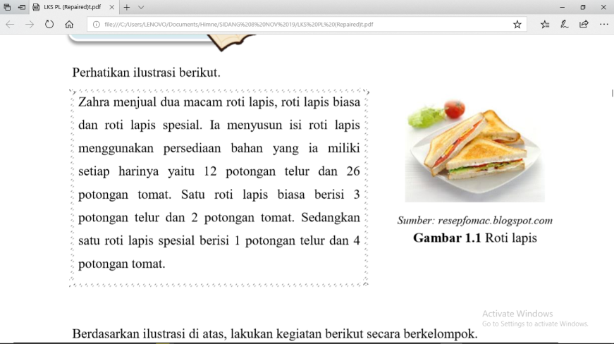

**Figure 1**. Realistic context 1

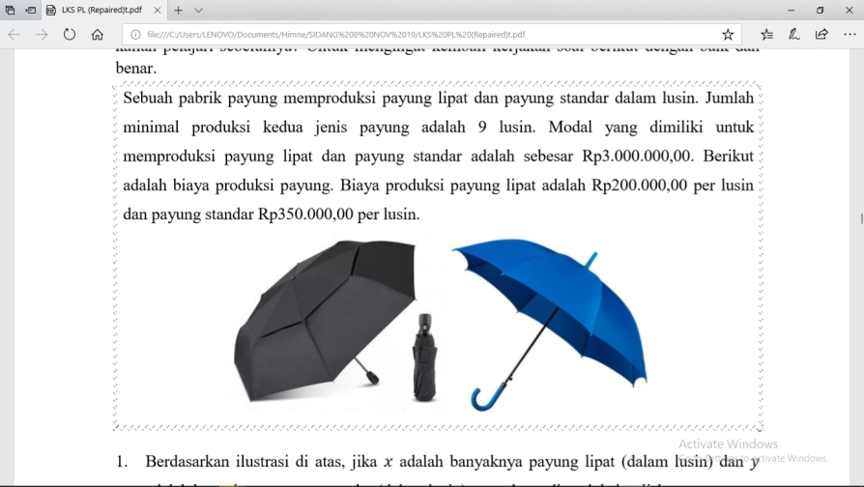

**Figure 2**. Realistic context 2

Context in Figure 1 is about sandwich to construct two variables linear inequality material, while context in Figure 2 is about availability of materials for making two kinds of umbrella to construct linear programming concept. The contexts in Figure 1 and 2 are meaningful because these contexts are real-world problem that can be imagined by students. These initial contexts supported student to construct their own knowledge about two variables linear inequality and linear programming concept.

The activities in student worksheets supported student to understand the linear programming material easily. This is indicated from the results of student response questionnaire that shown the convenience aspect score is the highest score.

After used the learning materials with realistic mathematics education learning approach, students’ score fulfilled the effective criteria because the average score is more than the passing score and the percentage of passing is more than 70%. This result is also supported by one sample t-test with a significant level 0,05. So that students’ mathematical justification skill test scores were good because they used the developed learning materials.with a confidence level of 95%. Therefore, the learning objectives had been achieved and the developed products are generally considered effective so that they are suitable for use. The following picture is one example of students’ answer in justification skill test that reached the highest score.

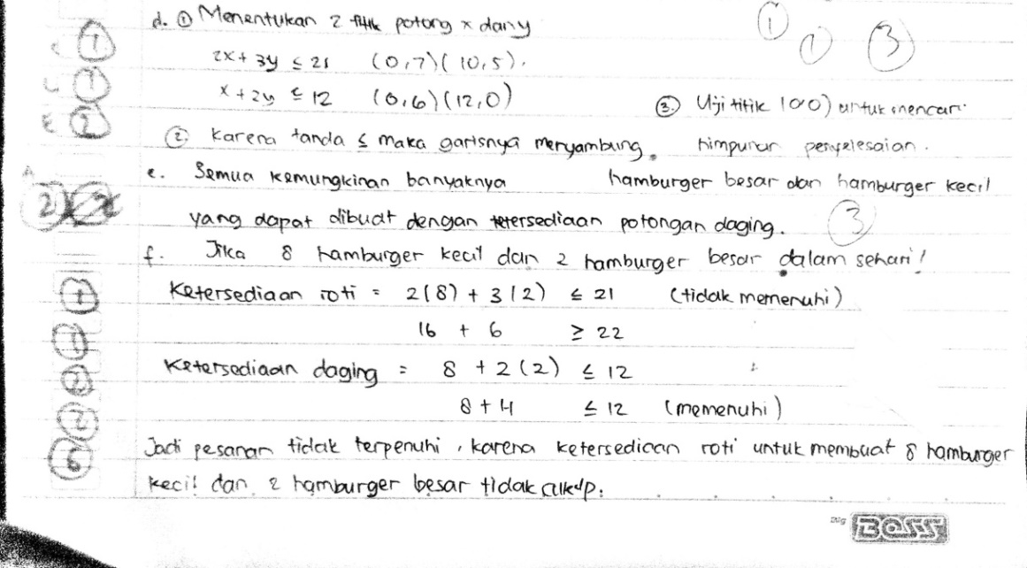

**Figure 3**. Students’ answer

The students’ answer in the Figure 3 show that students can explain the reason of their answer.

The learning materials with realistic mathematics education learning approach are effective to enhance mathematical justification skill because the developed learning materials consist of meaningful problem in the beginning of each material, provide activities in the worksheets that can mek students to be active in the class, and give them opportunities to explain and justify their answers.

The result of this study is accordance with the statement of that provide known and familiar problems for students can help them to generate an initial idea and developing a justification [3].

1. Conclusion

The results of the expert analysis show that the learning materials with realistic mathematics education learning approach has fulfilled valid criteria for use in the learning. The results of this study show that the developed learning materials are pratical and effective for enhancing mathematical justification skill.

References

1. Saavedra, A. R., & Opfer, V.D. 2012 Teaching and Learning 21st century Skills: Lessons from the Learning Sciences. APERA in Sydney
2. Staples, M.E. & Bartlo, J. 2010 *Justification as a Learning Practice: Its Purposes in Middle Grades Mathematics Classrooms*. CRME Publications, 3.
3. Cioe M. 2015. *Moving Student to “the Why”*. Mathematics Teaching in The Middle School, 20(8), 485-491.
4. Mata-Pereira, J. & Ponte, J.P. 2017 Enhancing Students’ Mathematical Reasoning in the Classroom: Teacher Actions Facilitating Generalization and Justification. Education Study Mathematics, doi 10.1007/s10649-017-9773-4
5. NCTM. 2000 *Principles and Standards for School Mathematics*. Reston: NCTM Inc
6. Sari, D. C. 2015 *Karakteristik Soal TIMSS*. Seminar Nasional Matematika dan Pendidikan Matematika UNY 2015, 303-308.
7. Mullis, I. V. S., Martin, M. O., Gonzales, E. J., et al. 2004*. TIMSS 2003 International Mathematics Report : Findings from IEA’s Trends in International Mathematics and Science Study at the Fourth and Eight Grades*. Chestnut Hill : Boston College
8. Mullis, I. V. S., Martin, M.O., & Foy, P. 2008 TIMSS 2007 International Mathematics Report: Findings from IEA’s trends in International Mathematics and Science Study at The Fourth and Eight Grades. Chestnut Hill : Boston College
9. Mullis, I. V. S., Martin, M. O., Foy, P., et al. 2012 *TIMSS 2011 International Results in Mathematics*. Chestnut Hill : Boston College
10. Mullis, I. V. S., Martin, M. O., Foy, P., et al. 2016 *TIMSS 2015 International Result in Mathematics*. Chestnut Hill : Boston College
11. Mullis, I.V.S & Martin, M.O. 2013 *TIMSS 2015 Assessment Frameworks*. Chestnut Hill: TIMSS & PIRLS International Study Center.
12. Wijaya, A. 2012 *Pendidikan Matematika Realistik; Suatu Alternatif Pendekatan Pembelajaran Matematika*. Yogyakarta: Graha Ilmu
13. Li, Y., Silver, E.A., Li, S., et al. 2014 *Transforming Mathematics Instruction :Multiple Approaches and Practices.* Basel: Springer.
14. Van den Heuvel-, M., & Drijvers, P. 2014 *Realistic Mathematics Education. In S. Lerman (Ed.), Encyclopedia of Mathematics Education* (pp. 521-525). Dordrecht, Heidelberg, New York, London: Springer.
15. Hadi, S. 2017 *Pendidikan Matematika Realistik: Teori, Pengembangan, dan Implementasinya*. Jakarta: PT Rajagrafindo Persada.
16. Branch, R.M. 2009 *Instructional Design: The ADDIE Approach.* New York: Springer.
17. Widoyoko, E.P. 2009 *Evaluasi Program Pembelajaran*. Yogyakarta: Pustaka Pelajar
18. Kemendikbud. 2016 *Peraturan Menteri Pendidikan dan Kebudayaan Nomor 22, Tahun 2016, tentang Standar Proses Pendidikan Dasar dan Menengah.*
19. Kemendikbud. 2016 *Peraturan Menteri Pendidikan dan Kebudayaan Nomor 37, Tahun 2018, tentang Kompetensi Inti dan Kompetensi Dasar Pelajaran pada Kurikulum 2013 pada Pendidikan Dasar dan Pendidikan Menengah.*