How to lecture statistics class?

Evvy Lusyana

STIT Muhammadiyah Tempurejo Ngawi, Indonesia

evvy.himalaya@gmail.com

**Abstract**. Statistics are compulsory courses throughout the majors. However, many students still consider that statistic is a challenging course, and that is only biased applied to quantitative research. This research aims to identify the essential statistical ability of the three new majors in STIT Muhammadiyah Tempurejo Ngawi, Indonesia. The study adopted the qualitative research approach to Creswell. Data collection was done at the statistical hour. Results show that several factors that lead students to study statistics include: fundamental knowledge statistics, how teachers convey, age, and skill in using the computer. So it is recommended that lecturers who teach statistics class with a diversity of the student background should be more strengthening the basic concept first.

1. Introduction

Statistics are taught in almost all majors in colleges [1]; even statistics become one of the compulsory courses and need to be understood when they want to do quantitative research. Many students think that statistics are not essential to learn when doing qualitative research [2]. Statistics are not only utilized for quantitative research only. Researchers [2,3,4] argue that statistics and probabilities are crucial in everyday life, and various disciplines are no exception to education, management, and economics.

For college students, there are a few things that need to be understood after they study statistics such as descriptive statistics, data presentation, probability, and its distribution, hypothesis testing for a population mean, hypothesis for two population means, variance analysis, and an introduction to regression and correlation [5]. As a lecturer, it is proper to observe the understanding of basic concepts at the initial meeting [2], so that the lecturers get an overview of the extent of the statistical material being taught. The common problem is that not very few lecturers are reluctant to observe their necessary abilities [3].

The basic concept of statistics has been introduced to primary and secondary schools where they are taught how to collect, process, present data with graphs or charts, and describe the data results [6,7]. Nevertheless, they stated that the statistics were difficult [2,8] and used only for quantitative thesis purposes. The difficulties faced by students are usually on the concept of rational numbers, counting, describing probabilities, and giving a statement [7]. Most likely the cause of the student's difficulties is the statistical learning experience, teaching methods used by the teacher, as well as the ability of students themselves [8]. It is true that to study statistics required a reasoned ability [9], the mastery of the concept [3], the ability to relate concepts and interpretations as the basic ability that students should master. The difficulties and understanding of students' basic concept became the inhibitory factors in the study of educational statistics, because the basic concept of statistics has been considered difficult by students [1].

Some researchers suggest alternatives to statistical learning problems in colleges. Researchers [2] suggest that lecturers observe basic student skills so that the knowledge of students is wider because it can be a statistical concept studied in secondary school only counting and starting with something abstract. It is also supported by opinions [7] that teachers are better at teaching more real stats first. Thus the need for improvement of the mathematical curriculum is related to statistical concepts taught [5,7]. Using software to simplify statistical computing [4]. Besides, lecturers can make demos in the form of video tutorials so that students can easily practice it [10].

In statistical classes, students are not only required to be able to resolve statistical problems manually. Nevertheless, they are also introduced with software that can make it easier to work with statistics such as Excel and SPSS. These were done to improve the curriculum [5,7] while also making it easier to complete analytical work [4].

## Purpose of the study

The purpose of this study is to identify the basic concepts of statistics, difficulties, and determine the best way to solve problems in the next statistical class.

1. Method

This research is a qualitative study adopted the stage of Creswell [11]; data collection is done by observation, interview, and analysis of the student's work. Participant of 21 students. Participants are from 3 majors: 7 Students of teacher Education Madrasah Ibtidaiyah (PGMI), 12 students of Early Childhood Islamic Education (PIAUD), and two students of Islamic Education Management (MPI).

Data collection is done during one semester at the lecture hour. Research is conducted by observing students ' understanding of basic statistical concepts. Observation is done to observe the basic concept of statistics and the ability of students using Excel. There are two stages of data retrieval, which are manual statistical learning and statistical learning using Excel. In the lecture process, researchers analyzed the difficulties experienced by students. After discovering the difficulties experienced by students, researchers are trying to provide the best solution for students to understand statistics.

1. Result

The study statistics consist of basic statistical concepts, data presentation, measurement, inferential statistics, hypothesized average testing, homogeneity, regression, and the results' performance. Researchers deliberately tried to explore the basic understanding of student statistics before too deep leads to research statistics because the condition of the third student majors is observed. The subject of the study is the student (after this called M) semester 6, which takes the course of statistics of the three departments, namely Madrasah Ibtidaiyah Teacher Education (PGMI), Islamic Early Childhood Education (PIAUD) and Islamic Management Education (MPI). The 21 students had diverse backgrounds ranging from age, occupation, and the following lecture periods.

**Table 1.** Student Age Grouping

|  |  |
| --- | --- |
| Ages Range (year) | **Respondent** |
| 20-24 | M10, M11, M12, M13, M14, M16, M18, M19, M20, M21 |
| 25-29 | M1, M2, M3, M4 |
| 30-34 | M2, M5, M6, M8, M9, M15, M17 |

Table 1 shows the student age range of research subjects from all three majors. The grouping that age is based on the personal data owned by the campus. It is revealed that ten students are still young. Although [12] states that age does not affect learning ability. However, it does not matter if we collect student age data also. The three groups have the last diverse educational background: 1 graduate of undergraduate, one diploma, and 19 high school graduates shown in Table 2.

**Table 2.** Last Education grouping

|  |  |
| --- | --- |
| Education | **Respondent** |
| Senior high school | M1, M2, M3, M4, M5, M6, M7, M8, M9, M10, M11, M12, M13, M14, M16, M18, M19, M20, M21 |
| Diploma | M17 |
| Undergraduate | M15 |

Table 2 shows that there is one student of 6 semesters whose bachelor degree and transfer to PGMI and 19 other high school graduates. However, if it is associated with table 1, then it is obtained that in the group of high school graduates, there are students with the age of range 30-34 years. Then 19 students have been working as teachers in elementary school and kindergarten. Besides, the students are the first generation, so there are not many references to the statistics lecture.

Before starting the first topic, researchers tried to observe and explore the recollection of research subjects by giving a simple question about what they remember about statistics.

"Mean, median, mode..." (M10, M11, M12, M19 responses)

"I did not remember" (M2, M5, M7 responses)

"It has not been thought, because it is not used in schools" (M6, M8, M9 responses)

"Tables, charts, single data, and group data" (M11, M15 responses)

"Population and samples" (M15 response)

"It has worn in kindergarten, not?" (M8, M9 responses)

Researchers show pie diagrams and ask students to observe.

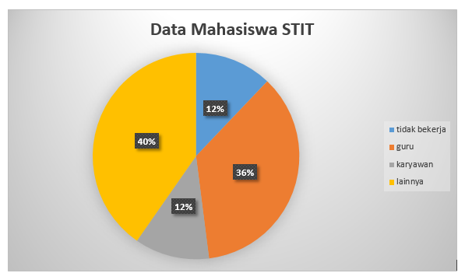

The diagram shows the work overview data of 248 students, and they work as a teacher, office worker, students, and others.

**Figure 1**. Diagrams for exploring data reading ability

"12% of students STIT does not work" (M7 response)

"Right, STIT students are mostly employed as shopkeepers or doing business" (M11 response)

"There are 30 students who do not work" (M16, M18 responses)

Based on the response, four students answered. While others just silence does not respond. Researchers tried to ask M2 and M21 related diagrams presented.

"I am confused with the diagram" (M2 response)

"36% of students work as teachers" (M21 response)

After being reminded about the statistical outline, it is followed by identifying student difficulties in resolving fundamental statistical issues such as mean, median, mode, standard deviation, differentiating single data with group data, and frequently used symbols. At first, the M18 meeting managed to solve the problem faster than other students. Then the researcher asks the difference of mean, median, and mode.

"Mean is the average. Median is the middle value. A mode is the most frequent value "(M5, M15, M18 response)

Researchers provide single data and ask students to determine the standard deviation manually. The following researchers show manual results.

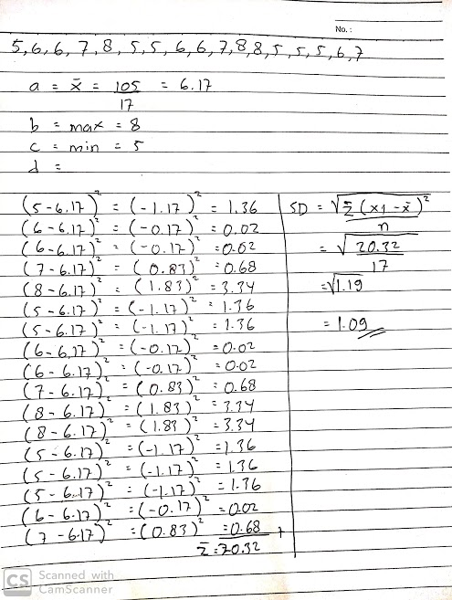

M21 work. M12 ways to solve a single data deviation standard by manual means. Looks simple.

M21 has a good basic concept, but the M21 way of writing the solution still does not show reasoning privileges.

**Figure 2.** Results of student work on basic material deviation standard

Thirteen students did the problem in a similar way to Figure 2. three students were working differently, and then the rest did not work. As a comparison, let us see another student's work in Figure 3.

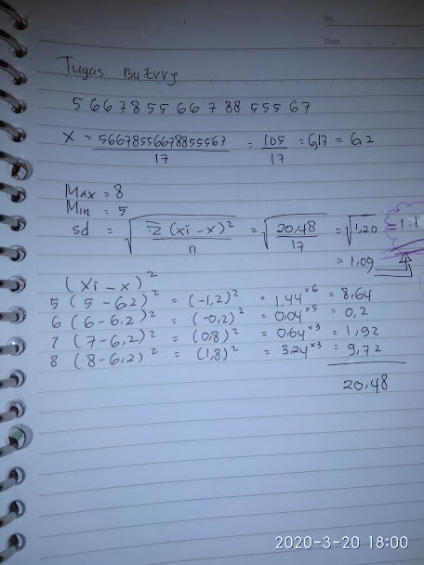

M11 work. The way M11 solves the problem quite differently. It is still simple but uses reasoning, i.e., shorten calculations by utilizing data multiplication.

However, M11 does wrong writing in determining the mean.

**Figure 3.** Student’s different ways to solve the problem

Both students are high school graduates, so they can still be invited independently to work out the statistics. Then to find out why other students do not work, researchers ask some of the students. The results were summarized as follows.

"I do not remember, and the standard deviation is what" (M5, M6, M9 response)

"I do not understand Mom; I have long not studied statistics..." (M8 response)

M5, M6, M8, and M9 are students of high school graduates aged 30-34 years. So they feel that their age is no longer able to think much. It is not an opinion of [12] that age does not affect the person's ability to learn. However, it is undeniable that the first semester six students were dominated by age over 25 years, married, and worked in elementary and kindergarten schools, so assuming that learning such model statistics is unnecessary. Moreover, their final tasks do not use statistics for data.

Based on the existing statement, researchers try to convey that there is a natural event to do the statistics by utilizing a computer that is Excel or SPSS. Fundamental to [4.10] that computer use can make it easier to solve statistical problems. However, doubts arise from the students of the 25-34 age group expressed as follows.

"I do not have a computer..." (M1, M2, M8, M9 response)

"Hold the computer is rare, how to do statistics with the computer? Add a headache... " (M9, M17)

Researchers practice calculating the mean, median, and standard deviations using Excel. Researchers demonstrate the use of the formula = Average, = stdev, and = median. Then the opinions submitted by the students are summarized as follows.

"Yes, Mom, it should be from scratch already use Excel. Giddy when counting many numbers... " (M15 response)

"It seems easy, and I do not have any idea if I practice it by myself" (M8, M9 response)

The student's positive response made the learning atmosphere in class more vibrant and encouraging researchers and statistical lecturers. Nevertheless, the situation changed after the existence of COVID, causing no direct learning. Instead, researchers provide material in—pdf format with the expectation that students will read and try to work with Excel. The response given by the student becomes changed as follows.

"Created a tutorial please, let it be easier to practice by ourselves" (M8, M14 response)

"If we have to read, we will not understand" (M1, M2, M8 response)

It is undeniable that there are many obstacles in statistical learning. In addition to understanding the basic concepts, human resources and means are also a problem in our statistical learning. After the student response, the researcher made a video tutorial to help students practice statistics from home, although there are many better statistics tutorials on the Internet. Researchers give assignments to students to determine the frequency distribution table, as seen in Figure 4.

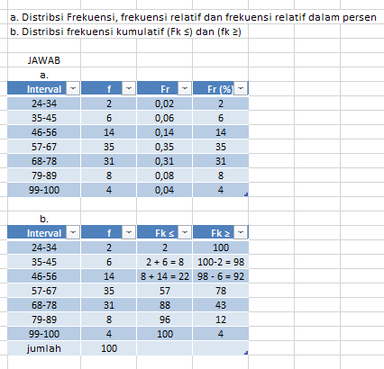

M18 work. In the Excel file sent by M18, researchers observe the way of writing correct data but the calculations made are still manual, M18 does not use calculations by utilizing cells in Excel.

**Figure 4.** Student’s work using excel

Figure 4 shows the effort made by M18 to solve a simple statistical problem with Excel. Then the researcher observed another job. Figure 5 is the result of the work by M10.

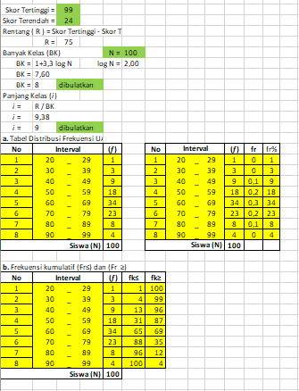

M10 work. In the Excel file sent by M10, there is manual typing and cell utilization in Excel. It can be said that the M10 has been able to complete simple statistics with Excel.

**Figure 5.** Another student’s work using excel

Figure 5 shows that there are already students capable of operating the computer. Unlike Figure 4, which M18 has also been able to, but not maximally in using Excel. Unlike the M8 and M9, which collect manual work because it is not capable of operating the computer but good enough to work, as shown in Figure 6.

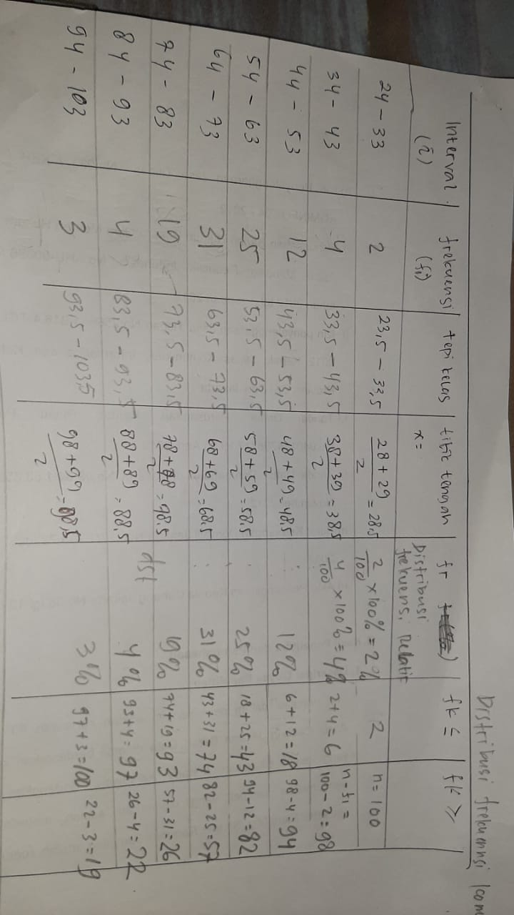

**Figure 6.** Another student’s work without excel

As it is known that the M8 and M9 include students aged category 30-34 and have been working. This makes it a reason for researchers. So researchers remain focused on continuing the material by using the software. Each student has a different learning way. It may be too early if concluding that the way students learn on statistical subjects is influenced by the background of age, occupation, and beliefs. However, researchers further agree that students ' ability in statistical classes is much influenced by the way teaching lecturers [8], understanding of the concept [3], the help of the counting tool, in this case, is Excel [4], lecturer guidance.

1. Conclusion

The results of observation and analysis show that students' difficulties in taking statistics courses are due to some things. They assume that statistics were only used for students who write final assignments (thesis) with quantitative methods, do not remember with statistic material, understanding the basic concepts of statistics they have. However, this can be solved by (1) Understanding the student's background; (2) observing conceptual abilities; (3) using the software; (4) give the tutorial. In connection with the results found, researchers advise lecturers who teach statistic courses, both with students in the background of the same study or not, should the lecturer get a study by observing and associating a student's background with future needs. So lecturers can arrange the best curriculum on the course statistic.

1. References
2. Mahmud Z, Wan Ramli W S, Sapri S, Ahmad S 2017 Diagnosis of students’ ability in a statistical course based on Rasch probabilistic outcome *AIP Conf Proceedings* **1836** 020047
3. Arican M and Kuzu O 2019 Diagnosis preservice teachers’ understanding of statistics and probability: Developing test for cognitif assessment Springer *International Journal of Science and Mathematics Education*
4. Batanero C, Godino J D, Vallecillos A, Green D R and Holmes P 1994 Errors and difficulties in understanding elementary statistical concepts *Int. J. Math. Educ. Sci. Technol.* **25** 527–547
5. Salkind N J 2017 *Statistics for people who (think they) hate statistics using microsoft excel 2016* (California: Sage Publication, Inc)
6. Retnawati H *et al* 2019 *J. Phys. Conf. Ser*. **1320** 012078
7. NCTM 2009 *Focus in high school mathematics: Statistics and probability* (Reston, VA: NCTM)
8. Garfield J and Ahlgren A 1998 Difficulties in learning basic concepts in probability and statistics: Implications for research *J. Res. Math. Educ.* **19** 44–63
9. Verma J P 2019 *Statistics and research methods in psychology with excel* (Gwalior: Springer)
10. Smith A E and Martinez-Moyano I J 2012 Techniques in teaching statistics: Linkin research production and research use *Journal of Public Affair Education* **18: 1,** 107-136
11. Van der Meij H and Dunkle P 2020 Effect of review video and practice in video based statistics training *J Computer & Education* **143** 103665
12. Creswell J W 2013 *Qualitative inquiry and research design: Choosing among five approaches* (Thousand Oaks, CA: Sage Publication)
13. Ozfidan B and Burlbaw L M 2019 A literature-based approach on age factors in school language acquisition: Children, adolescents, and adult *Int. Education Studies* **12** 27-36