Development of Student Worksheets Based on Ethnomathematics Context of Oil Palm Cultivation with IRME Approach on Flat Field Material for Junior High Schools

A S Marleny1, N Aisyah2, Somakim3

1Magister of Mathematics Education, Universitas Sriwijaya, Palembang, South Sumatra, Indonesia

2,3Mathematics Education Lecturer, Universitas Sriwijaya, Palembang, South Sumatra, Indonesia

*corresponding author’s email: [nys_aisyah@yahoo.co.id](mailto:nys_aisyah@yahoo.co.id)

**Abstract.** Ethnomathematics exists to bridge the gap between culture and education. Therefore, the study of ethnomathematics is important. The purpose of this study was to produce an ethnomathematic based student worksheets in the context of oil palm cultivation with the IRME approach to the flat area material of SMP. This research is a developmental type of research, which focuses on the preliminary stage and the formative evaluation stage which includes self-evaluation, prototyping (expert reviews, one-to-one, small-group) and field tests. The subjects of this study were students of class VII.1 SMP Negeri 4 Muara Enim. The data collection technique was carried out through a walkthrough, observation and interviews. The results of the data analysis show that this research has produced student worksheets that is by the flat field material with the 2013 curriculum. This student worksheets discusses flat field material using the context of oil palm cultivation, using the IRME approach, with the aim that students can construct their thinking skills to solve contextual problems. Based on the results of the research, it was obtained that valid,, and practical student worksheet of flat field material. Valid, can be seen from the results of the validator's assessment, where the validator comments on the student worksheets prototype one in terms of content, construct and language. Practical can be seen from the results of the small-group trial, where based on the analysis of the student's answer sheet, it was found that the students had been able to complete each stage. The developed student worksheets has a potential effect on learning outcomes from the cognitive (knowledge), affective (attitude), and psychomotor (skills) domains.

Introduction

One of the things that affects the achievement of mathematics learning objectives by students is if the students can master mathematics skills well [1]. Based on NCTM several abilities that students must achieve in learning mathematics, one of which is problem solving [2]. The National Council of Supervisors of Mathematics (NCSM) as quoted by Posamentier and Krulik said that learning to solve problems is the main reason in learning mathematics and problem solving abilities are the main capital for learning mathematical skills and concepts [3]. [4,5] Problem solving is the essence, cannot be separated from mathematics and has a role as the core of the competency domain in the implementation of the mathematics learning process. Interesting learning needs to be given from an early age so that mathematics is widely liked so that students do not have difficulty solving problems [6].

But in reality, based on the results of the PISA, it was carried out in 2015, Indonesia was ranked 69th out of 76 countries [7]. According to Khotimah, there are still, many students who have difficulty learning geometry [8]. According to the results of the 2015 National Examination, geometry subjects are at a low presentation [9]. Based on the analysis of PT PUN (National Exam Preparation) it also shows that only 44.75% of students can solve geometric problems. In Indonesia, several facts show that the geometry achievement of junior high school students still, needs to be improved. In the 2011 Trends in International Mathematics and Sciense Study (TIMSS) Result Report, it was stated that of the 43 geometry questions, the average correct answer of Indonesian students only reached 39% while Indonesian students only reached 24%. It is further explained that in general the potential of junior high school students in Indonesia is at a low level, namely at the level of knowing, not reaching the level of applying, understanding, let alone reasoning [10].

In the national report, based on the National Examination Result Report junior high school for three consecutive years, it is known that the mastery of geometry of Indonesian students is in the lowest proportion in 2013/2014 reaching 62.4; 2014/2015 reached 52.44 and 2015/2016 decreased to 47.19. Based on the results of daily tests for class VII geometry material the results are still, much below the KKM. Based on the proportion of the absorption capacity of the National Examination (UN), it shows that the proportion of mastery of material related to geometry at the Muara Enim Regency level has decreased, namely in 2013/2014 of 80.17; 2014/2015 decreased so that it became 63.77 and in 2015/2016 it decreased again to 59.75.

According to Van De Walle, the results of the National Assement of Educational Progress (NAEP) test show that students do not have a good understanding of flat shapes. In fact, if students in grade VII can master the geometry of flat shapes, when they are in grade IX learning about geometry, they will not experience difficulties. Teachers are expected to be able to make variations in learning models that make students active in the learning process. One of the uses of learning that can arouse students to be active in the teaching and learning process is meaningful learning.

Meaningful learning is learning that emphasizes more on everyday life (realistic). Ethnomathematicsis a term that arises based on the similarity between culture and mathematics which is the study of finding special or unique features of mathematics that arise and develop in certain groups of people. Ethnomatic learning is more suitable because it is realistic mathematics learning [11]. Suryanatha and Apsari state that ethno-mathematics grows and develops from culture, so that the existence of ethnomathematicsis often not realized by the user community [12]. Ethnomathematicsitself uses mathematical concepts widely related to mathematical activities. This means that ethno-mathematics is not fixated on one theoretical study, but on many theoretical studies such as agriculture, architecture, clothing motifs, weaving, ornaments, kinship, and spirituality.

With ethnomathematics, mathematics which has been considered difficult to apply in everyday life is no longer appropriate. Ethnomathematicsitself can be used as a medium or approach in learning mathematics so that mathematics can be understood well by students. One of the mathematical activities that are integrated with community culture is agricultural activities.

In Indonesia, agricultural culture needs to be preserved so that it is in harmony with the cultures of other communities [13]. Agriculture in Indonesia is not a strange thing anymore, because Indonesia is an agricultural country, which means that most of the population makes a living as farmers, especially in the Muara Enim area, South Sumatra. In the agricultural sector, Muara Enim is a palm oil producing area. In agricultural activities, both in the process of planting and harvesting, various mathematical concepts have been found which people unconsciously use in their daily lives, such as counting, measuring, counting, unit area, unit length and volume unit. Ethnomatematic activities that exist in oil palm cultivation can be integrated into the learning process. For example, making teaching materials using an ethno-mathematical approach to oil palm cultivation to understand basic mathematical concepts and geometry.

Based on this background, researchers are interested in and are trying to implement ethnomatematic learning in the context of oil palm cultivation using the Indonesian Realistic Mathematics Education (IRME) approach. IRME is a solution to lead students to the introduction of mathematical concepts and is seen as being able to bring changes to students' understanding [14]. Ethnomatic learning is more suitable because it is realistic mathematics learning [15]. This is because ethno-mathematics itself contains the necessary context for learning with IRME, while the context here is ethnicity or local culture [16].

There are several similar studies that look at aspects of flat fields and ethnomathematics, including research from: Asnawati, S., & Muhtarulloh, F in his research that the implementation of inquiry learning with ethnomathematicsin this study is limited to flat field subject matter (square and rectangle) , and is limited to students' mathematical understanding ability, so that further research is needed on other topics, and on other abilities mathematically by adjusting the culture relevant to teaching materials [17]; Irawan, A., & K Datingawaty, G in their study of ethno-mathematics-based realistic mathematics learning is an alternative in presenting learning in class and elements of Sundanese ethnic culture that are characteristic in Purwakarta Regency are alternatives for teachers to provide learning by linking cultural elements with mathematics [18]; and Putra, R. W. Y., & Indriani, P. in their research that ethno-mathematics-based learning in local culture into Mathematics Learning can make students better understand the concept of flat-plane mathematics as well as love and understand the results of their regional culture [19].

Because of this background, the researcher wants to develop student worksheets based on the Ethnomathematic Context of Oil Palm Cultivation with the IRME Approach on Flat Field Material for Junior High Schools. The formulation of the problem of this research is how the characteristics of student worksheets based on Ethnomathematicsin the Context of Oil Palm Cultivation with the Flat Field Material IRME Approach for grade VII students which are valid, and practical and how are the potential effects of student worksheets based on Ethnomathematicsin the Context of Oil Palm Cultivation with the Flat Field Material IRME Approach of Jnior High School.

The purpose of this study was to produce a student worksheet based on Ethnomathematicsin the Context of Oil Palm Cultivation using the Flat Field Material IRME Approach for grade VII students which is valid, and practical and has a potential effect on students' mathematical perceptions.

Method

This type of research is a developmental type of research, which focuses on the preliminary stage and the formative evaluation stage which includes self-evaluation, prototyping (expert reviews, one-to-one, small-group), and field tests. The subjects of this study were students of class VII.1 SMP Negeri 4 Muara Enim. The data collection technique is done through walkthrough, observation, and interview. The formative evaluation stage uses the formative evaluation stages according to Tessmer [20]; Which consists of expert reviews, one-to-one, small-groups, and field tests [21].

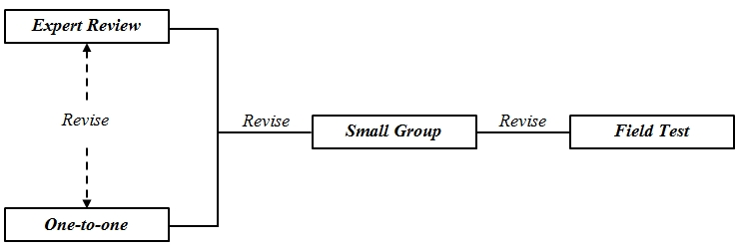

Figure 1. The flow of Tessmer's formative evaluation design (1993); Zulkardi (2006)

*2.1 Data collection technique*

The walkthrough process was carried out at the expert review stage by 3 experts as validators consisting of two mathematical modeling expert lecturers and one mathematics teacher. The 4 validators are Elika Kurniadi, S. Pd., M. Sc., and all the MGMP mathematics teachers at SMPN 4 Muara Enim, namely Mrs. Khadijah, S.Pd, Mrs. Elvira Roza, S.Pd, and Mrs. Rahada, S.Pd. In the implementation of validation, a validation sheet is used which aims to see the benchmarks whether the student worksheets are valid, in terms of construct, content, and language. The validator provides comments and suggestions about the student worksheets on the validation sheet that has been prepared by the researcher. Observations were made at the one-to-one, small-group, and field test stages which aimed to find out students 'complaints and difficulties during discussions on working on student worksheets based on mathematical modeling learning developed by the researcher as well as seeing students' mathematical modeling abilities. Observations of student activities in the one-to-one and small-group stages were carried out to see students' complaints and difficulties while working on the student worksheets which were then used as material to revise the student worksheets. At the field test stage, observations were also carried out to see students' abilities in doing student worksheets based on learning mathematical modeling by checking indicators and recording all group activities that appeared while working on student worksheets and analyzing student answers to student worksheets.

Student answer documents were obtained from students' answers to the student worksheets in each group during the lesson. Student answer documents are used to see students' abilities in doing student worksheets based on mathematics ethno-mathematics learning developed by the researcher.

The questionnaire was used to see students' responses to mathematics using the ethnomatics-based student worksheets developed by the researcher. This questionnaire focused on three categories, namely students' views about the benefits of mathematics in life consisting of 31 statements, students' confidence in mathematics consisting of 10 statements, and students' views on.

In this study, researchers conducted unstructured interviews for the one-to-one and small-group stages, while for the field test stage the researchers conducted structured interviews. Interviews in the one-to-one and small-group stages were conducted after students had worked on the student worksheets. Meanwhile, interviews in the field test stage were conducted after students filled out a post-test questionnaire which served as complementary data to the questionnaire to determine the potential effects of ethnomathematics-based student worksheets on students' mathematical responses.

*2.2 Data analysis technique*

The walkthrough data analysis was used to obtain the validity of the developed student worksheets. The walkthrough data were obtained from the validator's comments and suggestions as well as the scoring of each aspect that the validator assessed for the prototype 1 student worksheets. The data were analyzed quantitatively. The validity of the student worksheets is seen from the calculation of the score given by the validator for the student worksheets developed

The results of interviews at the one-to-one and small-group stages of students were analyzed descriptively in order to explore information about the difficulties of students using student worksheets and practicality of using student worksheets. While the results of interviews conducted at the field test stage after giving the questionnaire were analyzed descriptively as complementary data to the results of the questionnaire in order to determine the potential effects of student worksheet based on mathematics modeling learning on students' mathematical perceptions. The results of the interviews conducted in the field test stage after questionnaire were administered to three students who represented each student who perceived very good, good, and sufficient.

1. **Results and Discussion**

**3.1 Research result**

Analysis

In the analysis stage, the first thing the researcher does is an analysis of the needs and characteristics of students. From the analysis stage of the student's needs and characteristics, it was found that the research development respondents were grade VII.1 students of SMP Negeri 4 Muara Enim. with a total of 31 students whose age level is 14 years. The next analysis is the analysis of the curriculum and learning materials. In the analysis of the curriculum and learning materials, the researchers found that the concept of culture in curriculum 2013 (K-13) is relevant to the characteristics of ethnomathematics based learning. From the curriculum analysis stage, it was found that the ethnomathematics-based student worksheets developed by the researcher were suitable for application in K13 learning.

Design

At the design stage, the researcher designed the real problem and designed the student worksheets as a container for the real problem so that students could solve problems related to the flat field material. The real problem relates to oil palm cultivation.

Development

After the design stage, the researcher then carried out the development stage. The real problems that have been designed are then developed. For student worksheets, researchers develop practicum objectives by the context of the problem and basic competencies. Furthermore, the researcher developed instructions on how to use student worksheets, supporting information in the form of material, steps for using practicum tools accompanied by pictures, measuring steps, and problem solving steps.

Implementation and Evaluation

The next stage, namely the implementation and evaluation stage. The researcher implemented the questions in the form of the editor in the student worksheets format. At the implementation stage, the researcher obtained two ethnomatics-based student worksheets that contained solving problems based on ethnomatic-based steps. After the implementation stage, the researcher conducted an evaluation in the form of a formative evaluation of the student worksheets that had been developed starting from an expert review, one-to-one, small-group, and field tests.

Expert Review

At the expert review stage, the student worksheets that the researcher had developed was given to two mathematical modeling experts and the Mathematics MGMP teacher at SMP N 4 Muara Enim. The results of the expert review stage were used to see the validity of the ethnomathematics-based student worksheets. The validation results at the expert review stage can be seen in table 1.

Table 1 Results of the expert review stage for ethnomathematics-based STUDENT WORKSHEETS

|  |  |  |
| --- | --- | --- |
| **Expert Name** | **Comments and Suggestions** | **Revision Decision** |
| **Elika Kurniadi, S. Pd., M. Sc** | • In problems 1 and 2 the word "mathematical model" is changed to "mathematical symbol",  • In problems 1 and 2 the word "illustration" is changed to "describe it" | All suggestions from Mrs. Elika Kurniadi, S. Pd., M.Sc, researchers apply. |
| **Teachers Mathematics SMP N 4 Muara Enim** (Khadijah, S.Pd, Ibu Elvira Roza, S.Pd, dan Ibu Rahada, S.Pd) | Adding the draft student worksheets before the student worksheets to be studied. | Suggestions from the MGMP Mathematics Teacher at SMPN 4 Muara Enim, the researcher applied it, but still, student worksheets KD 4.11 was the focus of the researcher's research. |

One-to-one

As validated by the expert at the expert review stage, to see the validity of the prototype 1 student worksheets, the prototype 1 student worksheets was tried out in the one-to-one stage on 3 students to know the difficulties experienced by students as well as the clarity of language and students' understanding of student worksheets. The results from the one-to-one stage obtained from interviews and student comments written on the comment sheet and observation results can be seen in table 2.

Table 2 Results of the one-to-one student worksheets practicum

|  |  |
| --- | --- |
| **Observation Results** | **Revision Decision** |
| Students don't remember the field type formula | The formula for the type of flat area is added to the practicum student worksheets in the supporting information section. |

Small-group

Student worksheets that were declared valid, after being revised at the expert review stage and one-to-one, continued to the small-group stage where the researcher tested the student worksheets on 2 groups of students to see the practicality of the student worksheets.

Field Test

The next stage is the field test stage. At this stage, the researcher tested the student worksheets prototype 3 which was valid, and practical from the results of the trial and revision of the expert review stage, one-to-one, and small-groups. This stage aims to see the potential effects of ethnomathematics-based student worksheets and students' perceptions of the benefits of mathematics in everyday life. The results of the field test were seen from the analysis of observation data, student answers, questionnaires, and interviews at a meeting in class VII.1 SMP N 4 Muara Enim. The field test stage is carried out in one meeting.

At the first meeting, students were asked to carry out practicum activities following the instructions in the student worksheets procedures then continued to answer the questions in the student worksheets. Activities in student worksheets ask students to calculate the area and perimeter of triangles and rectangles.

As the field test was carried out, namely doing student worksheets based on learning mathematical modeling, the researcher made observations on groups 1 and 2. The results of the analysis of observations on groups 1 and 2 were that ethnomathematics-based student worksheets had a potential effect on ethnomathematics-based learning. Meanwhile, based on the results of the analysis of students' answers, the researcher concluded that the ethnomathematics-based student worksheets also had a potential effect on the ability to solve flat field problems.

After the students finished working on the ethnomathematics-based student worksheets, the researcher gave a questionnaire to the students of class VII 1 SMP N 4 Muara Enim to know the potential effects of the ethnomathematics-based student worksheets on student perceptions.

**Results of the Analysis of the Implementation of Ethnomatematic Based Learning**

The analysis results from the implementation of ethnomathematics-based learning

1). Exploration Stage

At this stage, students explore mathematical ideas in the culture of oil palm cultivation. Students are given material about the culture (cultural literacy) of the context of oil palm cultivation.

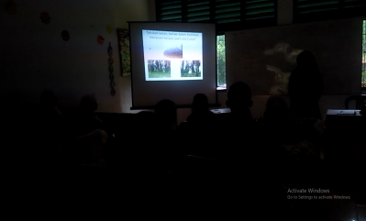

Figure 2 The teacher is asking students to explore mathematical ideas in oil palm cultivation

At this stage, the teacher reminds students about how to cultivate oil palm to students. At this stage students recognize and know and recall the culture that is the context for learning. At this stage, students also begin to explore their knowledge of mathematical ideas from oil palm cultivation, which is known as ethnomathematics

2). Mapping Stage

Through teacher assistance, students make maps of the relationship between flat plane concepts and ethnomathematics Then choose the concept of a flat plane that corresponds to the problem to be studied both individually and in groups.

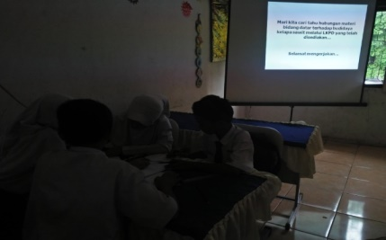

Figure 3 Students exploring mathematical ideas in the culture of oil palm cultivation

At this stage, students construct their knowledge carefully in solving problems with their groups.

3). Explanation Stage

At this stage, students study the flat area contained in the given problem and, communicate what is learned, share with each other, appreciate what is learned in various forms. This can be seen when the following observations are based on each group:

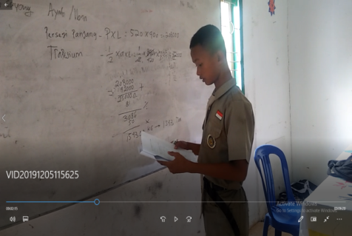

Figure 4 Subject 1 presenting the results of his work on problem 1

Based on the results of his explanation and interviews, subject 1 solved the problem using a rectangular and trapezoidal plane. In Subject 2 trying to give his opinion on problem 2.

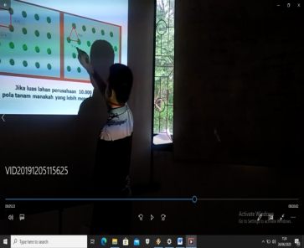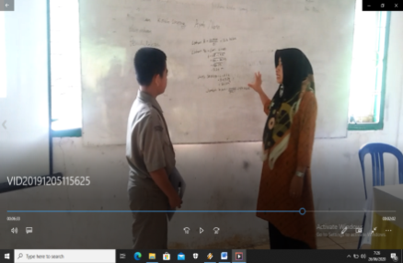

Figure 5 Subject 2 presenting the results of his work on problem 2

4). Reflection Stage

At this stage the teacher and students summarize what is learned both the mathematical knowledge obtained in the mathematics learning process.

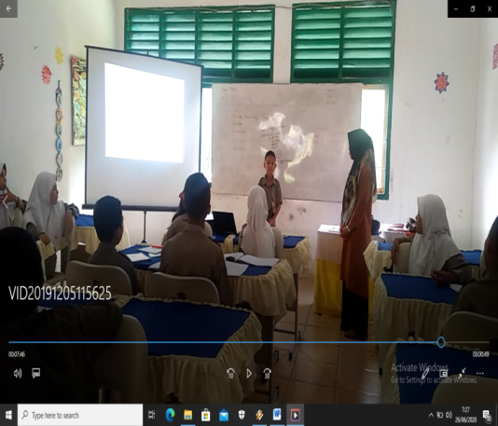

### Figure 6 Subject 3 conveys a conclusion from the material that has been obtained

**Results of Analysis of Student Response Data to Ethnomatematic Based Learning**

To find out the response of students, the researchers used measuring instruments for observation sheets, videos and pictures, test results, and interviews. In this study, the researcher took 3 subjects that had been determined with the teacher, namely 1 high cognitive student (T), 1 medium cognitive student (S), and 1 low cognitive student (R). The results of the analysis of student response data.

Analysis of the Response of Three Subject Students (R) Against Ethnomatematic Based Learning

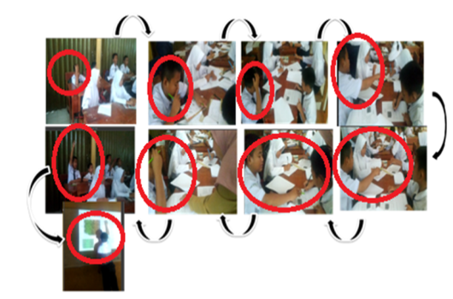

Figure 7 Moderate cognitive student responses to ethnomatematic based learning

Based on the analysis of the results of the observations, it is known that during the test, high cognitive students have seen the emergence of indicators that meet all response indicators, namely students feel happy with the way the teacher applies mathematics learning using the context of oil palm cultivation, can understand concepts and solve flat field material problems using the cultivation context palm oil and students are motivated to learn mathematics, although at first, the students showed movements that seemed to dislike the material, during the discussion he showed that he was curious by asking friends from his group, and finally could solve the problem himself, even he was sure to present his answer in front of the class of his own accord.

This can be shown based on the results of the answer. The answers of high cognitive students can be seen in Figure 8 below:

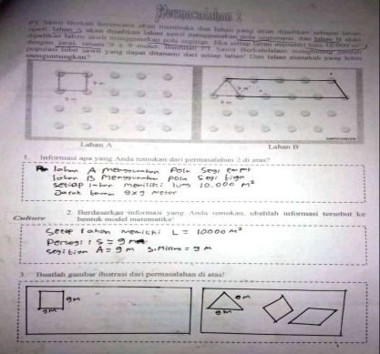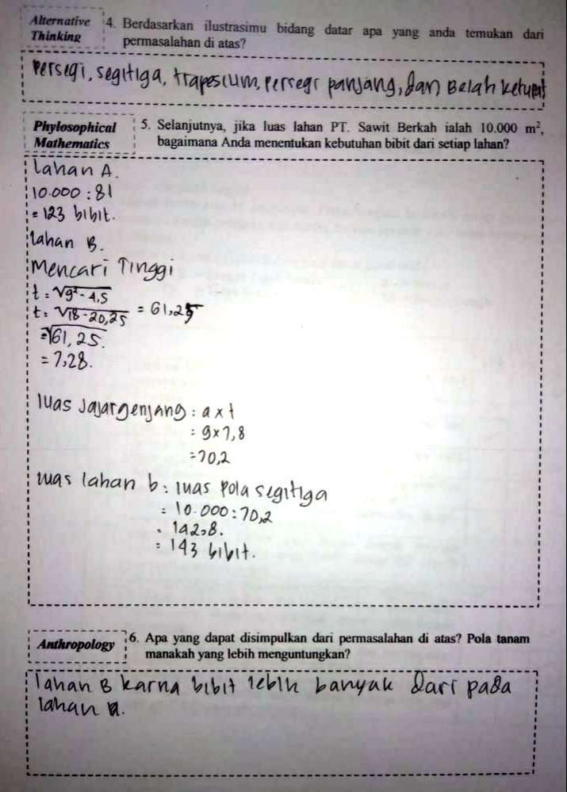

Figure 8 The results of the students' moderate cognitive answers

This was also supported by the results of the researchers' interviews with the following subjects:

Teacher: What is 7.79? Area of ​​the triangle or what?

Student: I used the Pythagorean formula to look for an unknown vertical side.

Teacher: I see, it should not be the area of ​​the triangle before it is equal, it means t. Then, why 9 suddenly appeared, how was that?

Student: 9 is the side of the base, so I already got the height, then I used the formula for the area of ​​a triangle, said Student A using the area of ​​a triangle.

**Discussion**

In this discussion, there are two, the first is a discussion of the characteristics of ethnomathematics based student worksheets using the context of oil palm cultivation that is valid, and practical. And the second is a discussion of the potential effects of ethnomathematics based student worksheets using oil palm cultivation on mathematical modeling abilities and student perceptions. At the analysis stage, it was known that the characteristics of students VII 1 SMP N 4 Muara Enim, students were never given questions based on ethnomathematics Then the researcher designed a forum in the form of an ethno-mathematics-based student worksheets so that students could solve flat-field material questions using the context of oil palm cultivation in the student worksheets, so the researcher designed a student worksheet based on mathematical modeling that was suitable for grade VII students. Furthermore, the student worksheets that have been designed are developed and tested. The student worksheets that have been developed are implemented into an ethnomathematics based student worksheet format. The next stage is the evaluation stage, the evaluation used is a formative evaluation which consists of four stages, namely expert review, one-to-one, small-group, and field test.

The expert review and one-to-one stages aim to get a valid, student worksheets. The validity of student worksheets is based on construct, content, and language. The expert review stage aims to see the validity in terms of content, construct, and language. Meanwhile, the one-to-one stage aims to see the validity in terms of ease of use of student worksheets. In terms of validity, based on the results of an expert review and one-to-one, it is known that according to the student worksheets that the researcher has developed, it can be tested on students at the next stage, namely the small-group after several revisions were made to see the practicality of the student worksheets. Meanwhile, in terms of practicality, based on the results of the small-group student worksheets that have been developed, it also meets the criteria. Furthermore, a field test was carried out to see the potential effects of the student worksheets based on the developed mathematical modeling learning.

Expert validation is carried out in parallel with one-to-one trials, which means that validation of teaching materials by experts is carried out in parallel with one-to-one trials [22]. student worksheets which are declared valid, based on the results of expert reviews and one-to-one. The criteria for the validity of this learning device are by the criteria put forward by Akker [23] that the validity aspect of a learning device must be related to two things, namely the first, the learning device developed is based on a strong theoretical rationale, in this case, the student worksheets have referred to the characteristics of learning mathematical modeling, as well as the use of the scientific context in student worksheets activities. Second, there is consistency internally, in this case, student worksheets are interrelated between mathematics modeling learning and mathematical perceptions. In the expert review and one-to-one stages as a whole, content, construct, and language validation was carried out.

In terms of content, the developed student worksheets based on mathematics modeling learning are by the core competencies and basic competencies of the K13 curriculum, and are by the indicators of competency achievement, learning objectives, context, content, and mathematical modeling. Whereas in terms of language, the sentences in the student worksheets use standard language, namely Indonesian which is good and correct where students have no wrong typing of information or questions in the questions, the pictures contained in the student worksheets use informative pictures or pictures that provide important information in completion student worksheets, as well as the terms used in student worksheets do not cause problems for students or misinterpretation of the terms used. Based on expert comments and suggestions, namely two lecturers and one mathematics teacher as well as student comments on the deficiencies contained in the student worksheets that occurred during the one-to-one stage used as material for revising or improving the student worksheets to produce a valid, student worksheets. Based on expert review validation and one-to-one then the researcher made revisions, there were many changes made to the student worksheets. for practicum student worksheets, the tools used for practicum are replaced with new tools where before revision the tools used are simple tools made by the researchers themselves, then after revision, the tools are replaced with new ones according to the advice of the supervisor. Likewise, steps or work procedures are also repaired.

The practicality of the student worksheets is seen from the results of observations, student responses, and small-group interviews. The student worksheets that have been developed meets practical criteria. From the results of student observations when working on student worksheets, student answers, and interview results it appears that students can use student worksheets even though there are still, students who feel confused and often ask questions because they have never worked on questions like those in student worksheets and they are also not used to using student worksheets-based mathematical modeling. So that it is appropriate according to Nieveen that the product developed is by the objectives, in this case, the assessment indicators include the suitability of the objectives of working on the problem in student worksheets and mathematical modeling; the product developed is easy to use, in this case, the assessment indicators include ease of use, understanding of the material, and language [24].

**Refrences**

[1] Muwahidah Anis 2015 *Hubungan Antara Intensitas Shalat Hajat Kubra Dengan Pengamalan Spiritual Santri Pondok Pesantren Al-Qudsy Kudus* Skripsi (Semarang: Fakultas Ushuluddin dan Humaniora UIN Walisongo)

[2] NCTM 2003 *Standards for Secondary Mathematics Teacher* (United States of America : The National Council of Teachers of Mathematics, Inc)

[3] Posamentier, A. S., & Krulik S 2009 *Problem-Solving in Mathematics Grades 3-6: Powerfil Strategies to Deepen Understanding* (Thousand Oaks: Corwin A Sage Company)

[4] Prabawa E. A., & Zaenuri, Z 2017 *Analisis Kemampuan Pemecahan Masalah Ditinjau Dari Gaya Kognitif Siswa Pada Model Project Based Learning Bernuansa Etnomatematika* Unnes Journal of Mathematics Education Research 6(1) 120-129

[5] Ulya H 2015 *Hubungan gaya kognitif dengan kemampuan pemecahan masalah matematika siswa* Jurnal konseling GUSJIGANG 1(2)

[6] OECD 2016 *PISA 2015 Results in Focus* (New York: Columbia University)

[7] Khotimah H 2013 *Meningkatkan hasil belajar geometri dengan teori van Hiele* In Prosiding Seminar Nasional Matematika dan Pendidikan Matematika (Vol. 9, pp. 9-16).

[8] Anjarsari Elly., Hobri., Irvan, Muhtadi., & Sunardi 2017 *Spatial Intelligence on Solving Three Dimensional Geometry Object Through Project Based Learning* The International Journal of Social Sciences and Humanities Invention, 4(8): 3817-3822.

[9] TIMSS 2011 *International Result In Mathematics* (Chestnut Hill : TIMSS dan PIRLS International Study Center, (Online), (http://timssandpirls.bc.edu/timss2011/international-result-math, diakses 6 Januari 2014))

[10] Mullis I V., Martin, M. O., Foy, P., & Arora, A 2012 *TIMSS 2011 international results in mathematics* (pp. 139-171)

[11] Zahroh Umy 2018 *Penerapan Pembelajaran Berbasis Etnomatematika*

[11] Suryanatha I N A S., & Apsari R A 2013 *Etnomatematika: Ketika Matematika Bernafas Dalam Budaya*

[12] Supriatna J., Dwiyahreni, A. A., Winarni, N., Mariati, S., & Margules, C 2017 *Deforestation of primate habitat on Sumatra and adjacent islands, Indonesia*. *Primate Conservation*, *31*(71-82).

[13] Dahlan AH 2017 *Pengembangan Model Pembelajaran Pendidikan Matematika Realistik Indonesia (PMRI)Untuk Meningkatkan Ketertarikan Belajar Matematika* (Universitas Sanata Dharma: Tesis)

[14] Marsigit M., Setiana, D. S., & Hardiarti, S 2018 *Pengembangan pembelajaran matematika berbasis etnomatematika.* In *Prosiding Seminar Nasional Pendidikan Matematika Etnomatnesia*

[15] Asnawati S., KD I L., & Muhtarulloh, F 2016 *Penerapan Pembelajaran Inkuiri dengan Etnomatematik pada Materi Bidang Datar terhadap Kemampuan Pemahaman Matematis Siswa*. Euclid, 2(2).

[16] Irawan A & Kencanawaty G 2017 *Implementasi pembelajaran matematika realistik berbasis etnomatematika*. *Journal of Medives: Journal of Mathematics Education IKIP Veteran Semarang*, *1*(2), 74-81.

[17] Putra R W Y & Indriani P 2017 *Implementasi Etnomatematika Berbasis Budaya Lokal dalam Pembelajaran Matematika pada Jenjang Sekolah Dasar* (NUMERICAL: Jurnal Matematika Dan Pendidikan Matematika, 9-14)

[18] Tessmer M 1993 *Planning and conducting formative evaluations: Improving the quality of education and training* (London: Kogan)

[19] Zulkardi & Putri R I 2010 *Desain Bahan Ajar Penjumlahan Pecahan Berbasis Pendidikan Matematika Realistik Indonesia (PMRI) untuk Siswa Kelas IV Sekolah Dasar Negeri 23 Indralaya* Jurnal Pendidikan Matematika 4 (2)

[20] Akker J Van den 1999 *Principles and Method of Development Research. London*. in van den Akker J., Branch R.M., Gustafson K., Nieveen N., & Plomp T , *Design approaches and tools in educational and training* (Dordrecht: Kluwer Academic Publisher)

[21] Nieveen N 1999 *Prototype to reach product quality* in van den Akker J., Branch R M., Gustafson K., Nieveen, N., & Plomp T *Design approaches and tools in educational and training* (Dordrecht: Kluwer Academic Publisher)