Mathematical reasoning ability: analysis of student’s strategies to problem-solving.

M A Abdullah¹, Sugiman², and H N Rahman¹
¹Graduate Program of Yogyakarta State University, Jl. Colombo No. 1, Karangmalang, Sleman, DI Yogyakarta, Indonesia
²Mathematics Departement, Faculty of Mathematics and Science, Yogyakarta State University

E-mail: mucharif.2019@student.uny.ac.id

Abstract. Reasoning ability is one of the abilities that must be possessed by students. TIMSS data in 2015 shows that the reasoning abilities of Indonesian students are not yet optimal. This is because some students still relate facts in solving problems. This study aims to determine the reasoning abilities of Madrasah Aliyah (MA) students. This research is a descriptive qualitative research type. The sample used as the research subject is the XI grade students of the MA Islamic Centre Bin Baz Yogyakarta. The instrument used in this study was a test of mathematical reasoning abilities. The method used to determine how students' mathematical reasoning abilities, namely by using analysis of student work results, seen from how the strategies used by students when answering these questions. As for the results of this study, there are various kinds of student answers, which can be seen in how the fulfillment strategy of the assessment aspect of mathematical reasoning abilities can be seen from the way students answer. With good reasoning skills, learning mathematics will be more meaningful.

1. Introduction
Knowledge and technology are always experiencing developments from time to time. The rapid development of science in the 21st century makes various countries compete to increase human resources through education. Education is a process to add insight so that students are more active in developing their mindset. A relevant field of science in education in mathematics. A science which is one of the essential sciences for other disciplines [1]. In an educational environment, mathematics is taught in a learning process called mathematics learning.
Mathematics learning is expected to train to reason and thinking in concluding, developing problem-solving abilities, and delivering information [2]. Besides, there are five skills that students need to have through learning mathematics, including (a) reasoning and proof, (b) problem solving, (c) representation, (c) communication, and (d) connection [3]. Mathematics and reasoning are closely related [4]. To understand mathematics requires the ability to reason [3]. Reasoning ability is a foundation to be able to build mathematical knowledge [5]. Learning, mathematics material, or topics at all levels of education include a reasoning process [6]. Problem-solving related to mathematics cannot be separated from reasoning abilities [7]. This is because reasoning is an essential aspect of solving problems [8]. By learning mathematics, students can improve their reasoning skills [9]. The most important thing about the learning process of mathematics in class is to use or develop students' reasoning abilities. The reasoning is the activity of examining a pattern and noting regularity, making assumptions about a possible generalization, and providing an evaluation of these assumptions [3]. Mathematical reasoning is a thought process carried out to produce new and true statements or reach a conclusion based on statements that have been obtained previously [10][11][12][13].
From some of the expert opinions above, it can be concluded that reasoning ability is an activity or activity that involves the way students think to observe a pattern, make an assumption, evaluate the truth of the conjecture and use generalizations to make conclusions from a given problem based on relevant sources.
In some cases, students' reasoning abilities are not optimal [14]. From the data obtained from PISA in 2010, it shows that the achievements obtained by Indonesia are still not optimal, this is supported by Indonesia's results which are ranked 61st out of 65th participating countries with an average score of 371 [15]. TIMSS results in 2011 and 2015 show a low percentage of Indonesian students' rational ability in the cognitive domain, around 17% and 20% [16].
In general, students still use rote methods to solve problems rather than using their reasoning skills [10]. This might happen if the learning provided does not support constructing or building reasoning abilities. Teacher activities in teaching are one of the factors that cause students' low reasoning abilities, memorizing or drill in the mathematics learning process is the cause of students having difficulty solving the problems given [17], besides teacher-centered learning makes students less active during the process. learning, so that students' reasoning abilities cannot develop optimally [18].
Based on the descriptions that have been described above, it is essential to research the mathematical reasoning abilities possessed by students. Therefore, the researcher conducted a study entitled "Mathematical reasoning ability: analysis of student’s strategies to problem-solving."

2. Methods
This research uses a qualitative descriptive method that is used to describe an event to produce descriptive data in the form of the subject's behavior being the material of observation. The subjects in this study were students of class XI MA Islamic Centre Bin Baz Yogyakarta. The assessment aspects follow the following stages: (a) Checking the pattern of the problems given; (b) Making an initial guess of the problem given; (c) Evaluating the allegations that have been previously made; and (d) Using generalizations to conclude. The research design used a case study with the instrument in this study to test mathematical reasoning abilities. Then, the test results will be processed and analyzed to see the strategies students use to solve problems.

3. Result and Discussion
To see the strategies used by students in solving problems. The reasoning ability test questions given to students are described in Figure 1.

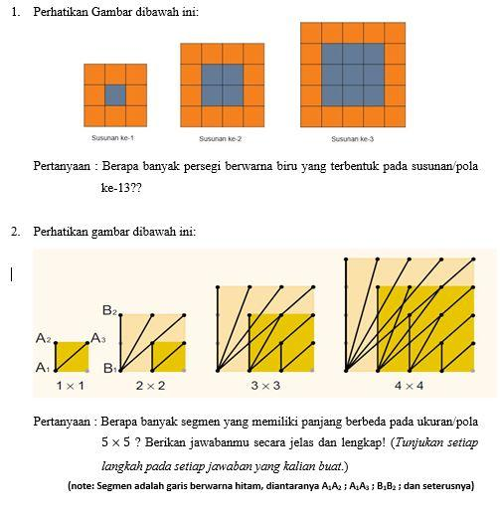
Figure 1. Reasoning Ability Test Questions

3.1. Student Work Results
By processing data and analyzing student work, a description of students' strategies in solving the problems given can be carried out.

3.1.1. Description of First Subject Reasoning Strategy (S1)

The description of the problem-solving strategy from S1 is depicted in Figure 2 below.

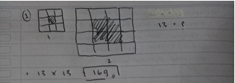
Figure 2. The results of the work of Problem Number 1 Subject S1
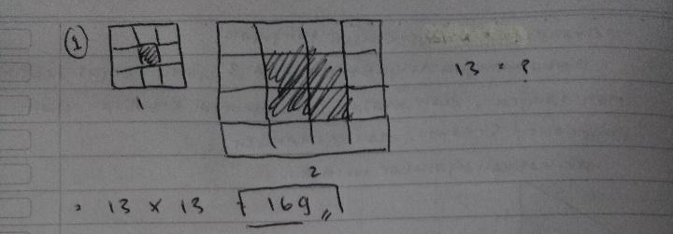
Figure 2 shows that the process carried out only includes the stage in the last aspect of reasoning abilities. The stages in the first to third aspects of the S1 answer sheet are not visible. This makes the thinking process carried out by students unobserved. However, students have gone through well the last stage of the reasoning ability activity. Students can conclude to determine the many blue squares formed in the thirteenth order; furthermore, other students' strategies in answering will be presented.

3.1.2. Description of Second Subject Reasoning Strategy (S2)

The description of the problem-solving strategy from S2 is depicted in Figure 3 below.

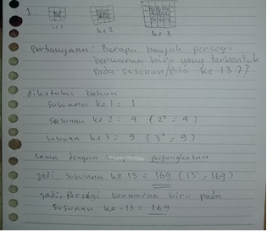
Figure 3. The results of the work on Problem Number 1 Subject S2

In Figure 3, it can be seen that the problem-solving process is quite structured and transparent. These students' initial steps were started by drawing and rewriting what was known in the questions on their answer sheet. This indicates that the students have good recognition abilities. In the next step, S2 writes the many blue squares formed from each arrangement, starting from the first arrangement to the third arrangement. It appears that the stage in the aspect of checking the pattern of the problems given by S2 has been fulfilled. Next, S2 writes the pattern that is formed in the form of power. This step is done to find out how many blue squares in each arrangement.
The number of blue squares in each arrangement results from the square of the sequence number formed. However, the process carried out by students does not directly show the stage of making initial guesses of the problems given and the stage of evaluating the allegations that have previously been made. In the next step, S2 makes conclusions and generalizations that the many blue squares formed in the 13th arrangement result from the squares of the sequence number, with the number of squares in blue are 169. This shows that the last step in the aspect of reasoning ability is to use generalizations. To conclude has passed well. Furthermore, other students' strategies will be presented in answering question number 2.

3.1.3. Description of Third Subject Reasoning Strategy (S3)

The description of the problem-solving strategy from S3 is depicted in Figure 4 below.

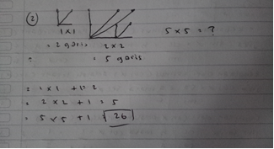
Figure 4. The results of the work on Problem Number 2 Subject S3

The results of student work in Figure 4 show that students do not carry out the recognition process. Besides, the identification of students' observations of the patterns formed from each square was not entirely carried out. Students only make observations of the segments formed in the first two squares to determine the algebraic process. Even though students have gone through the first aspect of their reasoning abilities, they have not yet identified the pattern optimally. Stage two and three aspects of reasoning ability are also not visible. Students only use algebraic processes on the two observed patterns to determine many segments that have different lengths in the fifth square. Students are also not right in carrying out the final stage because they only use two observed square patterns, resulting in incorrect conclusions. In observing facts, the process of observing the formed patterns should be carried out until the last image presented in the problem. Next, the strategies of other students in answering will be explained as in the picture below.

3.1.4. Description of Third Subject Reasoning Strategy (S4)

The description of the problem-solving strategy from S4 is depicted in Figure 5 below.

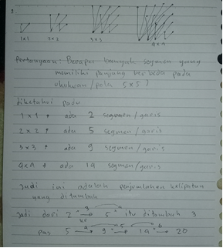
Figure 5. The results of the work on Problem Number 2 Subject S4

Figure 5 shows that students start by redrawing what they already know and writing down the questions. This step shows that the students' recognition skills have been passed. Then, the process the students undertook was to write down the pattern that was formed from each square size. This shows that the students' ability to identify the questions given is good enough, likewise with the first aspect of the reasoning ability stage that students have mastered well. Next, students explain the mathematical process that occurs from the segments formed at each square size, by writing the addition of the segment for each additional square size. This stage shows that students carry out the third stage first before the second stage of reasoning abilities. Students did not conduct a more in-depth evaluation of how many segments were formed in the fifth-order square in the third stage. Students only carry out the generalization process by looking at previous patterns to determine answers.
At the generalization stage, students only generalize by looking at the first to fourth patterns. Students ignore how many segments of different lengths will be formed in the fifth square. Students only assume that the segment formed in the fifth square is 20 segments with different lengths. In fact, in the fifth square, 19 segments with different lengths are formed because two segments have the same length, namely a segment with five length units. The second aspect of the reasoning ability does not appear clearly on the student's answer sheet, which is because students combine this stage with the fourth stage. The lack of evaluation carried out by student S4 resulted in the conclusion that their answers were incorrect.

3.2. Discussion
Based on the description of the analysis that has been described, the S1 and S2 answer sheets have different strategies and activities of reasoning abilities that have been passed. S1 problem solving only carries out activities at the last aspect of reasoning ability while S2 has gone through all aspects well. On the S1 answer sheet, there is no visible pattern identification process that students have observed. At the same time, S2 writes the observed pattern ultimately.
Students who master the facts will rewrite these facts and use them appropriately [19]. Students are said to understand the problems given when students can identify and mention the information contained in the questions correctly [20]. Students who experience problems in identifying and connecting the facts presented in the questions will result in students' difficulty in solving the problems given [21]. Problem-solving S1 has not shown the process of identifying the patterns formed in the questions. In theory, failure at an early stage in the aspect of reasoning will result in failure at a later stage as well, but S1 is able to carry out the last stage, namely drawing conclusions, well. Research constraints that were carried out when the COVID-19 pandemic hit caused researchers to be unable to make two-way interactions with students so that the cause of S1 being able to conclude correctly could not be ascertained. Researchers can only suspect a number of possible reasons for this, namely: students do calculations on other answer sheets, students use logic without needing to doodle, or students look at their classmates' answers.
Answer sheets for S3 and S4 have different variations in answering the questions given. S3 does not appear to observe the image given thoroughly so that the activity of gathering information or making guesses becomes less precise [22], resulting in errors in steps or results obtained. Solving problems in the context of mathematical reasoning requires analysis or identification of relevant facts so that the strategy used is correct. Meanwhile, S4 seems to have carried out the activities of the reasoning aspect stages well. Although the evaluation process is not in-depth, lead to the final result is not right [23]. The obstacle encountered by S4 students is the difficulty in evaluating the assumptions that have been made [24]. Students should be more careful when using generalizations from observed patterns in concluding [3]. It is necessary to evaluate whether the previous pattern applies to the next pattern so that the answers obtained will be correct.

4. Conclusion
Based on the analysis of the results of research and discussion, it can be seen that students have strategies to solve problems in different ways when we refer to the indicators of reasoning ability. Of all the population samples studied, four students with different answer strategies are described, which are quite significant. S1 can complete the given questions by applying all the stages of reasoning abilities and can answer questions with the correct answers. Even so, the first to third abilities' activities are not explained in detail from the process of solving the questions. For S2 students, problem-solving can be done by applying all indicators to reasoning ability, but the delivery is not detailed. Besides, students rarely do activities, such as revealing known facts, and rewriting the questions asked can be done appropriately. A small activity but very rarely carried out by some students.
In S3 student, in the process of observing the segment patterns formed in the questions, students do not complete the answers to the last square sequence, so this results in the process of constructing the resulting algebraic model incorrectly. Mistakes in identifying the facts contained in the questions given can result in errors in the process or subsequent answers. Finally, in the fourth student S4, the students seemed to have gone through all activities in terms of reasoning ability. However, there was a slight error in evaluating many different segments in the fifth square in the students' answers.
Furthermore, there are several different obstacles in determining the strategy to be taken in answering the questions given. Most students when answering these questions, the third activity in reasoning ability, namely evaluating, indeed needs to be taken into consideration for improvement, so that students do not just use generalizations in making a decision.

References
[1] Muijs D and Reynolds D 2011 Effective Teaching: Evidence and Practice (Thousand Oaks, California: SAGE Publication)
[2] Mendiknas Peraturan Menteri Pendidikan Nasional Republik Indonesia Nomor 22 Tahun 2006 Tentang Standar isi Untuk Satuan Pendidikan Dasar dan Menengah (Jakarta)
[3] NCTM 2000 Principles and Standars for School Mathematics (Reston: NCTM,Inc.)
[4] Frosch C and Simms V 2015 Understanding the role of reasoning ability in mathematical achievement EuroAsianPacific Jt. Conf. Cogn. Sci. 633–8
[5] Brodie K 2010 Teaching Mathematical Reasoning in Secondary School Classrooms (New York: Springer Science+Business Media, LLC, 233 Spring Street, New York, NY 10013, USA.)
[6] Jäder J, Lithner J and Sidenvall J 2019 Mathematical problem solving in textbooks from twelve countries Int. J. Math. Educ. Sci. Technol. 1–17
[7] NCTM 2009 Reasoning and Sense Making (Reston: NCTM,Inc.)
[8] Diezmann C M, Watters J J and English L D 2002 Teacher Behaviours that Influence Young Children’s Reasoning Proc. 27th Annu. Conf. Int. Gr. Psychol. Math. Educ. 2 289–96
[9] Maarif S 2016 Improving junior high school students’ mathematical analogical ability using discovery learning method Int. J. Res. Educ. Sci. 2 114–24
[10] Lithner J 2008 A Research Framework for Creative and Imitative Reasoning Educational Studies in Mathematics , Published by : Springer Stable URL : https://www.jstor.org/stable/40284656 67 255–76
[11] Boesen J, Helenius O, Bergqvist E, Bergqvist T, Lithner J, Palm T and Palmberg B 2014 Developing mathematical competence: From the intended to the enacted curriculum J. Math. Behav. 33 72–87
[12] Lithner J 2000 Mathematical reasoning in task solving Educ. Stud. Math. 41 165–90
[13] Jonsson B, Norqvist M, Liljekvist Y and Lithner J 2014 Citation for the original published paper ( version of record ): Permanent link to this version : The Journal of Mathematical Behavior Learning mathematics through algorithmic and creative reasoning 20–32
[14] Jelita L and Zulkarnaen R 2019 Studi Kasus Kemampuan Penalaran MatematisSiswa Kelas VIII dalam Menyelesaikan Soal TIMSS Pros. Semin. Nas. Mat. dan Pendidik. Mat. 803–8
[15] OCDE 2009 PISA 2009 Assessment Framework. Key competencies in reading, mathematics and science Assessment 20 528–33
[16] Mullis I V S, Martin M O, Foy P and Hooper M 2015 Timss 2015 International Results in Mathematics Distrib. Sci. Achiev. 1–380
[17] Boesen J, Lithner J and Palm T 2010 The relation between types of assessment tasks and the mathematical reasoning students use Educ. Stud. Math. 75 89–105
[18] Riyanto B and Siroj R A 2011 Meningkatkan Kemampuan Penalaran Dan Prestasi Matematika Dengan Pendekatan Konstruktivisme Pada Siswa Sekolah Menengah Atas J. Pendidik. Mat. 5 111–28
[19] Shadiq F 2011 Penerapan Teori Belajar dalam Pembelajaran Matematika di SD Modul Mat. SD Progr. BERMUTU Penerapan 70
[20] Musser G, Burger W F and Peterson B E 2008 National Council of Teachers of Mathematics Principles and Standards for School Mathematics Principles for School Mathematics ed J Jacobs (River Street, Hoboken: John Wiley & Sons, Inc)
[21] Safrida L N, As’ari A R and Sisworo S 2016 Pengembangan Perangkat Pembelajaran Berbasis Problem Solving Polya Untuk Meningkatkan Kemampuan Penalaran Matematis Siswa Materi Peluang Kelas Xi Sma J. Pendidikan-Teori, Penelitian, dan Pengemb. 1 583–91
[22] Zaenab S 2015 Analisis Kemampuan Penalaran Matematis Siswa Melalui Pendekatan Problem Posing di Kelas X IPA 1 SMA Negeri 9 Malang JINoP (Jurnal Inov. Pembelajaran) 1 90–7
[23] Kuo E, Hull M M, Gupta A and Elby A 2013 How students blend conceptual and formal mathematical reasoning in solving physics problems Sci. Educ. 97 32–57
[24] Akbar G A M, Diniyah A N, Akbar P, Nurjaman A and Bernard M 2018 Analisis Kemampuan Kemampuan Penalaran Dan Self Confidence Siswa Sma Dalam Materi Peluang J. Educ. 1 14–21

