Development of augmented reality with the ADDIE model in mathematics learning
H Pujiastuti^{1*} and R Haryadi²
¹Pendidikan Matematika, Universitas Sultan Ageng Tirtayasa, Jl. Raya Jakarta KM. 04 Pakupatan, Serang 42111, Indonesia
2Pendidikan Fisika, Universitas Sultan Ageng Tirtayasa, Jl. Raya Jakarta KM. 04 Pakupatan, Serang 42111, Indonesia

*henipujiastuti@untirta.ac.id
Abstract. The purpose of this study is to determine the increase in learning motivation and to determine the increase in student learning attitudes through the use of augmented reality media. The model used in this study uses the Analysis-Design-Development-Implementation-Evaluation (ADDIE) model. In the evaluation stage, the pre-test-post-test non-equivalent control group was used. Data analysis techniques used observation sheets, questionnaires, and pre-test post-test test sheets. From the results of data analysis, the validation results obtained by three math teachers on the use of augmented reality by 85%. The results of the student responses also showed very good results, namely 83%. Furthermore, the evaluation results show that the N-Gain value in learning using augmented reality media is 73% or 0.73. These results indicate that learning mathematics using augmented reality media on polyhedron material is declared effective for improving mathematics learning outcomes. Furthermore, it can also be seen that learning mathematics without augmented reality shows a high N-Gain result of 50% or 0.5. However, both of them are more effective by using augmented reality learning media. The difference is 23% or 0.23. Based on the results of the research conducted, it can be concluded that the use of augmented reality media can improve mathematics learning outcomes for junior high school students at SMP 10 at serang city.
Introduction
Learning mathematics is a process or activity of mathematics teachers in teaching mathematics to students, which includes the teacher's efforts to create a climate and service to the abilities, potentials, interests, talents and needs of various students so that optimal interaction between teachers and students occurs. as well as between students and other students in learning mathematics [1]. Mathematics learning is the process of providing learning experiences to students through a series of planned activities so that students gain competence about the mathematical material being studied [2].
Learning mathematics for students is the formation of a mindset in understanding an understanding and in reasoning a relationship between these meanings [3]. In mathematics learning, students are accustomed to gain understanding through experience about the properties that are owned and not owned by a set of objects [4]. Students are given the experience of using mathematics as a tool to understand or convey information, for example through equations, or tables in mathematical models which are simplifications of story problems or other mathematical description problems [5].
Learning mathematics is learning concepts. To be able to understand it, the teacher's role is very important during the learning process [6]. The teacher must be able to convey these concepts to students so that students can understand them, starting from the simplest sequence of concepts to the most difficult level [7]. With this, the use of instructional media not only makes it easier for students to understand the teaching material, but also makes it easier for teachers to explain the subject matter [8].
The use of instructional media should get the attention of teachers in learning activities [9]. Learning media in fact follow the development of existing technology, ranging from print technology, audio visual, computers to combined technology between print technology and computers [10]. One of the benefits that can be taken from the existence of this technology is to use it as an effective, creative and educational learning medium [11]. So that educational application media can continue to be developed, one of which is Augmented Reality (AR) technology. The use of learning applications using AR technology can simplify the teacher's task in presenting material, shorten the time duration needed and can create a more interactive learning atmosphere [12]. In addition, the advantages of this application are also expressed is that it has high interactivity, namely the existence of a virtual AR object that can interact directly with users [13].
Android learning media that can be selected according to the geometric characteristics is android media using Augmented Reality [14]. This is because Augmented Reality is a technology that combines two-dimensional and three-dimensional virtual objects into a real three-dimensional environment in our environment and projects virtual objects in real time with an android phone [15]. AR technology or it can be referred to as Augmented Realistic is the integrity of digital elements that are added to the real world directly and follow the environmental conditions that exist in the real world and can be applied to mobile devices [16]. Augmented Reality technology is a visual technology that combines virtual world objects into real-world views in real time [17].
By utilizing Augmented Reality technology and Android smartphones, polyhedron objects can be visualized concretely through three-dimensional virtual modeling similar to objects the original is just above the drawing of the flat side space on the paper [18]. For this reason, Android-based applications by utilizing Augmented Reality technology as a polyhedron mathematics learning medium can be an alternative to help students understand various polyhedron objects in a concrete manner [19].
The purpose of this development research is to produce appropriate learning media in the form of applications using Android-based Augmented Reality technology in the material of flat-sided space in mathematics. The products produced from this development research are learning media in the form of android-based applications and manuals on the use of these learning media.
Experimental Method
This research method uses the form of Research and Development (R & D), which is a research method that aims to produce certain products and test the effectiveness of the product. The development model used consists of Analysis, Design, Development, Implementation, and Evaluation (ADDIE) [20].
This research was conducted at State Junior High School (SMP) 10 Serang city, Banten province, Indonesia. The subjects in this study were 30 students, aged 13 years, consisting of 15 male students and 15 female students from each class. Furthermore, at the evaluation stage, the experimental class and control class were used. The experimental class uses augmented reality media, while the control class does not use augmented reality media. The research method used in this study can be seen in Figure 1 below [21].
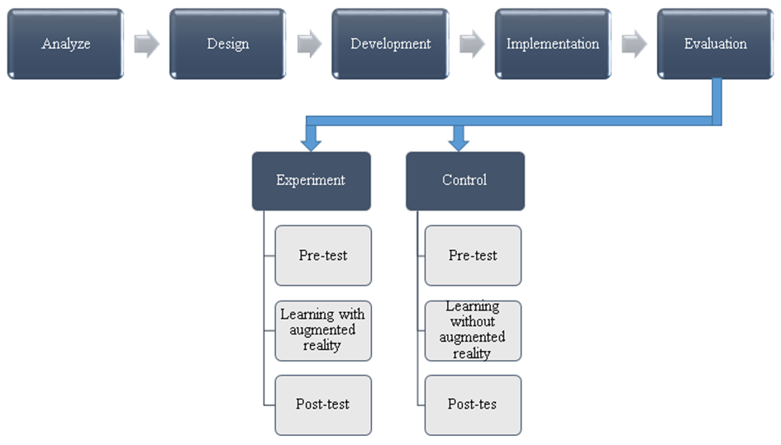

Figure 1. Research methods

After obtaining data from the pre-test and post-test results, then using the normalized gain score formula (N-Gain) in order to determine the increase in mathematics learning outcomes. With the existence of a normalized gain score (N-Gain) it provides an overview of the increase in student mathematics learning outcomes between before and after receiving treatment. The formula used can be seen in the equation below [22].
$$N-Gain= \frac{Posttest score-Pretest score}{Maximum score-Pretest score} (1)$$

Then, to determine the criteria for improving mathematics learning outcomes before and after learning mathematics using augmented reality learning media and not using augmented reality media, it can be seen in Table 1 below.
Table 1. N-Gain classification
N-Gain | Improvement Classification
g > 0,70 | High
0,30 < g ≤ 0,70 | Medium
g ≤ 0,30 | Low

Result and Discussion
  - Analysis
At this stage, an analysis of the use of learning media has been carried out, following the results of observations made on the use of learning media can be seen in Figure 2 below.

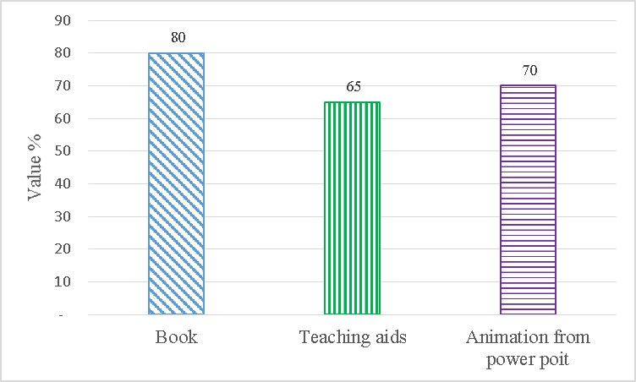

Figure 2. Analysis of the use of learning media

Based on Figure 2, it is found that the use of augmented reality learning media has not been used at all by teachers of the first high school located in the city of Serang, Banten, Indonesia.

3.2 Design
Furthermore, at this stage, namely designing an augmented reality learning media prototype, the following results from the augmented reality card prototype that have been developed can be seen in Figure 3 below.

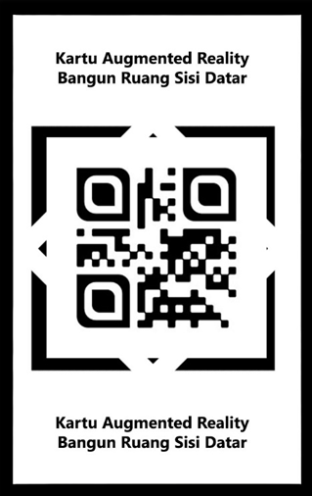

Figure 3. Card augmented reality polyhedron

3.3 Development
At the development stage, a validation test was conducted on three mathematics teachers who had taught for more than 10 years. This is done to calculate the feasibility of the percentage of augmented reality learning media. The following validation results can be seen in Figure 4 below.

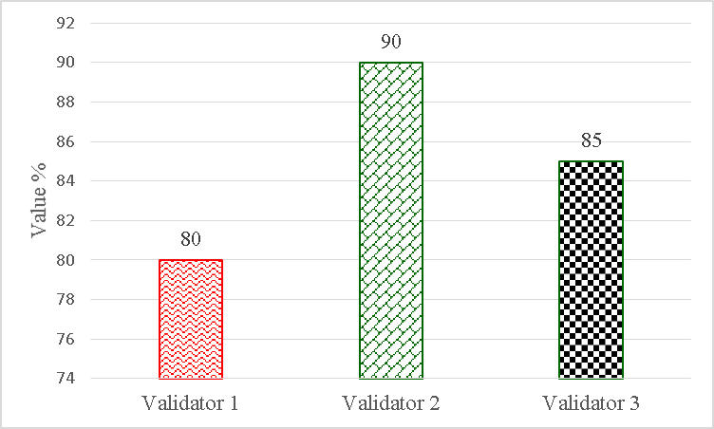

Figure 4. The results of the validation using augmented reality

Based on Figure 4, it can be said that the learning media shows that the average result of the validation of augmented reality media which is carried out on three teachers is 85, this means that the augmented reality media developed is very feasible to be used as a media for learning mathematics.

3.4 Implementation
Furthermore, the implementation was carried out for junior high school students. This stage involves the use or management of augmented reality learning media. This is done to determine the response of junior high school students to augmented reality media. The following results of student responses to augmented reality media can be seen in Figure 5 below.

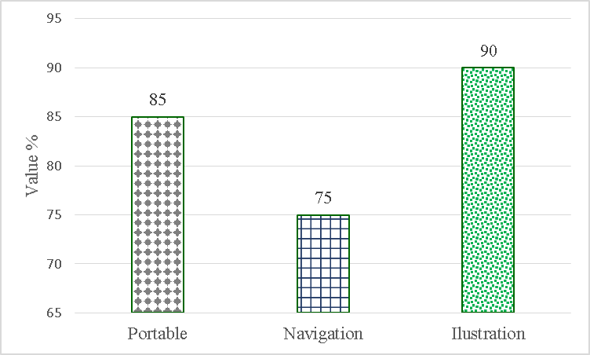

Figure 5. Results of student responses to augmented reality media

Based on Figure 5, it is found that the response of junior high school students shows an average result of 83. This means that students are very satisfied with the augmented reality media. Student responses were assessed from every aspect of augmented reality media, namely portable, navigation and illustration.

3.5 Evaluation
Furthermore, at the evaluation stage, the effectiveness of augmented reality media is tested for junior high school students. Following the evaluation results from the use of augmented reality media can be seen in Figure 6 below.

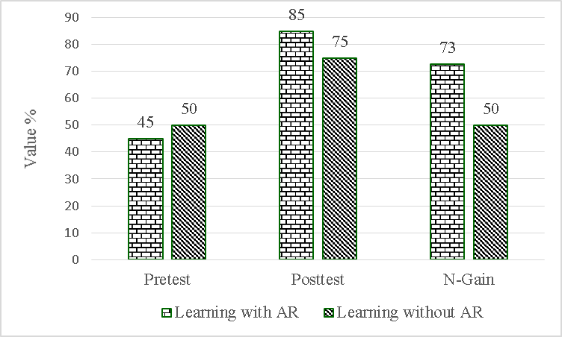

Figure 6. Results of evaluation of the use of augmented reality media

From Figure 6, it can be seen that the N-Gain value in learning using augmented reality media is 73% or 0.73. These results indicate that learning mathematics using augmented reality media on polyhedron material is declared effective for improving mathematics learning outcomes. Furthermore, it can also be seen that learning mathematics without augmented reality shows a high N-Gain result of 50% or 0.5. However, both of them are more effective by using augmented reality learning media. The difference is 23% or 0.23.
These results indicate that some research results on augmented reality can be used as a learning medium [23]. Augmented reality can serve as a tool in learning mathematics. Augmented reality is a novel learning medium so that students do not feel bored in the mathematics learning process. Every student has different characteristics, especially in their emotional and intellectual characteristics. There are those who easily understand the subject matter just by listening to the teacher's explanation. There are also students who just by reading they can understand mathematical concepts. However, there are also students who need help understanding the material to be taught and need media in teaching, in this case the augmented reality media is used, especially in mathematics subject matter on polyhedron material.
Conclusion
The conclusion from the above discussion is that learning mathematics will be easier for students to understand by using augmented reality learning media in the learning process. The most important thing in the application of augmented reality learning media is that which contains aspects of joy, pleasure, and away from tension while learning. By creating joy in students, they will easily accept the material taught by the teacher.
Acknowledgments
On this occasion the researchers thanked the Sultan Ageng Tirtayasa University Research and Community Service Institute (LPPM Untirta) for providing research grants to the Associate Research Lecturer (PDM) scheme.
References
[1] D. Hillmayr, L. Ziernwald, F. Reinhold, S. I. Hofer, and K. M. Reiss, “The potential of digital tools to enhance mathematics and science learning in secondary schools : A context-specific meta-analysis,” Comput. Educ., vol. 153, no. September 2018, p. 103897, 2020.
[2] H. Hellstrand, J. Korhonen, P. Räsänen, and K. Linnanmäki, “Reliability and validity evidence of the early numeracy test for identifying children at risk for mathematical learning di ffi culties,” Int. J. Educ. Res., vol. 102, no. December 2019, p. 101580, 2020.
[3] H. Pujiastuti, F. Ayatullah, and R. Haryadi, “The Influence of Inquiry Learning Model towards Students ’ Mathematical Critical Thinking Ability,” Unnes J. Math. Educ., vol. 8, no. 3, pp. 216–223, 2019.
[4] C. Attard and K. Holmes, “‘ It gives you that sense of hope ’ : An exploration of technology use to mediate student engagement with mathematics,” Heliyon, vol. 6, no. May 2019, p. e02945, 2020.
[5] G. Bolondi, L. Branchetti, and C. Giberti, “A quantitative methodology for analyzing the impact of the formulation of a mathematical item on students learning assessment,” Stud. Educ. Eval., vol. 58, no. May, pp. 37–50, 2018.
[6] H. Pujiastuti, R. Utami, and R. Haryadi, “The development of interactive mathematics learning media based on local wisdom and 21st century skills : social arithmetic concept,” J. Phys. Conf. Ser., 2020.
[7] U. Kuhl, A. D. Friederici, and M. A. Skeide, “Early cortical surface plasticity relates to basic mathematical learning,” Neuroimage, vol. 204, no. October 2019, 2020.
[8] J. Abdul, N. Ansari, and N. A. Khan, “Exploring the role of social media in collaborative learning the new domain of learning,” Smart Learn. Environ., vol. 7, 2020.
[9] H. Pujiastuti, D. Suvanti, R. Haryadi, and I. Marethi, “Development of mathmodule based on local wisdom and 21 st century skills : linear equation system,” J. Phys. Conf. Ser., 2020.
[10] R. Haryadi and H. Pujiastuti, “PhET simulation software-based learning to improve science process skills,” J. Phys. Conf. Ser., 2020.
[11] R. Haryadi and H. Pujiastuti, “Use of bungee jumping with stem approach to improve science process skills,” J. Phys. Conf. Ser., 2020.
[12] H. Pujiastuti and F. Fitriah, “Design of interactive teaching materials based on a scientific approach to support junior high school students’ learning: Line and angles,” J. Phys. Conf. Ser., vol. 1157, no. 3, 2019.
[13] T. K. Huang, C. H. Yang, Y. H. Hsieh, J. C. Wang, and C. C. Hung, “Augmented reality (AR) and virtual reality (VR) applied in dentistry,” Kaohsiung J. Med. Sci., vol. 34, no. 4, pp. 243–248, 2018.
[14] R. M. Yilmaz, “Computers in Human Behavior Educational magic toys developed with augmented reality technology for early childhood education,” Comput. Human Behav., vol. 54, pp. 240–248, 2016.
[15] M. Farshid, J. Paschen, T. Eriksson, and J. Kietzmann, “Go boldly ! Explore augmented reality ( AR ), virtual reality ( VR ), and mixed reality ( MR ) for business,” Bus. Horiz., vol. 61, no. 5, pp. 657–663, 2018.
[16] Y. Y. Wang, H. P. Liu, F. L. Hsiao, and A. Kumar, “Augmented reality for temporomandibular joint arthrocentesis: a cadaver study,” Int. J. Oral Maxillofac. Surg., pp. 10–13, 2019.
[17] R. Layona, R. Layona, B. Yulianto, and Y. Tunardi, “Web based Augmented Reality for Human Body Anatomy Learning,” Procedia Comput. Sci., vol. 135, pp. 457–464, 2018.
[18] C. Lindner, A. Rienow, and C. Jürgens, “Augmented Reality applications as digital experiments for education – An example in the Earth-Moon System,” Acta Astronaut., vol. 161, no. February, pp. 66–74, 2019.
[19] M. B. Ibáñez and C. Delgado-Kloos, “Augmented reality for STEM learning: A systematic review,” Comput. Educ., vol. 123, pp. 109–123, 2018.
[20] R. Munoo and R. Abdullah, Adding ADDIE to the Library Orientation Program at Singapore Management University Libraries. Kylie Bailin, Ben Jahre and Sarah Morris, 2018.
[21] W. Dick, L. Carey, and J. O. Carey, The Systematic Design of Instruction. 2015.
[22] R. R. Hake, “Interactive-engagement versus traditional methods: A six-thousand-student survey of mechanics test data for introductory physics courses,” Am. J. Phys., vol. 66, no. 1, pp. 64–74, 1998.
[23] H. Pujiastuti and R. Haryadi, “The Use of Augmented Reality Blended Learning For Improving Understanding of Food Security in Universitas Sultann Ageng Tirtayasa: A Case Study,” J. Pendidik. IPA Indones., vol. 9, no. 1, pp. 59–69, 2020.

