Ethnomathematics: Exploration Mathematics Learning Resources in Osing Culture
M Sholihah¹, Marsigit¹
¹Mathematics Education, Graduate School, Yogyakarta State University, Indonesia

Email: maratussholihah.2019@student.uny.ac.id, marsigit@uny.ac.id
Abstract. This study aimed to explore the mathematics learning resources in Osing culture. Learning mathematics using concrete learning resources such as in an ethnomathematics approach can make the learning process more meaningful. This study used the qualitative approach with techniques: observation, interview, and documentation. The results of data analysis are learning resources from Osing culture with learning activities which are appropriate with basic competencies at the elementary and junior high school levels. Many things in Osing culture can be used as mathematics learning resources: Udeng, Gajah Oling batik, Sekar Jagat batik, Totogan batik, Gedegan batik, Gesibu Blambangan, Apem Contong Cake, Kucur Cake, Ketot Cake, etc. These learning resources can be used as media for mathematics learning activities, such as: identifying the shape and space, determining the perimeter and area of the shape, determining the volume of various spaces, understanding the concept of transformation, explaining the types of angles, understanding the concept of line segments and the relationship of two lines. Based on the identification carried out, researchers found that learning resources from Osing culture can be used in mathematics learning from grade I in elementary school to grade IX in junior high school.
- Introduction
One approach to learning mathematics that is currently developing is ethnomathematics. ethnomathematics is a learning approach that is carried out by teaching mathematics by linking mathematics with cultural works and involving the needs and lives of its people [1]. D'Ambrosio [2] explained that ethnomathematics is an approach to teaching and learning mathematics that builds on students' prior knowledge, background, the role of the environment in terms of content and methods, and past and present experiences of their immediate environment. While Suryawan & Sariyasa [3] conveyed that ethnomathematics is mathematics that develops in certain cultures, and can be used as an alternative in developing mathematics teaching materials that so far tend to be conventional and are less contextual.
In learning mathematics through ethnomathematics, students learn mathematics with concrete and contextual learning resources so that the learning process of mathematics becomes more meaningful [4][5][6]. Ethnomathematics based learning resources not only convey knowledge but also be used as a medium for conveying values. Through this learning resource, the teacher not only transfers mathematical knowledge but also transfers the value of local wisdom contained in the student environment [7].
Indonesia as one of the multicultural countries in the world provides many cultural-based learning resources for mathematics. BPS and ISEAS (Institute of South Asian Studies) formulated that there are around 633 ethnic groups derived from ethnic and sub-ethnic groupings in Indonesia [8]. Each tribe has a distinctive culture that is different from one another. On Java island, which is the most densely populated island [9] there are various diverse tribes, namely Javanese, Sundanese, Baduy, Osing, etc. Osing ethnicity is an ethnic group that inhabits the eastern region of java island, precisely in the Banyuwangi district. In its development, the Osing ethnic group has a distinctive culture that they call the Osing culture. This paper presents the identification of ethnomathematics learning resources in Osing Culture according to grade and based competence for elementary and junior high school student based on the 2013 curriculum revised [10].
- Method
This research is qualitative research. The data was collected through observing Osing culture, interviewing, take documentation of the learning resources, and analyzed the 2013 curriculum revised. The data that was collected then analyzed, firstly the researcer analyze the content, material, and basic competence in 2013 curriculum revised. Researcher also analyzed the concept of mathematics that contained in the learning resources. Then the researcher formulate the learning activities that could be done with the learning resources. After that, continued by determining the based competence that could be attained by the learning activities and learning resources. So that, got applicative learning resources that are appropriate with based competencies of the 2013 curriculum revised [10].
- Results and Discussion

Learning Resources
Learning resource refers to anything that has instructional content or function that are used for formal or informal teaching/learning purposes [11]. In line with that, Sudjana and Ibrahim [12] defined learning resources as all resources that can be used to provide convenience to someone in learning. Whereas in the context of institutionalized teaching and learning, teaching and learning resources can be interpreted as an instrument for presenting and transmitting specified educational materials [13].
Learning resources have to support the achievement of educational curriculum objectives [11]. Meanwhile, according to Permendikbud No. 21 the year 2016 concerning content standards for primary and secondary education [14], the mathematics competencies that are expected to be achieved by students are as follows:
1) understanding mathematical concepts and use them in problem-solving.
2) understanding mathematical procedures and operations and able to apply them.
3) communicate mathematical ideas clearly.
4) using concrete and symbolic models or other strategies in problem-solving.
5) have the positive mathematical attitude: logical, critical, analytical, meticulous, and thorough, responsible, responsive, and persistent in problem-solving.
According to Nana Sudjana and Ibrahim [12] learning resources can be classified into a) printed learning sources, such as books, magazines, and newspapers; b) Non-printed learning resources, such as films and videos; c) Learning resources in the form of facilities, such as libraries, study rooms, laboratory, and studios; d) Learning resources in the form of activities, such as interviews, group work, observation, simulations; and e) Learning resources in the form of environment, such as markets, factories, museums, and others.
Meanwhile, in determining the learning resources used in learning have to notice to the following rules [11]: a) learning resources have to support the curriculum; b) learning resources able to stimulate knowledge growth; c) learning resources reflect various perspectives; d) learning resources developed by competent producers; e) learning resources appropriate for the subject area; f) learning resources have aesthetic, literary, and/or social values; and g) Has a physical form and appearance that suitable for its intended use.

Mathematics Learning Resources in Osing Culture
Researcher collected data during July 2020. The data collected from five places in Banyuwangi districk, those are Sabha Swagata Blambangan, Blambangan Museum, Osing Traditional Market, Kemiren Customary Village and Gesibu Blambangan. From those place, found many things that can be learning resouces for learning mathematics: udeng, gajah oling batik, sekar jagad batik, gedegan batik, monument, relief and pendopo of gesibu blambangan, apem contong cake, ketot cake, kucur cake, tampah, gebyok, sabha swagata blambangan building and osing traditional house. After the data was analyzed, the following results are obtained.
    - Udeng.
Udeng is a traditional hat that is usually worn by men. The shape is circular as the shape of the head circumference. What is unique about Udeng Banyuwangi is that the udeng circle is surrounded by two triangular pieces of cloth on the right and left. The triangular shape symbolizes the balance of nature, those are the relationship between humans and God, human and human, and human and nature.
The triangle shape in Udeng can be used as a mathematics learning resources, that is determining the perimeter and area of ​​a triangle. This learning activity is appropriate with basic competency 3.11, 4.11 grade VII.
    - Gajah Oling Batik
Gajah Oling batik is one of the typical batiks of the Osing tribe. The naming Gajah Oling comes from the words gajah (elephant) and oling. Gajah (elephant) is an animal with large size that symbolize something enormous, that is God, while oling means remembering. Therefore, Gajah Oling means remembering a great God. In the Gajah Oling batik, the Gajah Oling motif is arranged using the concept of translation. Each point on the Gajah Oling motif shift to and in the same.
Gajah oling batik can be used as a learning resource to understand the concept of translation using a concrete object which is a cultural product of society. This learning activity is appropriate with the basic competency 3.5, 4.5 grade IX.
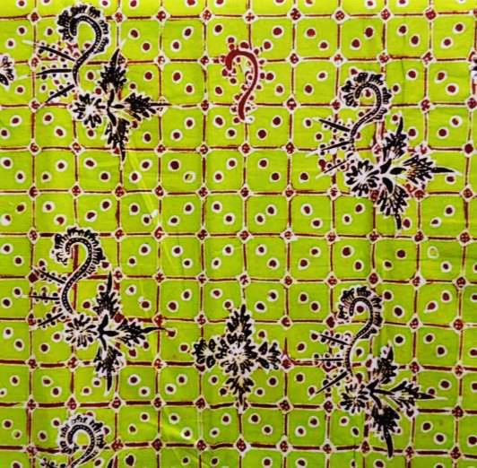
Figure 1. Gajah oling batik for learning the concept of Translation
    - Sekar Jagad Batik
Sekar jagad batik means beauty so that people who see it will be amazed. Sekar jagad batik is batik which consists of a collection of seven different motifs in one sheet of cloth. The number of seven motifs in the osing sekar jagad adopts the classic Javanese batik concept. Sekar Jagad batik of the Osing tribe depicts the typical motifs of the Osing tribe, those are the moto pitik motif, gedegan, totogan, kopi pecah, etc. The various motifs contain many geometric mathematical concepts, those are a) various forms of shapes (triangle, square, rectangle, rhombus), b) types of angles (right angle, acute angle, obtuse angle) and c) the concept of the perpendicular line.
The learning activities that can be carried out with the Sekar jagad batik are: a) Identifying the shapes, accord with the basic competency 3.6, 4.6 grade I; b) Describing the characteristics of various shapes, accord with the basic competency 3.9, 4.9 grade II; c) Determining the circumference of a shape, accord with the basic competency of 3.10, 4.10 grade III; d)Describing the types of angles (right, acute and obtuse angles), accord with the basic competency 3.11, 4.11 grade III; e) Analyzing the relationship between angles, accord with the basic competency of 3.10, 4.10 grade VII; f) Determining the circumference and area of ​​various quadrilaterals and triangles, accord with the basic competency of 3.11, 4.11 grade VII; g) Understanding the concept perpendicular lines, accord with the basic competency of 3.10, 4.10 grade IV.
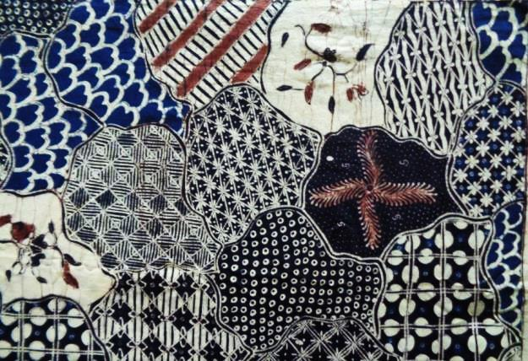
Figure 2. Sekar jagad batik for learning shapes, angle, perimeter and area
    - Totogan Batik
Totogan batik has a motif consisting of parallel lines. The word totogan means stuck or clogged. Totogan batik motif which is parallel lines contains the mathematical concept of line segments and parallel lines so that batik totogan can be used as a learning resource to understand the concepts of segment and parallel lines. These learning activities are in accord with the basic competency 3.8, 4.8 in grade II and basic competency of 3.10, 4.10 in grade IV.
    - Gedegan Batik
Gedegan batik is batik with woven bamboo motifs. Gedegan batik symbolizes strength and unity. When weaving, the bamboo is woven in such a way that it will stick together and become strong. In Gedegan batik, woven bamboo motifs are depicted in the form of interlocking squares. Therefore Gedegan batik can be used for learning activities to identify the elements of the square and determine its circumference and area. These learning activities are appropriate with basic competency 3.9 4.9 grade IV and basic competency 3.11, 4.11 grade VII.
    - Gesibu Blambangan
Gesibu Blambangan is a place for performing arts and cultural performances. Located in Blambangan Square. The location of gesibu blambangan is marked by a temple-like building. The temple-like building looks like Penataran temple located in Blitar district. The roof of the temple is in the form of a pyramid with the top of the roof is a cube. Gesibu blambangan can be used as a mathematics learning resource to determine the volume and surface area of ​​cube and pyramid. These learning activities are appropriate with the basic competency 3.5, 4.5 grade V and basic competency 3.9, 4.9 grade VIII.
    - Relief Gesibu Blambangan
Relief gesibu blambangan is located along the outer wall of the building. Relief gesibu blambangan tells about the life of the local community. There are lots of geometric shapes in relief. These are circles, triangles, squares, rectangles, trapezoid, etc. The relief can be used as a mathematics learning resource to identify shapes for elementary school students and also to determine the circumference and area of ​​shapes for junior high school students. These learning activities are in accord with the basic competency 3.9, 4.9 grade II and basic competency 3.11, 4.11 grade VII.
    - Pendopo Gesibu Blambangan.
Pendopo Gesibu Blambangan is located on the right and left of the front of the temple-like building. Pendopo has a rectangular floor and a triangular prism roof. The roof of pendopo is supported by 10 cuboid pillars. The roof decorated by ornaments in the form of squares, rectangles, and triangles.
Pendopo Gesibu Blambangan can be used as a mathematics learning resources to learn about shape and space structures. Students can carry out activities: a) Analyzing and explaining spaces and shapes that construct the Pendopo, this activity in accord with the basic competency 3.9, 4.9 grade II, b) Determining the perimeter and area of ​​the square, rectangle, and triangle, this activity accord with basic competency 3.9, 4.9 grade IV and basic competency 3.11, 4.11 grade VII, or c) Determining the surface area and volume of the prism and cuboid, which is accord with basic competency 3.9, 4.9 grade VIII.
    - Apem Contong Cake
Apem contong cake is a traditional sweet-flavored rice cake wrapped in cone-shaped coconut leaves. Apem cake has the meaning of forgiveness. Usually, apem contong cake is provided for traditional events. Apem contong cake can be used as a learning resource to learn the concept of the cone. Students can learn to understand the structure of the cone and determine the surface area and volume of the cone. These learning activities are appropriate with the basic competency 3.6, 4.6, and basic competency 3.7, 4.7 grade IX.
    - Ketot Cake
Ketot cake is white cake made from ketan flour. Ketot cake is sliced into blocks with a square roof and base then wrapped in banana leaves. Usually, ketot cake is served with tape ketan. Ketot cake can be used as a learning resource to understand the concept of the cuboid. moreover, students also able to learn to determine the surface area and volume of the cuboid. These learning activities are in accord with the basic competencies 3.9, 4.9 of grade VIII.
    - Kucur Cake
Kucur cake is a rice cake with a sweet taste that comes from palm sugar. This cake can be used as a learning resource to understand the concepts and part of a circle consisting of radius, diameter, chord, segment, etc. which is in appropriate with the basic competency 3.4, 4.4 grade VI. Furthermore, students can learn to determine the estimated area and circumference of the circle according to basic competency 3.5, 4.5 and also students can learn to understand the concept of center angle, perimeter angle, arc length, and area of ​​the circle according to the basic competency of 3.7, 4.7 grade VIII.
    - Rumah Adat Osing
Rumah adat Osing or The traditional osing house is located in the Kemiren traditional village, Banyuwangi. The traditional house consists of a living room, bedroom, kitchen, and bathroom. The roof of a traditional house consists of 4 sides. The roof of the osing house contains the mathematical concept of a triangular prism. The room of the house contains the concept of the cuboid. While the ornaments in the traditional osing house consist of geometric shapes such as triangles, rhombuses, squares, and rectangles.
Learning activities that can be done using traditional houses as a learning resource are identifying the shape and space and determining the surface area and volume of the triangular prism and cuboid. These learning activities are appropriate with basic competencies 3.5, 4.5 grade V, 3.7, 4.7 grade VI, and 3.9, 4.9 grade VIII.
    - Tampah
Tampah is a traditional tool made of woven bamboo with a circle shape like a plate with a flat base. Tampah is a multi-functional tool. Usually, tampah is used for winnowing rice (cleaning rice). Besides that, tampah is used for food containers, etc. Tampah can be used as a learning resource to understand the concept of the circle. Students can recognize the parts of a circle, those are radius, diameter, chord, and segment. Besides, students can learn to determine the circumference and area of ​​a circle. These learning activities are in accord with the basic competencies 3.4, 4.4 and 3.5, 4.5 grade VI.
    - Gebyok
Gebyok is furniture that functioned as a room divider. Gebyok made of wood be decorated with carved ornaments. The gebyok carvings are gajah oling patterns. The other gajah oling is a reflection of the gajah oling before. The carving object contains the mathematical concept of reflection. Gebyok can be used as a learning resource to understand the concept of reflection. This learning activity appropriate with basic competencies 3.5, 4.5 class IX.
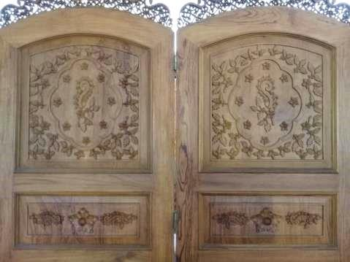
Figure 3. Gebyok for learning the concept of Reflection
    - Sabha Swagata Blambangan
Sabha Swagata Blambangan is the official residence of the Banyuwangi Regent. It consists of a house building, a meeting room, a pendopo, and a garden. Pendopo sabha swagata blambangan has a two-tiered roof. The first level consists of 4 isosceles trapezoids and the top consists of 4 triangles that form a pyramid. While the part of the room forms a cuboid without walls. Inside pendopo sabha swagata blambangan there are many ornaments and carvings.
Sabha swagata blambangan can be used as a learning resource to analyze the shapes and spaces that construct the sabha swagata blambangan and determine the surface area and volume of the pyramid and cuboid. These learning activities are appropriate with basic competency 3.7. 4.7 grade VI and basic competency 3.9, 4.9 grade VIII.
The result of analysing learning resources with the basic competencies of 2013 curriculum revised, that is the learning resources in osing culture can be identified for grade 1 to grade IX. It is shown that there are many alternative learning resources found in osing culture that can be used as learning resources for school mathematics learning. These learning resources can be used to provide meaningful learning experiences for students while learning mathematics [5][6], so that students become more interested and motivated in learning mathematics [15][16].
- Conclusion
There are many mathematics learning resources that can be used based on the osing culture. Those are Udeng, Gajah Oling batik, Sekar Jagat batik, Totogan batik, Gedegan Batik, Gesibu Blambangan, Contong Apem Cake, Kucur Cake, Ketot Cake, etc. These learning resources can be used for learning activities that are appropriate with the basic competencies of the 2013 curriculum revised at the elementary and junior high school levels.
References
- Fouze A Q and Amit M 2018 EURASIA J. of Math. Scien. and Technol. Educ. 14 2 pp 617-630
- D’Ambrosio U 2001 Teaching Child. Math. 7 6 pp 308-311
- Suryawan I P P and Sariyasa 2018 J. of Phys.: Conf. Series 1040 pp 1-9
- Mauluah M and Marsigit 2019 Intern. J. Of Sci. & Technol. Research 8 07 pp 776-780
- Rosa M and Orey D C 2011 Revista Latinoamericana de Etnomatemática 4 2 pp 32-54
- Risdiyanti I and Prahmana R C I 2017 J. of Phys.: Conf. Series 943 pp 1-6
- Imswatama A and Lukman H S 2018 Intern. J. of Trends in Math. Educ. Research 1 1 pp 35-38
- Pitoyo A J and Triwahyudi H 2017 Populasi 25 1 pp 64-81
- BPS-Statistics Indonesia 2018 Statistical Yearbook of Indonesia 2018 (Jakarta: BPS-Statistics Indonesia) p 86
- Permendikbud No. 37 Tahun 2018 Perubahan Atas Peraturan Menteri Pendidikan Dan Kebudayaan Nomor 24 Tahun 2016 Tentang Kompetensi Inti Dan Kompetensi Dasar Pelajaran Pada Kurikulum 2013 Pada Pendidikan Dasar Dan Pendidikan Menengah (Jakarta: Kemendikbud) pp 92-109
- Department of Education Prince Edward Island 2008 Evaluation and Selection of Learning Resources: A Guide Charlottetown (Prince Edward Island: Department of Education) pp 2-6
- Sudjana N & Ibrahim 2012 Penelitian dan Penilaian Pendidikan (Bandung: Sinar Baru Algensindo) pp 77-80
- Bušljeta R 2013 Czech-Polish Histor. and Pedag. J. 5 2, pp 55–69
- Permendikbud No. 21 Tahun 2016 Standar Isi Pendidikan Dasar dan Menengah (Jakarta: Kemendikbud) pp 111-121
- Ulya H and Rahayu R 2017 J. Mercumatika : J. Penel. Mat. dan Pend. Mat. 2 1 pp 16-23
- Fajriyah E 2018 PRISMA 1 pp 114-119

