Ethnomathematics – based Mathematical Representation to Improve Problem Solving Skill in Junior High Schools

R H Mumpuni1 and Marsigit2

1Graduate School of Mathematics Education, Universitas Negeri Yogyakarta, Indonesia

2Department of Mathematics Education, Faculty of Mathematics and Natural Science, Universitas Negeri Yogyakarta, Indonesia

1ronahappymumpuni@gmail.com, ronahappy.2019@student.uny.ac.id

2marsigit@uny.ac.id

**Abstract**. Mathematics learning using the ethnomathematics approach is rarely implemented in schools in Indonesia, particularly in lower secondary education. Students in junior high face transition from concrete learning experience already passed during primary education to abstract learning in secondary. During the later, students encounter abstract mathematic problems, which require good representation, as sufficient representation is the basis for comprehension to build the right plan to solve the problem. Based on this condition, ethnomathematics utilization in the learning process plays an important part in generating sufficient mathematical representation. Problems presented using the ethnomathematics approach are intended to enable students to associate their cultural living surrounding with mathematical problems they receive in school. Therefore, this study analyzed ethnomathematics-based mathematical representation and its correlation with problem solving skills.

1. Introduction

In recent years, mathematics learning with culture involvement or known as ethnomathematics gains more interest. Ethnomathematics become more significant as it needs comprehensive effort to develop beyond enrichment concept or only belongs to a particular society. Fourze and Amit [4] mentioned that ethnomathematics application in mathematics learning might help students to solve problems as they have connection with their culture while able to facilitate learning process through the cultural connection. Mathematics learning that far from daily lives and culture negatively affects student’s ability on contextual representation. As mathematical representation is one of ability that inseparable to problem solving, particularly contextual problem, ethnomathematics might contribute to put cultural context to the problem. Therefore, ethnomathematics plays an important role in mathematical representation for problems solving. Silver in Krawec [9] also mentioned that mathematical representation has pivotal role to solve problem as it can facilitate problem comprehension to design problem solving paths. Moreover, representation is also important to communicate the problems in form of diagram, graphic, figures, or other means alike.

Based on that, this article aimed to analyze (1) ethnomathematics-based mathematical representation and (2) correlation between ethnomathematics-based mathematical representations in problem solving.

## Mathematical Representation

Goldin [5] noted that mathematical representation is a method to express mathematical ideas for student’s concept comprehension and solution determination. Hwang & Chen [7] classified mathematical representation in five categories: real-life experience, model, arithmetic symbol, spoken or oral language, and diagram or graphic. Thompson & Chappell [20] classified mathematical representation as visual representations (such as graphic, table, sketch/figure, and diagram) and non-visual (such as mathematic equation and model). Below are mathematical representation indicators.

**Table 1.** Mathematical representation indicators

|  |  |
| --- | --- |
| **Aspect** | **Indicators** |
| Visual Representation | Re-presenting data or information from a form of representation into diagram. |
| Using visual representation to solve problems. |
| Figure Representation | Drawing of geometric patterns |
| Drawing of geometric figures to explain problems and to facilitate problem solving. |
| Equation Representation or Mathematical Expression | Composing mathematical equations or model from given representation. |
| Composing conjecture from number pattern |
| Solving the problem through involvement of mathematical expression. |
| Words or written text Representation | Explanation of problem situation based on data or given representation. |
| Writing an interpretation of a representation. |
| Writing the steps to solve mathematical problems in words. |
| Answer the questions by words or written text |

**Source:** Lestari & Yudhanegara, 2016

From description above, it can be concluded that mathematical representation is a form of student’s interpretation on mathematical problems used as means to determine the answer of the problems.

## Ethnomatematics

Conceptually, ethnomathematics is practical mathematics with utilization or correlation to cultural practice of society. The idea of ethnomathematics emerged as a broader view of correlation between mathematics and real life, or culture integration with mathematics learning, or mathematics with cultural aspect. Application of ethnomathematics might encourages student for contextual learning through correlation of their mathematics learning and daily life. Student are required to have proper representation ability to solve the problems. An example of ethnomathematics in Java culture perspective, particularly that of Jawa Tengah, is presented below.

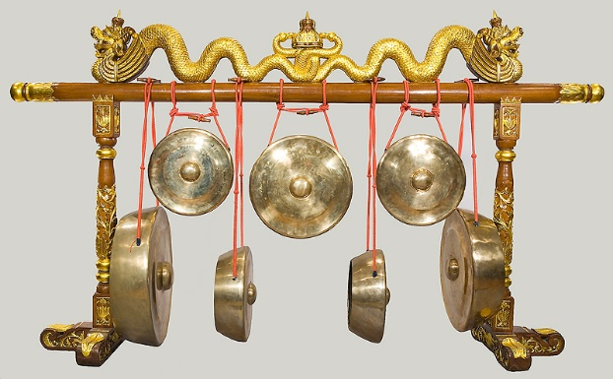

**Figure 1.** Utilization of shape of gong as ethnomathematics to explain the concept of circle and tangent (National Music Museum, [The University of South Dakota](http://www.usd.edu/), 2014)

1. Discussion

## Ability on Ethnomathematics-based Mathematical Representation

Study on ethnomathematics is classified into two groups: 1) study focusing on concrete artifact or cultural product, through study on mathematics concept using concrete cultural items; and 2) ethnomathematics study focusing on reasoning (way of thinking) and behavior (way to act) exploration of a society related to mathematical concept. Ethnomathematics likened as glasses that enable student to see better or understanding mathematical problems, while mathematical representation is their comprehension as a result of these visions. Cultural surrounding is potential learning means in ethnomathematics and considered to be closely related to one’s representation ability. An example of the first group of ethnomathematics is study on andong, a traditional horse-drawn carriage from Yogyakarta, which can be used as an ethnomathematics object for explanation activity on geometric. An andong has four wheels that differ in size and in spokes number between the front and the rear wheels, 12 and 14 bars respectively. Passengers ride from two side of entrance behind driver, or called “kusir”, with seats made them sit in opposite direction facing front and rear side.

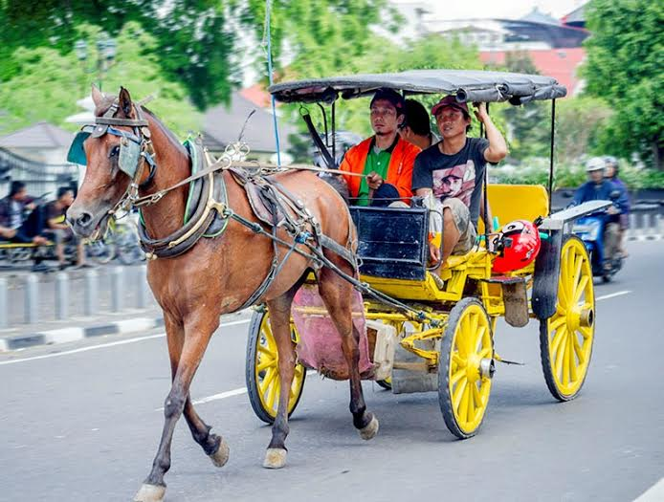

**Figure 2.** Ethnomathematics using andong wheels (yogyakarta.panduanwisata.id)

An example is presented below on artifact ethnomathematics-based problem.

Ethnomathematics problem:

An andong has four wheels, two each on the front and the rear. The size of front wheel’s spokes are $\frac{3}{4}$ time smaller than the rear. The length of each rear spoke is 70 cm. If the horse draw the andong from Yogyakarta Palace to Imogiri Royal Cemetery at 13.2 km distance, how many times do each of the wheels turn?

*Steps of mathematical representation:*

* Drawing andong’s wheel in circle form as presented below.

Rear wheel

Front wheel

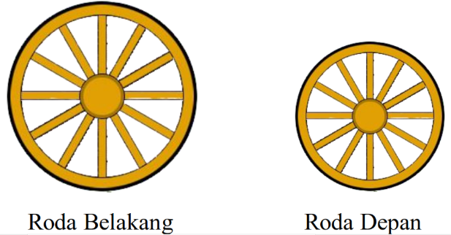

*R*

*r*

**Figure 3** Andong’s wheels

* Presenting the length of rear wheel spoke as big and small circles radius denoted by *R* and *r*, respectively.
* Forming equation or mathematic model based on given data

*r* = $\frac{3}{4}$ × *R*

* Presenting *R* and *r* in numbers:

*R* = 70 cm

*r* = $\frac{3}{4}$ × *R*

*r* = $\frac{3}{4}$ × 70 cm

*r* = 52.5 cm

* Representation of the distance traveled as *D*, thus *D* = 13.2 km
* Confirmation that how many times the wheel rotates is the answer being sought, thus related to circumference of the wheel. Calculation of one wheel from front and rear is sufficient due to the size similarity.
* Utilization of circumference equation and doing calculation.
* Transformation of distance into centimeter unit adjusted to circumference unit. *D* = 13.2 km = 1,320,000 cm
* Stating that distance traveled equals to wheel circumference multiplied by how many time the wheel turns.
* Utilization of equation of distance and doing calculation.
* Forming conclusion.

Apart from the artifact or concrete cultural products, ethnomathematics can be generated from abstraction of reasoning (way of thinking) and behavior (way to act) patten of a particular community, such as Javenese’s agricultural activity. Several regions in Indonesia have different traditional unit for size of land area, other than hectare or meter that applies nationally. People in southern part of Jawa Timur, for example, using local unit for land width that more familiar for them, such as: *wolon, bau, igar, kulen,* and *ru*. To help outsiders to understand those units, they need conversion into meter unit as well as proper mathematical representation. Conversion of traditional units are presented below.

Table 2. Conversion of traditional unit

|  |  |  |
| --- | --- | --- |
| 1 ru  1 bau  1 kulen  1 igar  1 wolon | 3.75 meter × 3.75 meter = 14.0625 ${\text{meter}}^{\text{2}}$ 500 meter × 14 meter = 7,000 ${\text{meter}}^{\text{2}}$ 250 meter × 14 meter = 3,500 ${\text{meter}}^{\text{2}}$ 125 meter × 14 meter = 1,750 ${\text{meter}}^{\text{2}}$ 62.5 meter × 14 meter = 875 ${\text{meter}}^{\text{2}}$ | (14 ${\text{meter}}^{\text{2}}$) |

An example of ethnomathematics-based problems in reasoning context is presented below

Ethnomathematics problem:

A farmer in Banyuwangi has total of 2 hectare field. He plans to plant corn on 35 are, soybean on 10,500 m², and the rest for rice. The wage for a group of farm worker for each 1 wolon corn is Rp 250.000, Rp 425.000/igar soybean, and Rp 700.000/kulen rice. Calculate the total wage for the group if the whole are can be planted according to plan!

Steps for mathematical representation:

* Transforming width unit of total field and cornfield into m².

Total field area = 2 hectare = 20,000 m²

Total cornfield = 35 are = 3500 m²

* Stating that total area for rice equals to total field area reduced by cornfield and soybean field.
* Forming equation or mathematical model.

Ricefield area = total area – (cornfield + soybean field)

Ricefield area = 20,000 m² – (3,500 m² + 10,000 m²)

* When ricefield area become known, the next step is unit transformation from each area into traditional units that related to wage.
* Calculation of total wage using multiplication.
* Drawing conclusions.

From problems mentioned above, ethnomathematics utilization cannot be separated from abstraction of artifact or people’s way of thinking. Mathematical representation exercise might be improved through ethnomathematics utilization in learning.

## The role of ethnomathematics-based mathematical representation in problem solving

Problem solving skill can be defined as ability to construct solution for problems. In its process, thorough ability, such as problem comprehension, communication, determination of the right solution, resolve, as well as re-examine problem solving, are all needed. These also applied in mathematics problem solving, with mathematics communication as one of the critical things. In communication, mathematical representation plays pivotal role. Representation helps to interpret a problem to build the right plan to solve the problem, that very influential to solve contextual problem in mathematic.

Contextualization of cases or problems might increase mathematics learning access, in which representation become part of problem solving process. Problems with cultural context closely related and contextual to student's daily life encourage the development of mathematical representation skill thus help them to solve mathematical problem. There are several studies reported student’s ability to solve ethnomathematics problem with good mathematical representation. Correlation of mathematical representation with problem solving skill is presented below.

**Table 3.** Correlation of mathematical representation with problem solving skill

| **Problem solving stages (Polya)** | **Indicator for mathematical representation in problem solving** |
| --- | --- |
| *Understanding the problem* | Ability to convey of known information through symbol or words/written text.  Example of student’s answer: (artifact ethnomathematics)    Example of student’s answer: (reasoning ethnomathematics) |
| Ability to convey of what was asked through symbol or words/written text.  Example of student’s answer: (artifact ethnomathematics)    Example of student’s answer: (reasoning ethnomathematics) |
| *Designing a plan* | Draw figures to clarify the problem and to facilitate problem completion  Example of student’s answer: (artifact ethnomathematics) |
| Formation of mathematic equation or model from other given representation which facilitate completion  Example of student’s answer: (reasoning ethnomathematics) |
| *Carrying out the plan* | Carrying out problem solving using symbol and mathematic expression  Example of student’s answer: (artifact ethnomathematics)        Example of student’s answer: (reasoning ethnomathematics) |
| *Re-examination* | Ability to re-examine problem solving by figure representation or mathematic expression to determine whether implementation is in accordance with the plan with correct stages, as well as ability to recognize wrong move.  Example of student’s answer: (artifact ethnomathematics)    Example of student’s answer: (reasoning ethnomathematics) |

1. Conclusion

The importance of ethnomathematics in mathematics learning can be seen through explanation above. However, utilization of ethnomathematics cannot be separated from student’s ability on mathematical representation as mathematics communication plays pivotal part in problem solving process. Mathematical representation demand students to find and to develop means as well as way of thinking on how to communicate mathematical ideas from abstract into concrete form that easier to understand. Ethnomathematics implementation might help the communication part of problem solving, as it increases mathematical representation skill, with better direction and correct solutions in problem solving.

References

1. Anwar, R. B., Yuwono, I., & Rahman, A. (2016). *Mathematical representation by students in building relational understanding on concepts of area and perimeter of rectangle*. *August 2017*. <https://doi.org/10.5897/ERR2016.2813>
2. D’Amborsio, U. (1985). “Ethnomathematics and Its Place in the History and Pedagogy of Mathematics”. *For the Learning of Mathematics Journal*. Vol 5(1), 44-48.
3. Fitrianawati, M., Sintawati, M., & Rethnowati, E. (2020). *Developing Ethnomatematics In Geometry Learning For Elementary Schools Students: A Preliminary Design*. *9*(1), 2754–2758.
4. Fouze, A. Q., & Amit, M. (2018). Development of Mathematical Thinking through Integration of Ethnomathematic Folklore Game in Math Instruction. EURASIA Journal of Mathematics, Science and Technology Education, 14(2), 617-630.
5. Goldin, G. & Shteingold, N. 2001. System of Representations and the Development of Mathematical Concepts. In The Roles of Representation in School Mathematics. NCTM Year Book.
6. Goldin, G. A. (2002). Perspective on Representation in Mathematical Learning and Problem Solving. *Handbook of International Research in Mathematics Education (Second Ed.).* 176 -201.
7. Hwang, W.-Y., Chen, N.-S., Dung, J.-J., & Yang, Y.-L. (2007). Multiple Representation Skills and Creativity Effects on Mathematical Problem Solving using a Multimedia Whiteboard System. Educational Technology & Society, Vol 10 No 2, pp. 191-212.
8. Kilpatrick, J., Swafford, J., & Findell, B. (2001). *Adding It Up: Helping Children* *Learn Mathematics.* Washington, D.C: National academy press.
9. Krawec, J. L. (2014). Problem representation and mathematical problem solving of students of varying math ability. Journal of Learning Disabilities, 47(2), 103-115.
10. Maryati, & Prahmana, R. C. I. (2019). Ethnomathematics: Exploring the activities of culture festival. *Journal of Physics: Conference Series*, *1188*(1). https://doi.org/10.1088/1742-6596/1188/1/012024
11. Mastur, Z. (2020). *The Problem Solving Ability of Students in the Cooperative Learning Simulation of Kancing Gemerincing Technique with Ethnomathematics Nuances Reviewed by the Cognitive Mode*. *9*(2), 179–184.
12. Mauluah, L. (2019). *Ethnomathematics for Elementary Student: Exploration The Learning Resources at Kraton Yogyakarta*. *8*(7), 776–780.
13. Muhammad Fedrik, Marsigit, M. N. W. (2020). Analysis of Riau traditional game-based ethnomathematics in developing mathematical connection skills of elementary school students. *Ilkogretim Online*, *19*(3), 1605–1618. <https://doi.org/10.17051/ilkonline.2020.734497>
14. NCTM. (2000). *Principles and Standards for School Mathematics*. Reston: VA: Nation Council of Teachers of Mathematics.
15. Nizaruddin, Nizaruddin & Muhtarom, Muhtarom & Murtianto, Yanuar Hery. (2017). Exploring of multi mathematical representation capability in problem solving on senior high school students. Problems of Education in the 21st Century. 75. 591-598.
16. Nursyahidah, F., Saputro, B. A., & Rubowo, M. R. (2018). *Students Problem Solving Ability Based on Realistic Mathematics with Ethnomathematics*. *3*(1), 13–24.
17. Polya, G. 1973. *How to Solve It*: A New Aspect of Mathematical Methode. Princeton: Princeton University Press.
18. Slavin, R. E. 1994. *Education Psycology Theory into Practice*. 4th Ed. Boston: Allyn and Bacon.
19. Thompson, D. R., & Chappell, M. F. (2007). Communication and representation as elements in mathematical literacy. *Reading and Writing Quarterly*, *23*(2), 179–196. <https://doi.org/10.1080/10573560601158495>
20. Ul, A., Samsuddin, F., & Yogyakarta, U. N. (2018). *Mathematical representation: the roles, challenges and implication on instruction*. *October*. <https://doi.org/10.1088/1742-6596/1097/1/012152>
21. Walkington, C. et al. 2012. “Playing the Game” of Story Problems: Coordinating Situation Based Reasoning with Algebraic Representation. Elsevier: Journal of Mathematical Behavior, 31: 174-195
22. Widada, W., Herawaty, D., Falaq, A., Anggoro, D., Yudha, A., & Hayati, M. K. (2019). *Ethnomathematics and Outdoor Learning to Improve Problem Solving Ability*. *295*(ICETeP 2018), 13–16.
23. Widakdo, W. A. (2017). *Mathematical Representation Ability by Using Project Based Learning on the Topic of Statistics*. Journal of Physics: Conference Series (Vol. 895, No. 1, p. 012055). IOP Publishing
24. Hariastuti, R., M., Budiarto, M.T, & Manuharawati. (2019). From Culture to Classroom: Study Ethnomathematics in House of Using Banyuwangi. *International Journal of Trends in Mathematics Education Research*, 2(2), 76-80. DOI: 10.33122/ijtmer.v2i2.60