Pendekatan Problem Based Learning Melalui Model Pembelajaran Kooperatif Tipe Numbering High Together (NHT) Untuk Meningkatan Kemampuan Kolaborasi, Literasi Matematis Dan Kemampuan Berpikir Kritis Matematis Siswa Di Kelas X SMA Negeri 1 Wiwirano

Lalu Wahyu Rizaldi *, Wahyu Setyaningrum, M.Ed.,Ph.D
E-mail: laluwahyu.2021@student.uny.ac.id

ARTICLE INFO | ABSTRACT
Article history  Received:  Revised:  Accepted:  Keywords  Problem Based Learning, Numbering High Together (NHT) , Collaboration skills, Mathematical Literacy, and Critical Thinking Skills | This study aims to improve students' collaborative working skills, mathematics literacy, and mathematics critical thinking skills through a collaborative learning model, Numbering High Together (NHT), using a problem-based learning approach. Significant values ​​were <100% in this study. A p-value (0.05) indicates a significant difference between pretest and posttest scores for collaborative ability, mathematical literacy, and critical mathematical thinking skills. Based on the results of the research conducted, the following conclusions can be drawn:  1. Mathematics learning applying the NHT-type collaborative learning model and the PBL approach can support the communication skills of students in the 21st century. 2. Applying the NHT-type collaborative learning model and the PBL approach to learning mathematics can support the critical thinking skills of 21st century students. 3. Mathematics learning by applying the NHT collaborative learning model with a PBL approach can support 21st century mathematics literacy skills. 4. Applying the NHT collaborative learning model and PBL approach to learning mathematics can support the collaborative skills of students in the 21st century.
 | 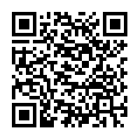
How to Cite: Pertama, P., Kedua, P., Ketiga, P (2019). Petunjuk penulisan naskah Jurnal Riset Pendidikan Matematika (versi template 2019). Jurnal Riset Pendidikan Matematika, 7(1) 1-3. doi:https://doi.org/10.21831/jrpm.v7i1.000000

INTRODUCTION
Mathematics as a basic science plays an important role in the development of science and technology as a thinking tool for developing logical, logical, systematic and critical thinking. Need to pursue further. In line with this statement, the 2013 curriculum will include mathematics for all students from primary school onwards in order to equip them with the ability to think logically, analytically, systematically, critically and creatively and to work. subject must be taught. jointly (Astrawan, 2018: 2). Efforts to improve the quality of mathematics learning, especially at the level of primary and secondary education, will be taken seriously, as the description shows that the role of mathematics in the process of improving the quality of human resources is very important. worthy of That is, we need to design learning that can support and develop students' potential, especially in terms of critical thinking, and to improve students' collaboration in school.
Critical thinking has many definitions. Beyer (1995) provides the simplest definition. “Critical thinking is about making rational decisions.” Beyer describes critical thinking as anything from the simplest activities, such as normal daily activities, to drawing conclusions from sentences that people use to assess the validity of something (statements, ideas, arguments). is deemed to use criteria to assess the quality of, research, etc.). Facione (2006) defines critical thinking as self-regulation in interpretation, analysis, evaluation, and decision-making (judgment), as well as evidence, concepts, methods, criteria, and or stating that it is exposure using contextual reasoning. make a decision. Critical thinking is important as a tool of inquiry. Critical thinking is a strength and a source of energy in a person's social and personal life. (Zubaida, 2010). Different perspectives related to critical thinking also provide guidance and advantages in solving highly complex contextual problems. In this respect, student collaboration is important in learning mathematics. Collaboration includes group interaction, working together in a group, respecting the opinions of group members, taking responsibility for group work, and being a skill that can contribute to group performance. (Azzurro, 2019). According to Johnson & Johnson, effective collaboration skills are characterized by positive interdependence, personal interaction in collaboration, a sense of responsibility for completing shared tasks, and the need for interpersonal skills and small group collaboration. (Emily, 2017). A common problem when learning mathematics is the poor ability of students to solve mathematics problems packaged in the form of problems that emphasize the student's critical thinking process. This is evident from the trending results of the International Mathematics and Science Study (TIMSS) in 2015, where the average score achieved was just 397 out of his 500, ranking him 44 out of 49 countries. (Mullis, 2016). This result is slightly higher than his TIMSS result in 2011 (39th out of 43 countries) with an average score of 386. Meanwhile, according to the 2015 International Student Assessment Program (PISA) results, Indonesia ranked 63rd among her 70 countries with an average score of 386 (OECD, 2016). This is a slight improvement from her PISA score in 2012 (64th out of 65 countries, with an average score of 375). As a result, 68.6% of students finished in grade 2 or below, and only 0.7% progressed to grades 5 and 6. This indicates that classroom mathematics learning is suboptimal. Specifically, observations and interviews with one of her mathematics teachers at SMAN 1 Wiwirano showed that the students' critical thinking ability was still low. This can be seen from the student's average score on a given pre-test that measures her critical thinking skills, namely her KD performance score:22.14559, collaboration result:21.84, Critical Thinking:25 and Literacy:18. Financial Factors To achieve this, learning models or approaches are supported in which the space of realization or student interaction is limited, as the learning process is still dominated by the teacher. Choosing the right learning approach and model is expected to improve critical thinking and collaboration skills. Among several learning models that support the development of students' critical thinking skills, researchers are interested in applying the NHT collaborative learning model using the PBL (problem-based learning) approach to classroom learning. I'm here. Atiyah (2018:308), the Numbered Heads learning model is a learning model that collectively divides students into groups of heterogeneous numbers, from her 3 to her 5 students, and assigns a head number to each student within the group. I suggest. Each discussion group receives the same material. With this numbering, students should always be ready to present the results of the group discussion. Therefore, each student tries to understand the results of group work, takes responsibility for the results of discussions, and actively participates in discussion activities. This model is combined with a problem-based learning (PBL) approach. Problem-based learning is a learning process in which a problem is presented to the learner before the learning process begins. Students are presented with real problems and driven to investigate, analyze and find solutions. Problem-based learning is so closely tied to student reality that students not only learn but also experience and feel in the realm of knowledge. For this reason, problem-based learning strategies are more likely to be accepted by students than other learning strategies that simply take students away from the real problem. (Rudy, 2013). Problem-based learning is a learning method that exposes students to practical problems that form the basis of learning, i.e., allows students to learn through problems. (Wenna, 2010). The primary goal of problem-based learning is not to give students a large amount of knowledge, but rather to develop critical thinking and problem-solving skills while students develop their ability to actively construct knowledge. (Fathurrohman, 2015). The corresponding opinion also says that PBL can improve critical thinking skills, foster student initiative in work, motivate internally to learn, and can develop interpersonal relationships in group work. (Widiasworo, 2017). Based on this description, the researcher is interested in conducting a study entitled Learning Trigonometric Ratios with Problem Based Learning Approach Through Cooperative Learning Model Type Numbering High Together (NHT) to Improve Collaboration Ability, Mathematical Literacy and Mathematical Critical Thinking Ability of Students in Class X SMA Negeri 1 Wiwirano
METODE
This study includes a pre-experimental design study. This study aims to improve learning outcomes, collaborative skills, critical thinking, and mathematical literacy using a problem-based learning approach with a NHT (Number Head Together) type of collaborative model. One class was included as the treatment class. Determined by the trigonometric ratio material. This study was conducted at SMAN 1 Wiwirano in even-numbered periods using the Trigonometric Ratio material. The study population was all students of Class X SMA Negeri 1 Wiwirano. Researchers interviewed school teachers to get an overview of the population. Information was obtained that class X SMA Negeri 1 Wiwirano consisted of three classes with no superclass and were heterogeneously distributed in the sense that there were generally high, medium and low ability students in each class. The sample for this study was determined using a targeted sampling method by looking at the mean mathematics scores on the odd semester tests for the 2021/2022 school year. The sample required for investigation is 1 class. Based on the sampling methodology, Class X Science 1 was taken as a research sample. Survey variables There are two types of variables in this survey.
1. The independent variable is treated in the form of a problem-based learning approach by NHT (Number Head Together) type collaborative learning models. 2. Dependent Variables (Dependent Variables) are student learning outcomes, collaborative skills, mathematical literacy, and forms of critical thinking. The research design used was a one group pretest-

posttest design. Before conducting the research, the selected class was given a pretest and after the research was conducted a posttest was given. The design is as follows O1 X O2 (Sarwono, 2007: 86)

Table 1. Description
O1 | Pretest scores, namely the test scores for learning outcomes, collaboration skills, mathematical literacy, and students' mathematical critical thinking before applying the Problem based Learning approach through the NHT (Number Head Together) Cooperative learning model.
X | Treatment (Treatment), namely applying learning with a Problem based Learning approach through a cooperative learning model of the NHT (Number Head Together) type.
O2 | Post-test scores, namely the test scores of learning outcomes, collaboration skills, mathematical literacy, and mathematical critical thinking of students after applying the Problem based Learning approach through the Cooperative learning model of the NHT (Number Head Together) type.

Research Instruments

The instruments used in this study are as follows:
- Teacher and student activity observation sheet
The teacher activity observation sheet is used to observe the teacher's activities in manage learning, while student activity observation sheets are used to observe the activities carried out by students in following learning. The observation sheet made refers to the implementation plan lesson plans (RPP) that have been made previously. Every activity observed in this study refers to the Problem Based Learning Approach with NHT Type Cooperative learning model.
- Student's Critical Thinking Ability Test Sheet
In this study to measure students' critical thinking skills, used research instruments in the form of a written test in the form of a description of 4 question item. Then determine the scoring guidelines to assess ability students' mathematical critical thinking.
- Student Learning Outcomes Ability Test Sheet
In this study, to measure student learning outcomes, the instrument used was. The research was in the form of a written test in the form of a description of 13 questions. Then determine scoring guidelines to assess students' mathematical learning outcomes.
- Student's Mathematical Literacy Ability Test Sheet
In this study to measure students' mathematical literacy skills, used research instruments in the form of a written test in the form of a description of 5 question item. Then determine the scoring guidelines to assess ability understanding of students' mathematical concepts.
- Student Collaboration Ability Questionnaire Test Sheet
In this study to measure students' mathematical collaboration skills, used a research instrument in the form of a questionnaire test. Then define guidelines scoring to assess students' mathematical collaboration ability.

RESULTS AND DISCUSSION

The pretest mean score result was 22.14559 with a standard deviation of 5.59184, the minimum score achieved by the students was 9.00, the maximum score achieved by the students was 41.47, and the basic skills achievement rate was 22.14%. For posttest scores, the mean score was 64.6968, standard deviation was 7.39617, the minimum student score was 53.45, the maximum student score was 82.3529, and the basic skills achievement rate was 64.70%. A paired-sample t-test was performed to determine whether there were differences in improvements in learning practices using a problem-based learning approach with a numbered head (NHT) collaborative model. This test is used to determine the difference between the results of pretests and posttests that are run. Here are the paired-sample t-test results:
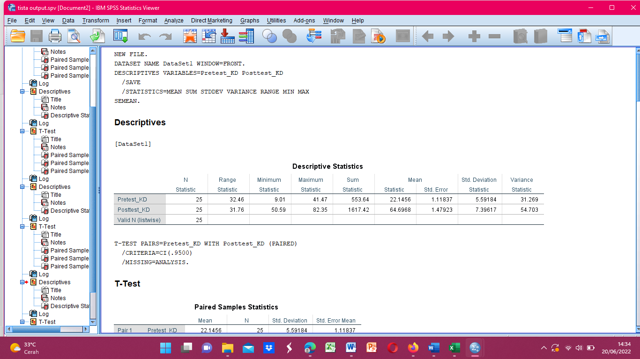

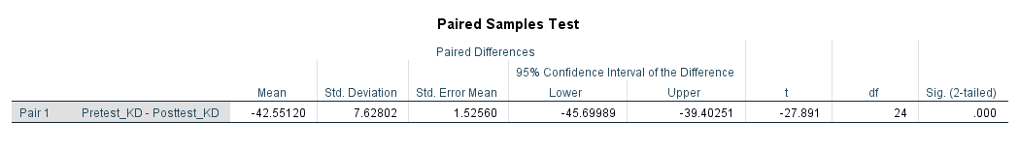

Test results using SPSS software show a significant value of 0.000. This value is less than 0.05, indicating a significant difference between pretest and posttest results. This means that learning with a problem-based approach to learning that follows the NHT-type cooperation model can significantly improve student achievement.
There is one skill measured in this study. It is the ability to think critically. This skill is one of her 21st century skills that teachers need to improve and students need to have. The results of the 21st century skill evaluation that researchers aim to improve through learning activities using a problem-solving learning approach based on the NHT (Number Head Together) collaborative model have led to the following results.
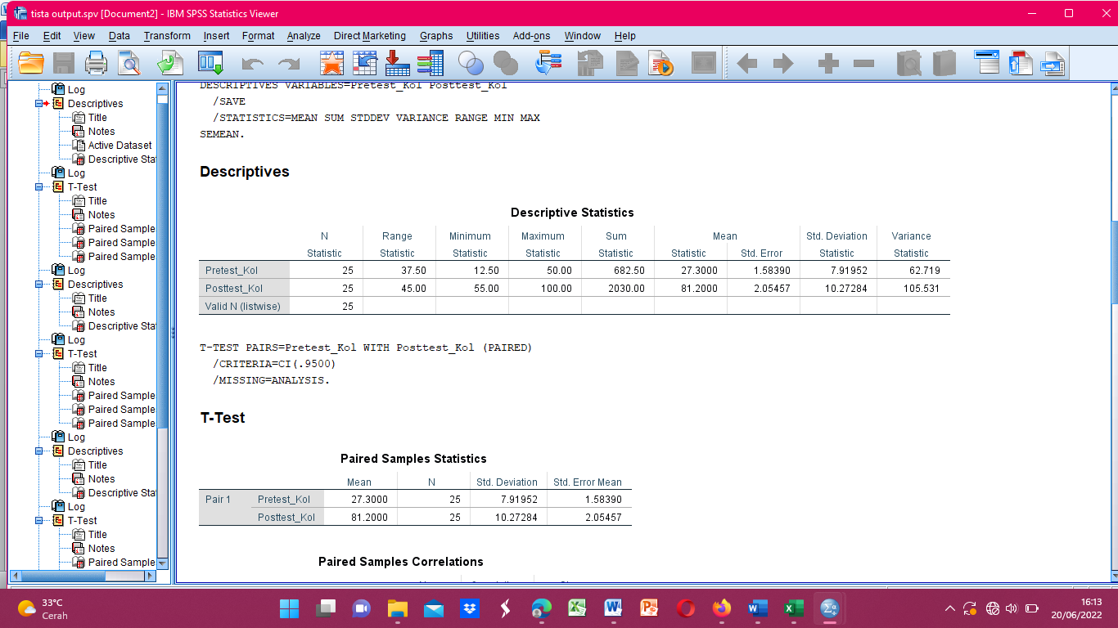

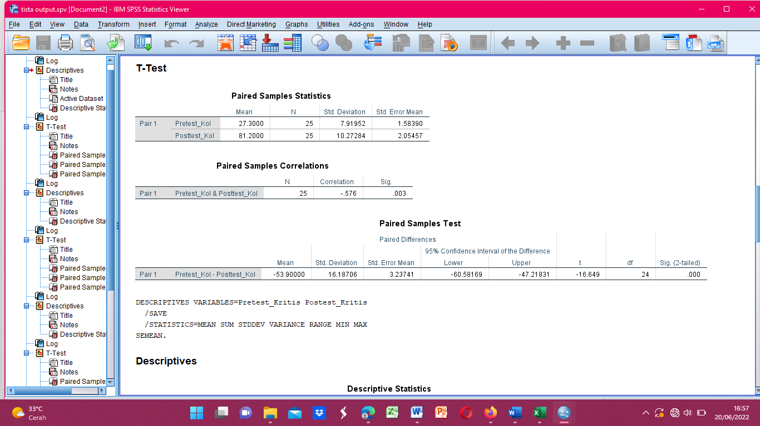

In the table above, we can see that the collaboration skill pretest score has an average of 21.84, a minimum score of 12.50, a maximum score of 55, and a standard deviation of 7.91952. The average score after testing was 65.18, with a minimum score of 55 and a maximum score of 100 with a standard deviation of 10.27284. Also, the significance value obtained is 0.000 and the significance value is less than the p-value of 0.05. p-value (0.05), significant difference between pre-test and post-test score results compared with problem-based learning approach using Number Head Together (NHT) collaborative model And then the mathematics learning approach to trigonometry material type can improve collaboration skills. Student of SMA Negeri 1 Wiwirano
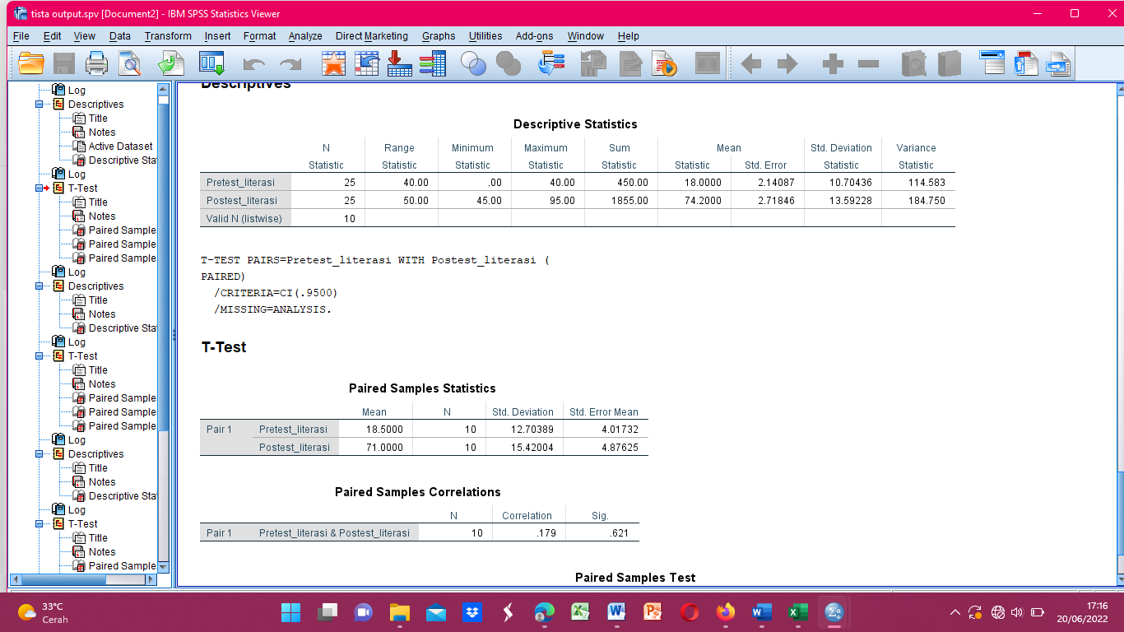

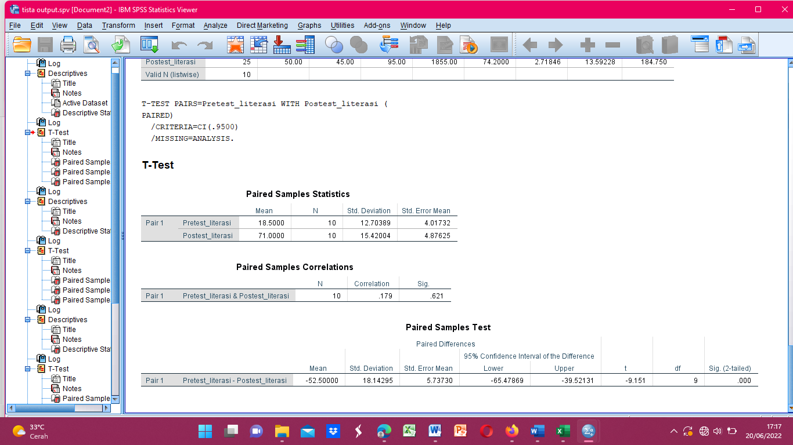

From the table above, we can see that the Basic Mathematics Pretest has an average of 18.00, a minimum score of 0.00, a maximum score of 45.00, and a standard deviation of 10.70436. For post-test scores, the average post-test score was 74.20, with a minimum of 45 and a maximum of 95 with a standard deviation of 13.59228. Also, the significance value obtained is 0.000 and the significance value is less than the p-value of 0.05. p-value (0.05), if there is a significant difference between the pre-test results, because the significance value is <
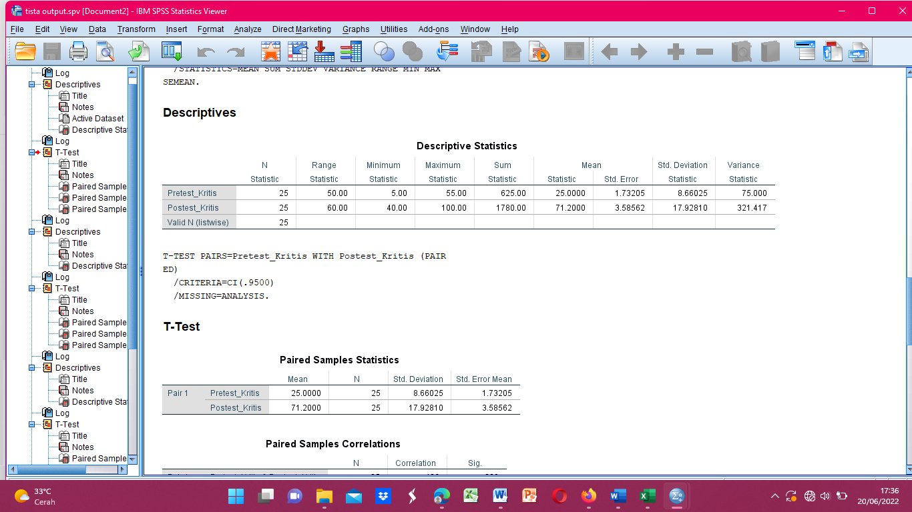

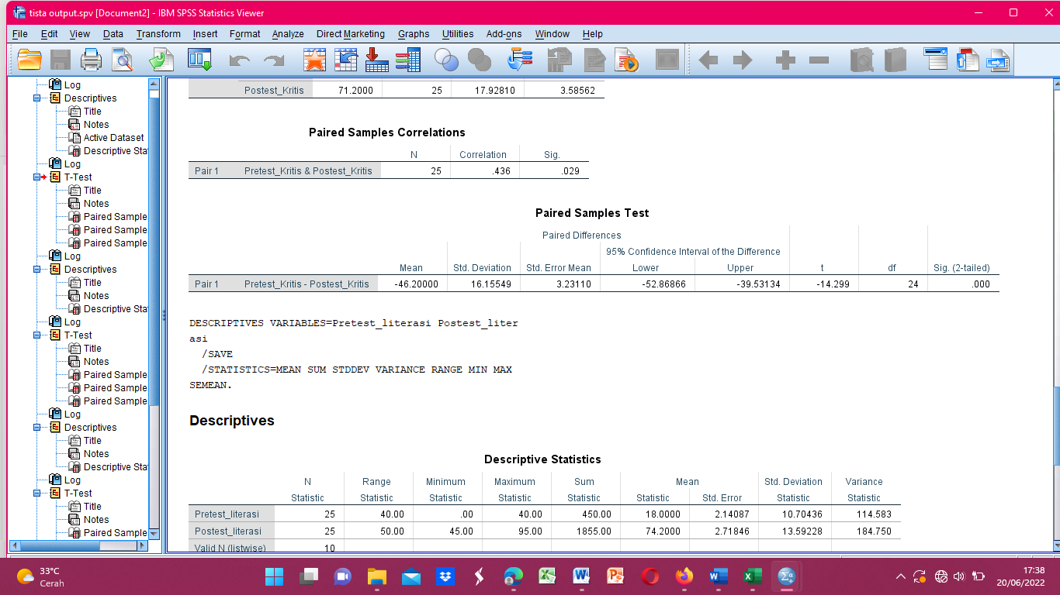

The table above shows the average pretest score for critical thinking skills of 25, the minimum value of 5.00, the maximum value of 60.00, and the standard deviation of 8.66025. As for the posttest value, the posttest average value was 71.2, the minimum value was 40.00, the maximum value was 100, and the standard deviation was 17.92810. Where the significant value obtained is 0.000, which is smaller than the p-value of 0.05. Because the significant value < p value (0.05) then there is a significant difference between the results of the pretest and posttest scores, which means that the mathematics learning approach Problem Based Learning approach with a number head together (NHT) cooperative model, Trigonometric Ratio material is able to improve critical thinking skills. Mathematical students of SMA Negeri 1 Wiwirano. If you look at the results above

CONCLUSION
Based on the results of the research conducted, the following conclusions can be drawn: 1. Learning mathematics by applying the NHT type cooperative learning model with a PBL approach can support students' communication skills in the 21st century. 2. Mathematics learning by applying the NHT type cooperative learning model with a PBL approach can support students' critical thinking skills in the 21st century. 3. Mathematics learning by applying the NHT cooperative learning model with a PBL approach can support Mathematical Literacy skills in the 21st century. 4. Mathematics learning by applying the NHT cooperative learning model with a PBL approach can support collaboration skills students in the 21st century.

DAFTAR PUSTAKA
Astrawan, I. P. 2018. Analisis Kemampuan Pemecahan Masalah Matematis Siswa Kelas VIII6 SMP Negeri 9 Kendari Ditinjau dari Perbedaan Gender. Skripsi. Program Sarjana Pendidikan Matematika Universitas Halu Oleo. Kendari.
Atiyah, U., Asri Untari, M. F., & Nashir Tsalatsa, A. (2019). Keefektifan Model Pembelajaran Numbered Head Together (NHT) Dengan Media Teka-Teki Silang Terhadap Hasil Belajar Tematik Siswa. International Journal of Elementary Education, 3(1), 46. https://doi.org/10.23887/ijee.v3i1.17284.
Azro, D. L.A. 2019. Pengembangan Perangkat Pembelajaran Matematika Model Kolaboratif Dengan Strategi Word Problem Roulette (Wpr) Untuk Melatih Kemampuan Kolaborasi Siswa. Skripsi. Prodi Pendidikan Matematika Universitas Islam Negeri Sunan Ampel Surabaya.
Beyer, B.K. (1995). Critical Thinking. Bloomington IN: Phi Delta Kappa Educational Foundation.
Erwin Widiasworo. 2017. Inovasi Pembelajaran.Yogyakarta: In Media.
Facione, P. a. (2011). Critical Thinking : What It Is and Why It Counts. Insight assessment. Diambil dari https://www.insightassessment.com/CT-Resources/Teaching-For-and-About-Critical-Thinking/Critical-Thinking-What-It-Is-and-Why-It-Counts/Critical-Thinking-What-It-Is-and-Why-It-Counts-PDF.
Fathurrohman, M. (2015). Model-model pembelajaran Inovatif. Jogjakarta: Ar-Ruzz Media.
Indicators, O. (2016). Education at a Glance 2016 (Summary in Italian). https://doi.org/10.1787/8d06afc6-it
Johnson, D. W., & Johnson, R. T. (2006). Learning Together and Alone : Overview and Meta ‐ analysis Learning Together and Alone : Overview and Meta-analysis, (May 2014), 37–41. https://doi.org/10.1080/0218879020220110
Lai, E., Foltz, P., & Lai, E. (2021). Skills for Today : What We Know about Written by, (January 2017).
Mullis, I. V. ., Martin, M. O., Foy, P., & Hopper, M. (2015). Timss 2015 International Results in Mathematics. IEA: TIMSS & PIRLS International Study Center, 1–971. Diambil dari http://timss2015.org/timss-2015/science/student-achievement/distribution-of-science-achievement/
Rudi Hartono, Ragam Model Mengajar Yang Mudah Diterima Murid. Cet. I Jogjakarta: Diva Press, 2013.
Sarwono, J., (2007): Analisis Jalur Untuk Riset Bisnis Dengan SPSS, Andi, Yogyakarta.
Sains, P. (2010). Berpikir Kritis : Kemampuan Berpikir Tingkat Tinggi, (2009), 1–14.
Wena, M. 2010. Strategi pembelajaran inovatif kontemporer (Suatu Tinjauan Konseptual Operasional). Jakarta : Bumi Aksara.

PROFIL SINGKAT
Profil singkat berupa narasi data kelahiran; pendidikan dari jenjang sarjana sampai pendidikan terakhir yang berisi prodi, dan tahun kelulusan serta pekerjaan/aktivitas yang dilakukan sampai saat ini.

