Mathematical justification skill of student in mathematics learning with Realistics Mathematics Education (RME) approach

Ardani ¹ *, Ilham Rizkianto ²
Mathematics Education, Yogyakarta State University
Jl. Colombo No 1, Karangmalang, Yogyakarta 55281, Indonesia
E-mail: daniad3555ds@gmail.com
* Corresponding Author

ARTICLE INFO | ABSTRACT
Article history  Received:  Revised:  Accepted:  Keywords  Mathematical justification, leraning tools, Realistic Mathematics Education (RME), Learning Trajectory  Scan me:   | This research is a research and development (R&D) that aims to describe the quality of mathematics learning tools developed based on the Realistic Mathematics Education (RME) approach which refers to learning trajectory in junior high school students class VIII and describes how the mathematical justification skill of students in RME learning can be developed by using these learning tools. Learning tools are developed with the ADDIE (Analysis, Design, Development, Implementation, and Evaluation) model. The results showed that the learning tools developed met the criteria of being valid, practical, and effective in mathematical learning. With the guided reinvention syntax of RME, the mathematical justification skill of student can be developed through RME learning with developed tools which are indicated by increasing the percentage of aspects of CLEAR assessment (Calculation, Label, Evidence, Answer the Question, and Reason why). Based on the results of pretests and postest, the Calculation aspect rose from 72% to 89.8%, the Label aspect rose from 60% to 78.8%, the Evidence aspect rose from 77% to 84.06%, the Answer the Question aspect rose from 65% to 92.9%, and the Reason why aspect rose from 34% to 65.6%. In addition, the mathematical justification skill of students has a significant influence on student learning outcomes. The magnitude of the relationship is determined by the determinance correlation coefficient of 79.5% in other words it can be explained through the equation Ŷ = 34.365 + 0.671X.
 | This is an open access article under the CC–BY-SA license.
How to Cite: Ardani, Rizkianto.I. (2022). Mathematical justification skill of student in mathematics learning with Realistics Mathematics Education (RME) approach. Jurnal Riset Pendidikan Matematika, 7(1) 1-3. doi:https://doi.org/10.21831/jrpm.v7i1.000000
PENDAHULUAN
Mathematics is a very important science in the development of human life. One of the very important mathematical abilities is the skill to justify mathematically. Justification skills are one of the main things in mathematics learning at various levels in addition to communication and argumentation skills (NCTM, 2000). Justification skill is a manifestation of adaptive reasoning skill that can hone students' reasoning skills and improve conceptual understanding (NRC, 2001). Learners need the skill to justify and explain ideas in order to make their reasoning clear, hone their reasoning skills, and improve their conceptual understanding (NRC, 2001:130).
The skill to justify plays a role in building mathematical skills in at least three aspects, namely mathematical reasoning, understanding concepts, and mathematical communication (Hamidy & Suryaningtyas, 2016). Therefore, it can be said that mathematical reasoning, understanding of concepts, and mathematical communication are in the same direction as the learners' mathematical justification abilities. However, the justification skill of Indonesian students is said to be still low. The achievements of Indonesian students in PISA from 2003 to 2018 show that the skill to understand mathematical concepts of Indonesian students is still not optimal, Pisa Indonesia's mathematics scores tend to rise and fall from year to year with an average of 380. The score is still very low when compared to the international average score of all participating countries, namely 500 (OECD: 2004, 2007, 2010, 2013, 2016, and 2019). The achievements of Indonesian students in timss 2007 and 2011 which showed that the mathematical reasoning skill of Indonesian students is still low (Mullis, et al., 2012). TIMSS uses a score range of 0-1000 and the international average score is 500, the score obtained by Indonesia in the reasoning domain is 388 and 394 which is still far below the average score of the international average score. Mathematical communication skills shown from the results of TIMSS that Indonesian students are weak in doing questions that require arguments and communication (Wardhani & Rumiati, 2011 and IEA, 2013). The skill to understand, interpret, and evaluate mathematical ideas, which is one of the indicators of mathematical communication skills, is still weak. In addition to the results of international research, the research results of Yanti (2019: 217) and Wahyuni (2019: 23) revealed that the mathematical communication skills of junior high school students are still not optimal from each assessment indicator.
From the data previously explained, it can be said that the mathematical justification skill of Indonesian students is still not optimal and there is a wide enough space to develop. This is in line with the results of research by Supriani et al. (2019) which resulted in findings that students experienced confusion related to justification such as answering justification questions, reasons for doing questions, beliefs in answering questions and beliefs in correct answers. Students have been able to solve problems according to the steps but have not been biased in relating scientific concepts in everyday life.
Some aspects that are indicated as causes are that teachers still rarely explore the justification skill of students in their learning. Whereas according to Ball & Bass (Back & Manilla, 2009: 291), justification is an skill that needs to be mastered by students. In practice, the teacher only asks the learner to explain or reason their answer only if the learner makes a mistake in answering, whereas the correct answer is rarely asked by the teacher to be given his reasoning or reasoning (Glass & Maher, 2004:469). In addition, if the teacher asks the learners to present their answers in front and asks them to explain, then what the learners do is re-read what they have already written in front. The teacher has not asked why the learner uses the strategy and how the learner believes the answer is correct Sarumaha (2015:287).
From these problems, learning is needed that facilitates the development of mathematical justification skills, with the characteristics of formulating a clear and relevant problem context to the student's world, directing students to be able to find new concepts, validating what has been obtained so that discussions occur and systematic knowledge are formed, providing opportunities for students to convey what has been found in public, directing learners to be able to explain "why" a way can be used. Li et al. (2014:42), learning that involves real activities at the time of guided discovery can train learners to provide acceptable explanations and justifications.
The RME approach is an alternative learning approach that emphasizes student-centered activities. Realistic mathematics education was developed in the Netherlands since the 1970s based on the philosophy of mathematics as human activity initiated by Hans Freudenthal. The meaning of mathematics is human activity, namely mathematics is constructed from human activities and can be implemented in human activities (Wijaya, 2012). Furthermore, Wijaya (2012: 21) stated that Realistic Mathematics Education is an approach in mathematics learning that uses situations that contain realistic problems, namely problems that can be imagined by students as a foundation in building mathematical concepts. The characteristics of RME are the use of context, the use of progressive models and mathematics, the utilization of student construction results, interactivity, and intertwinement (linkage) (Traffers in Wijaya, 2012: 21). With these characteristics of the RME, it allows providing a considerable opportunity to develop the mathematical justification skill of learners.
In learning, it is also very important to know the learning trajectory of students. Learning trajectory is related to hypothetical learning trajectory (HLT). According to Simon (1995: 135), HLT allows teachers to create certain learning designs, so that teachers can estimate how the learning process is going on. This can be demonstrated by making a learning plan in each situation to respond to the students' thoughts. Sapti (2014: 394) who stated the importance of teachers understanding the flow of thinking or learning trajectories of students, good learning tools should pay attention to the flow of thinking of students in learning starting from what has been learned and what will be learned which is hereinafter referred to as learning trajectory. Mathematics teachers who understand learning trajectory will definitely understand mathematics learning, understand how learners think and understand how learners learn mathematics, and understand how to help learn mathematics better (Clements & Sarama, 2009: ix). Empirically, learning trajectory is supported at the level or way of thinking of learners in using the knowledge that has been obtained (Daro, Mosher & Corcoran, 2011: 12).
Furthermore, based on these problems, research on the development of mathematics learning tools based on Realistic Mathematics Education (RME) refers to Learning Trajectory oriented towards the skill of mathematical justification of students. In addition, this study also aims to describe how the mathematical justification skill of students in RME learning can be developed by using these learning tools.
METHOD
This research uses research or Research and Development (R&D). The development model used is ADDIE. The ADDIE model was developed by Dick and Carry to develop a product because it is a complex framework in the development of educational products and other learning resources (Branch, 2009:2). The ADDIE development model consists of the stages of analysis, design, development, implementation, and evaluation. The research subjects in this study were students VIII A of Secondary School 1 Depok, Sleman, DI Yogyakarta as many as 23 people.
The first stage is in the form of an analysis which includes needs analysis, competency analysis, and analysis of student characteristics. The second stage is in the form of a design stage to compile the initial design of learning tools in the form of RPP and LKPD, as well as the preparation of research instruments in the form of RPP and LKPD assessment sheets, learning outcomes test instrument assessment sheets, teacher practicality assessment questionnaires, student practicality assessment questionnaires, assessment sheets, mathematical justification skill test questions, and observation sheets for learning implementation. in addition, at the design stage, the formulation of learning HLT is carried out in the form of learning objectives, learning activities, and alleged student thinking flows. The third stage is in the form of a development stage to realize the design of learning tools in the form of RPP and LKPD which are made in accordance with the RPP and LKPD components that have been designed at the design stage. At this stage, validation is also carried out until the learning device created is declared valid. The next stage is implementation in the form of testing the learning tools on a limited basis to schools that have been determined as research sites. The last is the evaluation stage to analyze the practicality and effectiveness of the learning tools developed.
The data used in this study is in the form of qualitative and quantitative data. Qualitative data is obtained from the results of validation by expert lecturers, teacher assessment questionnaires and student assessment questionnaires in the form of input/comments and suggestions. Quantitative data obtained from the validation results of expert lecturers, observation of learning implementation, teacher practicality assessment, assessment of student practicality, and test of students' mathematical justification skill The data collection instruments in this study include (1) RPP assessment sheets, (2) LKPD assessment sheets, (3) learning outcomes test instrument assessment sheets, (4) learning implementation observation sheets, (5) practicality assessment sheets by teachers, (6) a practicality assessment sheet by the learner, and (7) a test of the learner's mathematical justification skill. The data obtained are used to determine the validity, practicality, and effectiveness of the learning tools developed. Qualitative data in the form of inputs/comments and suggestions that are analyzed qualitatively for the next as input and advice to revise the learning tools developed.
Quantitative data on a scale of 5 are converted into qualitative data based on the reference in the following table (Widoyoko, 2009: 238
).
Table 1. Criteria for Validity Data Conversion with a scale of 5.
Score Range | Criteria
$$\overline{x}>4,2$$ | Very Valid
$$3,4<\overline{x}≤4,2$$ | Valid
$$2,6<\overline{x}≤3,4$$ | Valid Enough
$$1,8<\overline{x}≤2,6$$ | Less Valid
$$\overline{x}≤1,8$$ | Very Less Valid
Description: $\overline{x }$average score gain
Qualitative data in the form of inputs/comments and suggestions that are analyzed qualitatively for the next as input and assessment to revise the learning tools developed. Quantitative data on a scale of 4 are converted into qualitative data based on the reference in the following table (Widoyoko, 2009: 238).
Table 2. Practicality Data Conversion Criteria with a scale of 4.
Score Range | Criteria
$$3,25<\overline{x}≤4,0$$ | VeryPractical
$$2,5<\overline{x}≤3,25$$ | Practical
$$1,75<\overline{x}≤2,5$$ | Less Practical
$$1,0<\overline{x}≤1,75$$ | Very Less Practical
Description: $\overline{x }$average score gain
Based on table 2, learning tools can be said to be practical if the average assessment score of the validator obtained is minimal in the "Practical" criteria. Analysis of the effectiveness of learning tools was carried out based on the following table reference (Widoyoko, 2017: 242).
Table 3. Effectiveness Data Conversion Criteria
Persentase ketuntasan (dalam %) | Kategori
$$>80$$ | Very Good
$$60<p≤ 80$$ | Good
$$40<p≤60$$ | Good Enough
$$20<p≤40$$ | Less Good
$$p≤20$$ | Very Less Good
Learning tools are said to be effective if the average score of the test score of mathematical justification skill of minimal problems in the category of "good" and the percentage of learners who have the mathematical justification skill of minimal "good" problems is more than 70%.
RESULT AND DISCUSSION
- RESULT
The results of the study are presented in the form of graphs, tables, or descriptive. Analysis and interpretation of these results is necessary before they are discussed.
Analysis Stage
The competencies used in mathematics learning refer to the 2013 curriculum. The results of the analysis of flat-sided space building material which includes sub-matter: (1) Elements and Properties of Building Flat Side Space, (2) Surface Area and Volume, (3) Surface Area of Cubes and Beams, (4) Area of Prism and Pyramid Crushing, (5) Volume of Cubes and Beams, and (6) Volume of Prisms and Limas. According to the theory of cognitive development proposed by Piaget Men (in Arends, 2012: 330) junior high school students are included in the formal stage of the operational stage (formal operational stage). At this stage, junior high school students no longer depend on concrete objects and are able to think abstractly and symbolically according to the capacity or level of junior high school material, have the skill to introspect, think logically, think based on hypotheses, use symbols, and think flexibly so that it can be said that they are able to justify a mathematical problem.
Design Stage
The results of the analysis stage are used as the basis for compiling learning tools. The preparation of the RPP refers to the Minister of Education and Culture Number 22 of 2016 concerning Standards for the Primary and Secondary Education Process. The learning activity consists of three activities, namely preliminary activities, core activities, and closing activities. Opening activities include physical and mental preparation of learners, apperception, motivation, and delivery of learning objectives. The core activities are adapted to the learning steps of the RME. While the closing activity includes reflection activities on the learning that has been carried out, the delivery of information related to the material to be studied in the next meeting. Meanwhile, the development of LKPD refers to the preparation steps according to the Ministry of National Education (2008: 23-24) by taking into account the requirements of good quality LKPD. In addition, the preparation of LKPD is also adjusted to the RME approach.
According Permendikbud Nomor 22 Tahun 2016, RPP format model, namely learning steps are presented into two columns, namely student activities and teacher activities with time presented cumulatively in each section only. However, this RPP is designed to refer to a learning trajectory that contains three components as revealed by Daro et al., (2011: 23), including student activities, alleged student responses, and clear learning objectives. Therefore, the presentation of learning steps is designed with a table consisting of five columns containing teacher activities, student activities, alleged student responses, teacher response alternatives, and time allocation. The learning steps in the RPP are in accordance with the characteristics of the RME approach model according to Traffers (in Wijaya, 2012: 21), namely the use of context, the use of models for progressive mathematics, the use of student construction haisl, interactivity, and intertwinement.
LKPD consists of KD, indicators, learning objectives, and instructions for working on LKPD. LKPD is designed with activities with a guided reinvention syntax on the RME approach in the form of activities Ayo Pahami, Ayo Mengingat Kembali, Ayo Eksplorasi, Ayo Selesaikan, Ayo Simpulkan, Ayo Sampaikan, dan Ayo Berlatih. To achieve these stages is carried out by: (1) Presented real realistic problems; (2) Be given guided questions to determine the decision of the matter; (3) the learner is asked to formulate a question from the problem; (4) learners are asked to find answers to questions through exploration activities; (5) learners are guided to generalize their answers; (6) learners are required to present their work; (7) learners are asked to solve a problem independently.
Development Stage
At this stage, learning tools are developed according to the design that has been prepared and product validation by expert lecturers and teachers. The results of the RPP and LKS assessment by validators have a maximum score of 5 and are presented in the following tables 4 and 5.
Table 4. RPP Assessment Analysis Results
Aspect | Average Score | Category
Identity of RPP | 5 | Very Valid
Learning aims | 4 | Valid
Material | 4,5 | Valid
Time allocate | 4 | Valid
Learning method | 4,125 | Valid
Media and learning resources | 4,333 | Very Valid
Steps of learning activity | 4,45 | Very Valid
Assessment | 4,125 | Valid
Average | 4,316 | Very Valid

Table 5. LKPD Assessment Analysis Results
Aspect | Average Score | Category
Compliance with material | 4,8333 | Very Valid
Compliance with didactic terms | 4,3571 | Very Valid
Compliance with construction terms | 4,675 | Very Valid
Compliance with technic terms | 4,7 | Very Valid
Average | 4,645 | Very Valid
Based on Tables 4 and 5, the RPP and LKPD are valid for trial.

Implementation Stage
The results of the implementation stage are data from observations of learning implementation, results of practicality assessments by teachers, results of practicality assessments by students, and results of mathematical justification skill tests.
Evaluation Stage
The results of the evaluation stage are in the form of an analysis of the practicality and effectiveness of the learning tools developed, namely in the form of RPP and LKPD with an RME approach. Practicality analysis based on the results of practicality assessment by teachers and by learners is presented in the following table 6 and table 7.

Table 6. Table of Analysis of Practicality Assessment Questionnaire by Teachers
Tools | Score | Average Score | Category
RPP | 56 | 3,7333 | Very Practical
LKPD | 47 | 3,3571 | Very Practical
Average | 52,5 | 3,5452 | Very Practical

Table 7. Table of Analysis of Practicality Assessment Questionnaire by Learners
Tools | Average Score | Category
Ease | 3,19 | Practical
Helpfulness | 2,95 | Practical
The aid of the niece | 3,16 | Practical
Average | 3,101 | Practical

Based on table 6 and table 7 above, the learning tools from the practicality assessment questionnaire by teachers who meet the criteria are very practical and the LKPD from the practicality assessment questionnaire by students who meet the practical criteria, shows that the learning tools used have practical qualities.
An analysis of the effectiveness of learning devices is obtained as follows.
Table 8. Results of Mathematical Justification Skill Test Analysis
Calculate | Score Gain
Calculate | Pretes | Postes
Min score | 33,33 | 63,33
Max score | 93,33 | 100
Average score of math justification test | 55,217 | 77,9
Completion | 3 | 19
Not completion | 20 | 4
Percentage of completion (%) | 13,04 | 82,6

Table 9. Aspects of justification skill assessment
Aspect | Meaning
Calculation | Skill to calculate or draw for problem-solving steps
Labels | The skill to give a label or a brief description of each calculation performed
Evidence | Skill to provide proof of answers
Answer the Question | Skill to write down answers with complete sentences
Reason Why | Skill to provide a reason for each step used in resolving the problem

Table 10. Percentage of Achievement of Each Aspect of the Indicator Postest Justification Skill
Aspect | Percentage (%) | Category
Calculation | 89,7 | Very Good
Labels | 78,8 | Good
Evidence | 84,06 | Very Good
Answer the Question | 92,9 | Very Good
Reason Why | 65,6 | good
Average | 77,89 | Good

Based on tables 8, 9 and table 10 above, the classification of learning devices with the percentage of completion of the mathematical justification skill test is 82.6% and the average score of the mathematical justification skill test has reached the good category of 77.9 so that it shows that the learning tools developed are effective for use in learning.
In addition, an analysis was also carried out using inferential statistics, namely one sample t-test, which previously the data was tested for normality using Shapiro-Wilk with the help of SPSS Statistics software. The results of the Shapiro-Wilk test for justification skill postes obtained a significance value of 0.35>0.05. These results mean that the data postes the justification skill used comes from data that is normally distributed, so that it meets the assumptions and is worthy of hypothesis testing. Test results One sample t test for justification skill test results obtained a significance value of 0.01< 0.05. These results mean that the average test result of the mathematical justification of students is more than 70. Based on the predetermined criteria, learning tools in terms of the skill to justify students have effective criteria used.

- DISCUSSION
Based on the learning that has been carried out, the learning tools developed contribute to improving the mathematical justification skill of students. This is shown by the increase in the average learning outcomes from pretests before learning and postes results carried out after learning. The result can be seen in the following diagram image.
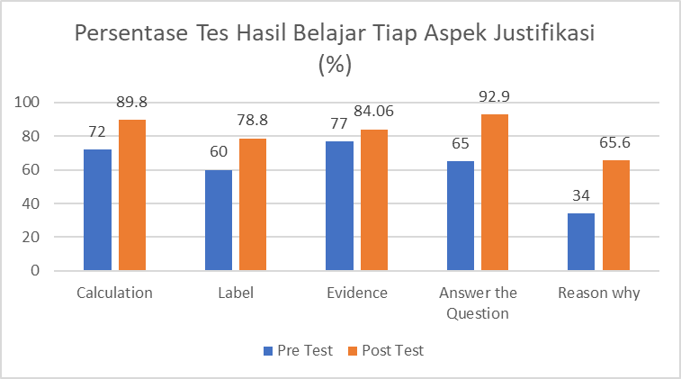
Figure 1. Percentage Diagram of Each Aspect's Learning Outcomes Test (%)
Based on figure 1, the justification skill of students assessed based on clear aspects increases from all aspects after learning with developed tools. The percentage of calculation aspects increased from 72% to 89.8%, the percentage of Label aspects increased from 60% to 78.8%, as well as the percentage of Evidence aspects which rose from 77% to 84.06%, the percentage of Answer the Question rose from 65% to 92.9%, and the percentage of Reason why aspects rose from 34% to 65.6%.
Furthermore, hypothesis testing was carried out to find out whether learning strategies using the learning tools developed had an effect on increasing the mathematical justification skill of students. The test was carried out with the statistics of the Paired sample t test using the help of the program Ms. Excel. The test results paired sample t test are as follows.
$t= \frac{{\overline{X}}_{D}- μ_{0}}{\frac{S_{D}}{\sqrt{n}}}$ where ${\overline{X}}_{D}= \frac{\sum{D}}{n}$ and
$S_{D}= \sqrt{\frac{1}{n-1}\left\{\sum{D^{2}- \frac{\sum{D^{2}}}{n}}\right\}}$
$S_{D}→$ $S_{D}= \sqrt{\frac{1}{n-1}\left\{\sum{D^{2}- \frac{\sum{D^{2}}}{n}}\right\}}= \sqrt{\frac{1}{22}\left\{16974.90334- \frac{{(-521.665)}^{2}}{23}\right\}}$
$=\sqrt{233.7715504}=15.28958961$
$t$ value $→$ $t= \frac{{\overline{X}}_{D}- μ_{0}}{\frac{S_{D}}{\sqrt{n}}}$ $= \frac{\left(-\frac{521.665}{23}\right)}{\frac{15.28958961}{\sqrt{23}}}= \frac{-22.68108696}{3.188099819}$ $= -7.114296367$
$t$table $→$ $t_{\left(n-1 , 0,05\right)}=2,074$

Based on these calculations it can be concluded that because $\left|t_{hit}\right|=\left|-7,114296367\right|=7,114296367> t_{table}=2,074$ , then $H_{0}$ rejected means that there is an average difference between the learning outcomes of pretests and postes. It can also be interpreted that learning strategies that use the learning tools developed have an effect on increasing the mathematical justification skill of students.
RPP is developed according to the rpp development principle stated in the Permendikbud Number 22 of 2016 concerning Standards for the Primary and Secondary Education Process. Then, the steps of learning activities are developed by referring to the LKPD that has been developed. The rpp is equipped with the alleged response of the learner and the alternative response of the teacher obtained from the tought-experiment and also the possibility of misconceptions that occur in the learner. Examples of alleged student responses and teacher response alternatives developed can be seen in figure 4.
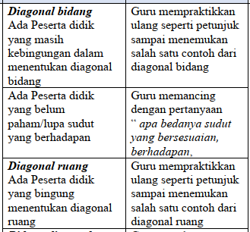
Figure 2. Examples of alleged student responses and alternative teacher responses

When the teacher has written down some conjectures, it does not guarantee that all students will have a response that matches the conjecture. In learning, researchers find learners' answers that appear unexpectedly. As a result, teachers should think of appropriate response alternatives as much as possible to direct learners to the right answers. The response of learners who are different from the conjectures is used by the researcher to correct the conjectures that have been made. This shows that HLT should always be developed and revised after use in learning. This is in accordance with the opinion of Simon & Tzur (2004: 93), namely because HLT is a conjecture or hypothesis which is not necessarily in accordance with the process that actually occurs, the teacher needs to modify every aspect of the HLT on an ongoing basis. In addition, learning tools that use learning trajectory can help students in solving mathematical problems because learning trajectory can help students improve understanding of concepts. HLT is also useful as a guide for the implementation of learning as well as providing various alternative strategies to help teachers overcome the difficulties of students in understanding the concepts learned (Wijaya, 2009).
Based on the mathematical justification skill test carried out after the use of learning tools, the percentage of student learning completion reached 82.6%, which means it is very good. In addition, based on the results of the average hypothesis test, the average justification skill test result obtained is more than 70. The results obtained show that the learning tools used in learning have achieved the expected competencies and have an influence on learning outcomes and also have an impact on formative evaluation, in accordance with the opinion of Nieveen (1999: 127-128) who states that the effectiveness of a product is achieved if students appreciate learning activities and want learning to take place and this must have an impact on the formative evaluation of large groups. Thus, the learning tools developed have met the effective criteria in terms of effectiveness aspects.
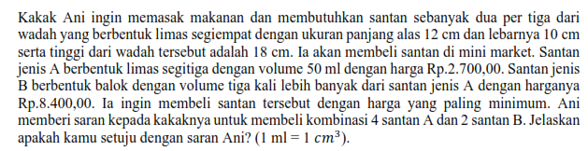
Figure 3 problems in learning

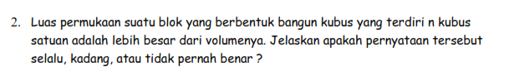
Figure 4 problems in learning

Figures 3 and 4 are examples of problems to find out the skill of mathematical justification of students. This problem is one example presented during mathematics learning. The issue requires students to provide justification for the answers presented. To solve this problem, students must be able to determine the volume of the two types of containers given before the student declares and gives the reason for the truthfulness of the answers submitted. From this problem trains students to be accustomed to justifying the answer, students not only need an understanding of the concept in solving this problem, more than that, students are required to be able to provide reasoning and communicate the idea of solving the problem by providing reasons why the answers given are correct.
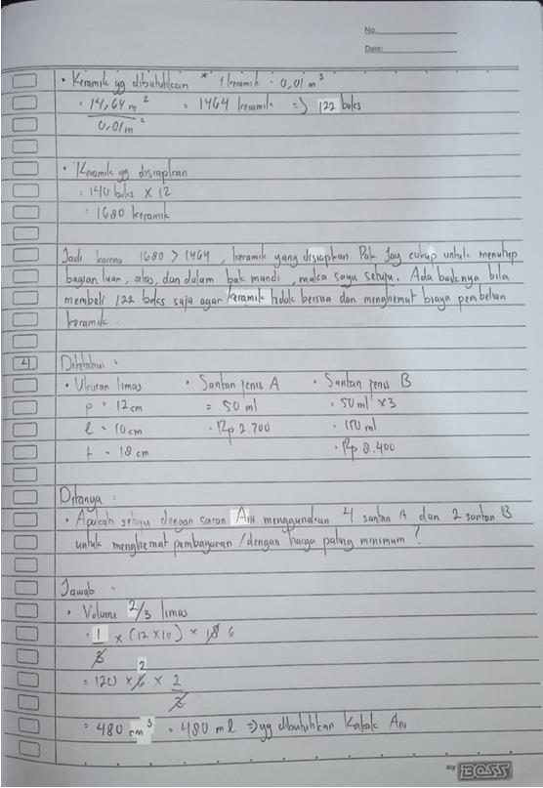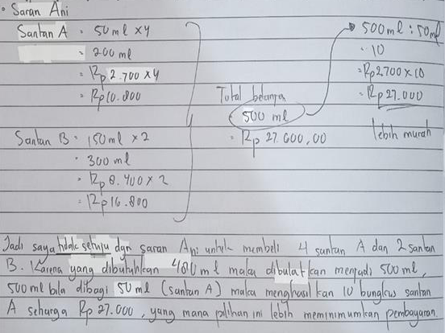
Figure 5. Student answers
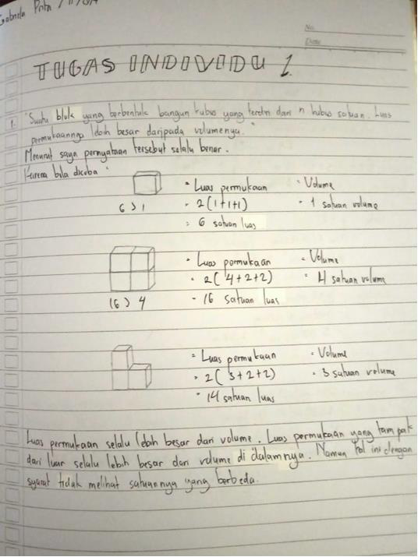
Figure 6. Students' answers

Figures 5 and 6 show how students solve the problem. Figure 5 shows the answer to the question in figure 3, and figure 6 shows the answer to the question in figure 4. In the calculations and labels aspect, the student has displayed calculations to answer the given problems and provide a description of each calculation. In the aspect of Evidence and Answer the question, the student displays the steps or stages of solving and provides answers to the problem. At the Reason stage, the student shows the reasons why he uses the steps and gives those answers based on the data he obtained when the calculations corresponded earlier.
The success of learning is certainly inseparable from the learning process with the RME approach which places students as the main subject of greetings to carry out guided reinvention activities and drawing conclusions based on exploration activities of special events given by the teacher. In addition, learning that uses the characteristics of RME learning, namely the use of context, the use of models, the use of student construction results, interactivity, and intertwinement can provide opportunities for students to develop students' mathematical justification skills. The utilization of student construction results gives students the freedom to develop problem-solving strategies so that it is hoped that varied strategies will be obtained. The results of the work and construction of learners are further used for the foundation of the development of mathematical concepts. In learning, the use of interaction in mathematics learning is useful in developing the cognitive and affective abilities of students simultaneously. The learning process of learners will become shorter and more meaningful when learners communicate with each other the results of their work and ideas. Students are free to give arguments, give reasons, justify answers based on the steps that students have already done. In addition, through interrelationships, learning can build mathematical concepts simultaneously so as to enrich the understanding of concepts in students to support students' skill to solve problems and provide justification for mathematical problems. Cioe, et al. (2015:488) state that one of the strategies for developing an understanding of justification is to discuss justification samples. For example, we show the results of the student's work in front of the class and ask the student to interpret the justification, decide whether to agree or not. This experience leads learners to achieve the expected competencies at the end of learning.
Achievement in learning mathematics is mathematics skill in the form of knowledge and skills possessed by students after learning mathematics and receiving their learning experiences in the form of behavioral changes in the form of cognitive, affective, and psychomotor forms indicated in the form of letters, numbers or test scores given by educators. The results of research conducted by Knuth (in Hamidy & Suryaningtyas, 2016) concluded that students will learn meaningfully when making proof (justification) as a tool in learning mathematics. When thinking mathematically, learners must learn how to justify, explain the reasons why their answers are correct, and convince teachers and other learners. Therefore, when students develop justification skills in their learning, the learners are also in an effort to develop their achievements. This means that when students' justification abilities increase, their learning achievements also increase. In learning using the learning tools developed, it shows the results that the increase in the results of the student's mathematical justification skill test is also followed by an increase in the results of the student's achievement test. The following results are interpreted in the form of a diagram.
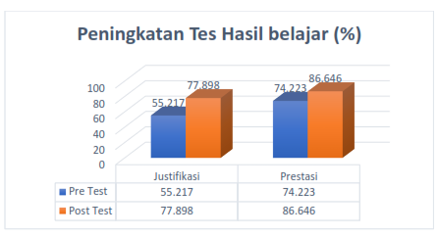
Figure 7. Learning Outcome Improvement Diagram (%)
Furthermore, testing was carried out to find out whether there was a relationship between the justification skill of students and the achievement of learning mathematics. The test was performed with a simple linear regression test with the IBM SPSS Statistics 25 program. Testing is carried out on justification skill test result data and student achievement test result data. Previously as a prerequisite test, normality testing was carried out, linear relationship testing of both variables and heteroskedasticity testing. The results of the normality test can be seen in the following table.

Table 11. Normality test results of learning outcomes test
Aspect | Justification Test | Learning Outcomes Test
Shapiro-Wilk | 0,954 | 0,928
Sig. | 0,352 | 0,101
Shapiro-Wilk test results for improving the learning outcomes of the achievement test significance value of 0.101 > 0.05. The result means that H0 is accepted. This means that the data on the results of the achievement test used are derived and distributed normally, so that they meet the assumptions and are worthy of hypothesis testing. Meanwhile, the results of the linear relationship test can be seen in the following table
Table 12. Linearity Test
Aspect | F | Sig. (2-tailed)
Deviation for Linearity | 0,857 | 0,600

Berdasarkan tabel 12 diperoleh nilai signifikansi sebesar 0,600 > 0,05 yang berarti H0 ditolak. Artinya ada hubungan linier antara hasil tes kemampuan justifikasi dengan hasil tes prestasi.
Hubungan antara hasil belajar tes justifikasi dengan hasil tes prestasi dapat dicari dengan menggunakan rumus sebagai berikut
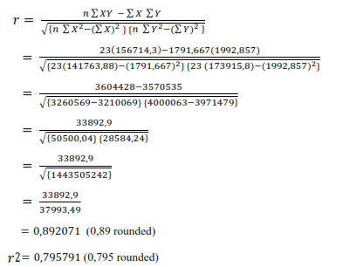
Based on calculations, there is a positive relationship (correlation) between mathematical justification skill and student mathematics learning achievement. The skill of mathematical justification is quite influential on the achievement of learning mathematics of students which is shown in the determinance coefficient $r^{2}= 0.795$ or 79.5%. This means that the increase or decrease in students' mathematics learning achievement is influenced by mathematical justification skill. Furthermore, the results of heteroskedasticity testing can be seen in the following table.

Table 13. Heteroskedasticity test
Aspect | Result
Sig. | 0,187
Based on table 13, a significance value of 0.187>0.05 is obtained, of which H0 is accepted. This means that there are no symptoms of heteroskedasticity in the regression model. Based on the plot chart, results such as the following are obtained.
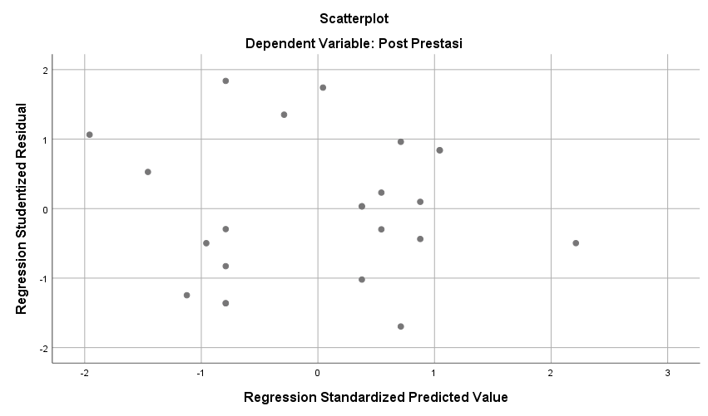
Figure 8 Heteroskedasticity test plot diagram
From the diagram in figure 8, it can be seen that there is no clear pattern. The dots do not form a wavy pattern widening then narrowing and then widening back. The dots spread above and below the number 0 on the y-axis. This means that there are no symptoms of heteroskedasticity. Next, is a simple linear regression test can be seen in the following table.
Table 14. Simple linear regression test
Aspect | Result
Sig. | 0,00
Based on table 14, a significance value of 0.00 < 0.05 is obtained, where H0 is rejected. This means that there is an influence of mathematical justification skill on students' mathematics learning achievement. The linear regression equation can be obtained from the output results in the Coefficientsª table in linear regression analysis with the help of the IBM SPSS Statistics 25 program as follows.
Table 15 Coefficientª
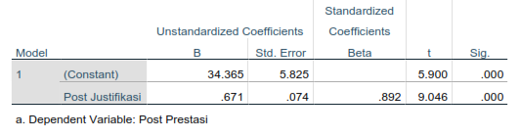 Based on table 15, a simple linear regression equation is obtained, namely $Ŷ = 34.365 + 0.671X$. This means that the increase or decrease in the learner's mathematics learning achievement is influenced by the mathematical justification skill described in the linearity relationship of the mathematical justification skill and the learner's mathematical learning achievement on the equation $Ŷ = 34.365 + 0.671 X$. If the mathematical justification skill is improved, the tendency of student mathematics learning achievement also increases by 0.671 at a constant of 34.365, the rest is determined by other circumstances.
Children who have high reasoning skills and mathematical communication skills will have high mathematical scores as well (Qomariyah, 2017: 49). Meanwhile, leonard & novitasari research (2017: 765) concluded that students who have a good understanding of mathematical concepts obtain high mathematics learning outcomes. Based on the analysis, the study proved that there is a positive and significant relationship between the mathematical justification skill and mathematics learning achievement of learners. The regression equation is $34.365 + 0.671 X$ which means that each increase by one point of mathematical justification skill will have an influence of 0.671 on the student's mathematics learning achievement. There are other factors that can affect learning achievement such as interests, talents, attention, skills, and environmental factors, both from outside, school, and society.
CONCLUSION
The learning tools developed met the criteria of being valid, practical, and effective in mathematical learning. With the guided reinvention syntax of RME, the mathematical justification skill of student can be developed through RME learning with developed tools which are indicated by increasing the percentage of aspects of CLEAR assessment (Calculation, Label, Evidence, Answer the Question, and Reason why). Based on the results of pretests and postest, the Calculation aspect rose from 72% to 89.8%, the Label aspect rose from 60% to 78.8%, the Evidence aspect rose from 77% to 84.06%, the Answer the Question aspect rose from 65% to 92.9%, and the Reason why aspect rose from 34% to 65.6%. In addition, the mathematical justification skill of students has a significant influence on student learning outcomes. The magnitude of the relationship is determined by the determinance correlation coefficient of 79.5% in other words it can be explained through the equation Ŷ = 34.365 + 0.671X.
REFERENCES
Back, R. J., Mannila, L., & Wallin, S. (2010). Student justifications in high school mathematics. In Proceedings of CERME (Vol. 6, No. 2009, pp. 291-300).
Branch, R. M. (2009). Instructional Design: The ADDIE Approach. New York: Springer
Cioe, M., King, S., Ostien, D., et al. (2015). Moving Student to the Why? www.nctm.org Journal: Mathematics teaching in the middle school Vol. 20 No.8
Clements, D.H., & Sarama, J. (2009). Learning and teaching early math: The learning trajectories approach. New York: Routledge
Daro, P., Mosher, F.A., & Corcoran, T.B. (2011). Learning Trajectories in Mathematics: a Foundation for standards, curriculum, assessment, and instruction. Philadelphia (USA): Consortium for Policy Research in Education)
Glass, B. & Maher, C.A. (2004). Students Problem Solving and Justification. Makalah disajikan dalam 28th Conference of the International Group for the Psychology of Mathematics Education, Ankara, April 2012. http://emis.dsd.sztaki.hu/proceedings/PME28/RR/RR016_Glass.pdf
Hamidy, A. & Suryaningtyas, S. (2016). Kemampuan Justifikasi Matematis Siswa SMP pada Materi Segitiga. Seminar Nasional Pendidikan Matematika. Universitas Negeri Malang.
International Association for the Evaluation of Educational Achievement (IEA). (2013). Released Mathematics Items: TIMSS 2011 Grade 8 Mathematics. TIMSS & PIRLS International Study Center, Lynch School of Education, Boston College, Chestnut Hill, MA, and International Association for the Evaluation of Educational Achievement (IEA), IEA Secretariat, Amsterdam, the Netherlands. https://nces.ed.gov/timss/pdf/TIMSS2011_G8_Math.pdf
Li, Y., Silver, E.A., Li, S., et al. (2014). Transforming Mathematics Innstruction;Multiple Approaches And practice. Basel:Springer.
Mullis, I. V., Martin, M. O., Foy, P., et al. (2012). TIMSS 2011 international results in mathematics (pp. 139-171). Chestnut Hill, MA: TIMSS & PIRLS International Study Center.
NCTM. (2000). Principles and Standards for School Mathematics. United States of America: The National Council of Teachers of Mathematics, Inc.
National Research Council (NRC). (2001). Adding It Up: Helping Children Learn Mathematics. Washington, DC: The National Academies Press. https://doi.org/10.17226/9822.pdf
Nieveen, N. (1999). Prototyping to Reach Product Quality. Dalam Plomp, T., Nieveen, N., Gustafson, K., Branch, R.M., & van den Akker, J. (eds). Design Approaches and Tools in Education and Training. Springer Netherlands ISBN: 978-94-010-5845-2, 978-94-011-4255-7
OECD. (2004). Learning for tomorrow’s world: first result from PISA 2003. Paris
_____. (2007). The Programme for International Student Assessment (PISA) 2006: Science Competence for tomorrow’s world.Executive Summary,(3),1-117.
_____. (2010). PISA 2009 Result: What Student Know And Can Do -Student Performance In Reading, Mathematics, And Science (Vol.1)
_____. (2013). PISA 2012 Assessment And Analytical Framework: Mathematics, Reading, Science, Problem Solving, And Financial Literacy. Diakses dari http://www.pisa.oecd.org
_____. (2016). PISA 2015 In Focus. OECD
_____. (2019). PISA 2018 Insights and Interpretations. OECD
Partnership for 21st Century Learning. (2015). P21 Framework Definitions. http://www.p21.org/storage/documents/docs/P21_Framework_Definitions_New_Logo_2015.pdf
Permendikbud. (2016). Permendikbud Nomor 22 Tahun 2016 Tentang Standar Proses Pendidikan Dasar dan Menengah
Sapti, M. (2014). Teacher’s Informal Learning Trajectory and Student’s Actual Learning Trajectory on Learning Cube and Cuboid Nets. Prosiding, International Seminar on Innovation in Mathematics and Mathematics Education. Yogyakarta: FMIPA UNY
Sarumaha, Y. A. (2015). Justifikasi dalam Pembelajaran Matematika. Dalam Prosiding Seminar Nasional Etnomatnesia. 286-295. Universitas Cokroaminoto Yogyakarta.
Simon, Martin. A. (1995). Reconstructing Mathematics Pedagogy from a Constructivist Perspective. Journal for Research in Mathematics Education Vol. 26, No. 2 (March., 1995), pp. 114-145
Simon, M. A. & Tzur, R. (2004). Explicating the Role of Mathematical Tasks in Conceptual Learning: An Elaboration of the Hypothetical Learning Trajectory. Mathematical Thinking and Learning, 6(2), 91-104
Supriani, Y., & Sholahudin, U. (2019). Mengembangkan Kemampuan Memformulasikan Konjektur Siswa melalui Experiential Learning. JKPM (Jurnal Kajian Pendidikan Matematika), 4(2), 173. https://doi.org/10.30998/jkpm.v4i2.3885
Wahyuni, T. S., Amelia, R., & Maya, R. (2019). Analisis Kemampuan Komunikasi Matematis Siswa SMP Pada Materi Segiempat Dan Segitiga. Jurnal Kajian Pembelajaran Matematika, 3(1), 18-23. http://journal2.um.ac.id/index.php/jkpm/article/view/7420
Wardhani, S. & Rumiati. (2011). Instrumen Penelitian Hasil Belajar Matematika SMP:Belajar dari PISA dan TIMSS. Yogyakarta: PPPPTK Matematika http://p4tkmatematika.org/
Widyoko, E.P. (2009). Evaluasi Program Pembelajaran. Yogyakarta: Pustaka Pelajar.
Widyoo, E.P. (2017). Evaluasi Program Pembelajaran: Panduan Praktis Bagi Pendidik dan Calon Pendidik. Yogyakarta: Pustaka Pelajar.
Wijaya, A. (2012). Pendidikan Matematika Realistik: Suatu Alternatif Pendekatan Pembelajaran Matematika. Yogyakarta: Graha Ilmu.
World Bank. (2010). Inside Indonesia’s Mathematics Classrooms: A TIMSS Video Study of Teaching
Yanti, R. N., Melati, A. S., & Zanty, L. S. (2019). Analisis Kemampuan Pemahaman dan Kemampuan Komunikasi Matematis Siswa SMP Pada Materi Relasi dan Fungsi. Jurnal Cendekia: Jurnal Pendidikan Matematika, 3(1), 209-219. https://j-cup.org/index.php/cendekia/article/view/95

