The implementation of mathematical e-learning assisted by storyboard

**J Pondryanti1, Ali Mahmudi2**

1Graduated Program of Mathematics Education, Yogyakarta State University, Indonesia

2Mathematics Departement, Faculty of Mathematics and Science, Yogyakarta State University, Indonesia

jesicapondryanti.2019@student.uny.ac.id, alimahmudi@uny.ac.id

**Abstract.** Nowadays, we are in the technological era. Sector of education should be able to adapt to the technological developments. The purpose of this study was to describe the implementation of mathematical e-learning assisted by Storyboard that oriented towards students learning outcomes. The types of research that used in this research was descriptive quantitative research. This research was conducted in SMP N 1 Yogyakarta which involved 25 students. Data collection techniques that used in this study were tests and questionnaires*.*  The results of this study indicate the data obtained related to student learning outcomes states that of the 25 students, the highest student learning outcomes are 100, and the lowest is 63 with an average student learning outcomes is 88 included in the high criteria, where 92 % of learning outcomes obtained by students are scattered in the medium, high, and very high categories. Then based on data obtained from the questionnaire responses of students during the e-learning that assisted by Storyboard showed that 80% of students' responses are spread in the medium, high, and very high categories. The result showed that Storyboard media give positive influence on the mathematical e-learning. Therefore, Storyboard can be utilized in supporting online mathematics learning and increasing student motivation in learning activities.

1. Introduction

Education cannot be separated from the developments that occur in our life. Technological advances can change people's lifestyles. The field of education is also one of the areas of life that have been positively affected by the rapid development of technological advances. Currently, the rapid development of technology has had a significant impact and influence in the field of education. The various conveniences and benefits offered by information technology are one of the considerations for the use of technology in teaching and learning.

Along with the development of technology, the use of learning methods and media will be better and more diverse. Interesting and interactive learning media can affect how students learn so that the learning process becomes more effective and efficient. The use of computers in helping the learning process has been used since the 1960s [1]. Then the various kinds of implementation of the use of technology in the field of education are growing.

As time goes by, there are several trends in the development of education in Indonesia in the future, such as the conventional teaching and learning process that will soon be replaced by modernization, which will be more open and more flexible [2]. The teaching and learning process will also emphasize the interaction and collaboration aspect so that it is not only fixated on the classrooms in the school building. Technological development makes it possible to carry out online learning or e-learning by using the internet for connecting interactions between teachers and students without the need to meet in person. Therefore, the teaching and learning process can be carried out remotely without having to meet, and then between any educational institutions can also collaborate and share various learning resources.

Many students are more interested in using gadgets such as computers, laptops, and smartphones than reading printed books, mainly textbooks [3]. Well-designed online learning can motivate students to be more active in using learning content so that the learning process becomes more interactive. The use of online learning must be able to make students active. Following the constructivism learning theory student build knowledge through the learning process, not transferred from teacher to student. Education does not occur in the space between the teacher's mouth and the student’s ears, but education occurs in the space in the brain of each student [4]. The use of learning media in online learning also influences the success of the learning process.

Mathematics is known as a boring subject because it seems too inexact, many students also think that mathematics is a scary subject because mathematics is usually presented in a written form that requires sharp reasoning because many things are abstract. Furthermore, there are several challenges in implementing mathematics learning, especially in online learning, including how to make students interested in learning, how to involve students in learning activities, and how to motivate students to take part in learning so that students do not think that they cannot learn mathematics [5].

One of the learning media that can be used in online learning is visual-based learning media. Visual-based learning media is a learning media that can show learning material in visual form. Visual media can also be interpreted as media with human vision or eyes. Good visual media is not just a media that can be seen by the eye, but media that delivers the messages in the form of visuals or images without reducing or eliminating the meaning of the message.

One of the visual media used in the learning process, especially online learning, is comics. Comics are a form of illustrated stories, consisting of various serial situations, sometimes humorous [6]. So a comic is a tool or a physical object in the form of a story using a series of images which doesn’t move and visualized in the form of frames/boxes and conversation balloons that are more than one but one unified story. Comics were chosen as learning media because of the tendency that many people like and have read comics and there are 80% of comic readers spread all over the world [7]. Students also described comics as something fun [7], [8]. In recent years, the use of comic books has become more common in the classroom [9]. For mathematics teachers, it is challenging to find comics relevant to mathematics concepts. Besides, there is limited study on comics for learning mathematics while most of the previous studies explored the use of coming in teaching and learning of science and language. Even though Comics provides another way of looking at abstract mathematical concepts [10]

Storyboards are comics that used as learning media in mathematics lessons in the form of stories that use a series of images which doesn’t move and visualized in the form of frames/boxes and conversation balloons and certain symbols used to convey messages containing mathematical problems. Storyboards are not just comics that convey mathematics learning material, but also have several features such as “*Ayo Cari Tau*” which invites students to think about the material being discussed and “*Tugas*” that invite students to write important points and invite students to work on some sample questions related to the material being studied. By using Storyboard as a learning media in online learning is expected to facilitate the delivery of teaching materials to students.

Based on the results of several previous researchers, it was found that the use of comic media had a significant influence on the learning process [11]. Comics and cartoons could increase students’ motivation and interest, especially in learning mathematics [12]. Comics also can improve student’s memory and understanding [13]; and the use of comics are very interested to students [14].

In the online learning process, sometimes what the teacher wants to convey to students regarding the material being taught is not conveyed optimally. Storyboards can be used as an alternative learning media that can be used by teachers in online learning. Storyboards can be used as learning media that students use to study material anywhere and anytime, and with an attractive appearance can make students interested in learning and reading Storyboards repeatedly. Meanwhile, there are not many articles discussing comic media used in mathematics learning, especially online learning or e-learning. Therefore this article discusses how students respond to the use of Storyboard (comics) in mathematics learning, especially in e-learning.

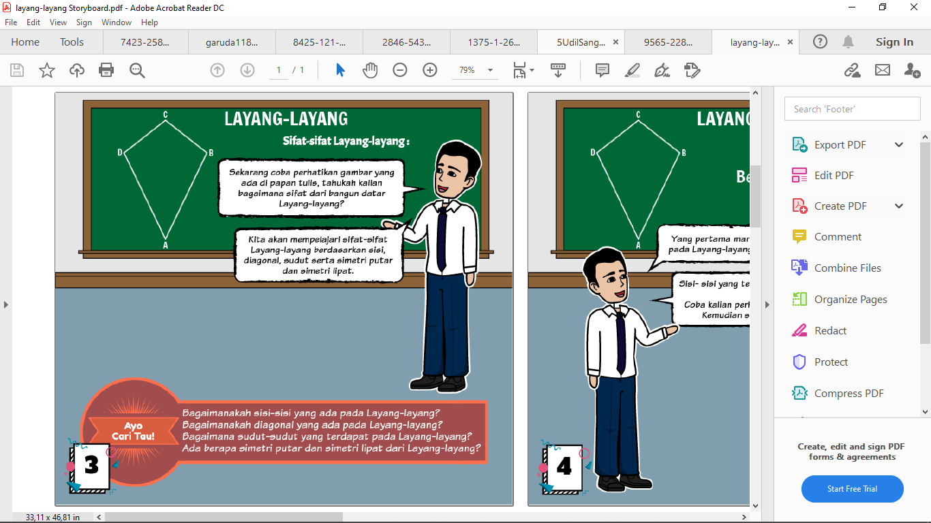

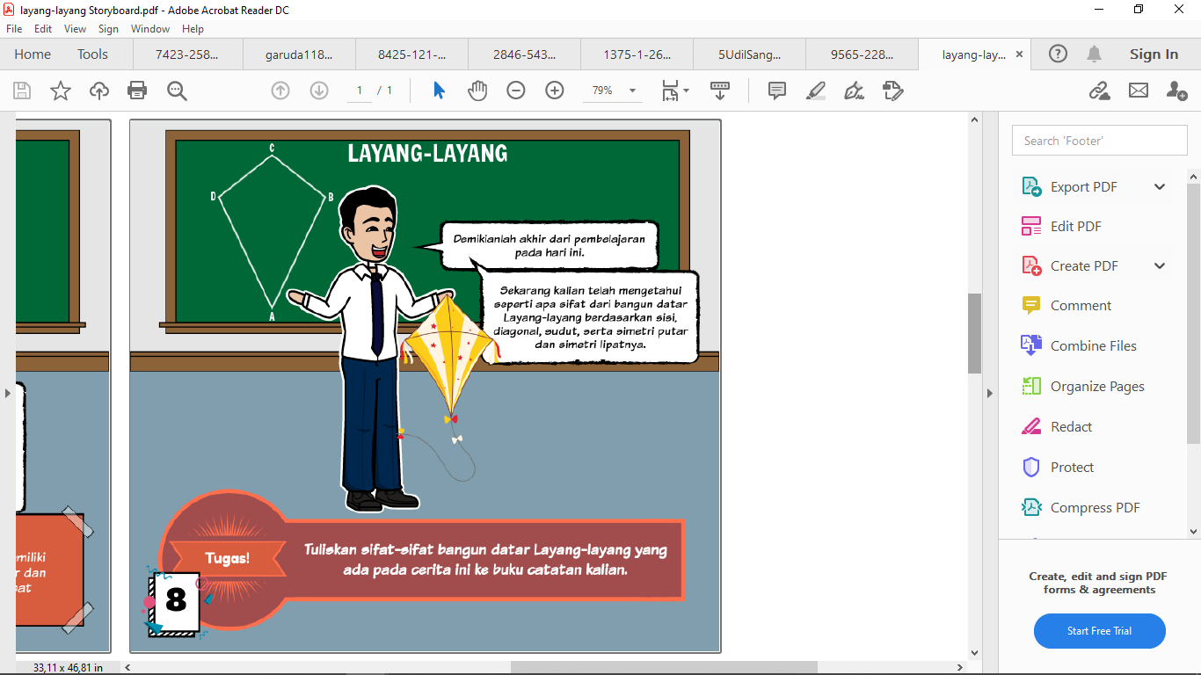**Figure 1.** “*Ayo Cari Tau*” feature in Storyboard

**Figure 2.** “*Tugas*” feature in Storyboard

1. Research Method

The type of research used in this research is a descriptive quantitative approach. The descriptive quantitative approach is expected to be able to produce an in-depth explanation of something that is observed from an individual or a group [15]. The purpose of this research is to describe the implementation of mathematical e-learning that assisted Storyboard which is oriented towards the learning achievement of students on the topic of quadrilateral.

This research was conducted in SMP N 1 Yogyakarta which involved 25 students. The school was chosen as a research place because the learning process uses online learning. The subjects in this research were given teaching materials in the form of Storyboard in the online learning process. Then, after the online learning process takes place, the teacher gives a learning outcome test. And at the end of the lesson, the researcher gave a questionnaire related to the students' responses to the use of Storyboard during the online learning process.

Data collection techniques used in this study were tests and non-tests. The test technique in this research used a learning outcome test. The non-test technique in this research was the learning implementation observation sheet and student response questionnaires to the use of Storyboard in online learning.

The research data will be described using descriptive analysis. In the descriptive analysis, the main data to be described are the test results, the results of the students' questionnaire responses to the Storyboard media. The data from the learning outcomes test were obtained through essay tests. The results of the test are in the form of values with a score of 0-100. The description of the test results consists of the number of students, the maximum score, minimum score, average score, variance and standard deviation in the research class. The average score of the learning outcomes test is also compared with the *Kriteria Ketuntasan Minimal* (KKM) at the school being researched. Furthermore, student response questionnaires are used to describe how students respond to online mathematics learning using Storyboard. Student response questionnaire data were obtained from non-test instruments in the form of a Likert scale questionnaire with 5 response categories.

1. Results and Discussion
2. *Results*

The results of this study are presented based on data obtained from student learning outcomes tests and student response questionnaires to the use of Storyboard media in the implementation of online learning given at the end of learning activities. The learning outcomes of students are measured using instruments in the form of test questions related to the rectangular shape material. The number of questions consists of 5 essay items that cover all indicators of achievement of learning outcomes.

The data obtained regarding the learning outcomes of students stated that of the 25 students, the highest student learning outcomes were 100, and the lowest was 50 with an average student learning outcomes of 84.7 which was included in the high criteria.

**Table 1.** Descriptive statistics of student learning outcomes

|  |  |
| --- | --- |
| **Descriptive Statistics** | |
| Frequency | 25 |
| Lowest Score | 50 |
| Highest Score | 100 |
| Average | 84.7 |

The frequency distribution of learning outcomes obtained by students was 56% or 14 students had very high learning outcomes which have a score interval from 90 to 100. In other words, all indicators in the achievement of the learning process have been met. Then there are 12% or as many as 3 students who get high learning outcomes. Furthermore, there are 16% or as many as 4 students who have learning outcomes in the medium category, then there are 4% or only 1 student who get outcomes in the low category, and the last there are 3 students or only 12% who have very low learning outcomes.

**Table 2.** Frequency distribution of student learning outcomes

|  |  |  |  |
| --- | --- | --- | --- |
| **Score** | **Frequency** | **Percentage** | **Category** |
| $$90≤100$$ | 14 | 56% | Very Good |
| $$80≤x<90$$ | 3 | 12% | Good |
| $$70≤x<80$$ | 4 | 16% | Medium |
| $$60≤x<70$$ | 1 | 4% | Low |
| $$0<60$$ | 3 | 12% | Very Low |
| **Total** | **25** | **100%** |  |

The indicator used is how students can understand the material related to rectangular shapes. How students can identify the properties of a rectangular shape and determine the perimeter and area of a rectangular shape. Furthermore, students are also required to be able to solve contextual problems related to quadrilateral shapes.

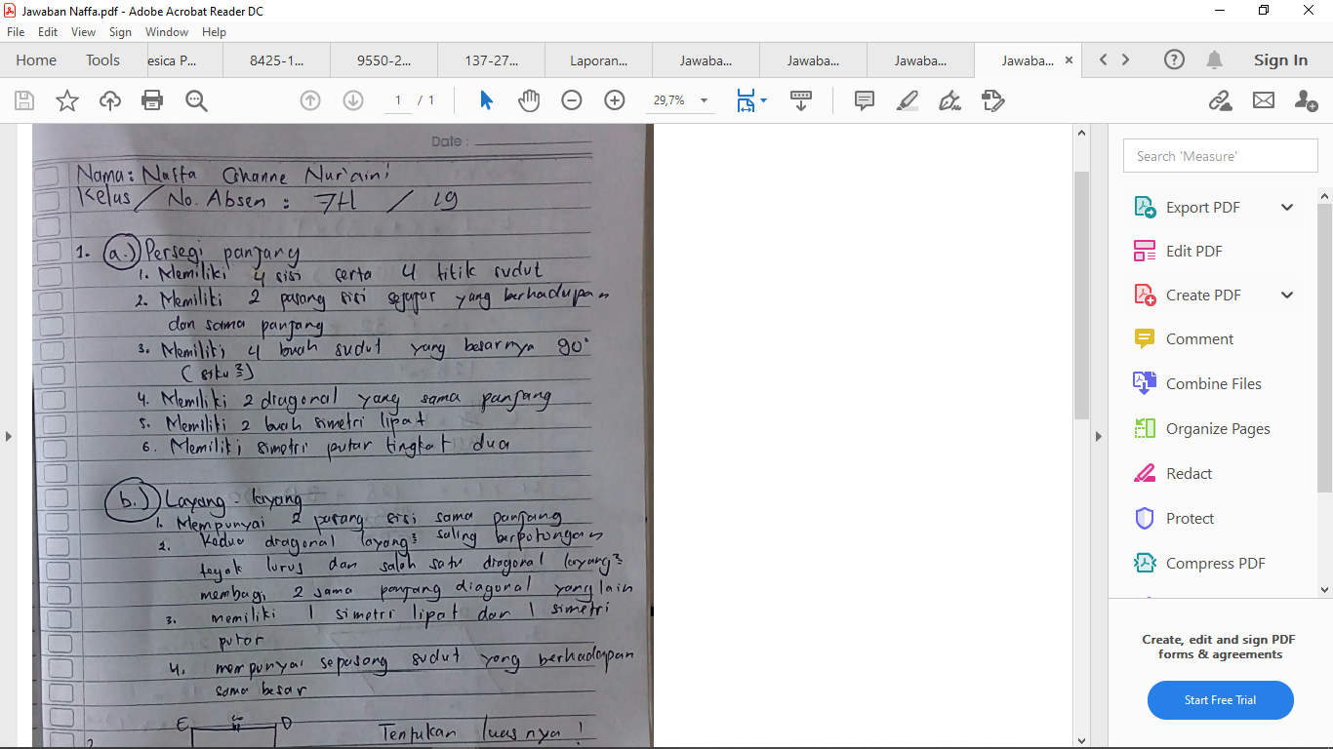

**Figure 3.** Student’s answer from number 1 with a very good category

In Figure 3, the teacher asks students to explain how the properties of the rectangle and kite are. The picture shows the answer to question number 1 which got a perfect score. This means that the student has understood the mathematical concept related to the properties of the quadrilateral shape.

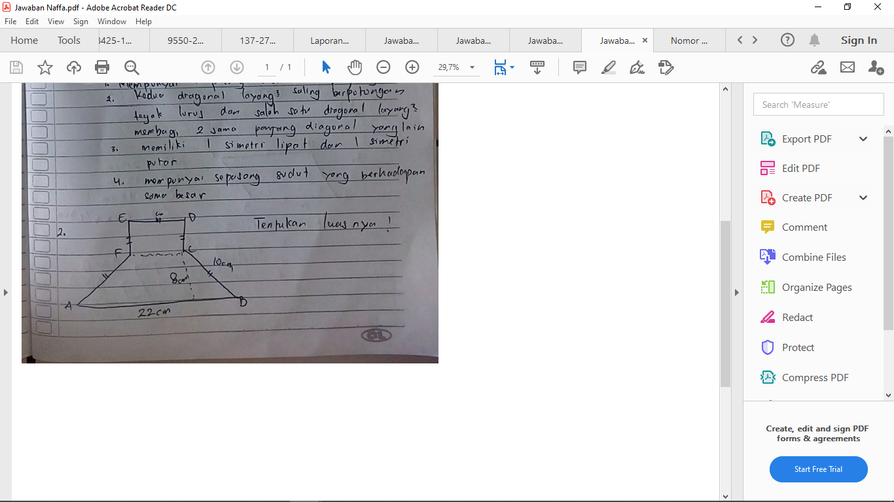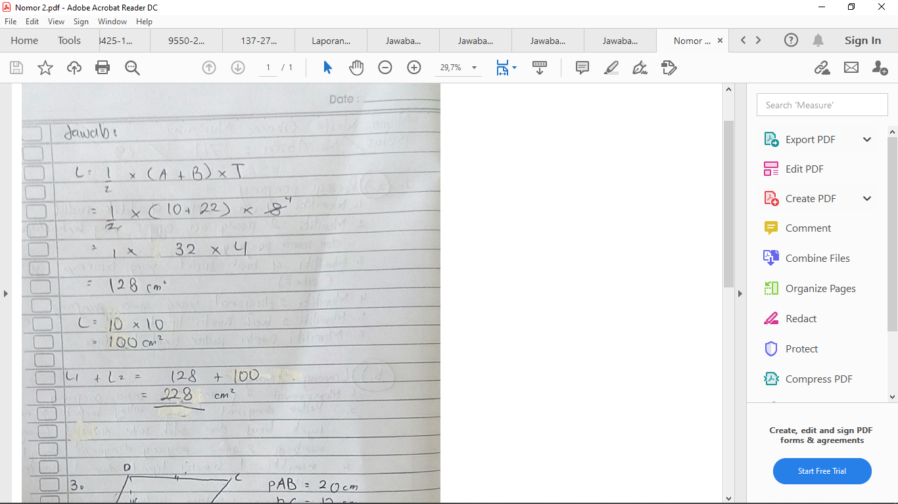

**Figure 4.** Student’s answer from number 2 with a very good category

In Figure 4, the teacher asks students to find the area of the shape. In the picture, two shapes are combined into one, namely the square and trapezoidal shape. From the picture, the student's answer shows the answer to question number 2 which gets a perfect score. This means that the student has understood mathematical concepts related to the perimeter and area of a quadrilateral shape.

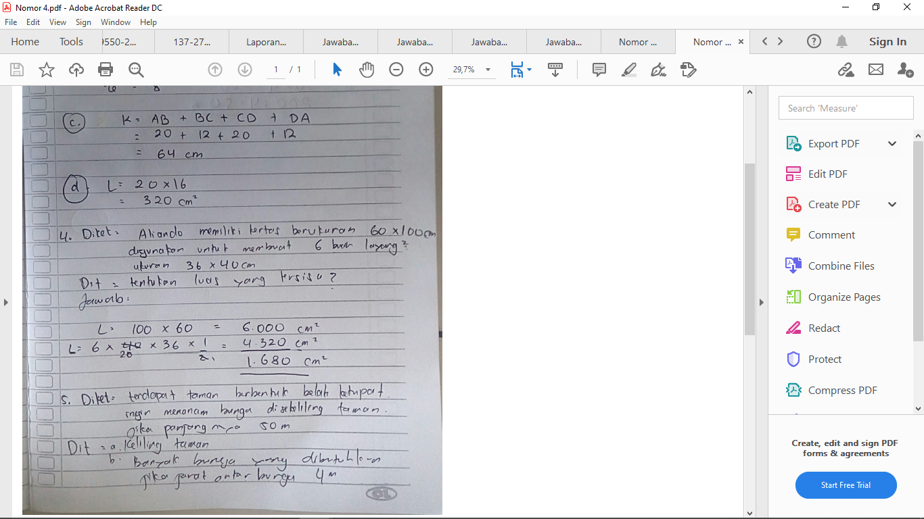

**Figure 5.** Student’s answer from number 4 with a very good category

In Figure 5, the teacher asks students to solve problems that exist in everyday life regarding rectangular shapes. From the picture, the student's answer shows the answer to question number 4 which gets a perfect score. This means that the student has understood and can solve contextual problems related to rectangular shapes.

Furthermore, based on data obtained from student response questionnaires during the online learning process assisted by Storyboard, the following results were obtained. From the 25 students, the highest response was 99 and the lowest was 65, with the average response of students at 82.

**Table 3.** Descriptive statistics of student’s questionnaires response

|  |  |
| --- | --- |
| **Descriptive Statistics** | |
| Frequency | 25 |
| Lowest Score | 65 |
| Highest Score | 99 |
| Average | 82 |

Then from the frequency distribution of students' responses to the use of Storyboard media in the online learning process, 16% of data were obtained or there were 4 students who had a very good response to the use of Storyboard media in the learning process. Then there are 24% or as many as 6 students who have a good response to the use of Storyboard media in online learning. Furthermore, there are 40% or as many as 10 students who have a moderate response. Then there were 4 students or 16% who had low responses and finally 1 student or 4% who had very low responses to the use of Storyboard media in online learning.

**Table 4.** Frequency distribution of student’s questionnaires response

|  |  |  |  |
| --- | --- | --- | --- |
| **Score** | **Frequency** | **Percentage** | **Category** |
| $$91≤100$$ | 12 | 48% | Very Good |
| $$85≤x<91$$ | 5 | 20% | Good |
| $$78≤x<85$$ | 6 | 24% | Medium |
| $$72≤x<78$$ | 0 | 0% | Low |
| $$0<72$$ | 2 | 8% | Very Low |
| **Total** | **25** | **100%** |  |

1. *Discussion*

This research aims to see how mathematics online learning assisted by the storyboard. This research is in the form of mathematical e-learning assisted by Storyboard that oriented towards students learning outcomes. Preparation begins with making plans for the implementation of learning that will be carried out during the learning process. Researchers also made storyboards as learning media to be used in online learning.

The Storyboard is uploaded into a virtual classroom where it is used as a place for students to learn, then students view or download the Storyboard media as teaching material used in learning. Students are given Storyboard media in accordance with the material to be taught at each meeting.

At the last meeting, students were given a learning outcome test instrument in the form of essay questions to measure the achievement of the learning process that had been carried out. Researchers also asked students to fill out questionnaires related to online learning that had been carried out with the help of Storyboards.

The results showed descriptively that the learning outcomes of 25 students of SMP Negeri 1 Yogyakarta were high criteria. It can be concluded that there is a good achievement of learning outcomes through online learning assisted by Storyboard media. In the online learning process assisted by storyboard, students are given more structured teaching materials and worksheets then students are allowed to explore the ideas they have.

From the results of the student work that has been described above, it can be said that these students have been able to solve the characteristics, circumference and area, and contextual problems related to the quadruple shape due to the media used in learning so that students easily remember the material that has been taught. These results are relevant to the statement that the media can facilitate students in the learning process [16]. Student learning outcomes in sufficient qualifications after using Storyboard.

Then based on a questionnaire response to online learning assisted by storyboards, students feel interested in this online learning activity. This is because students learn online which allows them to learn anytime and anywhere, especially the current generation is a technology literate generation. In addition, the use of Storyboard also makes students feel more interested in learning activities because learning is carried out online with the help of Storyboard. the use of learning media not only makes learning more effective but also makes students enjoy and comfortable in learning, understand mathematics, and improve their learning outcomes [17].

Based on students' comments on the questionnaire sheets provided, for questionnaire questions regarding student opinions about learning using comic learning media, it was found that they became happier learning because it made the material they studied easier to understand and remember. This agrees with the stetement that the use of media in learning can help students learn in impressive ways and provide variety in the classroom learning so that the knowledge that students acquire will always be remembered, provide motivation so that it increases interest so that learning becomes fast. and productive, making students interested so that students' attention will be focused on learning [18].

1. **Conclusion**

Based on the results of the research and discussion that has been described, it is concluded that online-based mathematics learning assisted by Storyboard media on quadrilateral material can be carried out well and has a positive impact on the motivation and learning outcomes of seventh-grade students of SMP Negeri 1 Yogyakarta. The response of students to the use of Storyboard media is quite good where students gain experience using technology in the learning process. Students feel interested in learning even though learning is carried out online. Overall learning outcomes of students have reached the minimum completeness criteria.

**References**

1. M Aparicio, F Bacao, and T Oliveira 2016 *Journal of Educational Technology Systems* **19** 292
2. Uno Hamzah B and Lamatenggo N 2010 *Teknologi Komunikasi dan Informasi Pembelajaran* (Jakarta: Bumi Aksara)
3. Budi Cahyono, Y Romadiasari and S Maslikah 2016 *Jurnal Pendidikan Matematika FKIP Unissula* **4** 71
4. Khan S 2012 *The One World Schoolhouse* (New York: Twelve, Hachette Book Group)
5. Sullivan P 2011 *Teaching Mathematics: Using Research-Informed Strategies* (Australia: ACER Press)
6. Ahmad R 1997 *Media Instruksional Edukatif* (Jakarta: Rineka Cipta)
7. Cary S 2004 *Going Graphic: Comics at Work in the Multilingual Classroom* (USA: Heinemann Portsmouth)
8. Graham S 2011 *Language Education in Asia* **2** 92
9. R Edel 2014 *Works and Days* **32** 1
10. Martin, T Fitzpatrick, R Hunting, D Itter, C Lenard, T Mills and L 2009 *Milne Eds Mathematics of prime importance: MAV yearbook* (Melbourne: The Mathematical Association of Victoria)
11. Laksono Y S, G Ariyanti, F G I Santoso 2013 *Jurnal Edukasi Matematika dan Sains* **1**
12. Toh T L, Cheng L P, Ho S Y, Jiang H and Lim K M 2017 *Asia Pacific Journal of Education* **37** 437
13. Monnin, K. (2012). *Teaching with Comics and Illustrated Novels: A Guide for Parents, Librarians, and Educators*. amp Teaching with Comics.
14. Septy L 2014 *Sea-DR Conference 2014*
15. Sugiyono 2014 *Metode Penelitian Kuantitatif, Kualitatif, dan R & D* (Bandung: Alfabeta)
16. Sundayana R 2015 *Media Dan Alat Peraga Dalam Pembelajaran Matematika* (Bandung: Alfabeta)
17. Miller D, Glover D, and Averis D 2008 *Enabling Enhanced Mathematics Teaching with Interactive Whiteboards* (Staffordshire: KEELE University)
18. Naz A A, Akbar A R 2008 *Journal of Elementary Education* **18** 35