Integrating Javanese Ethnomathematics Approaches into the Geometry Learning of Junior High School
Pardimin^{1, b)} Dafid Slamet Setiana^{2, c)} and Didi Supriadi^{1, a)}
Author Affiliations
¹Universitas Sarjanawiyata Tamansiswa, Yogyakarta, Indonesia
²Universitas Negeri Yogyakarta, Yogyakarta, Indonesia by
Author Emails
^{a)} Corresponding author: didi.supriadi@ustjogja.ac.id
^{b)} pardimin@ustjogja.ac.id
^{c)} dafidslametsetiana@uny.ac.id
Abstract. This study investigates the use of an ethnomathematical approach by mathematics teachers for mathematics learning. The main purpose of this article is to explore mathematics teachers' perception of integrating Javanese ethnomathematics approaches into geometry learning in Junior High School. The sample of this research is mathematics teachers from 12 junior high schools from DI. Yogyakarta Province, Central Java Province, and East Java Province. The data collection instrument is an ethnomathematics opinion survey questionnaire. A questionnaire to measure the application of the model integrating Javanese ethnomathematics approaches into the geometry learning of Junior High School. Focus Group Discussion was also conducted in this study to explore user assessment of the model. The data collected were analyzed using descriptive analysis. The analysis results show that mathematics teachers have a positive perception of ethnomathematics. The teacher's perception of ethnomathematics is shown by awareness, prior learning, evaluation of the activity design process, evaluation of the activity implementation process, use in professional life, and student evaluation. The acceptance indicator for integrating Javanese ethnomathematics into the geometry learning model is reasonable based on an assessment of the introduction, content, evaluation, and closing aspects.
Keywords: Javanese ethnomathematics, learning model, geometry learning

INTRODUCTION
The Covid-19 pandemic has resulted in changes in the order of human life, including in learning activities. All learning activities are carried out online through information technology and internet networks. Online learning facilitates the implementation of the independent learning program launched by the Ministry of Education and Culture. However, through the online system, the rapid development of information technology may erode the noble character of students' culture. It is urgent that cultural values as the foundation of the nation's character need to be instilled from an early age so that each individual can better understand, interpret, appreciate and realize the importance of cultural values in carrying out every activity. These efforts are done through ethnomathematics, integrating cultural elements into mathematics learning.
D'Ambrosio initiated ethnomathematics as a solution by studying and combining ideas, methods, and techniques used and developed by different socio-cultures or cultures.¹ Ethnomathematics tries to reposition mathematics to be rooted in different cultures and accommodate different ideas so that students become critical, democratic, and tolerant reasoning. Therefore, ethnomathematics as a pedagogical innovation in mathematics learning aims to make students love mathematics, be motivated and increase creativity in doing mathematics. Ethnomathematics includes ideas, procedures, processes, methods, and practices rooted in different cultural environments. Therefore, ethnomathematics is closely related to mathematics and national culture.² Ethnomathematics is mathematical knowledge that grows and develops ia country's culture. Knowledge of mathematics in a culture can be found in language, traditional rituals, houses, dances, songs, music, clothing, handicrafts, and traditional games.³
Mathematics is widely regarded as one of the most critical subjects in the school curriculum. Mathematics is the backbone of all scientific, technological investigations and all human development activities. The factors causing the low performance of students in mathematics are poor teaching methods, and the teacher does not use teaching materials. Nevertheless, the literature shows a variety of effective learning strategies that can maximize student performance in mathematics. The ethnomathematical approach has been proven by many researchers as an effective learning strategy. Aikpitanyi & Eraikhuemen, in their research, found that the ethnomathematical approach improved understanding and learning efficiency resulting in higher student achievement in mathematics.⁴
Ethnomathematical concepts sourced from the culture of everyday life can be implemented in learning mathematics in schools so that school mathematics learning is more concrete, engaging, and fun.⁵ The unique geometric shape of the model in the construction design of traditional buildings in several ethnic groups in Indonesia shows that people have practiced mathematics in their daily lives. Many models of traditional buildings have patterns, angles, building spaces, triangles, squares, cylinders, prisms, and circles. Ethnomathematics practiced by indigenous Indonesians can be seen from how they measure, design, and construct existing forms. The ethnomathematic form of the woven cabbage leaves of the Tutuwaru community illustrates the process of understanding mathematics from the perspective of indigenous peoples and local wisdom. The hexagonal concept based on the understanding of multiples is an "indigenous knowledge" that exists in the Tutuwaru community in constructing the form of nyiru woven, reflection, point, line, and tessellation. These mathematical ideas can be used as context in school mathematics learning.⁶
Cultivation of cultural values can be done through the family environment, education, and society, not least through learning mathematics. Cultural elements can be brought to mathematics learning through ethnomathematics.⁷ Ethnomathematics is a form of culture-based learning in the context of mathematics.⁸ Cultural activities are developed based on culturally relevant pedagogical principles, focusing on the role of mathematics in socio-cultural contexts. This activity involves ideas and procedures related to an ethnomathematical perspective to solve problems.⁹
One of the cultural products of the Madurese people of East Java is the traditional house of Tanean Lanjang. The intersection between mathematics, anthropology, and mathematical modeling is manifested through the geometric concept of the house, which underlies cultural values. The geometric concepts contained in the traditional Tanean Lanjang house include two-dimensional shapes (ie, rectangles, trapezoids, triangles), two-dimensional circumferences, two-dimensional areas, three-dimensional shapes (ie triangular prisms), three-dimensional volumes, curves, and the concept of reflection in geometry.¹⁰ Historically, mathematics is ivery close to everyday life and was developed by humans to answer the surrounding phenomena. Indonesia has a diverse culture, including Yogyakarta. This culture can be used to explore many mathematical concepts as a transformational effort to bring mathematics closer to the reality and perceptions of its people. Batik Yogyakarta has used the concept of geometric transformation in making batik motifs typical of Yogyakarta.¹¹
In addition to Javanese ethnomathematics, there is also Sundanese ethnomathematics, which is mathematics in a Sundanese culture which is implemented in the activities of the Sundanese people of West Java, Indonesia.¹²
Sundanese ethnomathematics in Muhtadi's research has three activities, namely estimating, measuring, and making patterns that appear in the kibik activity (a unit for measuring volume), bata (a unit for measuring surface area), and pihuntuan path (a unit for measuring volume). This is reflected in the size of activities based on the objects used and estimates based on cultural activities carried out for generations. The Sundanese apply rigorous mathematical concepts for measures of basic concepts and activities of making patterns. The sharing of knowledge about applying the basic concepts of size and pihuntuan patterns in compiling specific geometric patterns greatly inspires the application and development of mathematical concepts.¹³ Ethnomathematics is still widely used by the Sundanese people, especially in rural areas. Using units of measure, mathematical modeling, and symbolic clocks are still widely used in rural communities.¹² The mathematical model that still applies to Sundanese culture is related to the Tidal calculation model, which is still widely used in fishing communities.¹⁴
Fauzi's findings indicate that there are mathematical ideas that have the potential to be used as the first step in contextual mathematics learning.¹⁵ This study aims to describe the mathematical ideas contained in the architecture of the Sasak traditional house and educational values in a culture that can be used as the first step in designing the learning process in schools. Prahmana's study shows that the people of Yogyakarta use mathematical modeling to determine the system of seasons and funeral dates. These models can potentially be used as a starting point in learning mathematics.¹⁶ Ethnomathematics is a research program focusing on the relationship between mathematics and culture.¹⁴ The problem is how educators in formal schools can utilize and combine material formally to be supplied with a mathematical calculation culture that has been inherent in society, into a more dynamic learning format, so that mathematics can be presented more interestingly, can be learned with fun, and can be more enjoyable, easy to learn, because students do not feel alien to the daily habits of society.
Ethnomathematics can empirically improve students' cognitive abilities in primary and secondary schools. However, there are still limited studies on integrating ethnomathematics into learning resources. Busrah's research has applied interpolation in modeling polynomial functions and integral volumes on traditional Bugis and Makassar food forms.¹⁷ Furthermore, it can be used by students as a relevant learning resource regarding interpolation and the concept of volume of a solid-body revolution. Bugis and Makassar traditional foods are unique in terms of culture and education. This traditional food can be categorized as part of a food group served in religious events, traditional wedding ceremonies, or culinary snacks. Based on the discussion, this study found that the geometric shape of each type of cake is influenced by the shape of the mold, the materials, and the hands.
There are several ways to integrate ethnomathematics into the teaching and learning process. One such approach is ethno-modeling which Bassanezi first introduced.¹⁸ In learning mathematics, the use of ethnomathematics and mathematical modeling of ideas, methods, and techniques from what has been developed by the community is expected to be an alternative to introduce the surrounding life to students. Ethnomodelling will allow us to see mathematical performance holistically. In this way, it is possible to critically explore local mathematics by appreciating the diverse cultural values of different societies. Therefore, learning mathematics can be started by critically exploring the phenomena around students' environment and modeling them mathematically to develop critical awareness and reasoning, and get motivated.¹⁹
This study focused on the ethnomathematics of Javanese culture. Javanese culture originates from Java and is embraced by the Javanese people, especially in Central Java, Yogyakarta and East Java.²⁰ Javanese culture can be studied fr literature, language, kingdom, architecture, calendar, and art. The use of Javanese Primbon has material potential as a context in learning mathematics, such as the context for making ethnomathematical questions.²¹ In this research, Javanese culture is focused on the study of architecture by applying it to the concept of geometry. Through Javanese culture, noble values can be obtained and used as a source of universal character education. Given the importance of ethnomathematics to the formation of the noble cultural character of students in era 4.0, as well as in line with the policy of implementing post-pandemic learning, the researchers intend to conduct a study to know the acceptance for integrating Javanese ethnomathematics into the geometry learning model.

METHODS
The sample of this research is mathematics teachers from 12 junior high schools in DI. Yogyakarta Province, Central Java Province, and East Java Province. The data collection is an ethnomathematics opinion survey questionnaire and a questionnaire to measure the application of the model integrating Javanese ethnomathematics approaches into the geometry learning of Junior High School.
The instrument of ethnomathematics opinion survey was adopted from Ergene, Ergene, & Yazici questionnaire²². The questionnaires consisted of questions regarding issues, such as awareness of the relationship between mathematics and culture, prior learning, and designing and implementing activities in the teaching and learning process. The researcher used in closed form containing of Likert scale that provided five choices of response for the respondents in answering the questionnaire. Kinds of the answers strongly agree, agree, neutral, disagree, and strongly disagree. The Likert scale was chosen because this study intended to measure people's views or perceptions.
Focus Group Discussion was also conducted in this study to explore user assessment of the model. The data collected were analyzed using descriptive analysis.

RESULT AND DISCUSSION
Javanese ethnomathematics is a field of mathematical activity that comes from the community's cultural context, namely Javanese culture. This study examines mathematics teachers' perceptions and interest in ethnomathematical activities. The results of a survey of mathematics teachers from 12 junior high schools from DI. Yogyakarta Province, Central Java Province, and East Java Province are shown in Table 1.

TABLE 1. Teacher's Perception of Ethnomathematics for Mathematics Learning
Teacher's Perception of Ethnomathematics | Mean | Std. Deviation
- Awareness | 4.75 | 0.45
- Prior Learning | 4.33 | 0.49
- Evaluation of Activity Design Process | 3.42 | 0.51
- Evaluation of Activity Implementation Process | 3.75 | 0.75
- Use in Professional Life | 4.42 | 0.51
- Evaluation of Students | 4.50 | 0.52

The results showed that in terms of Awareness the teacher's perception of ethnomathematics was high with a mean of 4.75 and a standard deviation of 0.45. Mathematics teachers state that learning mathematics can be approached with a cultural approach. Most of the teachers already know about ethnomathematics. They know the purpose of the ethnomathematical approach, but they do not know for sure the principles, strengths, and weaknesses of integrating the ethnomathematical approach in learning mathematics. Teachers who do not understand the meaning of local wisdom tend to be less sensitive to local cultural diversity. Another obstacle that usually arises is the lack of skilled teachers; as a result, they are less able to create learning that respects regional cultural diversity.²³
The previous experience of mathematics teachers with ethnomathematics (Prior Learning) showed a fairly good score with a mean of 4.33 and a standard deviation of 0.49. Some mathematics teachers stated that they had been in an ethnomathematical learning environment or in an environment that could create knowledge about ethnomathematics in their previous educational life. Judging from the ethnomathematical approach, most teachers have never applied the ethnomathematical approach in the classroom and do not know the principles of implementing ethnomathematical learning strategies. As revealed in Supiyati's research that 87.2% of mathematics teachers use the basic principles of the ethnomathematical approach in terms of content and methods and past experiences during teaching.⁵ The concept of ethnomathematics that comes from the culture of everyday life can be implemented in learning mathematics at school.
The evaluation of the activity design process showed a poor response, with a mean of 3.42 and a standard deviation of 0.51. It means that some teachers do not understand in detail the contributions, benefits, and difficulties of the ethnomathematical approach design process in mathematics learning. It is a new challenge for teachers to apply ethnomathematics to mathematics learning.
The evaluation of the activity implementation process showed a sufficient response with a mean value of 3.75 and a standard deviation of 0.75. Teachers do not understand when teachers are asked to explain the advantages and disadvantages of carrying out ethnomathematics activities in learning. Teachers perceive cultural transmission can help increase students' interest in mathematics learning. The relationship between mathematics and culture can support relevant pedagogy.²⁴ Relationship of culture and mathematics by outlining what types of mathematical concepts are used in culture and how they can be linked to classroom mathematics.
Mathematics teachers are enthusiastic when applying ethnomathematics for mathematics learning, as seen from the Use in Professional Life aspect with a mean of 0.42 and a standard deviation of 0.51. Mathematics teachers plan to use math-related activities and culture in math lessons. It is crucial to study mathematics educators' perceptions of the cultural relevance of school mathematics because these perceptions can influence their actions in learning mathematics. Mathematics teacher educators' perceptions of basic mathematics's cultural relevance can influence how they develop or train mathematics teachers.²⁴
In the context of the Evaluation of Students, a mean score of 4.50 was obtained with a standard deviation of 0.52. Most mathematics teachers do not know about the instruments, content, and evaluation methods in ethnomathematics learning. Therefore, the teacher's view on the contextualization of mathematics education to empower and promote cultural capital through learning mathematics indicates the need for teacher motivation, and integration of mathematical concepts with cultural rituals.²⁵

Furthermore, mathematics teachers were asked to assess the integration of the Mathematics Learning Model Based on Javanese Culture Ethnomathematics. For the application of Javanese Ethnomathematics in the Mathematics Learning Model, model books, module books, and student worksheets have been prepared (LKPD).

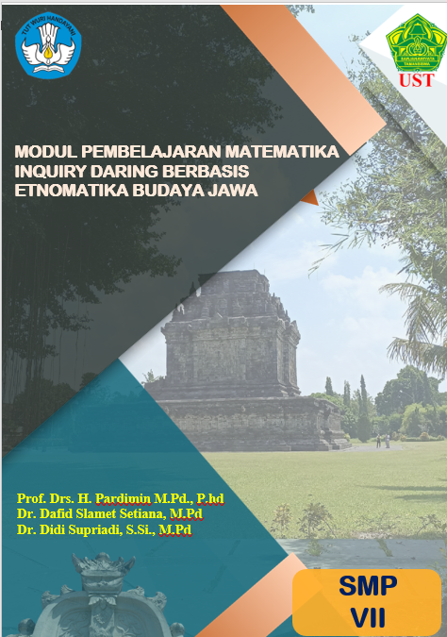
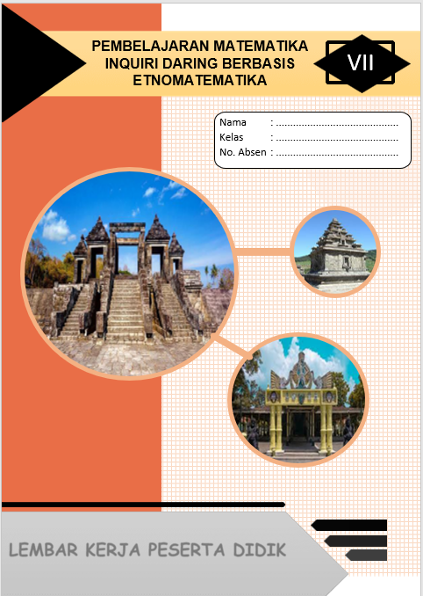
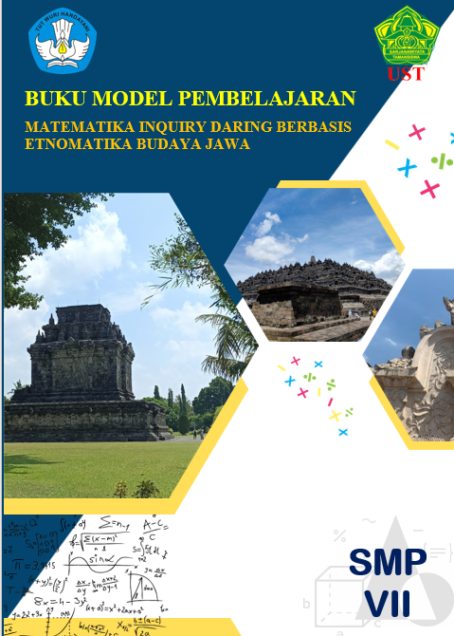

(a) Model User Guide (b) Learning Module (c) Student Worksheet

Figure 1. Javanese Ethnomathematics in Mathematics Learning

The Covid-19 pandemic requires teachers to prepare more effective and innovative teaching and learning activities to maximize learning activities even though they do not take place face-to-face. After the pandemic, teachers can collaborate online, offline, and hybrid learning methods so that students continue to have fun and meaningful learning experiences and achieve the learning objectives set by the teacher in lesson planning.
To maximize learning activities, teachers still have to apply learning models such as the demands of learning in the Merdeka curriculum. Teachers need to gain an understanding of applying various learning models in seeking competency achievement by students. Learning models that are not appropriately implemented result in various negative impacts that the teacher cannot resolve. One of the learning models that teachers can use is an online inquiry learning model based on Javanese Culture ethnomathematics. Pardimin, Setiana, & Supriadi (2021) have developed an online inquiry learning model based on Javanese Culture ethnomathematics to be implemented in mathematics learning.²⁶

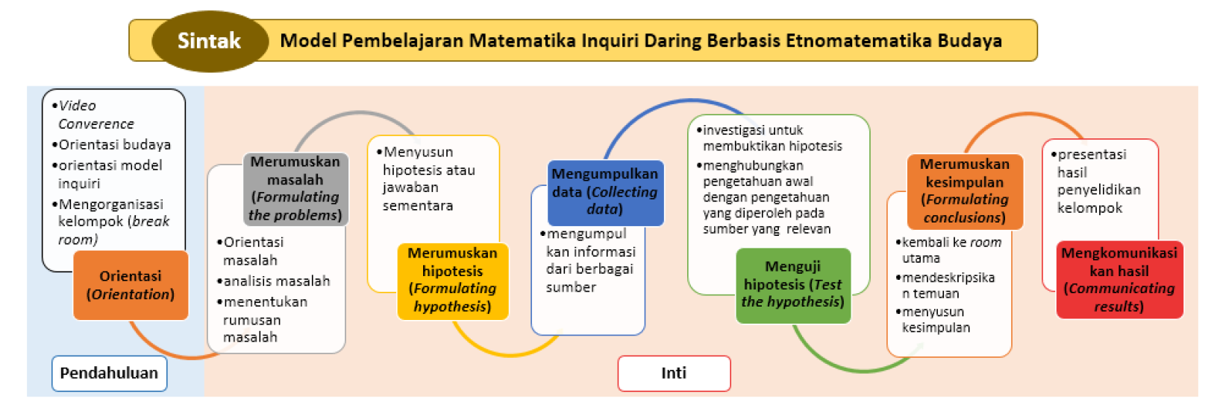
Figure 2. The syntax of the ethnomathematics-based mathematics learning model of Javanese Culture

The syntax of the online inquiry learning model based on Javanese Culture ethnomathematics is Orientation; Formulating the problems; Formulating a hypothesis; Collecting data; Testing the hypothesis; Formulating conclusions, and Communicating results. The syntax of the learning model that has been set is used as a guide in developing an online inquiry learning model book based on Javanese Culture ethnomathematics.
The ethnomathematics-based online inquiry learning developed is learning that guides students to find out, search for, and understand the concepts of two-dimensional and three-dimensional geometry through observing images and videos related to Javanese culture. In this lesson, students are freed to find and identify geometric objects, both two-dimensional and three-dimensional, from the given image. The identified geometric objects are then grouped according to their type, namely plane geometry or space geometry. For the geometry of the plane, then proceed with analyzing the area and circumference. For space geometry, it is continued by analyzing the volume and surface area.
This research will reveal the extent of the acceptance for integrating Javanese ethnomathematics into the geometry learning model. Test results on mathematics teachers at 12 Junior High Schools from DI. Yogyakarta Province, Central Java Province, and East Java Province are shown in Table 2.

TABLE 2. The Acceptance of Javanese ethnomathematics Learning Models by Users
No | Junior High School | Introduction | Content | Evaluation | Closing
1 | SMP Negeri 9 Yogyakarta | 4.00 | 3.70 | 4.00 | 4.00
2 | SMPN 1 Mlati Sleman | 4.75 | 4.10 | 4.67 | 4.00
3 | SMP Taman Dewasa Ibu Pawiyatan | 4.00 | 4.40 | 4.33 | 4.00
4 | SMP Muhammadiyah 6 Manisrenggo | 4.25 | 4.10 | 4.00 | 4.00
5 | SMP Negeri 2 Prambanan Klaten | 3.75 | 4.00 | 4.33 | 4.00
6 | SMP Negeri 1 Donorojo, Pacitan | 4.50 | 4.40 | 4.00 | 4.50
7 | SMP PGRI Gendaran, Donorojo, Pacitan | 4.50 | 4.60 | 3.50 | 4.50
8 | SMP Negeri 4 Depok | 4.50 | 4.00 | 4.17 | 4.00
9 | SMP Negeri 5 Baguntapan | 4.00 | 4.30 | 3.50 | 4.50
10 | SMP Negeri 1 Kota Mungkid | 4.25 | 4.10 | 3.83 | 4.00
11 | SMP Negeri 1 Mungkid | 4.00 | 4.30 | 4.17 | 4.50
12 | SMP Negeri 2 Muntilan | 3.50 | 4.00 | 4.50 | 4.50
 | Mean | 4,17 | 4,17 | 4,08 | 4,21
 | Standar Deviation | 0,36 | 0,24 | 0,36 | 0,26

Based on Table 2, it can be seen that the response of the mathematics teacher to the acceptance of Javanese ethnomathematics Learning Models is quite good. Viewed from the Introduction aspect, the teacher stated that the model could be implemented with a mean value of 4.17. This indicates that the introduction has clear Learning Instructions, Clarity of steps in preparation for learning, Clarity of learning achievements, and Clarity of the description of the concept map of the material to be studied.
The Content aspect is considered quite good, with a mean of 4.17. Javanese ethnomathematics Learning Models can be well received because of the coherence of the content, the breadth of the material, the factualization of the material, the actualization of the material, the clarity of the included examples to clarify the content, the clarity and suitability of the relevance of language, the attractiveness of the content of the material in motivating users, the suitability of the material with the objectives, the suitability of the content of the material with the standard concept, the suitability of the material for the character of students.
Teachers can well receive Javanese ethnomathematics learning models based on the evaluation aspect with a mean of 4.08. The teacher can accept the model because it is equipped with an evaluation instrument that contains clear instructions for working on the questions, the series of questions presented, the level of difficulty of the questions, the suitability of the exercises with learning achievements, the balance of the proportion of questions, and the provision of feedback on user answers. The assessment of Javanese ethnomathematics Learning Models is getting better because it is equipped with Closing, which contains a clear summary as repetition material and presentation of a reference list.
Integrating ethnomathematics can help to make mathematics more relevant and meaningful to students and promote student achievement. Ethnomathematics relates mathematics and socio-cultural contexts close to students by exploring Javanese culture for use in learning mathematics. Studying ethnomathematics has helped teachers and students understand mathematics in the context of ideas, ways, and techniques used in real life to increase students' interest, understanding, and creativity.²⁷ This research is in line with the goal of mathematics education in Indonesia, namely, so that students understand mathematical concepts and solve real-life problems mathematically. Education in Indonesia needs to contextualize mathematics in a social and cultural environment. This research is expected to provide motivation and inspiration for mathematics teachers to apply culture in mathematics learning activities in the classroom. By applying the local culture, students are led to understand mathematical concepts easily because they are presented contextually²⁸.
Traditional mathematics content has the opportunity to be integrated into academic mathematics.²⁹ The academic concept of mathematics can be adopted into mathematics learning in schools. Therefore, culture-based mathematics learning that is carried out simultaneously can be a solution to introduce integrated and culture-based mathematics learning. Number concepts and mathematical modeling can be taught through cultural contextual descriptions so that teachers in learning mathematics can avoid the mechanical and structural approach. Future mathematics learning can be done by maximizing the potential for contextual problems close to the student's environment and culture.
The ethnomathematical approach to teaching school geometry is based on the idea that learning school geometry is more effective and meaningful if it is associated with familiar geometric experiences and activities in the student's cultural environment. Furthermore, the findings reveal that teachers are aware of geometric cultural examples and activities that exist in the cultural backgrounds of their learners and from their experiences. Geometric shapes that are embedded in cultural activities and daily experiences are included in the ethnomathematics category and have the potential to improve the teaching and learning process of school geometry. Teachers' awareness of cultural examples and activities that can be integrated into geometry teaching has the potential to influence their understanding of how their students acquire geometry concepts and thereby encourage them to use students' local geometric knowledge in the classroom.³⁰

CONCLUSION
The analysis results show that mathematics teachers have a positive perception of ethnomathematics. The teacher's perception of ethnomathematics is shown by awareness, prior learning, evaluation of the activity design process, evaluation of the activity implementation process, use in professional life, and student evaluation. The acceptance indicator for integrating Javanese ethnomathematics into the geometry learning model is good based on an assessment of the introduction, content, evaluation, and closing aspects. The role of ethnomathematics as a new concept in bridging mathematics and culture provides opportunities for the world of education to integrate ethnomathematics into the school curriculum. The findings of this study are expected to assist teachers in choosing the right learning strategies or approaches to improve students' problem solving abilities.

Acknowledgments
The authors would like to thank the Ministry of Education, Culture, Research, and Technology of the Republic of Indonesia for providing research grants through the PTUPT scheme in 2022.

References

1. D’Ambrosio, U. Ethnomathematics Link between Traditions and Modernity. Philosophia Mathematica vols s2-4 (2006).
2. Rosa, M. & Orey, D. C. State of the Art in Ethnomathematics. in (2016). doi:10.1007/978-3-319-30120-4_3.
3. Massarwe, K., Verner, I. & Bshouty, D. Ethnomathematics and Multi-Cultural Education: Analysis and Construction of Geometric Ornaments Journal of Mathematics and Culture. J Chem Inf Model 53, (2013).
4. Aikpitanyi, L. A. & Eraikhuemen, L. Mathematics Teachers’ Use of Ethnomathematics Approach in Mathematics Teaching in Edo State. Journal of Education and Practice 8, 34–38 (2017).
5. Supiyati, S. & Hanum, F. ETHNOMATHEMATICS IN SASAKNESE ARCHITECTURE. Journal on Mathematics Education 10, 47–58 (2019).
6. Laurens, T., Kempa, R. & Serpara, H. The Ethnomathematics Of Tutuwaru Community In The Crafts Of Koli Leaf Weaving. Jurnal Pendidikan Matematika (Jupitek) 3, 71–80 (2021).
7. Rahmawati Z, Y. R. & Muchlian, M. Eksplorasi etnomatematika rumah gadang Minangkabau Sumatera Barat. Jurnal Analisa 5, (2019).
8. Rosa, M. & Orey, D. Ubiratan D’Ambrosio: Celebrating His Life and Legacy. Journal of Humanistic Mathematics 11, (2021).
9. Budiyono & Feriandi, Y. A. Menggali Nilai Nilai Kearifan Lokal Budaya Jawa Sebagai Sumber Pendidikan Karakter. Prosiding Seminar Nasional Bimbingan dan Konseling 1, (2017).
10. Sari, A. K., Budiarto, M. T. & Ekawati, R. Ethnomathematics study: cultural values and geometric concepts in the traditional ‘tanean-lanjang’ house in Madura – Indonesia. JRAMathEdu (Journal of Research and Advances in Mathematics Education) 7, 46–54 (2022).
11. Prahmana, R. C. I. & D’Ambrosio, U. Learning geometry and values from patterns: Ethnomathematics on the batik patterns of yogyakarta, indonesia. Journal on Mathematics Education 11, 439–456 (2020).
12. Setiawan Abdullah, A. Ethnomathematics In Perspective Of Sundanese Culture. Journal on Mathematics Education 8, 1–16 (2017).
13. Muhtadi, D., Sukirwan, Warsito & Prahmana, R. C. I. Sundanese ethnomathematics: Mathematical activities in estimating, measuring, and making patterns. Journal on Mathematics Education 8, 185–198 (2017).
14. Albanese, V. & Perales, F. J. Enculturation with Ethnomathematical Microprojects: From Culture to Mathematics. Journal of Mathematics & Culture 9, (2015).
15. Fauzi, L. M., Hanum, F., Jailani, J. & Jatmiko, J. Ethnomathematics: Mathematical ideas and educational values on the architecture of Sasak traditional residence. International Journal of Evaluation and Research in Education 11, 250–259 (2022).
16. Prahmana, R. C. I., Yunianto, W., Rosa, M. & Orey, D. C. Ethnomathematics: Pranatamangsa system and the birth-death ceremonial in yogyakarta. Journal on Mathematics Education 12, 93–112 (2021).
17. Busrah, Z. & Pathuddin, H. Ethnomathematics: Modelling the volume of solid of revolution at Buginese and Makassarese traditional foods. JRAMathEdu (Journal of Research and Advances in Mathematics Education) 6, 331–351 (2021).
18. Rosa, M. & Orey, D. C. Ethnomodeling as a Pedagogical Tool for the Ethnomathematics Program. Revista Latinoamericana de Etnomatemática 3, (2010).
19. D’Ambrosio, U. An Overview of the History of Ethnomathematics. in (2016). doi:10.1007/978-3-319-30120-4_2.
20. Zulaekhoh, D. & Hakim, A. R. Analisis Kajian Etnomatematika pada Pembelajaran Matematika Merujuk Budaya Jawa. JPT: Jurnal Pendidikan Tematik 2, (2021).
21. Utami, N. W., Sayuti, S. A. & Jailani. Math and mate in javanese primbon: Ethnomathematics study. Journal on Mathematics Education 10, 341–356 (2019).
22. Ergene, Ö., Ergene, B. Ç. & Yazıcı, E. Z. Ethnomathematics activities: Reflections from the design and implementation process. Turkish Journal of Computer and Mathematics Education 11, (2020).
23. Insyiroh, I. M., Hariani, E. P. & Mubaroq, S. Pendidikan berbasis kearifan lokal sebagai solusi menghadapi kesenjangan digital dalam kebijakan pembelajaran jarak jauh pada masa pandemi di Indonesia. Indonesian Journal of Social Development 1, (2020).
24. Sharma, T. & Orey, D. C. Meaningful Mathematics Through the Use of Cultural Artifacts. in (2017). doi:10.1007/978-3-319-59220-6_7.
25. Acharya, B. R., Kshetree, M. P., Khanal, B., Panthi, R. K. & Belbase, S. Mathematics educators’ perspectives on cultural relevance of basic level mathematics in Nepal. Journal on Mathematics Education 12, 17–48 (2021).
26. Pardimin, P., Setiana, D. S. & Supriadi, D. Development of Online Inquiry Mathematics Learning Model Based on Javanese Culture Ethnomathematics. Jurnal Mercumatika: Jurnal Penelitian Matematika dan Pendidikan Matematika 6, 24–32 (2021).
27. D’Ambrosio, U. & Domite, M. D. C. S. The potentialities of (Ethno) mathematics education: An interview with Ubiratan d’ambrosio. in Internationalisation and Globalisation in Mathematics and Science Education (2007). doi:10.1007/978-1-4020-5908-7_11.
28. Pathuddin, H., Kamariah & Ichsan Nawawi, M. Buginese ethnomathematics: Barongko cake explorations as mathematics learning resources. Journal on Mathematics Education 12, 295–312 (2021).
29. Umbara, U., Wahyudin, W. & Prabawanto, S. How to predict good days in farming: ethnomathematics study with an ethnomodelling approach. JRAMathEdu (Journal of Research and Advances in Mathematics Education) 6, 71–85 (2021).
30. Sunzuma, G. & Maharaj, A. In-service mathematics teachers’ knowledge and awareness of ethnomathematics approaches. Int J Math Educ Sci Technol 52, 1063–1078 (2021).

