**Ethnomathematics Exploration In The Traditional Game Pio Insana**

**Corsini Sako Dhego**1**, Stanislaus Amsikan**2**, Yohanis Ndapa Deda**3

1Mahasiswa Pendidikan Matematika Universitas Timor

2,3Pendidikan Matematika Universitas Timor

**Abstract**

This study aims to explore the mathematical concepts that exist in the Insana traditional game Pio. This research is qualitative research with an ethnography approach. The study was conducted in Letneo South Village, West Insana Subdistrict, North Central Timor District in the odd semester of the academic year 2020/2021. The research subject is the informant and playing topping Pio. The research instruments are the human instrument, observation guideline, and interview guide. Data collection techniques used in this study are observation, interview, and documentation. Data analysis was conducted through three-stage: data reduction, data display, and conclusion. The result obtained is as follows: found mathematical concepts as follows the idea of number, opportunity concept, and time concept. This shows that mathematics grows and develops in certain community activities called ethnomathematics. In the traditional game Pio, there are elements of character education in the form of togetherness, honesty, and sportsmanship. It is expected that this study becomes a reference for other researchers who want to conduct similar research related to local cultural ethnomathematics.

***Keywords:***Exploration, Ethnomathematics,  Pio Insana

**INTRODUCTION**

*According to D’Ambrosio (1999) I have been using the word ethnomathematics as modes, styles, and techniques (tics) of explanation, of understanding, and of coping with the natural and cultural environment (mathema) in different cultural systems (ethno).*

Indonesia is one of the countries that has a diversity of races and tribes. This resulted in Indonesia being rich in culture, one of which is traditional games (Yanu, Fianto, &Yosep, 2014). Traditional games are physical and non-physical activities performed by a certain group of people. There. There is a picture of the activities of the community in daily life and contains positive values to improve physical, mental, and spiritual health. Therefore, this study raises the traditional game that is almost extinct to be explored in mathematics learning. A variety of classic games are in great demand by older children, perhaps because it was not as sophisticated now. Nowadays, many games are based on technology, such as video games, online games, etc. In this study, researchers explored one of the traditional games of Pio as ethnomathematics.

Pio is a traditional game made of wood and equipped with ropes made of tree bark or nylon. In North Central Timor Regency, West Insana sub-district, Dawan people still maintain the form and way of playing Pio in an effort to maintain cultural values that are increasingly shifted by modernization.

Some exploration of mathematical activities in the culture in North Central Timor Regency, Amsikan and Nahak (2017) and Tlonaen and Deda (2021) has seen the relationship of the concept of traditional house space Ume Kbubu with school mathematics, Deda and Disnawati (2017) have explored the relationship of Dawan has woven fabric motifs with school mathematics, Son (2017) has revealed the mathematical concept in marbles games in the Dawan community and Deda and Amsikan (2019) has explored the idea of geometry contained in the motif of woven fabrics Kefamenanu society. Funan and Mamoh (2019) have also seen the concept of geometry in Uem Le'u Insana, and Kou and Deda (2020) have explored the ethnomathematics of Thelas Keta formal event in Noemuti society (Deda and Disnawati, 2019). Another ethnomathematics research conducted that Numeric Values (Utami, Sayuti, & Jailani, 2019); some mathematical consept in the Panjalin traditional house such as geometric  
concepts for plane shapes and geometric lines and series (Sulaiman dan Nasir, 2020). Therefore, research exploring ethnomathematics in traditional games *Pio* Insana needs to be done to be one of the sources of teaching materials in mathematics learning that is fun for children, especially in Insana about the presence of mathematics in daily play activities and is expected to increase the motivation of learning math in school.

**METHOD**

This study uses ethnographic research. The ethnography method is used to describe, explain and analyze the cultural elements or ethnic groups with qualitative research. In this case, the researchers made observations directly to the Pio player. The subjects in this study were people who played a Pio game. The instruments of this study are researchers, observation guidelines, interviews, and documentation. The research site is Mamsena Letneo Village South Insana Barat District, North Central Timor Regency. The data collection techniques in this study use observation data, interviews, and documentation. Traditional games Pio have also been played by writers as children. Thus the author is easy to describe the mathematical elements contained in the conventional game Pio.

**FINDINGS**

The traditional game Pio is a conventional game made of wood and equipped with rope or nylon as a game tool. The community still maintains the simple form as a form of love for traditional games with a form of gasing resembling the heart or in the local language called Pio aet in contrast to Sundanese gasing research (Febriyanti, et al. 2018) about "ethnomathematics in traditional Sundanese engklek and Pio games" has a form of Pio in the form of tubes and made of bamboo and gasing Barembang research results (Qoyimah, 2018) has a different shape also the form of gasing ceper and thick. In general, traditional games gasing have been discussed (Febriyanti, et al., 2018) and (Qouyimah, 2018). But they have not revealed mathematical concepts and cultural significance in gasing (Pio) play activities.

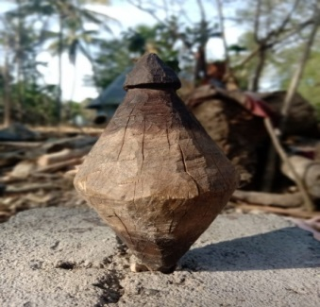

Figure 1. *Pio aet* İnsana



Figure 2. Gasing Barembang



Figure 3. Gasing Sunda

Children commonly play pio games, teenagers; even in ancient times, parents also participated or took part in the game and divided it into two stages. The details of each step in the game are;

**First Stage**

In this first stage, there are a few things to note. Usually, Gasing (Pio) used in the game is a type of Pio shop because of its large shape and not easily broken when thrown:

1. It consists of at least two players. The game can be played in groups.
2. The players determine each member of the group.
3. The players make the rules of the game.
4. After the rules of the game are agreed then, the players create a small circle on the ground to test the strength of the Gasing (Pio).

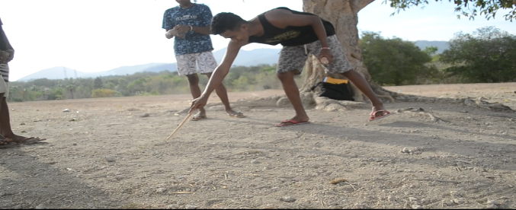

**Figure 4.** a player of Pio make a circle on the land.

1. The Pio is wrapped around the coil around the rope from the neck of the Pio until all the ropes are wrapped around the Pio body. Usually, the length of the string is adjusted to the size of each Pio player. The larger the Pio shape, the smaller the rope coils; otherwise, the smaller the Pio shape, the more twisted the rope.

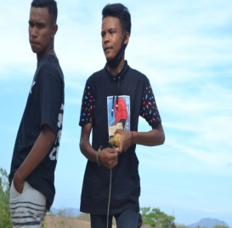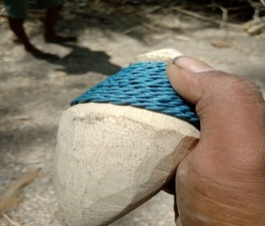

Figure 5. The Process of Wrapping Rope on Pio

1. In the three (signal) count, all players throw their Pio into the circle of this stage is usually called tilis pio. At the time of pio in tilis that survives, spin is the winner and entitled to be a pitcher while pio at the time of tilis and die first or out of the circle is considered defeated and willing to be an installer.

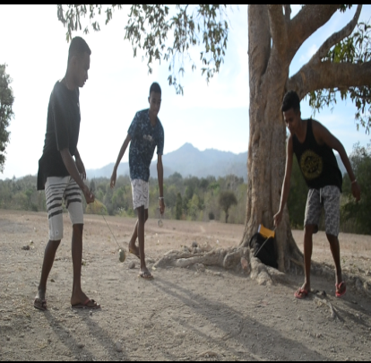

**Figure 5.** The Process of *Tilis* Pio

**Second Stage**

This second stage contains a few things to note:

1. After getting the winner in the tilis pio in the early stages, the winner will be the pitcher while the loser tilis become the installer.
2. The losing player (installer) first throws his gasing (Pio) on the ground.
3. The winning player tilis (a pitcher) is tasked with throwing (poel pio) Pio the opponent who is spinning with the provision, must hit the installer pio and keep turning to get points.

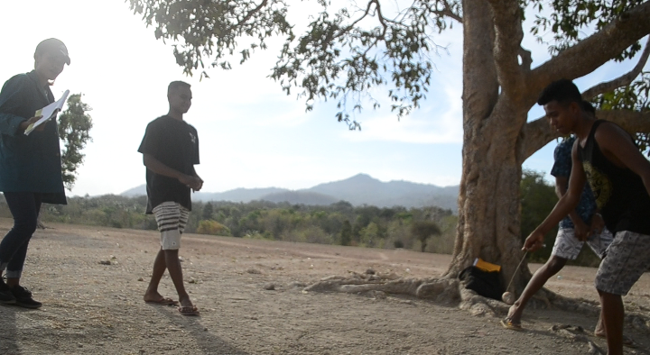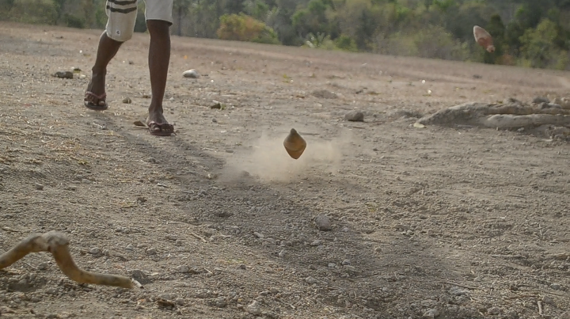

**Figure 6.** The Process of Throwing Pio (*poel pio*)

1. If the throw does not hit the opponent Pio (installer), the chance to get the point fails. The game will be repeated continuously until all group members get a throw and put up section.

**DISCUSSION**

The word Pio in Dawan is interpreted as gasing. The game is played in groups of at least three people (Dharmamulya, 2008). Traditional games are hereditary (Kurniawati, 2015), and games can also support learning so that students become more active in the learning process (Nuraeni, 2013). In traditional games, there are fundamental values for the physical and mental development of children. When children play unconsciously, they have to learn to socialize with the environment later in society as adults. Choosing the number of players involved in the game is not excessive if the gasing match serves as a medium of interaction and socialization, both for the players and the audience. In the contested gasing game, the players initially agreed to set the rules of the game.

This is following the research (Febriyanti et al., 2018), Ethnomathematics not only math but also explore the cultural values that existed inside, meaning in ethnomathematics not only understand those mathematics but deeper how cultural values that live in the heritage of ancestors can be useful and relevant to life today. It is essential that the mathematics contained in the artistic elements can be used as a handle for math educators to utilize local games that are still culturally strong to be used as learning materials. Besides, it instils character education elements in the form of honesty, togetherness, and high sportsmanship in performing traditional games.

Pio, like most gasing, is a toy that can spin on its centre and balance at some point. Concerning life in society, philosophically Pio game is a symbol of human behaviour in everyday life. According to Insana, there is a meaning of the traditional game Pio as Based on how to throw Pio must be with a flat slam, and it indicates that Pio is resistant to slamming. The nature of durable toys contains hope for the player's life so that living life can be resilient, challenging, and not easily discouraged. The longer the gasing can rotate in an upright position, the higher the quality of the game.

**Mathematical Concepts In Traditional Games *Pio***

If the game of gasing is well observed, then it can be noted that there are some mathematical concepts contained in it. This means that mathematics can be explored and found in the culture to be used as a concrete learning resource around students (Kou & Deda, 2020). The mathematical concept in the traditional game of Pio is in the form of the concept of numbers, the idea of opportunity, and the concept of measuring time. This can be seen from the following description:

1. **The Concept of Numbers in The Pio Game**

In a regular gasing game when gasing in the test the players do the signal by equally counting 1, 2, 3 starts gasing on the ground simultaneously. (Dharmamulya et al. 2008) explains that traditional games have the function of practicing thinking skills and practicing numeracy skills. The activity contains mathematical elements that there is a concept of numbers. In line with Hasanah & Pratiwi (2017) 's research, traditional games help children's cognitive development and recognize the idea of numbers.

**The Concept of Opportunities in The Pio Game**

Gasing (Pio) shop is a gasing that fights in the fight of the opponent gasing. Gasing is fat, more extensive than Bal'bali gasing and different from Gasings these other areas such as Barembang gasing which is more thinner (Qoyimah, 2018). The game of gasing trimmer is played in teams. The game field is a flat, circular build, and the player determines each squad member. Each team has the same member to do the gasing game. The determination of the number of members and each squad's playing turn relates to the concept of opportunities (Dwi Safitri, 2015). The chance to throw gasing at a traditional game of pio will turn to the opponent when one of the gasing players is turned upside down.

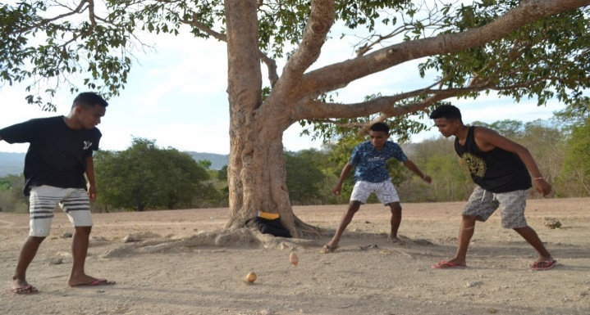

**Figure 7.** The Process of Traditional game Pio

1. **The Concept of Time Measurement**

According to research conducted (Jaelani, et al. 2013), "gasing games in time learning" activities measure time by seeing the gasing remains rotating or producing the most extended spin. The mathematical activity above is also included in measuring activities by comparing gasing with each other by just looking at the gasing rotates' length while in the fight. The activity contains mathematical elements that there is a concept of comparison between the gasing made and the concept of time to produce how long the round occurs by the gasing. In time measurement, the players also do not realize that there is a mathematical concept about the unit of time and comparisons that have been applied in comparing the gasing round. Hypotheses and logic are also systematically present in this activity to enable players to win the race by setting a good strategy to determine the length of the gasing round (Qoyimah, 2018).

Based on the presentation of data and discussions that contain the association of gasing activities (pio) with mathematics, here is a summary of the gasing section and the movement of playing gasing with mathematical concepts.

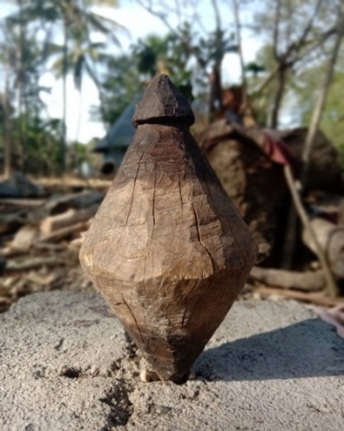

**Figure 8.** Gasing (Pio) Insana

This study showed that the traditional game of pio in Insana society culture has the meaning of honesty: a sportsmanship attitude, namely the perspective of ready to face defeat or victory with a positive mental attitude. mathematical concepts contained in the traditional game pio, namely:

1. The idea of numbers included on the signal when starting a match.
2. The idea of opportunities in gasing matches to determine who wins.
3. The concept of time on the comparison of the length of the spinning gasing.
4. In gasing form has one symmetrical axis.
5. The gasing shape resembles an open parabola upwards.
6. Cone on the condition of gasing body and gasing head.

Therefore, this traditional game can be used to create learning designs for children in school. Thus, it can motivate children and society that mathematics has a relationship with culture and can be learned fun. Also, some studies have documented the results of their research related to the implementation of students' daily activities in the mathematical learning process, such as gasing games in time learning (Jaelani, et al. 2013), (Son, 2017) disclosure of mathematical concepts and character of students in the marbles game of Dawan people, ethnomathematics in traditional Sundanese cultural engklek and gasing games (Febriyanti et al., 2018). Therefore, this study shows that *pio* classic game is a regular game that children play and contains cultural values. Further explored integrate mathematical concepts into mathematics learning (Deda and Maifa, 2020). The results of this ethnomathematical exploration research can be used as a source of innovative mathematics learning media (Hariastuti, 2017; Disnawati and Nahak, 2019; Taus, Nahak, & Deda, 2022).

**CONCLUSION**

Based on the description in the results and discussion section, we can conclude that the mathematical concepts in the traditional game of *Pio* are: the concept of numbers, the idea of opportunity, the idea of time, the symmetrical axis, the parabola, and the cone. *Pio* game also has the value of honesty culture, a sportsmanship attitude that is ready to accept defeat or victory. It is expected that this study becomes a reference for other researchers who want to conduct similar research related to local cultural ethnomathematics. Also, be learning for Insana people in Pulau Timor who know the interrelationship between mathematics and culture in daily activities.

**Recommendations**

Based on the findings and discussion results above, we recommend that traditional Pio games be used as context in mathematical learning. Mathematics learning will be more meaningful when learning using contexts close to the daily lives of students.

**Acknowledgements**

Thank you to the University of Timor and all those who have helped in completing the research.

**REFERENCES**

Ambrosio, U.D. 1999 *Ethnomathematics and Its Place in The History And Pedagogy Of Mathematics. For learning of Mathematics*.

Amsikan, S. & Nahak, S. 2017. Hubungan Konsep Ruang Ume Kbubu Desa KaenBaun Kabupaten Timor Tengah Utara dendan Konsep Geometri. Prosiding Konferensi Nasional Penelitian Matematika dan pembelajarannya II (KNPM II) Universitas Muhamadiyah Surakarta, 18 Maret 2017, hal.168-175.

Deda, Y. N. & Disnawati, H. (2019). Buku Ajar Etnomatematika Kawasan Perbatasan NKRI-Timor Leste. Deepublish: Yogyakarta.

Deda, Y. N. & Talisadika, S.M. (2020). Integrasi Kearifan Lokal Dalam Pembelajaran Matematika. Uwais Inspirasi Indonesia: Sidoharjo, Jawa Timur.

Deda, Y. N. & Amsikan, S. 2019. Geometry Concept on the Motifs of Woven Fabric Kefamenanu Community. *Jramathedu* 4 (1), 23-30.

Deda Y. N. & Disnawati, H. 2017. Hubungan Motif Kain Tenun Masyarakat Suku Dawan – Timor Dengan Matematika Sekolah. Prosiding Konferensi Nasional Penelitian Matematika dan pembelajarannya II (KNPM II) Universitas Muhamadiyah Surakarta, 18 Maret 2017, hal.201- 209.

Dharmamulya, S. (2008). *Permainan Tradisional Jawa*. Yogyakarta: Kepel Press.

Febriyanti, C., Prasetya, R., & Irawan, A. (2018). Etnomatematika pada Permainan Tradisional Engklek dan Gasing Khas Kebudayaan Sunda. *Barekeng: Jurnal Ilmu Matematika dan Terapan*, *12*(1), 1–6.

Funan, F.X. & Mamoh, O. 2019. Eksplorasi Etnomatematika Uem Le’u Insana dalam Kaitannya dengan Konsep Geometri. Range: Jurnal Pendidikan Matematika, 1(1),56-69.

Hariastuti, R. M. (2017). Permainan Tebak-tebak Buah Manggis: Sebuah Inovasi Pembelajaran  
Matematika Berbasis Etnomatematika. JMPM: Jurnal Matematika Dan Pendidikan Matematika,  
2(1), 25-35. https://doi.org/10.26594/jmpm.v2i1.776

Hasanah, U. (2016). Pengembangan kemampuan fisik motorik melalui permaninan tradisional bagi anak usia dini. *Al-Athfal: Jurnal Pendidikan Anak*, *2*(1), 115–134.

Disnawati, H., & Nahak, S. (2019). Pengembangan Lembar Kerja Siswa Berbasis Etnomatematika Tenun  
Timor pada Materi Pola Bilangan. Jurnal Elemen, 5(1), 64-79.  
https://doi.org/10.29408/jel.v5i1.1022

Jaelani, A., Putri, R.I.I., & Hartono, Y. (2013). Students’ Strategies of Measuring Time Using Traditional Gasing Game in Third Grade of Primary School. *Journal on* *Mathematics Education, 4*(1), 29-40.

Kou, D. & Deda, Y. N. 2020. Eksplorasi Etnomatematika Acara Adat *Thelas Keta* Pada Masyarakat Noemuti. RANGE: Jurnal Pendidikan Matematika 2 (1), 1-7.

Kurniawati, A. (2015). Pengaruh Permainan Tradisional Bandaran Modifikasi Terhadap Hasil Belajar Matematika pada Anak Autis Kelas 2 di SLB Autis Mutiara Hati Sidoarjo. *Permainan Tradisional Bandaran* *Modifikasi Pengaruh*, 1–7.

Kurniati, E. (2016). *Permainan Tradisional dan Perannya dalam Mengembangkan Keterampilan Sosial Anak* (1st ed.). Jakarta: Prenadamedia Group.

Nuraeni, Z. (2013). P – 88 permainan anak untuk matematika. *Matematika Dan Pendidikan Matematika*, (November), 978–979.

Qoyimah, 2018. *Analisis Etnomatematika Gasing Berembang KotaPiringTanjun pinang Kepulauan Riau dan Keterkaitan terhadap Topik dalam Pembelajaran Matematika*. Skripsi. Tanjungpinang: Jurusan Pendidikan Matematika, Fakultas Keguruan dan Ilmu Pendidikan, Universitas Maritim Raja Ali Haji.

Safitri, D. (2015). *Eksplorasi konsep matematika pada permainan masyarakat melayu sambas*.

Son, A.L. 2017. Study Ethnomatematics: Pengungkapan Konsep Matematika dan Karakter Siswa pada Permainan Kelereng Masyarakat Suku Dawan. Journal Of MEDIVES 1 (2), 100-110.

Sulaiman, H., & Nasir, F. (2020). Ethnomathematics: Mathematical Aspects of Panjalin Traditional House and Its Relation to Learning in Schools. Al-Jabar: Jurnal Pendidikan Matematika, 11(2),247–260.https://doi.org/10.24042/ajpm.v11i2.7081

Utami, N. W., Sayuti, S. A., & Jailani. (2019). Math and mate in javanese primbon: Ethnomathematics  
study. Journal on Mathematics Education, 10(3), 341–356.  
<https://doi.org/10.22342/jme.10.3.7611.341-356>

Taus, F. M., Nahak, S., & Deda, Y. N. (2022). EKSPLORASI ETNOMATEMATIKA PADA PERMAINAN TRADISIONAL CONGKLAK DI DESA FEMNASI. *MES: Journal of Mathematics Education and Science*, *7*(2), 1-9.

Tlonaen, M.A., & Deda, Y.N. 2021. [Exploration Ethnomathematics on Traditional House Ume Kbubu in North Central Timor Districts](javascript:void(0)). Journal of Physics: Conference Series 1776 (1), 012016.

Yanu, A., Fianto, A., & Yosep, S. P. (2014). Penciptaan Buku Ilustrasi Permainan Tradisional sebagai Upaya Pelestarian Warisan Budaya Lokal. *Art Nouveau Journal*, *3*(1).