Analysis of an elastic beam vibration model

Hartono; K P Krisnawan; H 'Arifah

Mathematics Department of Yogyakarta State University

hartono@uny.ac.id; kuspk@uny.ac.id; husna_arifah@uny.ac.id

**Abstract**. In this paper, the vibration of elastic beam that is exposed to external force is examined. The external force exposed MEMS/NEMS and some little portion of the force transferred to its main component, the beam. The explicit solution of unperturbed model is carried out by separation variable. To find the perturbed solution, the formal expansion of the unperturbed solution is used. The results show that the unperturbed solution has a simple form of sinus-cosines function and the perturbed solution has an order $ε$ differ from the unperturbed solution for a long time.

1. Introduction

Since technologies are growing, tools can be made verry small to micro and even in nano size. The tools in micro and nano size named as micro electromechanical systems (MEMS) and nano electromechanical systems (NEMS). Both tools, MEMS and NEMS, combine mechanical and electrical components. They used in many technical systems since their extraordinary small dimension. The other reasons are due to little energy consumption, high sensitivity, and the ease of creating digital output [2]. The applications of the technology in technical systems are micro-switches, transistors, accelerometers, blood sensors, glaucoma sensors actuators, etc [10, 11]. In principle, NEMS is the result of a 10-3 reduction in MEMS size [7]. Both have the same main component, beam (*microbeam* or *nanobeam*) [6].

Microbeam and nanobeam are flexible plate in micro or nano sized. Both beams are easy to vibrate non-linearly. One of the causes is the exposure of external force to MEMS/NEMS. The external forces may be dampened by MEMS/NEMS exterior part, but some little portion of the force can be transferred to the beam. Thus, the magnitude of the external force received by beam will be proportional to the amount of external force struck MEMS/NEMS exterior part with a small multiplier. This small multiplier named as perturbation variable. So, when nonlinear vibrations of a beam with external force and a small multiplier modelled mathematically, it will obtain a partial differential equation with perturbation.

The study of beam’s vibration is an interesting topic for many researchers [1]. In 2019, Krisnawan K.P. [3] investigate the effects of microbeam stiffness changes to the dynamic of beam’s nonlinear vibrations. In his research, Krisnawan exhibited the appearance of Hopf bifurcation. In the same year, Rezaee, M. and Sharafkhani, N. [8] showed that the vibration amplitudes of a beam can be controlled by the ratio of input voltage and beam density. Li, L., et al, 2017, in [4] found that the viscoelasticity affects the nonlinear dynamic of a beam. Sadeghzadeh, S. dan Kabiri, A., 2016, in [9] used high order Hamiltonian method to approximate the solution of beam vibration equation. Bayat M et al, 2014, in [1] applied the variational iteration method to find the approximation of vibration equation solution. In this paper, the separation variables used to get the explicit solution of unperturbed beam vibration equation. And then by applying the formal expansion, the solution of perturbed system is approximated.

1. Problem formulation

Figure 1 showed a simplified beam with a torsional spring at the left end and simply supported or pinned at the right end. Based on Pelesko, J.A. dan Bernstein, D.H., 2003, in [5], the form of beam vibration equation without beam tension is

|  |  |
| --- | --- |
| $$ρA\frac{∂^{2}y}{∂θ^{2}}+EI\frac{∂^{4}y}{∂X^{4}}=0$$ | (1) |

where $y$ denotes the deflection of the beam at position $X$ and time $θ$ from the horizontal line, $ρ$ is the mass density of the beam per unit volume, $A$ is the cross-sectional area of the beam, $E$ is Young’s modulus of the beam, and $I$ is the moment of inertia of the beam cross-sectional area.

$$x$$

$$y$$

$$x$$

$$y$$

$$ε\overline{f}(X)$$

a.

b.

**Figure 1.** A beam with a torsional spring and simply supported or pinned at its end

a. without an external force, and b. with an external force

From figure 1, we can see that the left end of the beam is attached to a torsion spring and the right end of the beam is simply supported or pinned, so we will have the boundary conditions as seen below.

The left end boundary conditions are

|  |  |
| --- | --- |
| $$y\left(0,θ\right)=0,$$ | (2) |
| $$EI\frac{∂^{2}y\left(0,θ\right)}{∂X^{2}}=k\frac{∂y\left(0,θ\right)}{∂θ}.$$ | (3) |

And the right end boundary conditions are

|  |  |
| --- | --- |
| $$y\left(l,θ\right)=0,$$ | (4) |
| $$\frac{∂^{2}y\left(l,θ\right)}{∂X^{2}}=0.$$ | (5) |

The initial conditions are

|  |  |
| --- | --- |
| $$y\left(X,0\right)=α\sin\left(π\frac{X}{l}\right) and$$ | (6) |
| $$\frac{∂y\left(X,0\right)}{∂t}=0,$$ | (7) |

where $α$ is a parameter.

When a time independent external forced is applied to the beam, the right side of the equation would be a function of position $X$, that is $\overline{f}(X)$. If we consider that the effect of external force is quite small, then we can give an epsilon factor, $ε>0$, where $ε$ is a small positive real number. Let us assume that the force makes the beam to curve upward as shown on figure 1.b. Mathematically, the force can be modelled as a sinus function, that is $\overline{f}\left(X\right)=\sin\left(π\frac{X}{l}\right)$ Thus, equation (1) becomes

|  |  |
| --- | --- |
| $$ρA\frac{∂^{2}y}{∂θ^{2}}+EI\frac{∂^{4}y}{∂X^{4}}=ε\sin\left(π\frac{X}{l}\right).$$ | (8) |

1. Analysis of the equation

If we take $x=\frac{X}{l}$ and $θ=l^{2}\sqrt{\frac{ρA}{EI}t}$ and substitute to equation (8), then we will have

|  |  |
| --- | --- |
| $$\ddot{y}+y^{iv}=ε\sin\left(πx\right),$$ | (9) |

where $\dot{y}=\frac{∂y}{∂t}$ and $y^{'}=\frac{∂y}{∂x}$. The left end boundary conditions (2) and (3) become

$$y\left(0,t\right)=0$$

$$\sqrt{EIρA} y^{''}\left(0,t\right)=k\dot{y}\left(0,t\right).$$

The right end boundary conditions (4) and (5) become

$$y\left(1,t\right)=0$$

$$y^{''}\left(1,t\right)=0.$$

The initial conditions (6) and (7) become

$$y\left(x,0\right)=α\sin\left(πx\right)$$

$$\dot{y}\left(x,0\right)=0.$$

1. *Unperturbed solution ($ε=0$)*

For a case $ε=0$, we can assume that equation (9) has a solution where variables $x$ and $t$ are separated, then we can apply separation variables method to equation (9). That is, if we consider

$$y_{0}\left(x,t\right)=P(x)Q\left(t\right)$$

and substitute it to equation (9), we will have

|  |  |
| --- | --- |
| $$\frac{P^{'v}\left(x\right)}{P\left(x\right)}=-\frac{\ddot{Q}\left(t\right)}{Q\left(t\right)}=λ^{2}.$$ | (10) |

1. For $λ=0$, equation (10) will have solution of the form $P\left(x\right)=A_{1}x^{3}+A_{2}x^{2}+A_{3}x+A_{4}$ and $Q\left(t\right)=B_{1}t+B_{2}$. But when we substitute $P(x)$ and $Q(t)$ we will get $A_{1}=A_{2}=A_{3}=A_{4}=B_{1}=B_{2}=0$. Thus $λ=0$ is not an eigenvalue.
2. For $λ>0$, equation (10) can be written as

$$P^{'v}\left(x\right)-λ^{2}P\left(x\right)=0$$

which has a solution of the form

|  |  |
| --- | --- |
| $$P\left(x\right)=C_{1}\sin\left(\sqrt{λ} x\right)+C_{2}\cos\left(\sqrt{λ} x\right)+C_{3}\sinh\left(\sqrt{λ} x\right)+C_{4}\cosh\left(\sqrt{λ} x\right)$$ | (11) |

and

$$\ddot{Q}\left(t\right)+λ^{2}Q\left(t\right)=0$$

which has a solution of the form

|  |  |
| --- | --- |
| $$Q\left(t\right)=D_{1}\cos\left(λt\right)+D_{2}\sin\left(λt\right).$$ | (12) |

Substitute $P\left(x\right)$ and $Q\left(x\right)$ into the boundary, we have $C_{2}=0$, $C_{4}=0$, $C_{3}=0$, $C_{1}$ is arbitrary, and $λ=n^{2}π^{2}$. The solution of equation (9) for $ε=0$ has the form

|  |  |
| --- | --- |
| $$y_{0}\left(x,t\right)=\sum_{n=1}^{∞}{\left(D_{1n}\cos\left(n^{2}π^{2}t\right)+D_{2n}\sin\left(n^{2}π^{2}t\right)\right)\sin\left(nπx\right)}.$$ | (13) |

Substitute equation (13) into the first initial conditions, $y\left(x,0\right)=α\sin\left(πx\right)$ we have $D_{11}=α$ and $D_{1n}=0$ for all $n≠1$. And, by substituting equation (13) into the other initial condition, $\dot{y}\left(x,0\right)=0$, we get $D_{2n}=0$ for all $n$. Thus, the solution of equation (9) for $ε=0$ is

$$y_{0}\left(x,t\right)=α\cos\left(π^{2}t\right)\sin\left(πx\right).$$

1. For $λ<0$, equation (10) will have the solution of the form like equations (11) and (12). But, since we have $λ<0$, we can write $λ=-b^{2}$ and $\sqrt{λ}=ib$, where $i^{2}=-1$.

As we know that $\sin\left(ibx\right)=i\sinh\left(bx\right)$, $\cos\left(ibx\right)=\cosh\left(bx\right)$, $\sinh\left(ibx\right)=i\sin\left(bx\right)$, and $\cosh\left(ibx\right)=\cos\left(bx\right)$, the solutions of equation (10) will have the form

$$P\left(x\right)=E_{1}\sin\left(bx\right)+E_{2}\cos\left(bx\right)+E_{3}\sinh\left(bx\right)+E_{4}\cosh\left(bx\right)$$

and

$$Q\left(t\right)=F_{1}\cos\left(b^{2}t\right)+F_{2}\sin\left(b^{2}t\right).$$

When we substitute $P(x)$ and $Q(t)$ into the boundary and initial conditions we will get $E_{1}F_{1}=α$, $F_{2}=0$, and $E_{j}=0$, for $j=2,3,4$.

Based on section *3.1.1.* to *3.1.3.* above, we see that the general solution of equation (9) for $ε=0$ is

$$y_{0}\left(x,t\right)=α\cos\left(π^{2}t\right)\sin\left(πx\right).$$

The simulation of graph of $y_{0}$ for $α=0,3$ and for some value of *t* is given on figure 2.

$$t=\frac{1}{π}$$

$$t=0$$

$$t=0.2$$

$$t=\frac{3}{4}$$

**Figure 2.** The graph of $y_{0}$ for $α=0.3$ and some value of .

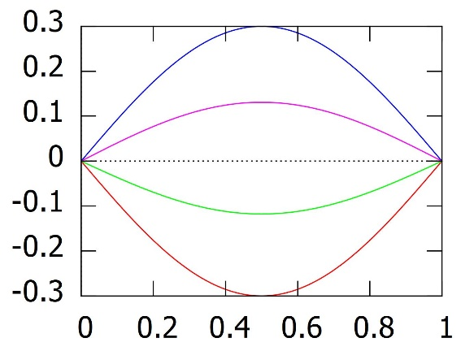

1. *Perturbed solution ($ε>0$)*

For the case $ε>0$, we use a formal expansion. Consider

|  |  |
| --- | --- |
| $$y_{ε}\left(x,t\right)=\sum_{n=0}^{∞}{ε^{n}y_{n}(x,t)}$$ | (14) |

as the solution of equation (9). Substitute equation (14) into equation (9) to get

$${\ddot{y}}_{0}\left(x,t\right)+y_{0}^{'v}\left(x,t\right)+ε\left({\ddot{y}}_{1}\left(x,t\right)+y_{1}^{'v}\left(x,t\right)\right)+ε^{2}\left({\ddot{y}}_{2}\left(x,t\right)+y_{2}^{'v}\left(x,t\right)\right)+…=ε\sin\left(πx\right),$$

where the boundary conditions are

$$y_{ε}\left(0,t\right)=0,$$

$$\sqrt{EIρA} y_{ε}^{''}\left(0,t\right)=k{\dot{y}}_{ε}\left(0,t\right),$$

$$y_{ε}\left(1,t\right)=0,$$

$$y_{ε}^{''}\left(1,t\right)=0.$$

And the initial conditions are

$$y_{ε}\left(x,0\right)=α\sin\left(πx\right)$$

$${\dot{y}}_{ε}\left(x,0\right)=0.$$

1. For $n=0$, we will have the same case as *3.1.* thus, we have the solution for $n=0$ is
$$y_{0}\left(x,t\right)=α\cos\left(π^{2}t\right)\sin\left(πx\right).$$

2. For $n=1$, we will have

|  |  |
| --- | --- |
| $${\ddot{y}}_{1}\left(x,t\right)+y_{1}^{'v}\left(x,t\right)=\sin\left(πx\right),$$ | (15) |

where the boundary conditions are $y_{1}\left(0,t\right)=y_{1}^{''}\left(0,t\right)=y_{1}\left(1,t\right)=y_{1}^{''}\left(1,t\right)=0$ and the initial conditions are $y_{1}\left(x,0\right)=0$ and ${\dot{y}}_{1}\left(x,0\right)=0.$

Define $v\left(x,t\right)=y_{1}\left(x,t\right)-\frac{1}{π^{4}}\sin\left(πx\right)$ and substitute into equation (15) to get

|  |  |
| --- | --- |
| $$\ddot{v}\left(x,t\right)+v^{'v}\left(x,t\right)=0,$$ | (16) |

where the boundary conditions are $v\left(0,t\right)=v''\left(0,t\right)=v\left(1,t\right)=v''\left(1,t\right)=0$ and the initial conditions are $v\left(x,0\right)=-\frac{1}{π^{4}}\sin\left(πx\right)$ and $\dot{v}\left(x,0\right)=0.$

Assume that equation (16) has separate solution $v\left(x,t\right)=P_{1}\left(x\right)Q_{1}\left(t\right)$ and use the analogue way like in section *3.1* we will get that the solution is $v\left(x,t\right)=-\frac{1}{π^{4}}\cos\left(π^{2}t\right)\sin\left(πx\right)$. Hence,

$$y_{1}\left(x,t\right)=-\frac{1}{π^{4}}\cos\left(π^{2}t\right)\sin\left(πx\right)+\frac{1}{π^{4}}\sin\left(πx\right).$$

1. For $n>1$, we will have

$${\ddot{y}}_{n}\left(x,t\right)+y_{n}^{'v}\left(x,t\right)=0,$$

where the boundary conditions are $y_{n}\left(0,t\right)=y_{n}^{''}\left(0,t\right)=y_{n}\left(1,t\right)=y_{n}^{''}\left(1,t\right)=0$ and the initial conditions are $y_{n}\left(x,0\right)=0$ and ${\dot{y}}_{n}\left(x,0\right)=0.$ Using the analogue way as in section *3.1* and *3.2.2* we will have that $y_{n}=0$ for all $n>1$.

According to section *3.2.1.* to *3.2.3.* above, we have general solution of perturbed solution is

$$y_{ε}\left(x,t\right)=α\cos\left(π^{2}t\right)\sin\left(πx\right)+ε\left(-\frac{1}{π^{4}}\cos\left(π^{2}t\right)\sin\left(πx\right)+\frac{1}{π^{4}}\sin\left(πx\right)\right).$$

The difference of the perturbed and unperturbed solution is

|  |  |
| --- | --- |
|  | (17) |

The form

$$\left|\left(1-\frac{1}{π^{4}}\cos\left(π^{2}t\right)\right)\sin\left(πx\right)\right|$$

in equation (17) is bounded by $(1+\frac{1}{π^{4}})$, so we can write that the difference of both solutions is of the form

$\left|y_{ε}\left(x,t\right)-y_{o}\left(x,t\right)\right|=O(ε)$.

Figure 3. shows the simulation of the perturbed solution over some values of $t$. On this figure, we take the value of parameter $α=0,3$.

$εf(x)$: $y_{ε}\left(x,0\right)$: $y_{ε}\left(x,\frac{1}{2}\right)$: $y_{ε}\left(x,\frac{1}{5}\right)$: $y_{ε}\left(x,\frac{1}{π}\right)$:

**Figure 3.** The graph of $εf\left(x\right)$ and $y_{ε}\left(x,t\right)$ for $α=0,3$ and some value of $t$.

The left graph is for $ε=0.05$ and the right graph is for .

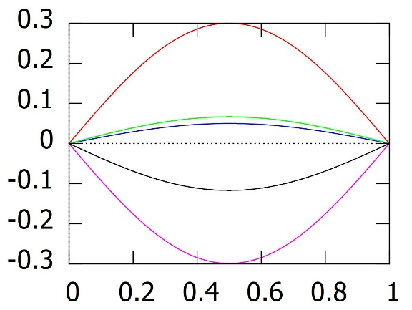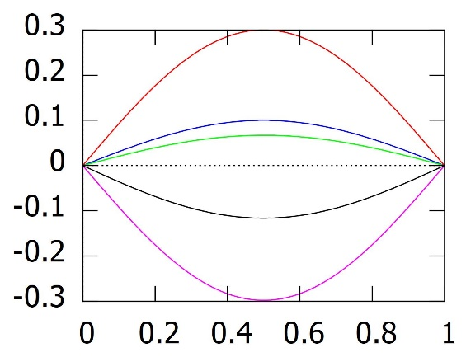

1. Conclusion

By giving the initial condition as a simple trigonometric function, $y(x,0)=\sin\left(πx\right)$ and $y^{'}\left(x,0\right)=0$, makes the solution of unperturbed model comes in a simple form of sinus-cosines function,

$$y_{0}\left(x,t\right)=\cos\left(π^{2}t\right)\sin\left(πx\right).$$

If we consider the small external force to the system, *i.e.*

$\overline{f}\left(X\right)=ε\sin\left(π\frac{X}{l}\right)$

where $ε$ is a small positive real number then the differ between the perturbed and unperturbed solution is order $ε$ that is $\left|y_{ε}\left(x,t\right)-y_{o}\left(x,t\right)\right|=O(ε)$.

References

1. Bayat M, Bayat M’ and Pakar I 2014 *Latin American Journal of Solids and Structures* **11** pp 534–44
2. Huang D, Li S, Chen C and Dai L 2011 *Proceedings of the ASME International Mechanical Engineering Congress & Exposition IMECE*2011-62898
3. Krisnawan K P 2019 *Journal of Physics: Conference Series* **1320** 012002
4. Li L, Zhang Q, Wang W and Han J 2017 *International Journal of Non-Linear Mechanics* **90** pp 21–31
5. Pelesko J A and Bernstein D H 2003 *Modeling MEMS and NEMS* (Florida: Chapman & Hall/CRC)
6. Pugno N 2004 *Glass Physsics and Chemistry Special Issue: Nanoparticles, Nanostructures and Nanocomposites* **31** pp 535–44
7. Pugno N 2005 *Journal Nanoengineering and Nanosystems* **219** Issue 1 pp 29–40
8. Rezaee M and Sharafkhani N 2019 *International Journal of Applied Mechanics* **11**(6) 1950061
9. Sadeghzadeh S and Kabiri A 2016 *Latin American Journal of Solids and Structures* **13** pp 478–97
10. Senturia S D 2001 *Microsystem Design* (Dordrecht: Kluwer Academic Publisher)
11. Younis M I, Abdel-Rahman M and Nayfeh A 2003 *Journal of Electromechanical Systems* **12**(5) pp 672–80