ANALYSIS OF MATHEMATIC REASONING ABILITY OF JUNIOR HIGH SCHOOL STUDENTS MATERIALS OF NUMBER PATTERNS
Fitri^{1,a)} dan Kana Hidayati^{2,b)}

¹Graduate Program of Yogyakarta State University, Jl. Colombo No. 1, Karangmalang, Sleman, DI Yogyakarta, Indonesia
²Mathematics Department, Faculty of Mathematics and Science, Yogyakarta State University, Indonesia

^{a)}Corresponding author: fitri.2020@student.uny.ac.id
^{b}kana@uny.ac.id

Abstract. Learning mathematics in schools to improve thinking patterns, reasoning in making generalizations, improve problem -solving abilities. This study, using qualitative (descriptive) research by applying a simple random sampling technique to determine the subject, aims to determine the students' difficulties in answering the description questions related to the mathematical reasoning ability of Tarakan City Junior High School students on number pattern material. Based on the results of the analysis, the average value of the percentage of reasoning ability in the first indicator is 89%, the second indicator is 73%, and the third and fourth indicators are 56% and 47%, respectively. Therefore, it can be concluded that the mathematical reasoning ability of Tarakan City Junior High School students is only 24% including the low category, so teachers need to improve students' reasoning abilities.
Keywords: Difficulty, mathematics learning; mathematical reasoning.

INTRODUCTION
Mathematics is one of the fields of science that is very important and many people use reasoning, at first, mathematics prioritized regularity of patterns, made generalizations, and made assumptions, so mathematics was made a compulsory subject in school [1]. Mathematics subjects need to be given to all students aiming to improve critical, logical, analytical, systematic thinking, and work skills [2]. In addition, the purpose of learning mathematics in schools is to improve thinking patterns, reasoning in making generalizations, improve problem- solving skills, and improve the ability to convey information through writing, ideas, ideas, maps, and graphs In recent years, mathematical reasoning has become part of the mathematics curriculum in various countries, the results of the PISA survey highlight mathematical competencies in the teaching and learning process of mathematics in the classroom such as mathematical modeling, problem-solving, and reasoning [3]. In contrast to the quality of education in Indonesia which is still quite low, this can be seen in the results of a survey conducted by the Program for International Student Assessment (PISA), showing that literacy skills in Indonesia are still low and in the lowest position [4]. The insistence of students' mathematical abilities is not only to have mastery of arithmetic, but the ability to reason logically, systematically, and critically in solving mathematical problems. One is to improve mathematical literacy skills through mathematical reasoning and thinking. In addition, the reasoning is also part of the five NCTM process standards, namely standard questions. There are five ability processes needed by students, namely reasoning and proof, problem-solving, representation, communication, and connection. In line with the opinion of [5] revealed that students' mathematical thinking skills should be encouraged to have several skills such as 1) mathematical connection, 2) mathematical reasoning and proof, 3) mathematical communication, 4) mathematical problem solving, and 5) mathematical representation. These skills are very important higher-order thinking processes for students to develop. The ability to think reasoning is important in mathematics because reasoning is able to solve problems in everyday life and requires reasoning and reasoning can train students' thinking skills [6]-[9]. Reasoning is also important to train students in using reasoning and will tend to find patterns, conjectures, and pattern regularities, and involve students in mathematical arguments in the form of proof [10], [11]. Therefore, it is important for teachers to have an instrument to measure students' reasoning.
Based on the evidence from the survey results by TIMSS and PISA shows that Indonesia in learning mathematics is still far from what is desired, especially in reasoning abilities. In 2011, the results of the TIMSS survey showed that the achievement of Indonesian students in the low category (400) was still very far from the expected category (600). There are three domains tested for the cognitive dimension in the implementation of TIMSS, Indonesian students only achieved an average score of 378 in the knowledge domain, 384 in the application domain, and 388 in the reasoning domain. Meanwhile, when viewed from the dimensions of the mathematical content tested, Indonesian students only achieved an average score of 375, Geometry 377, Algebra 392, and only 376 data and opportunities. That the mathematical reasoning ability of students in TIMSS in 2015, the average student answer results were only 20% compared to 44% internationally [1], [13].
Mathematical reasoning is the process of making guesses, proving something, and compiling mathematical ideas [14]. In addition, mathematical reasoning is an important point in the process of making generalizations, and mathematical reasoning is always associated with logical, systematic, and critical mathematical proofs in solving mathematical problems, so reasoning it is very important to analyze and produce an argument in oral or written form in justifying mathematical statements [3], [15]. Has four standard mathematical reasoning processes, namely: (1) finding patterns/natures of mathematical phenomena to make generalizations, (2) drawing conclusions, compiling evidence, providing reasons/evidence for the correct solution, (3) estimating answers and the solution process, and (4) using patterns and relationships to analyze mathematical situations. Mathematical reasoning is the ability of students to generalize or synthesize, analyze, or give appropriate reasons in solving non-routine problems, besides that there are several indicators of reasoning, including; 1) students' ability to present mathematics in writing, orally, graphs, pictures, and so on, 2) the ability of students to propose assumptions, 3) the ability to perform mathematical manipulations, 4) the ability to compose, provide evidence or reasons in providing solutions, 5) the ability of students to draw conclusions, 6) perform an argument, and 7) find patterns or mathematical properties to make a generalization [16].
This is based on the results of research [17] revealing that in solving mathematical problems students have difficulty identifying the relationship between known and unknown variables. Usually, the difficulties faced by students in solving number patterns are related to the difficulty of understanding vocabulary, translating problems into formulas to be presented in mathematical models, and the difficulty of students in concluding an explanation of mathematical problems. Therefore, researchers need to conduct research to determine the ability of mathematical reasoning.

METHOD
This research uses qualitative (descriptive) research by applying a simple random sampling technique to determine the subject. This study aims to determine the mathematical reasoning ability of Tarakan City Junior High School students on number pattern material which refers to the following indicators: (1) finding patterns/natures of mathematical phenomena to make generalizations, (2) drawing conclusions, compiling evidence, providing reasons/evidence against truth solutions, (3) predict answers and solution processes, and (4) use patterns and relationships to analyze mathematical situations. Qualitative research is research that is used to describe, explain, or describe the data that has been collected to make a conclusion [18]. This research instrument uses a student's reasoning ability test in the form of an essay question consisting of four questions and an interview guide. Interviews were conducted in a semi-structured manner aimed at clarifying, exploring problems, and clarifying students' thinking processes. Interviews are a series of flexible questions for researchers and subjects who ask more detailed questions than before so that they are more effectively used to obtain more open problems when the subject is interviewed by expressing opinions or ideas [15].
This study contains four indicators of mathematical reasoning ability, then to determine the score according to the guidelines [19]. The steps of this research, it was carried out by distributing essay test instruments to subjects who had been randomly selected. Then a calculation is made with the results of students' answers to see the level of students' mathematical reasoning abilities and apply a purposive sampling technique which will select several students who have difficulty or do not meet the indicators of mathematical reasoning ability in solving a problem. Interview guidelines were conducted to find out students' opinions regarding the problems in solving the problems given. The guidelines for scoring indicators for mathematical reasoning and table 1. The categories of mathematical reasoning abilities are as follows.
Percentage Value = $\frac{Skor Perolehan }{Skor Maksimal}$x 100 %
Table 1. Categories of Mathematical Reasoning
Category | Value Interval (%)
Sangat Tinggi |  | 81,25 < X <100
Tinggi |  | 71,50< X < 81,25
Sedang |  | 62,50 < X < 71,50
Rendah |  | 43,75 < X < 62,50
Sangat Rendah |  | 0 < X < 43,75

RESULTS AND DISCUSSION
This research was initiated by giving a mathematical reasoning ability test which was carried out on June 10, 2022 to June 21, 2022. Furthermore, a semi-structured interview stage was carried out to discuss the results of the test work which had been followed by 18 students of class VIII Tarakan City. The results and discussions that have been carried out by researchers are as follows.
In this study, there were four essay questions given based on indicators of students' mathematical reasoning abilities on number pattern material. Then an analysis of the results of student work can be obtained as much as 24% have high reasoning abilities. In addition, 30.375% have moderate mathematical reasoning abilities and 45.625% have low reasoning abilities. Based on Table 2. it can be concluded as follows.
Table 2. Level of Students' Mathematical Reasoning Ability
Value Interval (%) | Many Student | Percentage | Category
71,50 – 81,25 | 4 | 24% | Tall
43,75- 62,50 | 6 | 30,375% | Currently
71,50 – 81,25 | 8 | 45,625% | Low
Amount | 18 | 100%

Then based on the results of the student test results based on the average percentage on the reasoning indicator, it was obtained as follows: (1) as many as 89% found patterns/natures of mathematical phenomena to make generalizations, (2) drew conclusions, compiled evidence, provided reasons/evidence for solutions. 73% of the truth, (3) estimate the answer and solution process as much as 56%, and (4) use patterns and relationships to analyze mathematical situations as much as 47%.
Based on the first indicator, namely, students can find patterns or properties of mathematical symptoms to make generalizations, there are 12 out of 18 students who can find patterns or properties of the questions given correctly. In addition, as many as 6 out of 18 students were able to conclude, and compile evidence correctly and precisely. In addition, 4 out of 18 students have not been able to predict the answers and existing processes. The remaining 2 out of 18 students are only able to use patterns and relationships to analyze mathematical situations appropriately. For more details, the researcher tried to describe one of the answers including 10 of the 18 students.
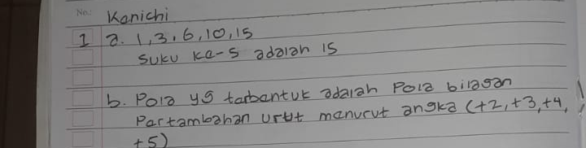

Figure 1. Student Answer 1

Based on Figure 1 shows that the results of student 1's answers have not been able to solve the questions asked. Student 1 seems unable to solve the problem well, besides that students have not been able to find the mathematical properties or patterns asked according to the first indicator. Therefore, encouraging researchers to conduct interviews with 12 students who were selected based on purposive sampling. The following are the results of interviews conducted on student 1,
Researcher: Did you understand before writing the answer what questions were asked of the question?
Student 1: Yes ma'am
Researcher: Then, what do you, do you understand this question?
Student 1: My understanding, from the problem, I was asked to look for the 5th pattern from the existing picture, then if part b was asked to look for what pattern would be formed
Researcher: Why do you write your answer like this, if you are asked the 5th pattern and what pattern will be formed from the picture?
Student 1: Yes ma'am, I seem to have answered wrongly, because I am also still confused about how many 5th patterns it is and I wrote it like this.
Researcher: Where do you have difficulty?
Student 1: The difficulty is in part b, ma'am, I did it like that, and then I didn't know what pattern was formed, so I did it like that using additions.
Based on interviews that have been conducted with 12 of 18 students, it shows that most students can find patterns or characteristics of mathematical phenomena. Although some students answered less correctly and precisely in finding the mathematical patterns or properties that were asked.

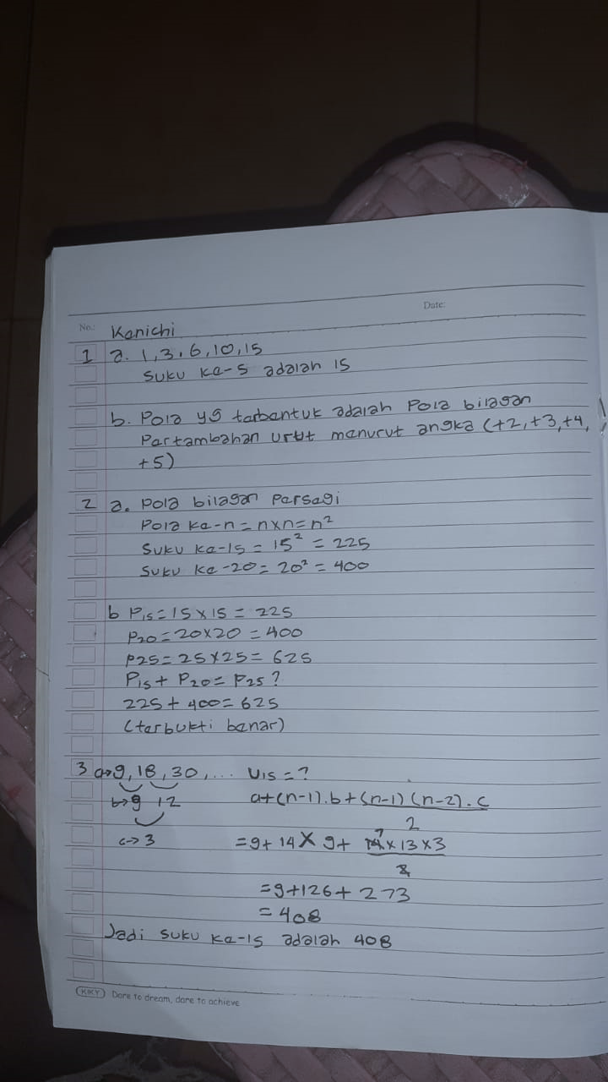

Figure 2. Student Answers 2

Furthermore, based on Figure 2 on the second reasoning ability indicator, students can draw conclusions, compile evidence, and provide reasons/evidence for true ruth solutions, but seen in Figure 2 shows that most 6 of 18 students can complete properly and correctly. Students start trying to solve using a square pattern (n2) in finding the value of the 15th and 20th patterns, then proving and investigating patterns 15 and 20 will result in the 25th pattern. The rest of the students are less than perfect in providing or compiling evidence of the correct solution to the question asked. . Based on the results of interviews conducted with one of the students who was able to give the right answer.
Researcher: From this question, what initial steps did you take in solving the problem?
Student 2: For question no. 2, ma'am, I use the formula for the square pattern n x n to determine the result of the pattern in question, then I calculate the value of the 15th pattern and the 20th pattern, well, I just need to enter the value later.
Researcher: In your opinion, are the steps you have taken correctly?
Student 2: I think it's correct, ma’am; because from the square pattern we can calculate the 15th pattern and the 20th pattern, while in part b we prove whether it is the same as the a.
Researcher: Next to prove part 2b, what steps did you use?
Student 2: ohh, for part 2b, I proved it with a square pattern, ma'am, so that a is looking for the 15th and 20th patterns, so we will get the results later, so it will be proven, ma'am, because p25 is the result 25 x 25 = 625 ma'am
Researcher: In the process of working, did you encounter any difficulties?
Student 2: No, ma'am, because I still remember the formula for the square pattern.

Furthermore, the third indicator of mathematical reasoning ability is estimating the answer and the solution process correctly and precisely. It can be seen that most of the students have difficulty solving the problem. Most showed that students did not understand the existing picture patterns and could not find the right answer solution. Only 4 out of 18 students were able to solve the problem correctly. In addition, the rest of the students have not been able to provide solutions or answers correctly and precisely. Therefore the researcher tried to describe one of the students' answers.
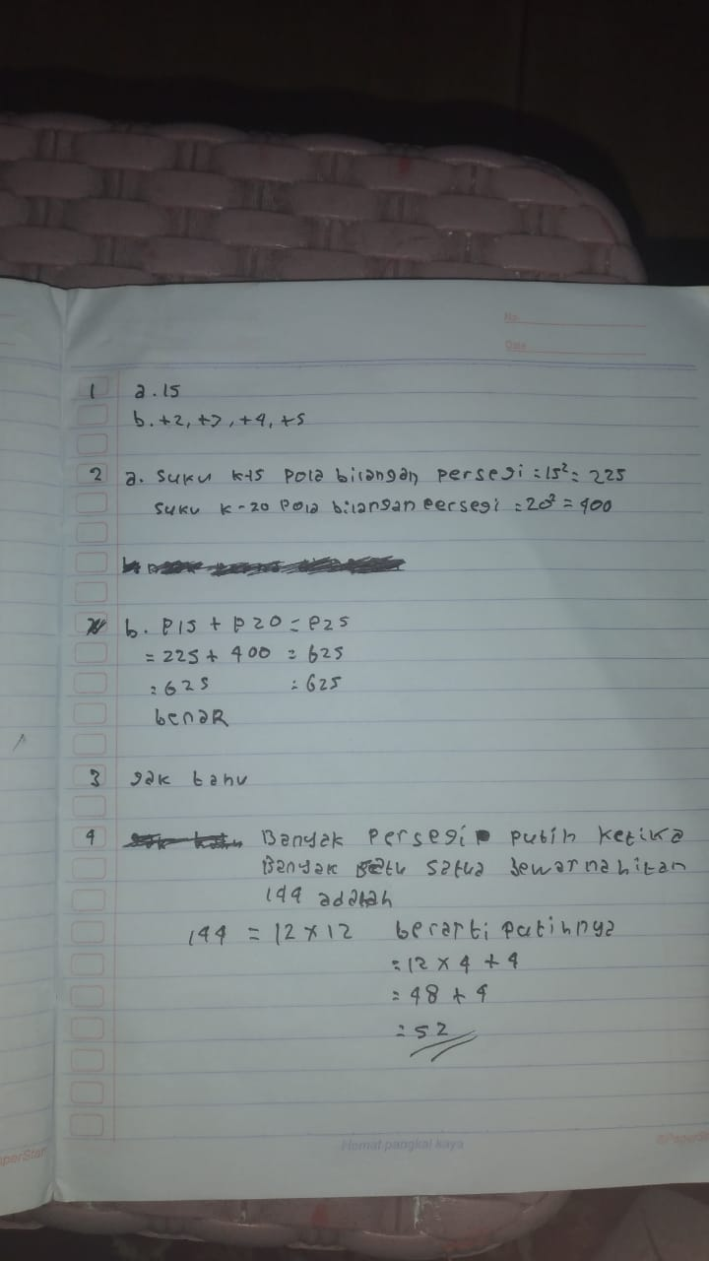
Figure 3. Student Answers 3
Based on the results of student answers 3 shows that students still have difficulty in solving the problems presented. Students seem unable to find or predict the answer correctly. It can be seen that most of the students have difficulty. Based on interviews conducted by researchers one of the results of student answers is as follows.
Researcher: Did you understand and read the question before working on it?
Student 3: Yes, ma'am, who tried to read it first before answering?
Researcher: Next, what can you understand from this question?
Student 3: Hey, as far as I know, after reading the problem, ma'am, I was asked to find the number of matches in the 15th pattern in the triangle shape of the picture you know, so ma'am.
Researcher: To solve the problem, what steps can you take to solve the problem?
Student 3: I don't know how to do it, ma'am, I'm still confused
Researcher: Which part confuses you?
Student 3: Everyone, ma'am, I understand the question that I was asked to look for but I'm confused about how to find the answer. I forgot the triangle formula so it's hard for me to do it. Moreover, they were asked to look for the 15th pattern.
Based on the results of interviews conducted by researchers, it was found that most students could understand the questions from the questions presented. Although students can understand the questions asked, students still feel confused in finding the number the of 15th pattern in the matching triangle, especially the triangle pattern formula. So that most students write answers that are not correct and appropriate or do not have strategies in answering the questions presented. Only 6 out of 18 students were able to solve the problem correctly. So it can be concluded that the third reasoning indicator shows that most of the Tarakan City Junior High School students have not been able to solve the problems presented by providing the right solution.
Finally, the fourth indicator is that students are able to use patterns and relationships to analyze mathematical situations. Based on the mathematical reasoning ability test that has been done, it is found that most of the fourth indicator is still a lot of students have difficulty in solving the problems presented. Likewise, with the third indicator, there are still many students who have not been able to provide appropriate answer solutions by connecting and using patterns to perform analysis based on mathematical situations. Only 2 out of 18 students were able to solve the problems presented correctly and appropriately. The rest are still many students who find it difficult to solve the problem. Therefore, the researcher tried to describe one of the students' answers.
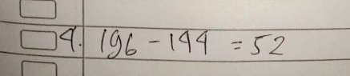

Figure 4. Student Answers 4
Based on Figure 4. This shows that students have not been able to solve the problems presented correctly. It can be seen from the answers given that students do not understand what is being asked and still have difficulty solving it. In addition, the answers presented are still wrong, it seems that students are unable to connect or use patterns to analyze existing mathematical situations so students immediately write down the answers they think of without writing down the problem-solving strategies correctly. Based on the results of interviews with one of the students inaccurate answers are as follows.
Researcher: Did you understand and read the question before working on it?
Student 3: Yes, ma'am, I read the question first.
Researcher: Then, what do you understand from this question?
Student 3: Oh, if the 4th question is ma'am, my understanding is that you are asked to find many one-unit squares that are white and black, ma'am.
Researcher: Then, what is the strategy for solving it?
Student 3: I don't know how to solve it, ma'am, I wrote the answer randomly because I was confused and didn't know the answer.
Researcher: Where are the difficulties in doing it?
Student 3: All ma'am, I'm confused about the answer when I was asked to count the white and black color units and I don't know what the formula is
Researcher: Then for the answer, you wrote, where did it come from?
Student 3: oh, that's what I answered, ma'am, I just added and multiplied, ma'am.

Based on the results of the interviews obtained, shows that the fourth indicator is still many students have difficulty in completing it. It is seen that some students write arbitrary answers and they do not have the right strategy to answer them. In addition, it appears that students have not been able to relate to reasoning abilities according to the fourth indicator. Although students are able to understand the questions presented, most students do not know the formula used in answering the fourth question so they have difficulty. Only 2 out of 18 students can complete it properly and correctly. Therefore, based on the analysis results obtained regarding the mathematical reasoning ability of Tarakan City Junior High School students on the number pattern material, it is still low, with a presentation of 24%. This shows that the category of mathematical reasoning is still low in line with the opinion (Sulistiawati et al., 2015; Yusdiana & Hidayat, 2018).

CONCLUSION
Based on the analysis results obtained, it can be concluded that the reasoning ability of Tarakan City Junior High School students on number pattern material is in a low category. It can be seen that when working, most of the students have difficulty doing it. In the first indicator, it appears that most students complete it well, and are acan patterns or properties of existing mathematical symptoms, although not give answers correctly and correctly. The second indicator of mathematical reasoning ability shows that students are can solve them well, students are seen to be able to compile evidence, draw conclusions, or give reasons for truth based on what is presented. Although for the most part, other students solved the problem less correctly. While the third and fourth indicators show that the average student has not been able to complete the questions asked. As Seen in the third indicator students have not been able to find or predict the right answer. Students only write down what they think without any solution strategy. In addition, many students still find it difficult to solve the problems presented. Then, the fourth indicator shows that many students find it difficult to solve the problem. It can be seen that students' errors in writing answers without connecting or linking pattern relationships to analyze mathematical situations. So it can be concluded that the reasoning ability of junior high school students is still low in the city of Tarakan teachers need to provide question instruments to improve students' reasoning abilities.

REFERENCES
1. L. Fajriyah and L. S. Zanthy , J. Educ. 1 (3), 211–216 (2019).
2. U. Lu’luilmaknun and D. U. Wutsqa, AKSIOMA J. Progr. Stud. Pendidik. Mat. 7 (3), 413–424 (2018).
3. A. Hjelte, M. Schindler, and P. Nilsson, Educ. Sci. 10 (10), 1–15 (2020).
4. S. Maoto, K. Masha, and L. Mokwana, Pythagoras J. Pendidik. Mat. 39 (1), 1–10 (2018).
5. L. C. Wilkinson, A. L. Bailey, and C. A. Maher, ECNU Rev. Educ. 1 (3), 1–22 (2018).
6. Ş. Danişman and E. Erginer, Cogent Educ. 4 (1), 36-47 (2017).
7. H. Hendriana, R. C. I. Prahmana, and W. Hidayat, Infin. J. 7 (2), 244-253 (2018).
8. N. A. Nur Sholihat, W. Hidayat, and E. E. Rohaeti, JPMI (Jurnal Pembelajaran Mat. Inov. 1 (3), 132-148 (2018).
9. J. Mumu and B. Tanujaya, Int. J. High. Educ. 8 (6), 85–91 (2019).
10. K. N. W. A. R. Barra Purnama Praja, Gammath J. Ilm. Progr. Stud. Pendidik. Mat. 5 (1), 1–8 (2020).
11. Annajmi, Edumatica. 8 (4), 1–8 (2018).
12. D. K. Putri, J. Sulianto, and M. Azizah, TSCJ (Thinking Ski. Creat. Journal). 2 (2), 93–102 (2019).
13. F. Bozkuş and Ü. Ayvaz, Eur. J. Educ. Stud. 4 (9), 16–34 (2018).
14. M. Lestari, Subanji, and S. Irawati, Aksioma J. Mat. dan Pendidik. Mat. 114 (1), 550–562 (2020).
15. S. Purwanti, M. Syofiana, and Risnanosanti, J. Pendidik. Mat. Raflesia. 5 (2), 145–152 (2020).
16. E. D. Spangenberg and A. K. Pithmajor, Eurasia J. Math. Sci. Technol. Educ. 16 (7), 717-731 (2020).
17. Sugiyono, Metode Penelitian Kuantitatif Kualitatif dan R & D. Bandung: Bandung: CV Alfabeta, 2013.
18. K. Karim and N. Normaya, EDU-MAT J. Pendidik. Mat. 3 (1), 148-162 (2015).
19. S. Sulistiawati, D. Suryadi, and S. Fatimah, Kreano, J. Mat. Kreat. 6 (2), 135-147 (2015).
20. B. I. Yusdiana and W. Hidayat, JPMI (Jurnal Pembelajaran Mat. Inov. 1 (3), 409-421 (2018).

