Analyzing the Exchange Rate USD/IDR under the Impact of Covid-19 by using Linear Regression in Indonesia

T W Septiarini1 and M R Taufik2

1 Department of Islamic Economics, Faculty of Economics and Management, University of Darussalam Gontor, Ponorogo, Indonesia

2 Department of Occupational Safety and Health, Faculty of Health Science, University of Darussalam Gontor, Ponorogo, Indonesia

triwijayantiseptiarini@unida.gontor.ac.id

**Abstract**. The aim of this study are to build a statistical model, to analyze the time series trend of COVID-19 and exchange rate time series data, and to find the relation between COVID-19 as an independent and exchange as dependent variable. Linear regression as statistical model has been implemented to seek the relationship between COVID-19 and the exchange rate in Indonesia. The result presented that the exchange rate USD/IDR has significant correlation with COVID-19. Thus, pandemic of COVID-19 had successfully given impact to economics factor in Indonesia.

1. Introduction

COVID-19 is the abbreviation of the coronavirus disease of 2019 [1]. It has been spreading initially in Wuhan, China. It is caused by severe acute respiratory syndrome coronavirus 2 (SARS-CoV2) (1,2). Since March 11 2020, the World Health Organization (WHO) announced COVID-19 as pandemic which reached the confirmation cases 200,000 patients with more than 8000 deaths across over 160 countries [2]. According to Setiati and Azwar [3] in the end of March 2020, Indonesia had been widely impacted by COVID-19 with case fatality rate (CFR) being 8.9%. As of June 14 2020 in Indonesia, there were 37,420 confirmed cases. The number of deaths related to COVID-19 also reached 2,091 in Indonesia.

According to Laing [4], COVID-19 as global pandemic has not only affected infections and deaths, but it has also caused chaos in the global economy on a scale the Great Depression. COVID-19 has the powerful to abolish individual livelihoods, businesses, industries and entire economies. The survey stated that GDP of Indonesia had been loss on 0.2%. There are 1.9 million of Indonesian people who have lost their jobs due to pandemic [5].

Failing of the exchange rate will impact in enhancing in foreign debt. If debt in the form of foreign exchange will certainly be arduous in slow-moving economic conditions convoyed by enhancing the situation namely decreasing liquidity and banking solutions. Setyawan and Lestari [5] stated that Indonesia has been projected to be developed country in 2030 by America. It is considered by the demographic which productive ages will be reached in 2030. Since America has proposed Indonesia as developed country by picking high taxes of Indonesia’s export commodities. But, COVID-19 come in Indonesia and it has been successful destroyed the national economy, the stock market, macroeconomic and microeconomic factor.

According to Kumari and Yadav [6], linear regression had been introduced by Sir Francis Galton in 1894. In economics research, linear regression had been applied in widely. Florax and Rey [7] presented the effect of miss-specified spatial interaction by using linear regression model. Elhami *et al.* [8] analyzed the energy and economics of lentil and chickpea production in Iran by applying ANFIS and linear regression models. Ng *et al.* [9] proposed genetic algorithm and linear regression to forecast housing demand. Wang *et al.* [10] applied multiple linear regression for modelling compositional data. Anghelache *et al.* [11] implemented multiple linear regression in economic analyses.

This paper proceeds as follows. Section II explains about linear regression. Section III discusses data and methodology. We discuss our main findings in Section IV. Finally, Section V sets forth our conclusions.

1. Linear Regression

Linear regression is kind of statistical tool to define the relation between independent and dependent variables. According to [6], the goal of linear regression is for following reasons:

1. Descriptive, to describe the association strength between dependent and independent
2. Adjustment, to adjust the covariate or confounder
3. Predictors, to predict the important risk factor of dependent variables
4. Optimize of prediction, to explore how to optimize the prediction by tuning the independent variable
5. Prediction, to predict for calculating new case

The most purpose of linear regression is finding the relationship between dependent and independent variable. The general formula of linear regression as follow:

$$Y=b_{0}+b_{1}X_{1}+b_{2}X_{2}+…+b_{n}X_{n}+e$$

where,

$Y$ is defined as the dependent variable,

$b_{0}$ is defined the intercept,

$b_{1}, b_{2}, … , b_{n}$ are defined the regression coefficient in each independent variable,

$X_{1},X_{2}, …, X_{n}$ are defined as the independent variables,

$e$ is defined as error.

Procedure to build linear regression [6] as follow:

1. Defining the dependent and independent variables
2. Checking the normality distribution
3. Building model
4. Methodology

## Data management

The Covid-19 data is obtained from https://ourworldindata.org/coronavirus-source-data. While, the data source of exchange rate USD/IDR is www.yahoofinance.com. There are 80 daily dataset during March, 27 2020 until June, 14 2020. Figure 1 and Figure 2 show the time series plot of exchange rate and COVID-19, respectively. The path diagram in this study is represented in Figure 3. The independent variables or determinant is an exchange rate USD/IDR and the dependent variable is a COVID-19 case in Indonesia.

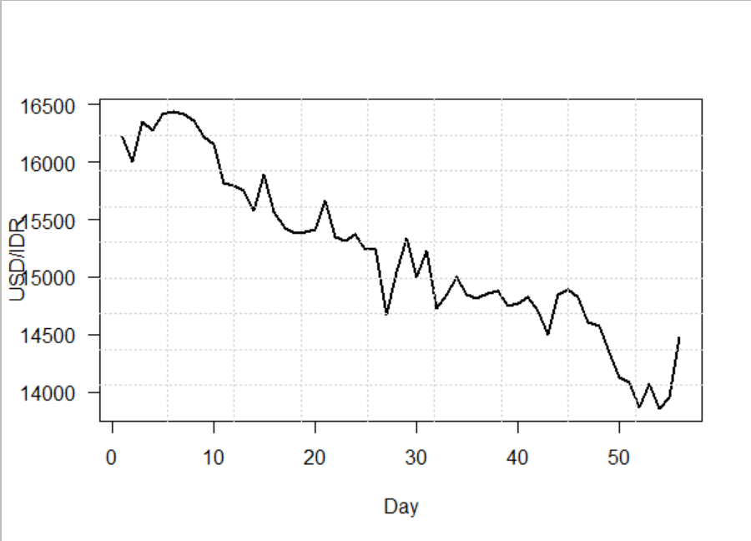

Figure 1. The time series plot of USD/IDR

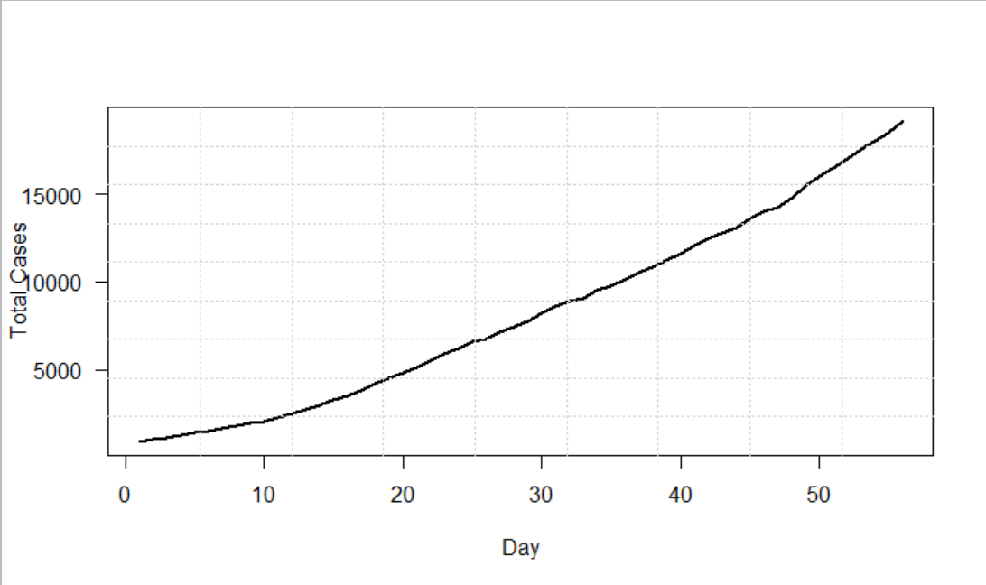

Figure 2. The time series plot of COVID-19 case

Figure 3. The study path diagram

## Statistical features of the data

In this section, it will be discussed several key statistical features of predictor variables

1. The linear relationship check by using scatter plot

Scatter plot is applied to find the linear relationship between COVID-19 data as predictor and the exchange rate USD/IDR as outcome. The scatter plot through the smoothing line shows a linearly decreasing relationship between COVID-19 and exchange rate.

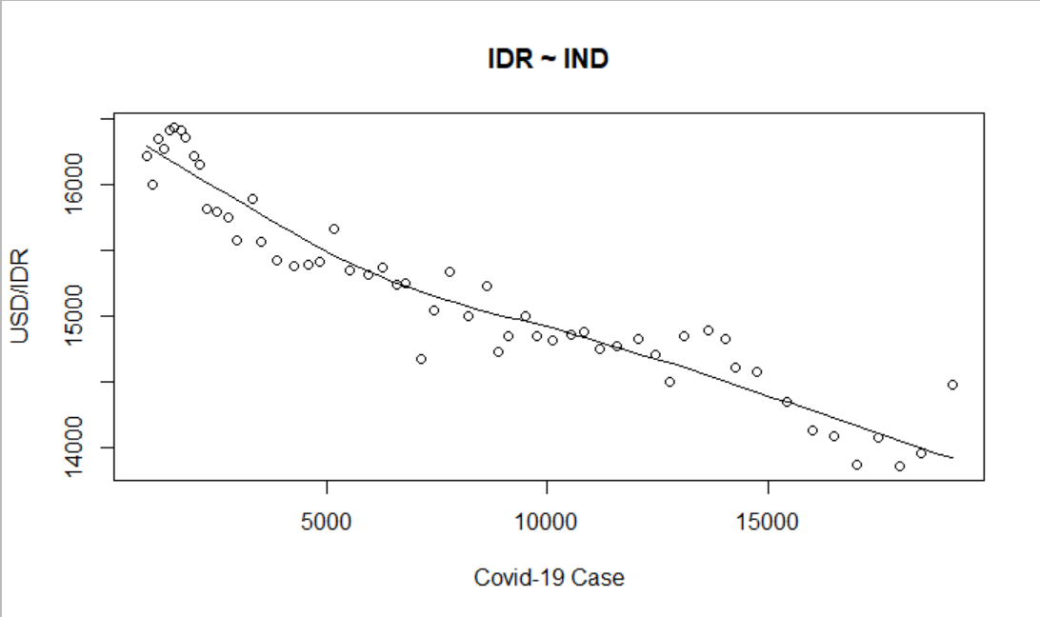

Figure 4. The scatter plot between predictor and outcome

1. The normality check by Shapiro Wilk, boxplot, and density plot

Shapiro Wilk test is most recommended normality test. It has assumption that if p-value>0.05 implying that the distribution of the data are not significantly different from normal distribution. In other words, we can assume the normality. In this study, since p-value is 0.228 thus it means the dependent variable satisfying the normality assumption.

Shapiro-Wilk normality test

data: linearMod$residuals

W = 0.97249, p-value = 0.228

Figure 5 showed boxplot represented the COVID-19 case and the exchange rate distributions. The both data were detected no outlier and seem normally distributed even COVID-19 case likely skewed to the left. Density plot captured the data distribution close to normal as shown in Figure 6. Thus, the normality assumption can be fulfilled. Then it can be continued to build linear regression model.

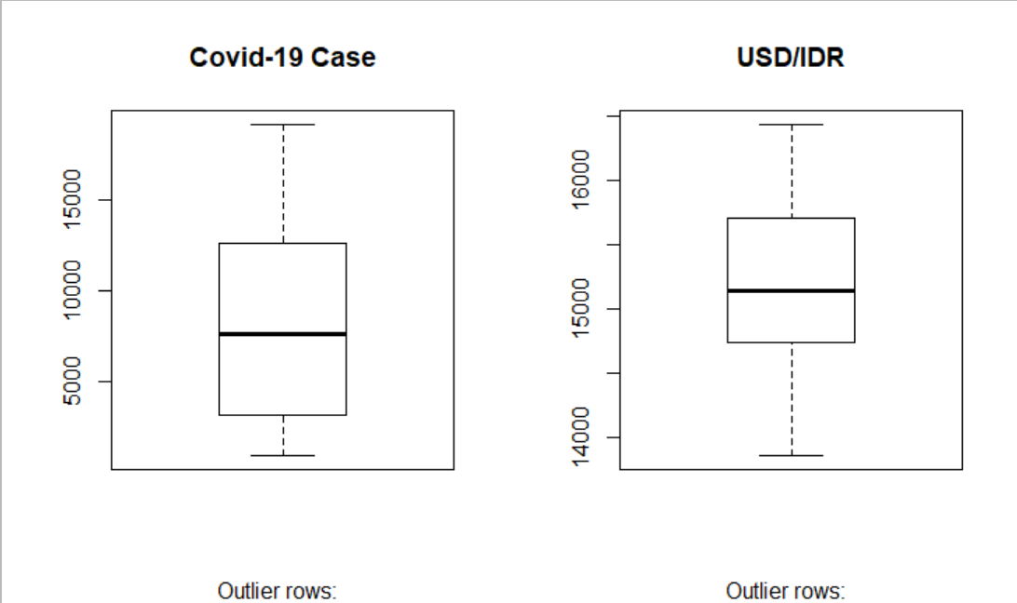

Figure 5. The box plot between predictor and outcome

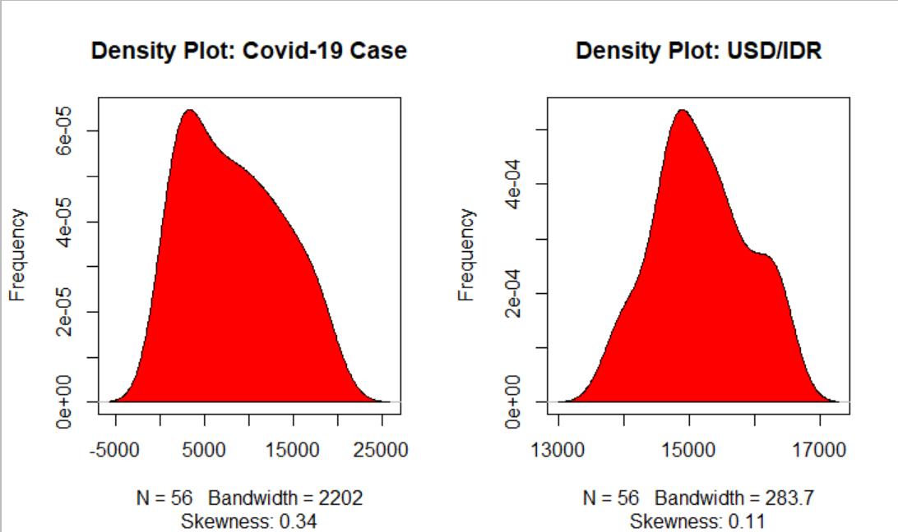

Figure 6. The density plot of predictor and outcome

1. Results and Discussions

Simple linear regression model of COVID-19 was analyzed using exchange rate USD/IDR as predictor.

In this study, we are applying R studio to execute linear regression. Our findings are as follows.

Call:

lm(formula = IDR ~ IND, data = rate)

Coefficients:

(Intercept) IND

16194.7586 -0.1225

Now, we have built the linear regression model. It also will propose the relationship between predictor and outcome in the form of mathematical formula for COVID-19 as function for exchange rate USD/IDR.

$$y=16194.7586-0.1225x$$

where,

$y$ is defined as outcome (COVID-19 case)

$x$ is defined as predictor (USD/IDR)

The model were able to estimate COVID-19 case up to 88% with very small p-value as shown in Figure 7. It means that the statistical model is powerful to predict the relationship between exchange rate USD/IDR and COVID-19. Based on summary as shown in Figure 8, it captured that linear regression well fitted to COVID-19 and exchange rate USD/IDR.

Residuals:

Min 1Q Median 3Q Max

-649.5 -155.0 -55.1 139.0 631.5

Coefficients:

Estimate Std. Error t value Pr(>|t|)

(Intercept) 1.619e+04 5.908e+01 274.13 <2e-16 ***

IND -1.225e-01 5.986e-03 -20.47 <2e-16 ***

---

Signif. codes: 0 ‘***’ 0.001 ‘**’ 0.01 ‘*’ 0.05 ‘.’ 0.1 ‘ ’ 1

Residual standard error: 243 on 54 degrees of freedom

Multiple R-squared: 0.8858, Adjusted R-squared: 0.8837

F-statistic: 419 on 1 and 54 DF, p-value: < 2.2e-16

Figure 7. The linear regression result

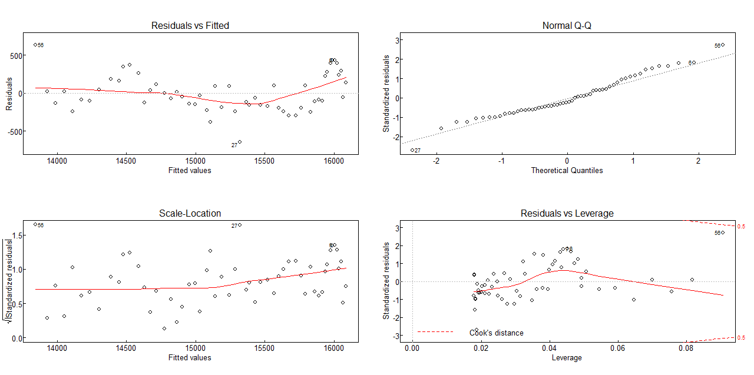

Figure 8. The model residuals plot

1. Conclusion

The purpose of this study are to build a statistical model, to analyse the time series trend of COVID-19 and exchange rate time series data, and to find the relation between COVID-19 as an independent and exchange as dependent variable. Linear regression has been implemented to deal with COVID-19 and exchange rate variables. The result of this study presented that the exchange rate USD/IDR as independent variable is significant to the dependent variables which is COVID-19. It means that exchange rate IDR/USD has significant relationship with COVID-19.

References

1. Driggin E, Madhavan M V, Bikdeli B, Chuich T, Laracy J, Biondi-Zoccai G, Brown T S, Der Nigoghossian C, Zidar D A, Haythe J and Brodie D 2020 Cardiovascular considerations for patients, health care workers, and health systems during the COVID-19 pandemic *Journal of the American College of Cardiology* **75** 2352-71
2. Spinelli A and Pellino G 2020 COVID-19 pandemic : perspectives on an unfolding crisis *The British Journal of Surgery* **107**785–87
3. Setiati S and Azwar M K 2020 COVID-19 and Indonesia *Acta Medica Indonesiana* **52** 84-9
4. Laing T 2020 The economic impact of the Coronavirus 2019 ( Covid-2019 ): Implications for the mining industry *Extr. Ind. Soc*. **7** 580–2
5. Setyawan F E B and Lestari R 2020 Challenges of stay-at-home policy implementation during the coronavirus ( Covid-19 ) pandemic in Indonesia *J. Adm. Kesehat. Indones.* **8** 15–20
6. Kumari K and Yadav S 2018 Linear regression analysis study *J. Pract. Cardiovasc Sci.* **4** 33-6
7. Florax R J G M and Rey S 1995 The impacts of misspecified spatial interaction in linear regression models *New directions in spatial econometrics* 111-35
8. Elhami B, Akram A, Khanali M and Mousavi-Avval S H 2016 Application of ANFIS and linear regression models to analyze the energy and economics of lentil and chickpea production in Iran *Energy Equip. Syst*. **4** 255–70
9. Ng S T, Skitmore M and Fai K 2008 Using genetic algorithms and linear regression analysis for private housing demand forecast *Building and Environment* **43** 1171–84
10. Wang H, Shangguan L, Wu J and Guan R 2013 Neurocomputing multiple linear regression modeling for compositional data *Neurocomputing* **122** 490–500
11. Anghelache C, Anghel M G, Prodan L, Sacala C and Popovici M 2014 Multiple linear regression model used in economic analyses *Romanian Statistical Review Supplement* **62** 120-7