**Prediction of palm oil production in Indonesia using fuzzy nonlinear autoregressive expgenous (NARX) neural network with optimization of genetic algoritm**

**L P Negara1 and D U Wutsqa2**

1Departemen of Mathematics, Faculty of Mathematics and Natural Sciences

2Departemen of Statistic, Faculty of Mathematics and Natural Sciences, Yogyakarta State University, Yogyakarta, Indonesia

[1primalouis70@gmail.com](mailto:1primalouis70@gmail.com)

[2dhoriva@yahoo.com](mailto:2dhoriva@yahoo.com)

**Abstract.** Indonesia is the world's largest producer of Crude Palm Oil (CPO) crude palm oil. Therefore oil palm has a significant impact on economic growth and is a support for foreign exchange earnings in Indonesia. Therefore, palm oil production predictions can be used as a reference so that production results remain stable or even increase. This study uses a Fuzzy Nonlinear Autoregressive Exogenous (NARX) neural network with the optimization of Genetic Algorithms (GA) to optimize the results of the best NARX weights by reducing the error rate (MAPE) by natural selection and selection processes caused by biological evolution. From the test results Fuzzy NARX optimization results optimized with GA to predict palm oil production in Indonesia give a better weight than without GA with MAPE data training values ​​shown from 5.6135% to 3.2884% and MAPE values ​​in the testing data of 5,5488% to 2.1294%. Prediction of oil palm production in 2020, 2021 and 2022 get output in the form of fuzzy set of 0.990, 1.0456, and 1.0240 get prediction results in the form of classical set (crisp) of 42,440,734 tons, 44,824,275 tons and 43,898,295 tons.

Keywords: Oil Palm, Prediction, NARX, Genetic Algorithm

1. **INTRODUCTION**

Indonesia is the largest producer of Crude Palm Oil (CPO) in the world. Conditions in 2018 are supported by as many as 43 million tons of CPO with oil palm plantations covering an area of 14.03 million hectares, and 40% of them are People's Plantation (PR). Therefore oil palm has a significant impact on economic growth and is a support for foreign exchange earnings in Indonesia [1]. Investors can take advantage of opportunities through palm oil by predicting palm oil production. Prediction is a way to predict something that will happen in the future in terms of data or information both in the past and present. With this prediction process you can find out and estimates future palm oil production. This estimate can be used by investors to determine investment-related decisions to be made. Therefore researchers conducted a study entitled "Predictions of Palm Oil Production in Indonesia using Fuzzy Nonlinear Autoregressive Exogenous (NARX) Neural Network with Genetic Algorithm Optimization". This research can be used by investors to determine investment-related decisions to be made. Research conducted by gao & joo, about predictions using Nonlinear Autoregressive Moving Avarage Exogenous (NARMAX) with fuzzy recurrent and feedforward neural network approaches [2]. Research about developing Neural Network models to estimate soil temperature for every day, in the research there are three Neural Network models with training algorithms, namely Backprogation Neural Network, Cascade-Forward and Nonlinear Autoregressive Exogenous Neural Network which are used to estimate soil temperature. The results showed that the NARX model is the best model for the field of prediction [3].

1. **Methodology**

2.1. Production Theory

Production is an activity that is carried out to add value to an object or create new objects so that it is more useful in meeting needs. Production is not only limited to manufacturing but also storage, distribution, transportation, retailing, and repackaging or otherwise [4].

* 1. Palm oil

Palm oil (Elaeis guineensis) is a type of palm that produces oil. The name Elaeis guineensis was given by Jacquin in 1763 based on observations of oil palm trees growing in Martinique, West Indies, Central America. The word Elaeis means oil, while guineensis was chosen based on Jacquin's belief that oil palm originated from Guinea, Africa [5].

* 1. Model Architecture of Exogenous Nonlinear Autoregressive Networks (NARX)

)

)

)

)

**Figure 2.2** Exogenous Nonlinear Autoregresive (NARX) Model

The Nonlinear Auto Regressive Exogenous (NARX) model is one model of a recurrent network with one input and one output. In this research, NARX input is a nonlinear repetitive dynamic neural network model, implemented with a feedback connection and consists of several layers, then it is described as the following chart [6].

The NARX model is based on the linear ARX model, which is usually used in modeling time series. Because NARX can accept dynamic input represented by a set of time series [7].

* 1. Genetic Algoritms

Genetic algorithms are a method for solving optimization problems by mimicking the process of natural selection, the process that causes biological evolution. In the process of evolution only strong individuals will survive the process of natural selection. The basic concept of genetic algorithms is to obtain the best individuals as solutions to problems through the process of selection, crossover, and mutations in genetic algorithms [8].

1. **RESULTS AND DISCUSSION**

3.1Model *Fuzzy* N*onlinear Autoregressive Exogenous* (NARX)

Fuzzy Nonlinear Autoregressive Exogenous (NARX) is a combination of fuzzy systems and Nonlinear Autoregressive Exogenous Neural Network (NARX NN). The Fuzzy Nonlinear Autoregressive Exogenous (NARX) model consists of feature input layers, feedback on hidden layers, and output layers. The NARX NN model uses fuzzy input variables that are based on fuzzy logic, ie the degree of membership of fuzzy representation.

The architectural model used in this study is the Fuzzy Nonlinear Autoregressive Exogenous Neural Network (NARX) network architecture. Where $x_{1}$, $x_{2}$,..., $x_{p}$ in neurons in the fuzzy input layer, $l_{1}$, $l_{2}$,..., $l_{p}$ are neurons in the hidden layer, $y_{t}$ is the context neuron which is the feedback from the output value, while the weight connecting the hidden layer with the output layer is $v_{k}$ where k = 1,2, ...., p , and $y_{t}$ is the predicted NARX output.

Mathematically the NARX model can be written as follows:

$y_{t}$ = $\sum_{\text{k=1}}^{p}{{\text{v}}_{\text{k}}}$ $\frac{\text{1-}\text{exp}{\text{(-(}\sum_{\text{j=1}}^{\text{p}}{\sum_{\text{k=1}}^{\text{p}}{{μ_{j}\text{(}\text{X}}_{\text{j}}){\text{W}}_{\text{jk}}}\text{+ }\sum_{\text{k=1}}^{\text{p}}{{u_{k}\text{W}}_{\text{j}}\text{+ }{\text{b}}_{\text{k}}\text{))}}}}}{\text{1+}\text{exp}{\text{(-(}\sum_{\text{j=1}}^{\text{p}}{\sum_{\text{k=1}}^{\text{p}}{{μ_{j}\text{(}\text{X}}_{\text{j}}){\text{W}}_{\text{jk}}}\text{+ }\sum_{\text{k=1}}^{\text{p}}{u_{k}{\text{W}}_{\text{j}}\text{+ }{\text{b}}_{\text{k}}\text{))}}}}}$ + ${\text{b}}_{\text{0}}$

dengan,

$y_{t }$ = prediction results on NARX models

$u_{k}$ = output value that is returned as input

${μ_{j}\text{(}\text{x}}_{\text{j}})$ = input value on fuzzy NARX NN training data, j = 1,2,3, ...,p

${\text{w}}_{\text{jk}}\left(\text{μ}\left(\text{x}\right)\right)$ = weight of the fuzzy input layer to the hidden layer, k = 1,2,3,...p

${\text{w}}_{\text{j}}$ = the weight of the extra layer to the hidden layer j = 1,2,3...,p

${\text{v}}_{\text{k}}$ = the weight of the hidden layer to the output layer*,* k = 1,2,...p

${\text{b}}_{\text{k}}$ = bias weight of the k neuron in the hidden layer, k = 1,2,...p

${\text{b}}_{\text{0}}$ = bias weight in output layer neurons

3.2 Algoritma Pembelajaran Pada *fuzzy Nonlinear Autoregressive Exogenous* (NARX)

Nonlinear Autoregressive Exogenous (NARX) fuzzy learning algorithm using the Levenberg-Marquardt backprogation algorithm The Levenberg-Marquardt backprogation algorithm is included in the supervised algorithm where the expected output is known beforehand.

The following is the Levenberg-Marquardt backprogation algorithm used in the NARX model:

Step 1: Initialize the weights (take the initial weights with the smallest random number).

*Step 2: Establish Levenberg-Marquardt learning parameters*

*Step 3: Each neuron input feature $\left(x_{j} , j=1,2,..,p \right)$*  receive the signal and forward the signal to all the neurons in the fuzzy input layer. Then each neuron in the fuzzy input $x_{j}$ forward signals to all neurons in the hidden layer.

*Step 4: Every neuron in the hidden layer $\left(l_{k}, k=1,2,…,p\right)$* add up the input signals.

Step 5: Each neuron in the hidden layer forwards the signal to the context neuron in the input layer $u_{k},i=1, 2,…, p$. The received signal is the result of activation of the hidden layer output signal.

Step 6: Every neuron in the hidden layer $\left(l_{k}, k=1,2,…,p\right)$ adding up the weighted input signals received by the input layer and context neurons.

Step 7: each output neuron $(y)$ add up the weighted input signals using the following formula:

${y_in}_{ }=\sum_{k=1}^{p}{\left(s_{k}\right)\left(v_{k}\right)}+b_{0}$

The activation function used in the output layer is tansig.

$$y=\frac{1-e^{-(y_in)}}{1{+e}^{-(y_in)}}$$

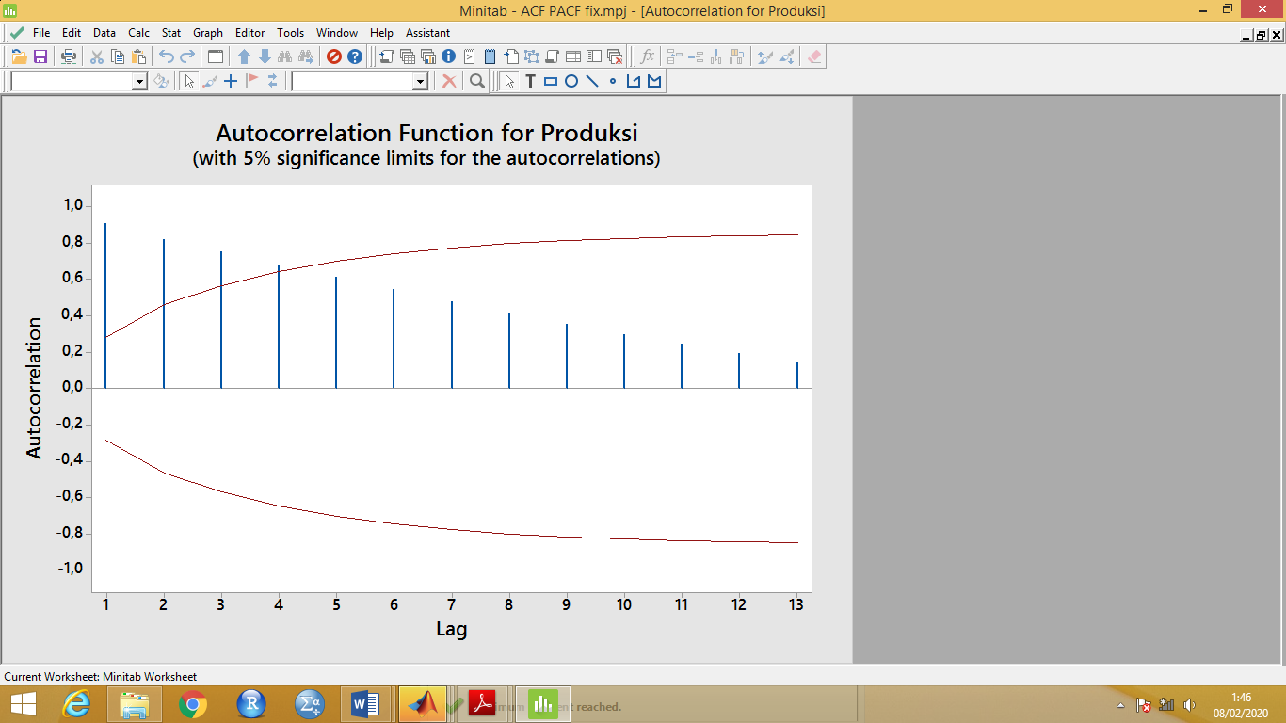3.3 Fuzzy Nonlinear Autoregresive Exogenous (NARX) prediction modeling procedure optimized by Genetic Algorithm

**Figure 3.4** ACF plot of oil palm production in Indonesia

1). ACF input and output variables

Based on Figure 3.4, the ACF plot shows that there are significant lags in oil palm production data in Indonesia in 1970 - 2019, namely lag 1, lag 2, lag 3, and lag 4.

2). Determine ACF input and output variables

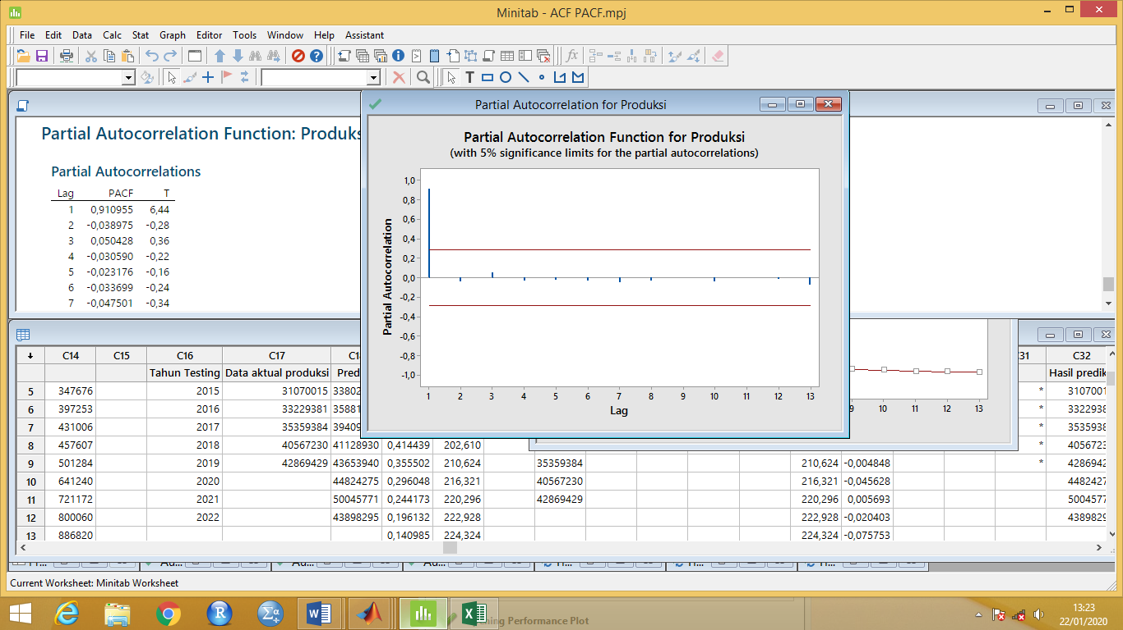

**Figure 3.5** PACF plot of oil palm production in Indonesia

Figure 3.5 shows that in the palm oil production data, the partial autocorrelation at lag 1 is significantly different from zero because the blue line crosses the confidence interval.

3). Data

In this study the composition of training data and testing data used were 75% (35 observations) for training data and 25% (11 observations) for testing data.

4). Changing data with fuzzy membership is a linear representation

**Figure 3.6**. Graphic fuzzification data for 1970 and 2019

5). Formation of the best fuzzy model Nonlinear Autoregressive Exogenous (NARX) The training function used in this paper is trainlm. Trainlm is a training function (training data) on the formation of models from NARX. In the NARX model there are feedback Delays and Delays, which are those that make the NARX network with a history of 2 previous data.

**Tabel 3.2** MAPE value data training and data testing

|  |  |  |  |
| --- | --- | --- | --- |
| 1000 Epoch | MAPE value | | Neuron |
| Training | Testing |
| MAPE | MAPE |
| **5 iterasi** | **5,6135** | **5,5488** | **10** |
| 15 iterasi | 11,5363 | 17,1046 | 20 |
| 20 iterasi | 10,2763 | 7,4270 | 10 |

6). *Fuzzy Nonlinear Autoregressive Exogenous* (NARX) is optimized using Genetic Algorithms

**Table 3.13 Results of the best fitness genetic algorithm**

|  |  |  |  |
| --- | --- | --- | --- |
| Trial to- | Population size | Number of Generation | *Fitness value* |
| 1. | 20 | 5 | 0,2722 |
| **2.** | **20** | **5** | **0,2960** |
| 3. | 20 | 10 | 0,559 |
| 4. | 20 | 20 | 0,2668 |

From the results of these experiments, the optimal fitness value is 0.2960.

3.4 Prediction Results of Fuzzy Nonlinear Auto Regressive Exogenous (NARX) Model with Genetic Algorithm optimization

Fuzzy NARX model optimized by genetic algorithm obtained prediction results in 2020, 2021 and 2022 get output in the form of fuzzy set of 0.990, 1.0456, and 1.0240 get prediction results in the form of classical set (crisp) of 42,440,734 tons, 44,824,275 tons and 43,898,295 tons.

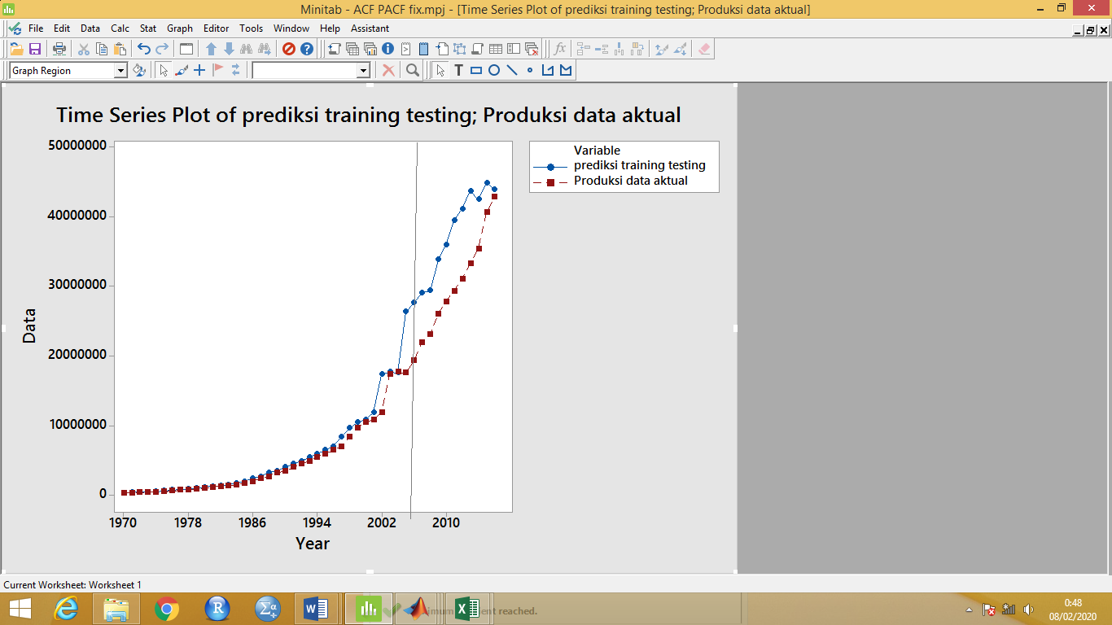 **Figure 3.15** Predicted results of oil palm production in Indonesia

1. **CONCLUSIONS**

The results of optimization of Fuzzy Nonlinear Autoregressive Exogenous (NARX) which is optimized by Genetic Algorithm to predict palm oil production in Indonesia gives a better weight than without Genetic Algorithm by showing the value of MAPE training data from 5.6135% to 3.2884% and the value MAPE in testing data from 5.5488% to 2.1294%. Predictions of oil palm production in 2020, 2021 and 2022 get outputs of 0.99, 1.0456 and 1.0240 to get prediction results of 42,440,734 tons, 44,824,275 tons and 43,898,295 tons.

References

[1] Kementan, “Kementan: Industri kelapa sawit berkontribusi besar terhadap ekonomi,” KOMPAS.com, 2018.

[2] Gao, Y., & Joo E. M. (2005). NARMAX time series model prediction : feedforward and recurrent fuzzy neural network approaches. Shool of Electrical and Electronic Engineering, Nayang Technological University, Singapore. vol 150, issue 2, hal 331-350.

[3] Al-Allaf, O.N.A. & AbdAlkader, Shahlla. (2011). Nonlinear autoregressive neural network for estimation soil temperature : a comparasion of different optimization neural network algoritms. Dept. of Computer Information Systems, Faculty of Sciences and Information Technology Al- Zaytoonah Private University of Jordan. UbiCC Jurnal, hal 43-51.

[4] Miller, R.L. & Meiners E, R. (2000). Teori mikroekonomi intermediate, penerjemah Haris Munandar. PT. Raja Grafindo Persada : Jakarta.

[5] Rohendar, R. (2013). Pendugaan tingkat kematangan buah sawit (elaesi guineensis jacq) berdasarkan pengolahan citra menggunakan metode logika fuzzy. Skripsi Universitas Syiah Kuala.

[6] Haykin, S. (2005). Neural networks a comprehensive foundation. Pearson Education, Cetakan ke-3 di India.

[7] Chen, S. Billings, S.A. & Grant, P.M. (1990) Non-linear system identification using neural networks. Int. J. Control, vol 51, issue 6, hal 1191–1214.

[8] Wati, D. A. (2011). Sistem kendali cerdas. Graha Ilmu : Yogyakarta.