Performance Index of Black Litterman SCAPM in the Indonesian Stock Market

Retno Subekti^{1,2}, Abdurakhman³, and Dedi Rosadi⁴

¹ Mathematics Department, Universitas Gadjah Mada, Indonesia
²Department of Mathematics Education, Universitas Negeri Yogyakarta, retnosubekti@uny.ac.id
³Mathematics Department, Universitas Gadjah Mada, Indonesia, rachmanstat@ugm.ac.id
⁴Mathematics Department, Universitas Gadjah Mada, Indonesia, dedirosadi@gadjahmada.edu

Abstract
The Black Litterman model is one of the strategies for compiling optimal portfolios. This model begins with a CAPM return and is combined with investor predictions. In order to conform to Islamic principles for sharia stock portfolios, the BL-SCAPM model was introduced as an alternative model that adheres more to Islamic principles. This study aims to determine the results of the Islamic portfolio with the BL-SCAPM model, which is seen from two performance indices, namely Sharpe and Treynor. BL-SCAPM is implemented on Sharia stocks in the Indonesian stock market and shows Sharpe's higher performance than BL-CAPM. Meanwhile, it is quite similar between the Treynor index of BL-SCAPM and BL-CAPM. Sharpe and Treynor index, the BL-SCAPM strategy can be used as an alternative to portfolio modeling with several Sharia principles to obtain an optimal allocation of Sharia-compliant stocks.

1. Introduction

The growth of Islamic investment assets in Indonesia has increased significantly in recent years. According to the Otoritas Jasa Keuangan (OJK) report, the contribution of various Sukuk, sharia mutual funds and market capitalization of the Indonesian Sharia Stock Index (ISSI) increased from 2015 to 2019. Likewise, the number of Sharia investors in Indonesia has almost tripled from 2017 to 2019, accounting for 68,599 investors in line with the list of Sharia stocks which increased yearly in Indonesia.

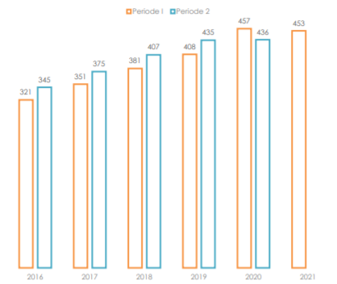
Source: www.ojk.go.id

Until June 2022, it is reported that the number of Islamic investors has increased to 111,500. The system that makes it easier for investors to transact Sharia-compliant stocks is also an important factor in the increasing number of Islamic investors. The development of the Islamic financial industry in Indonesia can also be seen by comparing the performance of Islamic stock indices worldwide. ISSI recorded a positive 6% performance. Several Islamic stock indices in other countries, including S&P/OIC COMCEC 50 shariah index, FTSE Bursa Malaysia EMAS Sharia, MSCI World Islamic Index, FTSE Sharia All World Index and Dow Jones Islamic Market World Index were reported negative (www.idxislamic.idx.co.id).

The development of the Islamic stock exchange in Indonesia triggers the potential of Islamic philanthropy in the stock market, such as zakat, sadaqah and waqf. The existence of zakat and sadaqah shares was introduced in Indonesia in 2017, followed by the emergence of stock waqf in 2019. So, the potential of stocks is not only an investment instrument asset but can become an object of philanthropy.

In line with this development, the obligation of zakat in investment has become a special academic concern captured by some researchers. The amount of zakat value is also a substitution of interest rates in adjusting the Capital Asset Pricing Model to the Islamic principles introduced (Ashker, 1987). Furthermore, Hazny et al. (2012) reviewed mean-variance modeling for portfolio optimization by involving zakat and purification components. CAPM involving Sukuk, zakat and purification instruments also showed a modeling modification process with actual conditions (Hazny et al., 2017; Derbali 2017). There are some new assumptions that are usually made as simplifications in modeling.

Diversification of assets/instruments can be an alternative way to minimize potential losses in the future. Stock diversification means that portfolios can be structured with stocks in different sectors. It is also important in the investment stage is asset allocation. Therefore, the optimization problem for Islamic investment is finding the optimal allocation with the modified model from the Sharia perspective. The downside of the MV model is that the resulting asset allocation is often less well or extremely diversified (Fabozzi et al., 2006). One strategy that can be used is the Black-Litterman model. This MV development model updates target returns through a combination of CAPM and investor predictions (Black and Litterman, 1992). Evaluation of this model showed better performance results measured from the Sharpe ratio index than other models (Bessler et al., 2017). Subekti et al. (2022) developed the BL model by involving zakat and purification as an alternative to obtaining the optimum allocation of the portfolio.

Some portfolio performance measures such as Sharpe ratio (SR) and Treynor (TR) are often used to assess the goodness of the Black Litterman model (Arisena et al., 2018; Widodo et al., 2017). Some other measures for portfolio performance are information ratio (IR) and Sortino ratio can also be used to compare the results of a BL portfolio with a benchmark portfolio. Subekti et al (2022) have developed BL for sharia stock portfolios by measuring Sharpe's performance results. Sharpe index is suitable for assessing a portfolio with a lack diversification (Agussalim et al., 2017). Meanwhile, Treynor has differences in the risk perspective of his portfolio. Because BL uses a CAPM basis that pays attention to the systematic risks of beta, this study measured the performance of the BL SCAPM portfolio by using the Treynor index.

The paper is compiled as follows. In the next section is presented the framework of the BL-SCAPM model. Part 3 presents a description of the data and section 4 discusses the results of the estimates. Finally, part 5 is presented with the results of the study and some suggestions.

2. Sharia-compliant stock portfolio using BL-SCAPM
The BL-SCAPM with the SCAPM selected from inflation substitution for interest rate was introduced as an attempt to deliver the Islamic principles in the portfolio optimization as a modification for the Sharia stock portfolio (Subekti, Abdurakhman and Rosadi, 2022). Following that, the BL-SCAPM model was developed by integrating zakat and purification levels so that it accommodates more sharia principles in addition to avoiding usury (Subekti, Abdurakhman, Rosadi, et al., 2022). Therefore, the BL-SCAPM approach with several sharia principles at once is then applied to form an Islamic stock portfolio with sharia stock data on the Indonesian stock market.

2.1 BL-SCAPM formulation
The BL-SCAPM model is specifically applied to sharia stock portfolios to obtain optimal weighting from the beginning of the BL process. It is similar to the procedure in the BL model, which begins with the determination of the starting point of CAPM, the input of predictions from investors then the estimation of the BL mean and its variance. Furthermore, weighting is obtained from updating the return target such as the MV model. The stages towards BL-SCAPM estimation can be illustrated as follows (Subekti, Abdurakhman, Rosadi, et al., 2022):

Figure 1. Step by step BL-SCAPM for portfolio optimization
2.2 BL-SCAPM optimization model
Mathematically, the BL-SCAPM Sharia stock portfolio optimization model is to determine the optimal allocation by updating the MV model with the new target return being the BL-SCAPM return. The purpose of the optimization is to minimize portfolio risks estimated by the variance of BL-SCAPM returns with an important obstacle to add, namely that the allocation must be positive. The BL-SCAPM model can be written as follows (Subekti, Abdurakhman, Rosadi, et al., 2022):

$Min w^{t}Σ_{BL-SZP}w$ | (2.1)
subject to $w^{t}μ_{BL-SZP}=μ_{p}$ | (2.2)
$$w^{t}1=1$$ | (2.3)
$$w≥0$$ | (2.4)
Where
$μ_{BL-SZP}$ = ${\left[{(τΣ^{*})}^{-1}+P^{t}{Ω_{s}}^{-1}P\right]}^{-1}\left[{(τΣ^{*})}^{-1}π_{s}+P^{t}{Ω_{s}}^{-1}Q^{*}\right]$ | (2.5)
$Σ_{BL-SZP}$ = $Σ^{*}+{\left[{(τΣ^{*})}^{-1}+P^{t}{Ω_{s}}^{-1}P\right]}^{-1}$ | (2.6)

3 Portfolio performance measures
The investment process can be broadly described in four stages, namely: specifications determine goals, determine constraints, formulate rules and then monitor and update the necessary portfolio (Bodie et al., 2014). In order to monitor and evaluate the performance of the portfolio, a measuring instrument is needed. Portfolio performance indices such as the Sharpe ratio (the ratio of portfolio returns and risks) are often indicators of portfolio excellence where the portfolio risk is represented by portfolio variance. Another performance index is the Treynor ratio which measures portfolio risk through portfolio beta. The beta of an asset indicates the relationship of the risky asset to the market described by CAPM. The Treynor index measures portfolios from a risk-related point of view. The Sharpe and Treynor index portfolio are defined as follows (Ruppert, 2010):

$$θ_{SR}=\frac{μ_{p}}{σ_{p}}$$ | (2.7)
$$θ_{TR}=\frac{μ_{p}}{β_{p}}$$ | (2.8)
Where
$$β_{p}=w'β$$ | (2.9)
$$μ_{p}=w'μ$$ | (2.10)
$σ_{p}$=$w' Σw$ | (2.11)

3. Data Description
The following six/ five selected stocks are stock data selected from previous research data, namely ADRO, ASII, LSIP, CTRA, SMGR and UNTR.

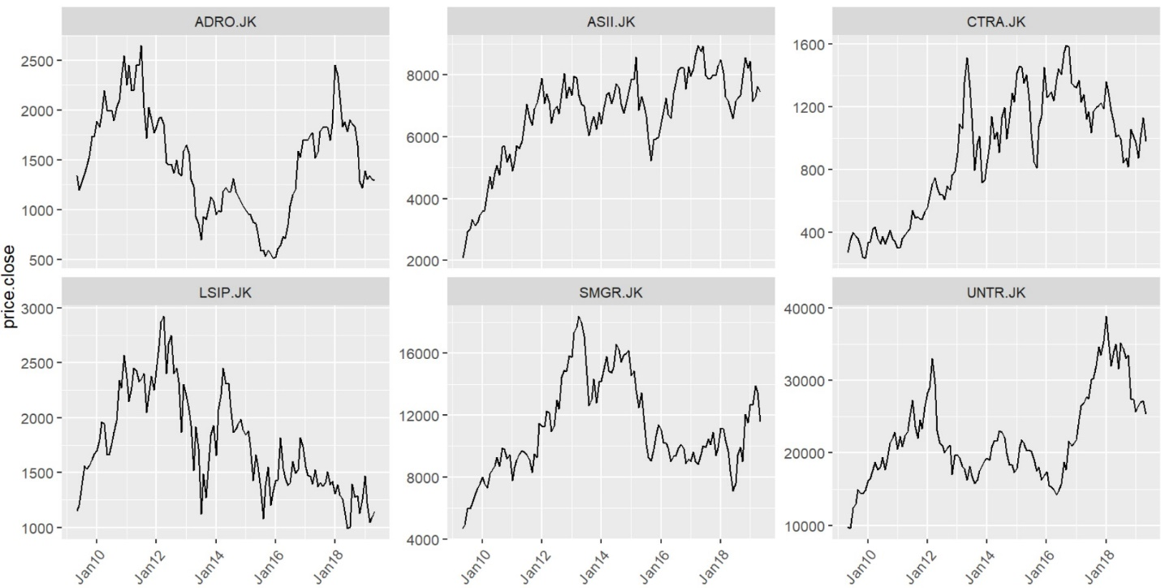
Figure 2. Price of six assets during June 2009-July 2019

Jakarta Stock Exchange (JKSE) or a composite index is a representative of Indonesian stock market. Figure 2 shows the price and return fluctuation of market. Figure 3 is an Islamic index that show a similar pattern.
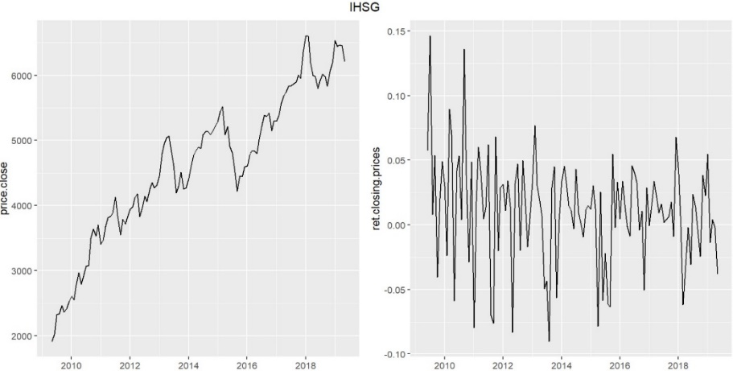
Figure 3. Market price and return (June 2009-July 2019)

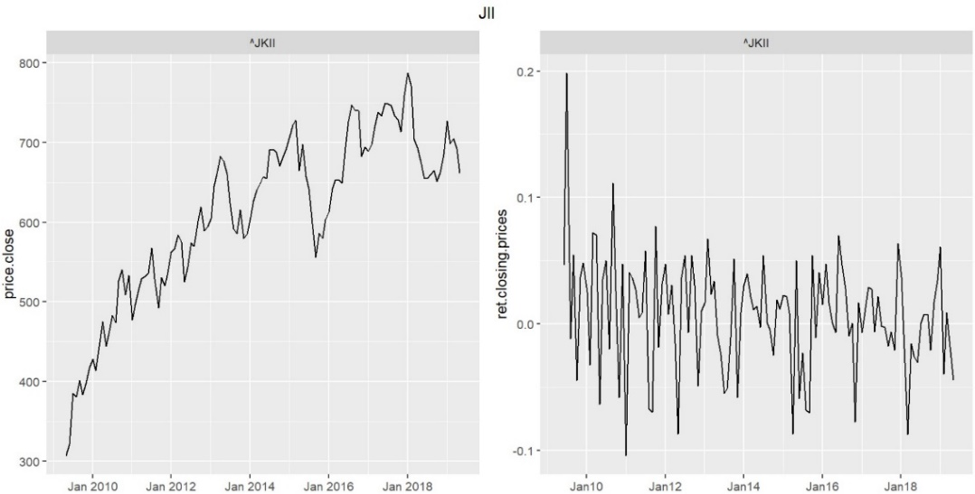

In this case, we use JKSE as a composite index to represent the market (both conventional and sharia compliant stocks).

Table I
 | ADRO | ASII | LSIP | CTRA | SMGR | UNTR
$$\hat{α}$$ | -0.0071 | -0.0063 | -0.0054 | -0.0036 | -0.0070 | -0.0041
p-value | 0.5141 | 0.1865 | 0.6226 | 0.7256 | 0.2598 | 0.5725
$$\hat{β}$$ | 0.8594 | 1.3536 | 0.6261 | 1.4976 | 1.1414 | 0.9677
p-value | 0.0053 | 0.0083 | 0.0038 | 0.0092 | 0.0070 | 0.0059
Purification | 0.0065 | 0.0077 | 0.0154 | 0.0328 | 0.0059 | 0.0090

Table II
Variable | Mean return | Std deviation
Market | 0.1150 | 0.453
Risk-free rate | 0.0051 | -
Sukuk rate | 0.0056 | -

4. Empirical analysis
The modified formula for CAPM in accordance with sharia principles such as no riba, the zakat obligation and purify the income from non-halal activity was proposed (Derbali et al., 2017; Hazny et al., 2017). Then this perspective was deployed with investors views to build a modified Black Litterman in Sharia framework (Subekti, Abdurakhman, Rosadi, et al., 2022). Based on the procedure depicted in Figure 1, the results of the calculation of each stage to obtain optimal weight with BL-SCAPM are shown in the following Table III-V.
Stage 1: Calculation of the SCAPM using a modified formula (Derbali et al., 2017; Hazny et al., 2017)
$${E(r}_{i})=\frac{1}{1-δ_{i}}R_{s}+β_{i}\left(μ_{M}-\frac{R_{s}}{1-δ_{M}}\right)$$

Table III. Expected excess return CAPM and SCAPM
 | ADRO | ASII | LSIP | CTRA | SMGR | UNTR
CAPM | 0.0053 | 0.0083 | 0.0038 | 0.0092 | 0.0070 | 0.0059
SCAPM | 0.0052 | 0.0082 | 0.0038 | 0.0090 | 0.0069 | 0.0058

Stage 2: Investor’s view can be declared into Q and P matrix. In this case is following the previous work that prediction is given to the three of stocks, namely ADRO, LSIP and SMGR.
Table IV. Views prediction from investor
 | ADRO | ASII | LSIP | CTRA | SMGR | UNTR
Q | 0.028 | - | 0.074 | - | 0.021 | -
Qs | 0.027 | - | 0.071 | - | 0.020 | -
Matrix of $Q_{s}$, P and $Ω_{s}$ are following:

$$Q_{s}=\left[\begin{matrix}0.0271 \\ 0.0710 \\ 0.0203\end{matrix}\right], P=\left[\begin{matrix}\begin{matrix}1 & 0 & 0 \\ 0 & 0 & 1 \\ 0 & 0 & 0\end{matrix} & \begin{matrix}0 & 0 & 0 \\ 0 & 0 & 0 \\ 0 & 1 & 0\end{matrix}\end{matrix} \right], Ω_{s}=\left[\begin{matrix}0.00113 & 0.00000 & 0.00000 \\ 0.00000 & 0.00111 & 0.00000 \\ 0.00000 & 0.00000 & 0.00053\end{matrix}\right]$$

Stage 3.
Based on the formula of modified Black Litterman return (Subekti, Abdurakhman, Rosadi, et al., 2022), we use $τ=0.1$
$${\hat{μ}}_{BL-S}={\left({\left(τΣ^{*}\right)}^{-1}+P^{t}{Ω_{s}}^{-1}P\right)}^{-1}\left({\left(τΣ^{*}\right)}^{-1}π_{S}+P^{t}{Ω_{s}}^{-1}(1-z)(1-δ)Q\right),$$
$$Σ_{BL-SZP}=Σ^{*}+{\left[{(τΣ^{*})}^{-1}+P^{t}{Ω_{s}}^{-1}P\right]}^{-1}$$
Where
$$Σ=\left[\begin{matrix}\begin{matrix}0.0147 & 0.0061 & 0.0032 \\ 0.0061 & 0.0144 & 0.0023 \\ 0.0032 & 0.0023 & 0.0063\end{matrix} & \begin{matrix}0.0016 & 0.0009 & 0.0054 \\ 0.0017 & -0.0001 & 0.0029 \\ 0.0040 & 0.0046 & 0.0035\end{matrix} \\ \begin{matrix}0.0016 & 0.0017 & 0.0040 \\ 0.0009 & -0.0001 & 0.0046 \\ 0.0054 & 0.0029 & 0.0035\end{matrix} & \begin{matrix}0.0069 & 0.0053 & 0.0021 \\ 0.0053 & 0.0165 & 0.0021 \\ 0.0021 & 0.0016 & 0.0078\end{matrix}\end{matrix}\right]$$

$$Σ^{*}=\left[\begin{matrix}\begin{matrix}0.0138 & 0.0030 & 0.0057 \\ 0.0030 & 0.0059 & 0.0021 \\ 0.0057 & 0.0021 & 0.0027\end{matrix} & \begin{matrix}0.0009 & 0.0015 & 0.0051 \\ 0.0042 & 0.0037 & 0.0033 \\ 0.0009 & 0.0016 & 0.0014\end{matrix} \\ \begin{matrix}0.0009 & 0.0042 & -0.0001 \\ 0.0015 & 0.0037 & 0.0016 \\ 0.0051 & 0.0033 & 0.0027\end{matrix} & \begin{matrix}0.0147 & 0.0048 & 0.0014 \\ 0.0048 & 0.0065 & 0.0020 \\ 0.0014 & 0.0020 & 0.0073\end{matrix}\end{matrix}\right]$$

$$Σ_{BL}=\left[\begin{matrix}\begin{matrix}0.0154 & 0.0034 & 0.0063 \\ 0.0034 & 0.0068 & 0.0024 \\ 0.0063 & 0.0024 & 0.0152\end{matrix} & \begin{matrix}0.0010 & 0.0017 & 0.0057 \\ 0.0049 & 0.0042 & 0.0037 \\ -0.0001 & 0.0017 & 0.0030\end{matrix} \\ \begin{matrix}0.0010 & 0.0049 & -0.0001 \\ 0.0017 & 0.0042 & 0.0017 \\ 0.0057 & 0.0037 & 0.0030\end{matrix} & \begin{matrix}0.0179 & 0.0055 & 0.0017 \\ 0.0055 & 0.0073 & 0.0022 \\ 0.0017 & 0.0022 & 0.0085\end{matrix}\end{matrix}\right]$$

$$Σ_{BL-SZP}=\left[\begin{matrix}\begin{matrix}0.0144 & 0.0032 & 0.0058 \\ 0.0032 & 0.0064 & 0.0022 \\ 0.0058 & 0.0022 & 0.0140\end{matrix} & \begin{matrix}0.0016 & 0.0016 & 0.0053 \\ 0.0039 & 0.0039 & 0.0035 \\ -0.0001 & 0.0016 & 0.0028\end{matrix} \\ \begin{matrix}0.0009 & 0.0044 & -0.0001 \\ 0.0016 & 0.0039 & 0.0016 \\ 0.0053 & 0.0035 & 0.0028\end{matrix} & \begin{matrix}0.0159 & 0.0051 & 0.0015 \\ 0.0051 & 0.0068 & 0.0021 \\ 0.0015 & 0.0021 & 0.0079\end{matrix}\end{matrix}\right]$$

 | ADRO | ASII | LSIP | CTRA | SMGR | UNTR
$${\hat{μ}}_{}$$ | 0.0082 | 0.0146 | 0.0071 | 0.0190 | 0.0115 | 0.0124
$${\hat{μ}}_{S}$$ | 0.0079 | 0.0141 | 0.0069 | 0.0179 | 0.0111 | 0.0120
$${\hat{μ}}_{BL}$$ | 0.0244 | 0.0173 | 0.0403 | 0.0128 | 0.0163 | 0.0158
$${\hat{μ}}_{BL-S}$$ | 0.0236 | 0.0168 | 0.0387 | 0.0124 | 0.0158 | 0.0153

Stage 4. Finding the optimal allocation using a new target return and variance of Black Litterman. A problem optimization of Islamic portfolio can be expressed as follows:

Table V. The result of allocation for each model
 | Naive | MV | MV-ZP | BL-traditional | BL-Syariah
ADRO | 0.167 | 0.0392 | 0.0395 | 0.0509 | 0.0488
ASII | 0.167 | 0.1883 | 0.1777 | 0.1731 | 0.1686
LSIP | 0.167 | 0.1455 | 0.1518 | 0.1924 | 0.1950
CTRA | 0.167 | 0.0781 | 0.0863 | 0.0677 | 0.0784
SMGR | 0.167 | 0.2918 | 0.2878 | 0.2961 | 0.2874
UNTR | 0.167 | 0.2571 | 0.2570 | 0.2199 | 0.2218
As depicted in Table V, there are corrections in proportion in from MV to BL. SMGR still gets the largest proportion in the portfolio, both through MV and BL. The second proportion, namely UNTR, is also generated from both models. LSIP and ASII get opposite corrections. This allocation change is an adjustment due to inputs in the second stage in the Black Litterman strategy. All portfolios are built with no short sales constraint to meet the Islamic principles in the investment.

Table VI. Shharpe and Treynor index of BL SCAPM
Portfolio | Expected return | Std.dev | Beta | Sharpe | Treynor
BL-Traditional | 0.0211 | 0.0043 | 1.0507 | 3.71 | 0.01120
BL-Syariah | 0.0206 | 0.0040 | 1.0518 | 3.82 | 0.01119

Based on Table VI, Sharpe index of BL SCAPM outperform the BL-traditional. Treynor index of BL-SCAPM performance is 0.001119. It is lower than BL-CAPM which is 0.01120. Meanwhile, the difference between the two BL portfolios is quite small and both have a similar portfolio performance. In this case, it can be concluded that the BL-SCAPM and BL portfolios have performed equally well. However, when viewed from the process, BL-SCAPM is more in line with sharia principles in producing an optimal sharia stock portfolio.

These empirical results show that although there is a change in benchmarks for BL, namely from CAPM to SCAPM with a reduction in zakat and purification, it can still produce a good portfolio in asset diversification, return expectations and portfolio risk.

5. Conclusion
These empirical results show that although there is a change in benchmarks for BL, namely from CAPM to SCAPM with a reduction in zakat and purification, it can still produce a good portfolio in asset diversification, return expectations and portfolio risk.

The evaluation of the BL-SCAPM portfolio in this study was measured by Treynor index. Compared to other models, namely the naive model, MV without short-sales, MV-ZP and BL-CAPM, the Treynor index of the sharia stock version of BL is slightly lower than BL-CAPM. However, with a small difference in this case study, BL-SCAPM outperformed the other models, namely the MV and Naive models.

Bibliography

Agussalim, M., Limakrisna, N. and Ali, H. (2017), “Mutual Funds Performance: Conventional and Sharia Product”, International Journal of Economics and Financial Issues, Vol. 7 No. 4, pp. 150–156.
Arisena, A., Noviyanti, L. and Achmad Zanbar, S. (2018), “Portfolio return using Black-litterman single view model with ARMA-GARCH and Treynor Black model”, Journal of Physics: Conference Series, Vol. 974 No. 1, available at:https://doi.org/10.1088/1742-6596/974/1/012023.
Ashker, A.A.F.E. (1987), The Islamic Business Enterprise, Croom Helm Limited, Backenham.
Bessler, W., Opfer, H. and Wolff, D. (2017), “Multi-asset portfolio optimization and out-of-sample performance: an evaluation of Black–Litterman, mean-variance, and naïve diversification approaches”, European Journal of Finance, Vol. 23 No. 1, available at:https://doi.org/10.1080/1351847X.2014.953699.
Black, F. and Litterman, R. (1992), “Global Portfolio Optimization”, Financial Analysts Journal, Vol. 48 No. 5, pp. 28–43.
Bodie, Z., Kane, A. and Marcus, A.J. (2014), Investments, Mc Graw Hill.
Derbali, A., El Khaldi, A. and Jouini, F. (2017), “Shariah-compliant Capital Asset Pricing Model: New mathematical modeling”, Journal of Asset Management, Palgrave Macmillan UK, Vol. 18 No. 7, pp. 527–537.
Fabozzi, F.J., Focardi, S.M. and Kolm, P.N. (2006), “Incorporating Trading Strategies in the Black-Litterman Framework”, The Jornal of Trading, pp. 28–37.
Hazny, M.H., Hasim, H.M. and Yusof, A.Y. (2012), “Revisiting Markowitzs Mean”, International Conference on Statistics in Science, Business and Engineering (ICSSBE), IEEE.
Hazny, M.H., Hasim, H.M. and Yusof, A.Y. (2017), “Mathematical modelling of a shariah-compliant capital asset pricing model”, Journal of Islamic Accounting and Business Research, No. December, available at:https://doi.org/10.1108/JIABR-07-2016-0083.
Ruppert, D. (2010), Statistics and Data Analysis for Financial Engineering, Springer, New York.
Subekti, R., Abdurakhman and Rosadi, D. (2022), “Toward the Black – Litterman with Shariah-compliant asset pricing model : a case study on the Indonesian stock market during the COVID-19 pandemic”, International Journal of Islamic and Middle Eastern Finance and Management, Vol. ahead-a-pr No. ahead a-print, available at:https://doi.org/10.1108/IMEFM-12-2020-0633.
Subekti, R., Abdurakhman, Rosadi, D. and Hasim, H.M. (2022), “Integrating Zakat and Purification in a Modified Black-Litterman for Shariah-Compliant Stock Portfolios”, Asian Economic and Financial Review, Vol. 12 No. 7, pp. 549–564.
Widodo, B.W., Achsani, N.A. and Andati, T. (2017), “An Application of the Black-Litterman Model with ARIMA-ARCH Views for Islamic Stock Portfolio in Indonesian Stock Exchange”, Asian Journal of Business Management, Vol. 05 No. 04, pp. 133–140.

