The efficiency frontier of Markowitz and Black Litterman model: study case on the sharia-compliant stock in Jakarta Islamic Index

R Subekti1,4, Abdurakhman2 and D Rosadi3

1 Universitas Negeri Yogyakarta, Yogyakarta, Indonesia

2,3Universitas Gadjah Mada, Yogyakarta, Indonesia

**Abstract.** The purpose of this study is to explain how to form the efficiency frontier based on two models in the portfolio. We focus on implementing portfolio construction using Markowitz and Black Litterman model. In the empirical experiment, we apply it to sharia-compliant stocks form Jakarta Islamic Index (JII). Since the Black Litterman model is developed from the Markowitz model, then we provide both results of the efficiency frontier. The result shows that the EF line without short-selling reduce the extreme combination of asset allocation.

1. Introduction

In the theory of modern portfolio, the term of the efficiency frontier (EF) is familiar. It is defined as the collective of portfolios that optimal, it means that the estimated of each portfolio withthe highest expected return for a given level of risk or the lowest risk for a given level of expected return. The model introduced by Markowitz in 1952, and it is known as an essential tool for investors to construct the portfolio with the best composition.

In other words, the EF is a financial tool for investors in getting the optimal allocation by analysing the risk and returns. We can compare the selected portfolio with the others in EF. It is useful for determining whether the portfolio is adequately performed or not. The EF can be described in the graph in which all portfolios along the EF curve are a set of portfolios that maximizes returns or minimizing risk. The portfolios that lie below the EF are the sub-optimal. The efficiency frontier is also called the efficiency curve, and we called an efficient portfolio for any portfolio along the EF line.

Many studies related to the EF has been emerged since the Markowitz model and related to the optimization decision [1]. Rather than provide only one solution, managers can adjust the chosen portfolio based on the EF information. Some of the studies of EF are [2]–[4]. The problem with how to make the EF line can be various. It can depend on the constraints, the goal, and many others. [3] developed a closed-form solution for all portfolios corresponding to the efficient frontier. [4] introduced the selection of portfolios by Sharpe ratio Efficiency Frontier to cope with the problem non-normal. [5], [6] proposed the portfolio frontiers that were built by considering constraints such as Value at Risk and Tracking Error Volatility. The other studies of EF in the context of the Indonesian market have been done by [7] and [8]. Both studies used data from LQ 45.

All studies above are developed from the Markowitz model. In 1991, Model Black Litterman was introduced by Fischer Black and Robert Litterman through the development of the Markowitz model. Therefore, the studies on the efficiency frontier in Black Litterman is also attractive compared to the Markowitz model. Moreover, there is no similar study for EF in the Black Litterman model with the Indonesian market. This study attempts to examine the EF in Markowitz and Black Litterman model, particularly for sharia-compliant stocks, which are listed in the Jakarta Islamic Index.

1. Markowitz optimization portfolio

Based on [9], the statement about efficient portfolios that forms the efficiency frontier constitutes the convex envelope in the Markowitz theory. The characteristic parameters of the portfolio are return and risk. Markowitz quantified the correlation that exists between portfolio risk and return. In this context, the average return on assets is viewed as a random variable. Then, we can define the expected return of the portfolio and its variance as follows:

|  |  |
| --- | --- |
| $R_{p}=\sum_{i=1}^{n}{w_{i}.R_{i}}$ | (1) |
| $$E\left(R_{p}\right)=\sum_{i=1}^{n}{w_{i}.E\left(R_{i}\right)}$$ | (2) |
| $$Var(R_{p})=σ_{p}^{2}=\sum_{i=1}^{n}{w_{i}^{2}σ_{i}^{2}+2\sum_{i=1}^{n-1}{\sum_{j=1}^{n}{w_{i}w_{j}σ_{ij}}}}$$ | (3) |

where

$E\left(R_{p}\right)$ = expected return of a portfolio

$w_{i}$ = allocation weight on asset i

$E\left(R_{i}\right)$ = expected return of asset i

$σ_{ij}$ = covariance between asset i and asset j

$n$ = number of assets

In general, we can write the Mean Variance (MV) model in matrix form as follows:

Model 1:

|  |  |
| --- | --- |
| Minimize $Var(R_{p})=w'Σw$ subject to $w^{'}μ=μ_{p}$ | (4) |

Calculating the efficiency frontier is similar to finding the proportion of the assets that build each portfolio. When no constraint is added to the problem, we can solve it by using the Lagrange multiplier.

|  |  |
| --- | --- |
| $$L=w'Σw-λ(w^{'}μ)$$ | (5) |
| $$\frac{∂L}{∂w}=\frac{∂\left({w^{'}Σw}^{}-λ(w^{'}μ-μ_{p})\right)}{∂w}$$ | (6) |
| $$\frac{∂L}{∂w}=2Σw-λμ$$ | (7) |

We notice that coefficient of risk $δ$ as a coefficient of risk-averse. In many kinds of literature, we also find the expression of the goal function in model 1 is $\frac{1}{2}w'Σw$**.** The factor $\frac{1}{2}$ is the scaling convention to get a simple result [10]. Manager Investment (MI) can set the preference of the target return, $μ_{p}$ as the constraint in Equation 4.

There is additional assumption that the manager invests the fund into all assets, or only part of the capital which is risky assets. It can be invested in another asset such that no risky. If the assumption all the capital is spent on this portfolio, we add the constraint that $\sum_{i=1}^{n}{w_{i} =1}$. In matrix form, we can write as $1'w=1$, where $1$ is a vector one. Model 1 can be developed into Model 2 as follows:

Model 2

|  |  |
| --- | --- |
| Minimize $\frac{1}{2}w'Σw$ subject to $w^{'}μ=μ_{p}$ and **1 $'w=1$** | (8) |

Model 2 is known a minimum variance model with short-sales event. This problem also can be solved with Lagrange Multiplier.

In the concept of efficiency frontier, we can use a grid of values of $E\left(R_{p}\right)$ and determine the corresponding efficient portfolios. In this process, we can start with expanding the combination of weight and calculate the $E\left(R_{p}\right)$ and its variance. From the process of calculating the variance of portfolio leads to finding the smallest value of a portfolio variance. As a simple way, then we connecting all the points.

The following illustration is using two assets in portfolio with expected return A and B. To construct an efficiency frontier, we calculate the portfolio expected return and its variance in Equation 2 and 3 for each possible combination of weight.

According to the additional constraint in Model 2 then $w_{B}=\left(1-w_{A}\right)$. The weight A is tracked from zero to one. Then we create a scatter plot and connect all points and give the illustration in the following graph.

|  |  |
| --- | --- |
| $$E\left(R_{p}\right)=w_{A}.E\left(R_{A}\right)+\left(1-w_{A}\right).E\left(R_{B}\right)$$ | (9) |

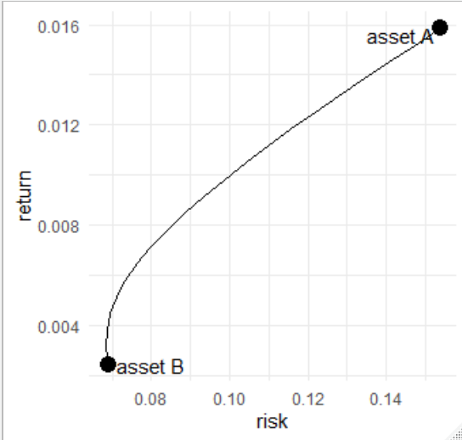

Figure 1. The illustration of efficiency frontier of two assets with rAB = 0.3

From Figure 1, all the combination of A and B is provided in along the line. The greater the predicted risk the higher the return of expectations. If the investor avoids risk then at the same level of risk, seen in the bottom left, it can be chosen the possibility of a combination that results in a higher return.

We can obtain the formula of weight in model 2 with the following step:

Step 1. Define the Lagrange function (L)

|  |  |
| --- | --- |
| $$L=\frac{1}{2}w'Σw-λ_{1}(w^{'}μ-μ_{p}){-λ}_{2}(1'w-1)$$ | (10) |

Step 2. Taking the partial derivative of L

|  |  |
| --- | --- |
| $$\frac{∂L}{∂w}=Σw-λ_{1}μ-λ_{2}=0$$ | (11) |
| $$\frac{∂L}{∂λ_{1}}=μ_{p}{-w}^{'}μ=0$$ | (12) |
| $$\frac{∂L}{∂λ_{2}}=1-1'w=0$$ | (13) |

Step 3. Solve the first order condition

From equation 11, we get the equation for w

|  |  |
| --- | --- |
| $$w=λ_{1}Σ^{-1}μ+λ_{2}Σ^{-1} 1$$ | (14) |

Let considering equation 13, $1'w=1$ then we can rewrite equation 14 by multiplying both sides with $1'$ as follows

|  |  |
| --- | --- |
| $$1'w=1=λ_{1}{1'Σ}^{-1}μ+λ_{2}{1'Σ}^{-1} 1$$ | (15) |

For simplifying the notation, we define two scalars, $C_{1}=$ ${1'Σ}^{-1}μ$ and $C_{2}={1'Σ}^{-1} 1$ then we can rewrite

|  |  |
| --- | --- |
| $$1=λ_{1}C_{1}+λ_{2}C_{2}$$ | (16) |
| $$λ_{1}=C_{1}^{-1}(1-λ_{2}C_{2})$$ | (17) |

While from equation 12 and notice that $w^{'}μ=μ'w$ we can also multiply equation 14 with $μ'$

|  |  |
| --- | --- |
| $$μ'w=μ_{p}=λ_{1}μ'Σ^{-1}μ+λ_{2}{μ'Σ}^{-1} 1$$ | (18) |

For simplifying the notation, we define two scalars, $C_{3}=μ'$ $Σ^{-1}μ$ and $C_{4}={μ^{'}Σ}^{-1} 1=C_{1}$ then we can rewrite

|  |  |
| --- | --- |
| $$μ_{p}=λ_{1}C_{3}+λ_{2}C_{1}$$ | (19) |
| $$λ_{1}=C_{3}^{-1}(μ_{p}-λ_{2}C_{1})$$ | (20) |

Now, we consider equation 17 and 20

|  |  |
| --- | --- |
| $$C_{1}^{-1}(1-λ_{2}C_{2})=C_{3}^{-1}(μ_{p}-λ_{2}C_{1})$$ |  |
| $${{λ_{2}C_{1}C_{3}^{-1}-λ}_{2}C_{2}C}_{1}^{-1}=C_{3}^{-1}μ_{p}-C_{1}^{-1}$$ |  |
| $$λ_{2}=\left(C_{3}^{-1}μ_{p}-C_{1}^{-1}\right){(C_{1}C_{3}^{-1}-C_{2}C_{1}^{-1})}^{-1}$$ | (21) |

We substitute $λ_{2}$ in equation 17 and getting the formula:

|  |  |
| --- | --- |
| $$λ_{1}=C_{1}^{-1}-\left(C_{3}^{-1}μ_{p}-C_{1}^{-1}\right){(C_{1}C_{3}^{-1}-C_{2}C_{1}^{-1})}^{-1}C_{1}^{-1}C_{2}$$ | (22) |

So, we have

|  |  |
| --- | --- |
| $$w=C_{1}^{-1}-\left(C_{3}^{-1}μ_{p}-C_{1}^{-1}\right){(C_{1}C_{3}^{-1}-C_{2}C_{1}^{-1})}^{-1}C_{1}^{-1}C_{2}Σ^{-1}μ+\left(C_{3}^{-1}μ_{p}-C_{1}^{-1}\right){(C_{1}C_{3}^{-1}-C_{2}C_{1}^{-1})}^{-1}Σ^{-1} 1$$ | (23) |

We can also define model 2 to a matrix form for the constraints as $A_{eq}$ and $b_{eq}$ as follows [11]:

Minimize $\frac{1}{2}w'Σw$ subject to $A_{eq}w=b_{eq}$ where

|  |  |
| --- | --- |
| $$A_{eq}=\left[\begin{matrix}1'w \\ w^{'}μ\end{matrix}\right],b_{eq}=\left[\begin{matrix}1 \\ μ_{p}\end{matrix}\right]$$ |  |

To produce the EF graph, we can use Solver menu in Excel or R program in the quadprog package.

When the short-sales case is prohibited, so we add constraints such that each weight of the asset is positive. Model 2 can be transformed into the model 3:

Model 3

|  |  |
| --- | --- |
| Minimize $w'Σw$ subject to $E\left(R_{p}\right)=w^{'}μ=μ'w$**, $1'w=w'1=1$**  and $w ≥0$ | (24) |

Model 3 is known as a minimum variance model with no short-sales event.

Those problems contain a quadratic objection function with restriction is a linear constraint. For both inequality or equality constraints, we can find the solution by using quadratic programming [11]. Minimize $\frac{1}{2}w'Σw$ subject to $A_{neq}w≥b_{neq}$. $A_{neq}$ is $n×n$ identical matrix for inequality constraint and $b_{neq}=0$, a vector of zeros. Then we have combination of equality and inequality constraints as follows:

|  |  |
| --- | --- |
| $$A=\left[\begin{matrix}{A'}_{eq} \\ {A'}_{neq}\end{matrix}\right]=\left[\begin{matrix}\begin{matrix}1'w \\ w^{'}μ\end{matrix} \\ I_{n}\end{matrix}\right],b=\left[\begin{matrix}b_{eq} \\ b_{neq}\end{matrix}\right]=\left[\begin{matrix}\begin{matrix}1 \\ μ_{p}\end{matrix} \\ 0_{n}\end{matrix}\right]$$ |  |

If there is no restriction of target return or expected return of a portfolio and short sales, Model 2 can be transformed into a global minimum variance (GMV) model that is expressed as follows:

Model 4:

|  |  |
| --- | --- |
| Minimize $w'Σw$ subject to $1'w=1$ | (25) |

1. Black Litterman

Some of the weaknesses of Markowitz model have been discussed by [12]–[14]. So many discussions developed the portfolio model by referring this MV model as a reference model for several new models. In general, this Markowitz model is the basic of several modified models. The Black Litterman model is one of the evolution of the MV model [15] when the MV renewing a target expected return. The new expected return is achieved by a combination of an equilibrium return and the prediction from investor

The formula of return target of BL ${(μ}_{BL})$ is expressed as follows:

|  |  |
| --- | --- |
| $$μ_{BL}={\left[{(τΣ)}^{-1}+P'Ω^{-1}P\right]}^{-1}\left[{(τΣ)}^{-1}π+P'Ω^{-1}Q\right]$$ | (26) |

where:

|  |  |
| --- | --- |
| $$τ$$ | : a scalar for scaling the variance of equilibrium return |
| $$Σ$$ | : variance covariance matrix of asset return, $Σ_{NxN}$ |
| $$P$$ | :pick or link matrix associated with k views return from investor*, $P_{kxN}$* |
| $$Ω$$ | :variance of error term in views, diag *($τ P'Σ^{-1}P$), $Ω_{kxk}$* |
| $$π$$ | : equilibrium return, $π_{nx1}$ |
| $$Q$$ | : a vector of view return, $Q_{kx1}$ |

The explanation of deriving the BL return using Bayesian and Theil mixed approach can be refer to [16]–[18]. From the Bayesian perspective, the variance of new return is defined as follows:

|  |  |
| --- | --- |
| $$Σ_{BL}={\left[{(τΣ)}^{-1}+P'Ω^{-1}P\right]}^{-1}$$ | (27) |

Next, the modelling of optimal allocation problem for Black Litterman can be expressed as Mean variance Markowitz.

Model 5:

|  |  |
| --- | --- |
| Minimize $Var(R_{p})=w'Σ_{BL}w$ subject to $E\left(R_{p_BL}\right)=w^{'}μ_{BL}$ | (28) |

The solution of Black Litterman allocation can be set into two types such as with or without short-sales.

Model 5 is the BL with short sales is allowed and the following model is the alternative one to prohibit the short-selling activity.

Model 6:

|  |  |
| --- | --- |
| Minimize $Var(R_{p})=w'Σ_{BL}w$ | (29) |
| Subject to : |  |
| $$w^{'}μ_{BL}=R_{p_BL}$$ |  |
| $1'w=w'1=1$ and $w ≥0$ | (30) |

1. Efficient Frontier

We limit the focus in providing EF line for model 1 and 6. In the concept of efficient frontier, we experiment to find a set of solution from MV and BL model. Regarding the specific portfolio in this study is selected from sharia compliant stock in Jakarta Islamic Index, we set two types of efficiency frontier. Firstly, the EF Black Litterman with short selling allowed. Secondly, EF Black Litterman without short selling. The graph will show the difference between EF Black Litterman with short selling with the second one.

*4.1 Data and specification*

We collect the data from JII listed in January 2019 and select seven assets with different sector. The sample data is monthly return collected from 2 February 2014 to January 2019.

**Table 1.** List of JII stocks in the portfolio

|  |  |  |  |
| --- | --- | --- | --- |
| Symbol | Sector | Expected return | Standard deviation of returns |
| INCO | Mining | 0.0158 | 0.1538 |
| INDF | Food and Beverages | 0.0024 | 0.0692 |
| INTP | Basic Industry and Chemicals | 0.0028 | 0.0950 |
| JSMR | Infrastructure | 0.0042 | 0.0738 |
| MAPI | Trade Services Investment | 0.0132 | 0.1059 |
| PWON | Property and Real Estate | 0.0173 | 0.0908 |
| TLKM | Telecommunication | 0.0108 | 0.0563 |

Toward portfolio using BL, we give four prediction statements on seven assets on INTP, JSMR, PWON and TLKM assets in the absolute view version:

|  |  |
| --- | --- |
| $$Q=\left[\begin{matrix}\begin{matrix}q_{intp} \\ q_{jsmr}\end{matrix} \\ \begin{matrix}q_{pwon} \\ q_{tlkm}\end{matrix}\end{matrix}\right]=\left[\begin{matrix}\begin{matrix}1.15\% \\ 1.83\%\end{matrix} \\ \begin{matrix}2.15\% \\ 1.09\%\end{matrix}\end{matrix}\right]$$ |  |

*4.2 The empirical result*

In the application of BL in this portfolio, we use parameter tau as 0.1, risk aversion is 0.025 and we calculate the expected return Black Litterman in Table 2. By using Equation 28 and 29, we calculate the return and risk then input them into model 5 and 6.

**Table 2.** Expected return of Black Litterman

|  |  |
| --- | --- |
| Symbol | Expected return BL |
| INCO | 0.0169 |
| INDF | 0.0156 |
| INTP | 0.0164 |
| JSMR | 0.0165 |
| MAPI | 0.0166 |
| PWON | 0.0208 |
| TLKM | 0.0091 |

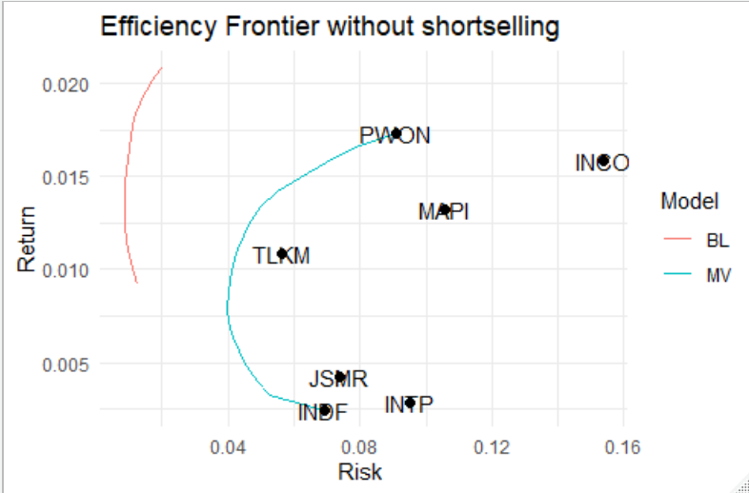

**Figure 2.** Efficiency Frontier without short-selling

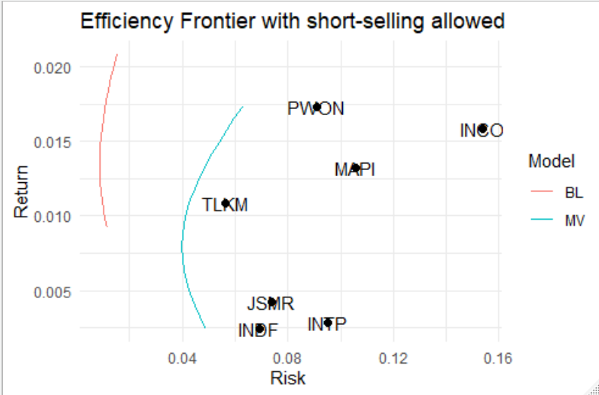

**Figure 3.** Efficiency Frontier with short-selling

In comparison Figure 2 and 3, it seems that taking into account the possibility of additional constraints, without shortsales, EF charts obtained from both MV and BL models in Figure 2 shows that the allocation weight yield a smaller portfolio risk. Furthermore, the BL allocation demonstrate the EF line is on the left side of MV. This position shows that the risk of BL is less than BL. We also note that in terms of returns earned, the BL model indicates a higher return target.

1. Conclusion

In the description of some Markowitz models with their expansion, it has been discussed about adding constraints to the model. There are other expansions such as tangent portfolios and additional constraints in reality. Such things become the limitations of this research. Furthermore, when viewed from the evolving BL model of the Markowitz MV, the EF line results indicate a better likelihood of results than the MV. Another possible outcome of the EF comparison is that taking into account that the practice of short-selling should have an impact on reducing the allocation of assets. In a portfolio built with seven assets from JII, BL portfolio with no short-sales is the best choice.

1. References

[1] Zhang L, 2019 A General Framework of Optimal Investment *J. Math. Financ.* **09**, 03 p. 535–560.

[2] Palomba G and Riccetti L, 2019 Asset management with TEV and VaR constraints: the constrained efficient frontiers *Stud. Econ. Financ.* **36**, 3 p. 492–516.

[3] Best M J and Hlouskova J, 2000 The efficient frontier for bounded assets *Math. Methods Oper. Res.* **52**, 2 p. 195–212.

[4] Bailey D H and de Prado M L, 2012 The sharpe ratio efficient frontier *J. Risk* **15**, 2 p. 3–44.

[5] Palomba G and Riccetti L, 2012 Portfolio frontiers with restrictions to tracking error volatility and value at risk *J. Bank. Financ.* **36**, 9 p. 2604–2615.

[6] Palomba G and Riccetti L, 2013 Asset Management with TEV and VAR Constraints: The Constrained Efficient Frontiers *Ssrn*.

[7] Bismark R *et al.*, 2013 Efficient frontier *J. Ekon. dan bisnis* **7**, 1 p. 1–26.

[8] Supandi E D, 2016 Karakteristik Kurva Efisien Frontier dalam Menentukan Portofolio Optimal *J. Tek. Ind.* **18**, 1.

[9] Amenc N, 2003 *Portfolio Theory and Performance Analysis (Wiley Finance* .

[10] Bodie Z Kane A and Marcus A J, 2014 *Investments* Mc Graw Hill.

[11] Ruppert D, 2010 *Statistics and Data Analysis for Financial Engineering* Springer US.

[12] Kooli M and Selam M, 2010 Revisiting the Black-Litterman model: The case of hedge funds *J. Deriv. Hedge Funds* **16**, 1 p. 70–81.

[13] Dziwok E, 2014 Asset Allocation Strategy in Investment – a Comparative Analysis *J. Econ. Manag.* **18** p. 123–132.

[14] Bessler W and Wolff D, 2013 A Theoretical and Empirical Analysis of the Black-Litterman Model *Algorithms from Nat. Life* p. 377–386.

[15] Mankert C and Seiler M J, 2011 Mathematical derivations and practical implications for the use of the black-litterman model *J. Real Estate Portf. Manag.* **17**, 2 p. 139–159.

[16] He G and Litterman R, 2005 The Intuition Behind Black-Litterman Model Portfolios *SSRN Electron. J.*

[17] Satchell S and Scowcroft A, 2016, A demystification of the black- litterman model: Managing quantitative and traditional portfolio construction, in *Asset Management: Portfolio Construction, Performance and Returns*, (Springer International Publishing), p. 36–53.

[18] Walters J, 2011 The Black-Litterman Model in Detail *SSRN Electron. J.* p. 1–51.