Brain Cancer Classification Using Elman Recurrent Neural Network with Genetic Algorithm Optimization
A T Abdulloh¹, D U Wutsqa²
Mathematics Education Department of Mathematics and Natural Science
Yogyakarta State Univesity, Indonesia

¹ahmadabd1904@gmail.com, ²dhoriva_uw@uny.ac.id
Abstract. Elman Recurrent Neural Network (ERNN) is a model that accommodates network output to be network input to produce the next network output. Genetic algorithms are computational approaches to solving problems that are modeled after the process of biological evolution. The purpose of this research is to classify brain cancer from Magnetic Resonance Imaging (MRI) brain with ERNN model. To improve the accuracy of the classification results, the ERNN model parameters are optimized with genetic algorithms. The data used in the model is the result of extracting MRI images using Gray Level Co-occurrence Matrix (GLCM) method, which consists of 13 variables, that is contrast, correlation, energy, homogeneity, entropy, sum of square variance, Inverse Difference Moment (IDM), sum average, sum entropy, sum variance, difference entropy, maximum probability, and dissimiliraity. Classification results are evaluated using accuracy, sensitivity, and specificity on training and testing data. The research have perfect results on testing data with no misclassification, while on the testing data the results are also very satisfying with sensitivity, specificity, and accuracy values is 100%, 93.33%, 96.43%.
Keywords : Brain Cancer, Recurrent Neural Network, Genetic Algorithm.
- Introduction
Cancer is a body cell that mutations (changes) and grows out of control [1]. Cancer cells can’t die after they are old enough, but instead grow continuously and are invasive, so the body's normal cells can be repressed or even die. Cancer is one of the causes of death, according to the Ministry of Health of the Republic of Indonesia in 2012, there are about 8.2 million deaths from cancer.
Cancer can occur in almost all parts of the body, including the lymph, blood, marrow, and brain [2]. The brain is one of the most important parts of the body that regulates the work of other body organs, so that if there any damage in the brain it can be harm the performance of other body organs. One of injury that can occur to the brain is brain cancer.
Brain cancer is a condition caused by abnormal cell growth in the brain and is malignant. Quoted from World Health Organization (WHO) in Indonesia there were 4,200 cases of brain cancer in 2012. Thus it is necessary to do early detection so that cases of brain cancer can be identified and handled appropriately.
There have been many studies to classify brain cancer, some of which are as follows : (1) Vaishnavi & Giraddi research [3] about cancer detection using Image Classification, (2) Heranurweni research [4] about the classification of brain cancer using backpropagation methods, (3) Zahran research [5] about the classification of brain cancer using neural network methods, and abadi, et al research [6] about the classification of brain cancer using the rbfnn method. This shows that the Neural Network architecture is quite reliable in classifying brain cancer.
Brain cancer classification research using neural network model can use feedforward network and the network model used using recurrent network. Like the research conducted by Derya [7] about diagnosing breast cancer using recurrent neural network method, Booldbatar [8] about the classification of breast cancer using elman recurrent neural network methods, and Wutsqa & Nurjanah [9] about the classification of breast cancer using the fuzzy elman recurrent neural network method. It is inevitable that the result of the classification will give rise to an error value, Thus, to get a smaller error value in the classification can be done by optimizing the model. One algorithm that can be used for optimization is a genetic algorithm.
The implementation of genetic algorithms for optimization problems is a very interesting subject to research, because genetic algorithms are very powerful and are optimization techniques that can work on many problems that are very difficult to solve with conventional techniques. [10]. This is supported by Zamani's research [11] about the genetic algorithm method that’s implemented in the neural network method can produce a high accuracy value that’s 97.00% and Sugiyarto, et al [12] about the algorithm method on the backpropagation neural network to predict the national rice production.
Based on previous research on the classification of brain cancer, researchers want to classify brain cancer using a recurrent neural network model and then optimize it with a genetic algorithm.
- Theoretical Review
  - Extraction
The image extraction process is one of the important characteristics used in identifying image objects or patterns. One of the image extraction methods is Gray Level Co-occurrence Matrix (GLCM). GLCM is an image extraction method used in image classification because it is able to provide detailed information about image texture [13]. The results of image extraction using the GLCM method resulted in 13 extraction features, the extracted features obtained in this study is: contrast, correlation, energy, homogeneity, entropy, sum of square variance, Inverse Difference Moment (IDM), sum average, sum entropy, sum variance, difference entropy, maximum probability, and dissimiliraity. Mathematical formulas [14] [15] [16] [17] [18] [19] of these features are:
- $Contrast= \sum_{i}{\sum_{j}{p\left(i,j\right){(i-j)}^{2}}}$
- $Correlation= \sum_{i}{\sum_{j}{\frac{\left\{\left(ij\right)p\left(i,j\right)\right\}-μ_{x}μ_{y}}{σ_{x}σ_{y}}}}$
- $Energy= \sum_{i}{\sum_{j}{\{p\left(i,j\right)\}^{2}}}$
- $Homogeneity= \sum_{i}{\sum_{j}{\frac{p\left(i,j\right)}{1+|i-j|}}}$
- $Entropy= -\sum_{i}{\sum_{j}{p\left(i,j\right)log_{2}\{p\left(i,j\right)\}}}$
- $Sum of square variance= \sum_{i}{\sum_{j}{p\left(i,j\right){(i-μ)}^{2}}}$
- $Inverse Difference Moment (IDM)= \sum_{i}{\sum_{j}{\frac{p\left(i,j\right)}{1+(i-j)^{2}}}}$
- $Sum average= -\sum_{k}{\{\left(k\right)\left(p_{x+y\left(k\right)}\right)\}}$
- $Sum entropy= -\sum_{k}{p_{x+y\left(k\right)}log\{p_{x+y\left(k\right)}\}}$
- $Sum variance= \sum_{k}{(i-SE)^{2}p_{x+y\left(k\right)}}$
- $Difference entropy= -\sum_{k}{(p_{x-y\left(k\right)})log\{p_{x-y\left(k\right)}\}}$
- $Maximum probability=\max_{i,j}\{p\left(i,j\right)\}$
- $Dissimiliraity= \sum_{i}{\sum_{j}{p\left(i,j\right)|i-j|}}$
with,
$p\left(i,j\right)$ = pixels in row i and column j.
$μ_{x}$ =$\sum_{i}{\sum_{j}{\left\{\left(i\right)p\left(i,j\right)\right\}}}$,
$μ_{y}$ =$\sum_{i}{\sum_{j}{\left\{\left(j\right)p\left(i,j\right)\right\}}}$,
$σ_{x}$ =$\sum_{i}{\sum_{j}{\left\{{\left(i-μ_{x}\right)}^{2}p\left(i,j\right)\right\}}}$,
$σ_{y}$ = $\sum_{i}{\sum_{j}{\left\{{\left(i-μ_{y}\right)}^{2}p\left(i,j\right)\right\}}}$,
$μ$ = average $\sum_{i}{\sum_{j}{p\left(i,j\right)}}$,
$p_{x+y\left(k\right)}$ = $\sum_{i=1}^{Ng}{\sum_{j=1}^{Ng}{p\left(i,j\right);i+j=k;k=2,3,…,2Ng.}}$
$Ng$ = gray levels are obtained from the image.
  - Elman Recurrent Neural Network (ERNN).
A recurrent network is a network that accommodates network output to become input on that network again in order to produce the next network output. There are 2 types of recurrent networks, Elman Network and the Hopfield Network [20]. The Hopfield network will store a set of points in a balanced position in such a way that given an initial condition, then the network will respond to design a point. The Elman network consists of N hidden layers, the first layer has the weights obtained from the input layer, every other layer will receive the weight from the previous layer.
The architectural model used in this study is Elman Recurrent Neural Network (ERNN). On figure 1, $X_{1},X_{2},{…,X}_{l}$ are neurons in the input layer, $Y_{1},Y_{2},{…,Y}_{m}$ are neurons in a hidden layer, and $Z$ are neurons in the output layer.$U_{1},U_{2},{…,U}_{m}$ are additional neurons which are feedback from the hidden layer. $U_{1}$ is the feedback from $Y_{1}$ , $U_{2}$ is the feedback from $Y_{2}$, etc. The weight of the input signal to the hidden layer is denoted by $w_{jk(x)}$, the weight of the additional neuron to the hidden layer is denoted by $w_{k'k(u)}$ and the weights from the hidden layer to the output layer are denoted by $v_{k(x)}$, the refractive weight of neuron k in the hidden layer is denoted by $b_{k}$ and the refractive weight of the output layer neurons is denoted by $b_{0}$where j = 1,2,3,…, l and k,k’ = 1, 2, 3, …, m, and Z is the output result.
U₂
U₁
U_{m}
b

w_{mm(u)}
b_{m}
v_{m}
w_{lm(x)}
Input Layer
Output Layer
Hidden Layer
Unit Konteks
b₀

Z

X₁

X₂

X_{l}

$$⋮$$
$$⋮$$
Y₁

Y₂

Y_{m}

$$⋮$$

Figure 1. Recurrent Neural Network Model.

the RNN model on the Elman network can be formulated as follows:
$$z= \sum_{k=1}^{m}{v_{k}\frac{1-exp⁡\left(-(\sum_{i=1}^{l}{x_{i}w_{ik\left(x\right)}+}\sum_{k'=1}^{m}{u_{k'}w_{k'k\left(u\right)}+}b_{k})\right)}{1+exp⁡⁡\left(-(\sum_{i=1}^{l}{x_{i}w_{ik\left(x\right)}+}\sum_{k'=1}^{m}{u_{k'}w_{k'k\left(u\right)}+}b_{k})\right)}}+b_{0}+ ε$$

  - Genetic Algorithm
Genetic algorithms are a computational approach to problem solving modeled after the process of biological evolution [21]. The implementation of genetic algorithms for optimization problems is a very interesting subject to research, This is because genetic algorithms are very powerful and are optimization techniques that can work on many problems that are very difficult to solve with conventional techniques [10].
The use of algorithms that mimic the workings of living things in solving optimization problems has been introduced since the 1960s. The genetic algorithm was invented by John Holland and developed by David Goldberg, The concept developed in this algorithm is how to search for an approximate solution based on the natural evolutionary process [22].
The genetic algorithm process can be presented in the chart in Fig 2:
Start
Initialization of Total Generations (jg), Counter Generation (cg) = -1, Total Population (pop), Crossover probability (Pc), Mutation probability (Pm), Treshold (θ), Population Convergent Percentage (pk)
Encoding
Population Awal
Calculation of the Fitness value
Calculation pk, cg = cg + 1
pk ≥ θ or cg ≥ jg ?
Selection and Etilisme
New Population
Mutation
Crossover
No
Decoding
End
Yes
Figure 2. Genetic Algorithm.
  - Procedure
The procedure used in the classification of brain cancer involves 6 steps, there are :
Step 1. Image processing
Image processing is using Gray Level Co-occurrence Matrix (GLCM) method which produces 13 features.
Step 2. Defining the input and output variables.
The input is GLCM features and the output is brain condition.
Step 3. Determining the training and testing data
The GLCM features are divided into two data sets, 75% for training data and 25% for testing data.
Step 4. Build ERNN model
The ERNN model is built by selecting the number of neurons in the hidden layer which gives the highest accuracy for both training and testing.
Step 5. Optimizing ERNN with Genetic Algorithm
Genetic Algorithm optimizing the weights of ERNN model.
Step 6. Classification results
Evaluation of a classification is generally carried out using a set of unused test data in the training with a certain measure. There are a number of measures that can be used to assess the classification model, including sensitivity, specificity, and accuracy [23]. The mathematic formula is :
$sensitivity = \frac{TP}{TP+FN} ×100\%$,
$specificitify= \frac{TN}{FP+TN}×100\%$,
$accuracy = \frac{TP+TN}{TP+TN+FN+FP}×100\%$,
with,
$TP$ = correctly labeled positive observations.
$TN$ = correctly labeled negative observations.
$FP$ = incorrectly labeled positive observations.
$FN$ = incorrectly labeled negative observations.

- Result and Discussion
The data used in this study are Magnetic Resonance Imaging (MRI) images of the brain extracted by the Gray Level Co-occurrence Matrix (GLCM) method, an example of MRI images can be seen in Figures 3 and 4.
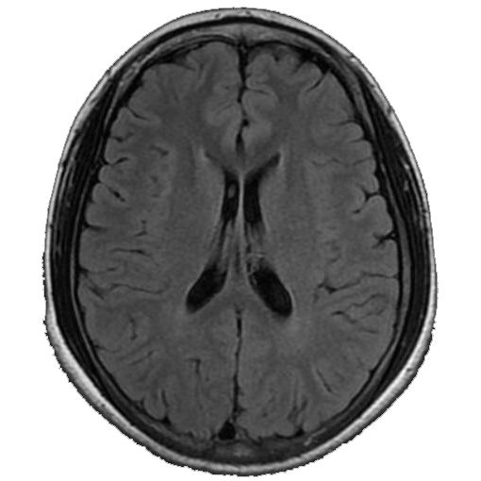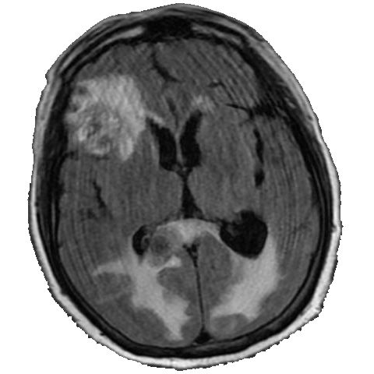
Figure 3. Normal Brain Image Figure 4. Brain Cancer Image
Next, after obtaining 13 extraction features, the Recurrent Neural network modeling begins by defining the input and output variables. The input variable used is the result of photo extraction of brain images using the Gray Level Co-Occurrence Matrix (GLCM) method. The output variable is a description of the condition of each brain image photo, namely brain cancer labeled 1 and normal brain labeled 2 Before the learning process is carried out the data is divided into testing and training data, the comparison in sharing the data used in this study is 75% for training data and 25% for testing data. The data that has been shared will be normalized with the help of Matlab with the prestd command. The complete syntax is as follows:
[Pn, meanp, stdp, Tn, meant, stdt]=prestd(P’,T’)
Table 1 is the results of trial and error using MATLAB's help to determine the number of neurons which is the MSE value for each experiment on many neurons from 1 neuron to 20 neurons.
Table 1. MSE Value
Neurons | MSE Training | MSE Testing | Neurons | MSE Training | MSE Testing
1 | 0.012124 | 0.042842 | 11 | 5.5932e-06 | 0.11202
2 | 6.9908e-06 | 0.062324 | 12 | 6.0091e-06 | 0.11333
3 | 0.011716 | 0.14179 | 13 | 5.2362e-06 | 0.070031
4 | 0.011704 | 0.1369 | 14 | 4.8733e-06 | 0.083108
5 | 6.3619e-06 | 0.11946 | 15 | 5.8668e-06 | 0.074058
6 | 6.4851e-06 | 0.089294 | 16 | 5.1971e-06 | 0.14145
7 | 6.5452e-06 | 0.10319 | 17 | 5.6053e-06 | 0.1351
8 | 5.5366e-06 | 0.084839 | 18 | 5.6193e-06 | 0.11975
9 | 5.5113e-06 | 0.13423 | 19 | 5.8761e-06 | 0.048624
10 | 6.3632e-06 | 0.035316 | 20 | 7.0334e-06 | 0.10457
From the experiment above, the best recurrent neural network model is obtained which consists of 10 neurons in the hidden layer, and 1 neuron in the output layer, which can be seen in Figure 5.
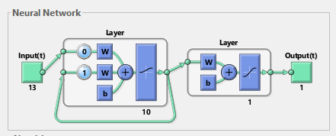
Figure 5. Jaringan Recurrent Neural Network
Denormalization is intended to return data that has been normalized during the learning process. Denormalization is done with the posttd command. The syntax in Matlab for the denormalization process is as follows:
$$[P, T]=posttd( Pn, meanp, stdp, Tn, meant, stdt)$$
After obtaining the final weight of the recurrent neural network, the weight will be optimized with a genetic algorithm to produce a better weight. In this study, several experiments were carried out to obtain optimal weight. The following results of the experiments conducted can be seen in table 2:
Table 2. Hasil Algoritma Genetika
Population Size | Number of Generations | Best Fitness
10 | 100 | 0.156908209725547
10 | 250 | 0.156950847743651
10 | 500 | 0.157300421993546
20 | 100 | 0.156914209267131
20 | 250 | 0.157163308578209
20 | 500 | 0.157345934259232
From the results of these experiments, the best fitness value is 0.157345934259232, the graph of the experimental results with MATLAB can be seen in Figure 6:
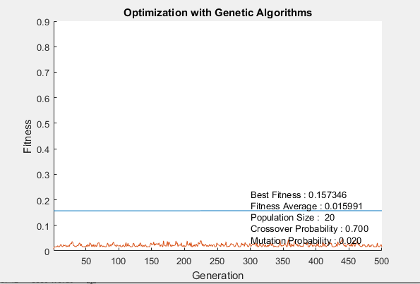
Figure 6. Grafik optimasi algoritma genetika.
The weights obtained from the optimization results using genetic algorithms are then used for the ERNN process. Comparison of the MSE value of the Recurrent Neural Network and Recurrent Neural Network models with genetic algorithm optimization is shown in Table 3:
Table 3. Comparison of MSE Value
Model | Nilai MSE
Model | Training Data | Testing Data
Recurrent Neural Network | 6.363152824502501e-06 | 0.035316406662910
Recurrent Neural Network with genetic algorithm optimization | 6.34542319353782e-06 | 0.035175696236476

In Table 3, it can be seen that the weight of the optimization results of the Recurrent Neural Network using the Genetic Algorithm provides a smaller MSE value than the weight of the Recurrent Neural Network without optimization with the Genetic Algorithm. The classification results certainly have errors and it is not uncommon to mistake brain cancer for normal brain cancer or otherwise. Therefore, it is necessary to test for sensitivity, specificity, and accuracy on the model results, the results of this test can be seen in Table 4.
Table 4. Classification Results
 | Training Data (%) | Testing Data (%)
sensitivity | 100 | 100
specificitify | 100 | 93.33
accuracy | 100 | 96.43

Based on table 4, it can be seen that the RNN model with genetic algorithm optimization provides good sensitivity, specificity, and accuracy values for training data and testing data by producing sensitivity, specificity, and accuracy values of 100%, 100%, 100% for the data, respectively. training, and 100%, 93.33%, 96.43% for testing data. The sensitivity of the RNN model is 100% meaning that a patient who does have a brain tumor has a 100% chance of testing positive for a tumor from a brain radiograph. The specificity of the RNN model testing data is 93.33%, meaning that patients who do not suffer from a brain tumor have a 93.33% chance of being negative for a tumor from the results of brain photographs. The accuracy of the RNN model testing data is 96.43%, which means that the diagnostic results are accurate for both positive and negative patients.

- Conclusions
Based on the results of the classification of brain cancer using the Recurrent Neural Network (RNN) method which is optimized with a Genetic Algorithm, Then the following conclusions can be drawn: The results of the Recurrent Neural Network (RNN) optimized with the Genetic Algorithm for the classification of brain cancer provide the best model with 10 neurons in the RNN network, as well as a population size of 20 and the number of generations of 500 in the genetic algorithm. The Recurrent Neural Network (RNN) model optimized with the Genetic Algorithm for the classification of brain cancer yields sensitivity, specificity, and accuracy values, respectively 100%, 100%, 100% for training, and 100%, 93.33%, 96.43% for testing.
References
[1] | R. Diananda, Panduan Lengkap Mengenai Kanker, Yogyakarta: Mirza Media Pustaka, 2009.
[2] | T. T. Tjay and K. Rahardja, Obat-Obat Penting: KHASIAT, PENGGUNAAN, DAN EFEK-EFEK SAMPINGNYA, Jakarta: PT. Elex Media Komputindo, 2007.
[3] | S. V. Vaishnavi and S. Giraddi, "Detection of Brain Tumour Using Image," International Conference on Current Trends in Computer, Electrical, Electronics and Communication, 2017.
[4] | S. Heranurweni, B. Destyningtias and A. K. Nugroho, "KLASIFIKASI POLA IMAGE PADA PASIEN TUMOR OTAKBERBASIS JARINGAN SYARAF TIRUAN (STUDI KASUS PENANGANAN KURATIF PASIEN TUMOR OTAK)," eLEKTRIKAL, p. Vol. 10 No.2, 2018.
[5] | M. B. Zahran, "Classification of Brain Tumor Using Neural Network," International Review on Coputers and Software, pp. Vol 9, No. 4, 2014.
[6] | A. M. Abadi, D. U. Wustqa and N. , "Diagnosis of Brain Cancer Using Radial Basis Function Neural Network with Singular Value Decomposition Method," International Journal of Machine Learning and Computing, pp. 527-532, 2019.
[7] | E. Derya, "Implementing automated diagnostic systems for breast cancer detection," Department of Electrical and Electronics Engineering, Faculty of Engineering, 2007.
[8] | E. Booldbatar, L. Lin and C. Lin, "Breast Tumor Classification Using Fast Convergence Recurrent Wavelet Elman Neural Networks," Springer, 2019.
[9] | D. U. Wutsqa and A. Nurjanah, "Breast Cancer Classification Using Fuzzy Elman Recurrent Neural Network," Jour of Adv Research in Dynamical & Control Systems, Vol. 11, 11-Special Issue, pp. 946-953, 2019.
[10] | M. Gen and R. Cheng, Genetic Algorithms & Engineering Optimization, New York: John Wiley & Sons, Inc, 2010.
[11] | A. M. Zamani, B. Amaliah and A. Munif, "Implementasi Algoritma Genetika pada Struktur Backpropagation Neural Network untuk Klasifikasi Kanker Payudara," JURNAL TEKNIK ITS Vol. 1 , 2012.
[12] | A. W. Sugiyarto, D. U. Wutsqa, N. Hendiyani and A. R. Rasjava, "Optimization of Genetic Algorithms on Backpropagation Neural Network to Predict National Rice Production Levels," International Conference on Applied Information Technology and Innovation (ICAITI), pp. 77-81, 2019.
[13] | D. Gadkari, "Image Quality Analysis Using GLCM," Electronic Theses and Dissertations, University of Central Florida, 2004.
[14] | M. S. Kalas, "An Artificial Neural Network for Detection of Biological Early Brain Cancer," International Journal of computer Applications, Vol.1, No.6, 2010.
[15] | L.-K. Soh, "Texture Analysis of SAR Sea Ice Imagery Using Gray Level Co-Occurrence Matrices," IEEE Transactions on Geoscience and Remote Sensing, Vol. 37, No.2, 1999.
[16] | P. Mohanaiah, P. Sathyanarayana and L. GuruKumar, "Image Texture Feature Extraction Using GLCM Approach," International Journal of Scientific and Research Publifications, Vol. 3, Issue 5, 2013.
[17] | M. Sharma and S. Mukharjee, "Artificial Neural Network Fuzzy Inference System (ANFIS) for Brain Tumor Detection," Advances in Intelligent Systems and Computing, pp. 329-339, 2013.
[18] | R. M. Haralick, K. Shanmugam and I. Dinstein, "Textural Feature for Image Classification," IEEE Transaction on System, Man and Cybernetics, 1973.
[19] | B. S. Anami and V. C. Burkpalli, "Texture based Identification and Classification of Bulk Sugary Food Object," ICGST-GVIP Journal, 2009.
[20] | S. Kusumadewi, Jaringan syaraf tiruan menggunakan matlab & excel link, Yogyakarta: Graha Ilmu, 2013.
[21] | B. Wilkinson and W. Allen, Parallel Programming - Teknik dan Aplikasi Menggunakan Jaringan Workstation & Komputer Paralel, Yogyakarta: Penerbit Andi, 2010.
[22] | A. Fanggidae and F. R. Lado, ALGORITMA GENETIKA dan Penerapannya, Yogyakarta: Teknosain, 2015.
[23] | Suyanto, Data Mining, Bandung: Informatika Bandung, 2019.

