Nonparametric Modelling on Women’s Discriminatory Attitude Toward People Living With HIV

R Rahani1,2, Y Andriyana1

1Department of Statistics, Universitas Padjadjaran, Indonesia

2Diploma IV Program of Applied Statistics, STIS Polytechnic of Statistics, Indonesia

rinirahani@stis.ac.id

**Abstract**. The community's discriminatory attitude towards people living with HIV/AIDS (PLWHA) is a major obstacle in the examination, prevention, and treatment of HIV/AIDS. Previous study had concluded that there is a negative correlation between knowledge about HIV/AIDS and discriminatory attitude toward PLWHA. Due to the pattern of the data, it seems that the data is exponentially decreasing. However, in some parts especially in the tail of the data, the patterns are not the same. This study aims to apply nonparametric smoothing method to the relationship between comprehensive knowledge and discriminatory attitude. In this study we implement Nadaraya-Watson Estimator and Local Polynomial Estimator. Data of individual women module from Indonesia Demographic and Health Survey 2017 is applied. Results shows that the most suitable nonparametric model describing relationship pattern between comprehensive knowledge about HIV and discriminatory attitudes toward PLWH is the Local Polynomial Estimator.

1. Introduction

The HIV/AIDS epidemic still be a serious threat for Indonesia which ranks fifth as the riskiest country in Asia. Since it was reported in 1987, the number of new HIV-positive cases had continued to increase until 2017. While the number of AIDS cases experienced an increasing trend in the detection of new cases until 2013, then tended to decline in the following years. This was estimated to occur because of the low number of AIDS cases reported from the region [1].

The identification whether a person infected of HIV/AIDS or not can be investigate through blood test which is done voluntary. The Information System of HIV-AIDS and IMS (SIHA) reported that the number of people taking HIV test increased steadily since 2013. However, in 2017 that number decreased by 41.76 percent compared to previous year. Data showed that 27,975 cases of 882,721 HIV test were identified as positive case of HIV [2].

Even though various counselling related to HIV/AIDS had been carried out, the community participation in conducting HIV test is still low. This condition usually is connected with two main factors. First, community awareness about the danger of HIV is still low. This encouraged people to neglect and pay no attention of the HIV test. Second, the anxiety about severe negative stigma of community toward people living with HIV (PLWH) [3]. PLWH usually were labelled as bad guys and also experienced feelings of rejection by their partners, friends and family, increasing social isolation, depression, loneliness, worthlessness, and lack of social and emotional support from others [4]. This condition can be a major barrier to HIV/AIDS program including the prevention, testing and accessing HIV treatment and care [3, 5].

Discrimination toward PLWHA is indicated by certain attitudes. First, the rejection to buy fresh vegetables from a shopkeeper or vendor with HIV. Second, the disagreement if children living with HIV are allowed to attend school with children who do not have HIV. Indonesia Demographic and Health Survey (IDHS) 2017 recorded that 64 percent of woman did not want to buy fresh vegetables from HIV-infected vendors and 35 percent of woman do not think that children living with HIV should be able to attend school with children who are HIV negative [6]. In line with this fact, UNAIDS reported that 47 countries showed quite high variation in reporting HIV discrimination cases. Indonesia belonged to the second group which discrimination rates ranged from 50 to 74 percent [7].

Negative stigma of HIV could be driven by the less knowledge about HIV. A study revealed a highly significant association between knowledge about HIV and discriminatory attitude toward PLWH. There was an inverse relationship between these two variables in which the higher the HIV knowledge, the lower the discriminatory attitude [4, 8]. Other studies found that the proper knowledge and well-informed community about transmission of HIV can reduce the discriminatory attitude [9, 10].

The previous study dealing with relationship between discriminatory attitude towards PLWH and comprehensive knowledge about HIV mostly implemented parametric analysis technique. Some of them applied correlation [4], log binomial regression [10], multiple logistic regression [11] multinomial logistic regression [8] and multiple linear regression [4, 5]. Based on this fact, this study is aimed to explore this relationship by utilizing nonparametric approach.

1. Data

This study uses data from IDHS 2017 specifically individual women recode (IR) module. Unit of analysis covers 34 provinces in Indonesia. However, the analysis does not accommodate the spatial effect contained in the data.

The response variable is percentage of woman with discriminatory attitude toward PLWH for each province. The discriminatory attitude toward PLWH is based on two criteria, such as:

* say “No” to the question, “Should children living with HIV be able to attend school with children who do not have HIV?”
* say “No” to the question, “Would you buy fresh vegetables from a shopkeeper or vendor if you knew that this person had HIV?”

Women who answer “No” to either of the two questions listed above are labelled to have discriminatory attitude [12].

The explanatory variable is the percentage of women with comprehensive knowledge about HIV for each province. Women are defined as having comprehensive knowledge of HIV if they:

* Know the two primary prevention methods (use of condoms and having just one uninfected faithful partner).
* Know that a healthy-looking person can have HIV.
* Reject the most common local misconceptions about HIV transmission of prevention (HIV cannot be transmitted by mosquito bites, and a person cannot become infected by sharing food with a person who has HIV) [12].

1. Parametric and Nonparametric

Regression is popular statistical method in investigating the effect of one or more independent variables toward dependent variable. The main differences between nonparametric regression and parametric regression is the nonexistence of an orientation toward the reduction of the number of parameters. Parametric regression favors expression with as small a number of parameters as possible and selects regression equation for representing data. On the other hand, nonparametric regression is mainly focused on the goal of deriving the beneficial trends from the data and does not give any special consideration to the parameter’s reduction [13]. Moreover, it does not require any assumption of the data. This make it more flexible toward the pattern of data.

Generally, relation between dependent variable and dependent variablecan be written as:

 (1)

The component of in nonparametric regression is an unkown smooth function. The is error which allows a deviation from a purely deterministic relationship.

* 1. *Kernel Function*

The Kernel Estimator was introduced by Rosenblatt (1956) and Parzen (1962). The kernel is a continuous, bounded and symmetric real functionwhich integrates to one [14]. Some alternative popular kernel functions are listed below in table 1.

**Table 1.** Some Kernel functions

|  |  |
| --- | --- |
| **Kernel Function** | **Explicit form** |
| Gaussian |  |
| Epanechnikov |  |
| Triangular |  |

* 1. *Nadaraya-Watson Estimator*

The weight sequence for kernel smoothers (for one-dimensional ) is defined by [14]:

 (2)

where

 (3)

and where

 (4)

The kernel function, is the kernel with scale factor . The also called as bandwidth which has dependency on sample size . Due to this, the kernel weight sequence (2) is conveniently abbreviated as  The form (2) of kernel weights has been proposed by Nadaraya (1964) and Watson (1964) and therefore:

 (5)

The form (5) is often called as the Nadaraya-Watson Estimator (NWE) [14].

* 1. *Local Polynomial Estimator*

Suppose the  derivative of the regression function at point exist. Then it can be approximated the regression function  locally by a polynomial of order . Employing Taylor expansion [15]:

 (6)

We can fit the polynomial locally by weighted least square regression, that minimize:

 (7)

The solution of regression problem (7) is denoted by. In the matrix notation:



let **W** be the  diagonal matrix of weight:



The weighted least squares of equation (7) can be written as:

 (8)

With . The solution vector is given by [15]:

 (9)

* 1. *Bandwidth Selection*

LPE performance depends strongly on bandwidth . A too large value of bandwidth will lead large modelling bias while a too small bandwidth will cause large variance and over-fitting problem. The optimal bandwidth can be developed in theory, but it cannot be used in practice since it will depend on some unknown quantities [15]. This procedure can be done by cross validation (CV) [16].

Let denote any estimate with bandwidth of the regression function . For each given , the data of  are used to build regression function of and validate the model by examining the prediction error The following function [15]:

 (10)

The assessment of regression function employs kernel gaussian. The optimal bandwidth is obtained by using function provided in R software.

* 1. *Model Performance Criteria*

The performance of model is shown by how close are the prediction values to the observed value. Comparison of model performances of NWE and LPW are evaluated by two different prediction consistency criteria, such as [16]:

1. Root Mean Square Error

 (11)

1. Mean of Absolute Error

 (12)

1. Result

## Descriptive of Discriminative Attitude and Comprehensive Knowledge

Data shows that the four provinces with high discriminative attitude toward PLWH are North Sulawesi, Aceh, East Nusa Tenggara and North Maluku. However, Yogyakarta has the lowest percentage of women discriminative attitude toward PLWH. The average of women discriminative attitude toward PLWH for 34 provinces is 39.17 percent. It indicates that the woman who discriminate toward both vendors having HIV and children with HIV is quite low.

For each component of discriminative attitude, the average of percentage of women who would not buy fresh vegetables from a shopkeeper who has HIV is about 71.25 percent. While the average of percentage of women who do not think that children living with HIV should be able to attend school with children who are HIV negative is 45.38 percent. This fact shows that women has higher discriminatory attitude toward vendors/seller with HIV than discriminatory attitude toward children with HIV.

As it is mentioned before, there is an inverse relationship between discriminatory attitude and comprehensive knowledge about HIV. Yogyakarta has the highest percentage of women with comprehensive knowledge of HIV about 26.6 percent. On the other hand, South Sumatera, Jambi, West Sulawesi and Southeast Sulawesi are the four provinces with the lowest percentage of women with comprehensive knowledge. The average of women’s comprehensive knowledge of HIV in 34 provinces is 12.59 percent. It shows that the number of women who understand HIV/AIDS comprehensively is very low. However, IDHS reported that 82.4 percent of the women having heard HIV/AIDS from various media sources such as radio, television, newspapers/magazines, posters, health workers, religious institutions, schools/teachers, community associations, friends/family, places of work, internet and the other. This indicates that having heard of HIV/AIDS does not guarantee that someone has comprehensive knowledge about HIV/AIDS [6].

The important step in analyzing pattern of relationship between two variables is investigating the pattern of data using scatter plot. Figure 1 visualizes indication of negative relationship between comprehensive knowledge and discriminative attitude toward PLWH. The higher the percentage of women which has comprehensive knowledge about HIV, the lower the percentage of women who has discriminative attitude toward PLWH.

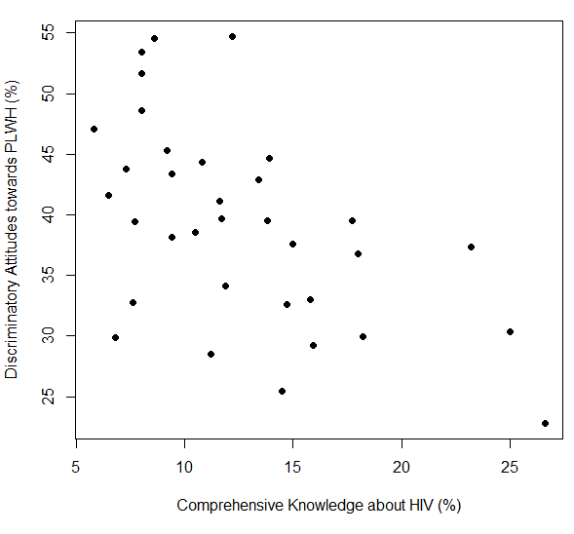

**Figure 1**. Scatter plot between ccomprehensive knowledge

and discriminative attitude toward PLWH

It seems that the data is exponentially decreasing. However, in some parts especially in the tail of the data, the patterns are not the same. This explains a signal that the relationship between comprehensive knowledge and discrimintave attitude toward PLWH is difficult to analyze using parametric approach.

## Optimizing the Bandwidth

The optimal bandwidth obtained from R software is 2.608767. The performance criteria of NWE and LPE is provided in the table 2:

**Table 2.** Performance criteria of the models

|  |  |  |
| --- | --- | --- |
| Estimator | RMSE | MAE |
| NWE | 9.768884 | 8.018045 |
| LPE | 9.755393 | 7.809746 |

According to table 2, the performance criteria obtained by LPE model are smaller than NWE. Hence, it can be said that LPE model is better than NWE. Ensuring this result, the figure 2 shows the curve of LPE and NPE. The LPE curve increase at the beginning, and shows an exponentially decrease before 10 percent of comprehensive knowledge about HIV. Moreover, it experiences a steady increase at percentage 23.2. This was followed by dramatic fall between percentage 23.2 and 26.6. However, the NWE curve has the same pattern but wigglier and rougher than LPE curve. Even tough, both of the curve is relatively following the actual observations. In fact, the LPE has smoother curve than NWE. On other word, the LPE is more flexible to predict the data than NWE.

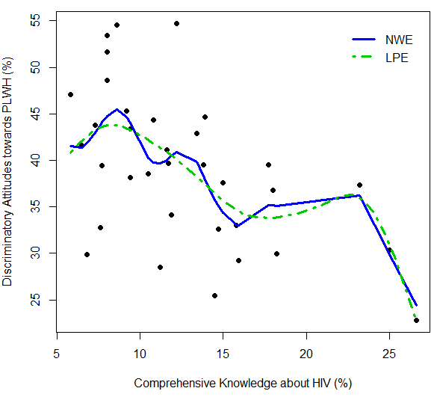

**Figure 2**. comparison smoothing curve using NWE and LPE

1. Conclusion and Implication

The data shows consistent result with the previous study in which there is a negative correlation between comprehensive knowledge about HIV and discriminatory attitude toward PLWH. The higher the percentage of women with comprehensive knowledge about HIV, the lower the percentage of women’s discriminatory attitude toward PLWH. The women’s comprehensive knowledge about HIV in Indonesia is still low. Therefore, there is a need of government intervention program related to knowledge understanding of HIV transmission and prevention method. Hence, the community discriminatory attitude can be reduced gradually. Moreover, this condition can support and improve the effectiveness of HIV/AIDS program dealing with the appropriate prevention, testing and accessing HIV treatment and care.

Based on the cross-validation criteria, the optimal bandwidth is 2.608767. Employing this bandwidth, the LPE has better performance than NWE. This study offers opportunity to explore more of nonparametric approach in social cases. The smoothing spline, quantile regression and many more can also be applied. Furthermore, the study can also be extended by considering the spatial effect attached to the data. It can be investigated whether the discrimination attitude in a province may be influenced by the discrimination attitude in other provinces.

References

1. Ministry of Health Republic of Indonesia 2018 *Indonesia Health Profile Year 2017* (Jakarta: Ministry of Health of the Republic of Indonesia)
2. Pusat Data dan Informasi 2018 *Infodatin: Situasi Umum HIV/AIDS dan Tes HIV* (Jakarta: Pusdatin Kemenkes RI)
3. World Health Organization 2017 *Review of The National Health Sector Response to HIV in the Republic of Indonesia* World Health Organization
4. Masoudnia E 2015 Public perceptions about HIV/AIDS and discriminatory attitudes toward people living with acquired immunodeficiency syndrome in Iran, SAHARA-J: *J of Soc. Asp. of HIV/AIDS* **12** pp 116-122
5. Sohn A and Park S 2012 HIV/AIDS Knowledge, Stigmatizing Attitudes, and Related Behaviors and Factors That Affect Stigmatizing Attitudes against HIV/AIDS among Korean Adolescents *Osong Public Health and Res. Perspect.* **3** pp 24-30
6. National Population and Family Planning Board (BKKBN), Statistics Indonesia (BPS), Ministry of Health (Kemenkes), and ICF 2018 *Indonesia Demographic and Health Survey 2017* (Jakarta: BKKBN, BPS, Kemenkes, and ICF)
7. UNAIDS 2017 Confronting Discrimination Overcoming HIV-related stigma and discrimination in healthcare settings and beyond (Geneva: UNAIDS)
8. Khan R, Bilal A and Siddiqui S H 2017 *Knowledge about HIV and Discriminatory Attitudes towards People Living with HIV in Pakistan* DHS Working Paper (Rockville, Maryland, USA: ICF) No.134
9. Ekstrand M L, Bharat S, Ramakrishna J and Heylen E 2012 Blame, Symbolic Stigma and HIV Misconceptions are Associated with Support for Coercive Measures in Urban India *AIDS Behav.* **16** pp 700-710
10. Li X, Yuan L, Li X, Shi J, Jiang L, Zhang C, Yang X , Zhang Y, Zhao D and Zhao Y 2017 Factors associated with stigma attitude towards people living with HIV among general individuals in Heilongjiang, Northeast China *BMC Infec. Diseases* **17**,p 154.
11. Pradnyani P E, Wibowo A, Mahmudah M 2019 The Effects of Socio-demographic Characteristics on Indonesian Women's Knowledge of HIV/AIDS: A Cross-sectional Study *J. Prev. Med. Public Health* **52** pp 109-114
12. Croft T N et al. 2018 *Guide to DHS Statistics* DHS-7 (Rockville, Maryland, USA: ICF)
13. Takezawa K 2006 *Introduction to Nonparametric Regression* (New Jersey: John Wiley & Sons Inc.)
14. H¨ardle W 1994 *Applied Nonparametric Regression* (Berlin: Institut f¨ur Statistik und Okonometrie)
15. Cao F 2017 Local Polynomial Kernel Smoothing with Correlated Errors *Graduate Theses and Dissertations* 16915
16. Aydin D 2007 A Comparison of the Nonparametric Regression Model using Smoothing Spline and Kernel Regression. *Int. J. of Math. and Comp. Sciences*  **1** pp 588-592