How the mathematics teacher in SMKN 1 Bulakamba Brebes managed the online learning
D D Jayanti, Haryanto and A L Emilda
Instructional Technology
Graduate School of Yogyakarta State University

desidwijayanti1295@gmail.com
Abstract. The learning activities during the COVID-19 pandemic require extra effort from teachers to conducted online learning for the students as they cannot attend the school as usual. This study aimed to describe and discuss how mathematics teacher in SMK Negeri 1 Bulakamba Brebes has conducted online learning during the COVID-19 pandemic. Data were collected by online interviews and also examining research documents and other related resources to describe the online learning process in the school during the COVID-19 pandemic. The results showed that mathematics online learning activities in SMK Negeri 1 Bulakamba Brebes conducted using YouTube and Google Form. The teacher created learning materials using YouTube and shared it with the students. Social media used so that the students were able to discussed and ask any questions. The teacher used Google Form for the student’s attendance and learning evaluation. Based on the interview, the teacher admitted that the online learning activities during the COVID-19 pandemic using YouTube and Google Form were satisfactory. The student’s performance from the exercise and examination result showed that most of the students were able to understand learning materials.
- Introduction
The deadly coronavirus (COVID-19) has been a threat worldwide since the end of 2019 and become an ongoing worldwide pandemic nowadays. It becomes a serious challenge to all parties, especially the health sector and government. Many countries in the world began to have either partial or complete lockdown avoiding the escalation of the death tolls number reported daily. [1] The first positive case in Indonesia has been confirmed on 2 March 2020. The pandemic spread to all 34 provinces in Indonesia by 9 April. On 23 July 2020, half of the provinces in the country had more than 1,000 cases. [2] [3] [4] The government decided to close the schools and universities following the number of positive cases reported daily. By 16 March 2020, all schools and universities started to had online learning activities. [5]
SMK Negeri 1 Bulakamba located in Bulakamba Brebes, one of the districts in Central Java province. There are six expertise programs offered by the school, electrical power installation engineering, audio-video engineering, technical light vehicle, motorcycle engineering, agribusiness of food crops and horticulture, and nautical fishing vessels. [6] SMK Negeri 1 Bulakamba Brebes also conducted online learning activities since March 2020 following the instruction of the government to close the school.

This article aimed to describe how the teacher in SMK Negeri 1 Bulakamba Brebes managed online learning activities, especially in the mathematic subject. Mathematics is one of the compulsory subjects for all expertise programs. It is necessary to see how the mathematic learning activities conducted in SMK Negeri 1 Bulakamba during the Covid-19 pandemic.
- Method
This study was done by the online interview with a mathematics teacher in SMK Negeri 1 Bulakamba Brebes, and also examining research documents and other related resources to describe the online learning process in the school during the COVID-19 Pandemic. An online interview was done on the 16th of June 2020 through WhatsApp application to discuss the effectiveness of media and the obstacles encountered during the online learning activities. Research documents were also used as secondary resources so that it could support data derived from the interview.
- Result and Discussion
Mathematics online learning activities in SMK Negeri 1 Bulakamba Brebes was conducted using two kinds of online media, YouTube and Google Form. YouTube is one of the popular websites in the world (third most visited website after Google and Facebook. [7] The use of this online media can bring a positive impact on learning activities so that will enhance student’s learning experiences. [8] [9] [10]
Based on the interview, the teacher stated that the reason for choosing youtube as an online media is because learning mathematics cannot be taught by only providing written material, but there must be a verbal explanation so that students can more easily understand the learning materials. Meanwhile, the Google Form application was used to create student attendance and collected the assignment. The teacher gave four days for all of the students to do the class attendance, study, and complete the assignments.
In this section, there will be a full description of how the mathematics teacher in SMKN 1 Bulakamba, Brebes managed online learning activities using Google Form and YouTube. The descriptions will be split into three parts: (a) Online learning activities, (b) The difficulty in online learning activities, and (c) The effectiveness of youtube in online learning activities.

3.1. Online Learning Activities
There are several steps was done by the mathematics teacher from the beginning to the evaluation of learning activities and student’s performance. They are student’s attendance, share the learning materials to the students, and share the platform to evaluate both learning activities and student’s performance.
    - Student’s Attendance

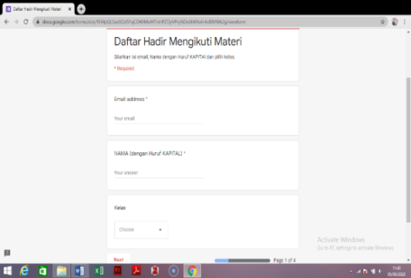
The students filled their data (full name, email address, and class/major) using Google Form. This online tool has been often used as evaluation tools for student’s attendance as it is easily accessible using internet connection in cellular phones or laptops. [11] Figure 1 shows the student’s attendance which was created using Google Form in Mathematics online class during the Covid-19 Pandemic in SMKN 1 Bulakamba, Brebes.
Figure 1
Student’s Attendance

    - Prepare and Share Learning Materials

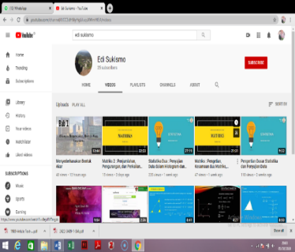
The Mathematics teacher in SMK Negeri 1 Bulakamba created a YouTube account for online learning activities during the Covid-19 Pandemic. The name of the channel, “Edi Suksimo” is taken from the teacher’s name. The teacher uploaded all of the learning materials (video) in the YouTube account and shared the link address in the Google Form.
Figure 2
Edi Sukismo YouTube Account
The first video uploaded on the 1st of April 2020. Figure 2 shows the appearance of the front page of the YouTube channel. The YouTube channel can be accessed at the following: address:https://www.youtube.com/channel/UCC3dH6lyHgLiIuqsXWmHIEA .

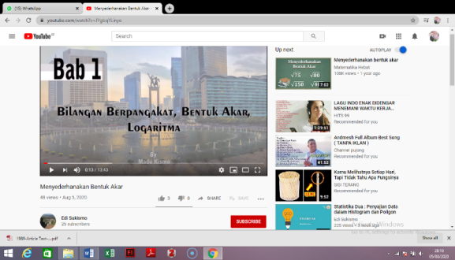
All of the learning materials were created, arranged, and uploaded according to the national curriculum (K-13). Several topics in the channel are trigonometric functions, sine rule, trigonometric identities, cosine rule, trigonometric formulas for area of the triangle, statistic part 1, matric, statistic part 2, matric part 2 (addition, subtraction, and multiplication), square root simplification.
Figure 3
Title of The Video
Figure 3 shows the front page of the video on the YouTube account. The topic discusses in the video is square root simplification. The front page of the video consists of the topic title so that the students can easily find the video which should be learned.
The teacher explained the topic using PowerPoint and recorded the explanations into a video. Figure 4 shows the appearance of the topic explanation page. Furthermore, the teacher also added several problems related to the topic and explain the steps about how to solve it. Figure 5 shows the appearance of the problem as well as the explanation in the video.

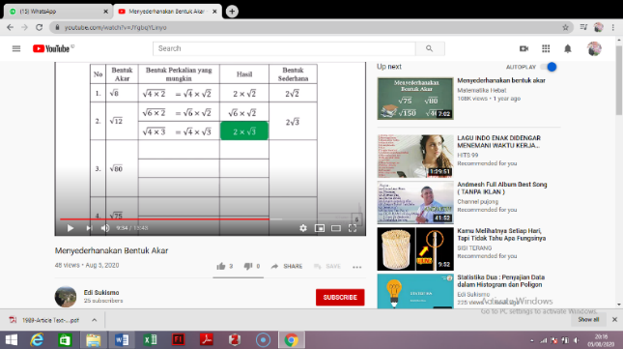
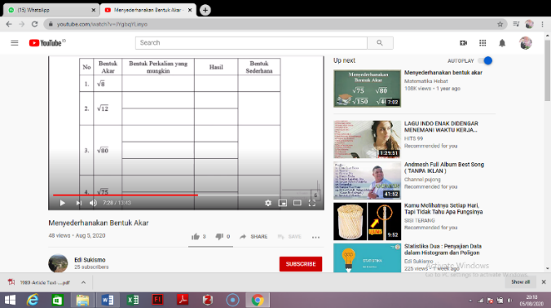
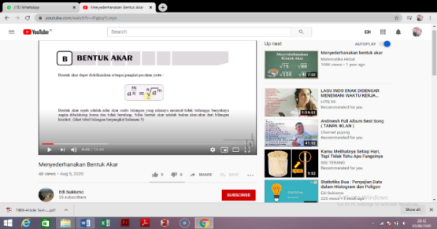
Figure 5
Problem Example Explanation Page
Figure 4
Topic Explanation Page

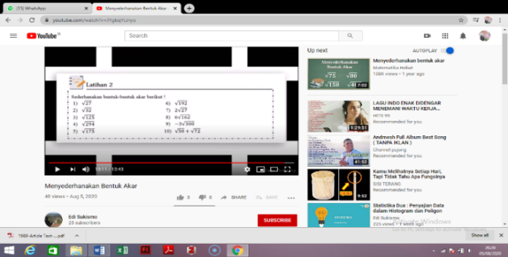
In the last part of the video, the teacher gave several exercises for the students to practice at home. These exercises intended to enhance students understanding of the topic which has been learned. Figure 6 shows the appearance of the list of questions in the video.
Figure 6
Exercise Page
The Mathematics teacher in SMK Negeri 1 Bulakamba Brebes created and managed all the video in the YouTube account to facilitate the students in online learning mathematics during the Covid-19 Pandemic.

    - Evaluation
The Mathematics teacher in SMK Negeri 1 Bulakamba Brebes used Google Form to evaluated online learning activities and student's performances. The teacher created a survey form for the students so that he got feedback from the students about several things that should be fixed in the next meeting.
The teacher also stated that he evaluated the student’s performance in the mid-term examination and the final examination using Google Form. Google Form is useful for the teacher to do an evaluation. The study showed that 33% of teachers stated the convenience of using Google Form, 44% considered its pace, 66% of teachers considered the practicality of Google Form, and 66% considered its efficiency. [12]

3.2 The Obstacles in Online Learning Activities
Several obstacles occurred during online learning activities, both from the teacher and the students. The teacher found that the process of making videos takes longer and requires creativity from the teacher. Meanwhile, there are still many teachers who have not mastered the technology for learning activities. Furthermore, the students could not ask questions to the teacher directly during learning activities so that the teacher allowed the students to contacted the teacher through social media. The school also facilitated internet quota for the teacher during online learning activities.
The online learning activities also require a lot of internet quota and a lot of file storage gadget (computer or mobile phone), while many students could not accommodate this need. Most students had spent file storage for another application, for example, online games, so that they can no longer save the task files from the teacher.

3.3 The Effectiveness of YouTube in Online Learning Activities
YouTube could be utilized as learning resources of new knowledge and information so that it can help the students to do schoolwork. Many videos on YouTube illustrate the real example of learning materials that can be accessed anywhere and anytime by users. [13] Based on the interview, the mathematics teacher in SMK Negeri 1 Bulakamba Brebes revealed that student’s performance during online learning activities was satisfactory. The teacher also admitted that their final examination results showed that most students understand the basics of all of the learning materials. The difficulty level of the exercises and examination was lower than usual. The main priority is the students can continue the learning activities although they cannot attend the school.
- Conclusion
The learning activities during the Covid-19 pandemic require extra effort from teachers to conducted online learning for the students as they cannot attend the school as usual. The mathematics teacher in SMK Negeri 1 Bulukamba Brebes utilized YouTube and Google Form as online tools. The teacher created a YouTube account and uploaded and shared the learning materials on YouTube to the students. The teacher also utilized social media as a platform for students to ask more explanations of the materials. Meanwhile, Google Form was utilized to list student attendance and evaluated the student’s performance.
Based on the interview, the teacher admitted that the online learning activities during the Covid-19 pandemic using YouTube and Google Form were satisfactory. The student’s performance from the exercise and examination result showed that most of the students were able to understand learning materials. Nevertheless, there were several difficulties during online learning activities, for example, the limitations from the teacher to created online materials and the limitations from the device of the students to access the materials.

References

- Mulenga, E. M. & Marbán, J. M 2020 Prospective Teachers’ Online Learning Mathematics Activities in The Age of COVID-19: A Cluster Analysis Approach. EURASIA Journal of Mathematics, Science and Technology Education, 2020, 16(9), em1872. ISSN:1305-8223 (online). https://doi.org/10.29333/ejmste/8345

- Ratcliffe, Rebecca (2 March 2020). "First coronavirus cases confirmed in Indonesia amid fears nation is ill-prepared for an outbreak". The Guardian. Retrieved 13 August 2020.

- "Indonesia confirms first cases of coronavirus". Bangkok Post. Reuters. 2 March 2020. Retrieved 13 August 2020.

- "Indonesia's COVID-19 recoveries beat active cases for the first time". Jakarta Globe. 13 July 2020. Retrieved 13 August 2020.

- Virus corona: Sekolah, universitas meniadakan kelas, pemerintah Indonesia belum resmi liburkan sekolah. BBC News Indonesia. 17 March 2020. Retrieved 13 August 2020.

- SMK Negeri 1 Bulakamba Brebes. School Profile. Retrieved from https://smkn1bulakamba.sch.id/identitas-sekolah/

- Alexa. (2015). Statistic report: Top sites in Spain. Retrieved from http://www.alexa.com/topsites/countries/ES.

- Fleck, B. K., Beckman, L. M., Sterns, J. L., & Hussey, H. D. (2014). YouTube in the classroom: Helpful tips and student perceptions. Journal of Effective Teaching, 14, 21–37.

- Suwarno, M. (2017). Potensi Youtube Sebagai Sumber Belajar Matematika. Pi: Mathematics Education Journal, 1(1), 1-7.

- Moghavvemi, S., Sulaiman, A., Jaafar, N. I., Kasem, N. (2018). Social media as a complementary learning tool for teaching and learning: The case of youtube. The International Journal of Management Education. 16, 37–42.

- Saktiono, M. A. (2019). Penerapan Google Form Untuk Evaluasi Kehadiran Perkuliahan Taruna-Taruni Teknika PDP UHT. Jurnal Aplikasi Pelayaran dan Kepelabuhanan, 9(2), 113-119.

- Mardiana, T., & Purnanto, A. W. (2017). Google Form Sebagai Alternatif Pembuatan Latihan Soal Evaluasi. URECOL, 183-188

- Samosir, F. T., & Samosir, F. T. (2018). The Effectiveness of Youtube as a Student Learning Media (Study at the Faculty of Social and Political Sciences, University of Bengkulu). Record and Library Journal, 4(2), 81-91.

