**Augmented Reality-based Mathematics Learning: Relevant Mathematics and Enhanced Abilities.**

# H N Rahman1 and W Setyaningrum2

1Graduate Program of Yogyakarta State University, Jl. Colombo No. 1, Karangmalang, Sleman, DI Yogyakarta, Indonesia

2Mathematics Department, Faculty of Mathematics and Science, Yogyakarta State University, Indonesia

E-mail: <hadinur.2019@student.uny.ac.id>

**Abstract**. During the COVID-19 pandemic, the delivery of material on learning must be more innovative. The application of technology in learning process can be a solution now Augmented Reality (AR) technology was implemented in various way, one of which in education. This study aims to explore how many developers integrate AR applications in mathematics learning and see the potential of the technology AR used, in terms of what abilities can be improved. The method used in this research is the literature review. Data obtained from were scientific journals, conference proceedings, and other related sources. The results showed that the mathematical materials used in the use of AR technology are geometry and integer operations. Then there are seven abilities identified to increase in mathematics learning based on augmented reality. So AR can be an alternative learning medium that can be used during this pandemic.

## **1. Introduction**

The era of the COVID-19 pandemic that is currently sweeping the world limits the space for humans to move in everyday life. It is recommended that work and study processes be carried out in the home as part of quarantine, namely limiting the movement of people suspected of having COVID-19 but not experiencing illness symptoms, either because they are not infected or because they are still in the incubation period [1]. One of the areas affected by the pandemic due to the cessation of the teaching and learning process in schools and universities is required to find a way out as an alternative replacement and support for learning Until now, online learning is still the best choice in continuing the teaching and learning process during a pandemic. This is in accordance with the Ministry of Education and Culture's Circular Letter dated March 17, 2020, as the Indonesian government's effort to prevent the spread of COVID-19 from becoming more widespread in the community [2]

The technology adaptation into mathematics learning was convinced to be an effective problem solving to support the implementation of online learning. In the 21st century, Augmented Reality (AR) technology is developing in swift. AR technology has been developed in various fields such as military[3], health[4], science[5] , education[6], construction[7] to entertainment[3]. This was caused by the superiority of AR technology's that allowed users to interact using their natural body movements[8]. Many research and development by the educators in order for integrating augmented reality into mathematical learning in the classes. Aji Pangestu[9] concluded that the development of media learning space geometry, particularly flat-side based on augmented reality to improve students' spatial reasoning ability at the junior high school level. AR allows students to explore the geometrical objects in three dimensional and from different angles. Then, Demitridaou also showed that augmented reality applications had a higher effect on students' learning and understanding of mathematical concepts than traditional teaching approaches[10]. So ontegration between AR technology and learning also has good impact on student interest, as stated by Giasiranis. He also said that the AR engenders impression and interest to students, which has; as a result, to motivate them more, to participate more actively and with more enthusiasm in course activities, to be more concentrated and comprehend better anything they are taught[11]. So AR technology in mathematical learning could be a solution applied during this COVID-19 pandemic.

Now we can see that smartphones become one of primary need in human life, especially in communication, work, entertainment and even learning and instruction. Several studies have shown that recently smartphones have a major role in education and its advantages in relation to potential pedagogical perspective[12]. In fact, AR Technology itself now highly in demand and can be developed by anyone, both in teamwork and individually, be on social media or in the application store on smartphones. So that during this pandemic, it was very possible for the educators to use and even develop AR technology in learning mathematics [13].

In subsequent discussions, it will be suggested how AR Technology can be used in mathematics learning, both in terms of the development that has been done or research on AR, which has been focused on improving the skills needed in learning mathematics. The method used in this study is a literature review, where the focused theme is research and development regarding AR Technology, which is integrated into mathematics learning. Articles adapted from Science Direct, Springer, IEEE, IOP, and JSTOR, which were compiled from 2013 to 2020.

## **2. The Development of AR for Math Learning**

In general, Augmented Reality can be defined in three main features: (a) combine real objects and virtual objects; (b) with Augmented Reality can interact in real-time; (c) provide accurate images with three-dimensional projection[14]. In another study, AR is defined as a state in which the real context is dynamically overlaid within the context of virtual information. Augmented reality adds, complements, or enhances the existing reality by adding elements of computational results obtained from input data, which can include audio, video, graphic, or GPS data[15]. AR also can provide interactive experiences to users by adding virtual information to the user's physical environment and allowing the user to use his entire body to interact with real and virtual content[16]. In addition, experts point out that AR can offer many potential benefits in children's lives, while at the same time, the use of AR in education has been associated with certain learning benefits[17]. In this case, what is meant is learning mathematics. According to Demitridaou[10], augmented reality in the future will become an essential educational tool, enabling students to understand facts better through illustrative demonstrations not seen in everyday life. Therefore, many researchers have developed AR media in mathematics learning. The following are AR-based learning media that have been developed in several countries around the world.

**Table 1.** List of augmented reality applications that have been developed

| No | Research | Application | Grade | Country |
| --- | --- | --- | --- | --- |
| **1** | S. Suherman et al. - 2020 [18] | AR-Geometry (Interactive Book) | 8th | Indonesia |
| **2** | A. Pangestu and W Setyaningrum – 2020 [9] | ARGEO | 8th | Indonesia |
| **3** | M. Fernando et al. - 2020 [19] | AR-Math | 1st-3rd | Mexico |
| **4** | MGK Ahsan et al. - 2020 [20] | Mathinact | 8th | Indonesia |
| **5** | YW Cheng - 2019 [21] | MathMon | 6th | Taiwan |
| **6** | RN Auliya and M Munasiah - 2019 [22] | Unknown Name | 8th | Indonesia |
| **7** | J. Young, M. Kristanda, and S. Hansun - 2016 [23] | ARmatika | 1st-3rd | Indonesia |
| **8** | I. Radu - 2016 [24] | Unknown Name | 1st-3rd | USA |
| **9** | L. Stefan and F. Moldoveanu - 2013 [25] | DiedricAR | 8th | Romania |

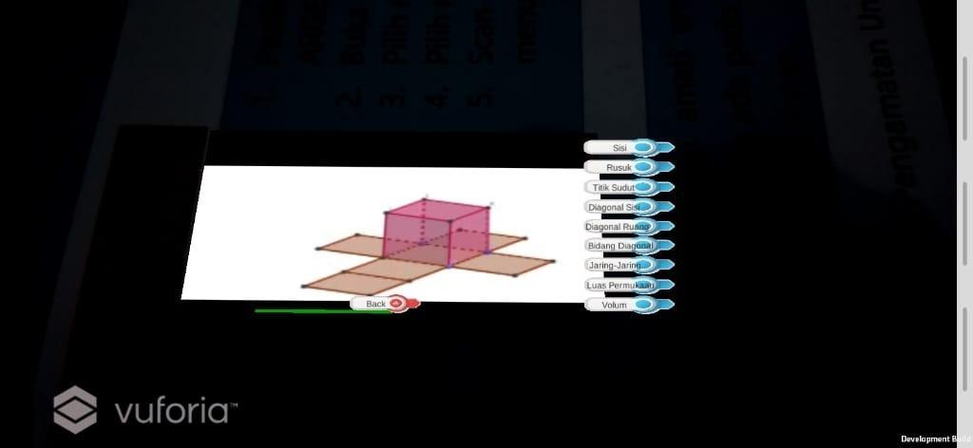It can be seen from the data in table 1, nine AR application developments have been carried out by researchers from various countries, of which there are five developers from Indonesia. This application was developed by researchers, in two main subjects in mathematics, namely geometry [9][18][20][22][25] and integer operations [19][21][23][24]. The geometry material used in learning using AR technology is at the junior high school level, while the integer operation material is taught at the elementary school level.

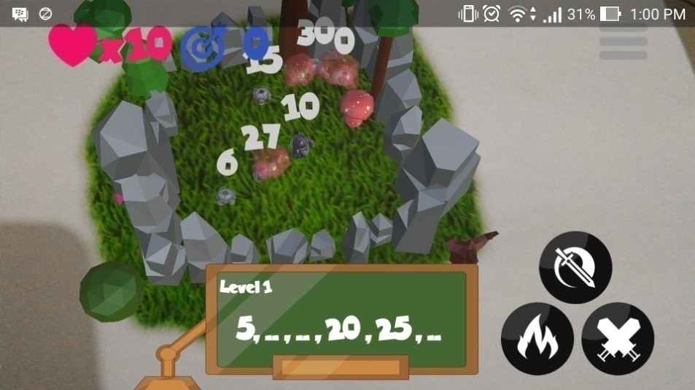

**Figure 1.** Example of ARGEO[9] **Figure 2.** Example of ARmatika[23]

In Figure 1, ARGEO displays an AR content on Geometry material, namely a flat side space. The use of AR-based learning media in understanding spatial geometry material is needed because it has been proven in several previous studies that show that this learning media is very effective[9]. Some research results reveal that learning geometry using 3D object models in AR can improve students' understanding of the material[26] and can facilitate students' reasoning abilities in general[27]. Then in Figure 2, ARmatika displays Games-based Learning content using AR technology on the addition of integers by playing number patterns with repeated addition operations[23]. This game is shown to improve learners' motivation to learn the factors associated with ego involvement, competitions, awards, and penalties as factors that motivate the spirit of learning for learners.

The needs assessment study that was conducted resulted in a list of mathematical topics that served as a starting point. Valuable for future educational tools. Iulian Radu[24] shows a list of mathematics topics that are considered difficult to teach, and the extent to which teachers and researchers determine the use of mathematics material that is considered suitable for AR if students can benefit from (a) visualizing mathematical content in three dimensions (e.g., visualizing volume ), (b) visualizing content through multiple representations at the same time (e.g., seeing physical and numeric representations together), (c) physically interacting with mathematical topics (e.g., physically valid number decomposition), or (d ) have in-context access to additional information (e.g., access to word definitions in word problems)[17]. Therefore, the appropriate mathematical material to be taught using AR technology is geometry and integer operations, because this material is easily realized in the form of 3D objects on digital content on smartphones. With a 3D display object, students can easily observe and learn about digital content that appears on the AR application that

Unfortunately, some of the applications developed and published in the form of articles are not available or not easily accessible freely, so its use in the study of mathematics is still very minimal. This is what makes educators very unfamiliar with the use of AR applications in mathematics learning. The hope is that in the future, researchers can develop the AR application so that it can be accessed by educators, and can be used with students in mathematics learning.

## **3. Research and Enhanced Skills on the use of AR**

Education has a very important role in improving the quality of human resources at present and in the future[28]. One way is to integrate technology in learning to be able to improve the abilities that support learning mathematics. With advances in science and technology and the popularization of the educational environment in recent years, digital learning materials have gradually been introduced. Learn through digital tools, computers, or mobile devices to provide students with different learning modes. The development of AR in mathematics learning allows teachers to have more diverse teaching aids and multimedia applications. Students are allowed to study on their own after class. After the experiment, we found that students provided positive affirmation and positive learning attitudes towards interactive AR Mathematics Applications[29].

There have also been many abilities in mathematics learning that have been studied in recent years. Below is a table that shows the research that has been done and the results that have been achieved based on the ability to be improved in using AR in mathematics learning.

**Table 2.** List of AR research to improve skills in mathematics learning

| No | Research | Field | Research Methods | Results |
| --- | --- | --- | --- | --- |
| **1** | The Effectiveness of AR-Geometry Interactive Book in Increasing Students' Mathematical Reasoning Skill  (S. Suherman et al - 2020) [18] | Geometry | Research and Development | The use of AR technology in mathematics learning makes the learning process more enjoyable, interactive, and fun. The findings also show that there was an increase (reaching 33.4% increase) in students' reasoning abilities from the start by using books. |
| **2** | Instructional Media for Space Geometry Based on Augmented Reality to Improve Students' Spatial Reasoning  (A. Pangestu and W Setyaningrum - 2020) [9] | Geometry | Research and Development | The results showed that AR-based learning tools improve students' spatial reasoning skills at the junior high school level. AR provides opportunities for students to explore geometric objects in three dimensions and from different angles. |
| **3** | How to improve critical thinking skills and spatial reasoning with augmented reality in mathematics learning?  (S. Anggraini et al. - 2020) [30] | Geometry | Literature Review | AR can improve critical thinking by utilizing features that can develop student confidence, facilitate student-centered learning, create problems, and create interactive learning. AR also makes students understand the understanding of objects in space and understand in imagining objects that change or move. |
| **4** | Can augmented reality improve problem-solving and spatial skills?  (MIS Guntur et al. - 2020) [3] | Geometry | Literature Review | AR technology can improve problem-solving and spatial skills. Based on expert opinion, it was also found that the spatial and the problem-solving skills are interrelated when the spatial skill is enhanced through the use of AR, the problem-solving skills will also be facilitated and vice versa. |
| **5** | The Effect of Augmented Reality in Solid Geometry Class on Students' Learning Performance and Attitudes  (E. Liu et al. - 2018) [31] | Geometry | Experiment | AR in solid geometry class has some positive effects on students' learning performance. AR could become a useful technology in learning in geometry and mathematics. Further studies compare the differences between AR and other multimedia tools, make AR technology correlated with well-designed inquiry-based learning. |
| 6 | The Effects of Augmented Reality on Elementary School Students' Spatial Ability and Academic Achievement  (ET Gün and B. Atasoy - 2017) [32] | Geometry | Experiment | Using AR materials in the educational environment increased the students' academic achievement. AR medium enriches the real objects by providing features, visuals, and animations related to volume, diagonals, and objects. The effects of the AR application on academic achievement were the same as their effect on spatial ability. |
| **7** | An Augmented Reality Application to Enhance the Children's Engagement in an Early Development Method for Mathematics Literacy  (A. Solano et al. - 2017) [33] | Integer Operation | Experiment | The application's intuitive capabilities in certain functionalities were still necessary for AR to be addressed to children between 4 to 7 seven years of age. However, its interaction methods with users and general interface design point to achievement of the system's ease of use and usability. This can help to increase the engagement of children to learn. |
| **8** | The Effect of an Augmented Reality Enhanced Mathematics Lesson on Student Achievement and Motivation  (A. Estapa and L. Nadolny - 2015) [34] | Geometry | Experiment | Students in digital activity increased their overall achievement, while the AR group demonstrated higher motivation. When achievement scores were closely examined for gain in technical and conceptual mathematics, there was a striking difference in both groups' overall learning gains. |

From this table, it can be seen from the results of the study that the researchers focused on trying to improve certain abilities in students. There are seven identifiable types of abilities that increase based on the use of AR technology as a medium for learning mathematics. The 7 kinds of abilities are mathematical reasoning[18], spatial reasoning[9][30][3][32], critical thinking[30], problem solving[3], mathematical literacy[33], motivation[34] and student achievement[31][32][34]. Spatial reasoning is the ability most often found in various kinds of research because the material that is widely used as the subject of research is geometric. Students think this AR Math learning App is easy to use, helps to understand the calculation of volume, and there is no pressure to learn[29].

## **4. Results**

We can conclude from the data found from table 1 and table 2, there are a total of 15 articles collected to see the AR application in mathematics learning that has been developed. From the two tables, two types of material are often used by researchers to use AR technology in mathematics learning, then there are seven abilities that have been successfully improved by using AR technology. From the results of the discussion above, the material suitable for use, and the student's increased ability to use AR technology in mathematics learning can be mapped, as shown in Figure 3.

Augmented Reality in Mathematics Learning

Fields

Geometry

Integer Operation

Skills

Mathematical Reasoning

Mathematical Literacy

Spatial Reasoning

Critical Thinking

Problem Solving

Motivation

Student Achievement

**Figure 3.** Chart of fields and skills from using ar in mathematics learning

## **5. Conclusion**

Based on the results of the review above, it is concluded that there has been a lot of research and development regarding the AR integration in the mathematics learning process. The limitation of AR used on smartphone media, which only produces visual content, is only used around geometric materials and integer operations, where both materials use a lot of the same type of content. Then it was found that there were seven students' abilities in learning mathematics that could be improved by using AR. This makes AR can be considered as a solution that can be used in face-to-face and online learning during a pandemic like now. The constraints and limitations obtained are the lack of access to applications that have been developed so that not many can directly use them in teaching and learning activities. It is hoped that there will be more researchers and developers of this integration of education and technology in the future so that AR can benefit both educators and students during the teaching and learning process.

# References

[1] Smith W and Freedman D 2020 Isolation, Quarantine, Social Distancing and Community Containment: Pivotal Role for Old-Style Public Health Measures in the Novel Coronavirus (2019-nCoV) Outbreak. *J. Travel Med.* **27** 01

[2] Kementerian Pendidikan dan Kebudayaan Republik Indonesia 2020 Surat Edaran Menteri Pendidikan dan Kebudayaan Republik Indonesia Nomor 35952/MPK.A/HK/2020 1–2

[3] Guntur M I S, Setyaningrum W and Retnawati H 2020 Can augmented reality improve problem-solving and spatial skill? *J. Phys. Conf. Ser.* **1581** 012063

[4] Carlson K J and Gagnon D J 2016 Augmented Reality Integrated Simulation Education in Health Care *Clin. Simul. Nurs.* **12** 123–7

[5] Techakosit S and Wannapiroon P 2015 Connectivism Learning Environment in Augmented Reality Science Laboratory to Enhance Scientific Literacy *Procedia - Soc. Behav. Sci.* **174** 2108–15

[6] Yip J, Wong S H, Yick K L, Chan K and Wong K H 2019 Improving quality of teaching and learning in classes by using augmented reality video *Comput. Educ.* **128** 88–101

[7] Meža S, Turk Ž and Dolenc M 2015 Measuring the potential of augmented reality in civil engineering *Adv. Eng. Softw.* **90** 1–10

[8] Guntur M I S, Setyaningrum W, Retnawati H and Marsigit M 2020 Assessing the Potential of Augmented Reality in Education *IC4E* 93–7

[9] Pangestu A and Setyaningrum W 2020 Instructional media for space geometry based on augmented reality to improve students’ spatial reasoning *J. Phys. Conf. Ser.* **1581** 06

[10] Demitriadou E, Stavroulia K E and Lanitis A 2020 Comparative Evaluation of Virtual and Augmented Reality for Teaching Mathematics in Primary Education *Educ. Inf. Technol.* **25**

[11] Giasiranis S and Sofos L 2017 International Forum of Educational Technology & Society Flow Experience and Educational Effectiveness of Teaching Informatics using AR Author ( s ): Stefanos Giasiranis and Loizos Sofos Published by : International Forum of Educational Technology & Societ **20** 78–88

[12] Nincarean D, Alia M B, Halim N D A and Rahman M H A 2013 Mobile Augmented Reality: The Potential for Education *Procedia - Soc. Behav. Sci.* **103** 657–64

[13] Papagiannakis B G, Singh G and Magnenat-thalmann N 2008 A Survey of Mobile and Wireless Technologies for Augmented Reality Systems *Comp. Anim. Virtual Worlds* **19** 3–22

[14] Azuma R T 1997 A Survey of Augmented Reality *Teleoperators Virtual Environ. 6* **4** 355–85

[15] Aprinaldi A, Rahmawati Y and Komaro M 2019 Implementation of Augmented Reality ( AR ) Android Based in Learning *J. Phys. Conf. Ser.* **1402**

[16] Billinghurst M, Clark A and Lee G 2015 A Survey of Augmented Reality *Found. Trends Human-Computer Interact.* **8** 73–272

[17] Radu I 2014 Augmented Reality in Education : a Meta-Review and Cross-Media Analysis *Pers. Ubiquitous Comput.* **6** 1533–43

[18] Suherman S, Zafirah A, Agusti F A and Usman R 2020 The Effectiveness of AR-Geometry Interactive Book in Increasing Students’ Mathematical Reasoning Skill *J. Phys. Conf. Ser.* **1554** 7

[19] Mateo-Fernando C-P, Mar´ıa-Elizabeth O-C, Alejandra G-C, Mayra-Socorro G-L, Torres-Tinoco A-M, P´erez-Medina J and Orge-Luis 2020 *Ar-Math: Augmented Reality Technology Applied for Education*

[20] Ahsan M G K, Miftahudin and Cahyono A N 2020 Designing augmented reality-based mathematics mobile apps for outdoor mathematics learning *J. Phys. Conf. Ser.* **1567**

[21] Cheng Y W, Wang Y, Cheng I L and Chen N S 2019 An in-depth analysis of the interaction transitions in a collaborative Augmented Reality-based mathematic game *Interact. Learn. Environ.* **27** 782–96

[22] Auliya R N and Munasiah M 2019 Mathematics learning instrument using augmented reality for learning 3D geometry *J. Phys. Conf. Ser.* **1318**

[23] Young J C, Kristanda M B and Hansun S 2016 ARmatika : 3D Game for Arithmetic Learning with Augmented Reality Technology *Int. Conf. Informatics Comput.* 1–6

[24] Radu I, McCarthy B and Kao Y 2016 Discovering educational augmented reality math applications by prototyping with elementary-school teachers *Proc. - IEEE Virtual Real.* 271–2

[25] Stefan L and Moldoveanu F 2013 Game-Based Learning with Augmented Reality – From Technology’s Affordances to Game Design and Educational Scenarios *9th Int. Sci. Conf. eLearning Softw. Educ.* 105–14

[26] Suharso A 2012 Model Pembelajaran Interaktif Bangun Ruang 3D Berbasis Augmented Reality *Maj. Ilm. Solusi* **11** 1–11

[27] Pangestu A, Susanti E and Setyaningrum W 2016 Pemanfaatan Media Pembelajaran Berbasis Augmented Reality (Ar) Pada Penalaran Spasial Siswa **16** 215–34

[28] Munawarah N and Surya E 2017 An Analysis of the Difficulties in Learning Mathematics by Using Scientific Approach at SMA Negeri 3 Manyak Payed *Int. J. Sci. Basic Appl. Res.* **33** 94–104

[29] Chao W H, Yang C Y and Chang R C 2018 A Study of the Interactive Mathematics Mobile Application Development *1st IEEE Int. Conf. Knowl. Innov. Invent. ICKII 2018* 248–9

[30] Anggraini S, Setyaningrum W, Retnawati H and Marsigit 2020 How to improve critical thinking skills and spatial reasoning with augmented reality in mathematics learning? *J. Phys. Conf. Ser.* **1581** 012066

[31] Liu E, Li Y, Cai S and Li X 2019 *The Effect of Augmented Reality in Solid Geometry Class on Students’ Learning Performance and Attitudes: Proceedings of the 15th International Conference on Remote Engineering and Virtual Instrumentation* vol 47 (Springer International Publishing)

[32] Gün E T and Atasoy B 2017 The effects of augmented reality on elementary school students’ spatial ability and academic achievement *Ezgi Tosik Gün , Bilal Atasoy* **42** 31–51

[33] Andrés Solano, Fabián Ugalde, Juan Gómez and L S 2018 An Augmented Reality Application to Enhance the Children’s Engagement in an Early Development Method for Mathematics Literacy *Adv. Usability User Exp.* **607** 405–14

[34] Estapa A and Nadolny L 2015 The Effect of an Augmented Reality Enhanced Mathematics Lesson on Student Achievement and Motivation *J. STEM Educ.* **16** 40–9