Development of interactive multimedia using Adobe Flash based on problem solving in Trigonometry learning

N Ratnaningsih*, S Santika, E Hidayat and R Nuraeni

Pendidikan Matematika, Universitas Siliwangi, Jl. Siliwangi No. 24, Tasikmalaya 46115, Jawa Barat, Indonesia

*Corresponding author: naniratnaningsih@unsil.ac.id

**Abstract**. Interactive multimedia is very important in learning, to help students learn mathematics so that they can learn independently, more easily understand and be motivated to learn. The purpose of this research describes the development of interactive multimedia using Adobe Flash CS6 based on problem-solving in learning trigonometry. This research was conducted in Indonesia. The research method used was the Research and Development (R&D) with the Analysis, Design, Development, Implementation and Evaluation (ADDIE) model. The research subjects were mathematics education experts, interactive multimedia experts, and 6 high school students. To test the feasibility of interactive multimedia, data were collected using the form of content validity, face validity, and questionnaires. Content validity measures the suitability of a concept with the curriculum syllabus and problem-solving. Meanwhile, face validity is more likely to measure performance style. The data collected were analyzed qualitatively. The results showed that interactive multimedia using Adobe Flash-based on problem-solving in Trigonometry learning was suitable for use as interactive multimedia in mathematics learning. The limitations of this research, which was carried out in the era of the Covid-19 pandemic, did not reach the implementation in the classroom but only limited trials with 6 students.

1. Introduction

Technology has a very important role in education, especially in learning. The use of technology in mathematics learning is recommended by the National Council of Teachers of Mathematics [1] and the 2013 Curriculum in Indonesia. Interactive multimedia is one of the technology-based learning media, which can stimulate students to learn mathematics [2]. Besides, interactive multimedia is very well used in learning to improve problem-solving skills [2,3]. Several studies on interactive multimedia have been carried out, such as [3] developing Augmented Reality-Based, the results of the study found that students' critical thinking using Augmented Reality-Based is better than before. Another, the development of Camtasia software has been carried out [4] the results of the study show that learning using Camtasia software is more interesting, students are enthusiastic and practical to use. The development research conducted [5] on the design of GeoGebra Applets shows that the GeoGebra Applets design can work as expected. Also, research [6] which developed the snake ladder game and mobile learning [7] research which developed about mobile learning, both studies found that the media developed can improve learning outcomes. Research [8] on designing media for cross-platform learning, research findings indicate that through this media can get better learning outcomes.

Examining the results of research that has been carried out earlier, shows that the importance of interactive multimedia in learning. Recently in schools located in the regions, the learning media used are still limited to books, power points, non-interactive videos, manual teaching aids. Therefore it is necessary to have innovation in learning media, namely interactive multimedia so that students are motivated to learn and enthusiastic.

The multimedia developed in this study uses problem solving-based Adobe Flash CS6. This is because problem-solving is a characteristic of mathematical activities [9] and problem-solving is one of the Higher Order Thinking Skills (HOTS) that students must master [10,11]. Likewise [2,4] suggested that interactive multimedia can train students in problem-solving. Students can solve problems at school and in everyday life [12,13]. Problem-solving is a focus in mathematics education because it can improve the skills of higher students [14]. Research conducted in Turkey by [15] shows that problem solving is very crucial in middle school students. The problem solving used in this study according to [16] includes understanding problems, devising a plan, carrying out the plan, looking back. This research is on the material Trigonometry because the material is difficult to understand by students. The purpose of this study is to describe the development and production of interactive multimedia products using Adobe Flash CS6 based on problem-solving on trigonometry.

1. Method

This study uses the Research and Development (R & D) method, adapting from [17] there are five stages: Analysis, Design, Development, Implementation, and Evaluating (ADDIE). The subjects in this study were 6 high school students and teachers in Indonesia, mathematics education lecturers, and interactive multimedia experts. The product in this research is interactive multimedia on the concept of trigonometry using Adobe Flash CS6 based on problem-solving. The research instrument uses content validity and face validity forms for experts and questionnaires for students. Data collection techniques provide form content validity and face validity for experts and questionnaires for students. The data analysis technique uses descriptive qualitative including the stages: data reduction, data presentation, and conclusions.

The stages of developing this interactive multimedia using ADDIE:

1. Analysis Stage

The analysis stage consists of a need assessment and front-end analysis. Need assessment is the process of digging up information about the gap between the real situation and the expected situation. Researchers conducted observations to schools in Indonesia, and interviews with teachers to determine the conditions of the school regarding learning media commonly used in learning. Analyze gaps, and determine priorities for actions to be taken.

2. Design stage

After conducting a needs analysis, then designing the initial interactive multimedia using Adobe Flash CS6 on Trigonometry based problem-solving. The programming language, namely Actionscript 2.0, which can be inserted Javascript, Hyper Text Markup Language (HTML), Personal Home Pages (PHP) and database with the Extensible Markup Language (XML) approach, can be collaborated with the web because it has the advantage of small file size.

3. Development Stage

In the development stage, the researcher carried out a feasibility test for content validity, face validity and construct validity. Content validity consisted of conformity to the 2013 curriculum, problem-solving abilities, and conformity to student characteristics. Face validity is a display of the consistency of layouts, images, colours, buttons, and ease of use.

4. Implementation Stage

Interactive multimedia that has been developed at this stage has been tried to be limited to students because during the Covid-19 pandemic in schools there was no face-to-face learning in class.

5. Evaluating Stage

The evaluation stage is a process to find out which interactive multimedia is successful and the goal is achieved, namely understanding the concept of trigonometry.

1. Results and Discussion

This research produces interactive multimedia using Adobe Flash Professional CS6 software in the programming language action script on Trigonometry. Research and Development use the ADDIE model, namely Analysis, Design, Development, Implementation and Evaluation. The development process begins with the analysis stage, namely the need assessment and front-end analysis to determine the conditions and needs in schools regarding learning media. Researchers conducted surveys to schools and interviews with teachers. Information was obtained that the mathematics learning media used were textbooks, simple power points, instructional videos, and conventional teaching aids that were not supportive of learning in the Covid-19 era. All existing learning media are not based on interactive multimedia. Even though schools have available school laboratory facilities. Besides, information was obtained that one of the materials that are difficult to understand is Trigonometry. Thus, innovation is needed in learning, using media that students can learn independently and in an interesting way, namely interactive multimedia. Then prepare the required software and hardware, content materials such as materials, images, animation and audio, to design the initial design. Prepare the components contained in interactive multimedia, namely materials, menus, media features in the navigation structure, flowcharts and storyboards.

Furthermore, the design stage, at this stage, makes a design in the form of a flowchart including the navigation structure, program block diagrams, storyboards. The navigation structure is a description of the relationship between various interactive multimedia content as a guide for the flow to explore students' mathematical problem-solving abilities and the association of all elements that will be used in interactive multimedia. A program block diagram is a diagram that briefly describes an interactive multimedia flow. The program block diagram is developed based on the pre-designed navigation structure. In general, the program block diagram that is designed consists of several parts, namely the main slide consisting of menus and navigation, material slides, and evaluation slides. The design includes: 1) home consisting of titles and eight other menus, namely instructions, maximize, competence, material, evaluation, game, profile, and exit, 2) instructions include the use of buttons for interactive multimedia, 3) competence consists of basic competences and indicators of competency attainment of the trigonometric comparison material on the triangle, 4) the material consists of teaching materials that must be done by students, 5) evaluation, namely student exercises, 6) puzzle games, 7) profiles.

After the components are completely prepared, then go to the design stage. At this stage, the development includes the activities of collecting materials, assembly, programming, testing, and packaging so that an initial interactive multimedia design is obtained using Adobe Flash CS6 on Trigonometry to explore problem-solving. The initial design of interactive multimedia begins with creating a navigation structure, mapping in navigation is a relationship between several interactive multimedia contents: a cover page that is linked to the home page, then linked to the instruction page, teaching materials, practise questions, games and profiles. Furthermore, the initial design was made based on the program block diagram, namely the home page is the main page menu, the material page is a concept map page, teaching materials and the evaluation page is a question practice page. As well as a storyboard that contains a brief descriptive description of the interactive multimedia flow to explore solving mathematical problems of students from the beginning to the end of the program. The designed storyboard consists of layer names, visual design, sound and navigation. The interactive multimedia main page, menus and flowchart can be seen in Figure 1.

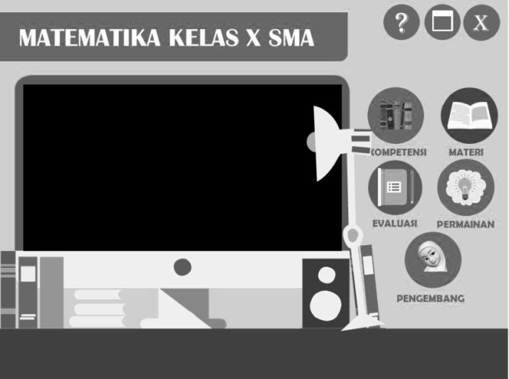****

**Figure 1.** Main menu and flowchart

Figure 1 illustrates that the visual design is made with several interactive multimedia pages on the home page which contains a title with eight other menus, namely instructions, competencies, material, evaluation, games, profile and exit. Help page serves to provide interactive multimedia usage instructions based on the buttons that have been created. The competency page contains basic competencies and indicators of achievement of trigonometric material competencies. The material page contains teaching materials that must be understood by students in learning by doing way, equipped with instructions. The material menu flowchart can be seen in Figure 2. While Figure 3 is an example of one display, namely the material menu.

|  |  |
| --- | --- |
| **Figure 2.** Material menu flowchart | D:\RANI'S FILE\BISMILLAH SKRIPSI AGUSTUS\bahan skripsi\okelah.png  **Figure 3.** Example of one display |

The evaluation page has a problem solving, students can find out the value of the answers obtained, there is a correction button to check the answer of the students is correct or wrong, if the answer of the students is wrong they can repeat the answer. Game pages have puzzles that students must do, besides games to motivate students to learn. Finally, the profile page contains the researcher data, as well as the exit page to exit the program. Figure 4 is an overview of the evaluation page and flowchart.



**Figure 4.** Overview of evaluation displays with a flowchart

From the flowchart, the initial design of the evaluation page is made so that the evaluation page view is obtained as shown in Figure 5.

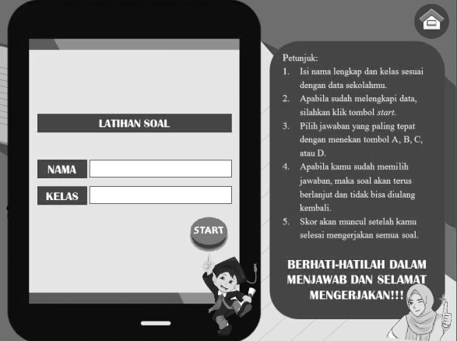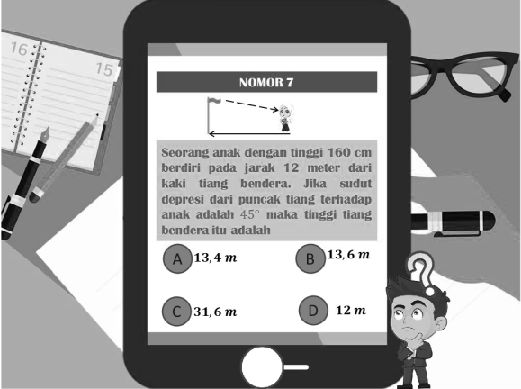

**Figure 5.** Evaluation page display

After making the initial design then go to the development stage. At this stage, the initial design is developed based on suggestions and input from lecturers who are competent in problem-solving, interactive multimedia experts, learning design experts, and mathematics teachers. Furthermore, it is validated including face validity, content validity, and construct validity. Face validity assesses display aspects, colour suitability, editorial readability, image suitability, and flow clarity. The validity content includes conformity between the material with the syllabus and curriculum, the suitability of the material with problem-solving questions and indicators, and conformity to user characteristics. The validity construct consists of content, presentation, and image components. The results of the validation from the math teacher on July 9, 2020, stated that the trigonometry material and the questions were by the 2013 curriculum and syllabus. Also, the validation results from lecturers who are competent in problem-solving that the steps of mathematical problem-solving abilities with indicators of understanding problems, planning solutions, implementing plans and checking the results are declared valid. The drawback is not maximized in exploring student problem-solving. Based on this statement, the arrangement of material with mathematical problem-solving steps in interactive multimedia is suitable for use with improvement.

Validation from learning design experts on 22 and 23 July 2020 stated that interactive multimedia content is by the 2013 curriculum. Colors, images, instructions are clear and are following user characteristics, but the context used is unclear because it lacks images to help understand. Thus learning design experts state that interactive multimedia products to explore students' mathematical problem solving abilities are feasible to use with improvement. The results of the validation from interactive multimedia experts on July 27, 2020 stated that the suitability of interactive multimedia content and graphic components, displays or interactive multimedia designs was declared valid. Based on this statement, interactive multimedia products to explore students' mathematical problem solving deserve to be used with improvement. Validation was carried out several times, the suggestions and input are summarized in Table 1.

|  |  |
| --- | --- |
|  | **Table 1.** Suggestion from experts |
| Validator | Suggestion |
| Material and problem solving experts | 1. Instructions must be clear so that students can understand problem solving 2. Improve the planning completion stage 3. Add information to work on step of implementing the plan 4. Use another method in step looking back |
| Learning design experts | 1. Add information linking between theory 2. Improve the story about problems in everyday life |
| Interactive multimedia experts | 1. Add audio to the animation on out of context 2. Add animation to the correction button 3. Basic competency layout and achievement indicators are put together |

Based on the suggestions of the validators on the initial interactive multimedia design, it is corrected repeatedly so that the final interactive multimedia design is obtained. An example of one page in the final interactive multimedia design can be seen in Figure 6.

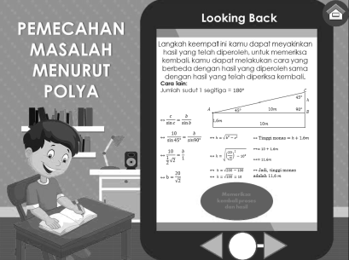 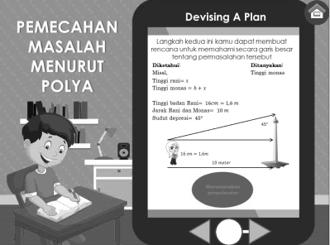 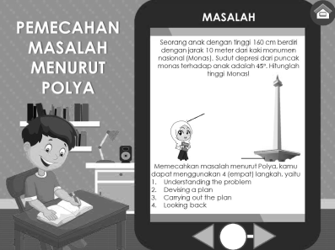

**Figure 6.** Example of final design problem solving display

The next stage of implementation, at this stage interactive multimedia, was tried on a limited basis because the research was carried out in the Covid-19 Pandemic era which did not allow face-to-face learning in class. Interactive multimedia is implemented to a small group of 6 subjects taken purposively from grade 10 IPA 4 high schools in Indonesia. Each subject is taken by 2 people from the high, medium, low achievement groups. After students learn to use interactive multimedia, then they are given a questionnaire to retrieve student response data to interactive multimedia. Student responses can be seen in Table 2.

|  |  |
| --- | --- |
| **Table 2.** Student responses to interactive multimedia | |
| Subject | Response |
| S1 | Directions, editorial, problem-solving can be understood easily and clearly, attractive colours and contrast, audio sounds clear, the animation is very smooth, easy to use, Trigonometric material is easier to understand. Students are motivated to learn Trigonometry because learning varies is not monotonous. In the future, interactive multimedia needs to be made again on other materials so that learning is not boring. |
| S2 | The text is very clear, the images are very clear and neatly arranged, the audio is very clear, the animation is attractive, the language used is short, concise, clear, not too long, easy to understand, very easy to use and effective. I became more enthusiastic about learning trigonometry and I needed to make an application like this for other materials so that I could study anywhere and anytime. |
| S3 | The text and animation are clear, attractive so that they are easy to understand, the images are attractive, the audio is clear, the text is not long, and it is easy to use because the animation fits its function. I am motivated to learn Trigonometry because it is easier with interesting animations. You need to make an application like this for other materials so you don't get bored when studying mathematics. |
| S4 | The text is very clear, the image is very clear, the audio is clear, the animation is attractive, the language is clear, easy to use, can be understood, can be applied. I am very motivated to study Trigonometry. Interactive multimedia needs to be made in the next material to make it easier |
| S5 | The text is clear even though some parts are still confused, the image is very interesting, the audio is quite interesting and adds excitement, the animation is interesting, the language and explanation are quite interesting. Very easy to use, the problem is easy to understand even though the answer is difficult. Increase motivation and enthusiasm for learning Trigonometry. It seems that an application needs to be made in other materials because it is interesting to learn. |
| S6 | There are parts of the text that are less clear, the image is very interesting even though it lacks variety, attractive colours, clear audio and animation, clear editorial. The problem is easy to understand even though it is sometimes confusing. Motivated to understand Trigonometry material and other materials, it needs application too. |

The last stage is evaluation, the subject is given a problem-solving test on Trigonometry. This test is to find out how students understand the Trigonometry material that is learned using interactive multimedia. The results can describe the effectiveness of learning through interactive multimedia. The test results are presented in Table 3.

**Table 3.** Problem solving test results

|  |  |  |  |  |  |
| --- | --- | --- | --- | --- | --- |
| Subject | Understanding problem | Devising a plan | Carrying out the plan | Looking back | Score |
| **S1** | 2 | 3 | 2 | 3 | 10 |
| **S2** | 2 | 3 | 1 | 3 | 9 |
| **S3** | 1 | 3 | 1 | 2 | 7 |
| **S4** | 2 | 2 | 2 | 2 | 8 |
| **S5** | 1 | 2 | 1 | 1 | 5 |
| **S6** | 1 | 2 | 1 | 2 | 6 |
|  |  |  |  |  |  |

Based on Table 3, of the 6 subjects, 4 have reached mastery learning, and there are no subjects who do not answer. Thus interactive multimedia using Adobe Flash CS6 on Trigonometry is effectively used to explore problem-solving.

1. Conclusions

Development of interactive multimedia on trigonometry using Adobe Flash based on problem-solving, suitable for use in learning according to mathematics education experts, multimedia, and users. The initial design of interactive multimedia to explore mathematical problem-solving abilities in trigonometry, shows that the navigation structure has not worked on all elements, the display is not yet colourful and eye-catching, the subject matter presented is not by student characteristics, the sound effect is incomplete. Thus there is still much that needs to be improved by the advice and input from experts. The final design shows that interactive multimedia is easy to use because it is set with a simple navigation system, a colourful and eye-catching display, games and sound effects that make learning mathematics more interesting and the concept of trigonometry easier to understand. User justifies interactive multimedia that text, images, audio, animation, is very clear and easy to understand. Besides, the language used is very clear, the applications and concepts of Trigonometry are easier to understand. Overall user response to the final interactive multimedia design is very good and can help in understanding the concept of Trigonometry.

1. Acknowledgments

The author would like to thank the rector of Universitas Siliwangi, postgraduate director, dean of the faculty of teacher training and education. Besides, thanks to all the experts who have validated interactive multimedia: mathematics education experts, multimedia experts, and mathematics teachers. Also, thanks to students as respondents in the limited test.

References

[1] National Council of Teachers of Mathematics 2000 *Principles and standards for school mathematics* ed National Council of Teachers of Mathematics (Reston, VA: Author)

[2] Nurwijayanti A, Budiyono and Fitriana L 2019 Combining google sketchup and ispring suite 8: A breakthrough to develop geometry learning media *J. Math. Educ.* **10** 103–15

[3] Syawaludin A, Gunarhadi and Rintayati P 2019 Development of augmented reality-based interactive multimedia to improve critical thinking skills in science learning *Int. J. Instr.* **12** 331–44

[4] Setiyani, Putri D P and Prakarsa D 2019 Designing Camtasia Software Assisted Learning Media Toward Students’ Mathematical Comprehension in Numeral Material *Infin. J.* **8** 143

[5] Nisiyatussani, Ayuningtyas V, Fathurrohman M and Anriani N 2018 GeoGebra applets design and development for junior high school students to learn quadrilateral mathematics concepts *J. Math. Educ.* **9** 27–40

[6] Syawaluddin A, Afriani Rachman S and Khaerunnisa 2020 Developing Snake Ladder Game Learning Media to Increase Students’ Interest and Learning Outcomes on Social Studies in Elementary School *Simul. Gaming* **51** 432–42

[7] Yunianta T N H, Putri A and Kusuma D 2019 Development and Comparison of Mathematic Mobile Learning By Using Exelearning 2.0 Program and Mit Inventor 2 *Infin. J.* **8** 43

[8] Fisch S M, Damashek S and Aladé F 2016 Designing media for cross-platform learning: Developing models for production and instructional design *J. Child. Media* **10** 238–47

[9] Son A L, Darhim and Fatimah S 2020 Students’ mathematical problem-solving ability based on teaching models intervention and cognitive style *J. Math. Educ.* **11** 209–22

[10] Ratnaningsih N and Hidayat E 2020 Reflective mathematical thinking process and student errors: An analysis in learning style *J. Phys. Conf. Ser.* **1613**

[11] Wahyudi W, Ambarwati M and Indarini E 2019 Development of Web Game Learning Materials for Primary School Students *Infin. J.* **8** 199

[12] Ratnaningsih N, Hermanto R and Kurniati N S 2019 Mathematical communication and social skills of the students through learning assurance relevance interest assessment and satisfaction *J. Phys. Conf. Ser.* **1360**

[13] Saunders A F, Spooner F and Ley Davis L 2018 Using Video Prompting to Teach Mathematical Problem Solving of Real-World Video-Simulation Problems *Remedial Spec. Educ.* **39** 53–64

[14] Olivares D, Lupiáñez J L and Segovia I 2020 Roles and characteristics of problem solving in the mathematics curriculum: a review *Int. J. Math. Educ. Sci. Technol.* **5211**

[15] Öztürk M, Akkan Y and Kaplan A 2020 Reading comprehension, Mathematics self-efficacy perception, and Mathematics attitude as correlates of students’ non-routine Mathematics problem-solving skills in Turkey *Int. J. Math. Educ. Sci. Technol.* **51** 1042–58

[16] Polya G 1945 *How to Solve It: A New Aspect of Mathematical Method* (Pinceton, NJ: Princeton University Press)

[17] Branch R M 2010 *Instructional design: The ADDIE approach* (New York: Springer Science+Business Media)