**Attractive Way to Teach and Learn Mathematics using Role-Playing Games: A Literature Review**

# S Ramadan1 and W Setyaningrum2

1Graduate Program of Yogyakarta State University, Jl. Colombo No. 1, Karangmalang, Sleman, DI Yogyakarta, Indonesia

2Mathematics Department, Faculty of Mathematics and Science, Yogyakarta State University, Indonesia

E-mail: [saifulramadan.2019@student.uny.ac.id](mailto:saifulramadan.2019@student.uny.ac.id), [wahyusetyaningrum@uny.ac.id](mailto:wahyusetyaningrum@uny.ac.id)

**Abstract**. As technology grows rapidly, education will always get the impact. Research to obtain an attractive way to teach and learn has been emerged due to application of technology. Digital game-based learning is one of many ways to teach in a fun way. Role playing game (RPG), as a part of digital game-based learning, can be implemented to be used in modern class. This study aims to explore how far RPG was developed to be implemented to aid teachers teaching mathematics. Data was obtained from scientific journal, proceeding article, books, and other related sources. The result shows that RPG can be used to provide motivational boost and attitude toward learning mathematics.

**Keyword:** digital game-based learning, role playing game, rpg

## **1. Introduction**

A big jump of technology development in recent years push technology usage to a lot of woks in daily life. We see a lot of people use technology to help them doing works that cannot be done by human easily or simply makes people work easier. We can buy something from home just by using pc or smartphone which is connected to internet and delivered to our home within days. We can play some games with people around the world and communicating with them. But can we use technology for educational purpose? Definitely yes. There are a lot of works has been done by researchers to show that we can use technlogies to aid teacher to teach at class. Moreover, teachers must be creative to find a good way to teach because of COVID-19 pandemic spreads around the world. Students and teachers have to adapt as the only way to hold a class right now is using internet or we called online learning.

Digital Game-Based Learning (or DGBL) has become an educational trend as technology grows rapidly [1][2][3][4]. It is also used in wide variety of subjects [5][6][7]. In [8], DGBL defined as:

“... including everything that has to do with teaching and learning using games, but games for learning should really be viewed from at least two perspectives. One is the perspective of the learner, which considers how people learn from games, and the other is the perspective of the teacher, which looks at how we can teach with games.”

Role-playing games, or simply RPG, is one of the most commonly known form of digital games [9]. Role Playing Game is defined as a game where the player takes a role of a character in the game [8][10]. The character will be played in a situated place and time (usually is fantasy world) where players have to solve some problem to progress or gaining expeiences [1][9].

In subsequent discussions, it will be suggested how RPG, which has been focused on improving the skills needed in learning mathematics. The method used in this study is a literature review, where the focused theme is research and development regarding RPG, which is integrated into mathematics learning. Articles adapted from Science Direct, IEEE, and Researchgate which were compiled from 2010 to 2020.

## **2. RPG Development for Math Learning**

RPG is chosen as suitable game format as it gives learners to determine their action [11], as the user play the role which is simulating the real world and its practical experience [12]. Role play provides situations which learners adopt a role and rehearse future performance to improve their learning performance [12].

**Table 1.** List of role-playing games which have been developed

| **No** | **Research** | **Application** | **Grade** | **Country** |
| --- | --- | --- | --- | --- |
| **1** | M. P. Chen and H. Y. Ren – 2013 [13] | Unknown name | 5th grade | Taiwan |
| **2** | F. Y. Chiu and M. L. Hsieh – 2016 [1] | Unknown name | 2nd grade | Taiwan |
| **3** | A. Wintarti and N. R. Dewi – 2019 [10] | Hello Counselor | Senior High School | Indonesia |
| **4** | C. Cezar et al – 2019 [14] | The Fellowship of the Calculus | University | Brasil |

It is shown that a few games based on RPG genre has been developed by researchers from some countries, of which the recent one are developed in Indonesia. These application is widely developed not only for elementary [13][1] and high school [10], but also can be used to teach at university level [14]. For elementary level, RPG games is used to teach fractional concept and prime number. For high school level, RPG game is used to teach simultaneous linear equation. And RPG game is used to teach calculus for university level.

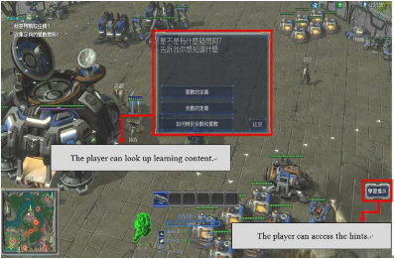

**Figure 1.** Developed RPG for 5th grade [13]

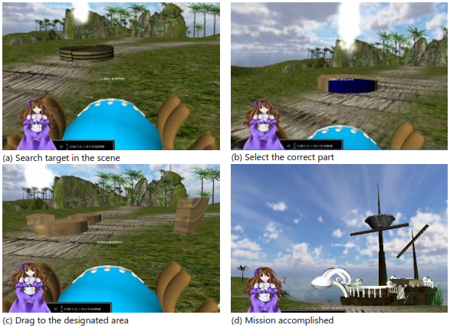

**Figure 2.** Developed RPG for 2nd grade [1]

As shown in Figure 1, the game is developed uisng StarCraft 2 Galaxy Editor –as part of StarCraft 2 game. It is design for learners to study prime number as they complete a couple missions. Learners should accomplished the mission given in the game to proceed to the next mission. The NPC (non-playable character) gives the mission to the player as they want to progress. Each mission has topic related to learn prime number for student at 5th grade. Student can learn defined math concept through exploration and completing the mission. [13]

Most RPG games use top-down camera perspective, while some use another camera perspective shown in Figure 2. This game is developed using Unity 3D. Learners play as virtual character and move using mouse (to move) and keyboard (to look around the environent). To complete this game, the learners will be given some instruction by virtual instructor. Each level in this game is entirely constructed based on textbook content. As each instruction is completed, player can progress to next level.[1]

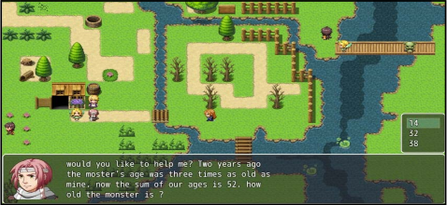

**Figure 3.** Gameplay of Hello Counselor [10]

Figure 3 shows a glimpse of how Hello Counselor is played. The design of this game is to defeat monsters as player get the hint by solving some problem about simultaneous linear equation. This game is developed using RPG Maker MV. There are four major steps to develop games using this game engine:

1. Mapping, designing the area.
2. Setting database, setting character and monster power, sound ffect, background music, etc.
3. Event making, source code which scripted as we intearct to object and the text shown for related interaction.
4. Extractig, extracting the game so the game can be played on another device (for example Android). [10]

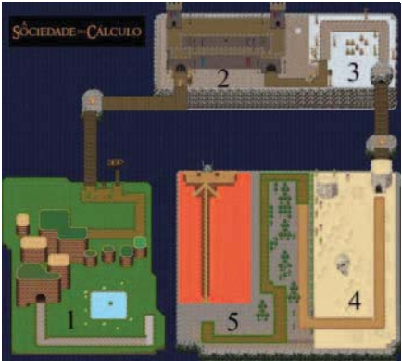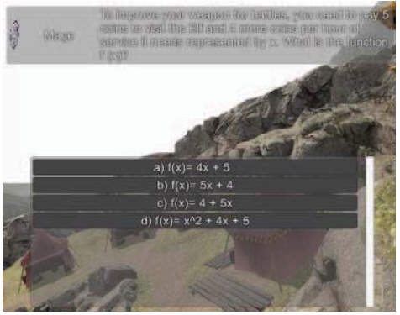

**Figure 4.** Interface of The Fellowship of the Calculus [14]

Another example of the development of RPG to teach mathematics is The Fellowship of the Calculus. This game is developed using a few tools such as Unity, 3ds Max, and Tiled. This game is design for player to complete mission in each cities. The way to advance to the next city is solving calculus problem as a challange and the final problem is presented at the last city. [14]

## **3. Result of RPG Development**

Education is developing rapidly as a result of technology integration in every aspect of our life. So as how teaching and learning shift towards e-learning. Below is a table that shows the results of the research we discuss above related to the development and experiment using RPG-based game.

**Table 2.** Results of research on RPG for teaching mathematics

| **No** | **Research** | **Field** | **Research Methods** | **Results** |
| --- | --- | --- | --- | --- |
| **1** | Designing a RPG Game for Learning of Mathematic Concept (M. P. Chen and H. Y. Ren – 2013) [13] | Prime Number | Experiment | The learners can achieve learning objectives properly by the help of RPG employment. The learners also show positive learning motivation. |
| **2** | Role-Playing Game Based Assesment to Fractional Concept in Second Grade Mathematics (F. Y. Chiu and M. L. Hsieh – 2016) [1] | Fraction Concept | Experiment | The result shows that RPG-based assessment was efffective to promote academic performance and learning attitude. The student show thier satisfaction towards the usage of RPG-based assessment. |
| **3** | The Application of RPG Game ''Hello Counselor'' to Support Students' Self-Study about Simultaneous Linear Equation (A. Wintarti and N. R. Dewi – 2019) [10] | Simultaneous Linear Equation | Research and Development | The result shows that Hello Counselor was practical and effective to support students to learn simultaneous linear equation. |
| **4** | Towards an RPG Game to Teach Calculus (C. Cezar et al – 2019) [14] | Calculus | Research and Development | The prototype test is reulting positive return on usability, confidence and satisfaction. This result shows possibility that game can aid teacher. |

Among these research shown above, they share the same result. All of reasearch above show that a game, especially in RPG genre, can be used as helper for teacher to teach mathematics. Early research on this topic also show that the usage of RPG-based game can motivate student to learn [13], boosts academic performance and learning attitude [1]. These results also prove that RPG-based game, as a part of DGBL, can be used to foster motivation and engagement towards learning [15].

## **4. Conclusion**

There are a lot of possibility to work on developing game based on RPG genre for teaching mathematics. As shown from the review above that many student show positive motivation and learning attitude towards mathematics. Overall, RPG application which is used in these research above shows that a game is not only used for having fun only, but also for education purpose as it can aid teacher so the student is having fun towards learning mathematics. In the future, more reasearch on RPG-based learning can be done to provide more innovative, interactive, interesting way to learn mathematics. It is hoped also to dig deeper on what skill can be achieve by the students to improve their learning attitude and capabilities to reach higher level thinking skill.

# References

[1] F. Y. Chiu and M. L. Hsieh, “Role-playing game based assessment to fractional concept in second grade mathematics,” *Eurasia J. Math. Sci. Technol. Educ.*, vol. 13, no. 4, pp. 1075–1083, Apr. 2017.

[2] A. All, E. P. Nuñez Castellar, and J. Van Looy, “Towards a conceptual framework for assessing the effectiveness of digital game-based learning,” *Comput. Educ.*, vol. 88, pp. 29–37, Apr. 2015.

[3] S. Vandercruysse *et al.*, “The effectiveness of a math game: The impact of integrating conceptual clarification as support,” *Comput. Human Behav.*, vol. 64, pp. 21–33, Nov. 2016.

[4] H. T. Hou, “Exploring the behavioral patterns of learners in an educational massively multiple online role-playing game (MMORPG),” *Comput. Educ.*, vol. 58, no. 4, pp. 1225–1233, May 2012.

[5] B. Brezovszky *et al.*, “Effects of a mathematics game-based learning environment on primary school students’ adaptive number knowledge,” *Comput. Educ.*, vol. 128, pp. 63–74, Jan. 2019.

[6] B. Magerko, C. Heeter, B. Medler, and J. Fitzgerald, “Intelligent adaptation of digital game-based learning,” in *ACM Future Play 2008 International Academic Conference on the Future of Game Design and Technology, Future Play: Research, Play, Share*, 2008, pp. 200–203.

[7] M. Steinicke, “Digital game-based learning as digitization of learning culture,” in *Digitisation of Culture: Namibian and International Perspectives*, Springer Singapore, 2018, pp. 73–96.

[8] K. Becker and K. Becker, “Digital Game-Based Learning: Learning with Games,” in *Choosing and Using Digital Games in the Classroom*, Springer International Publishing, 2017, pp. 25–61.

[9] M. D. Dickey, *Aesthetics and Design for Game-based Learning*. Routledge, 2015.

[10] A. Wintarti and N. R. Dewi, “The Application of RPG Game ‘Hello Counselor’ to Support Students’ Self-Study about Simultaneous Linear Equations,” in *Proceedings - 2019 International Seminar on Application for Technology of Information and Communication: Industry 4.0: Retrospect, Prospect, and Challenges, iSemantic 2019*, 2019, pp. 255–259.

[11] I. Zualkeman, M. Pasquier, M. M. Jibreel, R. S. Zakaria, and R. M. Tayem, “An adaptive learning RPG game-engine based on knowledge spaces,” in *ICETC 2010 - 2010 2nd International Conference on Education Technology and Computer*, 2010, vol. 2.

[12] W.-H. Wu, W.-C. Yan, H.-Y. Kao, W.-Y. Wang, and Y.-C. J. Wu, “Integration of RPG use and ELC foundation to examine students’ learning for practice,” *Comput. Human Behav.*, vol. 55, pp. 1179–1184, Feb. 2016.

[13] M. P. Chen and H. Y. Ren, “Designing a RPG game for learning of mathematic concepts,” in *Proceedings - 2nd IIAI International Conference on Advanced Applied Informatics, IIAI-AAI 2013*, 2013, pp. 217–220.

[14] V. Cezar, P. Garcia, V. Botelho, and E. M. Miletto, “Towards an RPG game to teach calculus,” in *Proceedings - IEEE 19th International Conference on Advanced Learning Technologies, ICALT 2019*, 2019, pp. 116–118.

[15] E. Sanchez, “Game-Based Learning,” in *Encyclopedia of Education and Information Technologies*, Springer International Publishing, 2019, pp. 1–9.