**HOW VIRTUAL REALITY CAN IMPROVE STUDENT MOTIVATION AND SPATIAL ABILITY ?**

**R Rafiu, H Retnawati, M I S Guntur**

Graduate Program of Mathematics Education, Universitas Negeri Yogyakarta, Yogyakarta, Indonesia

E-mail: rafliantirafiu.2018@student.uny.ac.id, heri_retnawati@uny.ac.id, muhamadikhsan.2018@student.uny.ac.id

**Abstract**. Along with the rapid development of technology, the world of education is certainly directed to be able to create competent human resources who will play a role in creating new technologies in the future. For this reason, learning is expected to increase student motivation. Students who are motivated in learning will certainly easily spend their time honing their abilities. In addition to learning motivation, spatial ability is also very much needed as a basic skill that students must have in new days. Of course the two variables can be developed through several learning approaches. One of them is the use of virtual reality technology. This research aims to show why virtual reality can improve student motivation and spatial ability. Data was obtained through literature reviews from reputable scientific journals and books. From the results of the study, it was found that virtual reality increases student motivation and spatial ability. This is inseparable from the concept of virtual reality technology that combines virtual access that looks real so as to make learning more interesting.

1. Background

Development of new technology-based learning media. One of the latest technology products that make changes to the world of education is Virtual Reality (VR)[1]. Virtual reality is defined as a technology that enables users to connect and can do this with spatial data in real time[2, p. 3]. he environment is an environment that is true or really an environment that only exists in access[3]. VR has the ability to present a three-dimensional environment, it is even possible to interact in 360o space. Since the use of these technologies, education offers fantastic things, where learning is not limited to space and time, even angles [4]. Based on a survey conducted by infographics of one thousand K-12 teachers in America, it was stated that 85% of teachers agreed that VR could have a positive impact on student learning. Meanwhile, only 2% of teachers are new to using VR in learning [5]. The survey above shows that VR has a good chance to be used as a learning medium. The process of learning abilities is an important thing in the teaching and learning process[6].

Ability is the ability to perform specific tasks under predetermined conditions. The learning process to achieve abilities is the goal of learning. These abilities are abilities that are described specifically stated and in terms of behavior. According to NCTM, one of the abilities a student must have is problem management [7][8]. In line with the suggestion, the ability of problem problems is very important for students to have because it becomes the basis for students to learn mathematics [9].

ecording to Lies Andriani, problem ability is part of high-order thinking skills [10] Meanwhile, according to Risnawati, problem solving ability is a skill which includes the ability to information, situations, and identify problems with the aim of producing alternatives so that they can take decision actions to achieve goals [11]. One of the triggers for maintaining the ability of the problem manager is students' understanding of the conditions of the given problem. For example, in geometry problems, students are required to understand the situation of geometric shapes in order to solve these geometry problems. For that students must have good spatial skills. Where spatial ability is the ability to manipulate and present spatial visual information. The spatial abilities of "Visualization" "the most complex multi-step tasks"[12], "Spatial Relations" includes "simpler tasks such as accelerated mental rotation of rather simple stimuli", and "Orientation" includes "tasks- tasks in which one has to change perspective changes. ”In addition,“ These spatial abilities are important for map reading and navigation, as well as skills necessary for fields such as pilot training, engineering (eg drafting), architecture (eg, 3D modeling), chemistry / physics / biology (eg, molecular structure) "[13].

Apart from spatial abilities, motivation also affects student learning outcomes [14]. Motivation is one of the factors in students that affect the effectiveness of learning in class. Schunk suggested that motivation has a relationship with learning ability [15]. Motivation brings a reciprocal relationship between the learning process and learning abilities. That is, motivation affects the learning process and the learning process also affects the motivation of students. The ideal learning process also depends on the ability of educators to motivate their students. Slavin suggests that teachers can increase intrinsic motivation by arousing student interest, maintaining curiosity, using various means of presentation, and the use of technology [16]. Based on the above background, it will be very interesting to know how VR can improve spatial abilities and learning motivation.

1. Method

The method used in this research is literature study by collecting various information needed and related to research topics regarding the relationship between virtual reality and spatial abilities and learning motivation. The information needed is collected from searches on Google Scholar to obtain 97,000 articles for the keyword "virtual reality spatial ability" and 89,100 for the keyword "virtual reality learning motivation". From the data that has been collected, only 41 articles were taken that meet the information needed and also take into account reputable journals. The information obtained is then analyzed by looking for the relationship between virtual reality and spatial abilities in learning and the relationship between virtual reality and learning motivation. Lastly, conclusions are drawn from the results of the analysis.

1. Result and Discussion

*3.1 Virtual Reality in Learning*

Virtual reality (VR) is a term used in graphics systems that produce interactive simulations in the form of a visible environment created from a combination of three-dimensional computers and various interference devices where the environment presented provides an immersive experience where users can explore and interact with that environment or in other words, VR can visualize abstract concepts so that they appear concrete[17]. VR technology is divided into two main types which are based on immersive environment and level of interaction. In an immersive environment, VR uses a stereoscopic unit that is useful as a interface for user interaction and visual environments that are mounted on the head such as the use of glasses. besides that VR is also displayed on space-sized screens. As a support tool to maximize interactions that feel real, tools such as gloves, coats, and others are used[18].

Alen et al.[19] Classified immersive VR into:

1. Partially or semi immersive VR where the user can still feel the interaction with the real world or in other words the user is not completely immersed in the world created by VR
2. Fully immersive VR takes the user completely into the visual world created by this technology.
3. Augmented Reality, namely the collaboration of VR and the real world through three-dimensional visuals displayed in the real world.

Currently, VR technology is widely used as a learning tool / media in the knowledge domain. Some non-immersive VR technologies that are utilized in learning include the Wearable Head-Mounted Display (HMD) which is useful for providing experiences to students such as application in architectural spatial design [17], the use of VRML (Virtual Reality Modeling Language) which is used by Song and Lee[20] in learning geometry, VR Physic Simulation (VRPS) by Kim, Park, Lee, Yuk, & Lee in studying wave propagation , namely relative optical rays contained in physics material, and VR also used in the visualization of earth science phenomena in geoscience learning developed by Li at al [18]. The immersive VR developed by Liu, Cheok, Lim and Theng [21] is in the form of a mixed reality classroom to study the solar system using tools such as glass which are used as objects that the user can touch as if they were monitoring the solar system, while studying the system Inocative plant visualization of plant activity can be filled, seed sowing and germination, to photosynthesis where the user must set the right conditions for the seeds to grow.

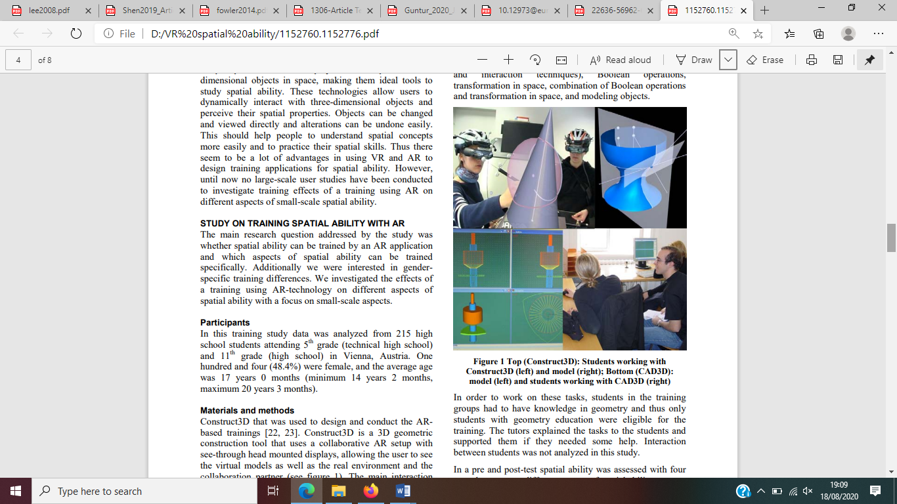

**Figure 1.** VR in Geometry

*3.2 Spatial Ability*

The spatial ability of a person greatly affects his performance in fields that require good spatial abilities. For example, people who work as architects, IT experts, astronauts and many more. In classroom learning, this ability is needed in many fields of science. Like studying geometry in mathematics, geosciences, architecture, or physics. Spatial cognitive abilities are the ability to obtain and utilize spatial information on objects or the environment [22]. It contains a perspective of understanding visual space, geometric shapes, the ability to transform mental images from visual images [20]. Spatial ability refers to a group of cognitive functions and talents that are essential in solving problems that involve the manipulation and processing of visuo-spatial information. The ability to visualize a 3-D object mentally is the main structure of spatial ability where a person can store, maintain, construct observations or mental processes on 3-D objects that may have been moved [23]

In learning, spatial abilities can also be assumed as a person's ability to transfer 3-D information into two-dimensional forms. For example in learning geometry, students are able to describe the shape of a pyramid and can imagine what shape will be formed if there is a change in the position of the pyramid. In learning mathematics, students who have high spatial abilities will find it easier to complete tasks related to spatial shapes [24]. Some researchers compose spatial abilities into three components, namely visual spatial, spatial orientation and spatial relationships. however, it is mapped again into spatial orientation and spatial relationships [25]. The ability to mentally arrange an object on its axis is defined as a spatial relationship while the ability to change and manipulate an object into another state is a spatial orientation [26].

*3.3. learning Motivation*

In doing something, sometimes someone needs encouragement both from within and from outside himself so that the thing that is done gives good results. These urges are often termed motivation. Motivation comes from the word motive, which is the driving force of a person to do something in order to achieve a goal [27]. However, motive is not the same as motivation. According to [15], a motive is a desire that encourages someone to initiate an action. Meanwhile, motivation itself is a process that fosters this desire which is sustainable. That is, it is motivation that moves someone to do something and continues continuously to achieve certain goals. As stated by Scunk & Benedeto [27] that motivation is the process that is instigated by a goal and is trying to be sustained. In addition, Garon & Carier [28] stated that motivation is grown by increasing cognitive ability or in the other hand the situation og cognitive ability can give much inpact. Similarly, Middelton & Spanias explains that “motivation are reasons individuals have for behaving in a given manner in a given situation”. This statement means motivation as a reason that is in a person to behave in an appropriate manner and situation.

In motivation, there are several elements that influence it, such as perceptions, beliefs, interests, and values ​​[19]. The elements that are mentioned as driving and driving a person are certain things. For example, students who have a tendency to certain lessons. Talk about learning motivation, all about how the learning prosses in the class rus effectively. Some condition that effect the intrinsic motivation are cognitive behaviour and interesting learning. How student can be motivating in learning is depend on how the class is running [29].

*3.4 How VR can improve spatial skill and Learning Motivation*

As a technology that is tied to visual depiction, VR has contributed to many studies in improving students' spatial abilities and learning motivation. Research conducted on technical students where students were divided into two groups treated with manipulation of geometric virtual pieces and virtual orientation games, showed that these two activities increased the components of spatial abilities (mental rotation, spatial visualization, and spatial orientation) in the form of abstraction abilities [30]. In research conducted by Dunser at al, using a personal interaction panel (PIP), a tracking table and a pen that allows direct user and content interaction where the development of spatial abilities is found in problem visualization and dynamic interactions with objects. Students can modify models in real time in 3-D space and travel around in their virtual environment. [31]

Perspective taking is suitable for evaluating the effect of real VR interfaces on spatial cognition because: 1) The ability to take perspective has been shown to be associated with body movements, and these movements form the basic interaction conditions of the visible interface; 2) Many tests of perspective-taking ability are available, thus enabling robust evaluation in context with other studies; 3) Perspective taking as a cognitive ability remains malleable, that is, it can change or increase beyond a certain age instead of remaining fixed after childhood, this suggests that intervention can lead to changes in this ability [17], [22]

One of the goals of virtual reality technology is to make users feel the experience of being spatially in a digital environment or it can be called a spatial presence [32]. In some cases, the use of virtual reality shows different results when tested on students with low initial spatial abilities and high ones where students with high spatial abilities show a significant increase in spatial abilities, but for students with low spatial abilities. increases with low presentation. Likewise with the gender category where the results of the study showed that men felt the effect of increasing spatial abilities more than women [33][34].

According to Chung, VR technology in the form of images, animation, video, and text can maximize a person's sensory. This can support increased spatial visualization and geometric reasoning [34]. Basically, the spatial cognitive principle is adopted by VR as a form of visualizing something abstract to something that appears sharp even though it is not real [35].

Talking about student learning motivation, in several studies, VR has been shown to increase student motivation. [36] explains that in learning physics the use of VR improves students' problem-solving and literacy abilities so that this triggers an increase in student learning motivation. In children with cerebral palsy, attractive VR presentations such as color degradation, images arouse children's interest in sports programs with VR. Every child enjoys the process that is running or in other words, they are more motivated to follow the program than just using conventional methods [37]. In addition, Burkhardi explained that virtual reality has the potential to increase student motivation because of the playful aspects contained in this technology. This is influenced because VR can bridge misconceptions from conventional visualization [38]

So is the use of VR in medical students, students can observe certain parts or certain processes more carefully than only when the explanation is completed with 2-D pictures which of course triggers the desire to know more [39]. In line with this, research conducted by Mei & Sheng [16] on human anatomy learning shows that students show more activity during learning and significantly increase their learning motivation. The existence of virtual reality which can be a substitute for indirect objects stimulates someone's interest to explore more of their knowledge. Coupled with interactive images that will bring users to mental experiences that will make an impression on their cognitive and psychological abilities [40].

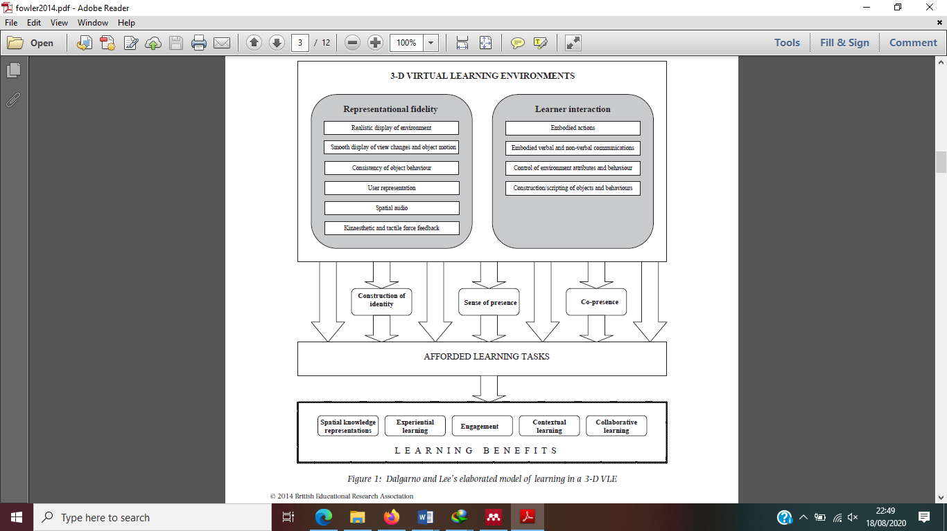

Figure 2. Dalgarno and Lee’s elaborated model of learning in a 3-D VLE[41]

1. Conclution

The explanation above shows how Virtual Reality can improve spatial abilities and learning motivation. Virtual reality as a 3-dimensional space technology is able to provide mental experiences to users in the form of glorious visual captures where abstract perceptions are transformed into forms that are like reality. In other words, VR combines the abstract world with the real world so that it trains users to abstract concepts as if they seem real. This is what supports the increase in spatial abilities where as we know that spatial ability is the ability to capture, process, and use visual capture or concept abstraction. The appearance of VR content is attractive because it gives users the opportunity to explore knowledge through 3D images, color degradation, interactive videos and the ability of users to interact in a virtual reality environment, which will certainly provide an interesting experience. This interesting experience will trigger someone to be motivated in learning.

In learning at school, geometry in mathematics is the material that most needs visual abstraction. For this reason, it is hoped that in the future there will be further research on the use of VR in more in-depth geometric materials.

References

[1] Guntur M I S Setyaningrum W Retnawati H and Marsigit M, 2020 Assessing the Potential of Augmented Reality in Education in *The 11th International Conference on E-Education, E-Business, E-Management and E-Learning (IC4E 2020)--EI & Scopus* p. 93–97.

[2] Whyte J, 2007 *Virtual reality and the built environment* Routledge. Architectural Press.

[3] Sihite, B., Samopa, F., & Sani N A, 2013 Pembuatan Aplikasi 3D Viewer Mobile dengan Menggunakan Teknologi Virtual Reality (Studi Kasus: Perobekan Bendera Belanda di Hotel Majapahit) *J. Tek. ITS* **2**, 2 p. A397-A400.

[4] Guntur M I S Setyaningrum W Retnawati H Marsigit M Saragih N A and Noordin M K bin, 2019 Developing augmented reality in mathematics learning: The challenges and strategies *JRPM (Jurnal Ris. Pendidik. Mat.* **6**, 2 p. 211–221.

[5] Sudana U *et al.*, 2018 Media Virtual Reality Desa Wisata Untuk Pembelajaran Bipa : Apa Dan Bagaimana in *Seminar Internasional Riksa Bahasa XIII* p. 115–120.

[6] Guntur M I S Setyaningrum W Retnawati H and Marsigit M, 2020 Can augmented reality improve problem-solving and spatial skill ? in *International Seminar on Innovation in Mathematics and Mathematics Education* p. 1581.

[7] NCTM, 2000 *The principles and standards for school mathematics.* Reston: National Council of Teachers of Mathematics.

[8] Guntur M I S Setyaningrum W Retnawati H and Marsigit, Jul. 2020 Can augmented reality improve problem-solving and spatial skill? *J. Phys. Conf. Ser.* **1581** p. 012063.

[9] Sugiman, 2013 Student’s competency in solving and creating mathematical problem in pre-service training program *J. Teknol. (Social Sci.* **63**, 2 p. 117–121.

[10] Lies A, 2016 Pengaruh Pembelajaran Matematika Menggunakan Strategi Inkuiri Terhadap Kemampuan Pemecahan Masalah Matematika. Suska *J. Math. Educ.* **2**, 1 p. 52–56.

[11] Risnawati, 2008 *Strategi Pembelajaran Matematika.* Pekanbaru: Suska Pers.

[12] Molina-Carmona R Pertegal-Felices M L Jimeno-Morenilla A and Mora-Mora H, 2018 Virtual Reality learning activities for multimedia students to enhance spatial ability *Sustain.* **10**, 4 p. 1–13.

[13] Rosenthal R Hamel C Oertli D Demartines N and Gantert W A, 2010 Performance on a Virtual Reality Angled Laparoscope Task Correlates with Spatial Ability of Trainees *Indian J. Surg.* **72**, 4 p. 327–330.

[14] Nugroho M H, 2016 Penerapan Model Pembelajaran Realistic Mathematics Education (RME) untuk Meningkatkan Motivasi dan Prestasi Belajar Matematika Materi Statistika Pada Peserta Didik Kelas XI TP3RP SMK Negeri 1 Kendal Tahun Pelajaran 2015/2016 *J. Medives J. Math. Educ. IKIP Veteran Semarang*.

[15] Schunk D H et. al, 2010 *Motivation in education.* Upper Saddle Rive: Pearson Education, Inc.

[16] Slavin R E, 2011 *Psikologi pendidikan: teori dan praktik edisi ke-9* Jakarta Barat: PT Indeks.

[17] Shen C wen Ho J tsung Ly P T M and Kuo T chang, 2019 Behavioural intentions of using virtual reality in learning: perspectives of acceptance of information technology and learning style *Virtual Real.* **23**, 3 p. 313–324.

[18] Lee E A L and Wong K W, 2008 A review of using virtual reality for learning *Lect. Notes Comput. Sci. (including Subser. Lect. Notes Artif. Intell. Lect. Notes Bioinformatics)* **5080 LNCS** p. 231–241.

[19] Paulus E Suryani M Farabi R Yulita I N and Pradana A, 2016 Evaluasi Aplikasi Semi-Immersive Virtual Reality Pada Bidang Pendidikan Menurut Aspek Heuristik dan Pembelajaran (Evaluation of Semi-Immersive Virtual Reality Applications in Education According to Heuristic and Learning Aspects) *JIKO (Jurnal Inform. dan Komputer)* **1**, 2.

[20] Song K S and Lee W Y, 2002 A virtual reality application for geometry classes *J. Comput. Assist. Learn.* **18**, 2 p. 149–156.

[21] Theng Y L Mei-Ling C L Liu W and Cheok A D, 2007 Mixed reality systems for learning: A pilot study understanding user perceptions and acceptance *Lect. Notes Comput. Sci. (including Subser. Lect. Notes Artif. Intell. Lect. Notes Bioinformatics)* **4563 LNCS** p. 728–737.

[22] Chang J S K *et al.*, 2017 Evaluating the effect of tangible virtual reality on spatial perspective taking ability *SUI 2017 - Proc. 2017 Symp. Spat. User Interact.* p. 68–77.

[23] Lajoie S P, 2008 Metacognition, self regulation, and self-regulated learning: A rose by any other name? *Educ. Psychol. Rev.* **20**, 4 p. 469–475.

[24] Kaufmann H Csisinko M Strasser I Strauss S Koller I and Gluck J, 2008 Design of a Virtual Reality Supported Test for Spatial Abilities *Proc. Int. Conf. Geom. Graph.* p. 2008.

[25] Merchant Z Goetz E T Keeney-Kennicutt W Cifuentes L Kwok O and Davis T J, 2013 Exploring 3-D virtual reality technology for spatial ability and chemistry achievement *J. Comput. Assist. Learn.* **29**, 6 p. 579–590.

[26] Hartman N W Connolly P E Gilger J W Bertoline G R and Heisler J, 2006 Virtual reality-based spatial skills assessment and its role in computer graphics education *ACM SIGGRAPH 2006 Educ. Program, SIGGRAPH ’06*.

[27] Schunk D H and DiBenedetto M K, 2020 Motivation and social cognitive theory *Contemp. Educ. Psychol.* **60** p. 101832.

[28] Garon-Carrier G *et al.*, 2016 Intrinsic Motivation and Achievement in Mathematics in Elementary School: A Longitudinal Investigation of Their Association *Child Dev.* **87**, 1 p. 165–175.

[29] OXFORD R and SHEARIN J, 1994 Language Learning Motivation: Expanding the Theoretical Framework *Mod. Lang. J.* **78**, 1 p. 12–28.

[30] Martín-Gutiérrez J García-Domínguez M Roca-González C Sanjuán-HernanPérez A and Mato-Carrodeguas C, 2013 Comparative analysis between training tools in spatial skills for engineering graphics students based in virtual reality, augmented reality and PDF3D technologies *Procedia Comput. Sci.* **25** p. 360–363.

[31] Martín-Gutiérrez J Mora C E Añorbe-Díaz B and González-Marrero A, 2017 Virtual technologies trends in education *Eurasia J. Math. Sci. Technol. Educ.* **13**, 2 p. 469–486.

[32] Coxon M Kelly N and Page S, 2016 Individual differences in virtual reality: Are spatial presence and spatial ability linked? *Virtual Real.* **20**, 4 p. 203–212.

[33] Billen E, 2004 Gender Differences In Spatial Ability Within Virtual Reality . Table of contents ...................................................................... II List of tables ........................................................................... XII List April.

[34] Kwon O N, 2003 Fostering spatial visualization ability through web-based virtual-reality program and paper-based program *Lect. Notes Comput. Sci. (including Subser. Lect. Notes Artif. Intell. Lect. Notes Bioinformatics)* **2713** p. 701–706.

[35] Lee E A L and Wong K W, 2014 Learning with desktop virtual reality: Low spatial ability learners are more positively affected *Comput. Educ.* **79** p. 49–58.

[36] Al-Amri A Osman M and Musawi A Al, 2020 The effectiveness of a 3D-virtual reality learning environment (3D-VRLE) on the omani eighth grade students’ achievement and motivation towards physics learning *Int. J. Emerg. Technol. Learn.* **15**, 5 p. 4–16.

[37] Bryanton C Bossé J Brien M McLean J McCormick A and Sveistrup H, 2006 Feasibility, motivation, and selective motor control: Virtual reality compared to conventional home exercise in children with cerebral palsy *Cyberpsychology Behav.* **9**, 2 p. 123–128.

[38] Sun R Wu Y J and Cai Q, 2019 The effect of a virtual reality learning environment on learners’ spatial ability *Virtual Real.* **23**, 4 p. 385–398.

[39] Article R, 2020 Effects of a virtual reality game on learning performances and motivation : example of Nanoviewer in the field of energy storage **57** p. 111–116.

[40] Huang Y C Backman S J Backman K F McGuire F A and Moore D W, 2019 An investigation of motivation and experience in virtual learning environments: a self-determination theory *Educ. Inf. Technol.* **24**, 1 p. 591–611.

[41] Fowler C, 2015 Virtual reality and learning: Where is the pedagogy? *Br. J. Educ. Technol.* **46**, 2 p. 412–422.