Visual Basic Application for Excel Learning Media with Synthesis Program Method on Mathematical Problem Solving Ability of Prospective Teachers
Martin Bernard^{1, a)}, Herman Dwi Surjono^{1,2,3 b)} and Sri Andayani^{1,2, 3, c)}
^{1,2,3} Universitas Negeri Yogyakarta
^{a)} martinbernard.2021@student.uny.ac.id
^{b)} hermansurjono@uny.ac.id
^{c)} andayani@uny.ac.id

Abstract. Abstract. College students or prospective teachers are the most important sources of knowledge to improve the quality of students' abilities in schools in preparing students to face industrial technological advances at the time and in the future. Prospective teachers must be able to master technology which changes continuously every day, which is currently leading to the development of digital technology. from a prospective teacher is to utilize technology into a medium that helps understand students to solve mathematical problems, where a media is in the form of several images created through several stages that must be solved through the preparation of a language program systematically from the ideas of a prospective teacher. The method used for making media is the Program Synthesis method with 4 stages, namely Specification, Synhesizier, Verification, and feedback. This method will show the effect on the problem solving indicators when using Visual Basic for Application Excel until the creation of a media. In the results of the study, it was found that making learning media using VBA for Excel through the synthesis method was better than making VBA for Excel learning media using the usual way.

INTRODUCTION
Information and communication technology is a very important role in every system in various fields, from the smallest to the largest, and of course, this role cannot be separated from the world of education other than in the industrial world. The times, always require us to master technology and create applications that can make it easier for users to run systems that suit their needs. Meanwhile, to master technology, we must first pay attention to several factors, first, analyzing the situation that occurs, second, designing the concept of making storylines in the form of scenarios and development in development based on analysis, and third, develop technology by considering how to overcome what is happening in the field. . In the field of education, users or teachers often take advantage of digital-based technology which has a very large scope of information and can encourage people to explore and develop technology more openly and creatively as they learn it ¹.
A teacher or prospective teacher (student) in this century must be able to master technology, the goal is to give importance to the use of technology in the future, s that students are able to develop creative ideas and create innovations, as well as students who dare to make the right decisions ² . The technology that is very well known today is the development of ICT-based technology which is now rife in schools, from the education school level to the university level. However, it should be noted that technology development is not a teacher's idea but a medium that helps to explain mathematics material as a more interesting and interactive learning.

REVIEW OF LITERATURE
Visual Basic Application Learning Media

The development of VBA Word and Excel does not only develop static limited learning but can also become the development of game media that can interact with students during teaching and learning³. In this study, to construct junior high school students there are 3 important steps that make a medium, namely 1) observing student difficulties that occur based on students' difficulty working on student questions; 2) describe and make steps for learning strategies and strategies for positioning the media delivery section appropriately; 3) Making media as an illustration to help teachers or students explain in the abstract; 4) media and improve media as evaluation materials to improve the thinking skills of first school students⁴.

Program Synthesis

The steps of the Synthesis program model, that the programming language was made before the topic of the story was made in general, then the purpose of the question like what or called the original question, after the program language was compiled based on the scenario story in stages to focus on the selected function, then finally tested that the media is in accordance with the results of the answers to the Sleep question, if not appropriate for students to improve the language program by paying close attention to the scenarios or stories made^{5,6}
The purpose of the Synthesis program is to check and improve work using VBA Word and Excel coding if there are errors made by students according to the objectives to be achieved by a good media so as to create a model that describes mathematical concepts⁷.

Problem solving skill

The ability to solve problems is the ability that must be possessed by a prospective teacher to describe non-routine questions. Because prospective teachers provide a good way of solving math problems to students with the aim of preparing future students to face industrial progress⁸. Mathematical problems are a very important material in learning, especially for prospective teachers and students, where prospective teachers must improve their creative abilities and solve problems by utilizing technology that creates mathematics learning media so that students are able to understand and solve problems independently. Of course, it is hoped that there will be collaboration between prospective teachers and their students to develop problem-solving skills⁹. In the use of technology developed by prospective teachers, it is necessary to pay attention to indicators of problem solving as a material for measuring ability according to polya¹⁰ by proposing 4 phase steps, namely 1) Understanding the problem; 2) Planning a settlement; 3) Solve problems; and 4) Re-checking all the steps that have been done.

REsearch methods
The research was conducted for 6 months, on two classes at one of the Cimahi universities, consisting of 31 prospective control class teachers, namely making learning media using VBA for Excel through the usual method and 33 prospective teachers in experimental class, namely making learning media using VBA for Excel through Program Synthesis Method. The purpose of this research is whether the class that makes learning media using VBA for Excel through the Program Synthesis method is better with the usual method?
The research method used to create learning media is the synthesis program method¹¹, namely 1) Determining the chosen topic according to level, this selection is carried out at the junior high school level, with various materials to be discussed; 2) Syntetizer, which is to create a scenario based on the scope of the selected material, then create questions that aim to develop the material into an interactive medium as input, after that, the scenario is transformed into the VBA for Excel language as the output code; 3) Verification, namely re-checking the results of the VBA for Excel language into the Microsoft Excel Developer menu to the Visual Basic for Applications section to see the results; 4) Feedback, which occurs if there is a discrepancy with the initial design regarding the problem solving process and adding back the necessary programs so that the media is getting better^{12–14}.

RESULT AND DISCUSION
After conducting research for 6 months on two classes, namely the control class and the experimental class, the assessment data obtained from the work of making learning media based on five criteria, namely 1) Interesting topics; 2) how to solve problems from developing scenarios that are systematically arranged, containing learning strategies, hypotheses, preparations for tackling when students have difficulty understanding the material when using media; 3) Writing program languages ​​based on creative and effective ideas, namely saving on writing the VBA for Excel program language; 4) The workings of the media results by observing the problem solving process; and 5) A written report of the steps of making and explaining the learning media using VBA for Excel.
The results of the assessment data are processed, to obtain hypothetical answers, whether the VBA for Excel learning media using the Program synthesis method on the problem solving abilities of prospective teachers is better than the usual method.

Table1. Descriptive Statistics
 | N | Minimum | Maximum | Mean | Std. Deviation
Control | 30 | 60 | 82 | 77.07 | 4.533
Experiment | 30 | 68 | 92 | 81.43 | 8.110
Valid N (listwise) | 30

Based on the table 1 the average value of learning the VBA for Excel ICT application using the Synthesis Program is higher, namely 81.43 compared to the average value of learning the VBA for Excel ICT application in the usual way, which is 77.07. However, the mastery ability of students learning the VBA for Excel ICT application using the usual method was more evenly distributed with a standard deviation value of 4.53 compared to learning the VBA for Excel ICT application using the Synthesis Program.

Tabel 2. Normality Test of Both class
 | Kolmogorov-Smirnovª |  |  | Shapiro-Wilk
 | Statistic | df | Sig. | Statistic | df | Sig.
Control | .308 | 30 | .000 | .714 | 30 | .000
Experiment | .158 | 32 | .054 | .892 | 32 | .005
The first step, experimental and control value data, was tested with a normality test, and it was found that the control value data had a significant value at Kolmogorov-Smirnov 0.000 < 0.05 meaning the control data was not normal, while the experimental value data had a significant value Komogorov-Smirnov 0.054 > 0.05, normal experimental value data. Because one of the control and experimental data values ​​is not normal, it is considered that both are not normal, as well as if tested for normality using Shapiro-WIlk, the control and experimental data values ​​are less than 0.05, which means that the control and experimental data are not normal.

Tabel 3. Test Mann-Whiyney
 | Value
Mann-Whitney U | 279.500
Wilcoxon W | 744.500
Z | -2.555
Asymp. Sig. (2-tailed) | .011
The second step, because the control data and experimental data were not normal, then continued with the Mann-Whiteney test to conclude the difference in the control and experimental data values ​​and the significant value obtained was 0.011 < 0.05, meaning that there was a difference in the average value of the control class. and experimental class value data. Based on the results of the average scores from the control and experimental classes that the average value of the experimental class is greater than the control class, it means that the VBA for Excel learning media using the synthesis program method on problem solving abilities is better than the VBA for Excel learning media using the usual way.
The research activity was carried out on 2 classes consisting of 31 students of mathematics education in the control class and 33 students in the experimental class, and the implementation for the experimental class of the learning process in the classroom was based on steps that were adapted to the synthesis program, with the aim that student learning could improve problem solving abilities.

Select topic as specification

In this section, the lecturer gives students the opportunity to choose a topic that will become a learning medium by using VBA for Excel software. After that, the topic is made based on an agreement from lecturers and students on junior high school or high school material.

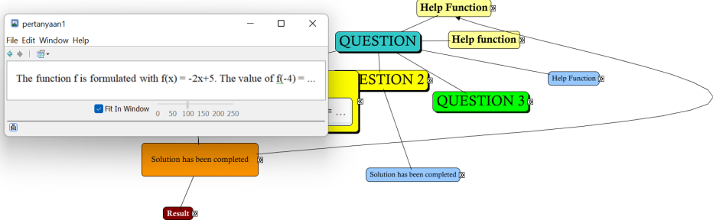

Figure 1. Create topics and questions

Figure 1 explains how to prepare the topic to be discussed. Students will observe from the questions and come up with new ideas or ideas to compose a scenario¹⁵.

Original Question

In this step, students are given questions related to the topic. The purpose of which will be made into the output of learning media in the form of interactive images according to the desired questions in Microsoft Excel software.

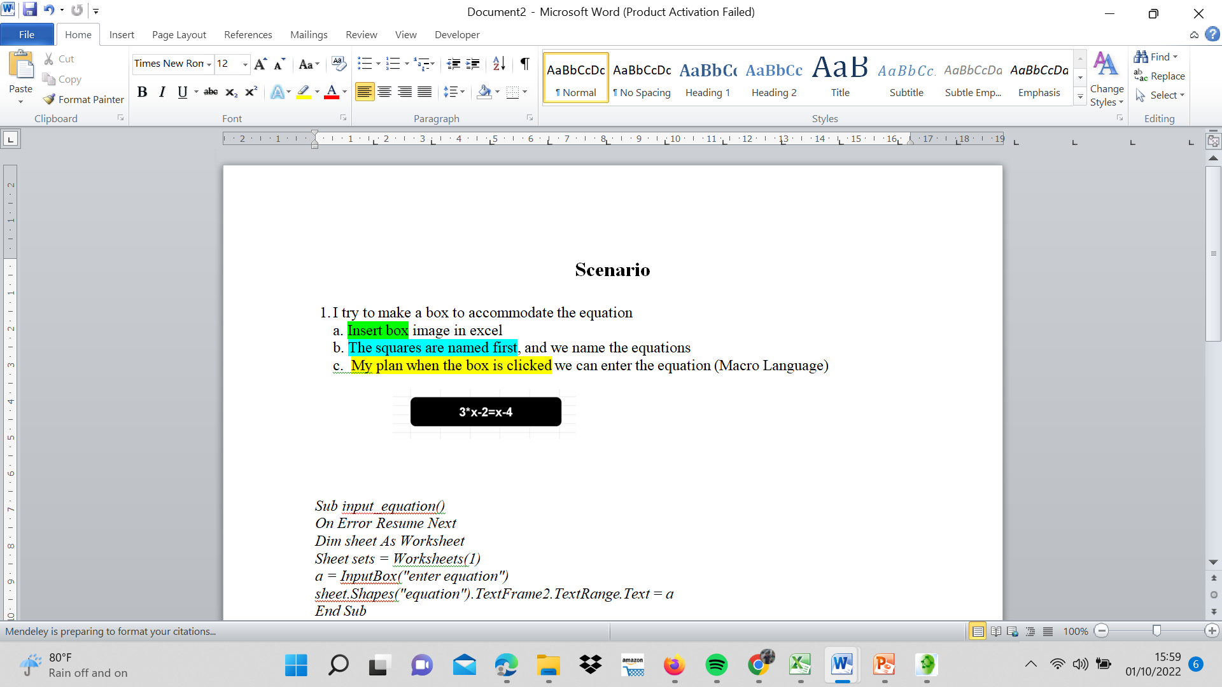
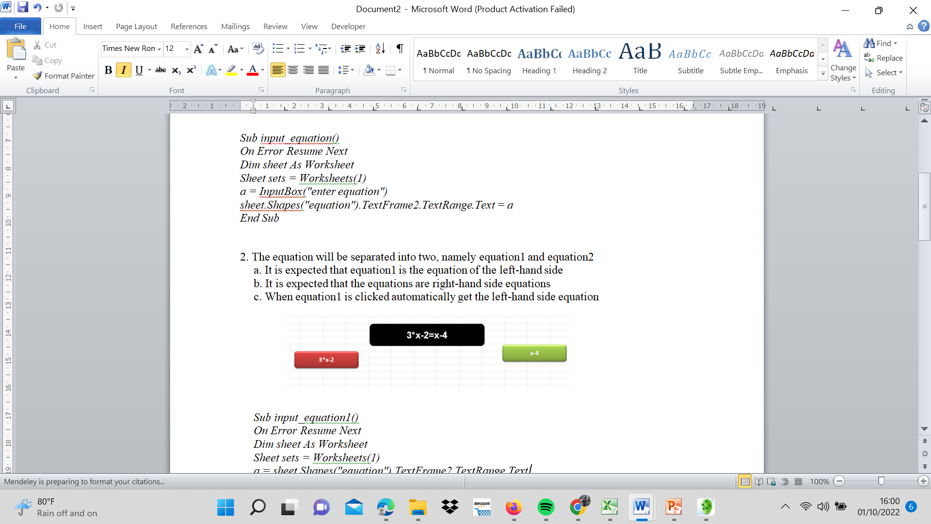

Figure 2. Scenario Creation

Figure 2 explains about making a strategy for making media through systematic scenario preparation from the initial process to the final process to making media according to learning objectives when the media can provide understanding to students when delivering in class.
Scenarios are explained based on the experiences of students who are told where there are obstacles for junior high school students or high school students who experience problems when delivering math material. Also in the content of the scenario, lecturers and students jointly issue their ideas to help students solve problems on math problems¹⁶.
In addition to strategies and ways to solve problems, scenarios provide questions to create a new hypothesis on the media when implemented to students in class, but have prepared stories to overcome the problems that will occur.

Codex Input

Lecturers and students discuss, by making scenarios based on several questions that compose a medium using everyday language before converting it into the VBA for excel program language.

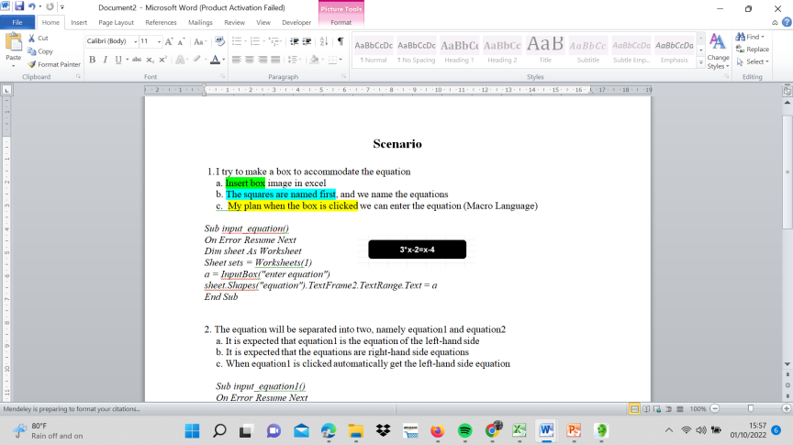
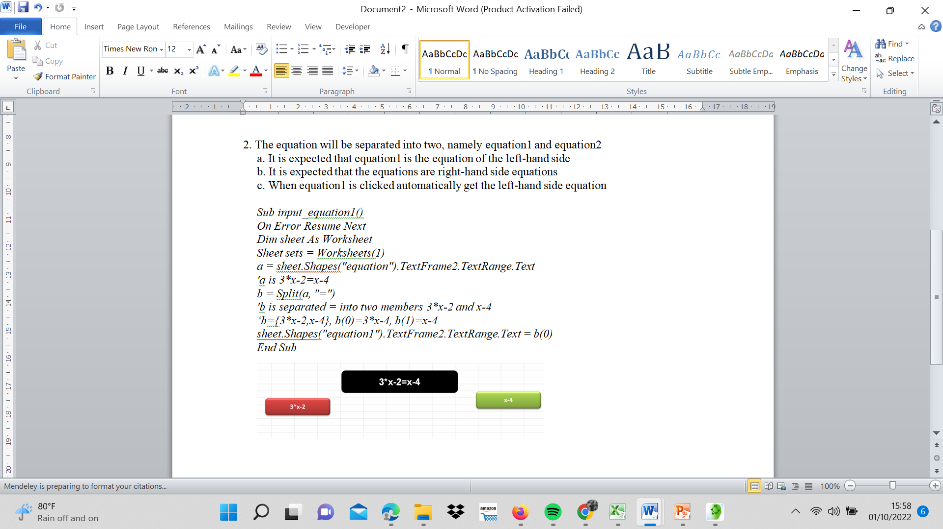

Figure 3. Codex Input Generation

Figure 3 describes the creation of code input in stages and systematically based on scenarios made from the everyday language used, then the meaning is transformed according to the VBA for excel program language. At this stage the lecturers and students both observe the suitability of the language by explaining the functions provided in VBA for Excel. The completeness of the program language will be prepared to be included in a module through the developer menu which will run on Visual Basic for Application in Microsoft Excel whether the program can run properly or not.

Codex Output

The output of the codex, from the arrangement of scenarios written based on questions, lecturers and students were discussed again by compiling a systematic algorithm using VBA for the excel language, then tested to see the final result in the form of media, whether the results were appropriate or not. . If it does not match, then the VBA for Excel program language is re-evaluated to enter the synthetic stage, which is to equate the topics and initial questions until the VBA for Excel media creation has been adjusted.

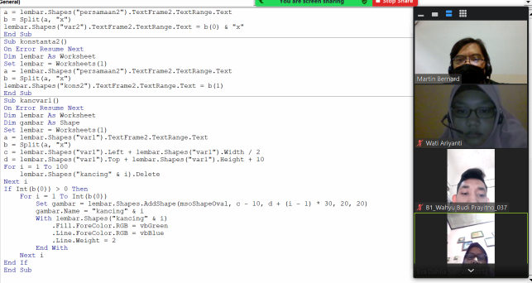

Figure 4. Codex Output Generation

Figure 4 explains that the creation of the output code is entering the code that has been adapted to the written scenario that is considered good, then executed by pressing the buttons in Microsoft Excel by paying attention to the details of the course of the media.
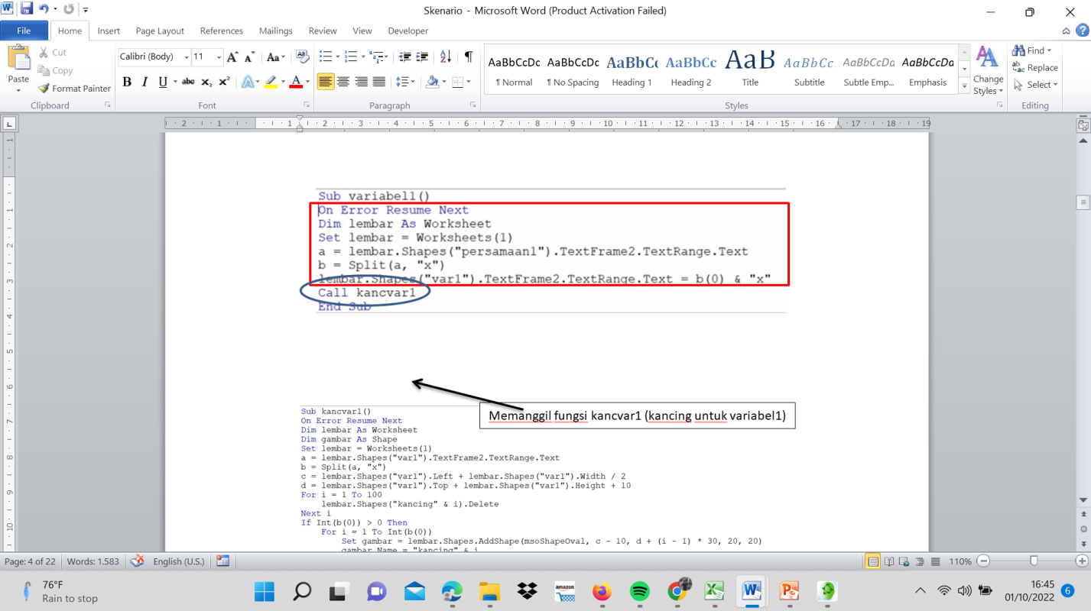
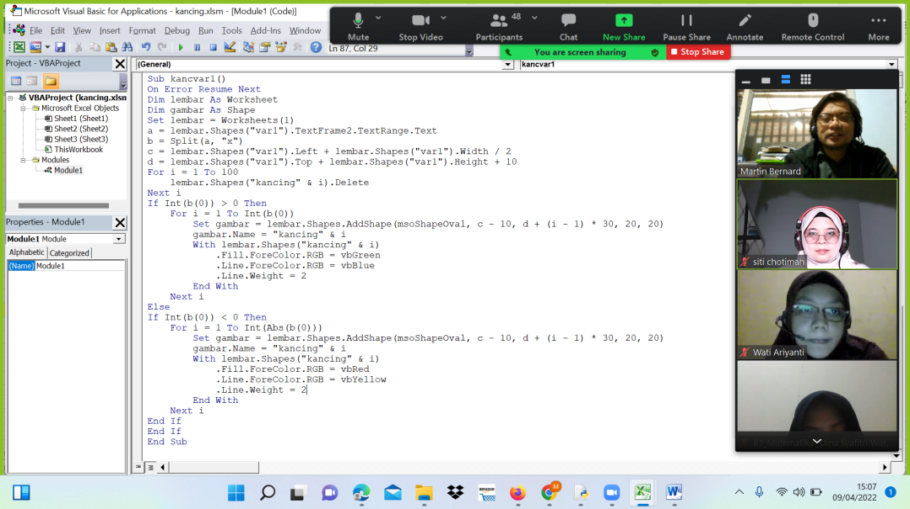

Figure 5. Evaluation Media

Figure 5 describes the evaluation of media by adding coding in VBA for Excel so that the media becomes more interactive and interesting. This approach becomes an effective way when students create with different materials.

Tabel 4. Student Activities in VBA for Excel Problem Solving Skills using the Synthesis Program method
Program Synthesis Method | The problem that happened | Mathematics Media using VBA for Excel | Student Problem Solving Ability | Student achievement
Specification | The choice of topics in the material is based on problems that occur based on student experience while teaching in the field | the pictures that will be designed based on | Promotes problem understanding of the topic, and organizes data. Problem. | Students are able to make pictures that are arranged to provide stages of explanation
Synthesiser | Discussion activities between lecturers and students by producing scenarios in the form of writing in the form of problem hypotheses, learning strategies, and process analysis from beginning to end | Setting up the Developer menu to create VBA coding commands for Excel to suit the scenario | Presenting mathematical problems in the form of scenarios and problem solving methods, and developed into VBA for Excel. | Students can develop algorithms from VBA for Excel commands both input and output codes.
Verifier | see the compatibility with the previous goal, so it is necessary to evaluate the media | VBA for Excel that has been created needs to add new coding to make the media function more flexible, and reduce it if it is not needed. | Identification of known elements and their adequacy | Students are able to identify by making notes of the advantages and disadvantages of the media and then adding new functions to make the media better
Feedback | As additional reference material on the initial topic after the media runs so that the desired media can be achieved as learning objectives for students. | VBA for Excel commands to form media that needs to be readjusted for math learning purposes. | Ability to check or re-check the media that has been created. | Students begin to realize the importance of learning by utilizing images, sounds and text that are not too excessive.

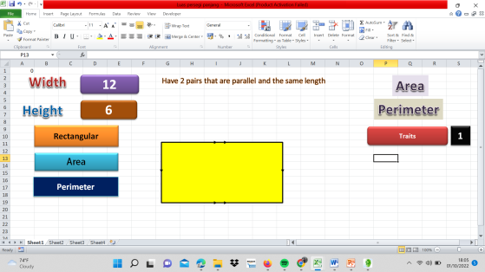
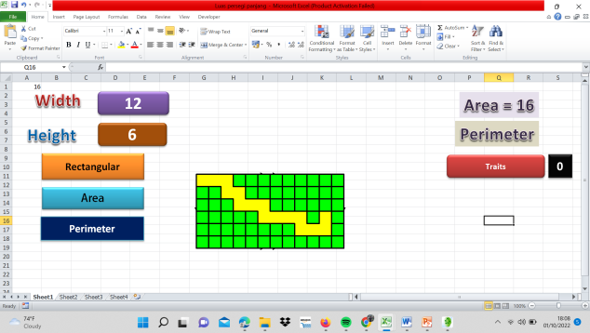
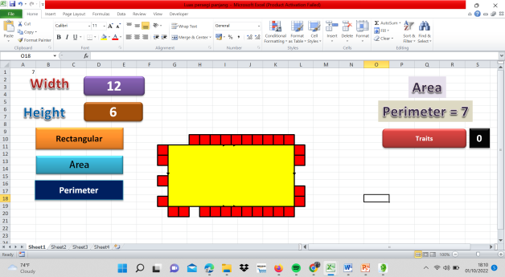
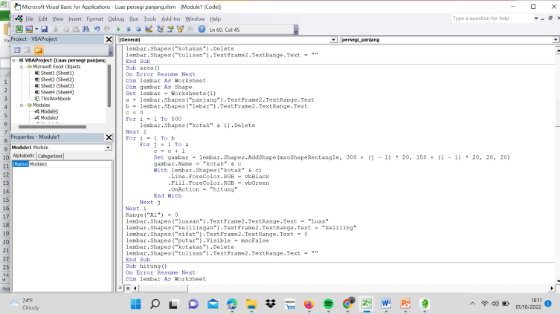
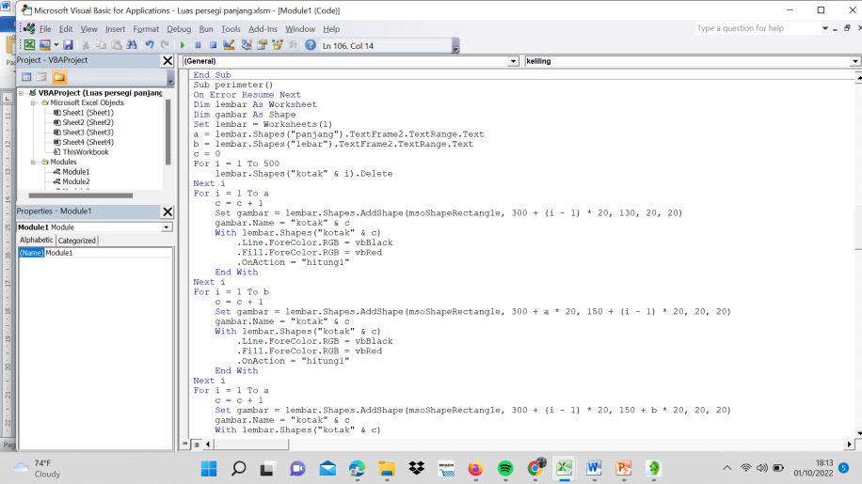

Figure 6. Example of Student Results using the Synthesis Program

Figure 6 describes the results of the process of making mathematics learning media with rectangular topics with synthesizer steps in the input code in the form of questions to interpret the topic, namely how prospective teachers can add to students about the area, perimeter, and properties of rectangles using VBA for Excel through a synthetic program approach, at first when running student media was constrained by the VBA for Excel program language which gave rise to many images, but after knowing the functions using for and next and also the definition of shapes for various forms, prospective teachers could facilitate the making of the media.

Conclusion
Based on the results, the VBA for Excel learning media using the program synthesis method is better than the VBA for Excel media using the usual method on problem-solving skills for prospective teachers. At the specification stage, prospective teachers can understand the topic and make plans by inserting each image into the Microsoft Excel display. Then at the synthesizer stage, students are able to create scenarios and start trying to systematically create VBA language program algorithms for Excel. Then at the verifier stage, students make important notes on the results of the media made through pictures and how the media works, and the last stage is feedback, where students begin to realize media improvements that need to be added or subtracted so that the media objectives are in accordance with the learning objectives.

AKNOWLEDGMENT
To the Siliwangi Institute of Teacher Training and Education for providing the opportunity to conduct research for students or prospective teachers who are ready to practice in schools, and also to Yogyakarta State University for their support to conduct and input on research results.

References
1. M.C.L. Huang, C.Y. Chou, Y.T. Wu, J.L. Shih, C.Y.C. Yeh, A.C.C. Lao, H. Fong, Y.F. Lin, and T.W. Chan, Interest-Driven Video Creation for Learning Mathematics (Springer Berlin Heidelberg, 2020).
2. G. Rahayu, H. Arga, D. Altaftazani, and M. Bernard, 370, 42 (2019).
3. M. Bernard, E. Dwi Minarti, and M. Hutajulu, Int. J. Eng. Technol. 7, 732 (2018).
4. X. Fang and R. Liu, Eurasia J. Math. Sci. Technol. Educ. 13, 5597 (2017).
5. I. Drori, S. Tran, R. Wang, N. Cheng, K. Liu, L. Tang, and ..., ArXiv Prepr. ArXiv … (2021).
6. M.S. Prokopyev, E.Z. Vlasova, T.V. Tretyakova, M.A. Sorochinsky, R.A. Solovyeva, M.S. Prokopyev, E.Z. Vlasova, T.V. Tretyakova, M.A. Sorochinsky, and R.A. Solovyeva, Propósitos y Represent. 8, (2020).
7. D. Fitzpatrick and A.I. Karshmer, 644 (2004).
8. T. Hidayat, E. Susilaningsih, and C. Kurniawan, Think. Ski. Creat. 29, 161 (2018).
9. M. Rojas, M. Nussbaum, P. Chiuminatto, O. Guerrero, S. Greiff, F. Krieger, and L. Van Der Westhuizen, Comput. Educ. 175, 104313 (2021).
10. E. Setiawan, G.M. Muhammad, and M. Soeleman, Mosharafa J. Pendidik. Mat. 10, 61 (2021).
11. N. Popov and T. Jebelean, Math. Comput. Simul. 79, 2302 (2009).
12. E.E. Rohaeti, M. Bernard, and R.B. Primandhika, J. Math. Educ. 10, 59 (2019).
13. M. Bernard and S. Chotimah, AIP Conf. Proc. 2014, (2018).
14. S. Chotimah, M. Bernard, and S.M. Wulandari, J. Phys. Conf. Ser. 948, (2018).
15. K. Powers, Nurse Educ. Today 86, 104324 (2020).
16. Y. Kishita, Y. Mizuno, S. Fukushige, and Y. Umeda, Technol. Forecast. Soc. Change 160, 120207 (2020).

