**Calculator-assisted mathematics learning enrichment model design for grade 8 junior high school students**

**C M S Sumantri1*, Sugiman2, H Retnawati2**

1 Postgraduate of Mathematics Education, Universitas Negeri Yogyakarta, Indonesia

2 Department of Mathematics Education, Faculty of Mathematics and Science, Universitas Negeri Yogyakarta, Indonesia

*Corresponding author: cahyamssumantri@gmail.com

**Abstract.** Enrichment learning is given to students who have completed mastering the competence of a material by providing additional learning activities that contain activities, one of which is problem solving. The use of technology in learning is one way to attract students' attention and motivation to further explore the material being studied. One form of this technology is the calculator, where a more sophisticated technology will have an effect on the calculator function itself. Initially used only for basic calculations, it will be developed to be able to tackle calculations that permit the use of formulas. In this article, we will discuss the model or design of a calculator-assisted enrichment learning tool for grade VIII Junior High School students and its application in enrichment learning. This research includes developmental research using the *Plomp* development model, consisting of preliminary research, prototyping stage, and assessment phase. The enrichment learning tools developed consisted of lesson plans, calculator-assisted student activity sheets, and calculator-assisted final tests. Based on the results of the questionnaire, the average student said that through calculator-assisted enrichment learning, they gained new knowledge and became appalled because they had just learned about other functions of calculators apart from simple calculations. In addition, mathematics teachers have the desire to use calculators in several mathematics learning.

1. **Introduction**

The world of education has several supporting elements, one of which is the students. Likewise with the different characteristics of students, where there are students who have high, medium, and low intelligence aptitudes. According to Wulan each individual must have different talents, characteristics, and aptitudes [1]. by therefore they will get learning facilities that are also different, for example students with special needs need educational services that are different from other students. According to Permendikbud Number 104 of 2014, enrichment learning is given to students who have completed their mastery of learning competencies, where the enrichment program is a more thorough and expansive mastery of the competencies being studied [2]. In contrast to learning during regular school hours, enrichment has a more relaxed learning style and focuses on various kinds of activities carried out by students. As in Compton's book, the enrichment model is specifically designed to make learning more relaxed and involve all students by selecting various activities and including them in the learning process [3]. Thus, enrichment learning does not always have to do practice questions, but can also do activities outside the classroom or use the help of assisting media to provide new experiences and knowledge for students.

In addition, enrichment learning has several roles, namely (1) maintaining the enthusiasm of students and reducing boredom; (2) offers challenges for students; (3) provide the opportunity to do cell-activity; (4) provide a deeper mathematical understanding; and (5) helping students to discover potential and stimulate personal growth [4]. Thus, the enrichment learning carried out has benefits for students not only in terms of science but also psychological benefits for students. This is supported by the statement of Jones and Simons who say that enrichment learning materials designed to show a broader picture of mathematics can encourage students to interpret mathematics as a subject that is interesting enough to do outside of school hours [5]. In addition, in enrichment learning, the teacher usually provides practice questions with various kinds of problems for students to solve. The goal of the teacher in giving this problem is in addition to developing thinking skills, but also to assist students in developing basic skills to solve everyday life problems [6].

The use of technology in education facilitates the process in the formation of mathematics classrooms, on the other hand, this tool contributes greatly to attracting students' attention and motivating them in learning [7]. One technology that is increasingly advanced in terms of its physicality and features is a calculation tool which is better known as a calculator. In line with Shaughnessy that STEM-based education refers to problem solving that refers to concepts and procedures from mathematics and science while combining teamwork and design engineering methodologies and using appropriate technology [8]. Thus, the use of technology such as calculators in the learning process experienced by students is an example of the application of STEM which refers to the increasingly sophisticated technology in calculators today. Technology is needed in classroom learning, such as computers, cellphones, calculators. Agree with the NCTM which suggests using technological assistance, one of which is a calculator in mathematics learning so that teachers do not need to use chalk, markers, blackboards, pencils, and textbooks frequently [9].

The calculator is one of the elements of the success of large-scale adoption of information technology in education and connects the use of technology with increased student achievement [10]. Such as findings in the Kent’s book which states that students who are classified as weak make progress in mathematics when the use of calculators is available [11]. Other researchers, namely Amanyi, Sigme, and Lloyd who concluded in their research indicated that teachers have a positive perception of the use of calculators in mathematics learning [12]. In this case, based on the questionnaire given to the teachers, they have the desire to use or combine calculators and mathematics learning. Another study by Retnawati, et al said that the use of calculators had a positive impact on students which indirectly developing the higher order thinking skills of students [13]. The preparation of questions in this final test is also based on Olympic questions and is adjusted back to the students' daily problems. Although learning based on higher order thinking skills still needs to be conducted in order for teachers to get used to it, one way to improve the quality of mathematics teachers is the need for media assistance to improve qualifications in organizing and implementing innovative learning [14].

Based on some of these problems, an innovation is needed that aims to help facilitate learning and teaching activities in schools, namely developing a mathematics enrichment learning tool. In line with Saparwadi, considering the importance of mathematics lessons, it is expected from a teacher to be able to determine approaches or innovations in learning that can change the thinking patterns and views of students towards mathematics [15]. There are various kinds of learning innovations that teachers can apply, one of which is developing enrichment learning tools. The existence of a calculator-assisted enrichment learning device can create meaningful learning and can create a more enjoyable learning atmosphere. In addition to using learning innovation, teachers also make contact interaction between themselves and students, students with students in which these interactions will enable the transfer of knowledge and interest of student learning. Such as research conducted by Daniyanti and Sugiman where one of the conclusion is that there is a significant relationship between interest in mathematics and student achievement [16]. The interest is supported by self-encouragement so that it can have an impact on learning persistence and produce good achievements.

The type of research used is Research and Development using a model from *Plomp*. In this development research, mathematics enrichment learning tools will be developed for Junior High School Class VIII Semester II with a calculator, consisting of a lesson plan, student activity sheets, and a calculator-assisted enrichment final test sheet. In this article, we will discuss the design of a calculator-assisted enrichment learning tool accompanied by supporting data such as questionnaire data that has been given to students and teachers. Based on one of the studies on the use of geogebra in teaching ssisted learning, it has resulted that geogebra-assisted learning can be used as an alternative media to increase student achievement and motivation to learn mathematics [17].Where the arrangement and selection of graphics for each part and content of the learning tool uses the help of the *Canva* application, Microsoft Word program, Geogebra etc.

1. **Methods** 
   1. *The feature components of the calculator*

The calculator has a function to facilitate human work or in other words; to accelerate human work in calculations. The features contained in the calculator are made to be used according to particular needs. For example, the addition button feature is used to calculate the sum of addition from several numbers input and by pressing the execution button, the sum of addition is obtained. The simple calculation operation buttons are as shown in the following calculator display:

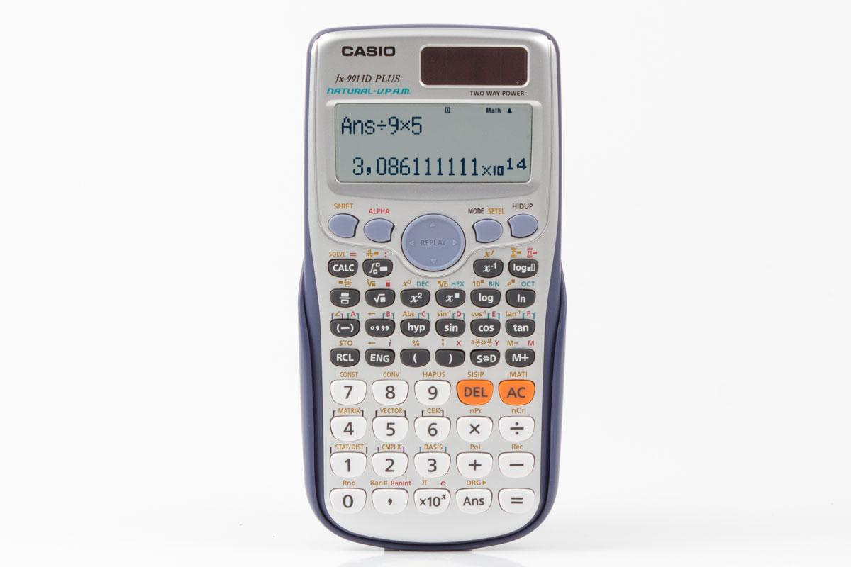

**Figure 1.** Calculator Casio fx-991IDPlus

Simple calculation operation keys

*Source: https://images.app.goo.gl/CjSjcx5JM7mqxUq67*

The use of a calculator that has been upgraded permits not only simple calculations but also specific calculations. For example, in one of the scientific calculators of the Casio fx-991ID Plus type there is a calculation operation like the following:

|  |  |  |
| --- | --- | --- |
| **Table 1.** Forms of advanced calculation operations on the calculator. | | |
|  |  |
| Forms of calculation operations | Operation keys |
| General calculation |  |
| Equation solution |  |
| Statistical and regression calculations |  |
| Etc. |  |

* 1. *Design and compilation of aspects in enrichment learning tools*

The implementation of this development research began with analyzing student characteristics, subject matter, and on-site conditions. The selection of material is adjusted to the needs of using a calculator, where not all material in mathematics can be applied using a calculator. The material used was taken from even semester material which consists of 5 chapters: the Pythagorean chapter, circles, flat-sided shapes, statistics, and probabilities. Broadly speaking, the material used in the preparation of calculator-assisted student activity sheets is only a few sub-sections where later students can find out other ways to determine the solution using the function keys found on the calculator.

The prototype began with the preparation of a learning implementation plan consisting of identity components, core components, basic competencies and competency achievement indicators, learning objectives, learning materials, learning methods, learning activities, media / tools, and assessment techniques. In this case, the Microsoft Word program was used as usual to type the entire contents of the lesson plan accompanied by pictures and the photos were obtained from several sources. Below is the proposed design of the lesson plan.

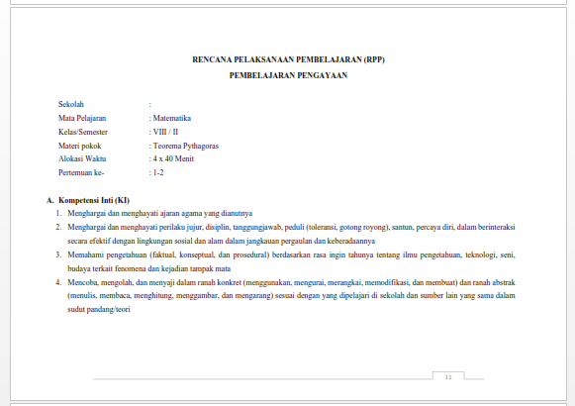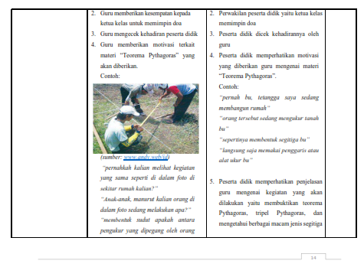

**Figure 2. Lesson plan design**

Student activity sheets were prepared by including the components of the title and student identity, basic competencies and indicators of competency achievement, student activities and conclusions. The program used in the making of these student activity sheets was Microsoft Word with the copy and paste technique of many templates, pictures, and writing. Some pictures were taken from sources and some were compiled by the author with the help of the *geogebra.* The image below is a partial display of the student activity sheets that have been compiled.

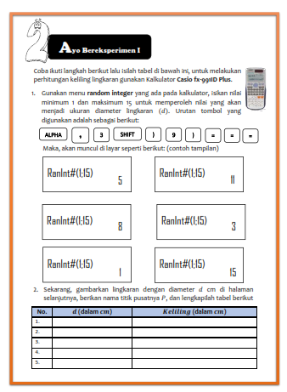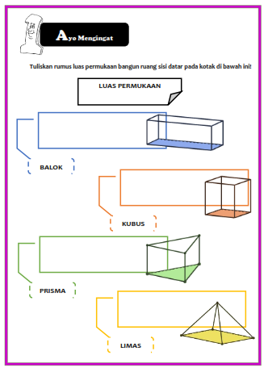

**Figure 3. Calculator-assisted activities design plan**

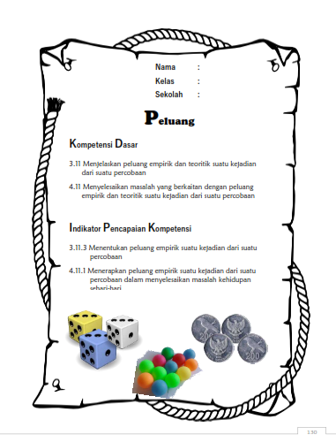

The students' final test sheets were previously arranged by making a grid and then there were components of the student's identity listed on the final test sheet, work instructions, and items. The making of the questions refers to the textbook, the Olympic questions with a little modification to adapt to the real life of students. The design structure used was still using the Microsoft Word program, some of the images are sourced from the website and others, the authors themselves make using the Microsoft Word program and *geogebra.* The following is a preview of students final test sheet.

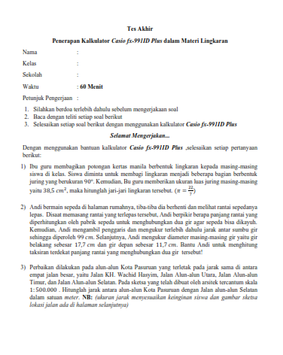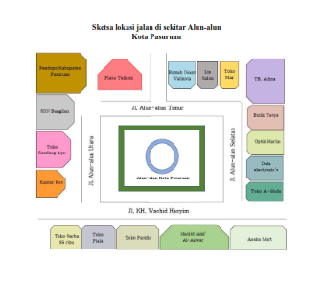

**Figure 4.** Final test layout design

Overall, the content of this calculator-assisted enrichment learning tool generally has fewer activities because its main use is for enrichment and the application of the calculator is limited to a few sub-sections. So that other activities can be assisted by using tools and materials according to the needs in that chapter. The learning device which consists of a learning implementation plan, student activity sheets, and the final test will then be summarized in one module. This module is divided into 4 parts, namely part A which is introduction, part B which is the learning tools of all the chapters in the even semester, part C which contains the test instruments, and part D which is the closing. The designs used in compiling this module mostly use the Canva application from the cover page design, preface, table of contents, to the boundary page to separate between sections and between chapters also use the application. The choice of colors, patterns, fonts, font sizes was adjusted to the junior high school level, where middle school-aged students have rather bright and fun spirit. Below is an example of the display of an enrichment learning tool module designed using Canva.

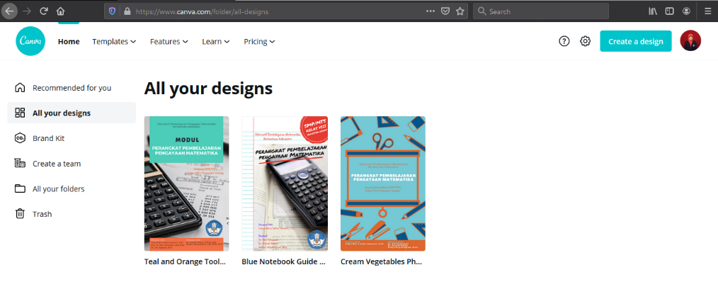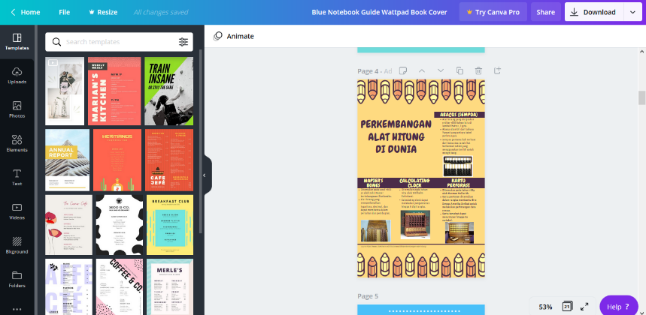

**Figure 5.** *Canva* worksheet design plan

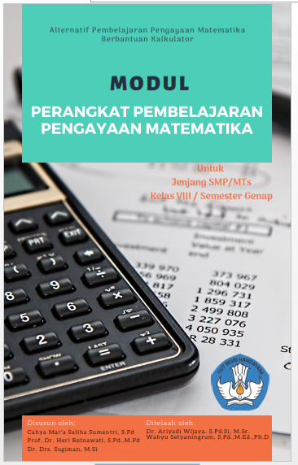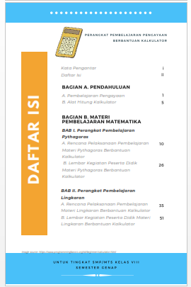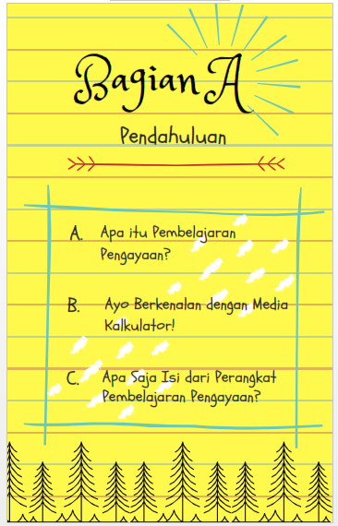

**Figure 6.** Layout for cover, index, and chapter borders

1. **Result and Discussion**

The implementation of enrichment learning began when the teacher had given students daily tests for circle chapters to obtain remedial student data. Students who took the remedial test will be given re-examination questions from the teacher, while students who did not take the remedial will be given enrichment learning. The data obtained were from 23 students who participated in enrichment learning. Furthermore, each student was given a calculator and LKPD. The lesson began with the instructions on how to use the calculator, explanation of the keys on the calculator and their functions according to the problems in the LKPD. This was done because initially, the calculator will only show the square root in its initial format. The students found it problematic as they need to see the root in its decimal format.

The effectiveness of the use of calculator-assisted enrichment learning products consisting of learning implementation plans and student activity sheets can be seen from the results of learning achievement tests. The percentage of completeness for the final test after the enrichment learning was carried out was on 95.45% with an average final test score of 83.72. This explains that many students (21 out of 22) who took the test attained the minimum KKM score of less than 71 reached the amount of 75%. In another way, to determine the effectiveness of this learning product, students and teachers were given a questionnaire containing their own opinions or impressions that they have experienced after using a calculator to solve some problems in student activity sheets during enrichment learning.

Another thing to note was that during the learning process, the students became more independent because they were in possession of their own calculators and had their own answers. This was supported by the fact that when applying the integer random key, almost each student had their own number that appears on the calculator screen. Before being told by the teacher of the random integer key function, they were already busy and nervous because it turned out that their numbers were different from their peers. However, when the teacher explained about the button, the students began to try again and had fun comparing the calculation result with those of their peers. On the other hand, the teacher expected that using a calculator and its learning tools as a companion or other way of teaching, although the problem is that not all students have a calculator.

1. **Conclusion**

Mathematics enrichment learning tools for grade VIII on an even semester using a calculator had several characteristics, including: enrichment learning activities are arranged according to the use of calculators in solving problems accompanied by illustrations of how to use the menu in the calculator, using problems that have many correct solutions, and using test instruments. The end is a matter of application from textbooks and other sources with the help of a calculator. Most of the designs used in completing each page use the Canva application, Microsoft Word, Geography, as well as several images quoted from several sources on the internet. The result that can be seen was that students were able to solve problems by relating the manual method they usually do through using the function keys on a calculator which results in a similar solution. The students also felt confident when using one of the function keys, namely the random integer, where peers might have had different results. This happened because the numbers that come out were indeed random and in the form of whole numbers, so students did not need to feel that they made errors. Therefore, one of the functions of the calculator is to provide opportunities for students to explore different results but still within the scope of the correct answer.

**References**

[1] Wulan D K 2011 *Humaniora*. **2** 269-76

[2] Permendikbud 2014 *Peraturan Menteri Pendidikan dan Kebudayaan Nomor 104 Tahun 2014 tentang Penilaian Hasil Belajar oleh Pendidik pada Pendidikan Dasar dan Pendidikan Menengah*

[3] Compton L 2014 *The Schoolwide Enrichment Model* (Waco:Prufrock Press Inc)

[4] Wiggins H, Ansie H and Johann E 2017 *International Journal of Mathematics Education in Science and Technology*. **48** S16-S29

[5] Jones K and Simons H 2000 *Proceedings of the 24th Conference of the International Group of the Psychology of Mathematics Education*.**3** 103-10

[6] Sulistyowati Y and Sugiman 2014 *PYTHAGORAS:Jurnal Pendidikan Matematika.* **9**  219-32

[7] Serin H 2017 *International Journal of Learning and Development*.**7** 60-7

[8] Shaughnessy M 2013 *Mathematics Teaching in the Middle School.* **18** 324

[9] NCTM 1989 *Curriculum and Evaluation Standards for School Mathematics* (Reston, VA:NCTM)

[10] Roschelle J and Corrine S 2008 *International Handbook of Information Technology in Primary and Secondary Education*. **20** 951-9

[11] Kent Ashley 2013 *School Subject Teaching: the history and future of the curriculum* (New York: Routledge)

[12] Amanyi C K, Sigme B B and Lloyd A O 2016 *European Journal of Educational and Development Psychology.* **4** 33-52

[13] Retnawati H, et al 2019 *Conference:2th ATCM.*

[14] Retnawati H, et al 2018 *Problem of Education in the 21st Century.* **76** 215-30

[15] Saparwadi L 2016 *Jurnal Didaktik Matematika*. **3** 39-46

[16] Daniyati N A and Sugiman 2015 *PYTHAGORAS:Jurnal Pendidikan Matematika.* **10** 50-60

[17] Fitriyani W and Sugiman 2014 *Jurnal Riset Pendidikan Matematika.* **1** 268-83