Impact of Web-Based Knowledge Building on Professional Identity of Prospective Teachers
Yurniwati ^{1, a)}, Cecep Kustandi ^{1,b)}
¹Universitas Negeri Jakarta, Indonesia

^{a)} Corresponding author: yurniwati@unj.ac.id
^{b)} cecep_kustandi@unj.ac.id

Abstract. Prospective teachers need to developed professional teacher in their initial teacher education cause solid teacher identity that would support and sustain them in their future profession. Educators must pay attention to developing prospective teachers’ professional identity. This study aims to determine the impact of web-based knowledge building on professional identity of prospective teachers. The study methods were quasi-experiment post-test only, conducted in primary teacher education in Jakarta, Indonesia. There was 150 prospective teachers get involved; 75 students for experiment group and 75 students in control group. Experimental group learned through Web-based knowledge building, and a control group learned through traditional teaching approaches. Teacher identity data was collected by Likert using 5 scalas, and data is analyzed using independent T-test. The research found that Webbed based knowledge building developed professional identity of prospective teachers. WBKB play role constructs psychological such as self belief, self efficacy, and identity besides knowledge for teaching.

INTRODUCTION
Teachers have an essential role in preparing students to become independent individuals, able to think at a higher level, solve problems and collaborate. Mathematics is one of the subjects that can accommodate this goal. In addition, teaching mathematics in elementary schools fosters basic knowledge and skills and a disposition that greatly affects the next level of education. According to Jacob et al. (2020), the teacher's task is to know how to organize the learning environment to facilitate students understanding of the concepts and contribute to their intellectual development.
Over the past two decades, international research on professional development has resulted in an understanding that pedagogical teachers can improve teaching quality and student achievement (2,3). But to be professional teacher not only have content knowledge, pedagogical knowledge and pedagogical content knowledge. At the beginning of 21 era, teacher identity become intresting tipic. Research founding shows that that a solid teacher identity results in higher emotional involvement and enthusiasm at school (Rots, Aelterman, Devos, & Vlerick, 2010) and also improve the quality of teaching in the classroom (Agee, 2004; Beijaard, 2009) , teacher with a strong identity have better socialization process and emotional involvement in school (Rots et al., 2010; Hanna et al.,2020). As a result, learning to be a teacher is as important as learning how to teach (Chong, 2011; Friesen and Bestley, 2013). A well-developed professional identity can also improve teachers’ confidence in their decision to work in education, and also their commitment to the profession (Rots, Aelterman, Devos, & Vlerick, 2010). Teacher educators should consider teacher identity as important aspect of the process of learning to become a teacher.
Beeing a teacher involved complect cognitive. Students teacher need to know who they are and where there stand (Timostsuk&Ugaste , 2010). Thus a focus on self is central to teacher education who you are as a person has a profound influence on what you will or will not learn in teacher education, but perhaps even more importantly, it shapes what you will be as a teacher, what and how you will teach, and how you will respond to the changing context of teaching (Bullough & Gitlin, 2001, p. 45).
Teacher have to maintaining their capacity and teaching quality in workplace until their retired. So it not easy job, sometime person get boring, downgrade motivation. To keep going as succes teacher, it need to create a solid teacher identity that would support and sustain them in their future profession.
Teacher identity have known in various terminology such as role anticipation, occupational values, and feelings of intrinsic satisfaction (Hanna et al., 2020). According to Timostsuk and Ugaste (2010) Teacher Identity is the person’s self-knowledge in teaching-related situations and rela- tionships that manifest themselves in practical professional activities, feelings of belonging and learning experiences. Hanna et al (2020) categorized teacher identity under six domains Self- image, Motivation, Commitment, Self-efficacy, Task perception, and Job satisfaction—that can be seen as important and relevant demarcations of teacher identity.
Day, Sammons and Stobart (2007), in their study of teachers’ lives and work propose three areas of influence on identity: professional, local and personal. From this viewpoint there is a socially accepted general view of the profession to which the individual belongs, a positioning within the department or local (institutional) situation and then their personal individual life outside the workplace.
But However, alongside this cultural diversity, the research on teacher identity is also charac- terized by a wide-range of theoretical perspectives, and a tendency toward disconnected qualitative studies that have conceptualized and operationally defined professional teacher identity from a number of different perspectives (Beijaard et al., 2004). For example, Friesen and Breiter (2012) professional teacher identity has been preceded by considerable theoretical and empirical work on self and identity in psychology and sociology going back over a hundred years, with additional contributions from anthropology and political science.
But development of teacher identity poorly understood by educators. They focus on student teacher development on curriculum, content knowledge, pedagogical knowledge and classroom management. Meanwhile student teachers need psychological constructs such as self belief, self efficacy, and identity besides knowledge for teaching. The present study considered to develop teacher identity in elementary teacher education that would support and sustain them in their future profession. Teacher identity development facilitated by LMS based on knowledge buiding.
Nowadays, the internet is entering all sectors, including education. The Internet facilitates learning media, references, and learning processes through Learning Management Systems. Web-based knowledge building (WBKB) is an LMS made with Moodle. WBKB emphasizes Knowledge Building following Scardamalia & Bereiter (2006) that the acquisition of knowledge together in the community. The community defines the learning objectives, including developing knowledge and skills. The Internet makes it easy to communicate between members located in different places, and they can integrate synchronously or asynchronously. They can have productive discussions through Q&A, sharing ideas that lead to many responses and solutions. Communication with computers and gadgets allows information transfer and exchange easily and quickly. In line (5), web-based learning provides easy access to fast learning resources, can be accessed anywhere and anytime, and helps students have knowledge and skills on time and act as active collaboration in the information-based society. This results in actively involved learners achieving a deep understanding.
Based on the criteria for developing effective teacher professional development according to (6) and (7), we designed the WBKB model framework (Table.1)
TABLE 1. WBKB Framework

Component | Activity
Online learning | Prospective teachers learn synchronous and asynchronous
Learning Object | Learning Object consist of:  - Content Knowledge:  - Pedagogical Knowledge: mathematical learning theory, learning tools, evaluation
Assignments | - video analysis  - teaching video
Collaboration | Participants engage actively: peer coaching, Q&A, sharing and generate ideas

Prospective teacher registered and login to LMS. The WBKB organized 16 topics for a semester. Every session consists of a learning object (PDF, video, or animation). Prospective teachers learn synchronously and asynchronously according to course design. Some assignments based on cases or projects triggered them to work together to achieve goals or solutions

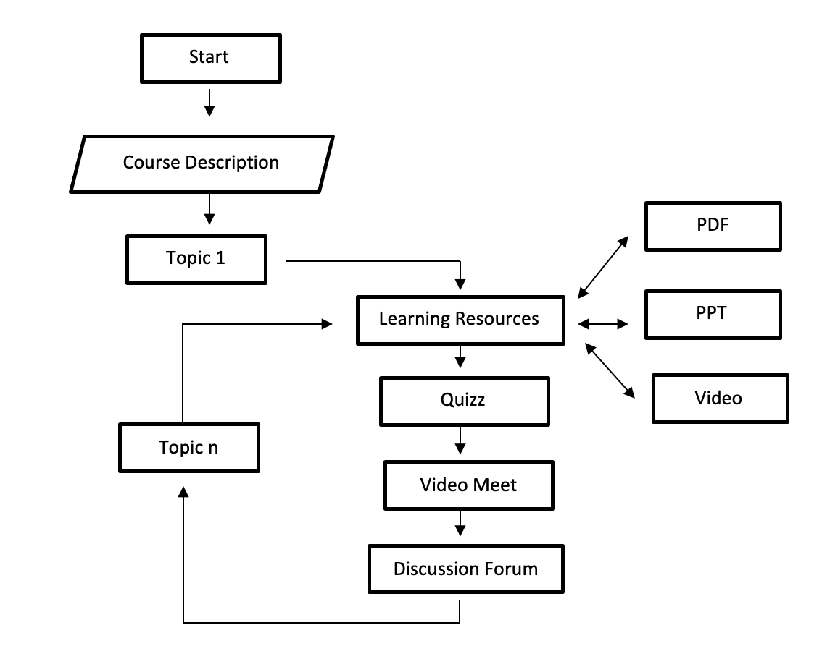
The final form of LMS Student activities in one semester. The learner will join the LMS after registering and logging in (Figure. 2). Then in the general section appears the course description and session in order (Figure 3). In the left navigation, there are topics contained in every session. Each Session contains toopic, learning resources, quizzes, video meets, and discussion forums. and learning objects are organized in LMS (Figure 4)


Fig 2. Registered Form

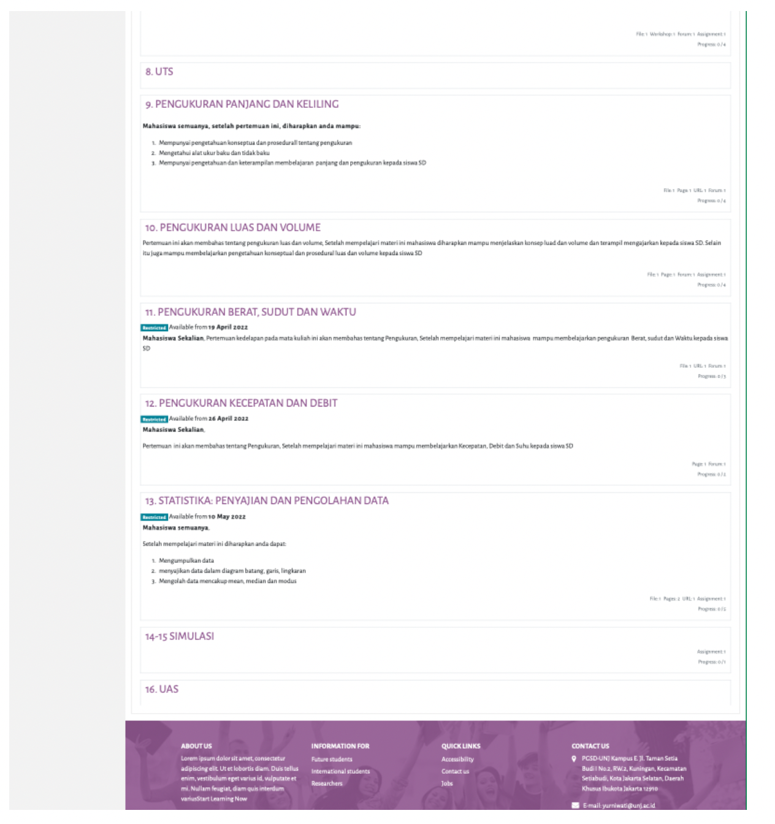
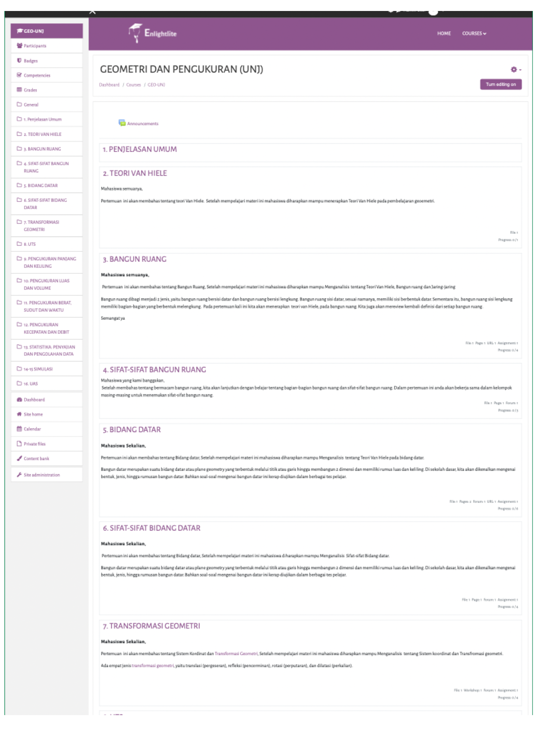

Fig 3. Course Session
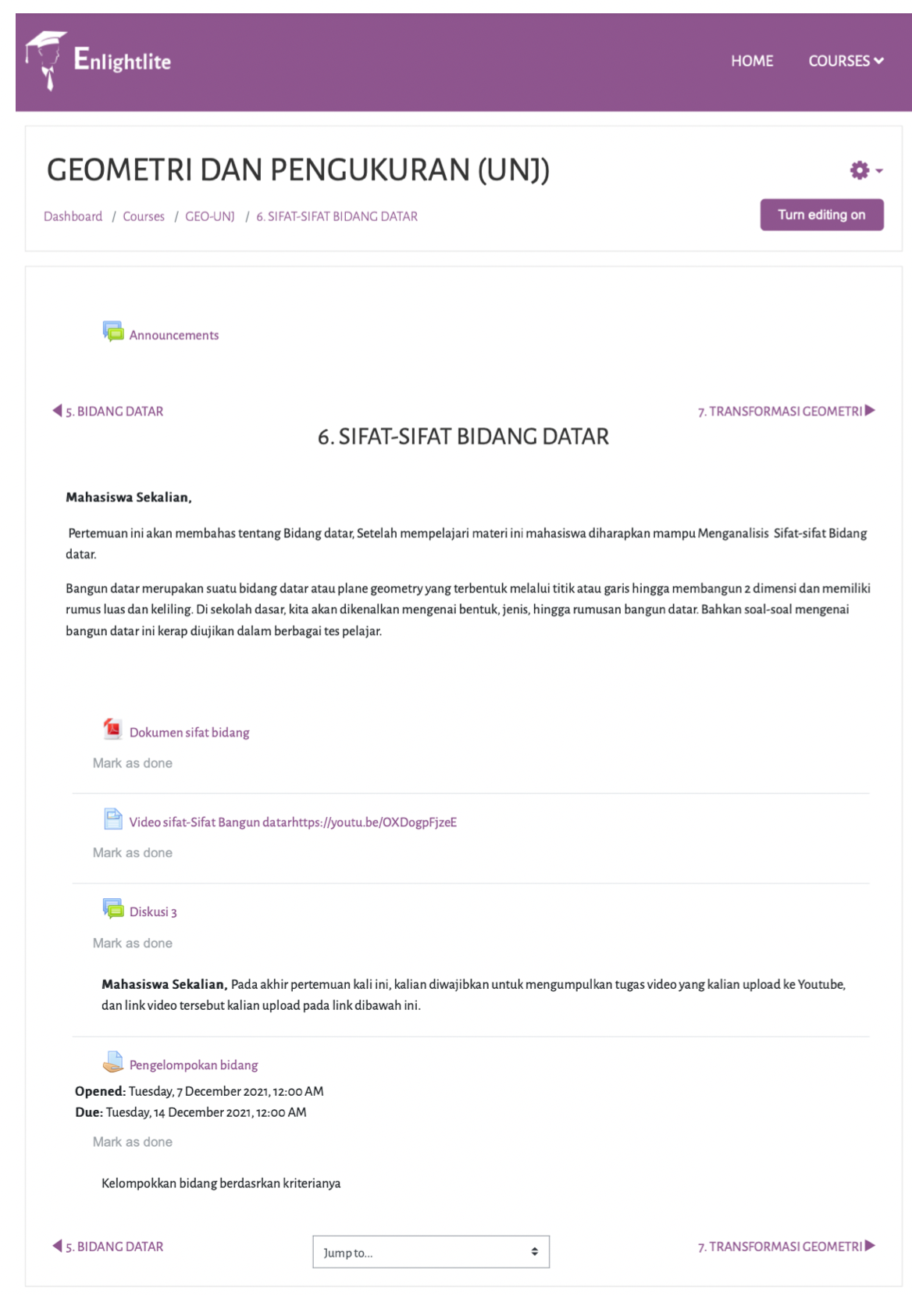

Fig 4. Plane Properties

METHODS
This research is conducted in elementary school teacher education in Jakarta and involves 5th-semester students who enroll in Geometry and measurement course. The study was carried out using a quasi-experimental post-test only and used a purposive sampling technique. We have 75 participants for the experimental group and 75 participants for the control group. The experimental group learned through WBKB, and the control group learned traditionally through Zoom meetings. The study was done in eight sessions, and finally the participants completed teacher identity questionaire.
Teacher identity questionair refer to Hanna et al. (2020) consist of four parts: motivation (8 items), self image (12 Items), self efficacy (12 Items) and, task perception (8 Items). We used the 5-point Likert scale, each: 1 (strongly agree), 2 (agree), 3 (unidentified), 4 (disagree), 5 (strongly disagree).
The data is analyzed in two steps. First, we do the normality test using the Liliefost and the homogeneity test using Levene’s test. Second, we use Independent Samples T-Test to determine the impact of WBKB on students teacher professional identity,

RESULTS
Descriptive statistics of the post-test results (Table. 2) show that there is a difference in the average score of the experimental group (mean = 161) and the control group (mean =157 )

TABLE 2. Descriptive Statistics

Group | N | Mean | Median | SD | SE
Experiment | 75 | 161 | 161 | 8.01 | 0.924
Control | 75 | 157 | 156 | 9.10 | 1.05

A normality test was carried out using Shapiro-Wilk (W = 0.998; P-value 0.220) Table. 3) the both data were normal. Test for Equality of Variances used Levene's test, and the data were homogenous (F = 1.32; P-value = 0.252)
To answer the question of the study, we used Independent sample T-test (Table.3) and got F = 12,506 and P-value < 001. It means that learning through WBKB influences the PCK of prospective teachers.

TABLE 3. Independent Samples T-Test

 |  | Statistic | df | P
F | Student's t | 3.24 | 148 | 0.001

DISCUSSION
The results showed that students who learn with Webbed based knowledge building have better teacher identity than students learn with traditional approaches. This finding is in line with Kwon et al. (2021) that identity changes in online learning if LMS designed and managed as a learning community; both instructors and learners should be repositioned as co-participants; and they should work together to build a post-learning community by practicing community membership.
Webbed based knowledge building refers to improving the quality of geometry learning lectures transferred to the LMS. But this is not just moving the material into the web but is equipped with the technicalities and strategies needed in online learning. Among them are facilities that can make participants actively involved through group tasks. The improvement of prospective teachers to teaching mathenatics alligned to how to feel and act as teacher. Prospective teachers can have opportunities to develop identities by participating in co-construction of mean- ing rather than consuming existing knowledge. In a study on learner identity, Khalid (2019) observed that learners’ identity changes occur when an online course is managed and facilitated towards building an online community by ensuring that learners have a shared goal and needs beyond learning objectives. Indeed, shifting learner identity from “a knowledge receiver” to “an interactive learning participant” is the ultimate benefit of online learning (Park, 2011, p. 179). This identity change is derived from the fact that quality learning is achievable through active participation and engagement in online learning environments for the reason: if quality human-to-human interactions are not organised in the online learning environment, technological features and learner needs remain mismatched, and the environment becomes a tool for self-learning (Park, 2011).

Conclusion
This study investigates the impact of web-based knowledge building on the professional identity of prospective teachers. Based on the data analysis found that web-based knowledge building influences teacher identity significantly. Web-based knowledge building is a learning management system that quickly promotes prospective teachers' access to information easily, discussion and collaboration. They construct knowledge through collaboration in a learning community, developed motivation, self image, self efficacy and task perception.

Acknowledgments

We would like to express our appreciation and thanks to the Directorate of Research and Development–Ministry of Research, Technology and Higher Education (Ristekdikti/MoRTHE), for financial support for this research. The authors would like to thank colleagues, Research Institution and The Master Program in Primary Education, Universitas Negeri Jakarta. The research grant number is 22/PG.02.00.PT/LPPM /III/2022, on April 18th, 2022.

References
1. Jacob F, John S, Gwany DM. Teachers ’ Pedagogical Content Knowledge and Students ’ Academic Achievement : a Theoretical Overview. J fo Glob Res Educ Soc Sci. 2020;14(2):14–44.
2. Kutaka TS, Smith WM, Albano AD, Edwards CP, Ren L, Beattie HL, et al. Connecting Teacher Professional Development and Student Mathematics Achievement: A 4-Year Study of an Elementary Mathematics Specialist Program. J Teach Educ. 2017;68(2):140–54.
3. Rodriguez JA, Condom-Bosch JL, Ruiz L, Oliver E. On the Shoulders of Giants: Benefits of Participating in a Dialogic Professional Development Program for In-Service Teachers. Front Psychol. 2020;11(February):1–10.
4. Scardamalia M, Bereiter C. Knowledge Building: Theory, Pedagogy, and Technology. Sawyer K, editor. Read Teach. 2007;61(2):157–60.
5. Harasim L. Collaborativist (aka Online Collaborative Learning or OCL) Pedagogies in Practice. Learn Theory Online Technol. 2017;142–55.
6. Desimone LM, Garet MS. Best practices in teachers’ professional development in the United States. Psychol Soc Educ. 2015;7(3):356–69.
7. Darling-Hammond L. Teacher education around the world: What can we learn from international practice? Eur J Teach Educ [Internet]. 2017;40(3):291–309. Available from: http://doi.org/10.1080/02619768.2017.1315399

